ETW IOANA COZMA
by Ioana Cozma
term1

Table of Contents
1 Models of Communication 3
1.1 Linear Model of Communications 3
1.2 Interactive Model of Communication 4
1.3 Transaction Model of Communication 6
2 Case Study 8
3 How to improve Communication skills 12
3.1 Poor communication in the workplace 12
3.1.1 Unclear objects 12
3.1.2 Lack of Empowerment 12
3.1.3 Limited Collaboration 13
3.2 Solution for Poor Communication in the workplace 13
3.2.1 Make objective Strong 13
3.2.2 Empower Employees 13
3.2.3 Encourage Collaboration 13
4 References 14

Models of Communication
Communication templates simplify the process by creatively illustrating the specific facets of a communication conference. Several models describe interactions more in depth than others, but not even the most complicated model recreates what we feel in a contact moment. Models also serve an important function for communication students, as they allow us to display those ideas and steps during the process of communication.
You can think more sensibly about how communication works through your communication sessions, which can help you better prepare for future communication and learn from your previous communication. The three communication models to be discussed are the models for transmission, interaction and transaction.
While these communication models differ, they contain certain common elements. Include the following parts: participants, message, coding, decoding, and channels: the transmission and interaction models, the two models we discuss. Participants are the transmitters or receivers of messages in a contact gathering in communication models. The message is the word or not that is sent from sender to recipient. When you say, for instance, "Hello! " Your colleague sent a message of greeting that your person receives.

Linear Model of Communications
As seen in Figure, the linear or transmission communication model defines communication as a linear, one-way mechanism where the sender intentionally communicates a message to a recipient (Ellis & McClintock 1990). The sender and message are based in this model in a contact conference. While the receiver is included in the model, this function is viewed more as a objective or target than as part of a continuous cycle. The recipient will either receive and understand the message successfully or will not. The scientists who developed this model were expanded to incorporate a debater, message and listener by a linear Aristotle model centuries ago.
The modern communications developments such as telegraphy and radio have both been influenced by and expanded, and these technologically significant influences will possibly be found in the pattern (Shannon & Weaver, 1949)). Consider how you hear a radio message from a person in the radio studio. The transmitter is the radio broadcaster who encodes the verbal message sent by electromagnetic waves by a radio tower (the channel), then enters the ears (the recipient's) through an antenna and microphones, so that it can be decoded.
The radio advertiser does not know whether or not you hear their post, so if the equipment operates and the channel is noise clear, then it is possible that the signal has been transmitted successfully.
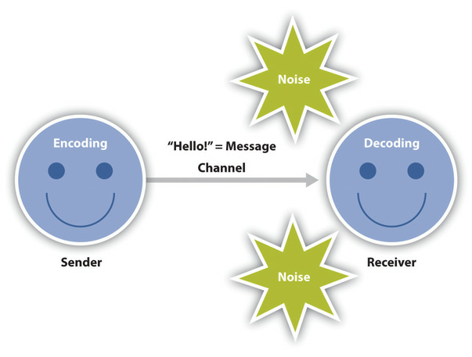
While today's models of transmission could be simplistic or even less established for us, it encouraged scientists to explore the communication mechanism in new ways, ultimately leading to more complicated models and communication theories.

Interactive Model of Communication
As seen in figure, the collaborative or interacting communication model defines communication as a method in which participants exchange sender and receiver roles and generate meaning by transmitting messages and receiving input in physical and psychological environments (Schramm 1997).
The interactive model incorporates feedback and makes communication more interactive and bidirectional than illustrating communication as a linear one-way process. Feedback comprises texts sent to other messages
For instance, answer a point you make during a lecture or point to the couch if your roommate asks you to figure out where the remote control is located. The inclusion of a feedback loop also makes it possible for people to understand the functions of a contact group. This model includes two sender recipients who exchange messages rather than a source, a message and a receiver. To sustain a contact experience, each person alternates positions as a sender and receiver. Although this appears like a perceptible and systematic process, we very easily and sometimes with no conscious thinking switch between sender and receiver functions.
The interactive template is also less dependent on communications and more dependent on communication. Whereas the linear model focused on how and how a message was conveyed, the immersive model became all on the communication process itself. However, this model acknowledges that so many messages are transmitted simultaneously that others are not received. Such texts are also delivered involuntarily. Communication in this model is therefore not judged to be effective or ineffective, based on the successful transfer and reception of one single message or not.
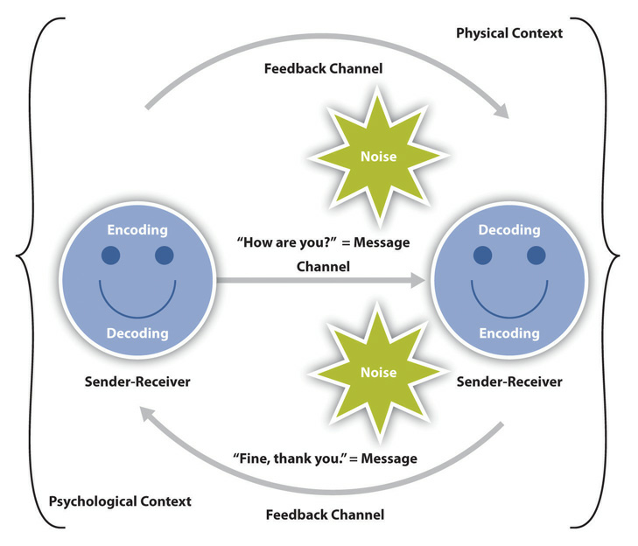
The interactive template takes into consideration physical and psychological aspects. The environmental factors for a communication encounter include the physical context. The space is influenced by size, layout, temperatures and lighting. Consider the actual environments in which work interviews are carried out and how the interaction can affect it. I had telephone interviews, crowded around a table of 8 people and seated around an extra-large conference table with a few people. I was also in an office to interview multiple members, in succession, one-on-one over a span of three hours, of a selection committee. It is necessary to recognize the role that physical environments play in our conversation, regardless of the room 's size or other environmental variables.

Transaction Model of Communication
Through the advancement of the study of communication, models developed to take further into account the communication process. Most researchers view contact as more than a dialogue mechanism used to convey information. We don't deliver messages like machines and when an exchange unfolds, we don't switch smoothly between the positions of sender and recipient. We cannot intentionally avoid communicating, however, because contact is more than simply transmitting and receiving messages. The transaction model varies substantially from models for transmission and interaction, including the principles of correspondence, sender and receiver position and meaning function (Barnlund, 1970).
Contact as a mechanism in which contact creates social reality within social, connection, and cultural contexts is defined in the transaction model of communication. We communicate to establish partnerships, develop intercultural alliances, mold our self-concepts and connect with others for dialog to create societies. We are not simply communicating to share messages; we communicate to create relationships.
The sender and receiver functions in the correspondence exchange model vary greatly from the other ones. The individuals in a contact group are named communicators, instead of labelling members as senders and recipients. The Transaction Model suggests that we are simultaneously senders and recipients, contrary to the interactive model, in which participants change positions as sender and receiver. This is an important addition to the model, as it helps us to consider how we can improve our interactions. For Instance, A verbal response based on the communication that we get at the same time from our interaction partner in the center of sending it.
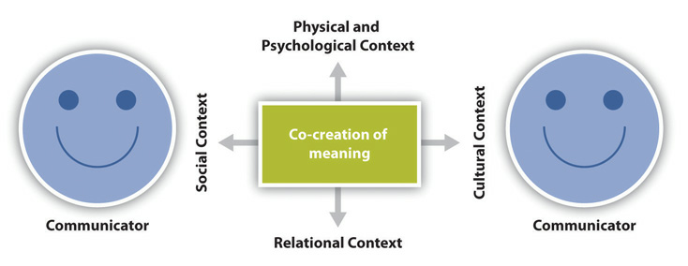

Case Study
Managing a broad variety of partners Tracking steel resource collections around Wales through the Archives and Records Council of Wales and Swansea University
Goal: Records on the steel sector in Wales in terms of the implementation of developmental projects and community involvement. The first move was an archive survey undertaken at the Tata Steel Records Centre. At the end of January, a five-day survey was carried out with Tata Steel 's approval. Secondly, to improve the findings of the study carried out by the Tata Steel Records Centre, a comprehensive study was carried out of the reports on the steel industry collected by Wales' archival services.
Situation: A variety of partners are recorded back to an archivist. This included managing various interests, particularly those of a corporation with issues of protection and secrecy and busy archiving.
Stakeholder Communication
Other Record Services
Message | - It is the goal of the project  - Please identify your steel archives holdings for established participants  - To prospective possible participants: up to date details on the project
Communication procedures | - To respondents to the sample: a survey questionnaire with a supporting email and follow-up text. Within a limited period of time details was available, so easy return was needed, such that the duration of time was very straightforward. To explain and schedule meetings, follow-up emails were used. Contingency measures needed to be worked up where solutions were unavailable.  - For prospective partners: knowledge, even though they did not take part at that stage, in order to guarantee their future engagement, though desired, i.e. the ability to build and maintain long-term interactions.
Conclusion | Nine Welsh archive providers offered full information of assets and two showed an interest in future participation

Tata Steel
Message | Tata Steel is associated with this important project.
Communication Procedures | The project included collaboration with the Database Center and the entire organization. In order to maintain bidirectional communication, it was necessary to establish constructive ties through personal meetings. E-mail communication (routine yet thorough procedure), has been used to generate contractual conditions for coping with legal and confidenzal problems.
Conclusion | Entry to the records center was given and a relationship with the organization was established

Survey Project Board
Messages | This is how the plan develops, and such are the challenges we face now.
Communication  Procedures | Regular schedule notifications via teleconferences with representatives of project boards in other regional areas. Written notes have been exchanged for review in advance at the meetings. Any participants have agreed to migrate and limit the amount of teleconference places. At those sessions, funders were described
Conclusion | The project board was advised of the project and any issues to avoid slippage in the project timetable have been found.

Conservators
Message | Develop and settle on an inquiry framework and perform an effective environmental needs survey
Communication  Procedures | - The first conference had to be informed about the proposal by the conservatives  - Email correspondence was used to construct a growing survey framework with multi-way feedback
Conclusion | Created and applied Survey Framework

Other groups
Messages | This survey is important as it can provide you with valuable knowledge.
Communication  Procedures | Face-to - face meetings for a sense of commitment and to encourage two-way dialogue with, for instance, Swansea University Campus academics to explore interdisciplinary desires, the Ebbw Vale Archival Trust
Conclusion | There were new connections with numerous organisations to establish potential projects

Conclusion
It was a dynamic communication scenario that involved specific messaging from two stakeholders: some were to stimulate response and engagement, while other communications were to educate and involve stakeholders. Usage of suitable methods for dialog (where necessary) ensure that the communication mechanism is productive and successful.

How to improve Communication skills
You have already the all-too-common confusion issue in your career. It is crucial to determine the root of a communication mistake until it creates frustration and employee distrust, or impacts the performance of an organization even negatively. However, it is just the beginning to address the question to determine weak communication. Identify the reasons and most successful approaches to overcome weak communication at the workplace.

Poor communication in the workplace
The workplace is like every other society in the world: it's filled with men. If you're operating with computer systems, communicating with client’s face-to - face or dealing with rich shareholders, contact channels need to be available, otherwise the device may crash. Below are several growing explanations for poor workplace communication.

Unclear objects
The bulk of corporate companies work from a top down system. The management committee takes specific choices, the management team decides how such choices are to be taken and the workers operate to achieve the management goals. Yet what if the targets are not clear?
If these be day-to-day or long-term targets, management cannot fulfill client standards because it is not expressing its objectives. This may frustrate both the employee team and the administrators, who now have to remind their superiors that goals have not been accomplished.

Lack of Empowerment
Employees empowered to speak up about obstacles or setbacks are not afraid. They know administrators will understand them, their problems will be dealt with and there will be no adverse repercussions as a result of their speaking up.
Moreover, they are less inclined to talk with possible issues in situations where workers do not feel motivated. Employees who are worried about their work may decide not to speak up and face elimination in a project. They may even not see the value of communicating because management has in the past overlooked them.

Limited Collaboration
Teams are also able to work together and exchange thoughts on projects. They are interested and can be proud of the project they have developed. But workers will not be as willing to work in a job that demands the administrators and supervisors call their shots. They prefer to talk badly or not at all when they do not think too much for a task.

Solution for Poor Communication in the workplace
Poor communications at the working place is, as you undoubtedly already know, just a symptom of a bigger problem. Now that you are aware of certain potential causes of communication issues, find possible solutions to each of these issues. Such solutions deal address behavioral issues in the workforce that will ideally improve efficiency, teamwork that social values.

Make objective Strong
Starts from the top with excellent contact. When the goals of the company are straightforward, realistic and understandable, so everybody needs to be on board. Employees who appreciate what is required of them on a regular, monthly, yearly or annual basis become more successful and happier with their work. Study these priorities at team meetings and results evaluations to keep the dialogue moving

Empower Employees
Employees deserve to feel like they have a choice in their future. Empower them to think about what they see in their employment and prevents them from being more successful. The main part of this phase is hearing and responding on what they suggest.

Encourage Collaboration
A working group is a communicative place of employment. Teams who operate together will often collaborate more often on certain topics. But don't stop with department teams – change up the workers' groups with a range of joint tasks. It is an easy way to bring workers out of their silos and through better ways of communication.

References
- Encyclopedia Britannica. 2020. Communication - Models of Communication. [online] Availableat:<https://www.britannica.com/topic/communication/Models-of-communication> [Accessed 5 August 2020].
- Cal.org.2020. [online]Availableat:<https://www.cal.org/caela/tools/program_development/elltoolkit/Part2-41Interaction&Communication.pdf> [Accessed 5 August 2020].
- Michman, R. and Harris, L., 1977. The Development of Marketing Channel Communication Models. Journal of Business Communication, 15(1), pp.29-39.
- Crackmycbse.com. 2020. Communication Skills Class 10 Notes PDF. [online] Available at: <https://www.crackmycbse.com/2020/06/Communication%20Skills%20Class%2010%20Notes%20PDF.html> [Accessed 7 August 2020].
- Udemy. 2020. The Complete Communication Skills Masterclass For Life. [online] Available at: <https://www.udemy.com/course/the-complete-communication-skills-master-class-for-life/> [Accessed 7 August 2020].
- Bednar, L., 2012. Teaching Case Using a Research in Technical and Scientific Communication Class to Teach Essential Workplace Skills. IEEE Transactions on Professional Communication, 55(4), pp.363-377.
- Goalcast. 2020. 7 Quick Tips to Improve Your Communication Skills (With Anyone). [online] Available at: <https://www.goalcast.com/2018/01/07/improve-communication-skills/> [Accessed 10 August 2020].
- Lifehacker. 2020. The Best Ways to Improve Your Communication Skills. [online] Available at: <https://lifehacker.com/top-10-ways-to-improve-your-communication-skills-1590488550> [Accessed 10 August 2020].
- Rimmer, A., 2017. How do I improve my communication skills? BMJ, p. j2587.

