

Programme: Master of Business Administration
Module: Human Capital Management
Module Code: LCMB7023

Assignment Title: Integrated Human Capital Blueprint

Student Name: Jainil Kanubhai Patel
Student ID: 2519957
Group: 3
Lecturer: Dr Nerys Dosseh

Table of Contents
Contents
Executive Summary 3
Part 1: Building a Culture of Innovation & Future Work Practices 4
1.1 Current practices in culture and work among the tech companies 4
1.2 Recommend cultural and structural initiatives 5
1.3 Future of Work Model for Aether Innovations 7
1.4 Enhancing Employee Motivation and Performance 8
Part 2: Reflection 10
2.1 Learning Journey using the Gibbs Reflective Model 10
2.2 Staying Relevent in the Age of AI 12
Conclusion 13
References 14

Executive Summary
Aether Innovations is a growing technological enterprise with approximately 300 workers and focuses on the creation of new digital solutions. Although the organisation has achieved success in the initial years, it is currently experiencing various strategic issues that risk the long-term competitiveness of the organisation. The organisation is facing flat organisational development, rising employee turnover, and deteriorating customer satisfaction.
This report presents an Integrated human capital Blueprint to help address these issues by aligning people management practices with the strategic directions of Aether Innovations. The report is based on the contemporary theories of Human Resource Management (HRM) to support new innovations, motivate employees and improve organisational performance.
Part 1 of the report is about creating a culture of innovation and implementing future work practices in the organisation. It explores existing cultural and work practices in the major technology firms and suggests some initiatives, such as innovation sprints, intrapreneurship programs, cross-functional teams, and a hybrid future of work model that enabled collaboration and creativity.
Part 2 of the report gives a personal reflection on the learning process from the Human Capital Management module based on the Gibbs Reflective Model. It also addresses how to stay professionally relevant in an increasingly AI-driven workplace.
Report to: The Board of Directors, Aether Innovations
From: Human Capital Consultant
Consultant Date: March 2026
Subject: Integrated Human Capital Blueprint: Aligning People and Performance

Part 1: Building a Culture of Innovation & Future Work Practices

1.1 Current practices in culture and work among the tech companies
Khan, Raya, and Viswanathan, 2022, state that organisational culture is a significant consideration in defining the behaviour of employees, the innovation, and the overall business performance in the modern technology industry. Several successful technology companies target flexible and cross-functional and innovation-based cultures to remain competitive in the fast-emerging markets. In the case of Aether Innovations, which is experiencing stagnant growth, high employee turnover, and decreasing customer satisfaction, the analysis of the current cultural practices of major technological companies can offer insightful information on how culture can affect organisational performance. A practical model to discuss organisational culture is the Schein’s Organisational Culture Model of HRM, which defines culture by three levels: artefacts, espoused values and underlying assumptions.
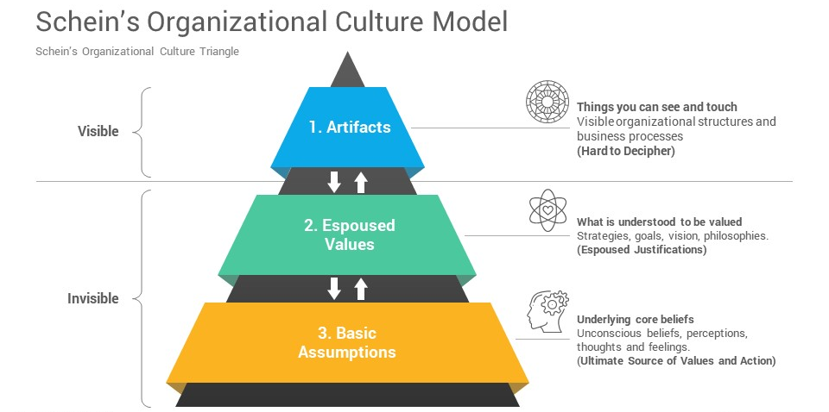
Fig 1: Schein’s Organizational Model
(Source: Akpa, Asikhia, and Nneji, 2021)
Artefacts are visual components like work design, communication patterns, and practices within an organisation. Artefacts found in most successful technology firms work to support transparency and teamwork, through open office space, digital cooperation, agile projects, and informal communication (Akpa, Asikhia, and Nneji, 2021). These practices promote knowledge exchange and quick problem solving which are vital to innovation driven organisations. The second tier is espoused values which are the strategies, goals and philosophies that govern organisational behaviour. The values common in technology companies include innovation, continuous learning, employee empowerment and experimentation. To illustrate, several companies use agile working methods and promote testing new ideas with the help of innovation laboratories or short development cycles (Savitha, and Kumar, 2025). At Aether innovations, it can be useful to reinforce these values to re-establish the engagement of employees and encourage the teams to think more creatively to solve problems. The lowest tier of the Schein model is the underlying assumptions, the unconscious beliefs that guide organisations in their behaviour. When technology firms perform successfully, the first assumption that underlies their success is that the employees are knowledge workers who can be relied upon to devise innovative solutions as they are free and with facilitating leadership (Gierlich, Baiyere, and Hess, 2024).
The implication of this assumption normally leads to flatter organisation structures, participative decision making and flexible work arrangements. However, in case of poor or inconsistent such cultural aspects, organisations may end up with issues that are similar to those of Aether Innovations. Lack of collaborative culture, independence or innovation support can reduce employee engagement and turnover. Therefore, organisational culture needs to be learned and enhanced at Aether Innovations to restore innovation, employee satisfaction, and customer outcomes.

1.2 Recommend cultural and structural initiatives
To address the issues faced by Aether Innovations, the firm must consider implementing cultural and structural initiatives that actively support innovation and employee engagement. A helpful theoretical framework that can be used to drive these efforts is Self-Determination Theory (SDT) that proposes that when three core psychological needs are met, autonomy, competence, and relatedness, employee motivation and performance are enhanced (Forner et al., 2021).
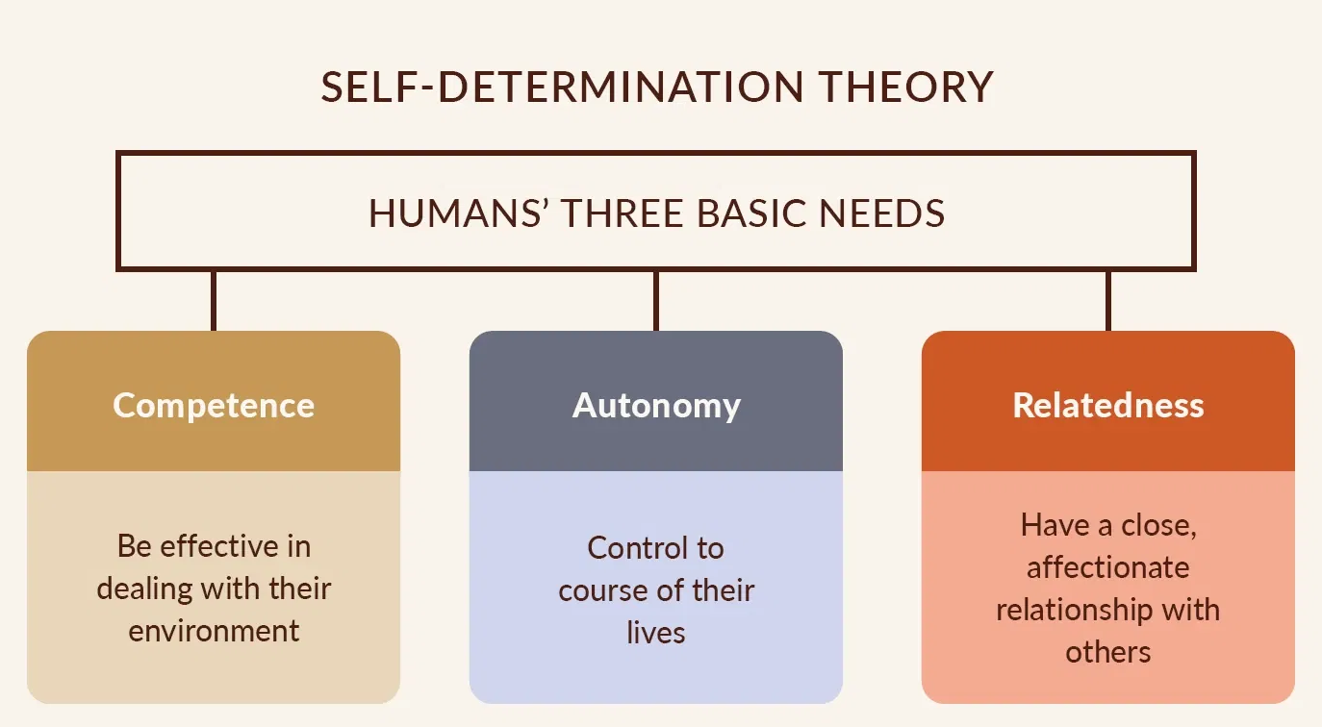
Fig 3: Self- Determination Theory
(Source: Forner et al., 2021)

Innovation Sprints
One of the effective initiatives that Aether Innovations can adopt is the introduction of innovation sprints. According to Randhawa et al., 2021, innovation sprints are brief and intense periods of work when employees develop new ideas, prototypes, or solutions to organisational issues in a teamwork setting. These sprints enable the employees to develop new ideas without necessarily being bound to routine tasks. Innovation sprinting, under the Self-Determination Theory, constitutes the autonomy need because employees are given freedom to share ideas and develop their own contribution towards organisational change.
Intrapreneurship Programs
The development of intrapreneurship programs is another initiative that can support innovation at Aether Innovations. Intrapreneurship helps in encouraging the employees to become entrepreneurs of the organisation by suggesting and advancing new business ideas or ventures. Afandi, 2021, explains that employees can receive mentoring, resources, and leadership support to turn their idea into a working solution. This program belongs to the competence dimension of the Self-Determination Theory, because the workers may have supplementary opportunities to sharpen their skills, apply their knowledge, and demonstrate creativity.
Cross-Functional Teams
Another significant structural initiative is to establish cross-functional teams. These teams consist of employees belonging to various divisions like research and development, marketing, engineering and customer support units to work jointly on projects. Cross-functional work facilitates the sharing of different ideas and world-views and frequently results in more innovative and efficient problem-solving (Attah et al., 2024). This initiative facilitates the relatedness facet of Self-Determination Theory since the employees gain better interpersonal relationships and sense of belonging to the organisation. Consequently, innovation can greatly boost through teamwork and knowledge sharing.

1.3 Future of Work Model for Aether Innovations
In order to enable cooperation and innovation at Aether Innovations, the Future of Work model relying on a hybrid working method can be adopted. Hybrid work is a practice that combines office-based and remote working, whereby employees spend their time to either work at home or at the workplace. Santillan et al., 2023 explains that this model is especially applicable in technology-based companies since digital work can be done remotely without losing chances to collaborate in-person when necessary. In the case of Aether Innovations, a hybrid work model would enhance flexibility in employees, their work-life balance, and the overall job satisfaction, which could be used to decrease the current high rates of employee turnover.

Fig 4: Hybrid Workplace
(Source: Santillan et al., 2023)
One of the elements of this model is flexible scheduling whereby employees are allowed more autonomy in the time and place of work provided organisational objectives are met. The organisation can also use a results-based performance system, which rates employees by outputs and project results, instead of paying attention to the number of hours they spend at work (Grzegorczyk et al., 2021). Hybrid working can also use digital tools. Such applications like Slack and Microsoft Teams can also assist in providing live communication and virtual meetings and managing the staff that works at different locations (Chaudhury, and Deng, 2022). Cloud systems further enable teams to share notes, work on projects as well as communicate effectively regardless of location. Another significant aspect of hybrid workplaces is leadership. The management of Aether Innovations should adopt a management approach that is associated with trust and coaching leadership that fosters open communication, employee development, and collaborative problem solving (Östergård, Högberg, and Lundh, 2025).

1.4 Enhancing Employee Motivation and Performance
The proposed culture of innovation at Aether Innovations and hybrid work model can greatly inspire the employees and enable them to do their best. A possible model to illustrate the impact of this is the Employee Engagement Theory which argues on the principle that when employees are emotionally, cognitively and physically absorbed in their work and feel connected to their organisations, they work best.
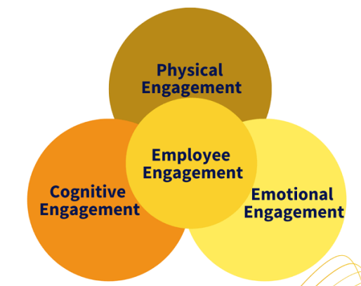
Fig 5: Employee Engagement Theory
(Source: Stofberg, Strasheim, and Koekemoer, 2021)
Motivated employees tend to be more committed, productive, and willing to offer innovative ideas that can make organisations successful. Aether Innovations can create an open and creative work environment through innovation focused initiatives such as innovation sprints, intrapreneurship programs, and cross-functional teams. Through these programmes, the employees are empowered to engage in problem solving and organisational development rather than with the usual tasks. Employee Engagement Theory states that employees feel more important and dedicated to their tasks when their ideas are listened to and offered a chance to impact organisational results (Stofberg, Strasheim, and Koekemoer, 2021). This feeling of ownership may boost morale and motivate employees to possess their work. The proposed hybrid work model can also improve engagement by increasing work flexibility and autonomy. Remote work and flexible scheduling enable employees to manage their work so that it may be helpful in meeting personal and professional demands. Employees are more motivated and satisfied with their work when they experience a better work-life balance. Digital collaboration tools and cloud platforms may also lead to optimal performance since they allow teams to share knowledge and communicate constantly. (Kossek, Gettings, and Misra, 2021). The technologies may be applied to allow employees work together, share ideas and find solutions fast even when they are not in the office.

Part 2: Reflection

2.1 Learning Journey using the Gibbs Reflective Model
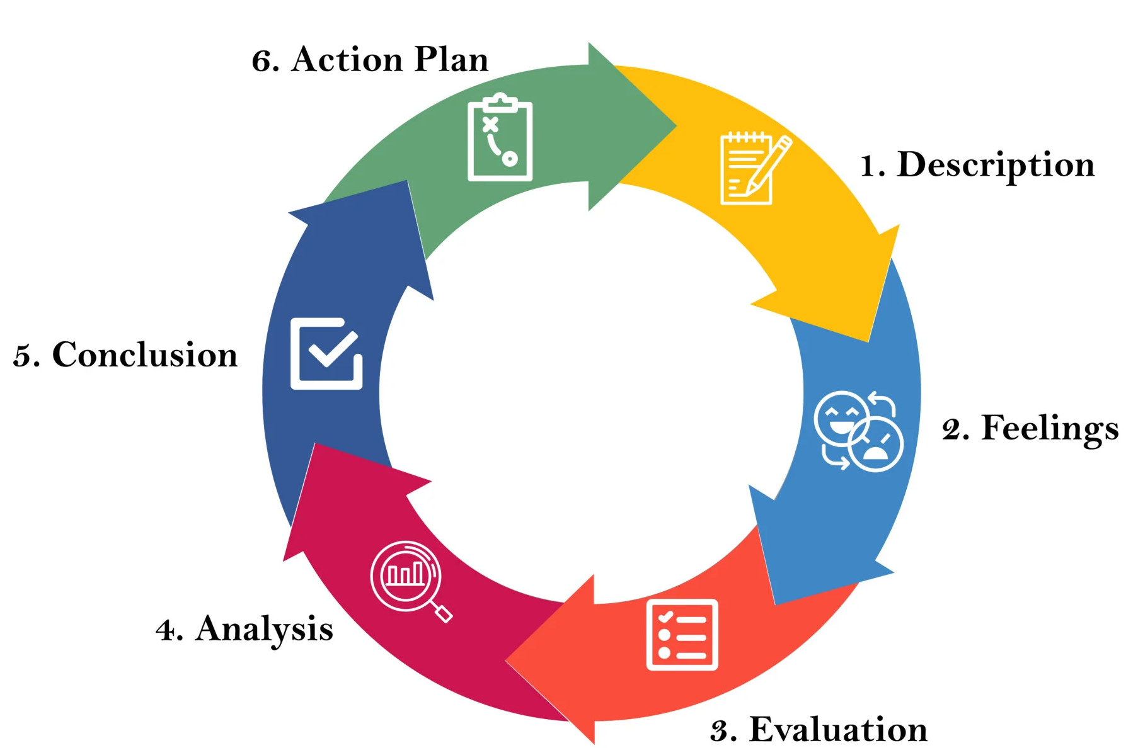
Fig 6: Gibbs Reflective Cycle
(Source: Simplypsychology, 2024)
Description
The module greatly expanded my knowledge of strategic Human Resource Management (HRM) as a whole system that links performance management, job design, organisational culture and employee engagement. Previously to this module, my understanding of HR was that it was primarily a recruitment, training, and employee relations role. Nevertheless, the lectures, reading materials, and case study discussions helped me to understand better how HR strategies can affect organisational performance and long-term competitiveness. Specifically, the module has emphasised the need to align the HR practices with the organisational strategy to ensure long-term success in performance management systems, future work model, and culture putting a strong emphasis on innovation. The integrated human capital theory of management suggested that productivity, innovation and staff retention were organisational outputs which are highly influenced by HR system design.

Feelings
At the beginning of the module, I was very confident about my competence in the basic HR concepts and operational HR practices. However, as I continued through the module, I discovered that the HRM strategic process is a much more involved task, which involves incorporation of psychological theories, organisational systems and long term business objective. It is a discouraging yet promising fact. On the one hand I have learned that the HR management is concerned with critical thinking, planning and ability to correlate certain theoretical knowledge on the real experience in the organisation. On the other hand, these concepts made me even more eager to learn how the HR strategies can impact the organisational culture and employee performance.
Evaluation
The primary strengths of this module were the focus on the interdependence of HR practices. Rather than perceiving the HR functions as isolated processes, the module has shown how the performance management processes, development of leaders, organisational culture, and employee engagement should change as a system. This perspective helped me understand why organisations sometimes do not handle employee turnover or engagement, even when they have practices related to individual HR. But one of the most difficult tasks I have faced was in translating the psychological and inspirational theories to practical HR models. Intrinsic motivation and employee engagement are very practical ideas, which, however, are usually hard to measure and implement to organisational processes. This highlighted the challenge of creating HR strategies that are conceptually sound and can demonstrate measurable organisational effects.
Analysis
Strategically, successful HRM demands organisations to shift their focus on problem-solving to system design. Turnover of employees, their engagement, and the performance outcomes are not independent issues but the dependent outcomes of organisational structures and management practices. Indicatively, a poor job design, the absence of autonomy, and less career development opportunities can all lower employee motivation and turnover (Khatoon et al., 2025). Thus, HR practitioners need to develop integrated systems that interlink job roles, leadership practices, and performance management systems with organisational goals.
Conclusion
Generally, this module has strengthened my understanding of the importance of strategic HRM in organisational success. It increased the necessity of aligning HR practices with business strategy and the importance of incorporating a culture of innovation and lifelong learning in organisational practice.
Action Plan
To apply the acquired knowledge in this module, I would like to pursue a systematic approach to my personal development. In the short term, I will increase the understanding of strategic HRM concepts and innovation management by researching additional academic literature and case studies.
I would prefer to develop practical leadership, communication, and collaborative problem-solving skills in the short run. Professional workshops, online courses of learning and networking will allow me to learn with more advanced practitioners and reflect on how HR can be applied in practice. My long-term goal is to enhance the culture of lifelong learning and willingness to embrace the technological changes within the workplace. This includes HR analytics, digital collaboration tools and innovation management practices.

2.2 Staying Relevent in the Age of AI
Artificial Intelligence (AI) is reshaping the workings of many organisations. AI systems can now perform many routine tasks that had previously been performed by humans. This involves data analysis, screening of recruits and administration (Raisch, and Fomina, 2025). Due to this, a lot of traditional jobs are evolving, and professionals must keep enhancing their skills to be able to stay relevant in the workplace. As a future professional, I recognize the need to embrace these changes of technology instead of opposing them.
To stay relevant, I will invest in the skillset that is not easily replaced by AI. These include human capabilities such as critical thinking, creativity, communication, leadership and emotional intelligence. Human resource management is highly dependent on people, relationship building and ethical decision making. It involves the human judgment and empathy which AI cannot fully replicate these capabilities. By improving these skills, I will be able to make my position helpful in organisations. At the same time, I believe that AI may act as a useful resource that might assist my work rather than substitute it. As an example, AI can help in handling large volumes of HR data, searching employee performance patterns, and recruitment. Incorporating AI may simplify work and make it faster. According to Vishwanath, and Vaddepalli, 2023, instead of spending time on unnecessary administrative activities, HR specialists can trust AI by focusing more on strategic activities such as employee development, organisational culture, and innovation. However, AI must be applied responsibly and critically. The output of AI must be supported by HR professionals and the decision must be equitable, ethical, and aligned to organisational values. In this way, AI may help to make decisions, but not substitute them. Overall, I believe that I will be relevant in an AI-driven workplace because I will be able to be curious, acquire new skills, and use technology wisely. By employing human judgment and AI, I can serve positively to organisations without replacing my role to technology.

Conclusion
In conclusion, this report shows that Aether Innovations needs to improve its people management to resolve its current problems. By implementing a strong culture of innovation, a hybrid workplace model, and focusing on employee engagement, the company can improve both the performance and employee satisfaction. The integration of the HRM theories emphasizes the importance of structured people management strategy. The reflection shows also that the AI-driven world needs lifelong learning and adaptability to ensure the relevance of the organisation and the professional in the long run.

References
Afandi, A., (2021). Mentoring program: Empowerment and human resources development. AKADEMIK: Jurnal Mahasiswa Humanis, 1(3), pp.87-94.https://ojs.pseb.or.id/index.php/jmh/article/view/458
Akpa, V.O., Asikhia, O.U. and Nneji, N.E., (2021). Organizational culture and organizational performance: A review of literature. International journal of advances in engineering and management, 3(1), pp.361-372.https://www.researchgate.net/profile/Professor-Asikhia/publication/356105838_Organizational_Culture_and_Organizational_Performance_A_Review_of_Literature/links/618bed3907be5f31b762d272/Organizational-Culture-and-Organizational-Performance-A-Review-of-Literature.pdf
Attah, R.U., Garba, B.M.P., Gil-Ozoudeh, I. and Iwuanyanwu, O., (2024). Cross-functional team dynamics in technology management: a comprehensive review of efficiency and innovation enhancement. Eng Sci Technol J, 5(12), pp.3248-65.https://www.researchgate.net/profile/Ifechukwu-Gil-Ozoudeh/publication/386480273_Cross-functional_team_dynamics_in_technology_management_a_comprehensive_review_of_efficiency_and_innovation_enhancement/links/6752ad9a8eca147b25deb83c/Cross-functional-team-dynamics-in-technology-management-a-comprehensive-review-of-efficiency-and-innovation-enhancement.pdf
Chaudhury, A. and Deng, P.S., (2022) Does hybrid working promote collaboration and creativity? An empirical study. Issues in Information Systems, 23(2).https://iacis.org/iis/2022/2_iis_2022_200-214.pdf
Forner, V.W., Jones, M., Berry, Y. and Eidenfalk, J., (2021). Motivating workers: how leaders apply self-determination theory in organizations. Organization Management Journal, 18(2), pp.76-94.https://www.emerald.com/omj/article/18/2/76/314438
Gierlich-Joas, M., Baiyere, A. and Hess, T., (2024). Inverse transparency and the quest for empowerment through the design of digital workplace technologies. Journal of the Association for Information Systems, 25(5), pp.1212-1239.https://research.cbs.dk/en/publications/inverse-transparency-and-the-quest-for-empowerment-through-the-de/
Grzegorczyk, M., Mariniello, M., Nurski, L. and Schraepen, T., (2021). Blending the physical and virtual: a hybrid model for the future of work (No. 14/2021). Bruegel Policy Contribution.https://www.econstor.eu/handle/10419/251067
Jostle, (2023) Organization Culture Available at. https://blog.jostle.me/blog/do-tech-companies-have-the-best-culture (Accessed: 18 March, 2026)
Khan, M., Raya, R.P. and Viswanathan, R., (2022). Enhancing employee innovativeness and job performance through a culture of workplace innovation. International Journal of Productivity and Performance Management, 71(8), pp.3179-3204.https://www.emerald.com/ijppm/article/71/8/3179/510960
Khatoon, U.T., Babgi, M., Hadi, N.T., Mir, R.N. and Velidandi, A., (2025). Technology-driven change in human resource management: Reshaping talent management and organizational design. Administrative Sciences, 15(11), p.452.https://www.mdpi.com/2076-3387/15/11/452
Kossek, E.E., Gettings, P. and Misra, K., (2021). The future of flexibility at work. Harvard Business Review, 28.https://www2.mvcc.edu/shn/pdf/presentations/2021-11/Future-of-Flexibility-at-Work.PDF
Östergård, N., Högberg, K. and Lundh Snis, U., (2025). Trust and leadership in the hybrid workplace. In 58 th Hawaii International Conference on System Sciences 2025 (HICSS) (pp. 5427-5436). University of Hawaiʻi at Mānoa.https://www.diva-portal.org/smash/record.jsf?pid=diva2:1939083
Raisch, S. and Fomina, K., (2025). Combining human and artificial intelligence: Hybrid problem-solving in organizations. Academy of Management Review, 50(2), pp.441-464.https://journals.aom.org/doi/abs/10.5465/amr.2021.0421
Randhawa, K., Nikolova, N., Ahuja, S. and Schweitzer, J., (2021). Design thinking implementation for innovation: An organization's journey to ambidexterity. Journal of Product Innovation Management, 38(6), pp.668-700.https://onlinelibrary.wiley.com/doi/abs/10.1111/jpim.12599
Santillan, E.G., Santillan, E.T., Doringo, J.B., Pigao, K.J.F. and Mesina, V.F.C., (2023). Assessing the impact of a hybrid work model on job execution, work-life balance, and employee satisfaction in a technology company. Journal of Business and Management Studies, 5(6), pp.13-38.https://al-kindipublishers.org/index.php/jbms/article/view/6271
Savitha, M. and Kumar, S.P., (2025). Building an agile organizational structure to drive innovation and technology. Cuestiones de Fisioterapia, 54(2), pp.2321-2334.https://cuestionesdefisioterapia.com/index.php/es/article/view/978
Simplypsychology, (2024) Gibbs Reflective Cycle Available at. https://www.simplypsychology.org/gibbs-reflective-cycle.html (Accessed: 18 March, 2026)
Stofberg, L., Strasheim, A. and Koekemoer, E., (2021). Digitalisation in the workplace: the role of technology on employee engagement and creativity teams. In Agile coping in the digital workplace: Emerging issues for research and practice (pp. 231-257). Cham: Springer International Publishing.https://link.springer.com/chapter/10.1007/978-3-030-70228-1_12
Vishwanath, B. and Vaddepalli, S., (2023). The future of work: Implications of artificial intelligence on hr practices. Tuijin Jishu/Journal of Propulsion Technology, 44(3), pp.1711-1724.https://www.researchgate.net/profile/Surendar-Vaddepalli/publication/376186700_The_Future_of_Work_Implications_of_Artificial_Intelligence_on_Hr_Practices/links/659ab3646f6e450f19d45d60/The-Future-of-Work-Implications-of-Artificial-Intelligence-on-Hr-Practices.pdf

