

Module: Effective Team Working and Communication
Module Code: BNSW4002
Student Name: Teodora Katsarov
Student Number: 2132878

Table of Contents
- Introduction…………………………………………………………………………………………3
- Model of Communication…………………………………………………………………….3
  - Shannon and Weaver Model of Communication………………………..3
  - Schramm’s Model of Communication…………………………………………4
  - Berlo’s SMCR Model of Communication……………………………………..5
- Communication Skills …………………………………………………………………………..6
  - Verbal Skills…………………………………………………………………………………6
  - Non – Verbal Skills……………………………………………………………………….7
  - Active Listening……………………………………………………………………………7
  - Empathetic Listening……………………………………………………………………8
- The advantages and disadvantages of communication technology………..8
- Examples of poor communication in the work place………………………………………………………………………………………………………9
- Conclusion……………………………………………………………………………………………..9
- Reference List ……………………………………………………………………………………10

1.Introduction
Before starting this report, we have to clear the meaning of the word “communication”. According to Cambridge Dictionary the word “communication” means “the process of sharing information, especially when these increases understanding between people or groups”. (Cambridge Dictionary, 2018). So, communication is one of the most important parts of the business, but to be effective it should be understandable and not in the end easy. Communication should be easy and understandable in all of its forms, it doesn’t matter if it will be verbal or non-verbal. Poor communication can lead to bad consequences for the team and the business. We cannot work as a team if we cannot talk to each other and if we cannot understand each other, we cannot reach our company goals and work together to build the prosperity of the company. In this report I will look at the different models of communication and what impact they have in working environment.

2. Models of Communication
2.1 Shannon and Weaver Model of Communication – 1949
The Shannon and Weaver model of communication is a mathematical theory that was first proposed by Claude Shannon and Warren Weaver in 1949. (Krippendorff, 2009). It is a linear model in which communication is a one-way process where information is transmitted from a sender to a receiver through a channel. This model is designed to develop the effective communication between the sender and receiver and also describes how the message cannot be transmitted properly because of ,,Noise’’ They are four main parts of this communication model: Sender, Message, Channel and Receiver. The sender is the person that initiates the communication, while the receiver is the person that receives the communication. The channel is the medium through which the communication travels from the sender to the receiver. For example, if someone (the sender) wants to send a message (the message) over the phone (the channel) to another person (the receiver) and for some reason that someone is in a nosy place, the message may not be understood properly because of this noise. The example that was given in class to explain the case study is ‘’Maria and Pedro’’. Maria callas Pedro and tells him to get chicken, but since he works in a noisy place instead of chicken, he understands kitchen and the communication between them in not successful. There is misunderstanding of the message due to noise.

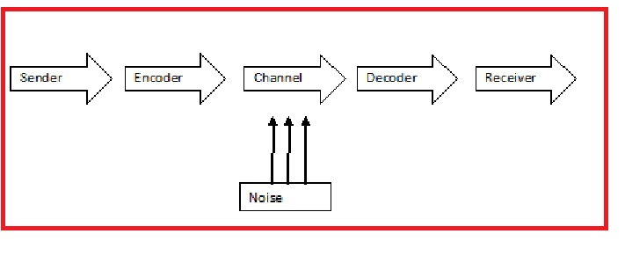

2.2 Schramm’s Model of Communication – 1954
The Schramm Model of Communication was proposed by Wilbur Schramm in 1954 and is a circular model of communication. In this model, the sender encodes a message and sends it through a chosen medium to the receiver, who decodes the message. The receiver then sends feedback back to the sender, which completes the communication cycle. (Blythe, 2012). Schramm's concept states that a message is not complete until the sender receives feedback from the recipient to show that the massage has been received. Any communication that does not involve decoding or feedback is not complete or effective. This model of communication highlights the importance of feedback. For example, if Pedro could have called Maria and asked what she meant when she said kitchen then there would be no misunderstanding and he would have understood the message correctly. In this way the mistake that Pedro made would have been prevented.

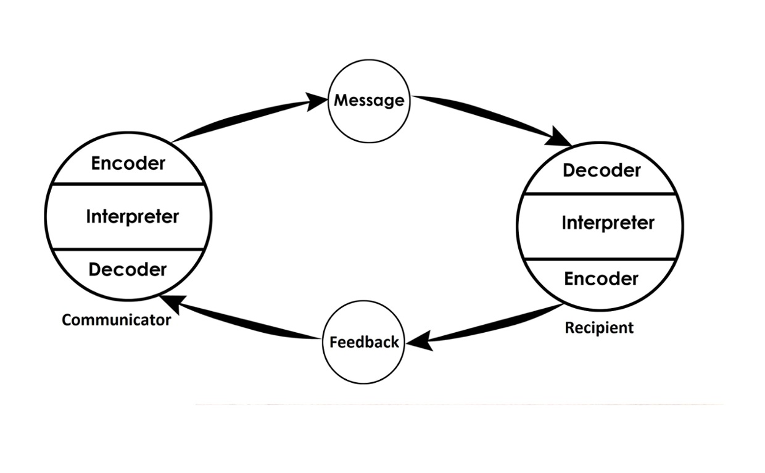

2.3 Berlo’s SMCR Model of Communication – 1964
Berlo's model of communication, also known as the SMCR model, was developed by David Berlo in 1960. He discussed the elements that affect each part of communication and improve its effectiveness. ( Cuofano,2021) Sender, message, channel, and receiver are the four components which describe the communication process. Communication skills, Attitude, Knowledge, Social systems, Culture are the five factors that are relevant to the sender and are also relevant to the receiver. Communication skills- If the person sending the message has strong communication abilities, the message will be received more successfully than if the person has poor communication skills. Similar to this, communication will not be successful if the recipient cannot understand the message. Attitude - the impact of communication is determined by the attitudes of both the person sending the message and the person receiving it. Social system- the manner in which messages are conveyed by the sender is influenced by various social factors such as values, beliefs, laws, religion, and others. These factors can modify the process of creating messages. Culture -something that is hurtful to someone from one culture may not be offensive to someone from another one. With the example that was given in class to understand more about this model of communication ‘The Professor and the Village People’ in this case the professor addresses them and uses a very high level of speaking and they can not understand what he is saying to them. They have another level of language knowledge and the communication between them is not effective. In this communication model there is no two-way communication- communication is linear There is no concept of feedback or concept of noise.

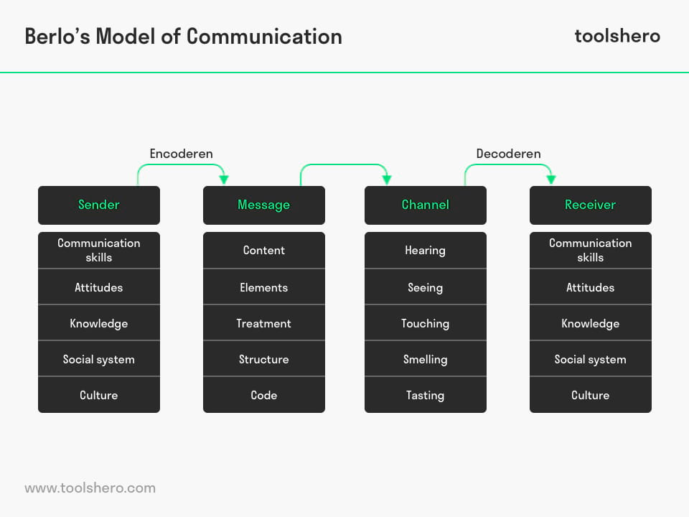

3.0 Communication skills
3.1 Verbal Skills
Verbal communication refers to the use of words, spoken or written, to convey a message or information between individuals or groups. (Kaplan,2022). It involves the use of language to express ideas, thoughts, feelings, opinions, and information to others through speaking or writing. Verbal communication can take place in various forms such as face-to-face conversations, phone calls, video chats, speeches, presentations, interviews, and meetings. It is an essential aspect of human communication, allowing us to exchange information, build relationships, and understand one another. Verbal communication includes not only the words spoken but also the tone of voice, pitch, and other vocal cues that can convey meaning and emotion.

3.2 Non-Verbal.
Nonverbal cues are very important in conversation. People typically believe in visual images but not speech because of a psychological distinction between the two. Non-verbal communication refers to the use of gestures, facial expressions, body language, tone of voice, and other nonverbal cues to convey meaning and emotion. It can be intentional or unintentional and is an essential part of human communication. (Skills You Need)
The example that used in-class to explain the case study is ‘’ A Day with the chief’’. The employee forgot where is he and start to act like he is with his friends and not with the CEO, he sit comfortable in the chair, release his tie and start complaining about the store managers. This made the chief to end the conversation and all of his achievements did not matter anymore. This is an example of bad non -verbal skills.
.

3.3. Active Listening
Active listening is a communication skill that involves paying full attention to the speaker in order to understand their message, and responding appropriately. ( Hargie and Tourish ,2017) It is a fundamental skill for building relationships, resolving conflicts, and achieving successful outcomes in personal and professional contexts. Active listening requires the listener to be fully present in the moment, to give their undivided attention to the speaker, and to show empathy and respect. This involves using nonverbal cues such as eye contact, nodding, and facial expressions to demonstrate understanding and engagement. Active listening also involves asking questions to clarify the speaker's message and to show interest in their perspective. When people feel heard and understood, they are more likely to feel valued and to develop a sense of trust and respect with the listener. Active listening can help to reduce misunderstandings, resolve conflicts, and build stronger relationships. It also helps the listener to gain a deeper understanding of the speaker's perspective, which can help them to make better decisions and to respond more effectively to their needs.In summary, active listening is a powerful communication skill that requires focused attention, empathy, and respect. By practicing active listening, individuals can improve their relationships, build trust and respect, and achieve more successful outcomes in personal and professional contexts.

3.4. Empathetic Listening
Empathic listening is a strong communication skill for building strong relationships and resolving conflicts. It involves actively listening to another person’s thoughts, feelings without judgment or interruption. Also involves using verbal and nonverbal cues to demonstrate empathy and understanding. (Chmielewski, 2019) The benefits of empathic listening include building trust, improving relationships between people. It can also help to reduce misunderstandings by enabling both parties to feel heard and validated. Empathic listening is particularly important in contexts where emotions are heightened, such as in personal relationships or in situations where there is conflict or disagreement. It can also be a valuable skill in professional contexts, such as in counselling, coaching, or leadership, where the ability to connect with others and understand their perspectives is crucial for success.

4.0. The Advantages and Disadvantages of Communication Technology

Communication technology has revolutionized the way people communicate and collaborate, making it easier for teams to work together and share information. Technology used for communication including things like emails, call phones, and social media. Communication technology has several advantages, it also has some disadvantages that can impact effective teamworking and communication. Advantages: One of the main advantages of communication technology is that it allows people to communicate and collaborate with each other from anywhere at any time. Tools such as video conferencing, instant messaging enable teams to work together even if they are located in different parts of the world (Cummings and Haag, 2016). Another advantage of communication technology is that it allows team members to share information and collaborate in real-time. For example, the people can use shared documents and messaging apps to work on projects together and receive feedback from each other instantly. Disadvantages: Communication technology also has some disadvantages that can impact effective teamworking and communication. The people can easily become overwhelmed and miss important messages because of so many communication channels available, this can lead to miscommunication. Another disadvantage of communication technology is that it can reduce the quality of communication. For example, when the people communicate via text or email, it can be challenging to convey tone and emotion.

5. Examples of poor communication in the work place.
In my work place a customer called the pizza shop I was working and place an order for a large pepperoni pizza. However, I did not repeat the order to make sure everything I heard is correct and to confirm it. In that case I misheard the order as a small pepperoni pizza instead of large pepperoni pizza and proceeded to made the wrong size. later when the pizza was delivered to the customer, they realized that it is the wrong size and were dissatisfied with the service.
This example of my work illustrates the effect of poor communication and this can lead to mistakes, complaints and loss for the business.

6. Conclusion
In conclusion I want to add that good communication can make the work environment much better, it can bring only positives to the team and company if it comes with good understanding. It doesn’t matter how big is the company, quality communication will positively impact your business productivity, staff, investors etc. Never forget that good communication is not only to be good at speaking, but to be a good listener and being able to understand what your colleagues and the business climate tells you. By using the proper communication tools and techniques, your business will grow and will be well prepared to face the challenges in today’s competitive business world.

7.Reference List

Cambridge Dictionary (2018). COMMUNICATION \ meaning in the Cambridge English Dictionary. [online] Cambridge.org. Available at: https://dictionary.cambridge.org/dictionary/english/communication

Chmielewski, T. (2019). Empathic Listening- Sage Research Methods. [online] methoods. Sagepub.com. Available at: https://methods.sagepub.com/reference/the-sage-encyclopedia-of-communication-research-methods?

Cummings, T. G., and Haag, S. (2016). Management Information Systems: For the Information Age (10th ed.). McGraw-Hill Education

Cuofano, G. (2021). What is Berlo’s SMCR model? Berlo’s SMCR Model In A Nutshell. [online] FourWeekMBA Available at: https://fourweekmba.com/berlos-smcr-model/.

Hargie, O., and Tourish, D. (2017). Communication skills for effective management. Routledge.

Kaplan, Z. (2022). What Are Verbal Communication Skills? [online] Forage. Available at: https://www.theforage.com/blog/skills/verbal-communication

Krippendorff, K. (2009). Mathematical theory of communication. In S. W. Littlejohn & K. A. Foss (Eds.), Encyclopedia of communication theory (pp. 614-618). Los Angeles, CA

Skills you need (No Date). Nonverbal communication. Available at: https://www.skillsyouneed.com/ips/nonverbal-communication.html?

