.


University of Wales Trinity Saint Davids
Ordnance, Munitions and Explosives Principals

Academic Year 2026

Eryn Legg

Use of multi-physics software to simulate a soft-core projectile impacting a metallic plate, investigating mesh independence and boundary influence

Supervisor: Lecturer Andrew Nobel

This thesis is submitted in partial fulfilment of the requirements for the degree of Ordnance, Munitions and Explosives BEng

© UWTSD 2026. All rights reserved. No part of this publication may be reproduced without the written permission of the copyright owner.

Academic integrity declaration
I declare that:
- the thesis submitted has been written by me alone.
- the thesis submitted has not been previously submitted to this university or any other.
- that all content, including primary and/or secondary data, is true to the best of my knowledge.
- that all quotations and references have been duly acknowledged according to the requirements of academic research.
I understand that to knowingly submit work in violation of the above statement will be considered by examiners as academic misconduct.

Abstract
This report contains a multi-physics simulation of a ballistic concepts of a lead projectile impacting a stainless-steel plate where the velocity increases from 600 m/s to 1000 m/s to finally 1200 m/s replicating a high velocity rifle to investigate penetration capability. With 600 m/s and 1000 m/s failing to fully penetrate, 1200 m/s was able to fully penetrate the plate after coursing extreme stress and strain within both projectile and plate. This report also details the importance of CAE and the importance of background knowledge of the context and use of the software to support validation of calculated models.

Keywords:
Simulation
Ballistic
CAD
Stress
Strain

Table of Contents
Academic integrity declaration i
Abstract ii
Keywords: ii
Listed Figures and descriptions iv
List of Tables iv
List of Equations iv
List of Abbreviations v
1 Introduction to primary understanding, analysis and use of computer-based systems to simulate OME design 6
2 Understanding and Explanation of key concepts in CAE 6
2.1 CAD specific software advantages and limitations 6
2.2 Mesh evaluation and optimisation. 7
2.3 Primary limitations and restrictions 8
2.4 Consideration of Fluid and Material models appropriate for OME systems 8
3 Modelled Test Case 8
3.1 Introduction to modelled test case 8
3.2 Contextual literature influence 9
4 Analysis of modelled test case 9
4.1 Mesh independence study. 9
4.2 Modelling of materials 11
4.3 Stress analysis and high strain considerations 12
4.4 Boundary influence consideration and input variables 13
4.5 Results and literature validation 14
5 Discussion and review of CAE tooling and multi-physics software 16
5.1 Literature of similar studies 16
5.2 Advancing the accuracy of the approximated simulation 17
5.3 Structural analysis and iterative design 17
6 Collective summary and further recommendations 18
Bibliography 19
Appendix 21
A Fusion 360 21
B Failed results due to material parameters 22
C Additionally collected data 27
D Additional results 28

Listed Figures and descriptions
1 | Component assembly completed by Fusion 360
2 | Very, fine mesh covering geometry equally
3 | Very, fine mesh using a sphere of influence
4 | Final mesh design for ballistic simulation
5 | Failed simulation due to excessive deformation
6 | The configuration of surface-to-surface interaction
7 | 600 m/s failed penetration of soft core
8 | Equivalent Stress (Von-Mises) at a velocity of 1000m/s
9 | Equivalent Stress (Von-Mises) at a velocity of 1200m/s
10 | Minimum, Maximum and average maximum principal stress (Pa) measured during 1200m/s testing

List of Tables
1 | Table 1, Lead-antimony alloy, hard lead 99-1 cast and stainless steel, martensitic AISI 414 parameters. [X][19]

List of Equations
1 | Johnson Cook Failure Model
2 | Johnson Cook Failure Combination Model
3 | Newtons Second Law

List of Abbreviations
OME | Ordnance Munitions Explosives
CAD | Computer Aided Design
CAE | Computer Aided Engineering
FEA | Finite Element Analysis
STEP | Standard for the Exchange of Product Data
UK | United Kingdom
BS 8888 | British Standard 8888
ISO | International Standard of Organisation
QMS | Quality Management System
EMS | Environmental Management System
SPH | Smooth Particle Hydrodynamics
FEM | Finite Element Method
DEM | Discrete Element Method

Introduction to primary understanding, analysis and use of computer-based systems to simulate OME design

Multi-Physics software uses mathematics to visually project and collect data on an approximation of the desired context. This software takes designed geometry and applies variables to represent a practical testing context at a lower cost and time frame than practical texting requires.

The chosen multi-physics software is Ansys WorkBench 2024, where the pre-designed STEP file, created using Fusion 360, is assigned materials using Granta EduPack 2024 and a variety of mesh styles is applied to achieve the most reliable results. Ansys is a collection of different software and libraries however, to model projectile motion, Explicit Dynamics is the appropriate software choice, where linear velocity of the bullet impacts the flat meshed plate expecting node distortion.

A multi-physics software allows use of finite element analysis (FEA) to explain potential mechanical, chemical, and physical interactions in ideal conditions. This allows for low cost and fast trialling of potential ideas, data gathering and interpretation, design iteration and improvement, complex problem solving. FEA has become crucial tool across a multitude of industries such as automotive, aerospace, defence, and engineering-based companies.

Understanding and Explanation of key concepts in CAE

CAD specific software advantages and limitations
Computer aided design software generally includes drafting, modelling and assembly. Drafting mode would produce technical drawings, build/manufacturing instructions, circuit drawings, family trees, rendering images and more. Drafting mode is the primary mode used for documentation of a process of design. The technical drawings would contain iteration dates and revision quantities, names of both drawn by and checked by, as well as technical information such as scale and perspective. [1]
Modelling involves a 3D simulated space, in this space the user can then use universal tools such as inserting a datum (plane, point or axis), sketching on a flat plane, extrude and revolve. Several other tools are usually offered, however these tools abilities, names and being included varies between packages. Different software packages have different advantages and tooling, usually chosen for the relevant industry. Majority of packages also contain controls such as surface finishing, basic analysis and rendering however the quality and existence of these additional features usually raise a software’s licensing price greatly. [1]
In Assembly mode, separate components can be inserted in the simulated 3D space and manipulated to create a complex model, using constraints, joints and other methods. In this space, entire products with moving parts can be visualised and provide insight into fit and interaction between the components.
CAD has revolutionised almost every modern industry. Previously, technical drawings and documentation was completed by hand which led to damage and degradation over time, drawing mistakes and issues, scaling issues and difficulty in revising designs. These designs also took a significant amount of time to complete and were difficult to correct. By modelling the object in 3D, the design can be viewed from every angle and can be modelled to scale, changes and modification of the designs can be completed here. The base-view of the model is automatically generated from the model and scaled accordingly which can also be edited and revised at will. This provided a faster solution with greater accuracy to previous hand drawn designing.
By using electronic drawings and databases, a set of universal rules can be applied allowing a drawing to be understood across all industries over several countries and over a long period. In the UK, BS 8888 is used alongside ISO standards to ensure quality, consistency and clear readability. [2] Depending on the drawing, ISO 9001 is used to ensure the use of QMS, but ISO 14001 is used to ensure EMS.
A disadvantage to 3D modelling is due to human error. In CAD almost anything can be modelled, however, that construction may not function in practical way as it does in theory when exposed to non-ideal variables such as external acting forces, behaviours of materials and manufacturing ability. Although additional parameters can later be applied in multi-physics software, most CAD packages can only apply this at the basic level and provide a minimal approximation.
A second disadvantage to CAD software is the price. Majority of industry uses CAD software relies on licenses, meaning a company can buy the software and choose which additional features they need and how many licenses they need for their company size and requirement. This cost can be monthly or annually, with the annual price usually ranging between £200 to over £10,000. [1]

Mesh evaluation and optimisation.
Multi-Physics software applies a mesh to the geometric components, effectively breaking each part down into a smaller component to get an individual value for each point. These points are where the mesh aligns and are referred to as nodes, most multi-physics software have a maximum node quantity dependent on license for example Fusion 360 built in analysis has a maximum limit of 10,000 nodes whilst Abaqus Student addition has a maximum of 250,000. [3] [4]
Mesh geometry is the triangular and quadrilateral shapes that connect the nodes, this geometry can either be manually determined or automatically determined in accordance with the geometry selected.
Mesh independence is important to consider as the finer the mesh, the greater quantity of nodes, results in the software calculating the experience of geometry in smaller areas and therefore by considering different areas the model theoretically has a greater accuracy. However, there are several other factors to consider, the plateau of detail and balance of importance.
In a simulation, there may be areas where it can be assumed that the geometry will experience either or greater quantities of force and more varied quantities of force. When using multi-physics software, the two primary limitations are node quantity and the computers’ ability to calculate, so for a simulation where there are expected areas of interest, a mesh gradient is used. This is where a finer mesh is localised to the point of interest, concentrating on a high number of nodes, which move to a course mesh where less variation of results is expected. Using this method, a high number of nodes can be used to collect the data whilst not overloading the computer with a highly fine mesh.
The plateau of detail is important to consider when running a simulation, theoretically the more nodes generate more data but as the mesh becomes finer, this data shows little to no variance and the quality of the simulation plateaus. Using a finer mesh than needed can result in a very long run and overworking of the computer unnecessarily.

Primary limitations and restrictions
By using multi-physics software, environmental, material and geometrical assumptions are made which reduce the accuracy of the generated results. The projectile simulation is projected in an ideal environment where there are no forces outside the system acting upon the components, including pressure, drag or atmospherically parameters. Material considerations include the idea of a completely homogenous material, without abnormalities such as temperature gradients. Geometrical assumptions include perfect symmetry with a perfectly smooth surface and without tolerance dimensions.
The simulation itself has several ridged parameters which may negatively affect the accuracy of the results. The bullet has a singular velocity with no acceleration or deacceleration when, according to past literature [5], the bullet would have maximum velocity when leaving the barrel to then deaccelerate as the projectile experiences opposing forces. Secondly, the velocity used in the simulation is a rounded approximation when the bullets’ average velocity will vary for several factors such as distance travelled and environmental conditions.
Thirdly, ridged boundary conditions are ideal in the multi-physics software. When applied, the component is designed to react under the assumption that no force can affect that boundary. In the real world, which is not an expected condition. In a practical application, there would be evidence of damaging around the mounting of the plate, deformation according to the method of mounting negatively effecting the accuracy of the simulation.
Multi-Physics software is a tool to provide primary evidence of an approximation of a practical test and should be investigated using the knowledge of the limitations and used alongside of validation studies such as varying mathematical models and past literature.

Consideration of Fluid and Material models appropriate for OME systems
Modelling ballistic models presents unique challenges due to the rapid changes occurring in the material. Extremely high stress and strain rates occur; non-linear and plastic deformation of the material occur as well as shock and pressure wave movements. To simulate how the materials would function, crucial parameters such as Johnson-cook, EOS, elasticity, and plasticity. When modelling ballistics, the hardware and software of the computer must calculate rapidly changing contact surfaces, failure, and fracturing, as well as large deformation and mesh distortions.
The consideration of fluid models for OME systems is crucial as this refers to the assumption that a material will react like a fluid under certain conditions such as extremely high impact (Such as a shape charge [6]) where stress values are high, and where ductile materials are being model to flow rather than modelling a brittle material to crack. SPH, Solid Particle Hydrodynamics, can be used to model this simulation as well as pressure-based modelling. [7]

Modelled Test Case

Introduction to modelled test case
The scenario presented is designed to investigate at which velocities can a 9mm lead bullet achieve full penetration of a steel plate.
The ballistic model of a simplified bullet model with a continuous velocity and acceleration of 0m/s². The bullet is modelled after a standard 9mm Lead Bullet, created using CAD software Fusion 360. The target plate, a solid steel cuboid, was designed to be 75x75 mm with a thickness of 2.5mm to ensure evaluation of force movement through the plate could be observed. This assembly is shown in Figure 1, and the further dimensions of the plate and projectile can be viewed in Appendix A, Fusion 360. This was converted as a STEP file to allow for geometrical compatibility between the two software.
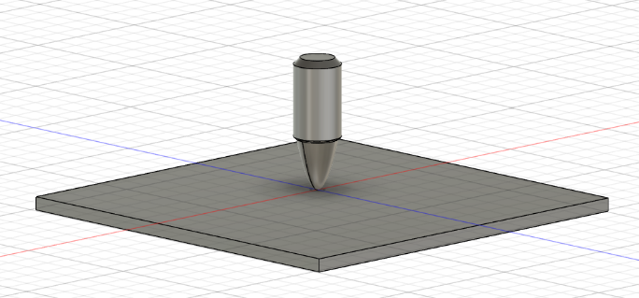
Figure 1, Component assembly completed by Fusion 360.
The bullet was simulated to have a constant velocity and impact the stationary plate in at the centre, allowing adequate movement of the shockwave to move throughout the plate. The simulation was conducted with a projectile velocity of 600m/s, 1000m/s and 1200m/s.

Contextual literature influence
A lead 9mm bullet is used in practice shooting, handloading contexts and subsonic requirements. For practice shooting and handloading contexts, lead 9mm bullets are low cost as a consumable as well as reduce the barrel wear in comparison to other ballistic options [8]. Subsonic, meaning a velocity below the speed of sound in air, testing allows for contexts where reduced noise is desired. [9]
The velocities that are being tested show the higher range of practical velocity of a 9mm lead bullet and will progress to the expected range of a high velocity rifle. This testing is designed to show insight into further design of release mechanisms as the standard method for releasing a 9mm lead bullet only reaches an average of 400 m/s. By exploring methods of increasing velocity to achieve full penetration, this allows for potential future options to redesign a low costing simplistic design.
The plate thickness chosen was 2.5mm and assigned material properties of stainless steel AISI 414, this mimics a standard sheet metal plate found in automotive contexts such as reinforced panels of a car body. [10]

Analysis of modelled test case

Mesh independence study.
In Figure 2, shows a basic mesh without any gradients. In this context, there areas of assumed high variance are the projectile and the centre of the plate as we expect to see the projectile experience high stress and strain as it impacts the centre of plate sending the shock wave uniformly outwardly.
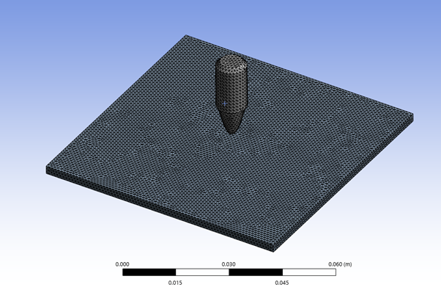
Figure 2, very fine mesh covering geometry equally.
To progress for fine mesh around the areas of interest, Figure 3, shows a mesh applied via a ‘Sphere of Influence’ which creates a finer mesh in the chosen sphere and transitions to a course gradient around the edge.
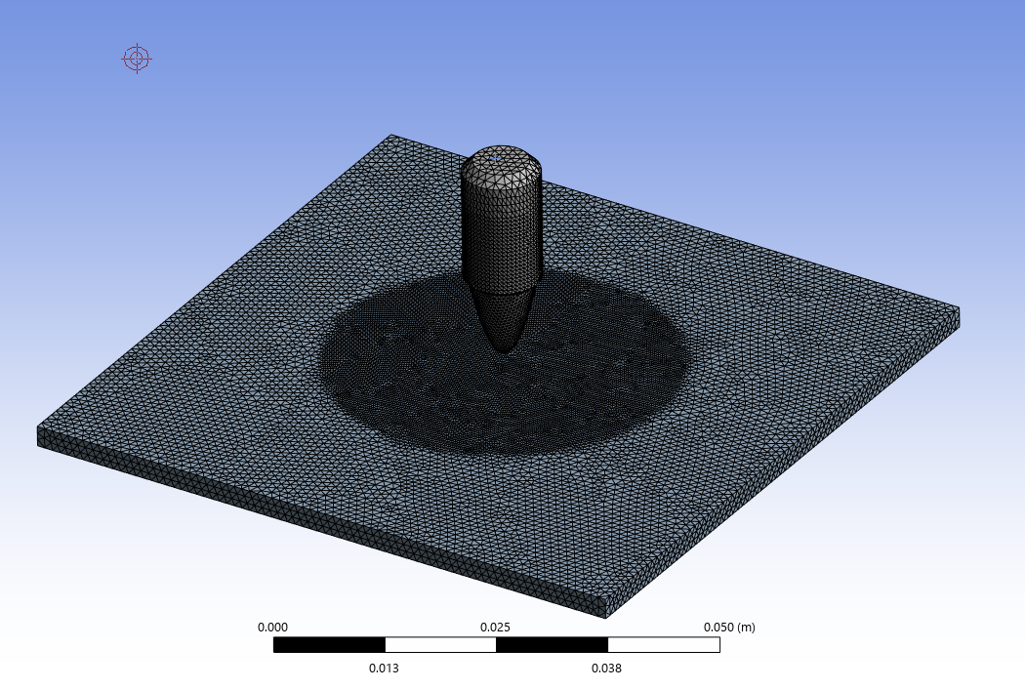
Figure 3, very fine mesh using a sphere of influence.
When this mesh was attempted to be simulated, the suggested run time was over 25 hours, this is due to the mass quantity of nodes and the quantity of calculations the computer needed to complete. To reduce the running time, either increases the core use or reduces the mesh. Due to hardware limitation, the mesh size was increased.
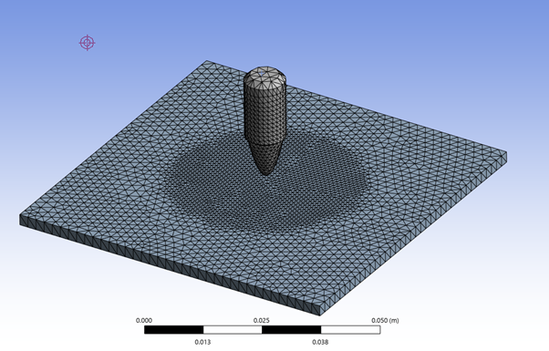
Figure 4, Final mesh design for ballistic simulation
Figure 4 shows the final distribution of the mesh, focusing a finer mesh at the points for interest for it to graduate to a course mesh around the outer plate where a uniform shockwave is expected to move too.

Modelling of materials
The projectile was modelled from Lead-antimony alloy, Hard Lead 99-1, cast; this was a crucial choice as it provides a more realistic material behaviour than pure lead due to its use contextually [11], improving internal ballistics accuracy due to the parameters supplied as seen in Table 1, and by using cast parameters this provides manufacturing realism are key parameters for predictions for extreme mechanical deformation. [12] Further parameters in appendix C.

 | Lead-antimony alloy, hard lead 99-1 cast | Stainless steel, martensitic AISI 414
Density | 11220 kg/m3 | 7800 kg/m3
Derive form | Young's Modulus and Poisson's Ratio | Young's Modulus and Poisson's Ratio
Young's Modulus | 1.396e10 Pa | 1.9e10 Pa
Poisson's Ratio | 0.44 | 0.28
Bulk Modulus | 3.8778e10 Pa | 7.6e10 Pa
Shear Modulus | 4.8472e9 Pa
Isotropic Thermal expansion | 2.88e-05 Celsius | 1e-05 Celsius
Tensile Ultimate Yield Strength | 2.236e07 Pa | 9e08 Pa
Tensile Yield Strength | 1.367e07 Pa | 76e08 Pa
Table 1, Lead-antimony alloy, hard lead 99-1 cast and stainless steel, martensitic AISI 414 parameters. [20][19]
The plate was modelled from Stainless steel, martensitic AISI 414; which allowed the calculations of extreme deformation and high stress and strain as well as the advantages of a peer revied validation of the materials mechanical properties [13], the common material type is used in several different contexts such as in automotive design which mimics expected real life targets. [10]
The inputted material parameters are chosen due the requirements of the behavioural modelling calculations required for the simulation approximation.
The Johnson Cook damage and material are used to calculate the accumulation of material deformation caused by plastic strain, strain rate and stress. At each nodal point, these calculations take place as each node will experience different interactions with the same parameters. The interaction between these nodal points represents the approximated material flow behaviour. [21]
The Johnson Cook fail module is also used which calculates the material interaction of the stress triaxiality ratio, temperature and strain rate, [21] calculated via Equation 1.

[D₁ + D₂ exp(D₃ (σ_{m} / σ_{eq}))][1 + D₄ ln(Ɛ_{p})][ D₅ T*]
Equation 1, Johnson Cook Failure Model [21]

Using this equation, D₁ through to D₅ represent damage type constants, whilst σ_{eq} is the equivalent stress and σ_{m} is the mean stress, these values contribute to the collective failure model as seen in Equation 2. Where Δ_{Ɛ} is the equivalent plastic strain increment and Ɛ_{f} is the equivalent strain to fracture.
D = Ʃ(Δ_{Ɛ}/Ɛ_{f} )
Equation 2, Johnson Cook Failure Combination Model [21]

Split-Hopkinson-Bar technique is also used for approximating material behaviour deformation rates. This models the stress waveforms in bars, remaining elastic throughout the simulation, monitoring both deformation and load occurring in the material. This testing was originally intended for negative stress results, showing compression in the material but can also be applied to positive stress results, showing tension and torsion of the material.

Stress analysis and high strain considerations
Due to the ballistic nature of the simulation, using literature research, [14] [15] it can be assumed that once the projectile impacts the plate, there will be a high impact of force over a small area which calculates stress. There is also the assumption that as the projectile impacts the plate, extreme deformation occurs which is interpreted as strain.
This high stress and strain can result in extreme nodal deformation where the computer can no longer calculate the relevant data due to size and calculations per node. That can greatly reduce the accuracy of the results and in some cases prematurely abort the simulation.
When reviewing high stress and high strain results, the nodes undergoing excessive deformation tend to be experiencing extremely high stress and strain and occasionally located away from the rest of the nodes. Figure 5 shows extreme deformation where the high stress and strain values resulted in a failed simulation, instead of breaking through the plate as validation studies would suggest, several nodes dispersed showing sporadic strain rates.
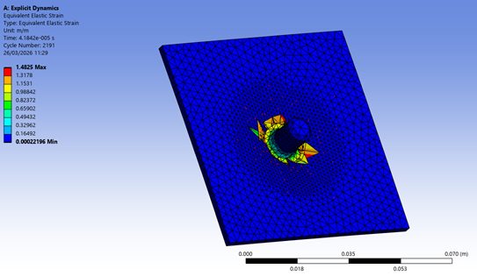
Figure 5, Failed simulation due to excessive deformation

Boundary influence consideration and input variables
Utilising boundaries in a ballistic simulation is crucial as without assigning static and dynamic components, the projectile will push the plate rather than causing deformation as the plate receives no opposing resistance.
The plate is modelling a connected side of target, meaning we would expect ridged sides which hold the plate in position from the sides. Therefore, using the boundary conditions, the sides remain ridged and as the waves move through the plate, this is seen as deformation rather than plate movement.
Figure 6 shows the configuration of surface-to-surface interaction. By inputting this parameter, it determines how the projectile will interact with the separate component, decided to be frictionless as in this context friction is nominal in comparison to the other experiencing forces.
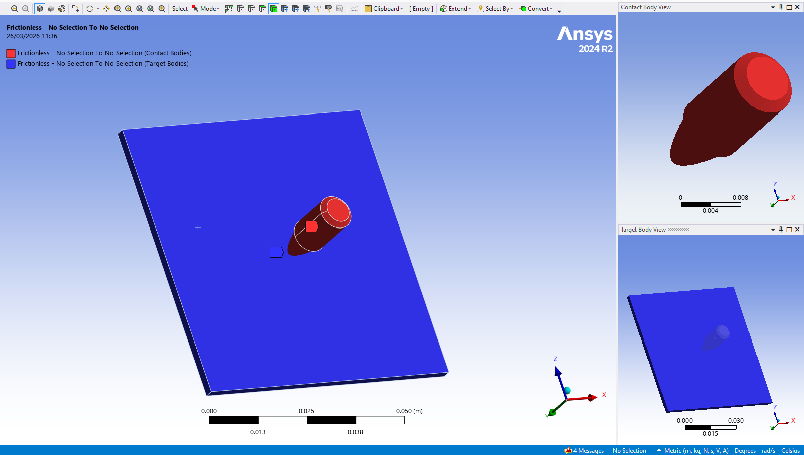
Figure 6 The configuration of surface-to-surface interaction
Pre-stress was inputted as none however in a practical application, the projectile would be expected to experience stress due to the force applied as it is released from the barrel. This reduces the accuracy of the simulation. Velocity input determined the direct and velocity of the projectile hitting the plate, due to this being an ideal simulation there is no requirement for acceleration from 0m/s.

Results and literature validation
At 600m/s, which is considered the max velocity of a lead projectile ordinarily [16], instead of deformation, the bullet compressed and deformed rather than penetrating the plate. This result is partially expected due to literature results, [16] where full bullet penetration was not reached. Figure 7 shows this side view as well as the remaining stress experienced by the plate.
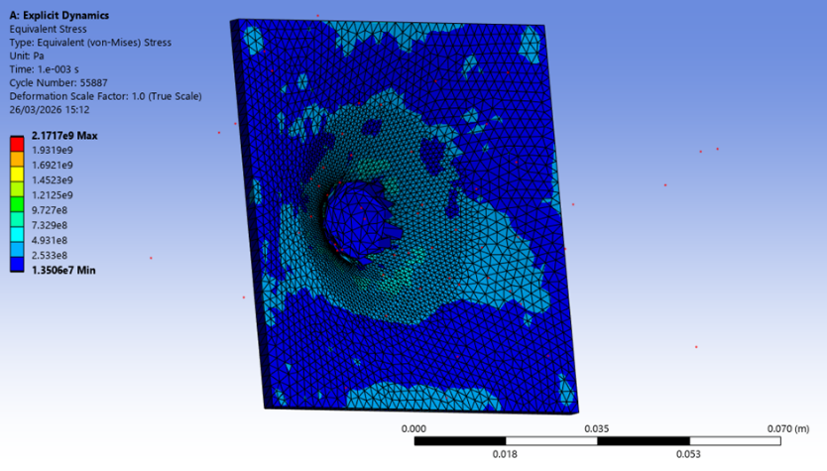
Figure 7, 600 m/s failed penetration of soft core
By changing the velocity only, all material and geometric parameters remained constant, a second testing was conducted. In this simulation the velocity was set to 1000m/s, the expect velocity of a .22 long rifle round [17]. The results shown in Figure 8, show a progressed deformation where the projectile has caused extreme distortion however, the projectile has appeared to become stuck without fully exiting the plate. This result can be validated by literature [16], showing at the velocity of 1000m/s, the projectile will commonly rapidly deaccelerate and become stationary, not reaching full penetration.
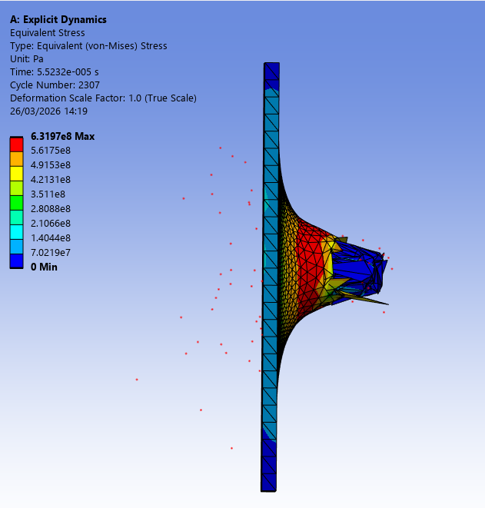
Figure 8, Equivalent Stress (Von-Mises) at a velocity of 1000m/s
The results show that partial penetration occurred at 1000 m/s however the simulation underwent extreme distortion potentially indicating that the lack of full penetration could have been achieved without the limitation of the software. This result could further be validated or contradicted by using a difficult mathematic model, redesigning the mesh to better provide nodal alignment and interaction or practical application.
The third simulation was conducted at the velocity 1200m/s, at this velocity it is expected that the soft-core bullet will fully penetrate and both objects will experience extreme plastic deformation [15]. Extreme stress is expected as nodal distortion occurs, as a shockwave moves from the centre of impact through to the surrounding plate. The result of this simulation is shown in Figure 10.
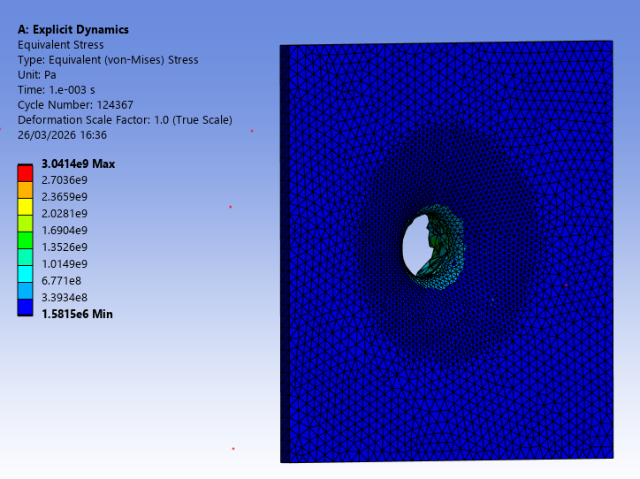
Figure 9, Equivalent Stress (Von-Mises) at a velocity of 1200m/s
Figure 9 does not show the deformed projectile rather the shearing through the plate. This result relates to previous testing [16], as this is the expected velocity for a lead 9mm bullet to reach and desired results which is full penetration. Figure 10 shows a graphical representation of the stress movement during the simulation. It can be observed that the stress increases almost instantaneously before extreme deformation occurred and the wave dissipates through the plate, leaving only residual stress localised to the point of penetration.
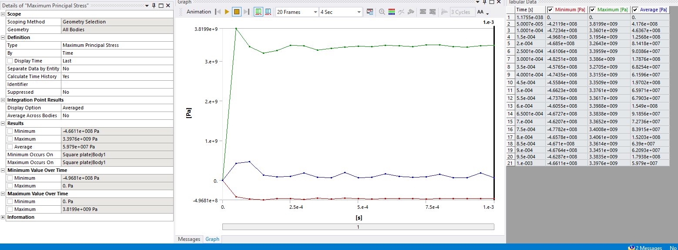
Figure 10, Minimum, Maximum and average maximum principal stress (Pa) measured during 1200m/s testing
In red, the minimum stress is shown, dropping below 0 Pa to -4.611e-008 Pa, this shows compression in the material which occurs rapidly before reaching max compression and plateauing. Green shows maximum stress where the material is undergoing tension and therefore deforming the material. The sudden spike occurs almost instantaneously as the projectile makes contact before exiting the plate. These results are best displayed by the blue result, where there is a sudden spike of positive stress (tension) the material deformed, and full penetration occurs, and the remaining wave can be observed by minor spikes every 2 to 3 nodal points.
To conclude the results collected, successful penetration occurred at 1200 m/s however, traditionally this velocity would only be achieved by a high velocity rifle round, suggesting possible future development of bullet release systems. [18]
Linear deformation validation compares the linear structural simulation to practical data on the physical behaviour of the materials response to applied loads. [21] In this context, the deformation of the stainless steel should be proportional to the applied load from the projectile. As the projectile impacts the plate, this accelerates the plate backwards with the sides remaining static due to boundary influence. The greater the velocity of the projectile, the greater the acceleration. The load applied or force can be calculated using newtons second law, Equation 3, the mass remains constant and therefore there is a directly proportional relationship between the force applied and the acceleration caused by the velocity of the projectile. This is shown in the collected results as greater linear deformation occurs as this velocity increases providing validation to these results.
Force = Mass x Acceleration
Equation 3, Newtons Second Law
Non-Linear validation beyond quantitative observation introduces the concept of using variation methodologies to apply context and nuance to the validation comparison. [22] The Internation Journal of Impact validation published a review on a brass jacket lead bullet impacting various steel plates investigation, led by T.Borvik, using this investigation, Borvik found that an impact velocity greater than 830 m/s for the differing projectile resulted in successful perforation testing which aligns with the collected results as the 600 m/s velocity projectile did not perforate the plate which partial and full penetration was achieved at 1000 m/s and 1200 m/s. [22]
Although the literature comparison did not mimic the simulation conducted identically, the material data can be used to support the validation of the results collected but not confirm due to the ranging thickness of the plates used. This provides validation to the approximation not confirmation of the results.

Discussion and review of CAE tooling and multi-physics software

Literature of similar studies
A previous study conducted by Derek G.Spear titled ‘Modelling and Simulation Techniques Used in High Strain Rate Projectile Impact’ researched a series of computational models and simulations to investigate high strain rate projectile impact where data was collected on the dynamic responses of a solid metal projectile impacting a target under a high strain rate. This directly mimics the ballistic simulation conducted where similar geometry and forces were applied using Ansys rather than Abaqus. [23]
In this study, [23] several methods of calculation and approximation were utilised to best validate, increase the accuracy and analyse the results. These methods included FEM, DEM and SPH. Finite element method was successfully used to model a projectile impact involving Langrangian mathematical methods. This use of Johnson-Cook was able to simulate was able to simulate the high velocity impact and extreme deformation however, discounted other factors such as air pressure, external forces applied to the system and assumes a perfect homogenous material composition. These are the same negative factors that occurred in decreasing the approximation accuracy in the simulation conducted. Spear went on to validate their results using DEM, Discrete Element Methods, to reduce the material assumption. DEM is a numerical method which is used to evaluate the stress and strains within a continuum of discontinuous materials. [23] This has been used to provide additional data for the simulation to calculate which reduces the inaccuracy of the approximation.
SPH, Smooth Particle Hydrodynamics, can additionally be used to increase the accuracy of the simulated model. SPH is used to mimic fluid flow in mechanical context. Due to the extremely high stress and strain values expected as well as complex boundary interaction, SPH can be used in ballistic context to help inform and increase the testing data provided. SPH works via modelling the geometry as particles and using the Kernel function to calculate the expected properties and reactions of each particle. [24]

Advancing the accuracy of the approximated simulation
Material irregularity is inevitable in real life conditions. This is due to the quantities of variables including internal temperature gradients, material impurities, machining control and tolerances, use of consumables such as graphite to protect the projectile barrel. The primary geometry capable of being modelled in multi-physics software however, this will always be only an approximation due to the quantities of variables and the context of real-life changing varying constantly.
Using DEM to aid material simulation can improve the accuracy of modelling however can require specialist software, which usually increases with price, hardware capable of running the software and can also massively increase the time variable.
Extreme boundary interactions occur during ballistic simulations and because of this, standard modelling techniques such as Johnson-Cook can fail due to the extreme deformation as these boundaries impact. Using SPH, the boundary interactions can be modelled as particles and different mathematic models could be applied (Kernel Function ect) to represent the geometry and mechanical behaviour. Using this kind of mathematic model usually requires significant hardware ability and not all multi-physics software is capable of such.

Structural analysis and iterative design
CAD limitations of ideal geometry includes only assuming ideal machining with perfect symmetry and without a tolerance. To counter this, iterative simulation with maximum, minimum and ideal tolerance control would be simulated to ensure the geometric changes have a nominal effect on the results.
Simulation iterations can also present information on validity, if an identical simulation is run multiple times however presents various results, this speaks to an inaccuracy of the program.

Collective summary and further recommendations
Further study into this simulation to be conducted using DEM to validate material qualities further however, this would require investment into both software and hardware. The material validation is crucial in this simulation as the results very such extremely between the velocities as 600 m/s showed extreme deformation of the projectile and 1000 m/s and 1200 m/s showed extreme deformation of the plate. Therefore, understanding the material behaviour reaction is primary to analysation for further results and improvement of validity.
The simulation provided results validated with linear deformation and literature comparison to show the projectile achieved full penetration at 1200 m/s, this velocity is current only achieved using high velocity rifle however further research into delivery system may allow for alternative projectile methods in the future.

Bibliography
[1]
P. E. Connolly, “CAD Software Industry Trends and Directions,” Engineering design graphics journal, vol. 63, no. 1, Aug. 2009, doi: https://doi.org/10.18260/edgj.v63i1.121.

[2]
Stefano Tornincasa, Technical Drawing for Product Design. Springer Nature, 2020.

[3]
Mary Kathryn Thompson and J. M. Thompson, ANSYS mechanical APDL for finite element analysis. Oxford, United Kingdom: Butterworth-Heinemann, An Imprint Of Elsevier, 2017.

[4]
R. Shih, Tools for Design Using AutoCAD 2021 and Autodesk Inventor 2021. SDC Publications, 2019.

[5]
D. R. Christman and J. W. Gehring, “Analysis of High-Velocity Projectile Penetration Mechanics,” Journal of Applied Physics, vol. 37, no. 4, pp. 1579–1587, Mar. 1966, doi: https://doi.org/10.1063/1.1708570.

[6]
S. Zaki, E. Uddin, B. Rashid, A Mubashar, and S. R. Shah, “Effect of liner material and explosive type on penetration effectiveness of shaped charge,” Proceedings of the Institution of Mechanical Engineers Part L Journal of Materials Design and Applications, vol. 233, no. 7, pp. 1375–1383, Jan. 2018, doi: https://doi.org/10.1177/1464420717753233.

[7]
A. V. Potapov, M. L. Hunt, and C. S. Campbell, “Liquid–solid flows using smoothed particle hydrodynamics and the discrete element method,” Powder Technology, vol. 116, no. 2–3, pp. 204–213, May 2001, doi: https://doi.org/10.1016/s0032-5910(00)00395-8.

[8]
L. Zou, J. Fan, J. Huang, and J. Chen, “The Construction of a Small-Caliber Barrel Wear Model and a Study of the Barrel Wear Rule,” Coatings, vol. 14, no. 9, pp. 1200–1200, Sep. 2024, doi: https://doi.org/10.3390/coatings14091200.

[9]
Gökhan İbrahim Öğünç, Nilgün Şen, Bayram Yüksel, Emre Oğur, and Hatice İşcan, “IMPACTS of SUPERSONIC and SUBSONIC AMMUNITION on GUNSHOT RESIDUE DISTRIBUTION,” Güvenlik Bilimleri Dergisi, vol. 13, no. 1, pp. 27–62, May 2024, doi: https://doi.org/10.28956/gbd.1384857.

[10]
K. Hariharan, G. Balachandran, and M. S. Prasad, “Application of Cost-Effective Stainless Steel for Automotive Components,” Materials and Manufacturing Processes, vol. 24, no. 12, pp. 1442–1452, Dec. 2009, doi: https://doi.org/10.1080/10426910903179989.

[11]
J. L. McQuirter, S. J. Rothenberg, G. A. Dinkins, M. Manalo, V.S. Kondrashov, and A. C. Todd, “The Effects of Retained Lead Bullets on Body Lead Burden,” Journal of Trauma-injury Infection and Critical Care, vol. 50, no. 5, pp. 892–899, May 2001, doi: https://doi.org/10.1097/00005373-200105000-00020.

[12]
W. Hofmann and Gerwig Vibrans, Lead and Lead Alloys. Springer-Verlag, 2013.

[13]
M. Chegini, M. R. Aboutalebi, S. H. Seyedein, G. R. Ebrahimi, and M. Jahazi, “Study on hot deformation behavior of AISI 414 martensitic stainless steel using 3D processing map,” Journal of Manufacturing Processes, vol. 56, no. 56, pp. 916–927, Aug. 2020, doi: https://doi.org/10.1016/j.jmapro.2020.05.008.

[14]
C. E. Anderson and S. R. Bodner, “Ballistic impact: The status of analytical and numerical modeling,” International Journal of Impact Engineering, vol. 7, no. 1, pp. 9–35, Jan. 1988, doi: https://doi.org/10.1016/0734-743x(88)90010-3.

[15]
D. Ma, Riccardo Scazzosi, and A. Manes, “Modeling approaches for ballistic simulations of composite materials: Analytical model vs. finite element method,” Composites Science and Technology, vol. 248, pp. 110461–110461, Jan. 2024, doi: https://doi.org/10.1016/j.compscitech.2024.110461.

[16]
M. Giglio, A. Gilioli, A. Manes, L. Peroni, and M. Scapin, “Investigation about the influence of the mechanical properties of lead core and brass jacket of a NATO 7.62 mm ball bullet in numerical simulations of ballistic impacts,” EPJ Web of Conferences, vol. 26, pp. 04010–04010, Jan. 2012, doi: https://doi.org/10.1051/epjconf/20122604010.

[17]
M. McTee and P. Ramsey, “Is lead‐free .22 long rifle ammunition worth a shot?,” Wildlife Society Bulletin, Mar. 2022, doi: https://doi.org/10.1002/wsb.1255.

[18]
DK, Firearms: An Illustrated History. Penguin, 2014.

[19]
“AISI 414 (S41400) Stainless Steel :: MakeItFrom.com,” Makeitfrom.com, May 30, 2020. https://www.makeitfrom.com/material-properties/AISI-414-S41400-Stainless-Steel (accessed May 04, 2026).

[20]
ANSYS, Inc., ANSYS Workbench Student – Engineering Data (Material Library), Release 2024 R1. Canonsburg, PA, USA: ANSYS, Inc., 2024.

[21]
L. Gambirasio and E. Rizzi, “On the calibration strategies of the Johnson–Cook strength model: Discussion and applications to experimental data,” Materials Science and Engineering: A, vol. 610, pp. 370–413, Jul. 2014, doi: https://doi.org/10.1016/j.msea.2014.05.006.

[22]
T. Børvik, S. Dey, and A. Clausen, “Perforation resistance of five different high-strength steel plates subjected to small-arms projectiles,” 2008, doi: https://doi.org/10.1016/j.ijimpeng.2008.12.003.

[23]
D. Spear, A. Palazotto, R. Kemnitz, S. Reich, and C. Cesarano, “mathematics Modeling and Simulation Techniques Used in High Strain Rate Projectile Impact,” 2021, doi: https://doi.org/10.3390/math9030274.

[24]
X. F. Yang, S. L. Peng, and M. B. Liu, “A new kernel function for SPH with applications to free surface flows,” Applied Mathematical Modelling, vol. 38, no. 15–16, pp. 3822–3833, Aug. 2014, doi: https://doi.org/10.1016/j.apm.2013.12.001.

Appendix

A Fusion 360
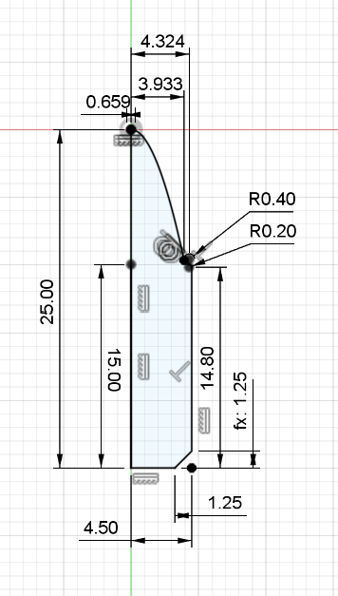
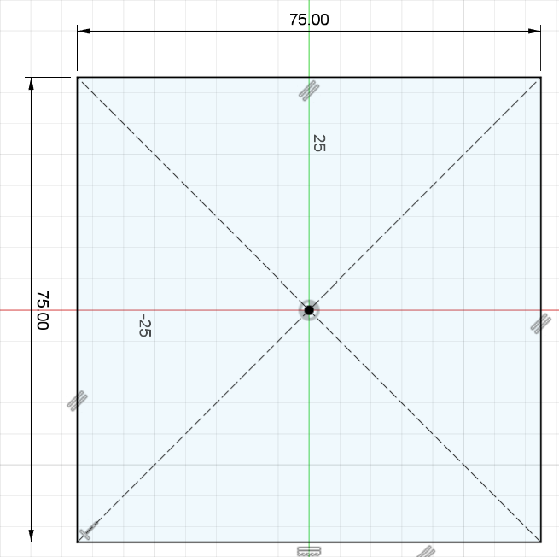

B Failed results due to material parameters
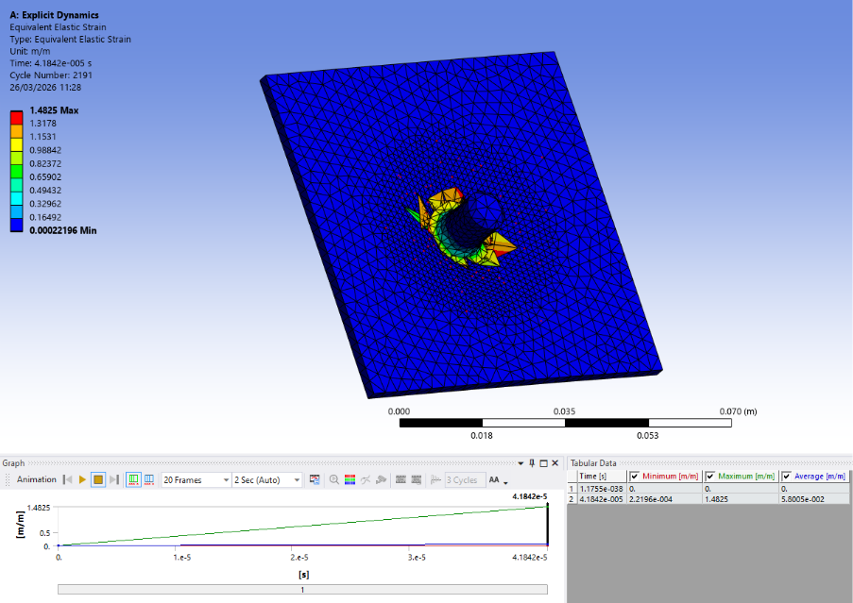
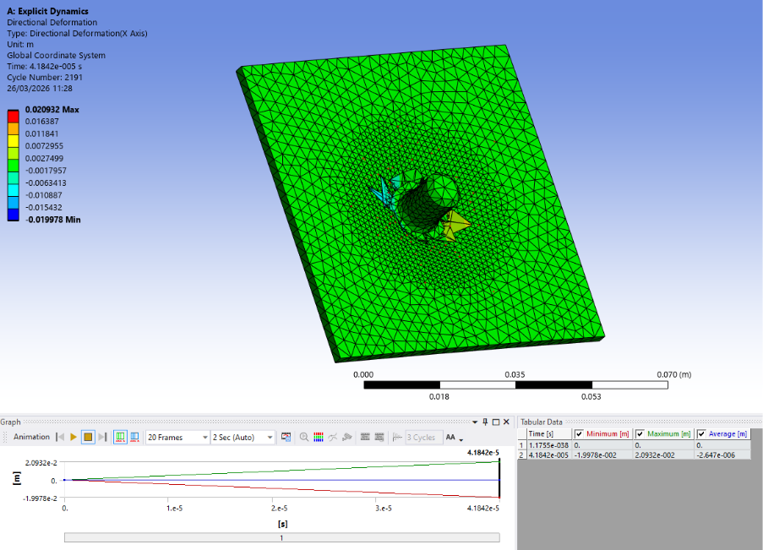
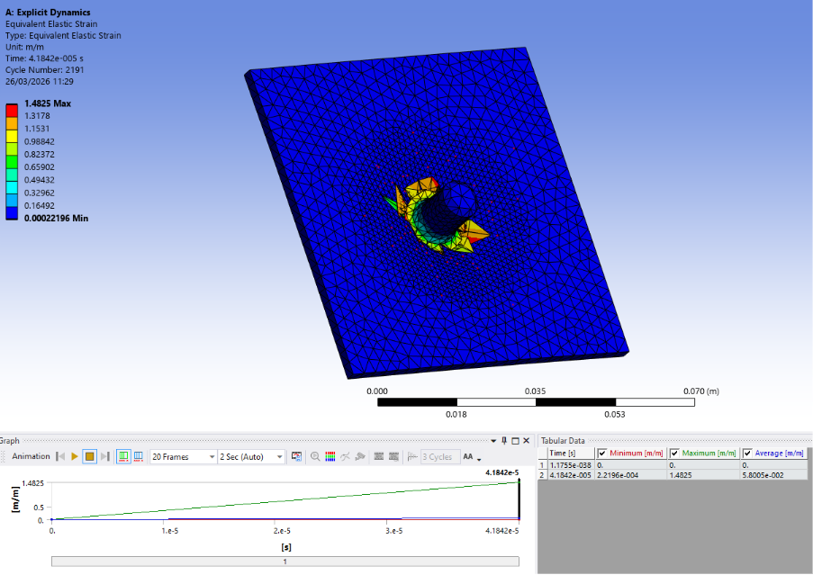

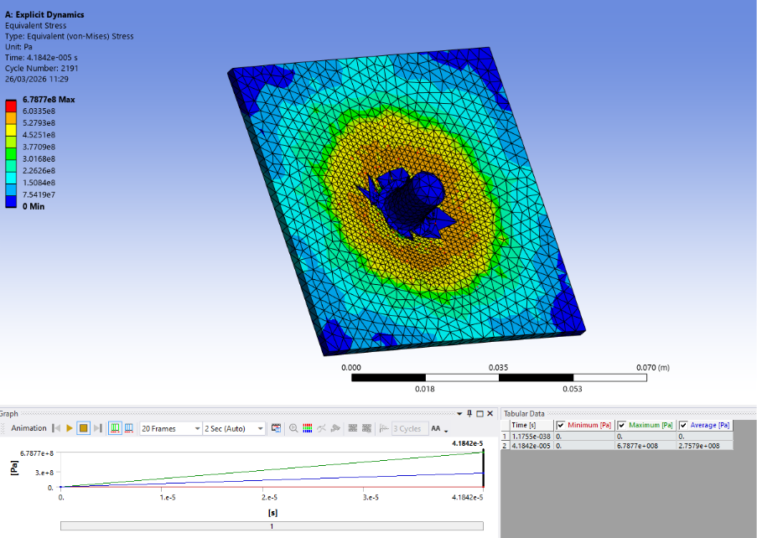
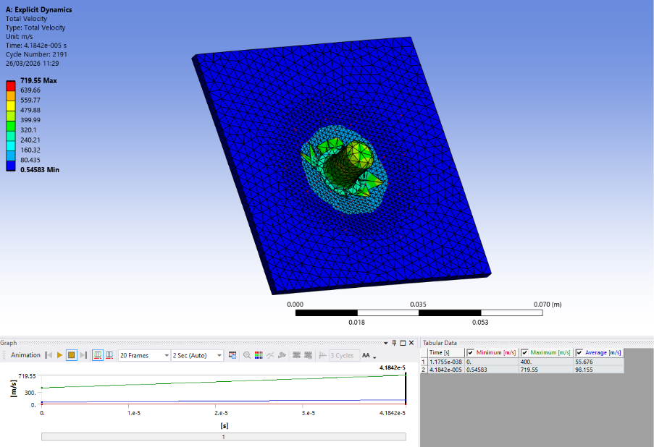
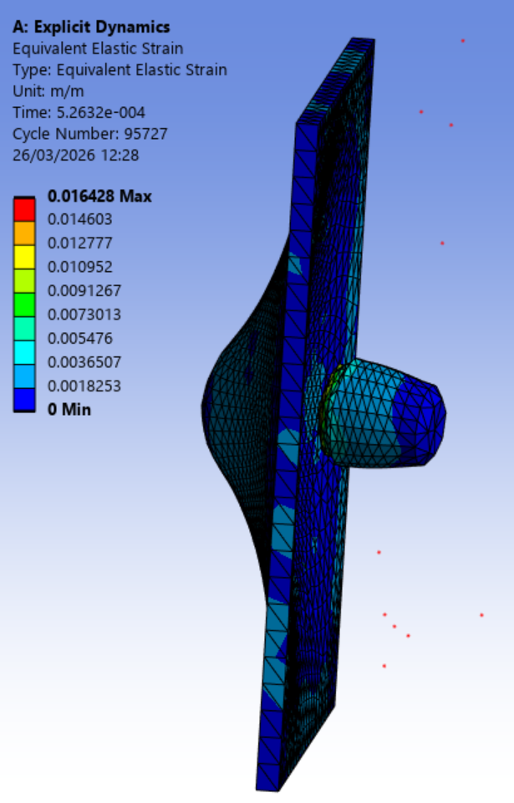
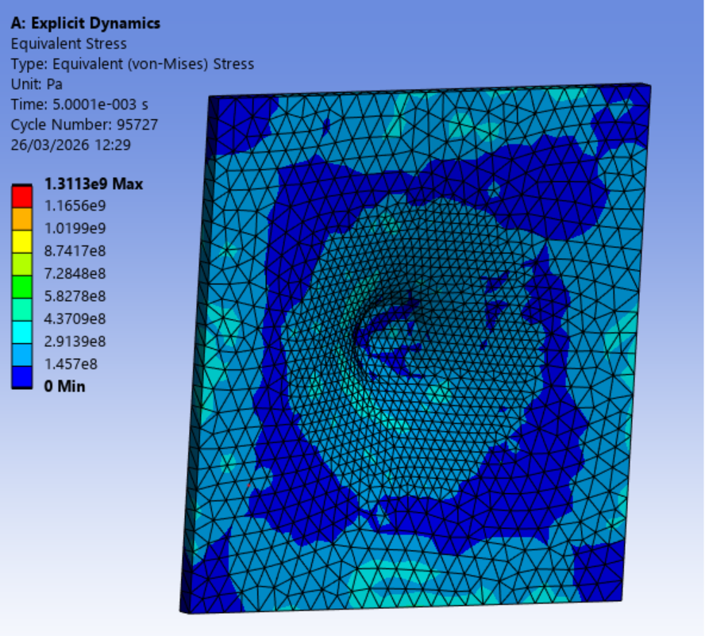

C Additionally collected data
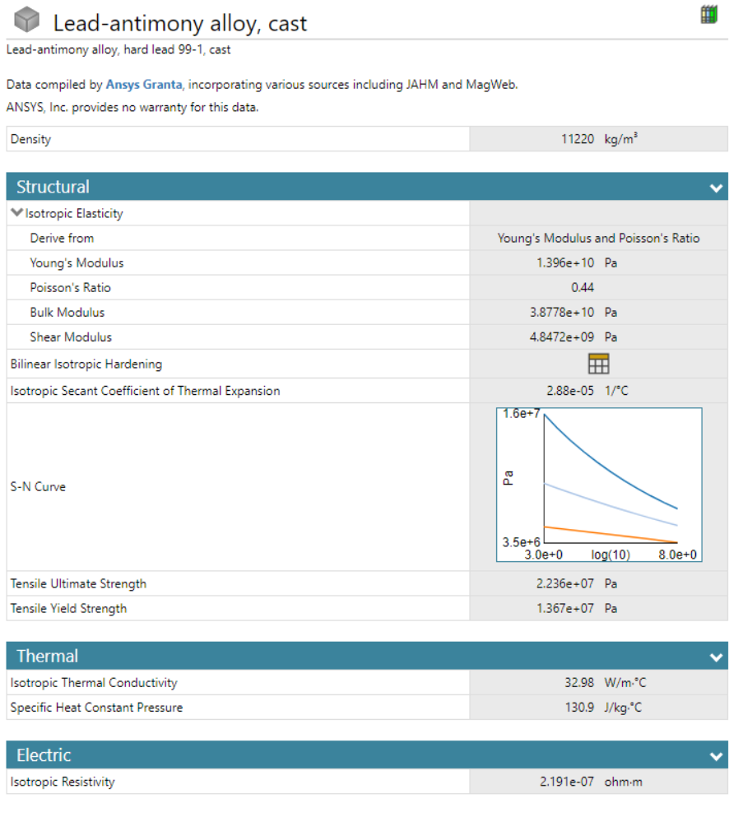

D Additional results


