
A Personal learning environment
BMSP4003

March 28, 2018
University of Wales Trinity Saint David
By Jordan Coller

Introduction

With the implementation of advanced digital equipment and software, learning has changed over the years to help education adapt to the advancements of the digital age, this is known as digital literacy. Prior to Web 2.0, learning in a classroom was once achieved through participation and traditional methods. However, since evolving into the digital age, it is assumed that educational methods may have been improved for teachers and students alike. For many individuals, there are many variables concerning digital literacy that may increase efficiency during an undergraduate programme, these regard; digital devices, device software, search engines, web 2.0 and disability specialised software that wasn’t accessible before the digital era, this enables teachers and students to create, evaluate, search and share information. However, this may bring forward the question; “has education become too dependent on digital literacy?”
Within this essay my individual reflection will be provided to determine if in true fact digital learning has benefited me. Various methods of digital learning will be analysed and compared through a visual representation of my own “Personal Learning Environment.” The PLE diagram will convey my individual strengths that weaknesses may occur with the use of digital technology during an undergraduate programme that regards my own use of digital literacy and competence in doing so. (Murray, 2018)

Digital Technologies and the Change in Learning

As technologies evolve, so do career opportunities and the economy. Educational programs implement digital traits so that students can adapt to the new idea of digital literacy. The transition from web 1.0 to web 2.0 impacted education significantly as it removed the focus from the teachers, which once was the primary source of delivered information and enabled the student to harness shared information via the internet. During the mid-1990’s, Web 1.0 provided information to website visitors and only allowed primary editors to communicate to readers. During late 2001 Web 2.0 was popular to internet users as it allowed user creative content. This allowed not only the primary editor to communicate with their users, but also the users to communicate back and between each other through sharing information and collaboration. (O'Reilly, 2005) (Youtube, 2013)
Technology has created the opportunity to take advantage of the prosumers within education as new device models and methods are produced, this concerns the need for expensive equipment such as; Tablets, laptops and smartphones to help cultivate one’s personal learning environment. New models in technology typically upholds added benefits. This can create a visual gap between the middle class and upper class students opposed to the working-class students as they may develop a disadvantage due to less income to purchase such device, thus certain resources may be unavailable to them during the learning process.
Many would argue that while Web 2.0 upholds beneficial traits, it also embodies disadvantages. Secondary-school and college students nowadays are born into the digital era therefore it is more than likely they may attend education with a digital citizenship, typically this results in the possibility of prior experience maintaining a web 2.0 learning environment. However, many mature students and teachers may not be familiar to the adoption of a web 2.0 environments. This creates difficulties that concern their ability to adapt due to lack of opportunity to use the internet prior to higher-education. A familiar term that concerns this is called “The Digital Divide”. (Lam & Lee, 2005) (Wong, 2015)
Means of learning through multi-media websites such as YouTube is deemed a new trend in learning today, as it allows a student to be taught effortlessly as the information is already shared in video format, which in theory makes learning easier to digest. This will be analysed in depth within “My Personal Learning Environment”.

Comparing Completion Rates of Online and Participational Universities
Open University courses are a prime example of how learning in higher education has transitioned since the evolution of web 2.0. The Open University UK online prospectus conveys this method of learning as “learning that fits around the time you have” and they can offer the support a student needs by streaming video information with “OpenLearn” tutoring to study a full-time degree describing the practice as convenient with words such as “when and where you decide to study”. However, according to The World University Rankings website, the Open University upheld a mere 13% graduation rate during the year 2016 due to student leaving online courses. The Open University remains adamant that personalisation of their students’ needs will remain minimalised and will push forward with plans to increase the gap between physical tutors to student communication. Since the decline in 2016, it is assumed The Online University have implemented a more personalised approach with social media. When compared with the overall domiciled completion rate in the UK that is shown in Graph 1 below, personalisation in The Open University truly conveys a need for concern. ("The OU community | Open University", n.d.) ("The Open University needs to make it personal", 2016)

Graph 1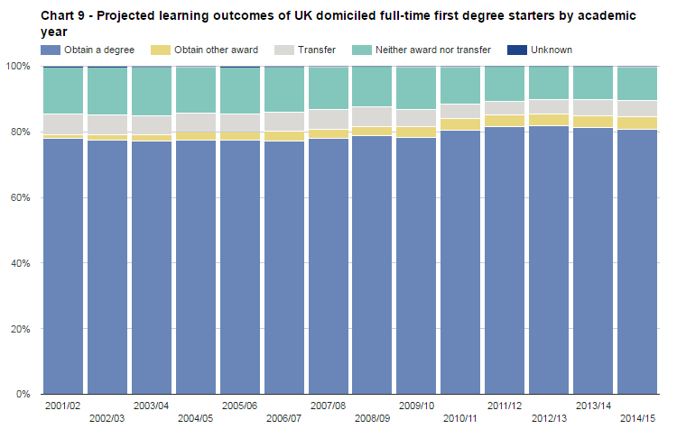
(Sourced from - https://www.hesa.ac.uk/data-and-analysis/performance-indicators/summary/2015-16)

Google and Education
The search engine “Google”, is considered highly beneficial in education today, as it enables the accessibility to search relevant information with ease, being the most popular website by today’s standards. With the correct use of searching for information, searching online can cultivate a student with the potential to learn beyond a teacher’s capability, however contributes to a student’s independency to learn, thus creating the possibility of dampening the role of the traditional classroom teacher. Although, this can vary between different subjects that require certain levels of participation, this points towards the “Two Metaphors of Learning” theory by Anna Sfard. Sfard conveys that gaining acquisition on a subject may not necessarily teach you how to perform said subject, you must participate through practice also, and therefore you must learn with an equilibrium of metaphors. This can concern many artistic and physical subjects within education. (Fitzpatrick, Eadicico & Peckham, 2017) (Godsey, 2015) (Sfard, 1998)

Digital Printing
Digital printing may vary when concerning types of informational outputs. Popular online printing outlets for students writing a paper would regard recourses such as; media outlets and online libraries. This is when online papers and books are copied and shared within a domain for the public to analyse, share and reference, therefore maximising the information that is digested, for example; searching for an academic article online may include a collective amount of cited and professional references. In theory this should benefit the reader, however, without adequate knowledge that regards the finding of suitable references, this may hinder one’s source of information as it may include inaccurate information. An example of this type of web domain can regard Wikipedia. This is vastly different when compared when harnessing information from analogue sources such as books. Before web 2.0, learning as a student or teacher would once entail collecting physical information such as; books from libraries along with still images and text from a white/blackboard that information is shared from teacher to student, but now it has transitioned through the years. However, this does not necessarily convey that physical references are not used in learning today, although physical referencing certainly has seen a decline since digital literacy. (Lester & King, 2009)

My [Digital] Personal Learning environment

My PLE Diagram
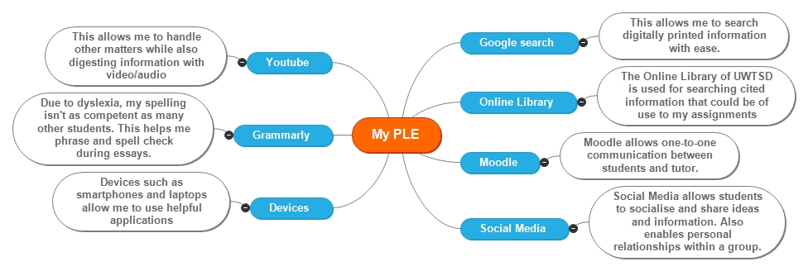

Supporting me with my dyslexia, I think Grammarly is easy to use and requires minor effort as it assists me and works in the background of Microsoft word. This software application suggests alternatives regarding my phrasing, scanning for plagiarism and spelling when writing an essay. The mention of Grammarly being free interested me, as being a full-time student means finances can be a disadvantage when acquiring expensive devices and software whilst maintaining a family life. Regardless of the supporting benefits Grammarly offers me, over time my dependency to the application may hinder my ability to write without said application. This implies that my dyslexia will truly be apparent when writing offline. (Grammarly.com, n.d.) (Kennard, 2018)
Recent studies from psychologists explain results regarding the theory behind “visual” and “auditory” methods of learning. These studies conclude that “93 percent of the public and 76 percent of educators believe that students learn better when taught according to their individual learning styles.” (Franz, 2017) The popular streaming website, Youtube, benefits my family life as it allows me to listen to the audio of a video while tending to my stepson or maintaining house-work. Information transferred in a video and audio format appeals to me as reading is not a strong asset of mine. Therefore I assume visual and auditory methods are better suited within my learning. However, in my experience I find Youtube to be distracting when writing a paper of importance. This could regard the high amount of prosumer activity within the website, as adverts are used to divert the audience over to other channels. (Franz, 2017)
Social media is my preferred means of student to student communication. For example: Facebook messenger as messages are in real-time. Social media can also can be used for harnessing information regarding currant news and breakthroughs. However, it should never be assumed to accept information from non-professional/no approved persons on social media at “face-value” as in my personal experience, social media conveys that it is dominated by users attempting to become popular opposed to becoming factual. This could regard the fact of social media condoning public-user content creation. This can be compared to a website that also condones public-user content creation; Wikipedia. Typically undergraduates will not use this website and tutors advise students not to also unless necessary. Another disadvantage concerning social media in my own experience would regard bullying. Dosomething.com states “70% of students report seeing frequent bullying online” this conveys social media websites are too lenient with its policies and needs to improve its monitoring and security within their websites. (O'Reilly, 2005) (Kuiken, Schuth, Spitters & Marx, 2017) ("11 Facts About Cyber Bullying | DoSomething.org | Volunteer for Social Change", 2018)

The cost efficiency of digital printing would in theory benefit myself, as online printing eliminates the need for buying physical hard-copies as it’s already provided by the online library. However, in my personal experience, prosumer activity could also become a disadvantage when using digital copies as the process of buying hardware devices to access said digital information could be very expensive depending on how recently released they are. (Lester & King, 2009)
During my undergraduate programme, it has become apparent that Moodle is a fundamental technology when learning. This educator platform allows resourceful information and schedules to be transferred from tutor to student via communication that incorporates web 2.0 aspects, such as; secure and relevant content that is created by tutors. Moodle enables a student to catch up on information that they may have missed out on due to attendance issues. A useful tool regarding Moodle would concern a student’s ability to search different dates where information was given, this increases the flexibility of time for a student while decreasing distance of travel and information that may be lost due to forgetfulness. ("About Moodle - MoodleDocs", n.d.)
In my own personal experiences, being a father in a household, this can cause me to stay home. For example; if a member of the household is ill and may need support at home, I am able to study from Moodle. However, my own lack of attendance is a great concern of mine as the participation and personalisation aspect of the course that support my learning is lacking.

My Digital Literacy

During March - April 2018, a student forum was submitted by professor; Dr. Alex Bell. The forum contained a series of set tasks throughout each week to enable the students with experience to analyse their own digital literacy. For this section of the essay, I will be critically reflecting upon my own competence towards digital learning by referring back to examples concerning week 1 of the course work.
The first task set in place is known as “A1 – Meeting fellow students and your tutor.” This required a student to upload a “profile picture” and state personal information regarding one’s hobbies and facts. This was not difficult to complete, however, when posting personal information and pictures regarding myself online, I do believe that personal information can be anonymously judged by other users. This is because when reading a brief biography regarding a person, it never truly reflects who a person is. (Chamorro-Premuzic, 2015)
Gathering information to participate in the tasks set in said forum was moderately easy for me to maintain as many questions that Dr. Alex Bell asked where available on google or was provided in hyperlinks within the question. However, it is apparent some may struggle with this way of digital learning as The Digital Divide may play a part in one’s limitations, as it does mine. This concluded in the weekly tasks building up, as I had to first complete previous questions before starting the most recent tasks. I believe this would not concern the younger generation participating within my course, as I assume their personal responsibility is in smaller proportion in comparison to mature students with children. (Ruane, 2015)
However, learning digitally enabled myself to revisit uncompleted tasks that were previously submitted. This enabled me to flexibly manage time when studying. Although, I believe with my lack of time management skills, this is a concern that needs to be rectified.

Conclusion
In conclusion, technology has changed rapidly to adapt within the new economy. Incorporating technologies within participational learning can support a student in maximising their ability to learn. However, personal preference can play a major factor within this statement as many variables can hinder one’s ability to digitally learn, examples concerning this may regard ”the Digital divide” and the price of prosumer activity.
The completion rates of The Open University conveys that when learning without physical participation, it is possible. However, the results aren’t efficient and lacks an equilibrium and personalisation which may result in students not obtaining the support they need.
Although, evidence of learning with aspects of digital literacy is proved to benefit a student, it brings to light a question I ask myself when participating such learning methods. These questions are; how dependant are we to this technology? and when will Personal Learning Environments replace a student’s ability to think for one’s self?

References
- 11 Facts About Cyber Bullying | DoSomething.org | Volunteer for Social Change. (2018). Dosomething.org. Retrieved 1 April 2018, from https://www.dosomething.org/us/facts/11-facts-about-cyber-bullying
- Chamorro-Premuzic, T. (2015). How different are your online and offline personalities?. Retrieved from https://www.theguardian.com/media-network/2015/sep/24/online-offline-personality-digital-identity
- Fitzpatrik, A., Eadicico, L., & Peckham, M. (2017). The 15 Most Influential Websites of All Time. TIME Magazine. Retrieved from http://time.com/4960202/most-influential-websites/
- Franz, J. (2017). Consider yourself a 'visual' or 'auditory' learner? Turns out, there’s not much science behind learning styles. Science Friday. Retrieved from https://www.pri.org/stories/2017-09-17/consider-yourself-visual-or-auditory-learner-turns-out-there-s-not-much-science
- Godsey, M. (2015). When the Internet Delivers Its Own Content, What’s Left for the Teacher?. The Atlantic. Retrieved 1 April 2018, from https://www.theatlantic.com/education/archive/2015/03/the-deconstruction-of-the-k-12-teacher/388631/
- Grammarly.com. Retrieved 1 April 2018, from https://www.grammarly.com/
- Kennard, K. (2018). What to do when your student maintenance loan is not enough | The Scholarship Hub. Thescholarshiphub.org.uk. Retrieved 1 April 2018, from https://www.thescholarshiphub.org.uk/blog/what-do-when-your-student-maintenance-loan-not-enough
- Kuiken, J., Schuth, A., Spitters, M., & Marx, M. (2017). Effective Headlines of Newspaper Articles in a Digital Environment. Digital Journalism, 5(10), 1300-1314. http://dx.doi.org/10.1080/21670811.2017.1279978
- Lam, J., & Lee, M. (2005). Bridging the Digital Divide – The Roles of Internet Self-efficacy towards Learning Computer and the Internet among Elderly in Hong Kong, China. City University Of Hong Kong, 1. Retrieved from https://pdfs.semanticscholar.org/e154/c2768fcb924181af09d128ce2cdec57af198.pdf
- Lester, P., & King, C. (2009). Analog vs. Digital Instruction and Learning: Teaching Within First and Second Life Environments (p. 470). Retrieved from http://paulmartinlester.info/writings/sl_face.pdf
- About Moodle - MoodleDocs. Docs.moodle.org. Retrieved 2 April 2018, from https://docs.moodle.org/34/en/About_Moodle
- Murray, J. (2018). Technology in the Classroom: What is Digital Literacy?. TeachHUB. Retrieved 30 March 2018, from http://www.teachhub.com/technology-classroom-what-digital-literacy
- O'Reilly, T. (2005). What Is Web 2.0. Oreilly.com. Page 1. Retrieved 30 March 2018, from http://www.oreilly.com/pub/a/web2/archive/what-is-web-20.html?page=1
- O'Reilly, T. (2005). What Is Web 2.0. Oreilly.com. Page 2. Retrieved 30 March 2018, from http://www.oreilly.com/pub/a/web2/archive/what-is-web-20.html?page=2
- Ruane, L. (2015). https://www.irishtimes.com/opinion/lynn-ruane-being-a-parent-and-a-student-feels-like-an-impossible-feat-1.2313844. Retrieved from https://www.irishtimes.com/opinion/lynn-ruane-being-a-parent-and-a-student-feels-like-an-impossible-feat-1.2313844
- Sfard, A. (1998). On Two Metaphors for Learning and the Dangers of Choosing Just One. American Educational Research Association, Vol. 27(No. 2), 4. Retrieved from https://moodle.uwtsd.ac.uk/pluginfile.php/102555/mod_resource/content/1/On%20Two%20Metaphors%20for%20Learning%20-%20Sfard%20%281998%29.pdf
- The Open University needs to make it personal. (2016). Times Higher Education (THE). Retrieved 31 March 2018, from https://www.timeshighereducation.com/letters/the-open-university-ou-needs-to-make-it-personal#survey-answer
- The OU community | Open University. The Open University. Retrieved 31 March 2018, from http://www.open.ac.uk/courses/what-study-like/community
- Wong, A. (2015). Digital Natives, Yet Strangers to the Web. Retrieved from https://www.theatlantic.com/education/archive/2015/04/digital-natives-yet-strangers-to-the-web/390990/
- Youtube. (2013). What is Web 2.0? What is Social Media? What comes next??. Retrieved from https://www.youtube.com/watch?v=iStkxcK6_vY

