Business Name: Grillify
Ayyub Khan 2017875
Radu Andreescu 2026729
Keisha Williams 2014976
Lecturer: Nauman Ali
Module number: BMSW4006_BIRM
Module: Managing Enterprise in the 21st century

Business Plan

Contents
Executive Summary: 3
Business/Company Overview 3
1.2 Restaurant statement 3
1.3 A realistic time timeline for opening the restaurant. 3
1.4 Your target location 3
1.5 A market analysis 3
1.6 What makes our restaurant unique? 4
1.7 Grillify core strength 4
Product and Services 4
Market audit 4
SWOT Analysis 5
Pestle Analysis 6
7. Target market 7
8. Marketing Plan 7
6. Management Team 8
7. Financial plan 9
7.1 Cash flow forecast 9
7.2 Forecast for Profit and loss 10
Reference 11

Executive Summary:
Grillify will be a new dining experience in Colmore row in Birmingham town centre in the west midlands; business will include ayyub khan as the general manager, Radu as the waiter and Keisha as the waiter bartender. The difference between our restaurant and the local area is that we have reasonable prices on our food; we welcome all kinds of back rounds because we serve halal meat. The business location is fundamental since it is in Birmingham town centre on Colmore road which is very busy with shoppers’ locals and staff from the local businesses. Our plans for the first year are to be known around Birmingham city and locals’ area for a place for people to eat steak and relax in our restaurant with their friends, family, and couples. And in the next five years, we hope to be well established as a hot spot for people outside of Birmingham to come and dine.

Business/Company Overview
The restaurant concept will have a classic design of the 1950s-70s with some modern ambience like the seats and tables. We like the seats to be comfortable with an outside view of pigeon park. This is an excellent way to show people from outside this is a nice place to eat because of all the different backgrounds of people within the restaurant

1.2 Restaurant statement
We want to provide families, friends, and couples of all backgrounds to come and dine in our restaurant, and we want to be very welcoming to knowing that we are providing an excellent service for people to come back to us. We also want to be a place for shoppers and staff members from local businesses to come and relax after a long day.

1.3 A realistic time timeline for opening the restaurant.
We hope to open the restaurant during the school holidays, which start on the summer Holidays, 25/07/22. Opening on these dates will show us the best maximum number of customers.

1.4 Your target location
Next to pigeon park on Colmore road, it is a prime location in Birmingham town centre. When customers dine, they have a fabulous view of pigeon park.

1.5 A market analysis
Birmingham City we are the second-largest city in the UK after London. Colmore road is filled with other restaurants that provide a fine dining place for all families, friends, shoppers, and staff from local businesses.

1.6 What makes our restaurant unique?
Our food quality is superb from having fresh meats and vegetables from the local sources. This means our quality of food is always new. Our staff are well knowledgeable of the menu and can help specific individuals with dietary needs.

1.7 Grillify core strength
Our chef is talented in cooking steak and how to cook it for individual customer taste. The chefs are dedicated on making the best steak in Birmingham due to the prime location of Birmingham city centre; the chef understands he is the key to making grillify a reputational restaurant.

Product and Services
The main product is our steak which the chief can grill in all readiness from rare, medium-rare, and well done. We offer T-bone, rib eye, sirloin, and rump types of steak. As well as providing fresh lobster from the fish markets in town which we get good deals on because they are local to call. This we can cut out the middleman, delivery and supplier with high fees—many sides such as mac and cheese, onions rings, steam vegetables, grilled vegetables, etc. Every time we get the same customers, we can recommend more options, especially to those going on a healthy lifestyle. The chief we will hire will also be able to make its sides, making Grillify unique.
Kid's meals are easy to understand, which will have grilled chicken slices and sweet corn or beans. Having an essential dinner like that we can sell this for cheaper will encourage families with children to come more often.
Desserts will also be simple, with five different cakes and five different ice creams that we change around once a month. Some customers might like this, but some might not, which brings us more opportunities for new customers.

Market audit
Perceptual mapping is a visual representation of where a brand, product, or service stands among competitors. It is also known as positional mapping.
This type of competitive analysis framework generally consists of two key attributes as a basis. Unhealthy on the left, healthy on the right and high price on top and low prince on the bottom (Kosaka, 2022)

3.1 Competitors
- The Alchemist
- Gaucho
- Fazenda grill
- Kuula poke

I have put the competitors from the Colmore area on the perceptual mapping. I have put the Alchemist's unhealthy side because their main product is alcohol and fried food. Guacho and Fazenda serve similar food as us but with smaller portions and higher prices. And last, you have kuule poke, which is the healthiest; they offer salad boxes that you can customise or get ready-made ones. These are the main competitors.

SWOT Analysis

Strengths  - Fresh local produce  - Location  - Internal attributes & resources  - Social media | Weaknesses  - Staff’s morale  - Budget restrictions  - People management  - Non vegan option
Opportunities  - In time introduce takeaway  - Target market  - Plant based  - Technology restructure | Threats  - New competitors  - Changes to markets demand  - Loosing staff to competitors  - Loss market share

SWOT is known as a strategic tool that can be used both in a personal and business form, manner, SWOT done correctly will help elevate our position in business and hospitality. As a new business the benefits we have from using SWOT so early on will also be allowing us as a business to asses other competitors in our surroundings by doing this will first start off by taking full advantage of what we know our strengths to be such as being able to offer fresh local produce, this not only supports local businesses but we have all the sourced information of where it is our produce is come from.
Another strength is our location of our restaurant being based in city centre Colmore row, means we get to make full use of the custom we may have such as Workers after or during work lunch breaks, tourist that visit from other cities, families on weekend or days out shopping, students who may live local, all this with the right promotion we aim to be highly successful for our business using social media to advertise our platform we hope this aims to gain familiar custom over time.

In order to minimize weaknesses within our company first we need to assess the gaps looking closely at any issues we may be having for example one of our weaknesses we believe we may face is staff morale first when opening a new business for any owner can be difficult to find competent staff to begin with as we don’t all as individuals hold the same morale’s and standards towards life whether that be in a work profession so finding the right people as passionate about your restaurant as you may be trial and error to begin with as a start up
Opportunities identified during SWOT analysis can be incorporated into your restaurant taking note of what is changed in consumers taste or even customers preferences such as plant-based products using this as leverage will help your business and customer intake as a lot of people of today care more about what goes into food and our bodies.
Threats are essential that as a business we monitor as the smallest turnover for another business can be a drastic cut for our pockets financially, in this case these refer to having external factors that are beyond any control of ours. Or even a new franchise opens offering the same type of services, so it is important you always stay up to date with what is going on around you as a hole.

Pestle Analysis
Pestle allows us to weigh up the current factors that can prevent or may even hinder our business from growth, as a upcoming establishment its important that we study the environmental factors, this will ensure stability of our restaurant and determine on how it will flourish
Political consist of the health & safety policies we have in place down to hygiene and cleanliness all have policies and correct standards to be met this means as a company we must be flexible and be able to adapt with the times accordingly.

Economic factors will help keep on track with long- & short-term goals to come ensuring economic growth ensuring costs of our business as change may come in this industry such as inflation costs tax rises.
Social demand is changing everyday new ways to communicate are being discovered every day in the social world will allow us to keep up with the vast growing population there are traditions cultural values and beliefs that we all hold by studying these means we always have a chance in the growing market.
Technological – Technology has become so advanced over the years and will only become more in the years to come even changing the way we pay for things now using our smart phones Apple watches the world is evolving around us so as a business we aim to be able to keep up with the vast tech coming out such as CCTV being able to protect your premisses from the comfort of your own home does bring somewhat of peace of mind.

7. Target market

Our business must be well prepared for target marketing.
- Geographical area where our main customers are located is 0,3 miles, households, and businesses in Birmingham downtown.
- Demographical target are adults, mid-level and high level education, women and men with medium and higher income
- Psychographic profile of our market that we target is traditionalists, conservative, active people, usually extroverted, social skills, blue collar and white collar. Family oriented and groups of friends.
- Behavioural profile: responsive to price and quality, looking for good services and quality of the food.

The perception of our restaurant for target market is of a posh place for
gourmand and gourmet, stylish and quality oriented with delicious steaks and good quality wines next to healthy and bio vegies. It is warm and welcoming an escape for the business around for lunch time or business lunch and a joy for friends at weekend time, a threat and welcoming place for fancy birthday and celebrations.
We profile our customers and target the market to know whom to reach and nudge with advertising (Graham at, 2022)

8. Marketing Plan

Planning gives a model to see how the business work and it is an instrument to analyse and evaluate (Nabil at, 2018)
Our restaurant will be a quality oriented, nice and cosy elegant place for business lunch and high-end cuisine.
Products will be medium high priced; food will be top quality prepared and ingredients the same.
We will promote our business mainly through e-channels with a boost of double budget spending on introducing ourselves on the market during first month, paying better positioning for google search, adds targeted for people nearby 0,5 miles radius through Facebook and Instagram. We will offer discounts and encourage influencers post on their channel’s pictures with meals from our restaurant. Will select the influencers that promote high style restaurants/ high lifestyle. We will spend also on flyers with coupons for discounts in business surrounding area, and surveys to get feedback from our customers encouraging criticism and using data to dynamically adjust and increase satisfaction of our visitors.
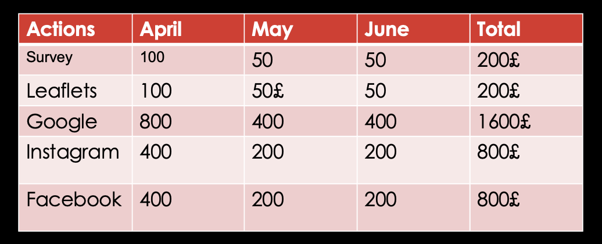

6. Management Team

General manager will be Ayyub Khan. His experience in management is wide, He has leadership skills and a great team player. He is also digitally literate with good abilities in using Facebook Instagram for our marketing purpose. A very honest person with a well valued integrity.
Chef – we will hire a very good skilled chef able to provide top quality. The Skills must include also creativity and passion for his work and we will encourage and nourish his appetite for being up to date with cuisine trends.
Bartender: Kiesha Williams- she is well trained , a good knowledge of drinks and an exquisite master of cocktails. She is also taking courses for sommelier to be able to have a better management of drinks and to be able to provide top quality advise to our customers.
Waiter- Radu Andreescu. – good experience and natural abilities to engage in a warm manner with customers, making them feel at home, good knowledge of the cuisine and drinks and able to make good recommendations.

7. Financial plan

To have a good management of our cash flow, we will pay the bills at the due date, The kitchen equipment and bar devices are in lease from a specialised company. The rent for the space is not a small amount of money but the space is located in an expensive area accordingly with the quality of the products and the market target. First month of the business the marketing expenses are bigger to boost business and to make us known. First month the only staff we hire it is the chef and as the number of customers increase, we will hire additional staff as reflected in financial plan. Calculations are made for a number of 30 customers/day in first month and they will double month by month to a capacity of 250 customers/day to maintain the comfort required for this level of services thinking of a minimum 20£ spent/customer as lowest amount.
Insufficient planning skills can lead to business failure (Snider and Davies, 2018)

7.1 Cash flow forecast
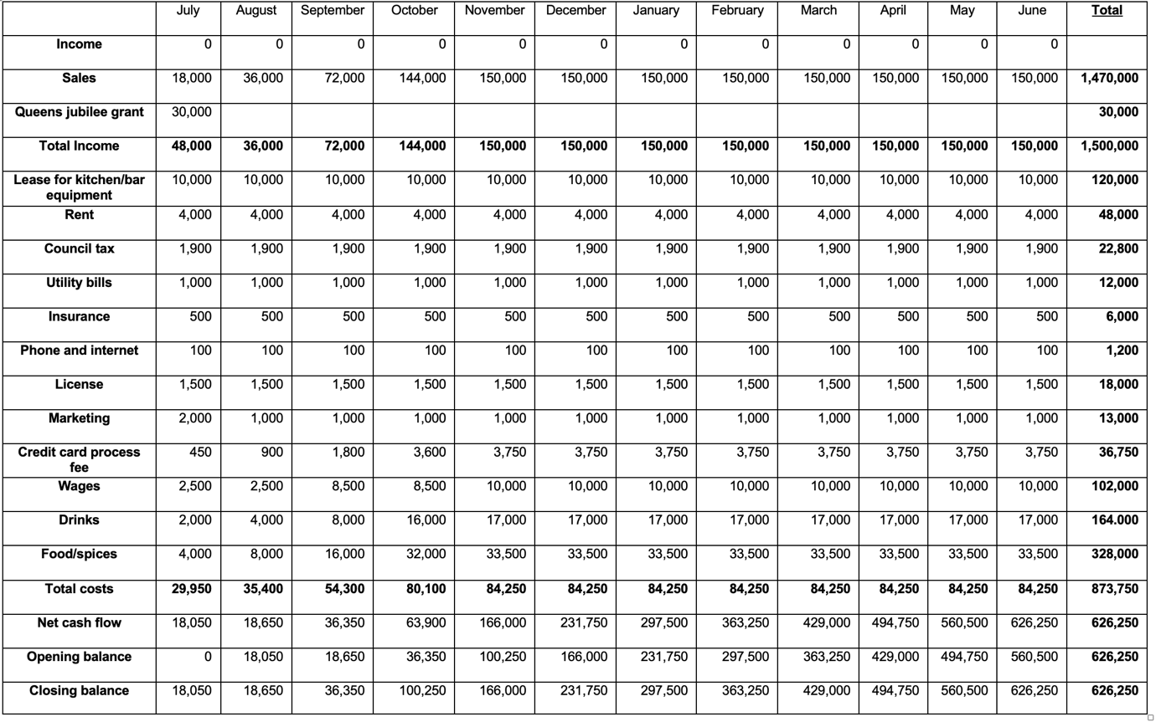
7.2 Forecast for Profit and loss

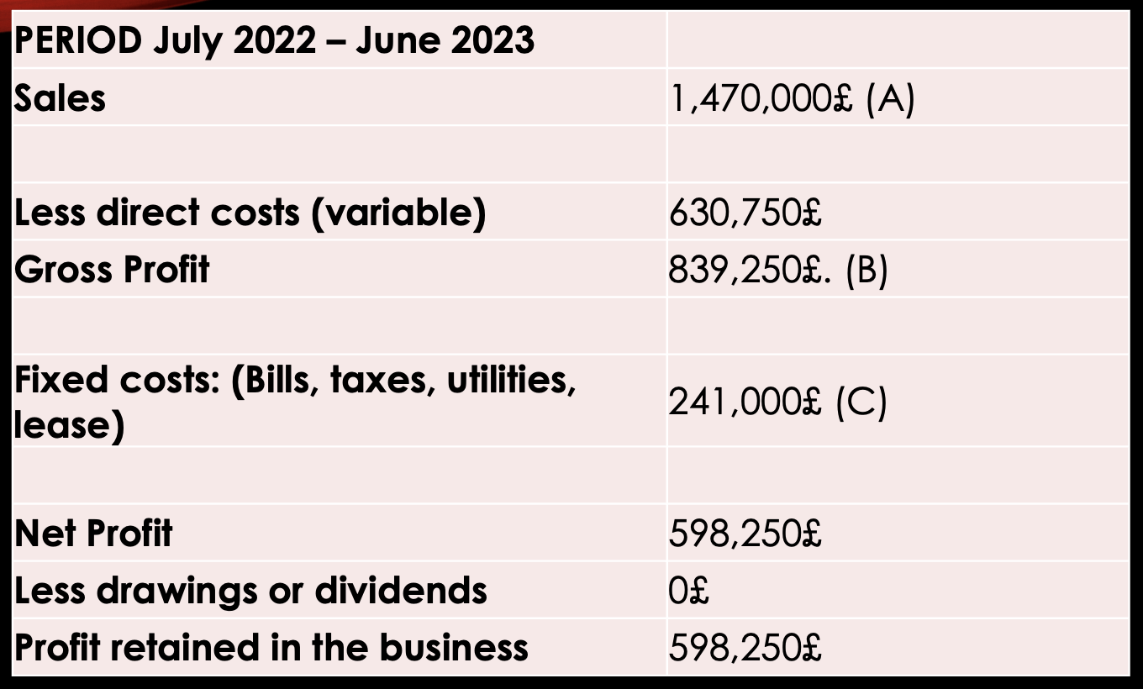
Break-even point = $\frac{C x A}{B}$ = 422,126.90£

Forecast of the profit and loss it is essential in business planning because it gives the final view over the business efficiency, and it is also a guidance in fallowing step by step through the year the accuracy of planning (Alam at, 2019)

Reference
- Bizfluent. 2021. 'Restaurant PESTLE Analysis', PESTLE Analysis, [online]. Available at: https://bizfluent.com/info-7911098-restaurant-pest-analysis.html (Accessed 26 June 2021).
- Bush, T., 2021. 'PESTLE Analysis of the Food Industry', PESTLE Analysis, [online]. Available at: https://pestleanalysis.com/pestle-analysis-of-the-food-industry/ (Accessed 26 June 2021).

Kosaka, K., 2022. Perceptual Mapping: The Benefit of Visualizing Your Competitive Landscape - Alexa Blog. [online] Alexa Blog. Available at: <https://blog.alexa.com/perceptual-mapping/).> [Accessed 24 March 2022].

Graham, C. and Kennedy, R., 2022. Quantifying the target market for advertisers. Journal of Consumer Behaviour, 21(1), pp.33-48.
Kosaka, K., 2022. Perceptual Mapping: The Benefit of Visualizing Your Competitive Landscape - Alexa Blog. [online] Alexa Blog. Available at: <https://blog.alexa.com/perceptual-mapping/).> [Accessed 24 March 2022].
Nabil, L., El Barkany, A. and El Khalfi, A., 2018. Sales and operations planning (S&OP) concepts and models under constraints: Literature review. In International Journal of Engineering Research in Africa (Vol. 34, pp. 171-188). Trans Tech Publications Ltd.
Snider, J.H. and Davies, K.J., 2018. Success strategies for small financial planning firms. International Journal of Applied Management and Technology, 17(1),

Alam, R., Hamzah, N., Putra, A.H.P.K., Ginting, W.A. and Teng, S.H., 2019, July. What Is More Important In Business? The Fallacy In Interpreting Innovation As a Strategy. In 1st International Conference on Life, Innovation, Change and Knowledge (ICLICK 2018) (pp. 286-291). Atlantis Press.
Graham, C. and Kennedy, R., 2022. Quantifying the target market for advertisers. Journal of Consumer Behaviour, 21(1), pp.33-48.
Kosaka, K., 2022. Perceptual Mapping: The Benefit of Visualizing Your Competitive Landscape - Alexa Blog. [online] Alexa Blog. Available at: <https://blog.alexa.com/perceptual-mapping/).> [Accessed 24 March 2022].
Nabil, L., El Barkany, A. and El Khalfi, A., 2018. Sales and operations planning (S&OP) concepts and models under constraints: Literature review. In International Journal of Engineering Research in Africa (Vol. 34, pp. 171-188). Trans Tech Publications Ltd.
Snider, J.H. and Davies, K.J., 2018. Success strategies for small financial planning firms. International Journal of Applied Management and Technology, 17(1),

