Streets of Rage
By: Teifion Gibson
Module name: Games design and history
Student Number: 2304294

INTENDED PLATFORMS | Pc, consoles such as Xbox one, PlayStation 4 and Nintendo switch

TARGET AGE / DEMOGRAPHIC OF PLAYERS
Target age for the game is roughly 13–17-year-olds, the reason for focusing on this age demographic is they tend to be interested in more action and combat focused games than younger children.

INTENDED PEGI / ESRB RATING
PEGI 12+, ESRB T for Teen as the game features violence prominently.

CONTRIBUTING TEAM MEMBER: | Teifion Gibson

SECTION 2: GAME OUTLINE

GAME STORY SUMMARY
In the past the city was safe until a criminal organisation took over the city, gaining control over the police force and the government. After this occurred the city has become full of violence and crime, 3 former police officers Adam Hunter, Axel Stone and Blaze Fielding, act as vigilantes to attempt to defeat the organisation and restore the city.
To do this they are even willing to risk their lives on the streets of rage.

GAME FLOW
A side-scrolling beat'em up follows 3 characters Adam Hunter, Axel Stone and Blaze Fielding, fighting their way through the city in order to defeat a criminal organisation.

CONTRIBUTING TEAM MEMBER: | Teifion Gibson

SECTION 3: MAIN CHARACTER(S)
& PLAYER CONTROLS

CHARACTER APPEARANCE
Adam hunter is a man with short dark hair, Adam also wears a tank top and jeans[1].
Refer to sketch for more details.
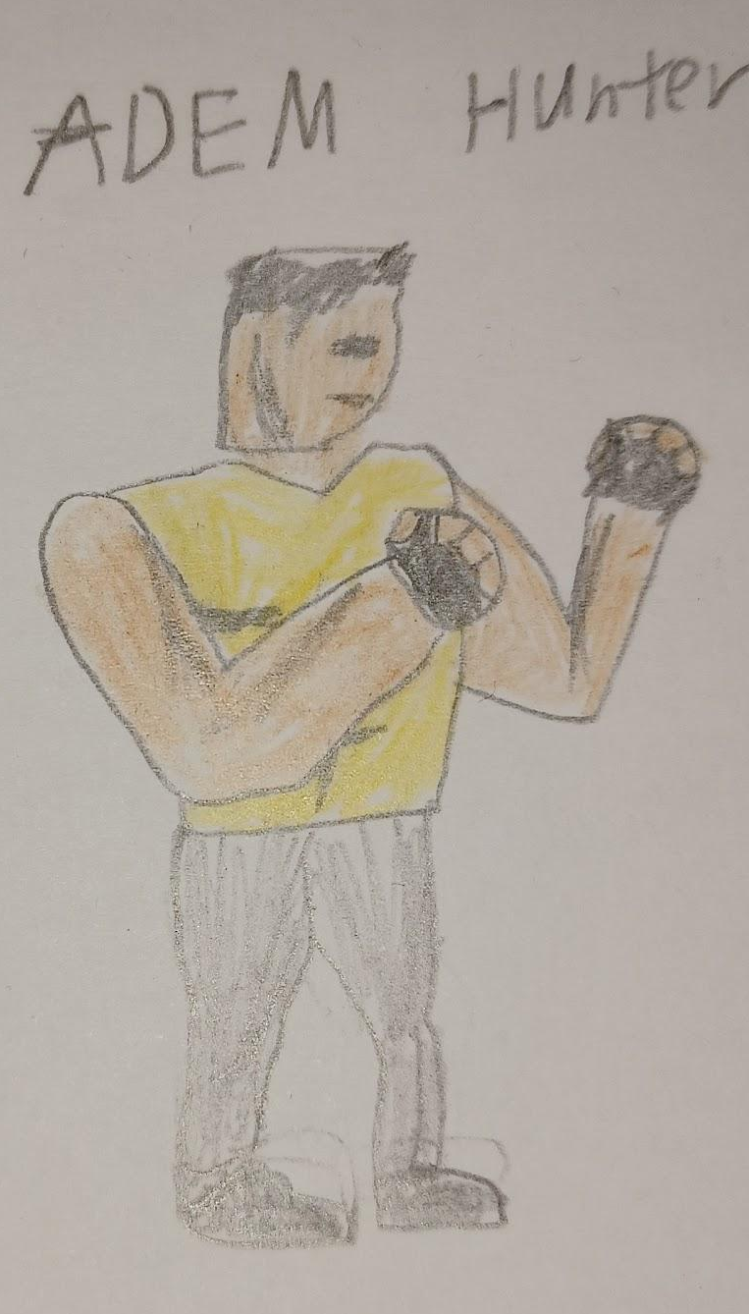

CHARACTER DETAILS
NAME: | Adam Hunter
GENDER: | male
AGE: | 23
FACTION: | police
KNOWN ASSOCIATES: | Axel stone and Blaze fielding
Hobby | Bonsai
Ability | Boxing

CHARACTER’S BACKSTORY
former police officer who has decided to take action against the crime in the city alongside 2 other former police officers, Axel stone and Blaze fielding

CHARACTER APPEARANCE
Axel is a man with blonde hair and blue eyes, Axel wears a headband around his head and a tank top with a pair of jeans [2],
refer to sketch for more details.
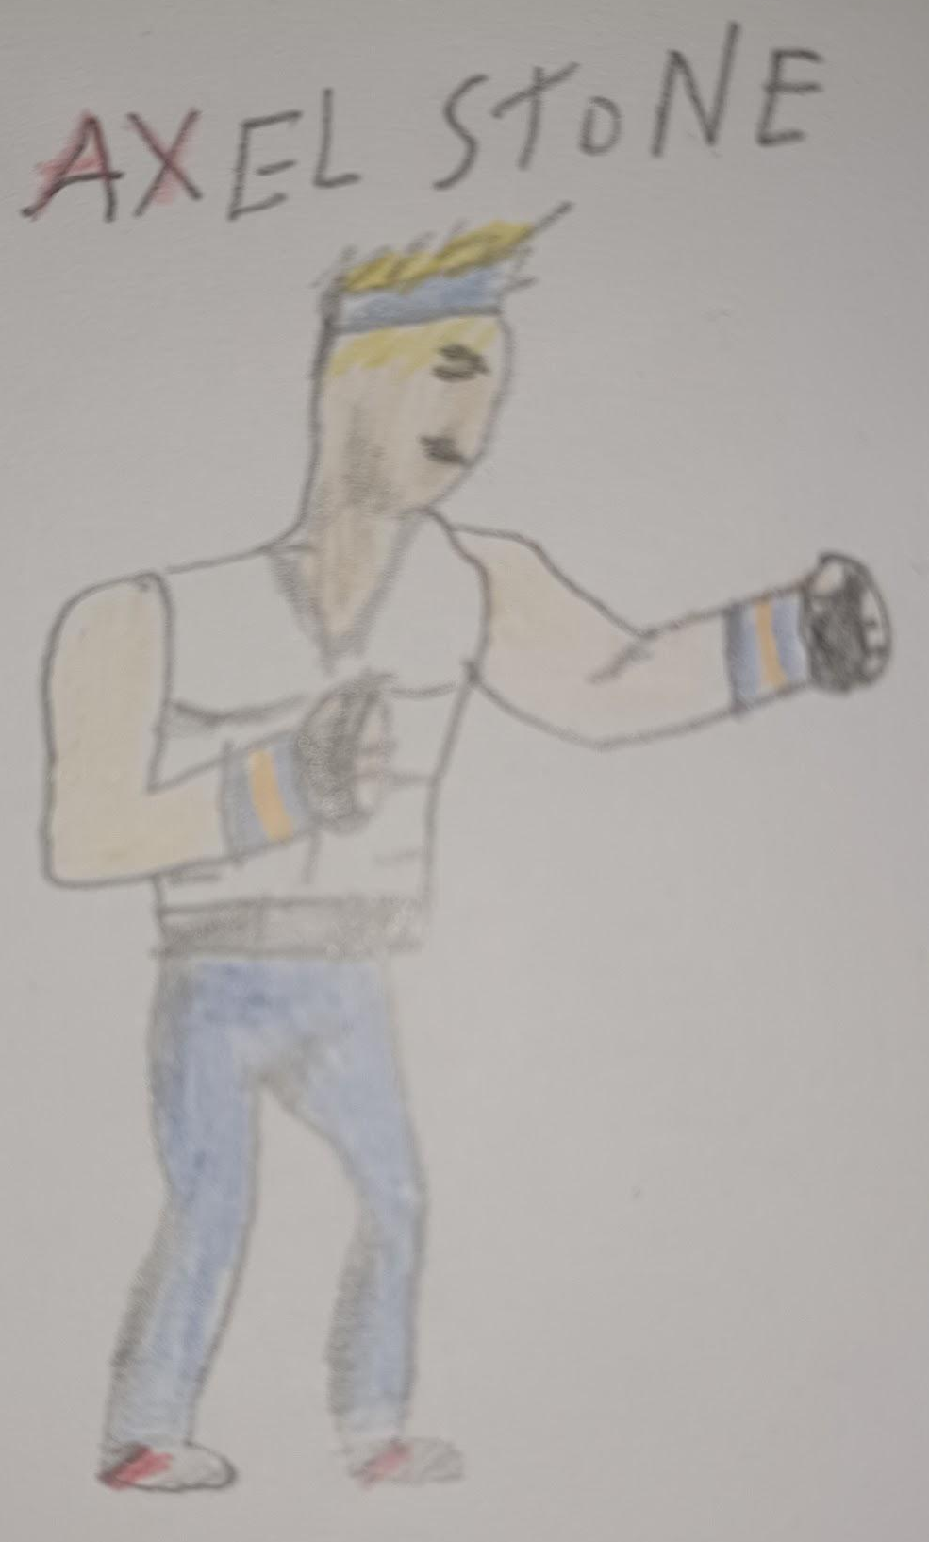

CHARACTER DETAILS
NAME: | Axel Stone
GENDER: | male
AGE: | 22
FACTION: | police / vigilante
KNOWN ASSOCIATES: | Adam Hunter and blaze fielding
Hobby: | Video games
Ability: | Martial Arts

CHARACTER’S BACKSTORY
Same backstory as Adam hunter

CHARACTER APPEARANCE
Blaze is a woman, with long dark brown hair. Blaze wears a headband and a jacket and shorts. Also is wearing a pair of gloves, and red boots [3].
Refer to sketch for more details.
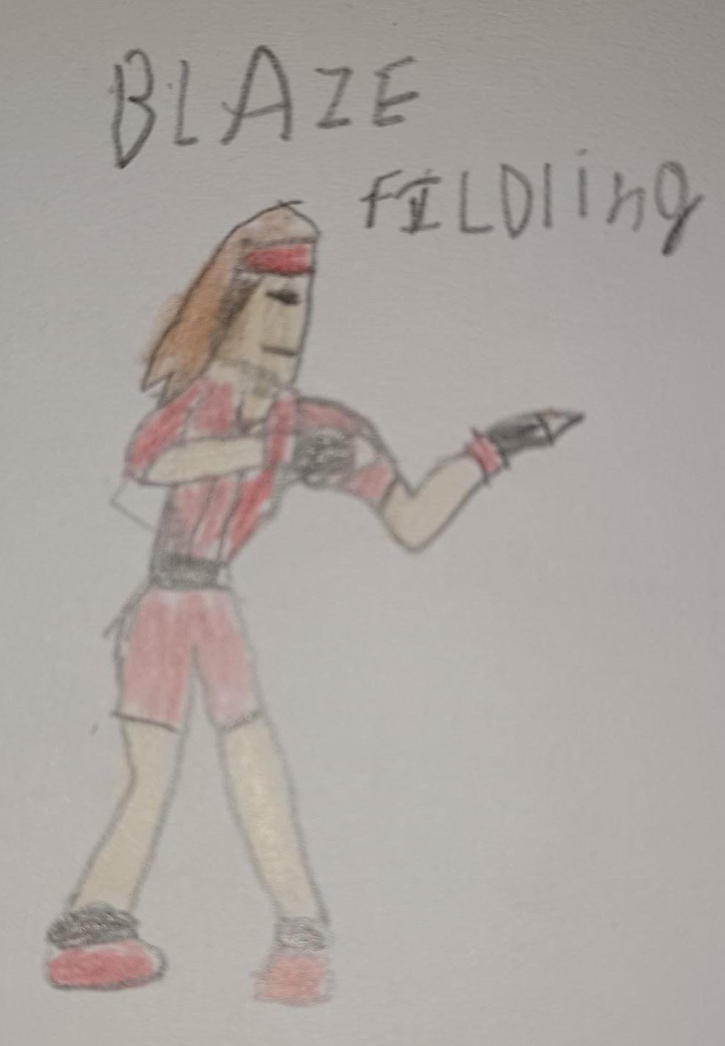

CHARACTER DETAILS
NAME: | Blaze Fielding
GENDER: | female
AGE: | 21
FACTION: | police / vigilante
KNOWN ASSOCIATES: | Adam Hunter and Axel stone
Hobby: | Lambada
Ability: | Judo

CHARACTER’S BACKSTORY
Same backstory as Adam hunter

CHARACTER CONTROLS / PLAYER CONTROLS
The game's controls are using directional buttons on the keyboard for movements, s for punches and d for jumps, the special attack is on the a key, the s key can be held allowing the player to grab onto an enemy. Furthermore, inputs can be combined to create more complex attacks.

If s is pressed midair the player will do a jumping kick through the air, the player can also attack behind them by pressing both jump and attack, knocking the enemy back.

imaged below are inputs for consoles with their inputs mapped to specific controls
Pc
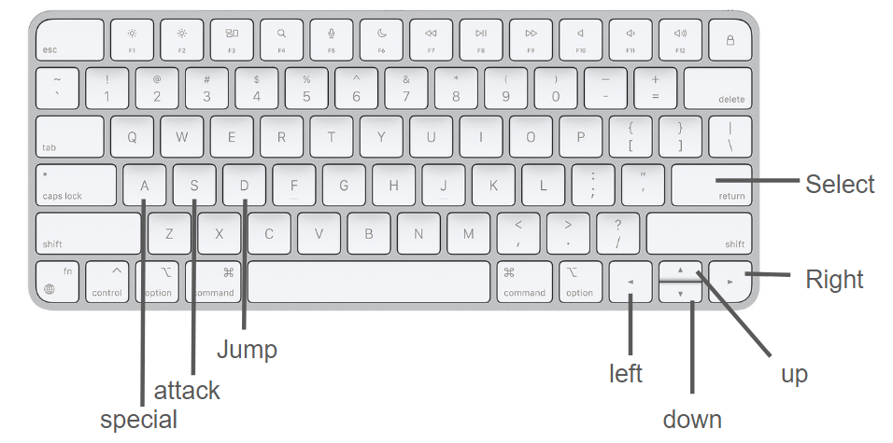
[4] for keyboard

Xbox one
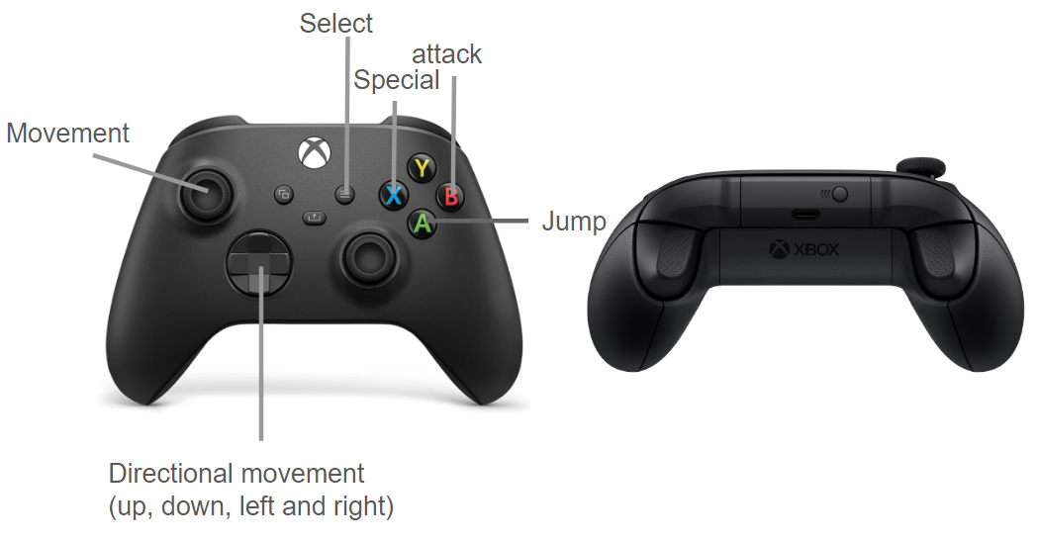
[5], [6] for controllers
PlayStation 4
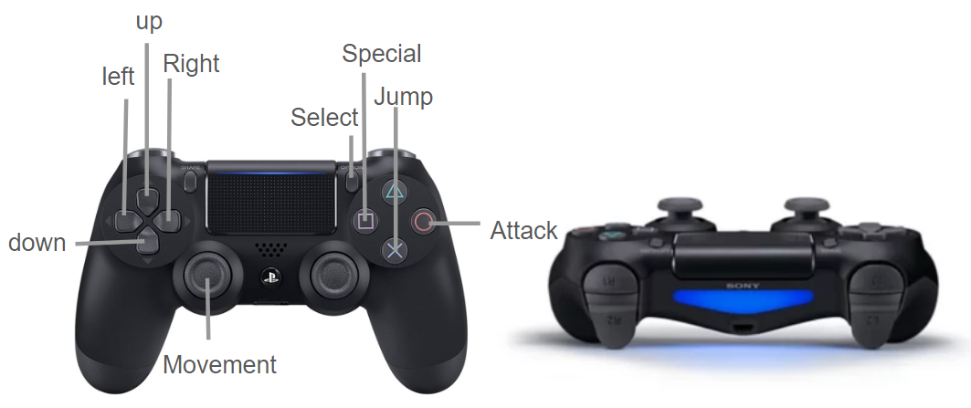
[7], [8] for controllers

Nintendo Switch
the Nintendo switch controller allows for different controlled for whether the player is using one or two controllers, therefore are two different control layouts for the controllers.
Both JoyCon controllers
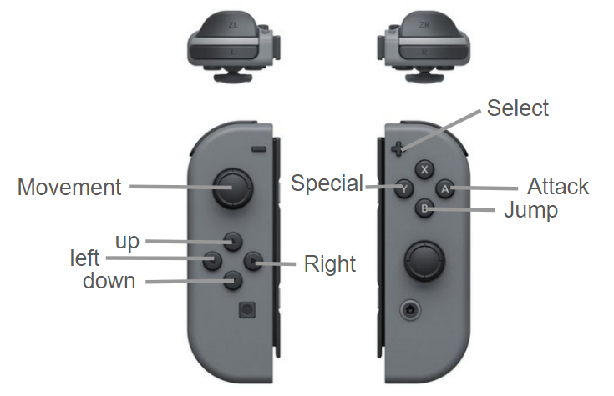
[9] for controllers
One JoyCon controller.
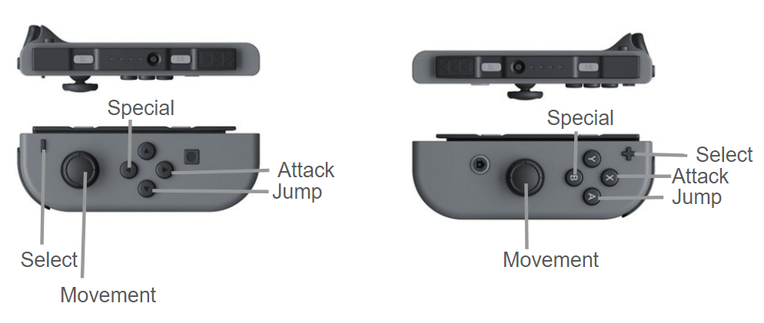
[9] for controllers

CONTRIBUTING TEAM MEMBER: | Teifion Gibson

SECTION 4: GAMEPLAY

SEQUENCE OF PLAY
The game will feature 8 stages which have waves of enemies, the player needs to defeat all enemies in the stage to progress, these enemies will require more attacks by the player later on. The game will feature at the end of most levels a boss fight, each boss is different and will have different attacks.

These levels will be referred to in-game as rounds, the game upon bootup creates the setting for the game world that will give the player the story so far. Each stage is in a specific setting showing the player journey through the city.

Diagram of planned gameplay loop.
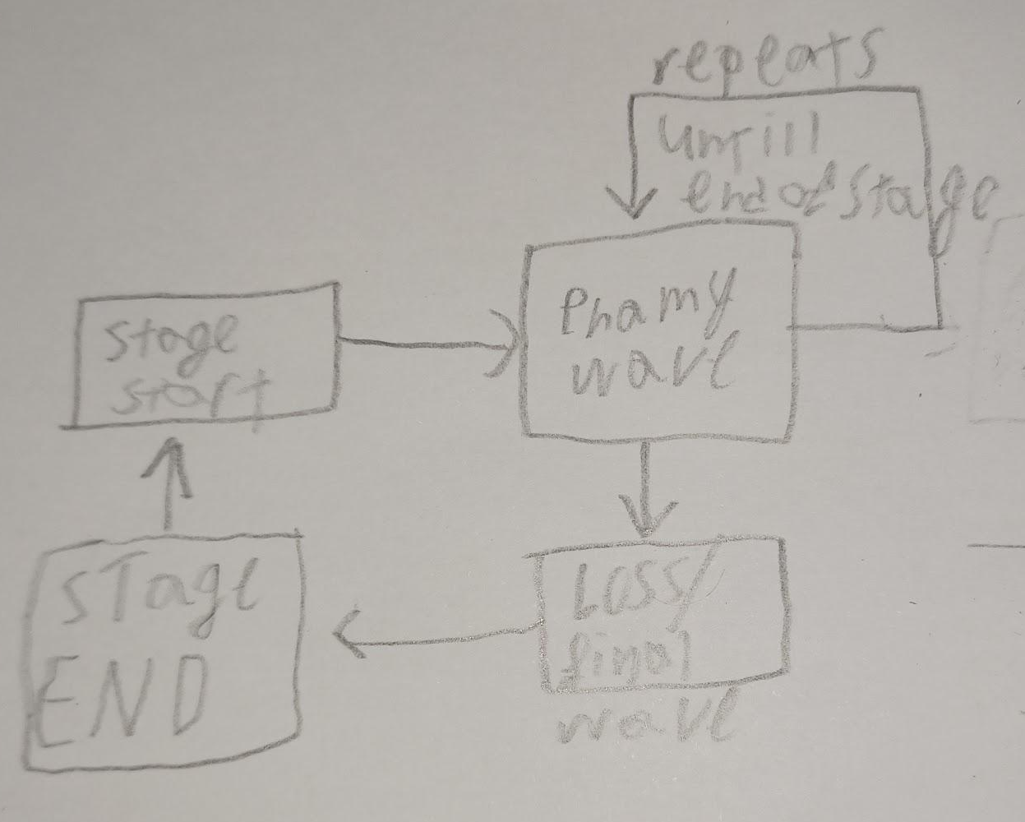

UNIQUE SELLING POINTS
arcade style combat. simple controls with a high skill ceiling allowing players to learn and master the controls, to obtain high scores. Simple to understand gameplay loop, addictive gameplay, replayability, support for co-op in main campaign.

PLATFORM-SPECIFIC FEATURES
Gamepad support on pc, custom inputs on pc.

CONTRIBUTING TEAM MEMBER: | Teifion Gibson

SECTION 5: GAME WORLD

GAME WORLD
The game world occurs in a variety of different areas of the city, there will be 8 areas the player sees in this city. Some of these areas are described below.

LOCATION DETAILS
NAME: | City Street
WHAT DOES IT LOOK LIKE? | city street with lots of windows and neon lights.  Refer to concept sketch.  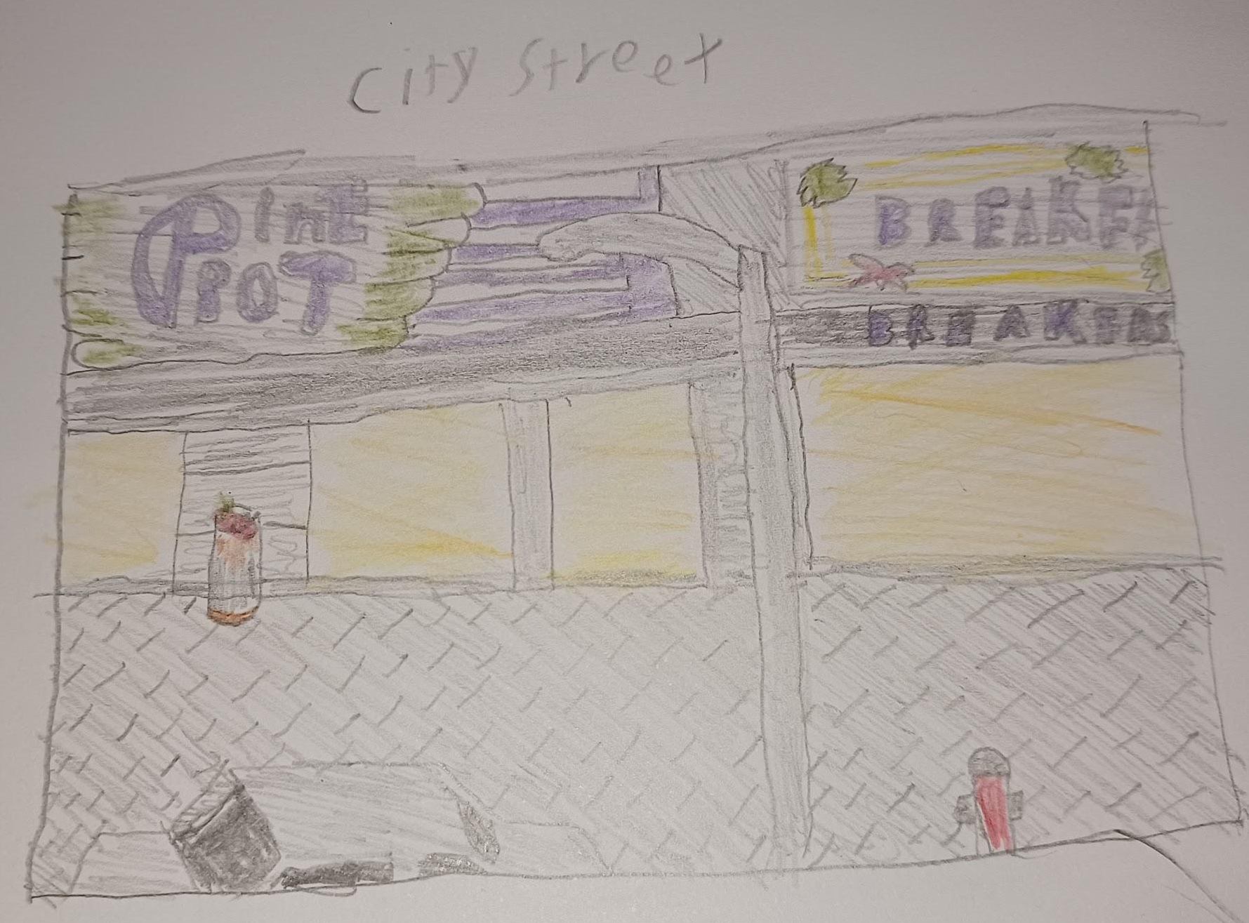
WHAT MOOD IS BEING INVOKED IN THIS LOCATION? | A casual atmosphere, designed to make the player feel that they are battling their way through a high street in the night, the overall tone here is relaxed.
WHAT KIND OF MUSIC WILL BE USED FOR THIS LOCATION? | Upbeat track with a fast-paced tempo, with a lot of electro type sounds, this is to reflect the bright lighting of the environment.
HOW ARE THE LOCATIONS CONNECTED IN THE GAME WORLD? | The game will begin in this stage. Upon completion of the stage the player progresses to the inner-city Stage.

NAME: | Inner-city
WHAT DOES IT LOOK LIKE? | Run-down back alley, with graffiti and vandalism prevalent. Cityscape can be seen behind chain fence.  Refer to concept art.  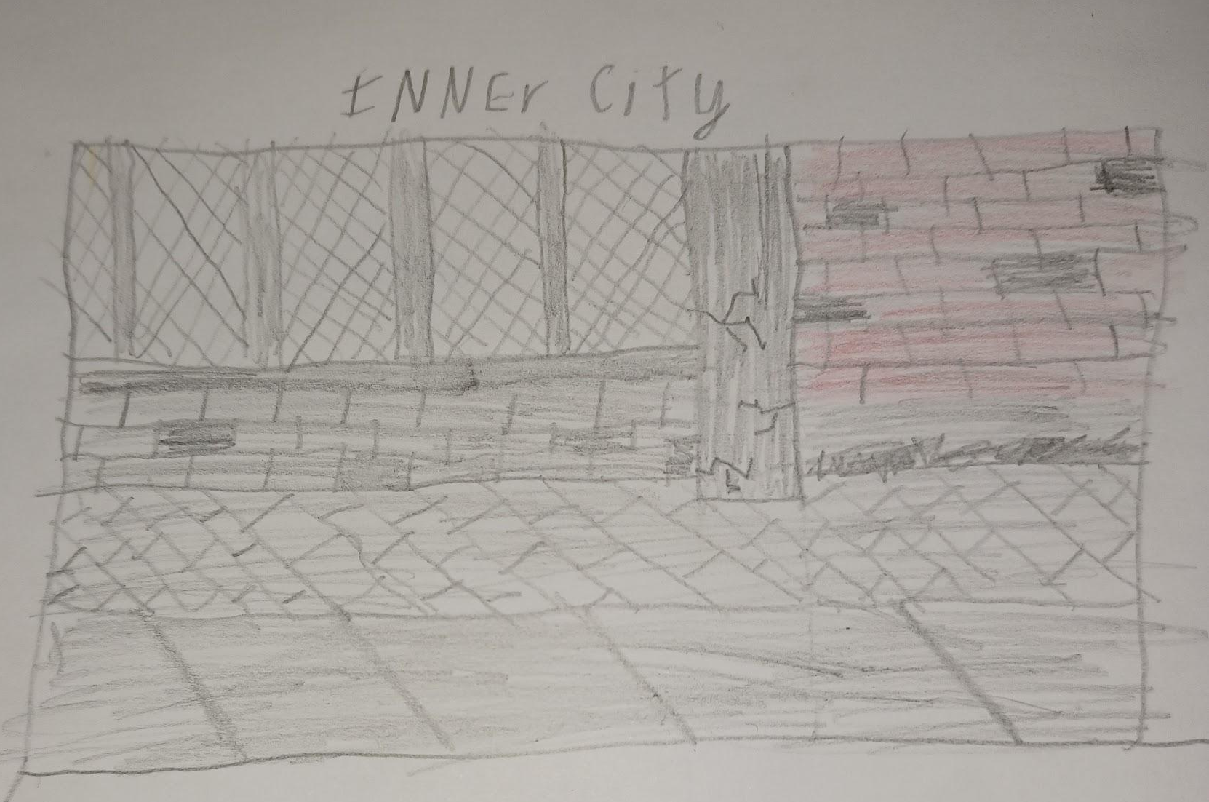
WHAT MOOD IS BEING INVOKED IN THIS LOCATION? | A more intense but still casual atmosphere, as the player is brawling their way through the back alleys the player should feel more unsafe than the first level.
WHAT KIND OF MUSIC WILL BE USED FOR THIS LOCATION? | Upbeat track with a rhythm, Police siren can be heard in the background of this track emphasising how lots of crime is occurring in the area
HOW ARE THE LOCATIONS CONNECTED IN THE GAME WORLD? | Player progresses here after the City Street stage. Upon completion of the stage the player progresses to Stage 3.

NAME: | bridge
WHAT DOES IT LOOK LIKE? | Waterfront and Cityscape can be seen in the background, bridge is unfinished and under construction.  Refer to concept art.  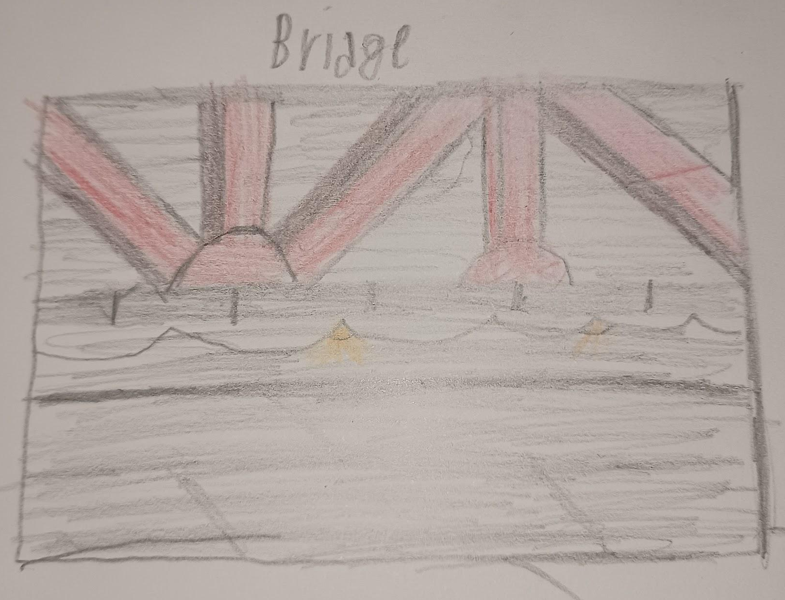
WHAT MOOD IS BEING INVOKED IN THIS LOCATION? | Once again a casual atmosphere, setting should make the feel as if they are trespassing onto a construction site.
WHAT KIND OF MUSIC WILL BE USED FOR THIS LOCATION? | Upbeat casual music like the first stage with a prominent drum loop.
HOW ARE THE LOCATIONS CONNECTED IN THE GAME WORLD? | Player progresses here after the Beach Front stage. Upon completion of the stage the player progresses to Stage 5

NAME: | Factory
WHAT DOES IT LOOK LIKE? | Mostly grey with safety tapes giving the environment colour.  Refer to concept art.  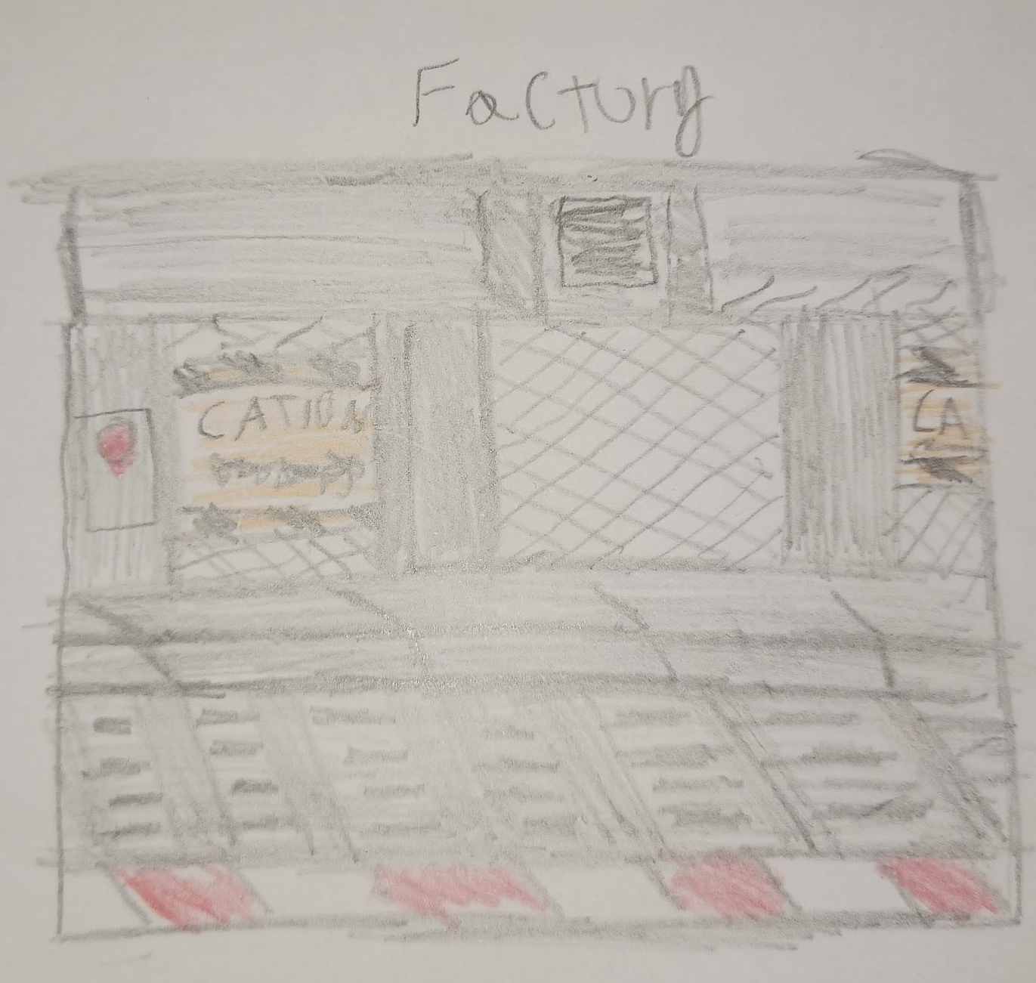
WHAT MOOD IS BEING INVOKED IN THIS LOCATION? | Unsafe, as the player is navigating a factory, and tense.
WHAT KIND OF MUSIC WILL BE USED FOR THIS LOCATION? | Casual, Music feels mechanical like a machine featuring only a basic beat.
HOW ARE THE LOCATIONS CONNECTED IN THE GAME WORLD? | Player progresses here after stage 5. Upon completion of the stage the player progresses to Stage 7

GAME FLOW
The game will follow a set flow in gameplay, where from starting the game, the player will play through each stage in order before reaching the ending of the game as shown in the flowchart below.
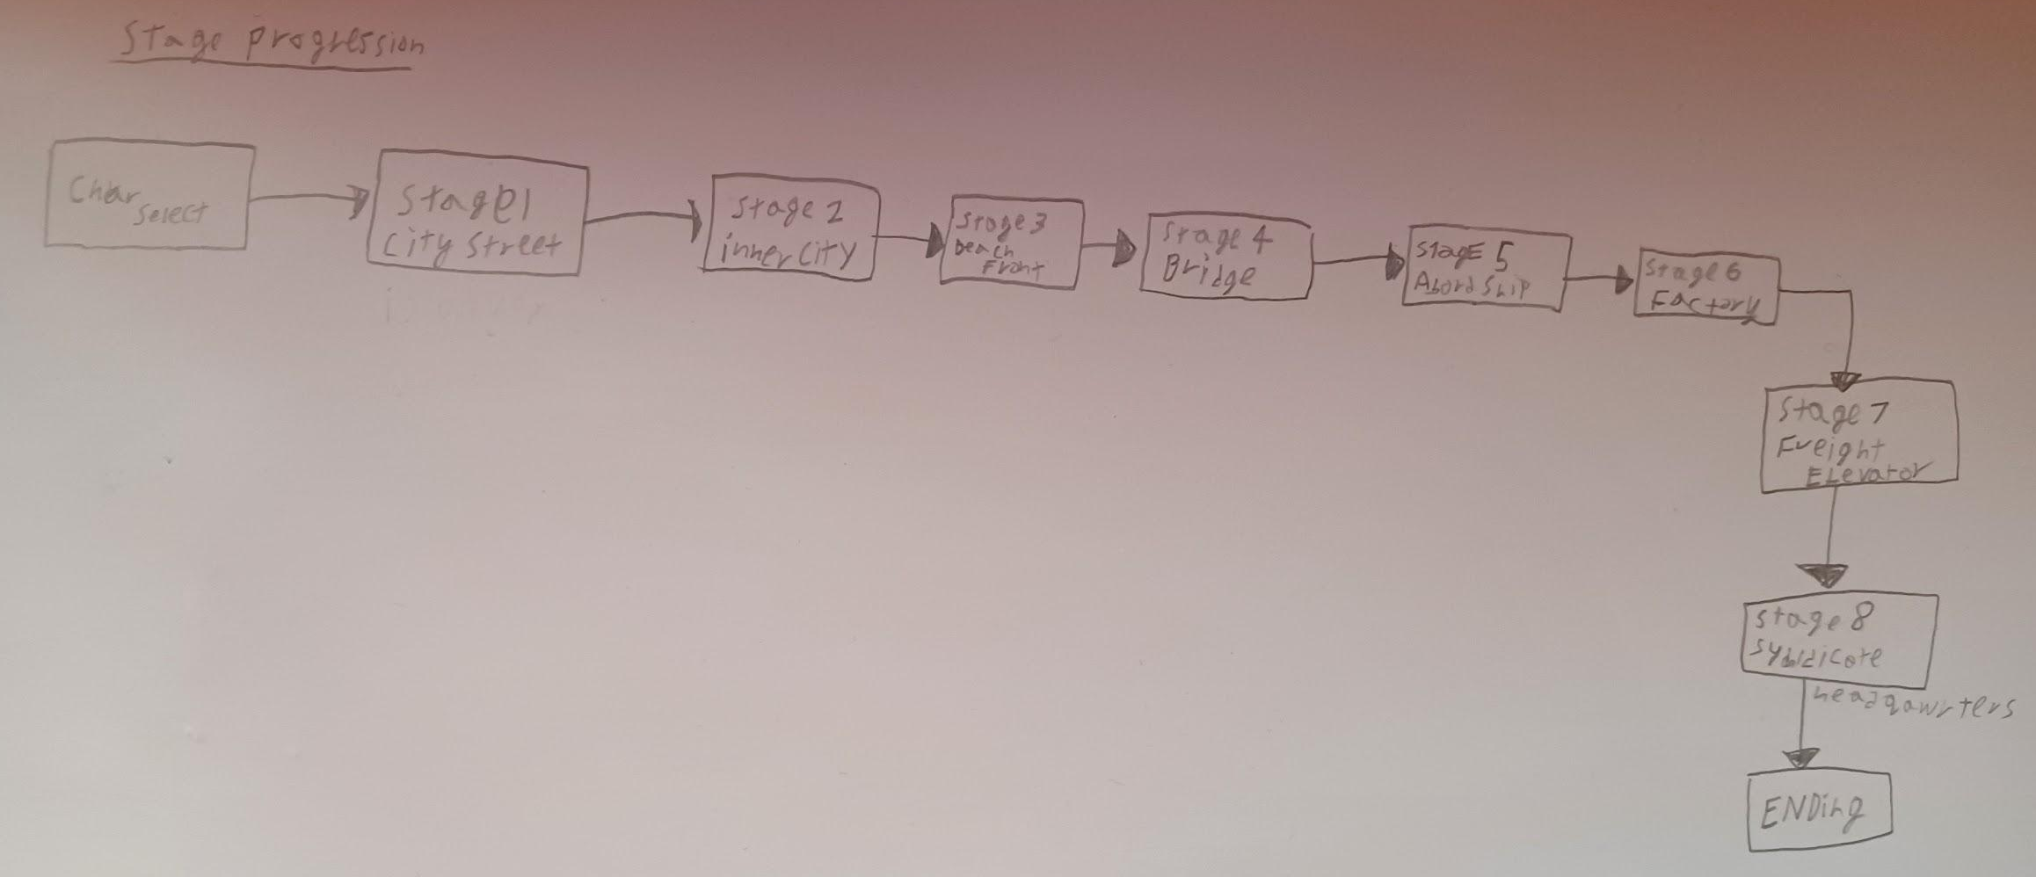

CONTRIBUTING TEAM MEMBER: | Teifion Gibson

SECTION 6: GAME EXPERIENCE

GAME EXPERIENCE
The overall theme of the game is Arcady, featuring dark colours for the environments and bright colours for the characters on screen, additionally it will have an arcade style soundtrack. The game makes the player feel that they are fighting an uphill battle. Brawling their way through large groups of enemies.

HOW IS THIS FEELING GOING TO BE PRESENTED TO THE PLAYER?
An Arcady feel is presented to the player using retro sound effects for attacks such as punches, additionally the soundtrack is designed to have an arcade feel for each of the stages using a chiptune soundtrack to give the stages an arcade feel. The environments, will contrast this with memorable designs for each stage.

ARE THERE ANY SPECIAL MODES OR INTERFACES FOR GAMEPLAY?
the game will feature a UI on the top of the screen featuring information, during boss fights, the bosses hp will be a yellow bar under hp bar.
See sketch for details and concept of UI.
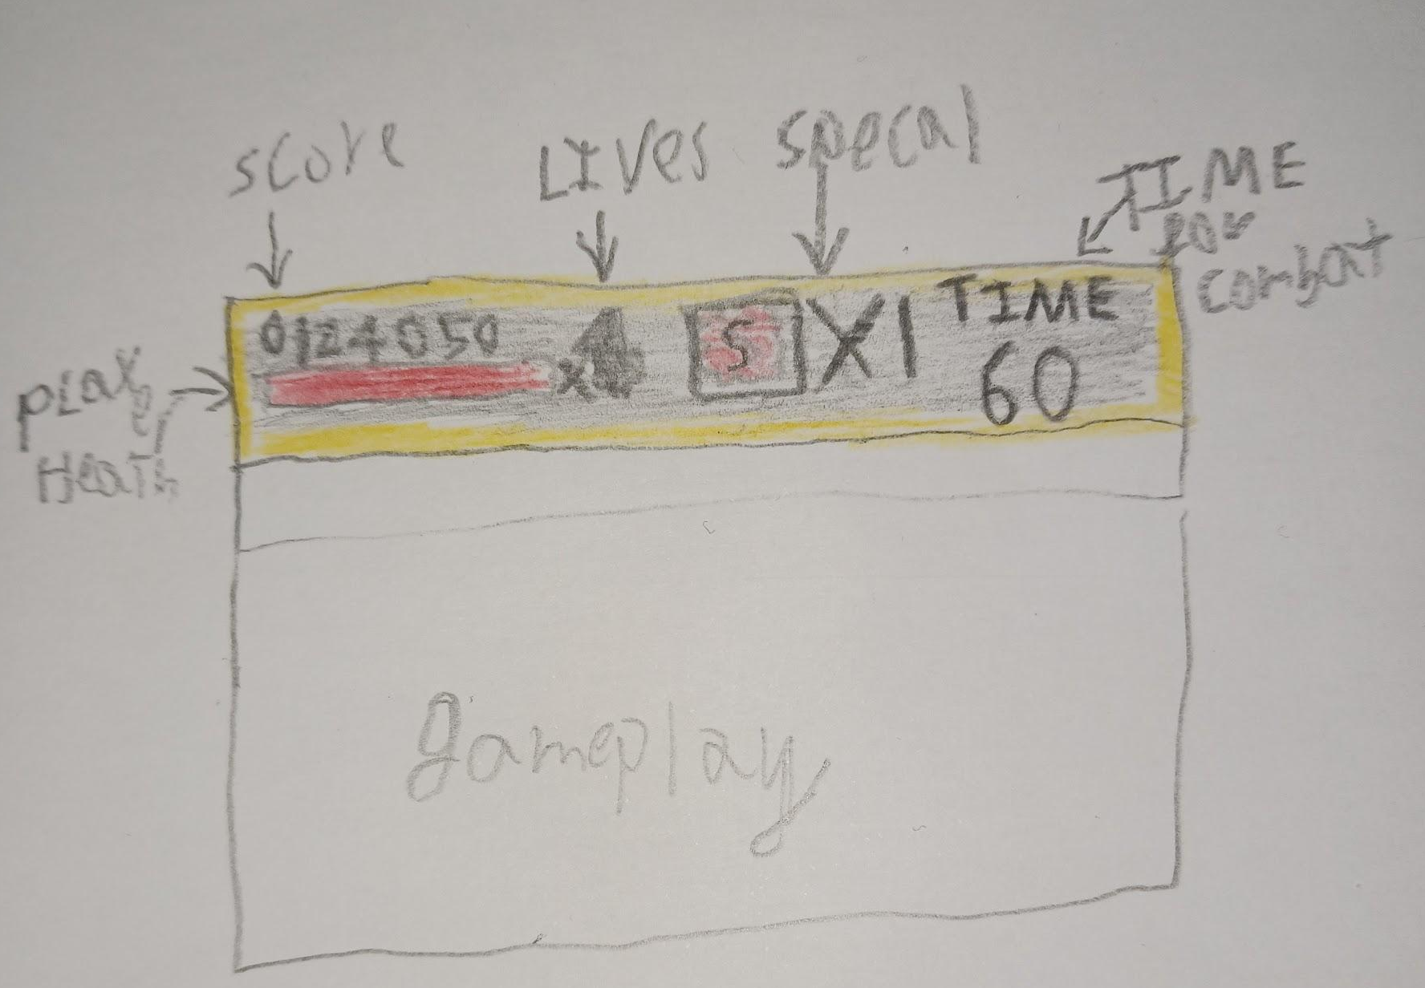

WHAT DOES THE PLAYER FIRST SEE WHEN THEY START THE GAME?
the initial story, presented to them in a set of scrolling text followed by each character appearing on the screen alongside a bio describing a bit of information about the characters, finally the main menu ends with the title screen showing the 3 playable characters and the games logo.
Refer to storyboard.
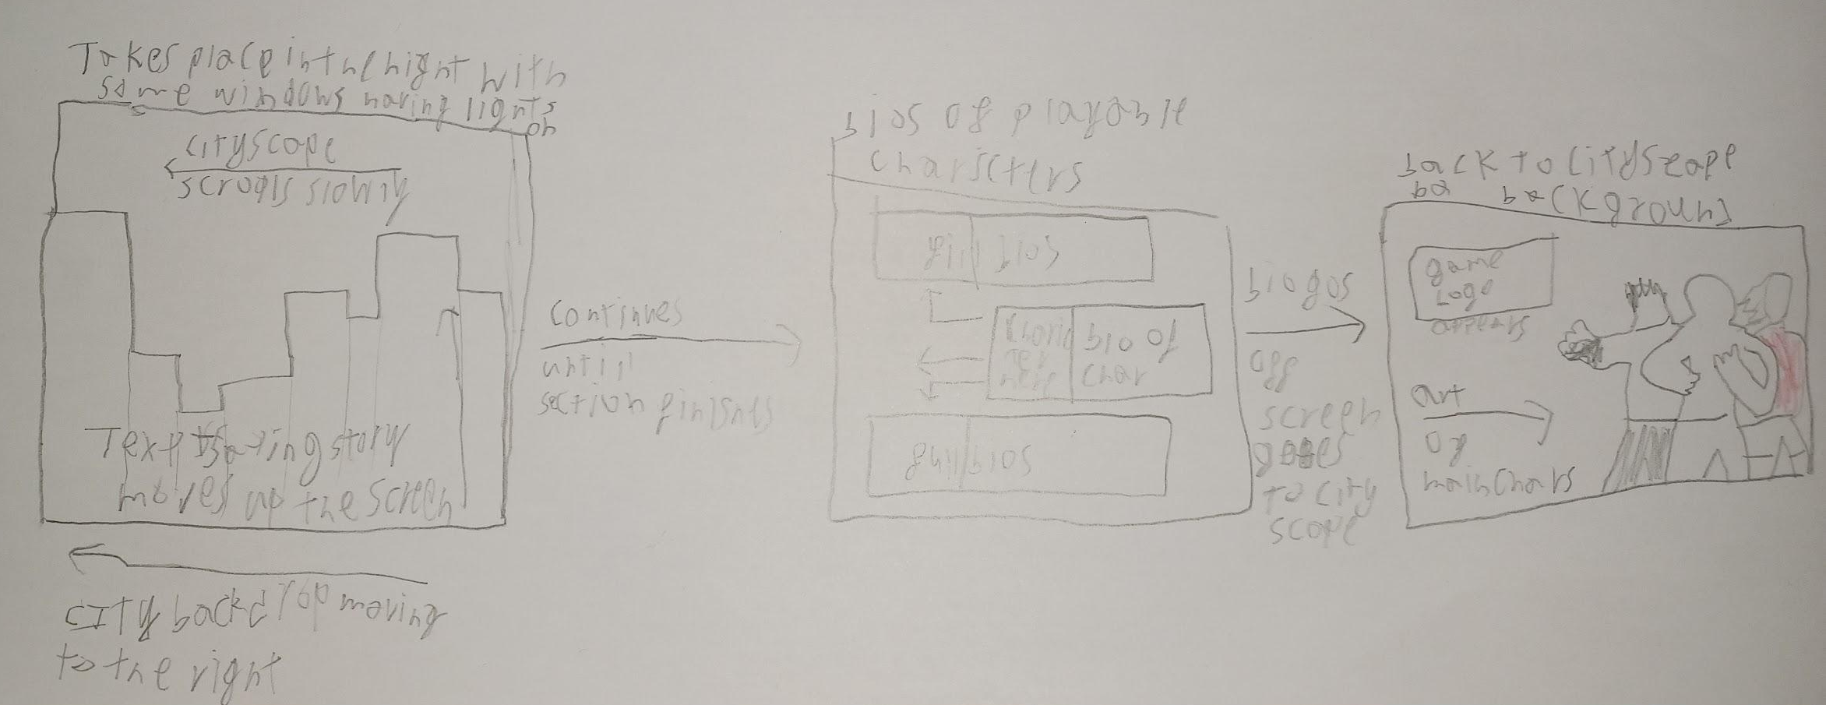

WHAT EMOTIONS ARE MEANT TO BE INVOKED BY THE GAME?
Satisfaction, the player should feel challenged by the gameplay. the player should feel immersed and the player should feel challenged by the enemies, as the main characters have to fight their way through the stages whilst still being successful.

HOW ARE MUSIC AND SOUND GOING TO BE USED?
I want the music tracks of the game to help set the mood of the environment the player is in while keeping an Arcady feel, furthermore the music of the game should match the environment. For example, on the main menu a calmer track is played, whilst when the player is in a stage a more suitable track for the environment is played in the background of the stage.

Sound should make attacks between the characters feel that they have impact, such as the whip making a whip noise, and the punch having a clear loud impact sound, coming from the enemy being hurt.

HOW DOES THE PLAYER NAVIGATE THE SHELL MENUS/ SCREENS OF THE GAME?
Title screen to gameplay, flowchart below.
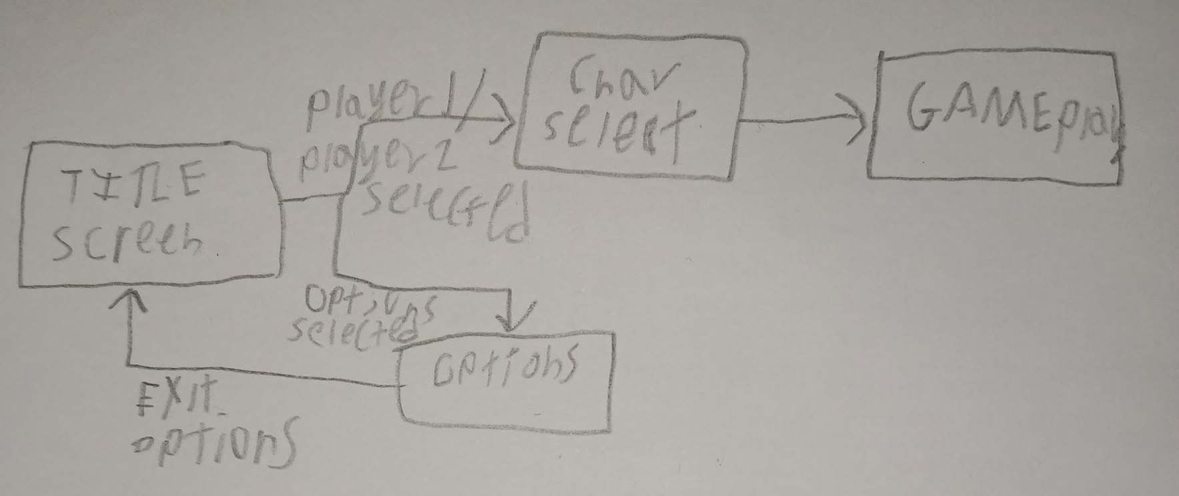
Game over and score saving flowchart, occurs when player is out of lives.
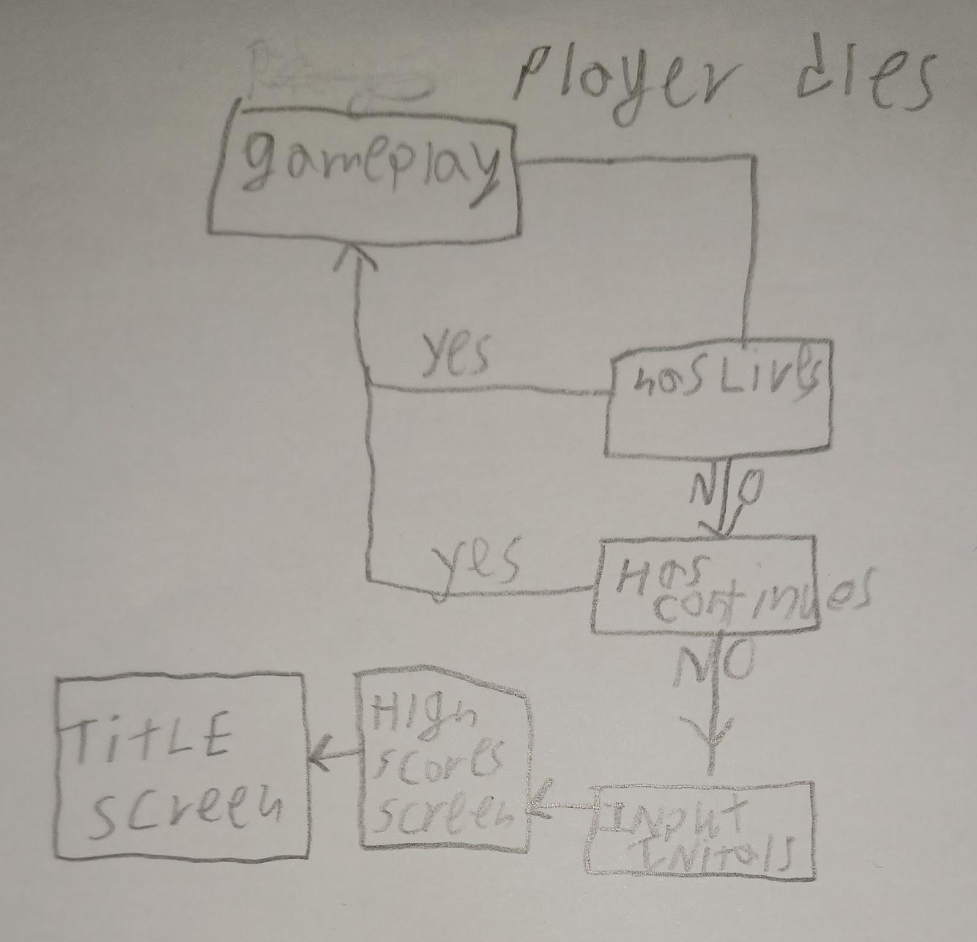

CONTRIBUTING TEAM MEMBER: | Teifion Gibson

SECTION 7: GAMEPLAY MECHANICS

GAMEPLAY MECHANICS
MECHANIC: destructible objects.

HAZARD: Bridge holes, Factory crusher.

POWER-UP: apple / beef, 1up, special, money bag, Knife, baseball bat / lead pipe.

MECHANIC DETAILS
NAME: | destructible objects
WHAT DOES IT LOOK LIKE? | dependant on stage, refer to sketches.  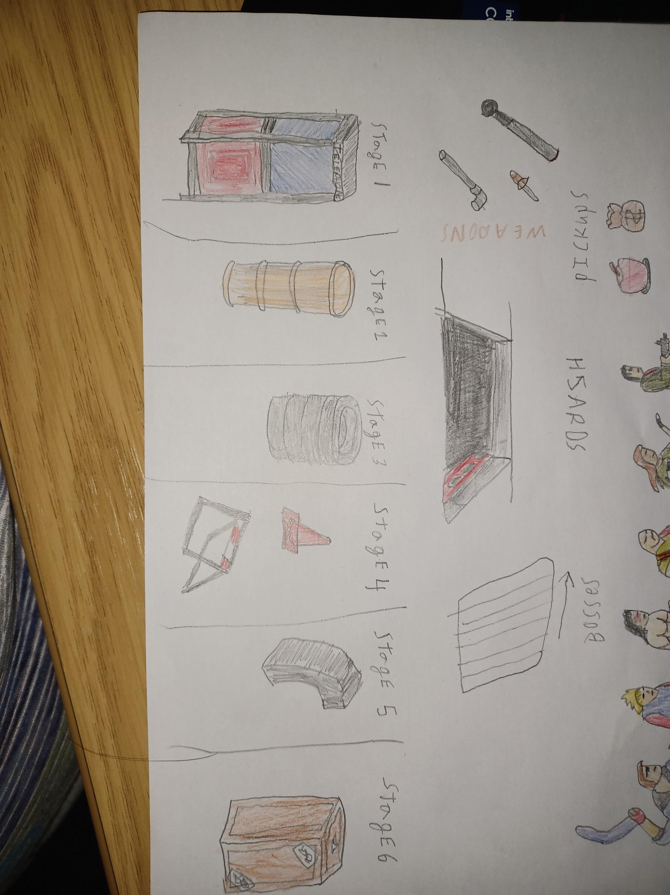
EFFECT ON PLAYER: | Can be destroyed, has a chance to Spawn a pickup.
WHEN WILL IT FEATURE IN THE GAME? | Variants appear on most stages.

HAZARD DETAILS
NAME: | Bridge holes
WHAT DOES IT LOOK LIKE? | Refer to sketch.
EFFECT ON PLAYER: | causes the player to lose life when they fall into the hole, the player will respawn after.
WHEN WILL IT FEATURE IN THE GAME? | stage 4.

NAME: | Factory crusher
WHAT DOES IT LOOK LIKE? | Refer to Rough sketch.  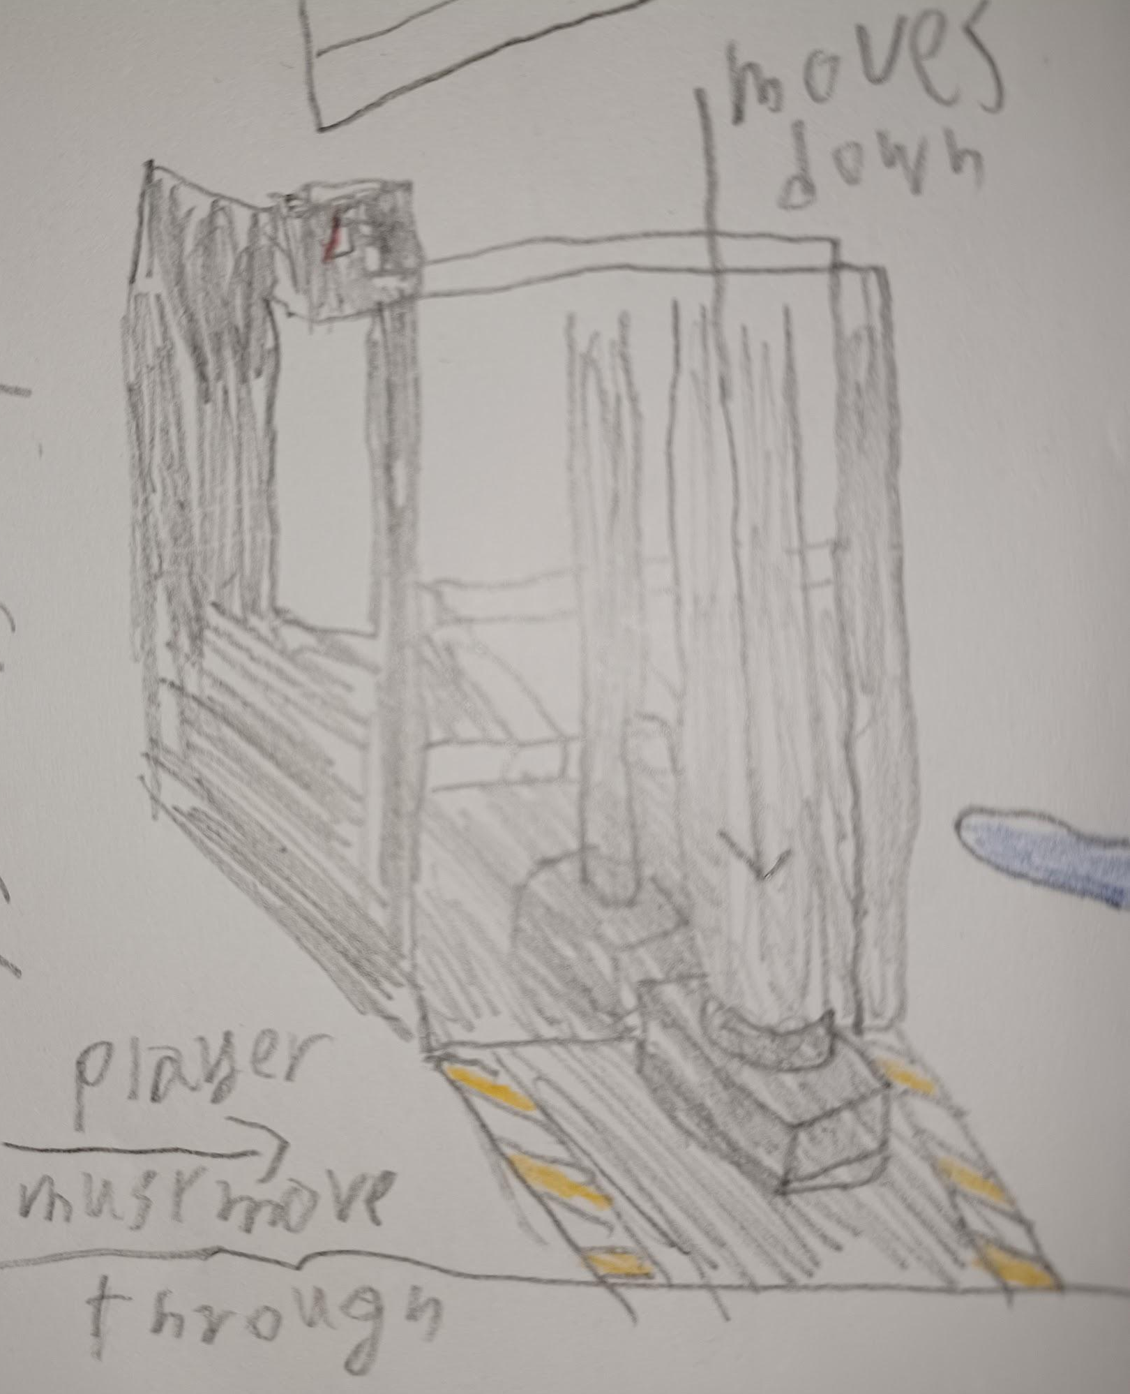
EFFECT ON PLAYER: | causes the player to lose life when walking under the crusher, only falling when the player is passing through. player will be knocked back by the crusher.
WHEN WILL IT FEATURE IN THE GAME? | on stage 6.

POWER-UP DETAILS
NAME: | Apple / beef
WHAT DOES IT LOOK LIKE? | Refer to sketch.  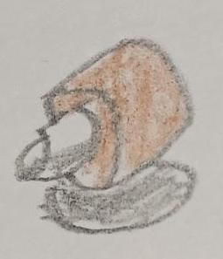
EFFECT ON PLAYER: | returns a small amount/ large amount of health to the player.
WHEN WILL IT FEATURE IN THE GAME? | Throughout the game, chance of dropping when a destructible object is destroyed.

NAME: | 1up
WHAT DOES IT LOOK LIKE? | Refer to sketch.  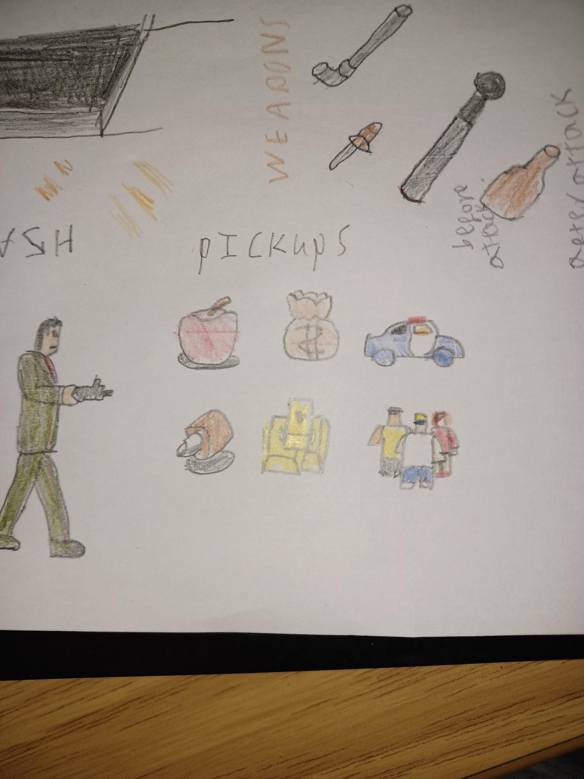
EFFECT ON PLAYER: | grants the player an extra life.
WHEN WILL IT FEATURE IN THE GAME? | Throughout the game, chance of dropping when a destructible object is destroyed.

NAME: | special
WHAT DOES IT LOOK LIKE? | Refer to sketch.
EFFECT ON PLAYER: | grants the player an additional special attack.
WHEN WILL IT FEATURE IN THE GAME? | Throughout the game, chance of dropping when a destructible object is destroyed.

NAME: | money bag
WHAT DOES IT LOOK LIKE? | Refer to sketch.
EFFECT ON PLAYER: | grants the player 1000 points of score.
WHEN WILL IT FEATURE IN THE GAME? | Throughout the game, chance of dropping when a destructible object is destroyed.

NAME: | knife
WHAT DOES IT LOOK LIKE? | Refer to sketch.
EFFECT ON PLAYER: | makes player attacks knock enemies down and can be thrown.
WHEN WILL IT FEATURE IN THE GAME? | from the first stage onwards, some enemies may be carrying the weapon, and is dropped when attacked by the player.

NAME: | baseball bat / lead pipe
WHAT DOES IT LOOK LIKE? | Refer to sketch.
EFFECT ON PLAYER: | player is able to knock enemies back in a wider range.
WHEN WILL IT FEATURE IN THE GAME? | from the first stage onwards, some enemies may be carrying the weapon.

COLLECTIBLE ITEMS
Score.

COLLECTIBLE DETAILS
NAME: | score
WHAT DOES IT LOOK LIKE? | points counter that increases During gameplay.
BENEFIT FOR PLAYER: | None.
WHEN WILL IT FEATURE IN THE GAME? | throughout the gameplay.
CAN IT BE USED AS CURRENCY? | No.
WILL IT EARN PLAYERS AN ACHIEVEMENT? | No.

GAME ECONOMY
The game will have no economy system.

CONTRIBUTING TEAM MEMBER: | Teifion Gibson

SECTION 8: ENEMIES

LIST OF ENEMIES
The enemies within the game are,
Basic,
Grappler,
Whip woman,
Juggler.

ENEMY DETAILS
NAME: | Basic
WHAT DOES IT LOOK LIKE? | In a blue generic thug outfit.  Refer to the sketch for further details.  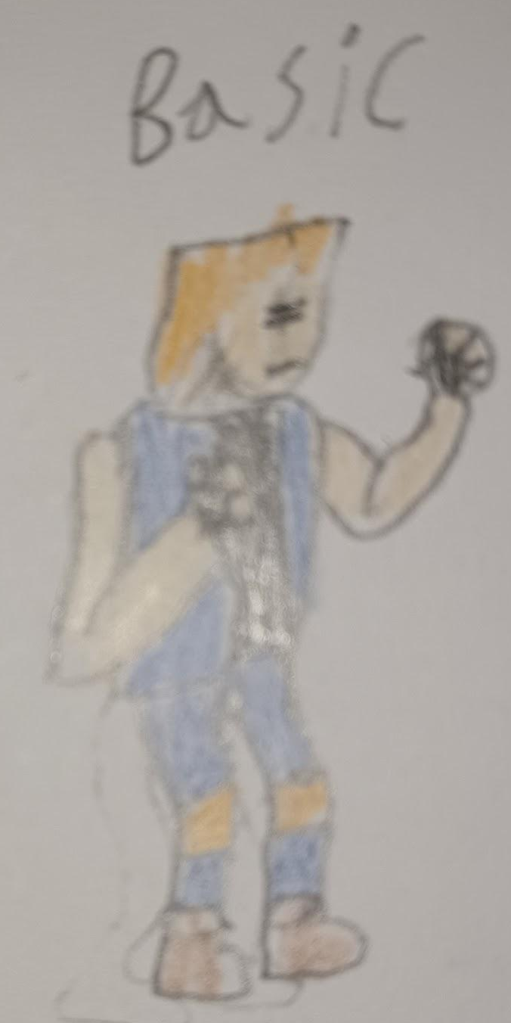
ATTACKS: | Basic attacks,  Basic punch,  3 punches,  Can also wild weapons.
WHEN WILL IT FEATURE IN THE GAME? | all stages of the game.
HOW DOES THE PLAYER DEFEAT IT? | All attacks, enemy is the weakest in the game.
WHAT DOES THE PLAYER EARN FOR DEFEATING THEM? | score and progression through the stage.

NAME: | Grappler
WHAT DOES IT LOOK LIKE? | Is in a yellow gangster outfit.  Refer to diagram for further detail.  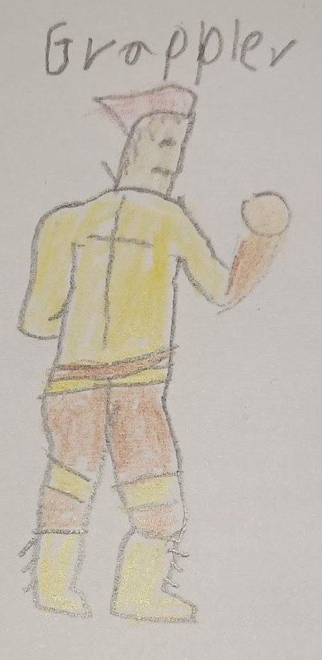
ATTACKS: | A grab attack here he throws the player behind him.
WHEN WILL IT FEATURE IN THE GAME? | all stages in the game.
HOW DOES THE PLAYER DEFEAT IT? | All types of attacks work to defeat the enemy.
WHAT DOES THE PLAYER EARN FOR DEFEATING THEM? | score and progression through the stage.

NAME: | Whip woman
WHAT DOES IT LOOK LIKE? | Woman in a red outfit and wields a whip.  Refer to sketch for more details.  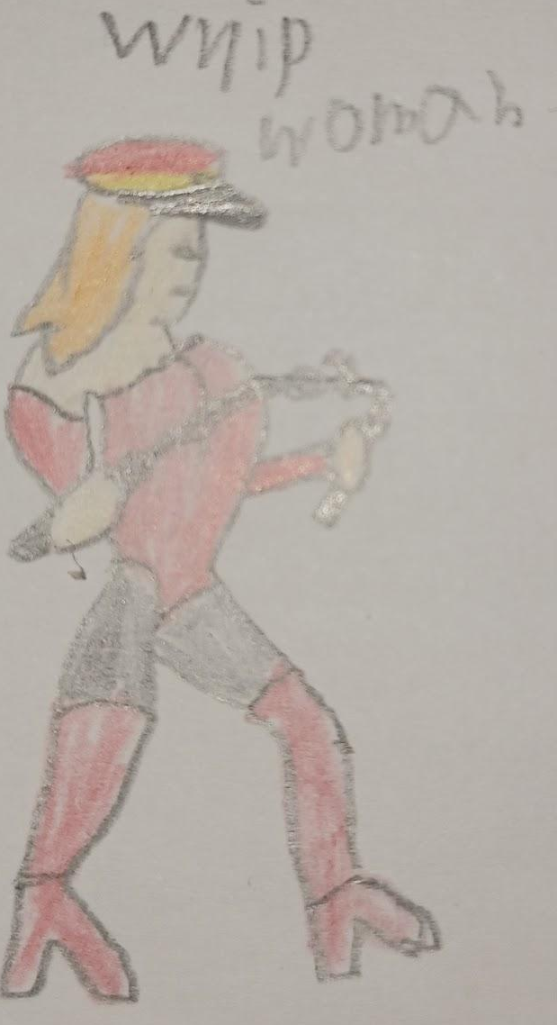
ATTACKS: | Swings whip in front of her, dealing damage and knocking the player back.  When knocked down, will kneel on the floor, being immune to attacks until the player walks away.
WHEN WILL IT FEATURE IN THE GAME? | all stages in the game.
HOW DOES THE PLAYER DEFEAT IT? | All types of attacks work to defeat the enemy.
WHAT DOES THE PLAYER EARN FOR DEFEATING THEM? | score and progression through the stage.

NAME: | Juggler
WHAT DOES IT LOOK LIKE? | Wearing a red punk type outfit and is juggling torches or axes.  Refer to sketch for more details.  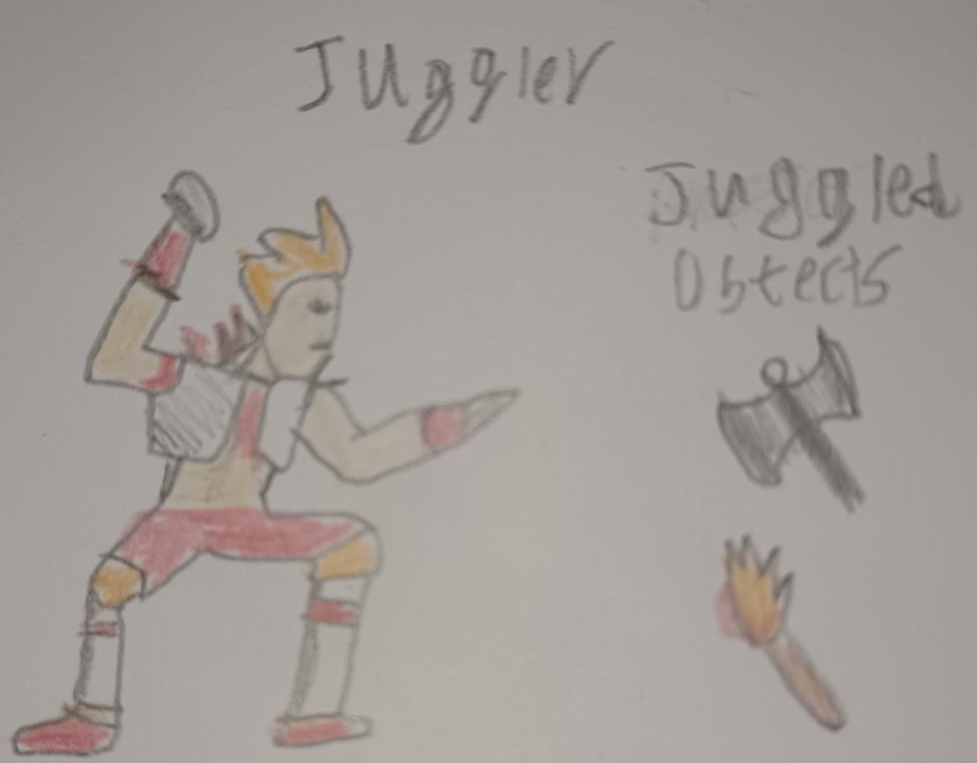
ATTACKS: | Runs from across the screen, knocking over the player if he runs into them.
WHEN WILL IT FEATURE IN THE GAME? | Introduced, on the second stage, appears throughout the game.
HOW DOES THE PLAYER DEFEAT IT? | Rapid attacks while the enemy is juggling, will be knocked back after all objects are gone.
WHAT DOES THE PLAYER EARN FOR DEFEATING THEM? | score and progression through the stage.

LIST OF BOSS CHARACTERS
Bosses will have a higher health and appear at the end of a stage except for stage 7.
Boomerang,
claws,
Charger,
Criminal organisation leader.

BOSS CHARACTER DETAILS
NAME: | boomerang
WHAT DOES IT LOOK LIKE? | Is wearing a Generic greaser outfit and is wielding a boomerang.  Refer to sketch for more details.  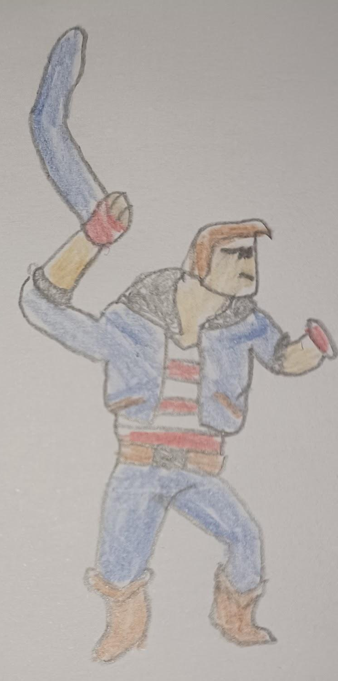
ATTACKS: | throws a boomerang from the side of the screen, travels to the other side of the screen before returning to the boss.  The boomerang can be deflected by attacking it when it is in range.
WHEN WILL IT FEATURE IN THE GAME? | will feature at the end of the first stage.
HOW DOES THE PLAYER DEFEAT IT? | can be attacked by all attacks.
WHAT DOES THE PLAYER EARN FOR DEFEATING THEM? | progression onto stage 2.

NAME: | claws
WHAT DOES IT LOOK LIKE? | The boss is a man wielding a pair of claws on his hands and in a blue jacket.  Refer to sketch for boss’s design.  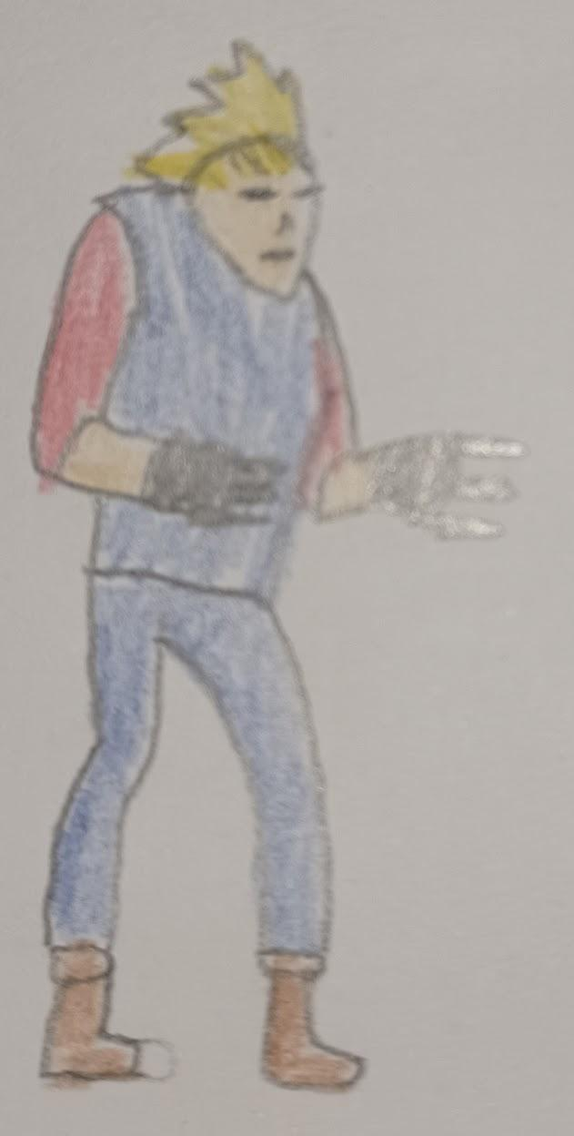
ATTACKS: | backs away for the player and then dashes and slashes at the player with his claws.
WHEN WILL IT FEATURE IN THE GAME? | appears at the end of the second stage and appears in the factory stage.
HOW DOES THE PLAYER DEFEAT IT? | This boss is resistant to aerial attacks, making the player have to use ground attacks.
WHAT DOES THE PLAYER EARN FOR DEFEATING THEM? | progression onto stage 3.

NAME: | charger
WHAT DOES IT LOOK LIKE? | In an orange wrestler outfit.  Refer to sketch for more details.  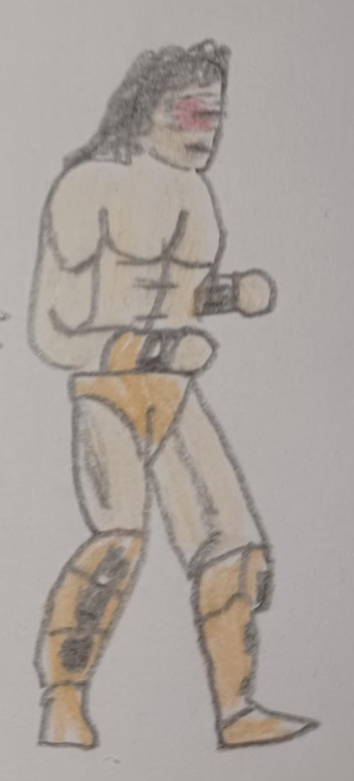
ATTACKS: | charges at the player and attacks at the end of his dash.  will also after being attacked, pick up the player and throw them.
WHEN WILL IT FEATURE IN THE GAME? | will feature at the end of the third stage. and again, during stages 5 and 8.
HOW DOES THE PLAYER DEFEAT IT? | attacking the boss during the charge, vulnerable to air attacks as they can land through the boss's charge.
WHAT DOES THE PLAYER EARN FOR DEFEATING THEM? | progression onto stage 4.

NAME: | Criminal organisation leader
WHAT DOES IT LOOK LIKE? | is wearing a green suit with a tie, is also wielding a machine gun.  Refer to sketch for more details.  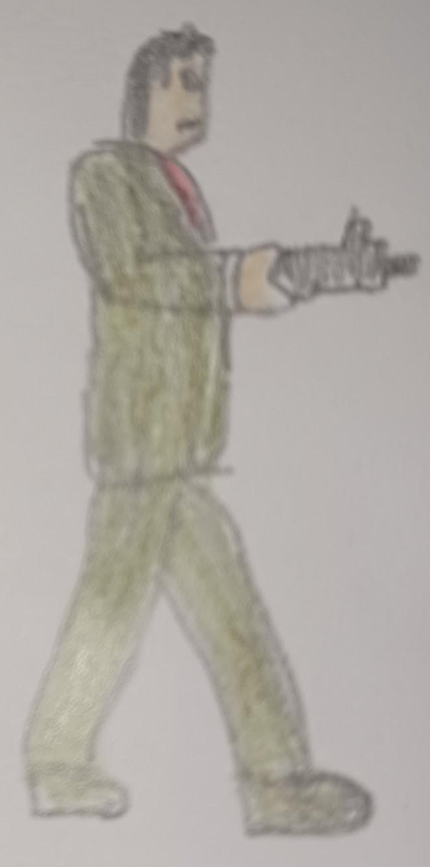
ATTACKS: | The boss has 2 phases, first phase he is sitting on a chair in the background, the player needs to defeat enemies, after this he gets up and enters the second phase.  In the second phase will run across the screen and spray a machine gun around the room, additionally basic enemies will keep spawning. When attacked he may do a retaliation attack.
WHEN WILL IT FEATURE IN THE GAME? | will feature at the end of the final stage.
HOW DOES THE PLAYER DEFEAT IT? | All attacks can hit this boss.
WHAT DOES THE PLAYER EARN FOR DEFEATING THEM? | Competition of the game.

CONTRIBUTING TEAM MEMBER: | Teifion Gibson

SECTION 9: CUTSCENES

CUTSCENES
The game will feature 2 cutscenes, these are,
Introduction cutscene,
Special attack.

CUTSCENE DETAILS
VISUAL STYLE: | 2D pre-rendered cutscene.
BRIEF DESCRIPTION OF SCENE: | First a cityscape with the games story, then a bio section on the playable characters then a splash screen of the games logo.  Refer to storyboard for animations.
WHEN WILL IT FEATURE IN THE GAME? | When the player boots up the game.
PURPOSE: | Cutscene is used to introduce the games world and main characters.

VISUAL STYLE: | 2D in game cutscene.
BRIEF DESCRIPTION OF SCENE: | Camera moves back, a police car pulls over, a police officer shoots a missile out the window, back to play area, fire appears on the ground.  Refer to storyboard for animations.  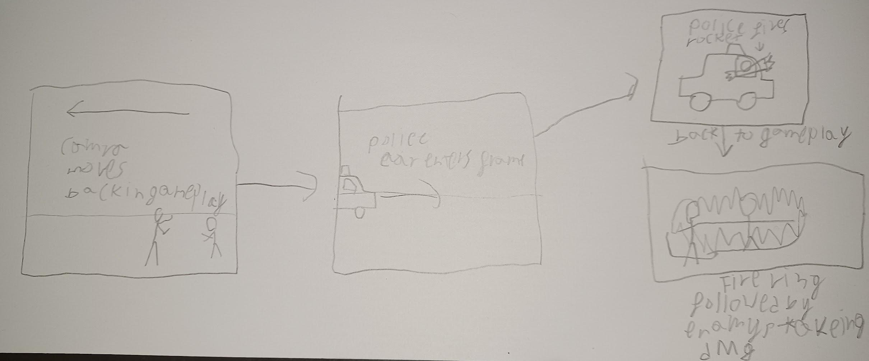
WHEN WILL IT FEATURE IN THE GAME? | When player uses special attack.
PURPOSE: | To convey when a special attack is used.

CONTRIBUTING TEAM MEMBER: | Teifion Gibson

SECTION 10: BONUS MATERIALS

BONUS MATERIALS
simultaneous local multiplayer supporting up to 2 local players.

REPLAY VALUE
An incentive for the player to replay the game will be for the player to attempt to obtain a new high scores.

CONTRIBUTING TEAM MEMBER: | Teifion Gibson

References
[1]fandom.com, “Adam hunter,” fandom.com. https://streetsofrage.fandom.com/wiki/Adam_Hunter (accessed Dec. 08, 2023).
[2]Fandom.com, “Axel stone,” fandom.com. https://streetsofrage.fandom.com/wiki/Axel_Stone (accessed Dec. 08, 2023).
[3]Fandom.com, “Blaze fielding,” fandom.com. https://streetsofrage.fandom.com/wiki/Blaze_Fielding (accessed Dec. 08, 2023).
[4]apple, apple keyboard. Accessed: Nov. 20, 2023. [Online]. Available: https://www.apple.com/uk/shop/product/MK2A3LB/A/magic-keyboard-us-english
[5]Microsoft and Amazon, Black Xbox controller. Accessed: Nov. 20, 2023. [Online]. Available: https://www.amazon.co.uk/Wireless-Controller-Black-Xbox-One/dp/B08DF248LD

[6]Microsoft, Xbox controller top. Accessed: Nov. 20, 2023. [Online]. Available: https://www.xbox.com/en-US/accessories/controllers/xbox-wireless-controller

[7]Sony and Amazon, Sony PlayStation controller Black. Accessed: Nov. 20, 2023. [Online]. Available: https://www.amazon.co.uk/Sony-PlayStation-Dualshock-Wireless-Controller/dp/B07D28WVGG

[8]Sony, PlayStation controller top. Accessed: Nov. 20, 2023. [Online]. Available: https://direct.playstation.com/en-gb/buy-accessories/dualshock4-wireless-controller-for-ps4-jet-black

[9]Vox media and Nintendo, Nintendo switch joy cons. Accessed: Nov. 20, 2023. [Online]. Available: https://www.theverge.com/circuitbreaker/2017/1/12/14260812/nintendo-switch-joy-con-controller-new-features

[10] Streets of rage [software], Japan: Sega, 1991

