Certificate in Higher Education Skills for the Workplace

Module - Managing Enterprise in the 21st Century
Module code - BMSW4006
Assignment – Group Written Business Plan
Tutor: Dr. Obinna Nkwocha
Student’s:
Zeba Arif- 2017461
Toni Trevis- 2016781 (pages 1-5)
Serina Williams- 1915864 (pages 9-10)
Daniela Milkova- 2018263

1
Executive summery

Sweet street doughnuts. A brand-new doughnut dipping business that aims bring a wow factor to a well-loved product. The aim is to satisfy the needs of every customer. The outrageously flamboyant designs, toppings, dips, and fillings are sure to attract attention and make a huge statement within the industry. With a target market of 16–36-year-olds. Sweet streets intend to develop a menu for customers with allergies and intolerances. Enabling customers to experience the urban craziness that is sweet street doughnuts. We use biodegradable boxes and cups to limit plastic waste and help minimise harm to our planet
The aim is to ensure sweet street Doughnuts stand out from current competitors on the market and give customers reason to try our products. The quirky logo, urban van and upbeat staff are sure to attract people to come and enjoy the services provided.
Estimated Revenue of around 80k in the first year with an estimated 20% increase within the first three years. bringing annual turn-over up to roughly 96k.
Sweet streets intend to progress from the doughnut van to their first store within 3 years of trading. enabling them to mass produce and cater to more online orders and give better time and space for party planning, whilst using the fast-food van solely for venues, weddings, and parties. Bringing in more customers and chance to further increase annual turnover.

2
Table of content

Business/ company overview 4
Product and services 5
Market audit 6
Competitors 7
SWOT Analysis 8
PESTLE Analysis 9
Marketing plan 10-11
Management plan 10-11
Target market 12
Financial plan 12.1
Cash flow forecast 13-14
Profit & loss 15
References 16

3
Business/company Overview

The history of the doughnut dates back centuries, with various countries introducing their own versions. In ancient Rome and Greece, cooks would fry strips of dough in hot oil and coat them in honey. (The History of Doughnuts, 2021)
Sweet street Doughnuts is an urban doughnut company. A four-way partnership. Run and managed by owners initially, with the intention to employ young enthusiastic individuals who have not had the best of starts, giving them an opportunity to work within the company. Sweet street intends to develop some of the most extravagant doughnuts ever seen.. Sweet street will take a traditional well-loved product and give it a 21st century twist.
Trading will commence from a fast-food truck enabling mobility. Initially the intention is to trade within the West Midlands, with the plan to venture further once custom is established. Sweet street will use social media platforms to advertise the company. The intention is to also cater to parties, weddings, and events, offering different packages to the consumer to accommodate different budgets and requests.
Sweet street Hope to progress from the food truck and eventually broaden the business. Renting a shop to bake their delicious doughnuts. Offering more variety, a place to relax, a brilliant atmosphere and some truly amazing Doughnuts.

4
Products and services
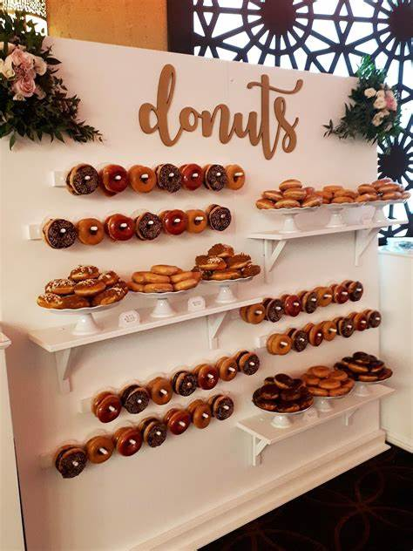

Initially the intention is to concentrate solely on doughnuts and the dips, fillings, and toppings we intend to supply. Ensuring maximum potential and high standard products and services. Hot and cold non-alcoholic refreshments will also be available to buy. Doughnuts will be priced at £2 each or 3 for £5 extra dips and toppings available for an additional cost of 50p per tub.
Combo boxes/or share boxes are also available. Customers who purchase a combo box receive £2 off their next visit,
Sweet street doughnuts will cater to events, parties, and weddings. Offering gold silver and bronze packages to accommodate a varied budget. Display stands and doughnut walls will also be available to hire at an additional cost of £50 per display, And Packages can be tailored to suit the customer.

5
Market Research and Competition Analysis

The confectionery market is large due to the traditionally high demand for these products on special occasions or simply to meet the needs of those who love sweets. Small-scale production is growing rapidly. It is characteristic that it can quickly change the range depending on consumer tastes.
-The market will consist mainly of potential users of age- 18 up to 35 years.
-In general, the most pronounced factor in choosing a confectionery product is the price, but when considering the individual groups for consumers up to 35 years of age, taste and originality are more important.
Market research helps us find customers for our business. Market research blends consumer behavior and economic trends to confirm and improve our business idea. Competitive analysis helps us make our business unique. Competitive analysis helps us learn from business competing for our potential customers. This is key to defining a competitive edge that creates sustainable revenue. When we combine them, we can find a competitive advantage for our small business.
There are many reliable sources that provide customer and market information at no cost. Free statistics are readily available to help small businesses owner.

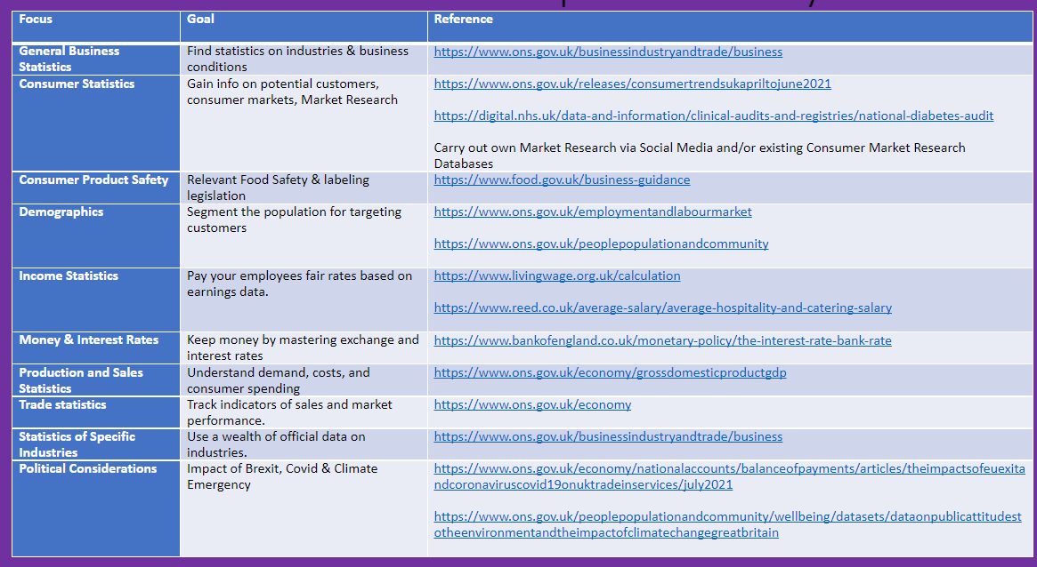

6

Competitor’s analysis

“Keep your friends close, but keep your enemies even closer”
Competitor’s competition has a great influence on the goals and strategies of any enterprise, so they must be identified and studied. It should be clarified in which markets they operate, market share, what are the strengths and weaknesses of their goods or services, what is the attitude of consumers to them, their advertising strategies and more. Therefore, the company strives to offer and present a wide range of high-quality products, fully meet the needs and requirements of consumers, and gain their trust. The goal of the company is advantage and establishment over the competitors. Competitive analysis is a cornerstone of effective strategy formulation and execution (Zahra and Chapel,1993).
The main competitors of Street Sweets in UK are:
1.Krispy Kreme 5. Starbucks
2.Dunkin’ Donuts 6. Costa Coffee
3.Greggs 7.Mc Donald’s
4.Supermarket brands 8. Subway

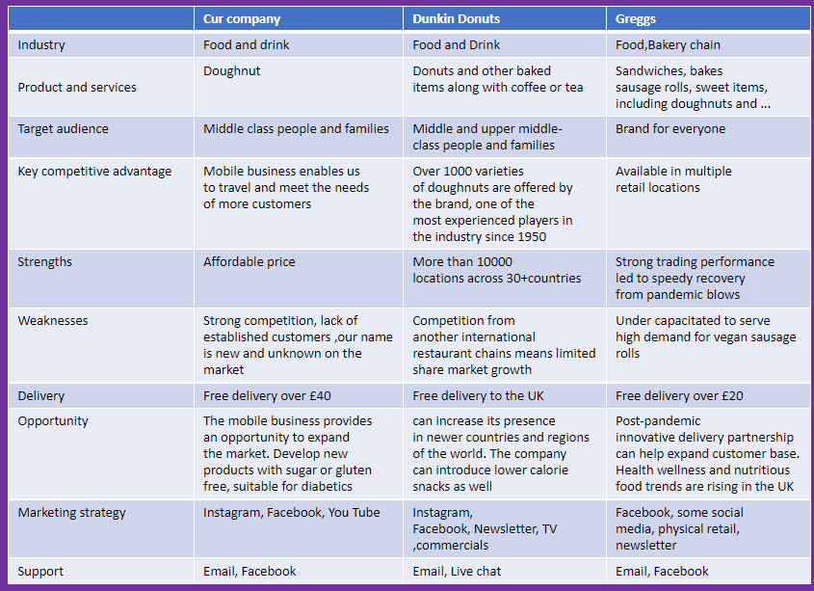

7
SWOT Analysis

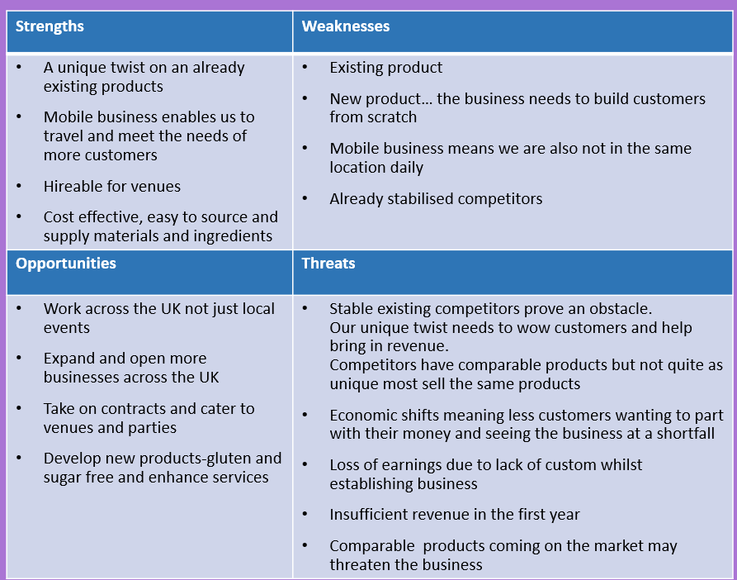

8

PESTEL Analysis

PESTEL analysis is a tool used for analysis and monitoring of external environmental factors with an impact on the organization (Christodoulou & Cullinane,2019). PESTEL analysis enables identifying business opportunities and threats, that are later addressed in SWOT analysis, as one of the basic tools for defining organizational strategy. (Kolios & Read ,2013).

Excellent analysis is the key to successful insights and intelligence and can provide high-value strategic decision support capability in contemporary enterprises (Fleisher & Bensoussan,2015).

9

Marketing & Management Plan

This Segment of the report will show the building of a management team the ideas that were used to produce a business plan so that our ‘Street Sweets Doughnut Company’ would become a reality and become successful. It will show the positions of each person, how the marketing, advertising and promotion were put together.

Bruce Tuckman’s Team Development Model

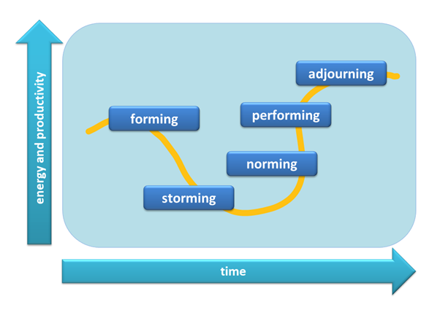
THE MANAGEMENT TEAM
When the four of us came together with the idea to start up a Doughnut Business. It was essential to get it right so we used the ‘Tuckman Model’ that would help us work out the right position for everyone.
Source: Google

The result of using the Tuckman Model is as follows…
Toni Trevis: - Managing Director/Sales Representative: This was the right position for her,
10
as the main founder and creator of the company. She also had management experience and knowledge of the doughnut business accompanied by her unique sales technique.
Zeba Arif: - Financial Director/Caterer because of her financial background & experience in the field of catering. Daniela Milkova: - Research Analyst/Caterer because she has an analytic approach and her knowledge in research was an asset to the company as well as experience in the bakery. Serina Williams: - Marketing Director/Sales Representative Due to her knowledge in Marketing & sales. It was decided that we all did two roles each to keep costs down until the business was established. Communicating a business plan to partners, investors, major customers or suppliers, and key employees gives useful feedback on all aspects of the business, so was important to do this from the start.

Marketing and sales plan

After great discussions, researching and reviews it was decided to put together and strategize when and how to bring in the most revenue. Lunch time and weekend was the obvious way to start, then student discounts and groups buying in bulks. Doing doughnut deals with free drinks during specific hours for example., 11.30am-2pm weekdays. This was an effective way to target the customers most likely to buy doughnuts etc. Starting in areas where there is less competition was also especially important, as well as places where doughnuts businesses were already established. "The aim of marketing is to know and understand the customer so well the product or service fits him and sells itself.” (Drucker, 2020)

Marketing and sales plan:
Marketing Channels: social media, Blogs, advertising billboards, buses/vans etc.,
Target Market 18-36 years, working class, mass market
Customer Incentives (referrals, discounts etc.,)
Advertising and posters were equally as important.
With Street Sweets There will be a ‘Grand Opening’. This will include Celebrity guest, free tasters, a chance to dress your own doughnut free and first 20 customers get a free drink (including milkshakes).

11

Target market

They say, “having a well-defined target market is the most important thing ever.” (Porta, 2021) doughnuts are for everyone however, we have a target market of range 18 – 36 the middle- and working-class people. Our main target is to target people who have a sweet tooth and are want them crazy flours on the go. Our doughnuts are to cater to individual needs so the customer would be able to pick and choose how they desire the taste. Our main target is schools, universities, shopping centres. These locations are ideal for our target market range, and this is the crowd we want to draw in. while this is our main crowd, we also want to cater to individuals needs for people who can’t have gluten or sugar. In our target market there will be customers with these needs, and we aim to cater to them, this will also increase our revenue and profit, as there are not many others who offer the same services. We aim to start locally and then expand our location.
The 4 Ps for our business highlight the main purpose of the business. The first P being product, our product is to create doughnuts which cater to the individual needs and can be crazy as the customer desires. Second P price, we aim to provide unique doughnuts at an average price, like our competitors. Third P place, our aim is to target schools, universities, retail parks and events as this meets our target market. Forth P promotion, we aim to draw in groups of people by offering combo deals and loyalty cards to encourage them to return.

Financial plan
What is a financial plan? “A financial plan is a document that contains the money situation and long-term goals, it is a document that helps put your finances in prospective” (Scott, 2021). Every small business needs a financial plan to help identify its outgoings and help it get a better understanding of its finances. We have completed a cash flow document (appendix 1) that identifies all our outgoing costs for the year. It is broken down into 3 sections the firsts state any one-off costs which is for items like the trailer and the card machine. The other 2 sections have a breakdown of our monthly and yearly cost, this makes it easier to understand our outgoings and understand our finances.
The second document we have completed is the profit loss forecast (appendix 2). This is a document which has our revenue then a breakdown of our cost of sales, other expenditures and then a net profit before and after taxes. This document also contains a detail break down of each of the products we intend to sell and how much it we can make off each product.
We will be using the app quick books which will manage our daily finances and all finances will be reviewed every 6 months and yearly.
12
Cash Flow 13

Item | Total cost | Weekly cost | Monthly cost | Yearly cost
Food trailer inc. sink, fridge, and workspace | £5,200 | n/a | n/a | n/a
fuel |  | £65.00 | £260 | £3,120
Repairs | £1,000 – may not be required but will be kept
Staff wages | All staff to be hands on profit to be split 4 ways | n/a | £800 | £9,600
Trailer insurance |  | n/a | £24 month | £288
Road tax | Under £500 | n/a | £41.66 | Under £500
Card reader | £35 | n/a | n/a | n/a
Doughnut making machine | £400 | n/a | n/a | n/a
Street food licence | Depends on council varies from £10 - £50 per day depending on location | n/a | n/a | £498.00
level 2 food safety and hygiene | £49.99 | n/a | n/a | n/a
Registration with local authority | Free need to be done at least 28 days before
Public liability insurance | Varies on company between £20 - £50 per month | n/a | £50 month | £600
LGP and PAT test certificates | Gas - £35 -£150  Electric - £1 per item (25) | n/a | n/a | n/a
HACCP plan | Free able to download templet online | n/a | n/a | n/a
risk assessments | Need to be conducted
Ingredients | £40 for 12.5 kg readymade doughnut mix  (250 doughnuts) | £80 | £320 | £3,840
Ingredients | Tea bags – 440 tea bags bag for £11 | n/a | £11 | £132
Ingredients | Coffee – 750g for £23  (416 cups) | n/a | £23 | £276
Ingredients | De-caf- 500 for £25 | n/a | £25 | £300
Ingredients | Hot chocolate – 2kg for £15  (47 cups) | £15 | £60 | £720
Ingredients | Milk-  6x2.27l | £12.89 | £51.56 | £618.72
Ingredients | Cream- 6x2.27l | £9.69 | £38.76 | £465.12
Ingredients | Sugar sachets-  Brown – 1000 for £10 | £10 | £40 | £480
Ingredients | White – 1000 for £ 9 | £18 | £72 | £864
Ingredients | sweetener – 30 for £1 | £4 | £16 | £192
Ingredients | Caned drinks -  Coke  Pepsi  Orange tango  7 up  (13 cans daily) 300 monthly | £60 | £240 | £2,880
Quick books app to manage finance |  | n/a | n/a | £139.20
Disposable items | Containers, cups, forks, and napkins | £43.94 | £175.74 | £2,108.89
Business cards 1000 |  | n/a | n/a | 5 x £20 = £100
 | Total outgoing | £318.52 | £2,248.72  including the one-off costs | £33,581.92

Aim target is £80.000 by calculations total profit is £46,418.08 Profit split in 4 = £9,283.616
http://streetfoodcentral.com/what-food-truck-catering-license-do-i-need-for-the-uk/
https://assets.publishing.service.gov.uk/government/uploads/system/uploads/attachment_data/file/907390/v149x1-rates-of-vehicle-tax.pdf
14
http://www.donutedvd.com/about_the_donut_business.html
https://www.cater4you.co.uk/acatalog/seasonal-products.html https://www.brake.co.uk/dairy/cream/fresh

Profit and loss forecast
 | Costs out going | Costs outgoing for events
Total revenue | £87,040 | £3,636
Total costs of sales | £10,767.84 | £275.20
All other expenses | £22,814.08 | £200
Total | £33,581.92 | £475.20
Total net profit | £53,458.08 | £3,160.8
Total net profit after tax (19%) | £43,301.0448 | £2,560.25

Financial breakdown –
Item | Per day | Per year | Total income
doughnuts (£2 each) | 80 | 20,480 | £40,960
Hot drinks (£2each) | 40 | 9,600 | £19,200
Cold drinks (£1.20 each) | 10 | 2,400 | £2,880
Extra toppings (£0.50 each) | 200 | 48,000 | £24,000
Total, income |  |  | £87,040

Total amount required to set up based on monthly outgoing is - £10,252.18
Event and party packages -
Gold package (£600) – 300 doughnuts with a minimum of 12 toppings and (surprise doughnuts for wedding couple)
Silver package (£300) – 150 doughnuts with minimum 6 toppings
Bronze package (£120) – 50 big doughnuts and 50 mini doughnuts with a minimum of 6 toppings
We aim to get
4 x silver packages £300 = £1,200 (weddings and party’s)
4 x gold package £600 = £2,400 (events)
Total £3,600
15
Reference List

Tuckman, B. (1938 -2016), Bruce Tuckman: The forming, Storming, Norming & Performing Team Development Model, [accessed 07 11 2021]
Drucker, P. (2020), The Essential Guide to Marketing Strategy, [accessed 7 11 2021]

Porta, M. (2021, 01 05). Defining your target market. Retrieved from inc.com: https://www.inc.com/guides/2010/06/defining-your-target-market.html
Scott, G. (2021, 10 14). what is a financial plan? Retrieved from Investopedia: https://www.investopedia.com/terms/f/financial_plan.asp

Christodoulou, A., & Cullinane, K. (2019). Identifying the main opportunities and challenges from the implementation of a port energy management system: A SWOT/PESTLE analysis. Sustainability, 11(21), 6046.

Fleisher, C. S., & Bensoussan, B. E. (2015). Business and competitive analysis: effective application of new and classic methods. FT press

Kolios, A., & Read, G. (2013). A political, economic, social, technology, legal and environmental (PESTLE) approach for risk identification of the tidal industry in the United Kingdom. Energies, 6(10), 5023-5045.

Zahra, S. A., & Chaples, S. S. (1993). Blind spots in competitive analysis. Academy of Management Perspectives, 7(2), 7-28

Tori Avey. 2021. The History of Doughnuts. [online] Available at: <https://toriavey.com/history-kitchen/the-history-of-doughnuts/#:~:text=The%20history%20of%20the%20doughnut%20goes%20back%20centuries%2C,coat%20them%20with%20honey%20or%20fish%20sauce%20%28eww%21%29.> [Accessed 29 November 2021].

16

