Student Name: Rosario del Rocio Garcia Baez  Student ID: 2230623  Module Title: Foreign Languages & Cultural Awareness  Module Code: BMIH5003  Lecturer: Heidi Prosser  Date: 08/02/2024 | 
ASSIGNMENT 1: PORTFOLIO
(4 Components)

Component 1: Professional Reflection (500 words +/- 10%)

Weighting: 25%
I find myself working as a waiter in a hotel restaurant during breakfast service. The hotel attracts a diverse international clientele, and one morning, a guest from Japan enters the restaurant. As a diligent employee, I strive to provide excellent service to all guests. However, a cultural misunderstanding arises when I attempt to engage with the Japanese guest.

Explanation of Cultural Misunderstanding:
In Japanese culture, there is a strong emphasis on politeness and humility. The guest, not proficient in English, may not be comfortable with direct eye contact or assertive communication styles, which are more prevalent in Western cultures. As a waiter, I might unintentionally exhibit behaviours that make the guest feel uneasy, such as maintaining prolonged eye contact or using overly formal language that might be perceived as too authoritative. (Silver, no date, p.32).

Reflection on Cultural Misunderstanding:
Cultural misunderstandings often stem from differences in communication styles, non-verbal cues, and social norms. In this scenario, my lack of awareness regarding Japanese cultural norms could lead to discomfort for the guest. To prevent such misunderstandings in the future, I need to develop cross-cultural communication skills. (Edmundson, 2006, p.12).

Firstly, I must educate myself on the cultural practices and preferences of the diverse guests the hotel attracts. This can involve cultural sensitivity training, studying cultural guides, and attending workshops to enhance my understanding of various customs.

Secondly, it is crucial to adapt my communication style based on the guest's cultural background. In the case of the Japanese guest, I should be more mindful of maintaining an appropriate level of formality and using indirect communication techniques to ensure their comfort. This might include bowing slightly as a sign of respect or using more nuanced gestures.

Thirdly, language proficiency is vital. While I may not become fluent in every language, learning basic phrases and greetings in the languages commonly spoken by guests can go a long way in creating a positive and inclusive environment. This could involve language courses or online resources to acquire essential language skills.

In essence, developing cultural competence is an ongoing process that requires continuous learning and self-reflection. By actively seeking knowledge about different cultures, adjusting communication styles, and acquiring basic language skills, I can enhance my ability to provide exceptional service to guests from diverse backgrounds. (Gudykunst, 2003).

References:
Edmundson, A. (2006) Globalized e-learning, cultural challenges. 1st edn. Hershey, Pa: Information Science Publ. Available at: https://doi.org/10.4018/978-1-59904-301-2.

Gudykunst, W. B., & Kim, Y. Y. (2003). Communicating with strangers: An approach to intercultural communication. McGraw-Hill.

Silver, J.M.W. (Jacob M.W. (no date) Sketches of Japanese Manners and Customs. Project Gutenberg.

Component 2: Training Plan (500 words +/- 10%)

Weighting: 25%

Identified cultural misunderstanding (in a few words) :
The cultural misunderstanding involves misinterpreting the Japanese guest's discomfort with direct eye contact and assertive communication during breakfast service in a hotel restaurant.
Training plan (Why/What//Who/Where/When):
To ensure a seamless and culturally sensitive service experience for our diverse international clientele at our hotel, it is imperative that all employees are equipped with the necessary cross-cultural communication skills. This training plan aims to enhance the staff's cultural competence, enabling them to navigate potential cultural misunderstandings and create a more inclusive environment for our guests.

Training Objectives:
Cultural Awareness and Sensitivity:
Objective: To develop an understanding of various cultural norms, communication styles, and social practices.
Methods: Conduct workshops and training sessions on cultural diversity, using real-life scenarios and case studies. Encourage open discussions to share experiences and insights.

Adapting Communication Styles:
Objective: To recognize and adapt communication styles based on the cultural background of the guests.
Methods: Role-playing exercises simulating interactions with guests from different cultural backgrounds. Provide guidelines on appropriate language use, body language, and gestures. (Bengsch, 2010).

Language Proficiency:
Objective: To enhance basic language skills for effective communication with guests.
Methods: Implement language courses or online resources focusing on essential phrases and greetings in languages commonly spoken by guests. Encourage language exchange programs among staff members. Alhamami (2018) Computer assisted language learning.

Continuous Learning and Self-Reflection:
Objective: To instil a culture of continuous learning and self-reflection regarding cross-cultural communication.
Methods: Implement regular cultural competence check-ins during team meetings. Encourage staff to share their experiences and challenges, fostering a supportive environment for learning.

Evaluation and Feedback Mechanism:
Objective: To measure the effectiveness of the training and gather feedback for continuous improvement.
Methods: Conduct periodic assessments and surveys to evaluate staff members' understanding of cross-cultural communication concepts. Encourage open feedback to identify areas for improvement in the training program. Flegl (2022) Training on Their Performance Improvements.

Conclusion:
By implementing this comprehensive cross-cultural communication training plan, our hotel aims to create a more culturally aware and inclusive environment. This proactive approach will not only enhance the overall guest experience but also contribute to a positive workplace culture where employees feel empowered to navigate diverse cultural landscapes confidently.

References:

Alhamami, M. (2018) ‘Beliefs about and intention to learn a foreign language in face-to-face and online settings’, Computer assisted language learning, 31(1–2), pp. 90–113. Available at: https://doi.org/10.1080/09588221.2017.1387154.

Bengsch, G. (2010) The influence of culture on the perception of politeness: An investigation of front-line staff at a mid-priced hotel chain in New Zealand.

Flegl, M., Depoo, L. and Alcázar, M. (2022) ‘Impact of Employees’ Training on Their Performance Improvements’, Kvalita inovácia prosperita, 26(1), pp. 70–89. Available at: https://doi.org/10.12776/qip.v26i1.1665.

Component 3: Student Self-Reflection (500 words +/- 10%)

Weighting: 25%
I have chosen the Gibbs Reflective Cycle as a model to critically reflect on my understanding of the importance of cultural awareness within the hospitality industry. Sekarwinahyu (2019) Reflective cycle and e-portfolio to enhance reflective thinking skills.

Description:
In the early stages of my career in the hospitality industry, my understanding of cultural awareness was somewhat limited. I primarily focused on providing excellent service, without fully appreciating the impact that cultural differences could have on guest interactions. The turning point in my awareness came when I encountered a situation in which a cultural misunderstanding occurred with an international guest.

Feelings:
Initially, I felt a sense of confusion and frustration as I grappled with why the interaction had not gone as smoothly as expected. It prompted me to delve deeper into understanding the cultural nuances that might have contributed to the misunderstanding.

Evaluation:
Upon reflection, I realized that my lack of awareness regarding the guest's cultural background had played a significant role in the miscommunication. This realization led me to acknowledge the importance of cultural awareness as a fundamental skill in the hospitality industry. Guests from diverse backgrounds bring unique expectations, communication styles, and preferences, and understanding these factors is crucial for providing exceptional service. (Choi, 2008).

Analysis:
To enhance my cultural awareness, I actively sought out resources such as cultural sensitivity training programs, academic articles, and books on intercultural communication. This proactive approach allowed me to analyse my own biases and assumptions, fostering a more open-minded perspective towards cultural differences.

Conclusion:
As a result of this experience, I learned that cultural awareness is not a static skill but a continuous journey of self-improvement. It goes beyond merely acknowledging cultural differences; it involves adapting communication styles, anticipating potential challenges, and being open to learning from every interaction.

Action Plan:
Moving forward, I am committed to ongoing self-development in the realm of cultural awareness. I will continue to engage in training programs, stay updated on cultural trends, and actively seek feedback from colleagues and guests. Additionally, I will encourage a culture of cultural awareness within the team, fostering an environment where diverse perspectives are valued.

In conclusion, this reflective process has been instrumental in my personal and professional growth. It has underscored the importance of cultural awareness as an essential skill in the hospitality industry, influencing my behaviour, mindset, and approach towards interactions with guests from diverse backgrounds. Continuous self-reflection and a commitment to learning are integral components of cultivating cultural competence in the ever-evolving landscape of the hospitality industry. Feng (2015) Educational strategies for the next generation leaders in hotel management.

References:
Choi, C.-Chung. and Parker, M.L. (2008) Empathy training for ethnic and cultural awareness. Hanover, MA: Distributed by Microtraining and Multicultural Development.

Feng, Jiuguang. (2015) Educational strategies for the next generation leaders in hotel management. Edited by J. Feng, S. Stocklin, and W. Wang. Hershey: IGI Global. Available at: https://doi.org/10.4018/978-1-4666-8565-9.

Sekarwinahyu, M. et al. (2019) ‘Development of problem based learning for online tutorial program in plant development using Gibbs’ reflective cycle and e-portfolio to enhance reflective thinking skills’, Journal of physics. Conference series, 1157(2), pp. 22099-. Available at: https://doi.org/10.1088/1742-6596/1157/2/022099.

Component 4: Training Presentation (6 Slides)

Weighting: 25%
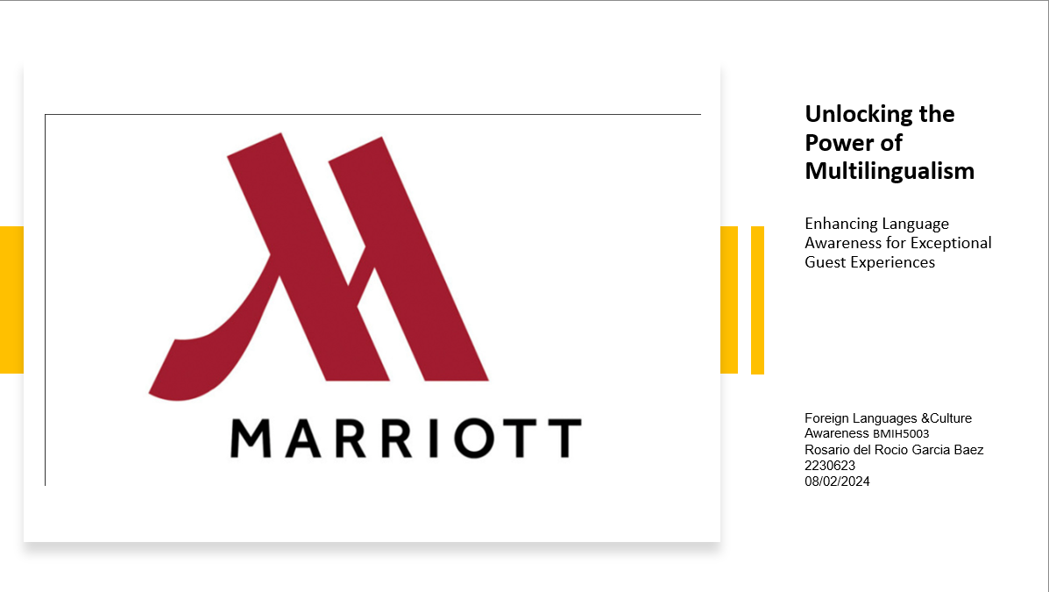
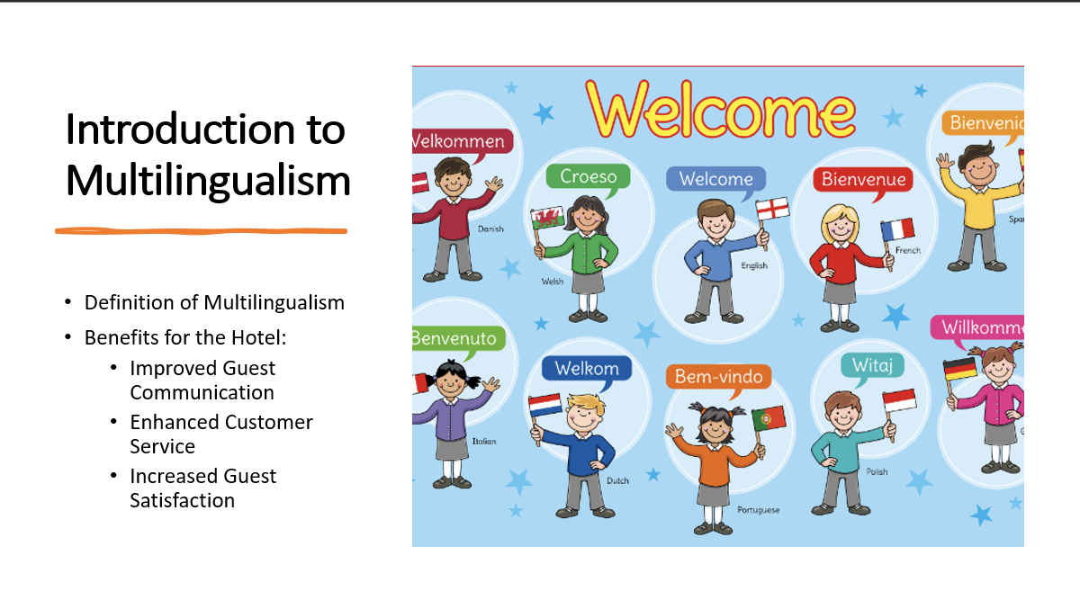

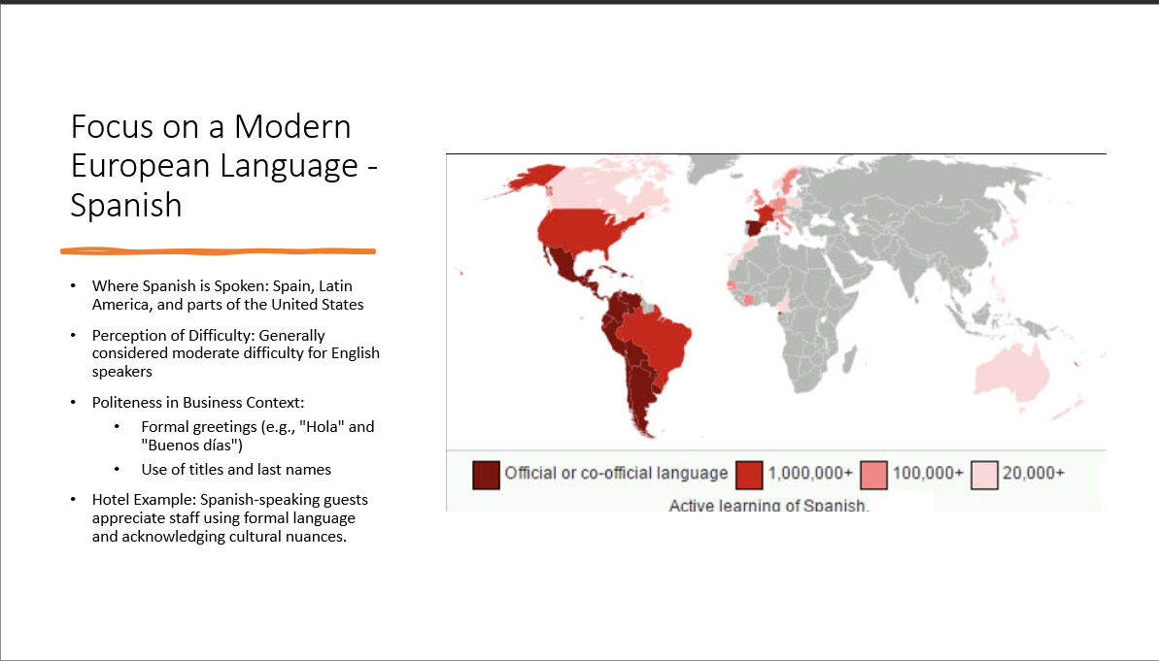
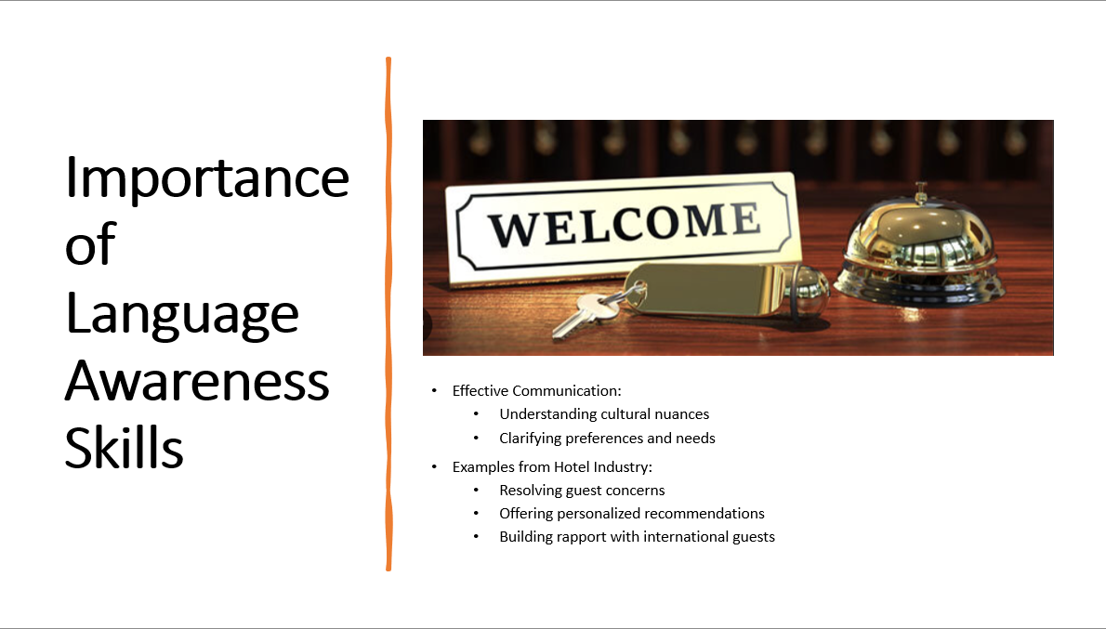
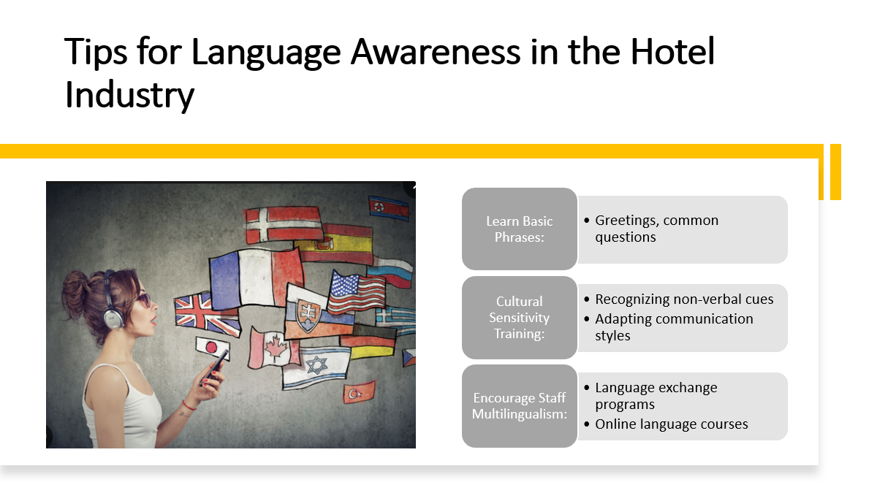
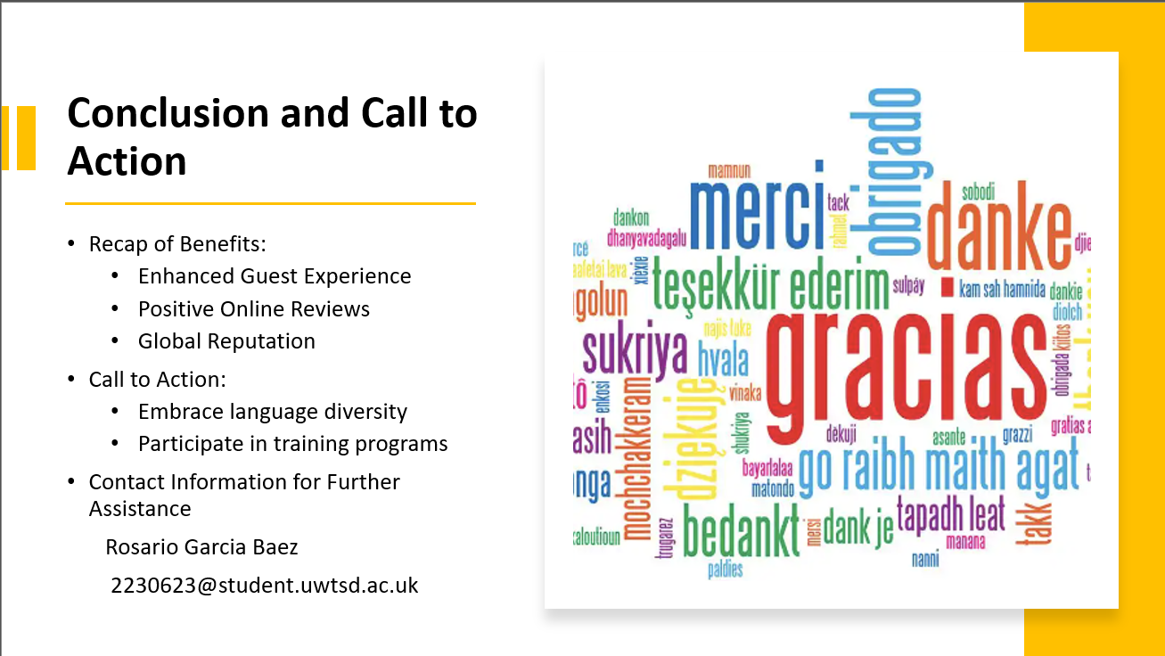
References (no screenshots):

Killian, K. (2014) ‘56 MILLION SERVED?’, Restaurant Business, 113(5), pp. 19-.

Korstanje, M.E. (2020) Strategies for promoting sustainable hospitality and tourism services. Edited by M.E. Korstanje, B.P. George, and A. Nedelea. Hershey, PA: IGI Global. Available at: https://doi.org/10.4018/978-1-7998-4330-6.

Sarma, S. (2017) Global observations of the influence of culture on consumer buying behavior. Edited by S. Sarma. Hershey, Pennsylvania: IGI Global. Available at: https://doi.org/10.4018/978-1-5225-2727-5.

Timothy, D.J. (2021) Cultural heritage and tourism : an introduction. Second Edition. Bristol, UK ; Channel View Publications.

Tina Orel Frank (2016) ‘Recent Research in the Field of the Interrelation of Foreign Languages and the Field of Tourism: Report from the 3rd International Conference Foreign Languages and Tourism’, Academica Turistica, 9(2).

