

BSc (Hons) Professional Police Practice

LEVEL 4 - 40 Credits

Workbook title: Competency Based Workbook 1 (PCDA)

(SOUTH WALES POLICE, GWENT POLICE AND UWTSD)

Learner name: Michael Pearce_________________

Learner’s University Registration Number:
2117785____________________

FACULTY OF BUSINESS AND MANAGEMENT
PUBLIC SERVICE PROGRAMME

Module title: Professional Police Practice 1 (PCDA)

Workbook Guidance

Please read these notes carefully; they provide essential information.

What is the workbook for?

The purpose of this workbook is to enable learners to demonstrate and provide evidence of how they meet the learning outcomes set by the College of Policing, for the BSc programme. Essentially, you are being asked to outline your experiential learning based upon your theoretical understanding in a range of operational situations.

Area of Professional Practice covered, (called elements in your module descriptor):

- Wellbeing and Resilience
- Communication Skills
- Managing Conflict
- Valuing Difference and Inclusion
- Criminal Justice
- Decision making, discretion
- Conducting Investigations
- Criminal Justice (Managing offenders)

You may wish to use the same incidents as you’ve outlined in the Occupational Competence Portfolio.

How should the workbook be presented?

Blank electronic copies can be found on Moodle of this workbook. You must submit this document electronically therefore it is important that you save your work regularly and upload the final typed version through Turnitin on Moodle.

Word count policy can be found in chapter 7 of the Academic Quality under section 7.7 (this applies to presenting work above and under the specified word count).
(https://www.uwtsd.ac.uk/media/uwtsd-website/content-assets/documents/academic-office/aqh-chapters/chapters---en/Chapter_07_Assessment_Taught_Programmes_Pages_72-79-UPDATED-05-11-2019.pdf)

Reflective practice is a core aspect for your workbooks and although there is a variety of useful resources on Moodle, there is one particular book, that is specifically based on reflective practice in policing, here is a link to one chapter from Selina Copley’s Reflective Practice for Policing Students:
https://moodle.uwtsd.ac.uk/pluginfile.php/298870/mod_resource/content/1/Reflective%20Practice%20for%20Policing%20Students%20-%20Selina%20Copley%20Chapter5.pdf

How is the workbook assessed?

Advice and support about the completion of this workbook will be provided by university staff as part of your initial training day. Your tutor constable and in-force training staff will not be involved in assessing or marking your workbook after it has been submitted.

Dates of workbook submission will be made available during the initial training day and posted on Moodle.

Once submitted your workbook will be assessed and marked independently.

Confidentiality

It is important that no individual can be identified either directly or indirectly from the information in the workbook. Therefore, you must:

- adhere to guidance in the Student Handbook about unfair practice and plagiarism;
- not identify individuals including witnesses, victims or offenders by name;
- not write information that enables any individual to be identified indirectly through the description you provide. This includes references to names, colleagues, places (including hospitals, schools, town, villages, streets) specific incidents which were high profile and could be identified due to past publicity, other professionals or any other personal information including medical or other conditions;
- take personal responsibility for adhering to confidentiality rules.
- not include any dates of any incidents or anything that specifically identifies an actual incident.

Please be aware that any content that is deemed to be inappropriate, disrespectful, or abusive will not be tolerated. Following review of any content of this nature the information will be shared with the employer of the student responsible.

Should any health and wellbeing concerns be raised because of disclosures made by the student within this workbook, the employer of the student will be informed.

NOTE

Your workbook will be submitted electronically via Turnitin on Moodle. Guidance on this is in the Student Handbook.

Remember that the workbook is YOUR responsibility you must not rely on the assessor or anyone else to pick up any confidentiality breaches as this is your work and you must accept full responsibility for confidentiality. Meeting all the confidentiality requirements is very important.

Dyslexia and other special circumstances

If you have any condition that you feel may affect your ability to deal with any part of the programme, please see the Student Handbook for further guidance. The University has a Student Services Unit that may be able to help but it is the learner’s individual responsibility to contact them.

Guidance:

- Your workbook must contain the items specified in the table below (clearly identified and in the order given);
- You should use this particular document to insert your text / answer within each section of this workbook;
- You should upload your completed document as a saved pdf of this workbook; if this is not possible then a Worddoc file is acceptable. Do not send a scanned file from a photocopier, an apple.dot file, or a Microsoft publisher file as Turnitin will not be able to assess them despite you being able to upload them.

Contents:

Workbook | Area of Professional Practice | Word count
Task 1 | Wellbeing and Resilience | 1000
Task 2 | Communication Skills, Managing Conflict, Valuing Difference and Inclusion | 1500
Task 3 | Criminal Justice, Valuing difference and inclusion | 1500
Task 4 | Decision making and discretion, Conducting Investigations and Criminal Justice (Managing offenders) | 1500
 | Bibliography
Task 5 | Development Plan | 500
 | Total | 6000
Confirmation of Confidentiality and Plagiarism
This is confirmed by submitting through Turnitin

Task 1

Relevant areas of the National Policing Curriculum:
Wellbeing and Resilience

Guidance:

Focussing on your initial 6 months of learning and since being attested as a Police Constable, outline the coping strategies you have applied to develop resilience and minimise stress.

1000 words (+/- 10%: include your actual word count at the end of each section)

ANSWER:

In order to answer the task, I have chosen the Gibbs reflective cycle. I have chosen this model as it has multiple stages to order a reflection into a structure that mines the most detail out of a person’s experience (Gibbs, 1988). Furthermore, to form an action plan to establish what has been learnt during an experience and how to improve in the future.
On October 4th I began my training at Vantage point in the role of a Police Constable and as of October 5th I was attested into the role, the training lasted 6 months. The training period included classroom learning, assessed practical’s and three exams as well as remote learning as an infection control measure during the Coronavirus pandemic. I successfully completed all assessments and assignments within this rigorous training period which required me to work and revise learning materials in and out of work hours.
This level of workload required me to be resilient and hard working as well as deal with the stresses of managing a suitable work life balance. Stress being how we react when we feel under pressure or threatened is usually associated with when we don't feel we can manage or control a situation (MIND, 2022).
I have developed a capacity for resilience through an ability to bounce back from difficult experiences and by maintaining flexibility in my work life balance (APA Help Center, 2004b). For instance, taking on board constructive criticism in practical’s in order to improve on my performance in future. To develop my skills in resilience I have built up a support network with family and friends, as developing good social networks increase a person’s resilience (APA Help Center, 2004a).
I felt both nervous and excited to be starting the role of a Police Constable, primarily throughout the training I felt motivated to learn and eager to address the challenges of the assessments involved.
I decided it was important to maintain a good work life balance, as this would make me more effective during training. This required me to focus my energies between time working on assignments and revising the learning materials such as legal legislation and policing procedure and other important areas of my life (Duncan, 2009, pp 300). In order to do this, I would factor into my weekly schedule activities that would help minimise my stress levels and bolster my resilience to the on going demands of training. I thought it would be important to take this step, taking responsibility for my own self-care, a key benefit being to ensure and maintain my health and wellbeing (Department of Health, 2005).
During the training period I began engaging more heavily in physical exercise as a means of reducing and minimising my stress, this included going to the gym within the Cwmbran Police Headquarters with classmates, playing football weekly and going for walks and hikes on my weekends. My strategy for engaging in physical activity was because exercise increases overall health and a sense of well-being, also exercise has some direct stress-minimising benefits (Mayo Clinic, 2020). Benefits such as reducing the negative impacts of stress by providing a stress relief for my body while imitating effects of stress, such as the flight or fight response, and helping my body and its systems practice working together through those effects (Mayo Clinic, 2020).
Further benefits of my exercise regime included the release of endorphins during exercise, a proven benefit of an aerobic activity that contributed toward improving my mood and ultimately allowed me to shed my daily tensions through physical activity. Coupled with the bolstering effects on my immune system and bodily functions such as digestion (Mayo Clinic, 2020). For example, during training I had no periods of sickness and physical activity helped minimise the effects of my irritable bowel syndrome.
In addition, the social support network of my classmates, friends and family bolstered my resilience. Social support is shown to moderate environmental vulnerabilities for causes of stress and fosters effective coping strategies through effects on neurobiological factors (Ozbay et al, 2007). Had I not had the benefit of friendships in my cohort and family at home I would have likely been more impacted by the stresses of training as well as finding my other coping strategies to be less effective. Therefore, developing and maintaining support networks is essential.
On the other hand, whilst the pressures of exams, assessed practical’s and revising on my rest days were present throughout training, I did experience difficulties when my physical activity declined during the winter break. During this time, I stopped playing football and engaged less with my support network and subsequently my motivation suffered, my stress levels increased and my engagement with tasks like revising were impacted, as I began accomplishing very little.
Additionally, during this time I saw flare ups in stress induced physical effects, such as irritable bowel syndrome and eczema (NHS, 2020). These conditions soon subsided once I resumed my physical activity after the winter break.
In hindsight I would have continued with my strategy of using physical activity as a stress minimising mechanism during the winter break, as I ceased taking part in physical activity during this time to focus my energies between revising for the upcoming exams and relaxing. My reasons being for wishing I had done this differently were that having a more sedentary lifestyle during this period led to me gaining weight and feeling more lethargic. Crucially this negatively affected my overall energy levels as well as the obvious negative associated health effects, additionally the added stress and mental fatigue negatively impacted my motivation, mood and self-esteem (NHS, 2018a).
To maintain my overall resilience and well-being regarding minimising stress I plan to develop an ongoing strategy of weekly physical exercise as well as recreational activities such as connecting with people in my support network as these are proven methods of stress reduction and will preserve my wellbeing and resilience (NHS, 2018b). To prevent any lapses in motivation I will make sure I do not interrupt these coping strategies for any prolonged length of time as I did during my winter break as this could lead to a drop in my effectiveness and make me more susceptible to stress and burnout. This approach should aid me in my subsequent tutorship and probationary period as well as my future career.
Word Count: 1053 with citations / 1014 without citations

Task 2

Relevant areas of the National Policing Curriculum:
Communication Skills, Managing Conflict, Valuing Difference and Inclusion

You must choose a policing incident involving conflict in which you played a significant role with an offender/service user/victim and reflect on what happened.

Give a brief description of the incident including social and legislative contexts and any relevant cultural, ethnicity and language issues.

Review the fundamental elements of effective communication used (verbal, non-verbal, active listening skills, open and closed questions, building rapport and negotiation skills).

Describe the process for determining whether the use of force was necessary in a conflict situation (including any theories or models underpinning the causes of conflict within policing interventions – e.g. Betari’s Box, The Drama triangle, Emotional versus rational brain) and provide a reflection on the outcome of the incident.

Your reflection must illustrate your understanding and application of core principles of ethics, equality, diversity and human rights, as well as any relevant Code of Practice considerations, culturally sensitive practice and language preference.

1500 words (+/- 10%: include your actual word count at the end of each section)

ANSWER:
I have structured my reflection using the Gibbs model of reflection as it is easy to understand as well as use, also the Gibbs model allows you to learn over time, based on your experiences (Gibbs, 1988).
Figure 1: The Gibbs reflective cycle (Gibbs, 1988).

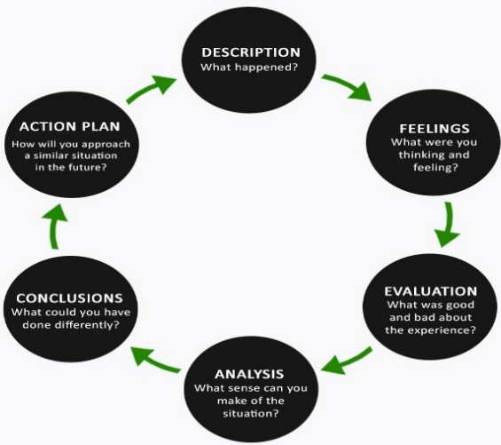

I received a call from force control requesting my call sign to attend an emergency on the town regarding an unknown male refusing to leave a gambling arcade in the early hours of the morning. When we arrived the male was still refusing to leave and appeared to be very drunk and aggressive, a member of staff had stated that the male had been hitting the slot machine he had been playing after losing, as well as physically resisting staff trying to escort him off the premises. After being initially uncooperative and refusing to leave until he received his losses back, I was able to convince the male to come outside and talk to me. I firmly told the male he was being asked to leave the premises and that his behaviour may result in myself arresting him for a breach of the peace should he return.
Breach of the peace is an all-encompassing common law offence providing police grounds to control and prevent any public disorder (Finch & McGroarty, 2010).
Once I had built a rapport with the male, he told me he felt he had been taken advantage of and that he should be reimbursed because he had a gambling addiction and was self-excluded from the premises. I told him not to return to the premises and that he should go home with his cousin as he appeared quite drunk and he had lost money gambling. The male made another attempt to enter the property at which point I had to reiterate to the male that if he did not leave the premises he would be arrested at this time my colleague attempted to escort the male away from the front door of the premises. The male became hostile towards my colleague, accusing him of being racist at this point I objected to the accusation as my colleague had dealt with the male who was Muslim and of Pakistani origin fairly and had made no comment or action that would be deemed discrimination. After we kept a presence on the door the male complied with the instruction and left the area to go home.

Communication Skills

When walking into the premises we had little information on the behaviour we could expect from the subject, as the male was unknown at this time so no PNC checks could be conducted to confirm any warning markers making me feel uneasy and alert to the possibility of danger. As I entered the premises the subjects were arguing with a member of staff for the arcade, shouting that they wanted their money back. When the male first saw us, he said “Are you going to arrest me without letting me speak, I’m not going anywhere!”. I measured my response to be firm in removing the male from the premises in line with the wishes from the staff who had called the police and to be calm whilst attentive so I told the male “You’ve been asked time leave sir so come with me outside and you can tell me your side out there”, the male complied with my instruction. In my initial and overall interactions with the male I considered and applied the principles of Betari’s box.

Figure 2: The Betari Box Model (Mind Tools, 2017).

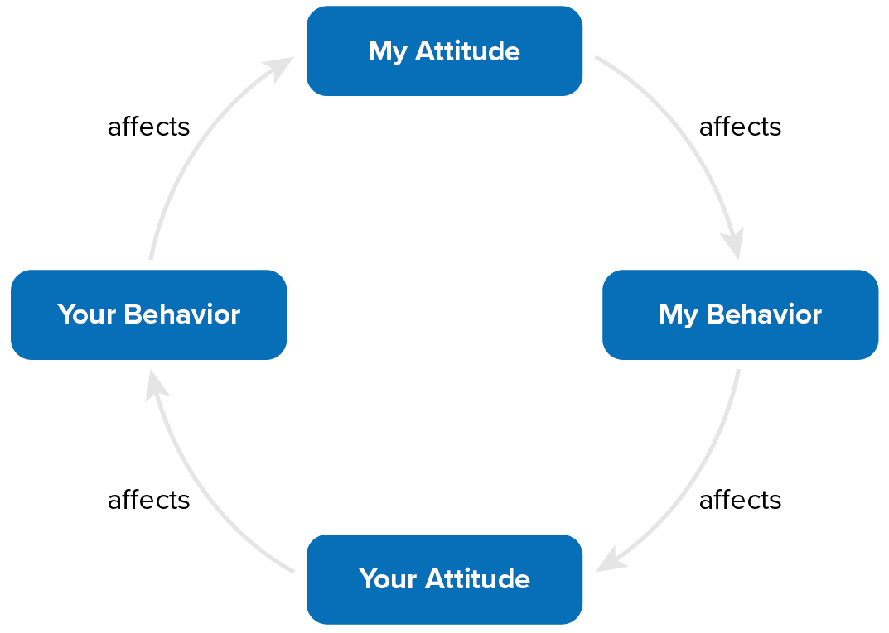

The Betari Box, seen in figure 2, is a model that helped me understand the impact that my attitude and behaviours have on the attitudes and behaviours of the people I interact with (Mind Tools, 2017). In the provided scenario I considered how my initial approach and conversation with the male would affect his compliance for instance if my initial request for the male had been angry and impatient the already aggressive male would have likely escalated whereas to break this negative cycle I tried a more empathetic approach. This approach was beneficial as the male deescalated his aggressive mood and complied, likely feeling I had considered his request to hear him out and thus feeling listened too. I then used open questions to allow the male an opportunity too explain what had happened.

I listened to the male tell me why he felt aggrieved, he told me he had lost £500 at the slot machine and naturally felt angry at the loss but as he was drunk he was belligerent about the loss and took his frustration out by hitting the machine and shouting at the staff. I used techniques such as active listening; keeping eye contact, nodding or confirming I had heard his points and using these techniques made the male feel listened too and subsequently the male’s mood became more placid (MTD Training, 2010, pp48).

Managing Conflict

Throughout managing the situation, I applied the national decision model (NDM) to ensure my actions were in keeping with the standards and principles of, the NDM has six key elements (College of Policing, 2014b).

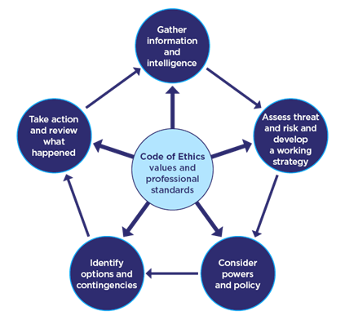
Figure 3 The National Decision Model: (College of Policing, 2014b).

- Code of Ethics.
- Gather information and intelligence.
- Assess threat and risk and develop a working strategy.
- Consider powers and policy.
- Identify options and contingencies.
- Take action and review what happened.

My treatment of the male was respectful and fair, consistent with the code of ethics in respecting the male’s human rights, however as the male had made an attempt to re-enter the premises after being told this would result in a breach of the peace myself and colleague were required to use force to escort him away, this was within our powers and merely required we turn the male away as it was proportional to the offence we were preventing (College of Policing, 2014a). If we had not intervened the male would likely have escalated and in turn the staff of the premises who had remained content with just seeing the male removed as a resolution would likely have made a complaint requiring the males arrest for his behaviour. To turn the male away we took a hold of each shoulder and walked the male away, the male became aggressive once again in response to my colleague becoming impatient and angrily saying “ You have already been told, now leave or you will be arrested for a breach of the peace”.

In hindsight this loss of patience from my colleague exacerbated the situation the male in turn became belligerent as he was before speaking with myself, furthermore the male now believed he was being treated unfairly. This was not the case however as the total workforce of the police is only 4.3% Asian and all the officers in attendance were white, a lack of representation can make the public feel discriminated against and in certain instances victimised (College of Policing, 2017).

This fed into a narrative for the male who in this instance was a perpetrator who sought to blame others for the role they played in the situation, I had stated to the male that if he had self-excluded himself from the arcade that he should never return given his gambling and financial issues as well as stating he had a responsibility for his own conduct if he wished to gamble and risk losing money this relationship between perpetrator, victim and rescuer is outlined in Karpman’s Drama Triangle.

Figure 4 Karpman’s Drama Triangle (Assured Strategy, 2019):
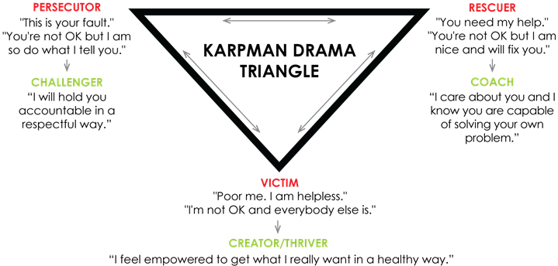

Using my emotional intelligence as an ability to understand my own feelings and those of others, enables me to handle those feelings well. People who have high emotional intelligence are good at identifying and meeting the needs of others while taking responsibility for their own needs and feelings (Doyle, 2020). By suppressing my own conflict provoking behaviours like impatience and frustration we were able to negotiate with the male that he would finally leave and not return.

Valuing Difference and Inclusion

Throughout my interactions with the male I was aware that British Asian men can feel as though the perception of them as inherently suspicious has become normalised and therefore the male may have felt victimised (Millings, 2013). In reflection building a rapport with the male was an effective de-escalation strategy that made the male respond more compliantly to my instructions however this took longer to establish and as the male was highly distracted and drunk the longer, he was present at the scene the higher the likelihood that the male may offend. It would have been more prudent to use dispersal powers to move the male along earlier and reduce the risk of the male becoming more challenging. Although the resolution reached required minimal use of force on account of the communication skills and de-escalation strategies used, if I had been more firm there would have been a higher likelihood that the male would have been more aggressive in response and could have led to an arrest. Fortunately no offences requiring an arrest were committed during the incident, through use of my discretion I was able to decide if this male required arresting using my professional judgement (Bryant & Bryant, 2021), however the behaviour of the male was borderline on the verge of requiring arrest he eventually complied with our instructions.

Word Count: 1554 (with citations) / 1512 (without) citations

Task 3

Relevant areas of the National Policing Curriculum:
Criminal Justice, Valuing difference and inclusion

You must choose a policing incident in which you played a significant role with an offender/service user/victim and reflect on what happened.

Give a brief description of a relevant incident including social and legislative contexts and any relevant cultural, ethnicity and language issues.

Explain and reflect on your responsibilities and procedures in line with the relevant Codes of Practice to support victims and witnesses through the criminal justice system.

Illustrate how policing values were engaged, as well as any other considerations including culturally sensitive practice and language preference.

1500 words (+/- 10%: include your actual word count at the end of each section)

ANSWER:

To structure my answer, I will be using the Kolb reflective model illustrated in Figure 1, as it highlights the link between experiences, feelings, thoughts, and behaviours, providing a holistic overview of the learning process and helps users to understand the links. Furthermore, it can be used to develop emotional intelligence and resilience more generally (Essay Writing Service UK, 2022).

Figure 1: The Kolb Reflective Cycle (Essay Writing Service UK, 2022).
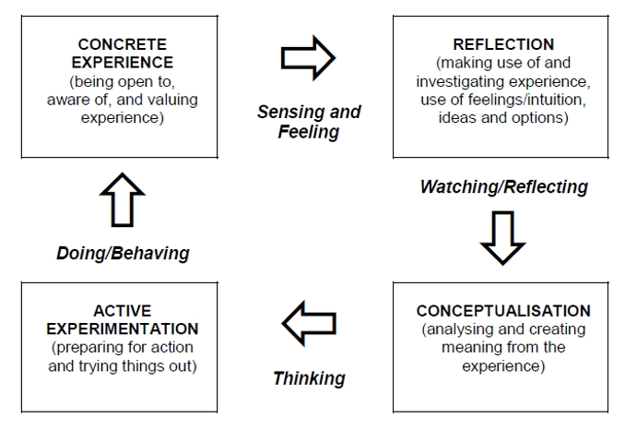

I attended a priority call in which the caller had stated an ex-partner had assaulted her and that she had fled home. The perpetrator whom she had stated had domestic violence and mental health markers and was known to police as I was able to view the relevant information on the call log. She had been assaulted by her former partner whilst walking home with her 2-year-old. The victim had been awaiting officers from in the afternoon who had been diverted, however as we were allocated the call within an hour of the of the target response time, we attended straight away to ensure the we met the grade 2 response time. Victims have a protected right under the Victims code to have details of a crime recorded by police as soon as possible after an incident, with a further requirement to provide a witness statement or be interviewed, victims have the Right to be provided with additional support to assist them through this process (Ministry of Justice, 2021). In this instance when taking the statement I asked the victim if she would be willing to attend court and if so, what measures could be put in place to make attending court more comfortable for her, in which she disclosed that she would not want to see the offender and would prefer to have the use of a video link to give testimony. I recorded this into my details on the pre statement form as the victim appeared fearful, which I was also able to capture in a victim personal statement and DASH form to support this. The victim personal statement would allow the victim to tell the court how the incident, voicing how affected they have been before considering the sentencing of the offender.

The victim was scared when we arrived and had been awaiting police to attend with the lights off in the hope that If the perpetrator arrived at the address, he would not try to get in thinking no one was home. When speaking with the victim I made use of active listening and empathic tone of voice to make her feel safer and listened too in an effort to be emotionally aware of how the victim was feeling. As a guide on how to interact and meet the needs of the victim I tried to incorporate the Competency and Values Framework into my dealing with the incident by conducting my service and the values that underpinned my behaviour as a foundation of my thought processes using empathy as a means of building a rapport when listening to the victim (College of Policing, 2016).

Figure 2: The Competency and Values model (College of Policing, 2016).
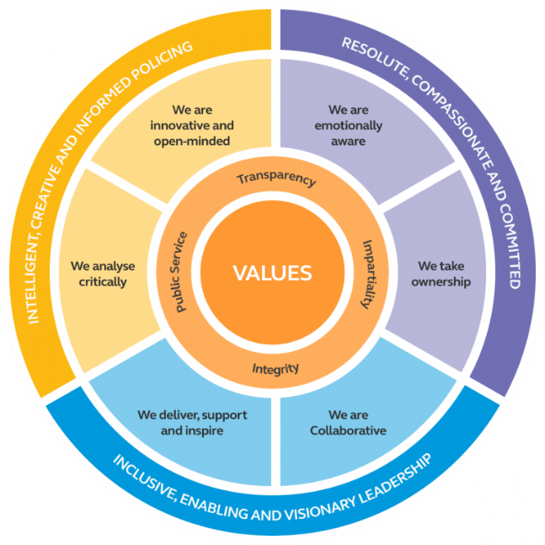

I was aware that a statement and Domestic Violence and Abuse Risk Identification, Assessment and Referral Form (DASH) would be necessary, firstly I asked the victim what they wanted from police action, the victim made me aware that she supported police action to arrest the male and that she wanted a restraining order against him, adding she wouldn’t feel safe until the offender was arrested. The victim gave consent for information to be shared with partner agencies such as women’s aid and social services and I advised that I would be making a public protection notification report for child concern in the relevant child concerned authorities for the area. Within the victim’s code there is a guarantee to be referred to services that support victims, including the right to contact them directly for the victims needs to be assessed so services allowing for support to be tailored to the individual. If eligible, this can include specialist support and additional support available at court, for example special measures (Ministry of Justice, 2021).

To support the victim, I safety planned her in the hope to prepare her for any potential encounter with the offender at her home as well as make her feel more secure by giving her control over her own safety. As having a safety plan can help a victim protect themselves and their children It helps to plan what to do in the case of future violence or abuse (IDAS, 2021). I advised the victim to call 999 should the offender return, as well as keep their mobile fully charged and in reach at all times, I also recommended that they have a friend or relative stay with them this night as they were fearful.

I used active listening and an empathic tone when dealing with the victim as this helped the victim open up, active listening helps to develop an understanding, and it builds a bond of empathy between myself and the victim I was listening to by maintaining eye contact and using reassurance when writing in my pocket note book that I was still listening by giving appropriate feedback (Altura Learning, 2017).

When following on with our inquiries we attended two address associated with the male, one belonging to his mother in which we were invited to search the premises and another an abandoned former address for which we did not have authorisation to enter for the purposes for a search although we were able to knock the door of the address and make house to house enquiries to see if anyone had witnessed the male attend the address. We considered the powers present under code B of PACE codes of practice which covers the search of premises by police officers and the seizure of any property found, as this provides guideline on how to protect a person rights in relation to the conduct of the search (Bryant & Bryant, 2021, pp69). Furthermore we considered that should we locate the male or someone matching the description given by the victim we would have grounds for a search of their person and potentially an arrest as Code G of PACE covers the statutory power of arrest by police officers, outlining the correct procedures for arresting a person (Bryant & Bryant, 2021, pp69).

As we had exhausted all lines of inquiry during our efforts to resolve the incident with an arrest of the offender we decided to update the victim of the progress of our investigation, we were keenly aware that the victim had stated they would not be able to rest while the offender was still at large and wanted to be updated of our progress as they knew we had hoped to find and arrest the individual at the associated addresses. As part of the victim code provided the victim with a right to be updated on their case and to be told when important decisions are taken, with a further right at certain stages of the justice process, to ask for decisions to be reviewed by the relevant service provider (Ministry of Justice, 2021). The victim appreciated this update and appeared to feel supported by the fact that we had made her aware of the developments in the investigation, these details were also updated to the NICHE occurrence as a matter of record and to provide a background of actions taken for any other officers that would be involved in the investigation in the coming days.

Furthermore, updating victims is an important part of observing policing values by giving an accurate representation of my actions and recording these actions and by being clear and comprehensive when communicating with others displays transparency of myself as a police officer and the criminal justice system in action (College of Policing, 2016).

The Equality Act 2010 represents the culmination of years of debate about how British equality law can be bettered by offering individuals who would normally not have their cultural, language or other sensitive concerns met thereby giving such individuals stronger protection against discrimination (Lancashire Constabulary, 2022). The positive actions encouraged by the act include a range of measures and initiatives allowed under the Equality Act 2010, to actively encourage people from communities that are under-represented to engage with the criminal justice system (West Yorkshire Police, 2022). As the Victim was a welsh speaker who identified English as being their second language I was able to offer services including the attendance of a welsh speaker for the purposes of a statement of if they would require these services in court, however the victim identified that they were comfortable speaking in English as they were a fluent speaker but I reminded them they could request language services at anytime during the criminal justice process if this would be more comfortable for them.

In conclusion I felt we had supported the victim as best we were able by submitting all the relevant safeguarding paperwork and alerting all the necessary supporting service agencies of the incident and by ensuring with the victim that all their needs were being met.

Word Count: 1527 with Citations/ 1476 without citations.

Task 4

Relevant areas of the National Policing Curriculum:
Decision making and discretion, Conducting Investigations and Criminal Justice (Managing offenders)

You must choose a policing incident in which you played a significant role with an offender/service user/victim and reflect on what happened.

Give a brief description of the situation including social and legislative contexts and any relevant cultural, ethnicity and language issues. Reflect on how you applied the National Decision Model (NDM) to assist in resolving this incident. Consider the role of discretion in the decision-making process.

Explain your responsibilities with regards to the provision of the CPIA when conducting this investigation including when managing the offender and suspects and recording and retaining significant information.

Illustrate how policing values were engaged particularly through an analysis of the potential impact of bias on the decision-making process.

1500 words (+/- 10%: include your actual word count at the end of each section)

ANSWER:

To structure my answer, I will be using the Kolb reflective model illustrated in Figure 1, I have chosen this model to facilitate my learning as the model helps to identify gaps in skills and attitudes in order to facilitate continued professional development.

Figure 1: The Kolb Reflective Cycle (Essay Writing Service UK, 2022).

I attended an emergency call in the company of several officers, where the caller who was known to police had made an accusation that a male had thrown her out of his address. The caller was flagged with domestic violence markers as well as the alleged offender, therefore officers blue lighted to get to the address as quickly as possible because of the potential risk involved and the 15-minute target time. When we arrived, a female was outside the address in a state of distress, a male was stood in the upper window of the address. Officers began speaking with the female to discover what had happened and to check on her well-being. During this time, I spoke with a nearby neighbour who had signalled to get my attention, in order to gather information and intelligence on the incident as part of my decision making using the national decision model (NDM) (NHS, 2014b) I spoke with the neighbour to understand what had happened. She was able to show us video footage she had taken, clearly showing the female throwing projectiles as well as shouting threats and abuse at the male inside, I asked the neighbour if she would be willing to produce this as evidence and attend court which she confirmed she would.

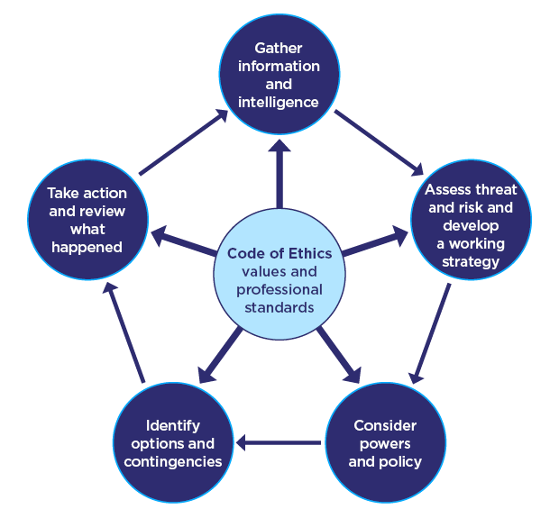

Figure 2: The NDM model (College of policing, 2014b).

At this time the officers in the presence of the female had spoken to the male through the window of his address in which he stated she had been throwing his doorstop at his windows resulting in visible damage. We relayed onto the officer’s present with the caller what we had seen recorded on the neighbour’s phone confirming the males account. Speaking with witness it became clear that the caller had committed offences of criminal damage and threats to kill while the male had in fact committed no offences. The necessity for an arrest in this instance was to prevent damage or loss to property as the female had already damaged a window of the address and to allow a prompt and effective investigation which would entail taking statements, making house to house enquiries and completing a DASH form to support a subsequent interview.

The female became aggressive and required officers to get hands on to prevent her leaving the scene, as the caller became more aggressive, she was escorted to the police van and arrested initially for a breach of the peace, subsequently the subject was further arrested for the offences of criminal damage. My colleague cautioned the caller and informed her of the offence for which she was being arrested as well as the necessity for her arrest before conveying the subject to custody. After securing the subjects detention in custody I attended the address to check on the male’s welfare, complete a statement and DASH form and gather an exhibit statement from the neighbour.

During the incident there were several elements to consider and take appropriate action on, Firstly, we were made aware that the female subject was pregnant and when using force to restrain her I operated in line with the code of ethics, using only the minimum amount of force necessary to achieve the required result (College of Policing, 2014a). When the female became aggressive and actively resisted arrest the use of force used by us as arresting officers had to be proportional and justified, in keeping with the application of human rights act in everyday policing by which I considered the pneumonic JAPAN as well as JPLANE (Bryant & Bryant, 2021, pp63-64). We were careful to prevent injury to the female avoiding any contact with her abdomen and conscious during her restraint of asphyxiation. The use of restraint became necessary in conveyance to custody as the subject began to violently bang their head against the cage of the police van.

During the female’s arrest she made a significant statement about only throwing a small stone at the window of the address and that the damage to the window was damage from another time she had thrown a stone at the window. This significant statement was recorded on my body worn video (BWV), this statement came after the female was cautioned and thus was capable of being used as evidence (Health and Safety Executive, 2022).

The arrest of the female was permissible and necessary under The Police and Criminal Evidence Act 1984 (PACE), Code G of the PACE codes of practice gave us as police officers the statutory powers of arrest, maintaining we follow the correct procedures for the relevant person so that their liberty is considered at all times and that proper justification was given for arrest (Bryant & Bryant, 2021, pp69).

Before we left as a developing strategy, we spoke with the male to check on his welfare and to advise of a safety plan as well as confirm we could return for a statement from himself and neighbour. The purpose of managing the investigation by a direct and conduct investigative actions to gather the maximum amount of material which may generate further lines of enquiry and establish the impact of the incident on the community (College of Policing, 2021).

Once custody of the subject was authorised, I returned to the address to record and retain any significant information. The Managing of police information requires data to be gathered and processed in a secure manner, that the information is gathered for specified and legitimate purposes as well as being processed lawfully and fairly (Bryant & Bryant, 2021, pp89). The victim and witness agreed to give statements and attend court if required providing a signature as legal verification, the information I gathered was a routine collection in line with specific requirements for its recording and use, as is the case with information covered by the Regulation of Investigatory Powers Act 2000 (College of Policing, 2019).

Furthermore, I offered to complete a Domestic Violence and Abuse Risk Identification, Assessment and Referral Form (DASH) with the male who accepted as this was relevant to the domestic nature of the incident, gaining consent from the male allowed me to complete this form in order to share the information with relevant partner agencies. When speaking with the neighbour I was able to gather an exhibit statement including video footage of the subjects offences and statements made by the subject, retention of material is a duty for attending officers to obtain material for use in the criminal investigation (Ministry of Justice, 2015). Furthermore, to ensure all lines of inquiry had been exhausted before interviewing the suspect house to house enquiries were conducted to identify suspects and canvas for witnesses in areas connected to an incident (College of Policing, 2020).

When preparing the interview for the subject a disclosure was prepared, the disclosure procedure begins with the interviewing officers making a list of the supporting evidence they have gathered during the investigation and giving the verbal or written disclosure to the subject or their solicitor if present (Polykarpou, 2022). The interviewing process was explained to the defendant within an aide memoire explaining that the interview would be recorded audially and was evidential in accordance with Code E of PACE which sets out that the data of the recording must be handled securely (Bryant & Bryant, 2021, pp69). The defendant was subsequently released pending CPS review, with bail conditions not to return to her ex partners address upon concluding the interview.

In reflection I have analysed how we dealt with the incident and considered what role bias played or could have influenced the actions we took. Our initial call came from a female who we eventually identified as the offender in this incident, however if we had not been impartial in this instance bias could have led to a different outcome. When I consider my use of discretion the female was abusive and their attitude towards police negative, while the male in his bedroom window had been calm and co-operative despite being initially being suspected to be an offender but eventually identified as the victim. In terms of an attitude test the subject’s behaviour became aggressive and it was in the public interest to arrest her. However, I should be mindful as it is likely to perpetuate problems if in future if I do not consider how people who regularly interact with police are likely to be more immune to warnings and will be more confident in challenging authority (Bryant & Bryant, 2021. pp81).

Also I considered how gender biased policing in the instance could have affected the outcome as if there had been an assumption of the male as the abuser we would have Failed to properly investigate or misclassified the domestic violence element before a full investigation was conducted because of the victim’s gender, sexual orientation, dress, sexual history, criminal history, emotional state, or appearance (ACLU, 2016). I conclude that the conduct of myself and other officers evidenced fairness and objectivity as our choices on the evidence and our best professional judgement guided our decision making and our treatment was fair.

Word Count: 1557 with citations/ 1492 without citations

Task 5

Personal Development Plan (PDP) / Learning Plan.

As part of your reflective process, please use this table to aid you in identifying the next steps for development. This is equivalent to 500 words. Please note that this not the actual number of words you need to use, the wordcount reflects the thought and research you put into it.

Identified area for development | How it will be achieved | Who can provide support? | Timeline
Improve communication skills with offenders, victims, witnesses and control. | Leading conversations with service users, victims, witnesses and offenders. Speaking/updating control for all the calls I attend. Reviewing literature on communication and making use of active listening and recording. | My tutor, my sergeant and my fellow police constables. | As I will be expected to communicate independently once signed off as independent my goal is to complete this goal by 22nd of June
Build a case file independently | Assisting in the building of a case file when a handover is given to a member of my team. Followed by taking a handover and independently completing any relevant MG5. I also have practice examples of completed case files that I can review and blank examples I can complete and have my tutor evaluate. | My tutor, my sergeant and my fellow police constables. | As I will be expected to complete case files once signed off as independent my goal is to complete this goal by 22nd of June
Preparing and leading an interview of a suspect Independently. | Allocating myself for handovers and independently planning the interview and leading the interview, introducing exhibits and updating the NICHE occurrence independently. Also debriefing the custody sergeant in regard to offences admitted to or denied. | My tutor, my sergeant and my fellow police constables. | As I will be expected to complete Interviews independently once signed off as independent my goal is to complete this goal by 22nd of June

Word count: 240
Bibliography
The bibliography should only include sources referenced within the workbook using the Harvard referencing system. Information about referencing in written assignments and how to avoid plagiarism can be found on Moodle. It is important that you are aware of the importance of ensuring that the work submitted is your original work.
References

Altura Learning. (2017). The Power of Active Listening: How To Show Empathy And Understanding. [Online]. Available at: https://www.alturalearning.com/the-power-of-active-listening-how-to-show-empathy-and-understanding/. (Accessed 1st June 2022).

American Civil Liberties Union, (2016). Understanding Gender-Biased Policing: Police Misconduct, Domestic Violence, and Sexual Assault. [Online]. Available at: https://www.aclu.org/sites/default/files/field_document/aclu_memounderstanding_gender_biased_policing2016_0.pdf#:~:text=In%20this%20era%20of%20reform%2C%20new%20attention%20must,between%20law%20enforcement%20and%20the%20communities%20they%20serve. (Accessed on 31st May 2022).

APA Help Center. (2004a). The Road to Resilience. [Online]. Available at: http://www.apahelpcenter.org/dl/the_road_to_resilience.pdf. (Accessed 22nd April 2022).
APA Help Center. (2004b). What Is Resilience? [Online]. Available at: http://www.apahelpcenter.org/featuredtopics/feature.php?id=6&zch=2. (Accessed 22nd April 2022).
Assured Strategy. (2019). Workplace conflict – how to manage employee drama through a new lens. [Online]. Available at: https://www.assuredstrategy.com/workplace-conflict-how-to-manage-employee-drama-through-a-new-lens/. (Accessed 20th May 2022).

Bryant, R & Bryant, S. (2021). Blackstone’s Handbook for Policing Students. Fifteenth Edition.
Oxford: Oxford University Press.

College of Policing. (2014a). Code of Ethics. [Online]. Available at: code_of_ethics.pdf (college.police.uk). (Accessed 20th May 2022).

College of Policing. (2014b). National decision model. [Online]. Available at: https://www.college.police.uk/app/national-decision-model/national-decision-model. (Accessed 20th May 2022).

College of Policing. (2021). Managing investigations. [Online]. Available at: https://www.college.police.uk/app/investigation/managing-investigations. (Accessed on 31st May 2022).

College of Policing. (2020). House-to-house enquiries. [Online]. Available at: https://www.college.police.uk/app/investigation/investigative-strategies/house-house-enquiries. (Accessed 31st May 2022).

College of Policing. (2019). Collection and recording. [Online]. Available at: https://www.college.police.uk/app/information-management/management-police-information/collection-and-recording. (Accessed on 31st May 2022).

College of Policing, (2017). Valuing Difference. [Online]. Available at: Valuing Difference.pdf (college.police.uk). (Accessed 20th May 2022).

College of Policing. (2016). Competency and Values. [Online]. Available at: https://d17wy4t6ps30xx.cloudfront.net/production/uploads/2017/09/Competency-and-Values-Framework-for-Policing_4.11.16.pdf. (Accessed 1st June 2022).

Department of Health. (2005). Self-care – A real choice self-care support – A practical option. [Online]. Available at: http://www.dh.gov.uk/PublicationsAndStatistics/Publications/PublicationsPolicyandGuidance/PublicationsPolicyAndGuidanceArticle/fs/eh?CONTENT_ID=4100717&chk=Khgu1l. (Accessed 22nd April 2022).
Doyle, A. (2020). Conflict Management: Definition, Skills, and Examples. [Online]. Available at: https://www.thebalancecareers.com/conflict-management-skills-2059687. (Accessed 20 May 2022).

Duncan, E. (2009). Skills for Practice in Occupational Therapy. 1st Edition. Edinburgh: Churchill Livingstone Elsevier.
Essay Writing Service UK. (2022). Kolb Reflective Model. [Online]. Available at: Kolb Reflective Model (essaywritingserviceuk.co.uk). (Accessed 30th May 2022).

Finch, V & McGroarty, J. (2010). Human Rights Law Essentials. [Online]. Available at: http://www.jstor.org/stable/10.3366/j.ctt1g0b4pb. (Accessed 20 May 2022).

Gibbs, G. (1988). Learning by Doing: A guide to teaching and learning methods. Oxford: Oxford Polytechnic.
GOV.UK. (2022). Police and Criminal Evidence Act 1984 (PACE) codes of practice. [Online]. Available at: https://www.gov.uk/guidance/police-and-criminal-evidence-act-1984-pace-codes-of-practice. (Accessed 30th May 2022).
Health and Safety Executive. (2022). Interviewing suspects. [Online]. Available at: Questioning of suspects - Investigation - Enforcement Guide (England & Wales) (hse.gov.uk). (Accessed 30th May 2022).
IDAS. (2021). Safety Plan. [Online]. Available at: https://www.idas.org.uk/our-services/domestic-abuse/safetyplan/#:~:text=Plan%20how%20you%20would%20respond%20in%20an%20emergency%3A,there%20is%20a%20way%20...%20More%20items...%20. (Accessed 1st June 2022).
Lancashire Constabulary. (2022). Valuing Difference & Inclusion. [Online]. Available at:https://www.lancashire.police.uk/about-us/our-commitment/valuing-difference-inclusion/. (Accessed 1st June 2022).
Mayo Clinic. (2020). Stress Management. [Online]. Available at: Exercise and stress: Get moving to manage stress - Mayo Clinic. (Accessed 22nd April 2022).
Millings, M. (2013). Policing British Asian Identities: The Enduring Role of the Police in Young British Asian Men’s Situated Negotiation of Identity and Belonging. [Online]. Available at: https://doi.org/10.1093/bjc/azt041. (Accessed 20th May 2022).

Mind Tools. (2017). Betari Box. [Online]. Available at: Betari Box - Communication Skills Training from MindTools.com. (Accessed 20th May 2022).

Ministry of Justice. (2015). Criminal Procedure and Investigations Act 1996 (section 23(1) Code of Practice. [Online]. Available at: https://assets.publishing.service.gov.uk/government/uploads/system/uploads/attachment_data/file/447967/code-of-practice-approved.pdf. (Accessed 30th May 2022).

Ministry of Justice. (2021). Code of Practice for Victims of Crime in England and Wales (Victim's Code). [Online]. Available at: Code of Practice for Victims of Crime in England and Wales (Victim's Code) - GOV.UK (www.gov.uk). (Accessed 1st June 2022).

MTD Training. (2010). Effective Communication skills. Coventry: Ventus Publishing.

NHS. (2018a). Benefits of exercise for mental and physical health. [Online]. Available at: Benefits of exercise and mental health (cntw.nhs.uk). (Accessed 22nd April 2022).

NHS. (2018b). 10 Stress Busters. [Online]. Available at: 10 stress busters - NHS (www.nhs.uk). (Accessed 22nd April 2022).
NHS. (2020). Short- and Long-term effects of stress. [Online]. Available at: Short and Long term effects of stress (nhsbt.nhs.uk). (Accessed 22nd April 2022).
Polykarpou, M. (2022). Prosecutorial and Police Disclosure Ethics in Criminal Evidence Review in the UK and the US. [Online]. Available at: Prosecutorial and Police Disclosure Ethics in Criminal Evidence Review in the UK and the US. A Compa (uwtsd.ac.uk). (Accessed 30th May 2022).
Ozbay, F et al. (2007). Social Support and Resilience to Stress. [Online]. Available at: Social Support and Resilience to Stress - PMC (nih.gov). (Accessed 25th April 2022).
The National Archives. (1996). Criminal Procedure and Investigations Act 1996. [Online]. Available at: Criminal Procedure and Investigations Act 1996 (legislation.gov.uk). (Accessed 30th May 2022).
The National Archives. (2003). Criminal Justice Act 2003. [Online]. Available at: https://www.legislation.gov.uk/ukpga/2003/44/contents. (Accessed 1st June 2022).

West Yorkshire Police. (2022). Valuing difference. [Online]. Available at: https://www.westyorkshire.police.uk/about-us/diversity-equality-and-inclusion/valuing-difference. (Accessed 1st June 2022).

CONFIDENTIALITY and PLAGIARISM – Will be confirmed through Turnitin.
Recognition and Confirmation of the progress on the Occupational Competency Portfolio (OCP).

By signing the section below you are acknowledging your progress on O.C.P. This is recognised by the university as work that is fully supporting this module and is equivalent to 500 words towards the overall wordcount.

I confirm that I am progressing with the Occupational Competency Portfolio (OCP) in accordance to the regulations.

Signed: _ Michael Pearce_ _ (Learner - Electronic signature or type name)

Date: _ _ _05/06/2022_ _ _ _

