

Module name: The Global Business Environment
Module code: LCBB4005
Lecturer: Dr. Uwaoma Ochonogor
Individual project report
Name: Gurduz Ana
Student no: 2029605

Table of Contents
1. Introduction 3
2. Company Overview 4
3. Five Critical Global Factors of the Macro-environment of China 5
3.1 Demographic 5
3.2 Economic 5
3.3 Political 6
3.4 Ecological 7
3.5 Socio-Cultural 8
4. The Comparative Advantage of China using two factors of Porter’s Diamond Model 10
4.1 Demand Condition 11
4.2 Related and Supporting Industries 12
5. Conclusion 13
6. References 14

1. Introduction
To expand the business in a new country, analysis of the macroenvironmental factors of the countries can help the company to make decisions effectively. This report focuses on the global business environment will discuss a small company name “Dr Will’s” which is a food and beverage company operating in the UK serving customers with different food products. The first part of this report will analyse the critical global factors of the macroenvironment of China. And the last part will analyse the comparative advantage of China through using a model. Furthermore, China has the highest rate of greenhouse gas emissions of any nation on the planet. China is the world's biggest coal producer, and it uses more coal than any other nation. As a result, many non-profit organisations have urged China to decrease greenhouse gas emissions by enforcing stringent corporate rules (Gan, 2021).

2. Company Overview
“Dr Will’s” is a food and beverages company that manufactures different kinds of sauces for the customers of the UK. The main products of “Dr Will’s” are sauce and mayonnaise. Different kinds of sauces are made with natural products which are both healthy and tasty. The company claim itself as the first UK based company to produce products with all-natural ingredients (dr-wills.com, 2021).

Figure: Logo of “Dr Will’s” (dr-wills.com, 2021)
Mission
To capture the target market
Vision
To reach the top leading position

3. Five Critical Global Factors of the Macro-environment of China
The global business environment is very complex compared to the local. For this reason, businesses face much trouble in expanding their business operation in a new country. Every country of the world has different political, social, economic factors that differ the country from others. For this reason, companies assess the country and the capability of the company before expanding the operation in a new country. As “Dr Will’s” wants to expand the business operation in China in the next year, the company needs to assess the global factors of the macroenvironment of China. So, the next section will analyse the macroenvironmental factors of China (Ahlstrom et al., 2018).

3.1 Demographic
China is one of the largest populated countries in the world where more than 1.4 billion people live. The youth population of China is relatively smaller because of the birth policy used by the Chinese people. For this reason, it can impact the demand for the products of “Dr Will’s”. Also, the population growth rate of China is 0.59% which should be understood by “Dr Will’s”. Life expectation rate 77.5 years which is comparatively higher. 59.7% of people of China live in urban areas which can increase the sale of the products of “Dr Will’s” (Gan, 2021).
Shanghai city of China has the largest population where more than 20 million people live. As a result, it will help “Dr Will’s” if the company targets these cities like Shanghai, Beijing, etc. From the total population, around 91.11% of people of China are Han Chinese and others are different minorities. So, by focusing on the Han Chinese, who are the original native of China, “Dr Will’s” can develop the marketing strategies for attracting customers (Chen et al., 2017).

3.2 Economic
China has one of the biggest economies in the world. The GDP of China is 14.72 trillion US dollars which is one of the largest GDPs in the world. The current unemployment rate in China is more than 6. Because of the large economy it will very profitable for “Dr Will’s” to expand the business in China. Although the global pandemic hit China very hard, the company has recovered from the negative impact of the global pandemic and now developing the country. Because of having great relationships with the UK, China provides economic facilities to the businesses of the UK (Wu et al., 2020).
China's unemployment rate is now above 6%. Because of the huge economy, expanding the company in China will be extremely lucrative for "Dr Will's." Despite the fact that China was struck particularly hard by the worldwide pandemic, the business has recovered and is currently expanding the nation.
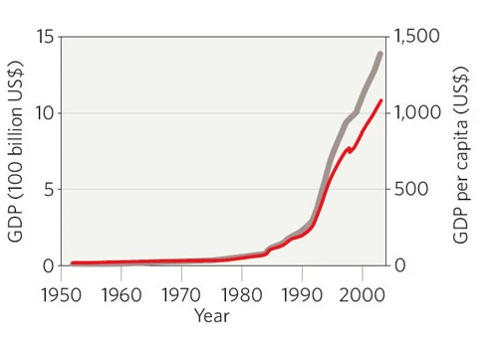
Figure: GDP of China (Zeng et al., 2018)
In this aspect, “Dr Will’s” will get help from China to expand the business operation. Many renowned companies around the world have direct and indirect operations in China because of the economic advancement of the country. For this reason, “Dr Will’s” can gain more profit through expanding the operation in China rather than expanding the business in other countries (Shan et al., 2018).

3.3 Political
China is one of the politically stable countries where the government supports foreign investment for the development of the country. As a developed country, China invites foreign companies and foreign investment for developing the country more. China is a socialist country where the country is run by a single party. For this reason, the violation and political problems are less in China. The rapid growth of the country because of technological advancement has made China an attractive destination for businesses (Gan, 2021).
As a result, China has developed good business relations with different countries of the world including the UK. As a result, this can help “Dr Will’s” if the company expand its business in China. Corporate tax rates in China are 25% which is 19% in the UK. This is the negative aspect of the governmental rules of China that can create a problem for “Dr Will’s” to operate profitably. Paying more taxes to the government will decrease the profit of “Dr Will’s” and the company needs to analyse this factor (Evans et al., 2020).

3.4 Ecological
The ecological condition of China is not good enough for the general people. Because of the modernisation and development of the country, the pollution rate in China is very high impacting negatively on the life of the people. Analysis of the macro-environmental variables of the nations may assist the firm in making successful choices while expanding its operations in a new country. In comparison to the local business environment, the global business environment is very complicated. So, businesses operating in China have to obey the strict rules of the government to protect the environment from further pollution. While expanding the business facilities in China, “Dr Will’s” needs to understand the regulations of the environment operate properly (Chen et al., 2019).
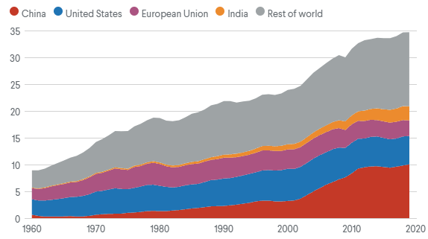
Figure: Environmental Pollution in China (Shen et al., 2019).
In addition, the greenhouse emission rate of China is larger than any other country in the world. China is the largest coal producer in the world and consumes coal more than any other country in the world. As a result, companies operating in China must adhere to the government's stringent regulations in order to preserve the environment from additional pollution. While developing company facilities in China, "Dr Will's" has to learn how to comply with environmental laws (Chen et al., 2019).
For this reason, different non-profit organisations advised China to reduce the emission of greenhouse gases by implementing strict regulations of the businesses. For this reason, the Chinese government now emphasises greatly on the regulations of environment protection. So, to expand the business operation in China properly, “Dr Will’s” needs to obey the environmental regulations of China (Gan, 2021)

3.5 Socio-Cultural
China is one of the friendliest countries in the world where the people emphasise harmony, honesty, wisdom, and loyalty, courtesy. The Chinese people are friendly towards the people of other countries. They like to do business and develop relations with the people of other countries. This will help “Dr Will’s” to expand the business operation in China and trade with the people of China. Chinese people like to work collectively. They emphasise teamwork rather than working alone. As a result, this must be ensured by “Dr Will’s” if they expand the business by using a foreign direct investment strategy. Also, Chinese culture focuses on giving gifts to the people (Li et al., 2018).
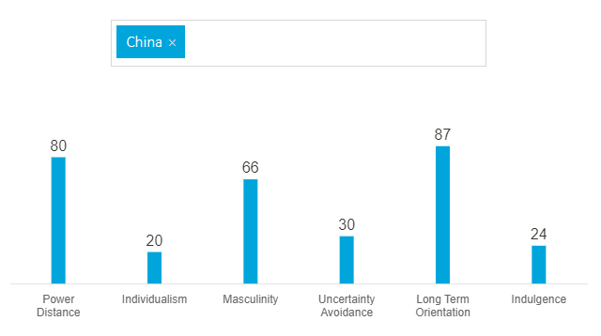
Figure: Hofstede Cultural Dimension of China (Ye et al., 2021).
For this reason, people give gifts to each other on different occasions to build and develop business relations. This understanding of the culture can help “Dr Will’s” to develop business relations with different partners, suppliers, etc. Another factor that should be understood by “Dr Will’s” is the acceptance of the power distance of the people of China. For example, the Chinese people understand the inequalities and they accept this without hesitation. So, this can help “Dr Will’s” in terms of managing the people in the company (Sawyer et al., 2017).

From the analysis of the critical global factors of the macroenvironment of China, it can be concluded that “Dr Will’s” should expand the business operation in China in the next year. In this regard, China will assist "Dr Will's" in expanding its commercial operations. Because of China's rapid economic development, many well-known businesses from across the globe have direct and indirect operations there. As a result, rather of growing the company in other countries, "Dr Will's" may make more money by increasing its operations in China (Shan et al., 2018).
China is one of the world's biggest nations, with a huge population and advanced technology. Many businesses from all over the globe desire to do business in China because of its political stability, technical capabilities, and pleasant consumers. As a result, the Chinese government now places a strong focus on environmental laws. As a result, in order to effectively grow its commercial operations in China, "Dr Will's" must adhere to China's environmental laws (Gan, 2021)
Because of the political stability of the country, positive economy, advanced technology and friendly environment of the country, “Dr Will’s” can achieve good profit if the company expand the business in China. Focusing on the appropriate strategies and developing good relations with the suppliers and different business partners in China, “Dr Will’s” can gain good market profit because of the consumption pattern of the country (Suntharalingam and Othman, 2017).

4. The Comparative Advantage of China using two factors of Porter’s Diamond Model
The comparative advantage of the country indicates the ability of the country to complete an activity more efficiently than others. Every country has some comparative advantage to produce some products or services better than other products. The businesses need to identify the comparative advantages of the country where they want to expand the business operation. It will help the company understand better about the country (Gan, 2021).
Understanding the comparative advantage and analysing the business pattern of the company will help “Dr Will’s” to decide whether the company should expand the business in China or not. To analyse the comparative advantage of China, one of the popular models which are Porter’s Diamond model can be used here. Through this model, the comparative advantage of China in terms of producing food and beverage items are analysed here which can help “Dr Will’s” to take decisions in terms of the business expansion in 2022 (Kharub and Sharma, 2017).
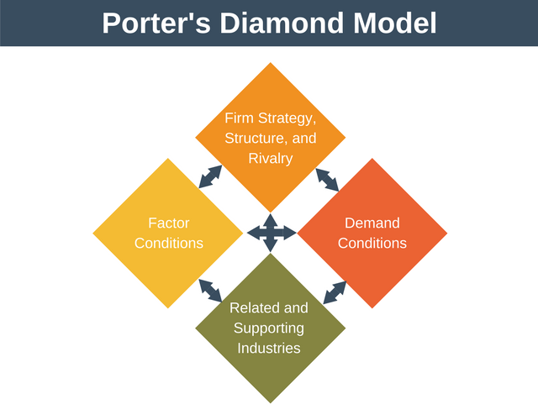
Figure: Porter’s Diamond Model (Zeng et al., 2018).
Porter’s diamond model is used to analyse the comparative advantages of the country through analysing the four factors of this model. By using two factors of this model which are Demand Condition and Related and Supporting Industries, the comparative advantage of China in terms of producing food and beverage items are identified below:

4.1 Demand Condition
China is a populous country where more than half of the people live in urban areas. As a developed country, most of the people are related to either manufacturing or service factors. For this reason, the people of China earn a good amount of money every year. The per capita income of the people of China is 17,200 PPP dollars which is comparatively higher than others. For this reason, the spending nature of the people is higher. As a result, the demand for food and beverage products is higher in China. Also, China has the largest population in the world. Because of this large population, the demand for food items is greater in China compared to other countries. Because of this higher demand for food and beverages in China, many countries from China and other countries serving the customers (Shan et al., 2018)
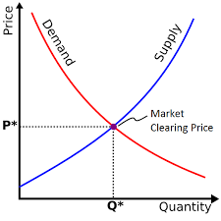
Figure: Demand Condition (Gan, 2021).
As result, it can help “Dr Will’s” to sell the products in China easily because of the higher demand condition of China. Because of this higher demand for foods and beverages, the companies operating in China are trying to develop the company through innovation and development. As a result, China will gain a comparative advantage soon. So, it will help “Dr Will’s” to expand the business in China because of the comparative advantage of the country in food and beverage. However, to cope with the innovation rate of China, “Dr Will’s” needs to develop proper strategies to compete with the food and beverages companies that is already operating in China (Evans et al., 2020).

4.2 Related and Supporting Industries
As stated earlier, China is an economically developed country where different industries are established enough to attract the businesses of different countries. It is a technologically advanced country where the cost of labour is very low. For this reason, China has a competitive advantage over other countries in terms of cheap labour and technological advancement. As a result, this competitive advantage is helping China to create a comparative advantage in many aspects. The food and beverage industry of China can gain a comparative advantage if the country wants to develop (Chen et al., 2019).
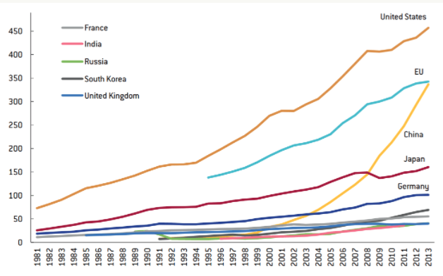
Figure: Technological Advancement of China (Shen et al., 2019)
According to the diamond model of Porter’s countries can develop comparative advantages if the related and supporting industries are established. Because of the technological advancement and cheap labour, China can gain a competitive advantage in the food and beverage industry which can help “Dr Will’s” to expand the business and operate in China properly. For example, the technological advancement of China can help “Dr Will’s” to produce and sell the products effectively. Also, the cheap labour in China can help “Dr Will’s” in terms of producing sauce and other products cheaply (Gan, 2021).
As a result, before extending operations in a new nation, businesses evaluate the country and their own capabilities. China offers economic advantages to UK companies as a result of its strong connections with the United Kingdom (Wu et al., 2020). As "Dr Will's" plans to grow its commercial operations in China in the next year, the firm must evaluate global macroeconomic variables in China. As a result, the following part will look at China's macro- environmental variables (Ahlstrom et al., 2018).

5. Conclusion
China is one of the largest countries with a vast population and technological advancement. Because of the political stability, technological facilities, friendly customers, many companies around the world want to establish a business in China. However, it is not an easy task to establish a business in China because of different macroenvironment factors compared to the UK. To expand the business in China, a company can use an appropriate expansion strategy by analysing the environment of the business. However, it is also important for the companies to understand the comparative advantage of the country where they want to expand. Assessment of the comparative advantage and analysis of the macroenvironment of China can help businesses to decide the business expansion process (Gan, 2021).

6. References
Ahlstrom, D., Yang, X., Wang, L. and Wu, C., 2018. A global perspective of entrepreneurship and innovation in China. Multinational Business Review.
Chen, C., Park, T., Wang, X., Piao, S., Xu, B., Chaturvedi, R.K., Fuchs, R., Brovkin, V., Ciais, P., Fensholt, R. and Tømmervik, H., 2019. China and India lead in greening of the world through land-use management. Nature sustainability, 2(2), pp.122-129.
Chen, Z., Dong, J. and Ren, R., 2017. Urban underground logistics system in China: opportunities or challenges?. Underground Space, 2(3), pp.195-208.
Erboz, G., 2020. A qualitative study on industry 4.0 competitiveness in Turkey using Porter diamond model. Journal of Industrial Engineering and Management, 13(2), pp.266-282.
Evans, T.S., Shi, Z., Boots, M., Liu, W., Olival, K.J., Xiao, X., Vandewoude, S., Brown, H., Chen, J.L., Civitello, D.J. and Escobar, L., 2020. Synergistic China–US ecological research is essential for global emerging infectious disease preparedness. EcoHealth, 17(1), pp.160-173.
Gan, J., 2021. Relationship Between Urban Biodiversity and Built Environment and in Macro Scale: The Case Study of Shanghai, China. In Urban Biodiversity and Built Environment (pp. 39-76). Springer, Singapore.
Great Tasting Natural Condiments | “Dr Will’s” (2021). Available at: https://www.dr-wills.com/ (Accessed: 18 October 2021).
Kharub, M. and Sharma, R., 2017. Comparative analyses of competitive advantage using Porter diamond model (the case of MSMEs in Himachal Pradesh). Competitiveness Review: An International Business Journal. Romel
Li, Z., Razali, M.N., Fereidouni, H.G. and Adnan, Y.M., 2018. Macro-economic index effect on house prices in China. International Journal of Housing Markets and Analysis.
Sawyer, W.C., Tochkov, K. and Yu, W., 2017. Regional and sectoral patterns and determinants of comparative advantage in China. Frontiers of Economics in China, 12(1), pp.7-36.
Shan, Y., Guan, D., Zheng, H., Ou, J., Li, Y., Meng, J., Mi, Z., Liu, Z. and Zhang, Q., 2018. China CO 2 emission accounts 1997–2015. Scientific data, 5(1), pp.1-14.
Shen, N., Liao, H., Deng, R. and Wang, Q., 2019. Different types of environmental regulations and the heterogeneous influence on the environmental total factor productivity: Empirical analysis of China's industry. Journal of Cleaner Production, 211, pp.171-184.
Suntharalingam, C. and Othman, M.F., 2017. Competitiveness of Malaysia’s fruits in the global market: Revealed comparative advantage analysis. Malaysian Journal of Mathematical Sciences, 11, pp.143-157.
Wu, H., Hao, Y. and Ren, S., 2020. How do environmental regulation and environmental decentralization affect green total factor energy efficiency: Evidence from China. Energy Economics, 91, p.104880.
Ye, S., Cheng, C., Song, C. and Shen, S., 2021. Visualizing bivariate local spatial autocorrelation between commodity revealed comparative advantage index of China and USA from a new space perspective. Environment and Planning A: Economy and Space, 53(2), pp.223-226.
Zeng, S., Jiang, C., Ma, C. and Su, B., 2018. Investment efficiency of the new energy industry in China. Energy Economics, 70, pp.536-544.

