Student Name: Tasmia bano
Student Id: 2433992
Moodle code: LCHS4009_BIRM
Moodle Name: professional development within health and social care
Lecturer Name: Hajira Mustasim

TABLE OF CONTENTS
Professional Identity, Employability Readiness, and Reflective Practice in Health and Social Care: A Skills-Based Portfolio for the Role of Healthcare Assistant 1
1. Introduction: Professional Context and Career Orientation 3
2. Task 1 : 3
2.1 Curriculum Vitae – Healthcare Assistant 3
2.2 Strategic Purpose of the CV in Health and Social Care Recruitment 5
2.3 CV Content Alignment with the Healthcare Assistant Role 6
3. Task 2 : Personal Statement: Employability Narrative for the Healthcare Assistant Role 6
3.1 Career Aims within Health and Social Care 7
3.2 Integration of Education, Experience, and Professional Values 7
3.3 Value Proposition to Employers 7
3.4 Critical Positioning and Evidence-Based Claims 8
4. Task 3 : 8
4.1 SWOT Analysis: Employability Readiness for the Healthcare Assistant Role 8
4.2 Personal Development Plan (Two-Year Horizon) 10
5. Task 4: Critical Reflection on LCHS4009 Component 1 Presentation Using Gibbs’ Reflective Cycle 10
5.1 Dscription of the Presentation (LCHS4009 Component 1) 11
5.2 Emotions and Preliminary Self-Perception. 11
5.3 Evaluation of Performance 11
5.4 Analysis Informed by Lecturer Feedback 12
5.5 Conclusion: Key Learning Outcomes 12
5.6 Action Plan for Improvement 12
References : 13

Introduction: Professional Context and Career Orientation

The reason why the Healthcare Assistant (HCA) position has been chosen is because the UK health and social care has experienced a persistent shortage of the workforce, and it is the core of delivering the frontline service. The position is like an informal caregiving experience in the past, which allows transferring such skills as communication, emotional resilience, and responsibility. The core sector values that are operationalized by HCAs are person-centered care, dignity, safeguarding, and teamwork (across disciplines). The portfolio combines a focused professional resume, role-specific personal statement, SWOT analysis, and Personal Development Plan along with a critical reflection based on Gibbs model. Overall, these elements testify the readiness to employability, reflective capacity, and systematic professional development, directly responding to the learning outcomes of modules.

Task 1:

2.1 Curriculum Vitae – Healthcare Assistant
Section | Details
Name | Tasmia Bano
Location | Birmingham, West Midlands
Profile | Compassionate, reliable, and motivated aspiring Healthcare Assistant with extensive informal caregiving experience and strong interpersonal skills. Demonstrates a values-driven approach to care aligned with NHS principles of dignity, respect, safeguarding, and teamwork. Seeking an entry-level HCA role to contribute to high-quality, person-centered care while undertaking further professional training.
Key Skills (Mapped to HCA Role Requirements)
Skill Area | Application
Communication | Clear verbal communication with adults and children; active listening; calm reassurance in stressful situations
Person-Centred Care | Experience supporting children’s wellbeing, routines, and emotional needs
Emotional Resilience | Maintains composure under pressure; manages competing responsibilities effectively
Safeguarding Awareness | Practical understanding of safety, supervision, and duty of care
Teamwork | Coordinates with family members and service providers to meet care needs
Digital Literacy | Basic use of computers and handheld devices for everyday tasks

Employment & Care Experience
Role | Dates | Responsibilities & Transferable Care Competencies
Home Maker / Informal Caregiver | Present | • Provided daily care and supervision for children, supporting emotional, physical, and social development • Maintained safe and structured environments, ensuring wellbeing and safeguarding • Managed household routines, nutrition, hygiene, and schedules • Coordinated appointments and liaised with service providers • Demonstrated accountability, discretion, and consistency in care delivery
Education & Training
Qualification |  | Institution | Year
FA Qualification |  | Government College, Mirpur, Pakistan | 2016
Certificate of Higher Education – Skills for the Workplace (Health & Social Care) |  | UK | Current
 | Achievements

Achievement |  | Description
Informal Care Leadership |  | Independently managed care responsibilities within the household
Reliability & Trust |  | Consistently entrusted with caregiving and household coordination
Continuous Learning |  | Actively seeking further training (Care Certificate, safeguarding, infection control)
Interests & Hobbies (Role-Relevant)
Interest | Professional Relevance
Supporting children’s development | Reinforces empathy, patience, and observation skills
Learning new skills | Demonstrates motivation for CPD and progression
Community engagement | Supports teamwork and communication values

References
Status
Available upon request

2.2 Strategic Purpose of the CV in Health and Social Care Recruitment
In the United Kingdom, health and social care, values-based practice is the priority among other recruitment criteria of reliability and interpersonal competence, because of the long-lasting workforce shortage. NHS workforce statistics describe more than 1.3 million employees that are engaged in the NHS services, and the continual pressure of vacancies in support positions (NHS Digital, 2024). As a result, CVs are professional signaling devices, as they demonstrate a correspondence to organizational values, including dignity, protecting, and collaborating. The NHS England definitions of Healthcare Support Worker recruitment have pointed out compassion, dependability, and readiness to take training as the key employability factors (NHS England, 2021). The CV is thus arranged in a way that it anticipates behavioral evidence and not just formal qualifications.

2.3 CV Content Alignment with the Healthcare Assistant Role

The education section places the FA qualification (2016) as the base of literacy, responsibility, and structured learning, and enabling employability preparedness which has been determined as imperative to entry-level practice (Wynne et al., 2024). The experience on home makers is re-packaged as informal caregiving and care coordination in employment history due to transferable competencies including supervision, emotional support, and safety management being reflected. Skills mapping has an expressive compliance to communication, protection of awareness, resiliency, and teamwork with the foundational HCA role expectations, which is reactive to the recorded recruitment priorities in adult social care (Skills for Care, 2024).
The CV openly recognizes the lapses in the official clinical contact and Care Certificate education. It has been demonstrated that structured training positively affects readiness to practice and retention (Morris et al., 2023), which is why unverifiable clinical claims should be excluded and the willingness to continue professional growth should be included.

Task 2: Personal Statement: Employability Narrative for the Healthcare Assistant Role

3.1 Career Aims within Health and Social Care

The long-term career goal of the applicant is to find a low-level rise in health and social care in the UK environments in the capacity of a Healthcare Assistant (HCA) due to long-term workforce requirements. The information provided on NHS workforce suggests that over 1 300 000 people are currently employed at NHS services, whereas support roles remain under heavy pressure regarding staffing (NHS Digital, 2024). The immediate objective of the applicant in the short term is to engage in the frontline care provision, and he/she acquires role-related skills during the organized training. The future career is the transition into senior care or nursing careers, which can be aligned with the workforce development strategy of focusing on internal development as the key to reducing the problem of recruitment and retention (Health Foundation, 2022).

3.2 Integration of Education, Experience, and Professional Values

Foundational academic skills, namely literacy, organization and learning discipline, included in the FA qualification (2016) of the applicant are fundamental building blocks of employability preparedness in the health and social care settings (Wynne et al., 2024). The experience of informal caregiving obtained due to the long-term domestic care involvement is directly connected to the HCA position. This experience has shown compassionate care in terms of regular emotional support, patient safety in terms of supervision and risk awareness and cultural sensitivity in terms of responsive care practices in a diverse family setup. Skills for Care (2024) provides evidence that the key values involved in effective care delivery include dignity, respect, and person-centered support, which supports the importance of lived experience of being a caregiver to professional practice.

3.3 Value Proposition to Employers
The candidate has a proven level of reliability as reflected by being responsible for performing daily care practices, schedule organization, and compliance with safety-oriented practices. Emotional intelligence is manifested through the management of stress, calm response to behavior and emotional needs, and nurturing the relationship, which were found to be crucial in retaining workforce and quality of care (Cha manga et al., 2025). The applicant also portrays a strong desire to receive further training, such as the Care Certificate, safeguarding, and infection control. According to NHS England (2021) guidance, commitment to training is one of the primary signs of Healthcare Support Worker roles suitability, especially when a formal clinical exposure is minimal at the level of entry.

3.4 Critical Positioning and Evidence-Based Claims
The personal statement does not generalize anecdotal data with narratives since his claims are based on the behavior that he can observe, and responsibilities that have been documented instead of hypothetical qualities. The applicant does not exaggerate clinical competence, but informal caregiving is put forward as a valid basis on professional development. Evidence shows that precursory training and reflective practice build upon the preparedness to a professional position and care environment compassion (Ahmadpour et al., 2025; Al-Mutawa et al., 2024). The applicant becomes aligned to the recruitment models by stating the existing constraints in a clear and transparent way, on one hand, as well as demonstrating ambition to move forward, on the other hand (Morris et al., 2023).

Task 3:

4.1 SWOT Analysis: Employability Readiness for the Healthcare Assistant Role
- Strengths:

- Weaknesses:

- Opportunities: Threats:

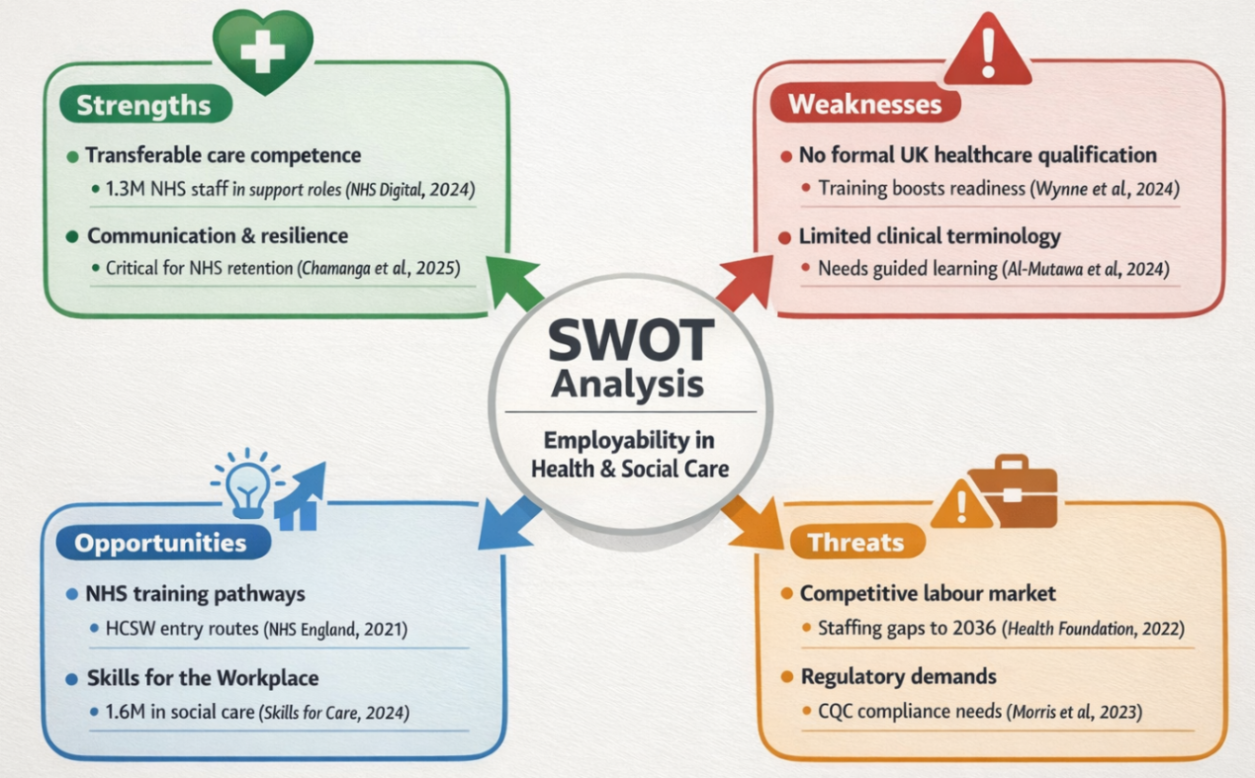
Table: Personal Swot Analysis
Strengths | Weaknesses
- Compassionate nature, strong communication skills, informal caregiving experience, emotional resilience, willingness to learn and develop professionally.  - Informal care experience of the applicant gives him/her firsthand experience of supervision, emotional support, and awareness of safety which are key areas of Healthcare Assistant practice. Positive interpersonal communication and stress tolerance are consistent with workforce evidence that shows compassion and resilience to be the determinants of care quality and retention (Cha manga et al., 2025). NHS workforce statistics reveal that more than 1 300 000 employees depend on proper collaboration and interpersonal communication to maintain the service provision (NHS Digital, 2024). | - Lack of UK healthcare qualification and use of limited clinical terminology limits direct clinical input. A literature review on employability readiness shows that systematic training is very vital in addressing such discrepancies in the entry level (Wynne et al., 2024).
Opportunities | Threats
- Availability of NHS training programmes, Care Certificate completion, apprenticeship pathways, and growing demand for Healthcare Assistants.  - NHS training structures, apprenticeship schemes, and CPD pathways offer well-defined lines of progression, and Skills for the Workplace scheme is employed in the development of employability to react to shortages in the sector (Skills for Care, 2024). | - Competitive job market, increasing regulatory requirements, need for continuous professional development and adaptation to workplace pressures.  - Competitive labor market, rising regulatory requirements in the CQC standards, and greater documentation pressure are entry barriers that have strengthened the necessity of specific skills training (Morris et al., 2023).

4.2 Personal Development Plan (Two-Year Horizon)
Goals | Actions to Achieve the Goal | Resources Needed | Target Date | Review Date
Complete the Care Certificate to improve professional competence as a Healthcare Assistant | Enroll in Care Certificate training programmed; complete all required modules; undertake supervised practice and competency assessments | Workplace mentor, training provider, online learning materials | Within 6 months of employment | After 6 months
Improve professional communication and documentation skills in healthcare settings | Attend communication skills workshops; practice SBAR framework during placements; seek feedback from supervisors; maintain reflective learning log | Lecturer guidance, mentor feedback, communication training sessions | Within 12 months | After 12 months
Gain practical clinical experience to enhance confidence in care delivery | Apply for healthcare assistant roles; participate in supervised patient care tasks; volunteer in care settings if possible | NHS recruitment support, placement opportunities, supervision from senior staff | Within 12–18 months | After 18 months
Progress towards Senior Healthcare Assistant or Nursing Associate role | Undertake additional CPD courses (safeguarding, infection control); discuss career pathway with manager; apply for internal progression opportunities | Employer training programmed, career guidance, professional development workshops | Within 2 years | Every 6 months

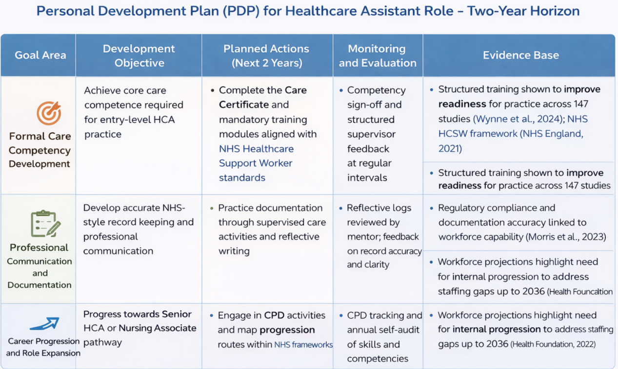5. Task 4: Critical Reflection on LCHS4009 Component 1 Presentation Using Gibbs’ Reflective Cycle

5.1 Description of the Presentation (LCHS4009 Component 1)

Professional Communication as a Determinant of Safety, Quality, and Accountability in Health and Social Care Practice. This was the presentation that explored communication as systematic, controlled competency and not soft skills of an individual. It focused on studying the failure of professional communication, putting the SBAR framework into practice, and critically reflecting on communication as a safety and governance tool in relation to patients (Gleeson et al., 2023; Choi et al., 2024).

5.2 Emotions and Preliminary Self-Perception.
My confidence initially was averagely high as I was well-prepared and knowledgeable on the subject matter before beginning the presentation. Nevertheless, I also felt nervous regarding the desire to speak in front of the audience and the short time that can be used. Initially, I feared that I would forget the main points or could not clearly explain theoretical concepts. My confidence was slowly growing as the presentation went on, especially when I effectively demonstrated the SBAR framework and saw a positive response among the audience. This experience made me more aware of the impact of anxiety on performance in communication.

5.3 Evaluation of Performance
When I assess my performance, I think that one of my strengths was that I was able to explain structured communication understandably and associate it with patient safety and accountability. I also showed good knowledge and the logical structure of the content. I, however, identified weaknesses in time management and slide design. There were slides with excessive information that made me talk fast in a bid to address all the issues. This could have decreased clarity and depth of reflection provided.

5.4 Analysis Informed by Lecturer Feedback
The feedback on lecturers indicated that there is the need to enhance pacing, structural signposting, and the degree of balance between theoretical and reflective insight. This enabled me to realize that effective communication involves emphasis on important messages other than to be overly detailed. It has been indicated that information overload, as opposed to lack of knowledge, is the cause of communication failure in many cases (Choi et al., 2024).

5.5 Conclusion: Key Learning Outcomes
Altogether, this experience helped me to improve my self-awareness, academic confidence, and knowledge about communication as a professional responsibility. It has compelled me to keep on improving my presentation, time-management, and reflective skills in future academic and healthcare practice environments.

5.6 Action Plan for Improvement

The development is to be done in the form of structured rehearsal strategies, formal presentation skills development, and refinement based on feedback in the future. There are indications that the guided Euro-Opponent feedback and reflection loops can significantly enhance the communication competence and the escalation confidence (Morris et al., 2023).

References:

Ahmadpour, N., Shariati, A. and Moghadam, M.P. (2025) ‘Effect of narrative writing based on Gibbs’ reflective model on the empathy and communication skills of nursing students’, BMC Medical Education, 25(1), p. 10. Available at: https://pmc.ncbi.nlm.nih.gov/articles/PMC11697928/
Alkan, E., Cushen-Brewster, N. and Anyanwu, P. (2024) ‘Investigating healthcare workforce recruitment and retention: a mixed-methods study protocol’, BMJ Open, 14(2), e074100. Available at: https://pmc.ncbi.nlm.nih.gov/articles/PMC10860040/
Al-Mutawa, N.A.A.M., Mahmoud, M.H., Baisa, K.G.G., Daher-Nashif, S. and Al Wahedi, Z. (2024) ‘Reflective writing among healthcare practitioners in primary care: a qualitative study from Qatar’, Cogent Education, 11(1). https://doi.org/10.1080/2331186X.2024.2373555
Cha manga, E., Dyson, J., Jarrett, M. and McKeown, E. (2025) ‘Investigating factors influencing recruitment and retention of adult community nurses: an exploratory qualitative study across NHS trusts in England’, Primary Health Care Research & Development, 26, e87. Available at: https://pmc.ncbi.nlm.nih.gov/articles/PMC12555078/
Health Foundation (2022) NHS workforce projections 2022. London: The Health Foundation. Available at: https://www.health.org.uk/reports-and-analysis/reports/nhs-workforce-projections-2022
Morris, M.E., Brusco, N.K., McAleer, R. et al. (2023) ‘Professional care workforce: a rapid review of evidence supporting methods of recruitment, retention, safety, and education’, Human Resources for Health, 21, p. 95. https://doi.org/10.1186/s12960-023-00879-5
NHS Digital (2024) NHS workforce statistics. Leeds: NHS Digital. Available at: https://digital.nhs.uk/data-and-information/publications/statistical/nhs-workforce-statistics
NHS England (2021) Attracting people into healthcare support worker roles (HCSW guidance). London: NHS England. Available at: https://www.england.nhs.uk/wp-content/uploads/2021/07/attracting-people-into-healthcare-support-worker-roles-guidance-july-2021.pdf
Parliament UK (2024) Adult social care workforce in England (CBP-9615). London: House of Commons Library. Available at: https://researchbriefings.files.parliament.uk/documents/CBP-9615/CBP-9615.pdf
Skills for Care (2024) The state of the adult social care sector and workforce in England 2023/24: Executive summary. Leeds: Skills for Care. Available at: https://www.skillsforcare.org.uk/Adult-Social-Care-Workforce-Data/workforceintelligence/resources/Reports/National/The-state-of-the-adult-social-care-sector-and-workforce-in-England-2024-Executive-Summary.pdf
Wynne, K., Mwangi, F., Onifade, O., Abimbola, O., Jones, F., Burrows, J., Lynagh, M., Majeed, T., Sharma, D., Bembridge, E., Stubbs, M., Sunner, C., Bergmann, J., Bagade, T. and Malau-Aduli, B.S. (2024) ‘Readiness for professional practice among health professions education graduates: a systematic review’, Frontiers in Medicine, 11, 1472834. https://doi.org/10.3389/fmed.2024.1472834
Zhan, T.T., Wang, L.L., Wang, Y. and Sun, C.J. (2023) ‘Master of nursing specialist experiences of an internship through the use of written reflections: a qualitative research study’, Heliyon, 9(2), e13299. Available at: https://pmc.ncbi.nlm.nih.gov/articles/PMC9939592/

