Presenting the dead: The Iconography of Graves in St. Peter’s Church, Lampeter.
In this survey of St. Peter’s Church, I decided to explore the iconography of gravestones in the church graveyard. I focused on a number of different criteria when selecting which graves to explore, with the most important criteria being decoration. I chose a wide selection of graves, from those with very little decoration, to those with lots of decoration, to explore how the dead are represented in a graveyard.
Methodology
To begin with, I began by identifying the area of the graveyard. This was simple, as the graveyard is contained on the church’s grounds and surrounded by walls. In order to have a map of the graveyard, I simply took a screenshot of the area on the Ordnance Survey online map and chose two points to crop from (Top left: SN 57452 4849. Bottom right: SN 57609 48262).
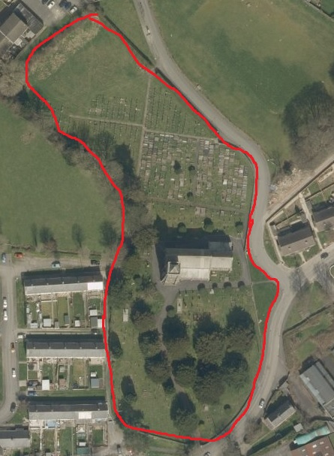
Figure 1 - Map of St. Peters Church, Lampeter
I have outlined the area of the graveyard in red, for ease of viewing. I chose not to divide the graveyard up into further points, and instead chose to use Ordnance Survey grid references to identify my chosen graves.
Once I had identified my graves, I was able to gather information on them. I chose to gather the following information: names, inscription, stone type, language and the decoration. Once I had the majority completed, I was able to go back to the graveyard over a period of several days and do a simple survey of many different graves from different eras, where I focused on age, year of death, stone type, decoration and language. This was so that I could easily create surveys regarding the most common stones, the use of language, and the different types of decoration. For this smaller survey, I examined 85 graves.
All images of graves presented in this survey were taken by the author.
Headstones
One way in which the dead are represented is most obvious when you first walk into a graveyard. There are many different styles of headstones available. By looking at figure 2, you can clearly see that out of the 85 I examined, the most popular style was an upright headstone.

Figure 2 - A Pie Chart showing the occurrence of different styles of headstones
This could be due to the simple nature of the upright headstone. You can fit a lot of information on there, and it does not stand out from the rest. The second most popular style was a cross, as shown in Figure 3. This style of grave marker shows someone’s dedication to their faith. Usually a person of the Christian faith might have a cross carved into their grave, however to have your headstone in the shape of a cross must surely demonstrate the strength of your faith.
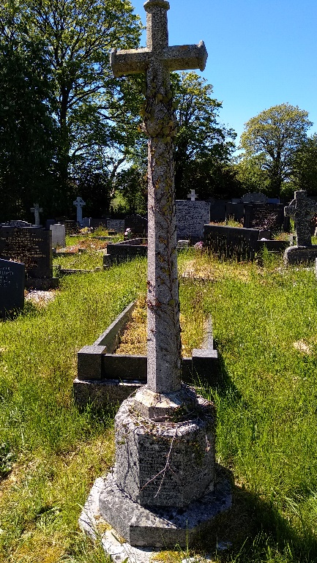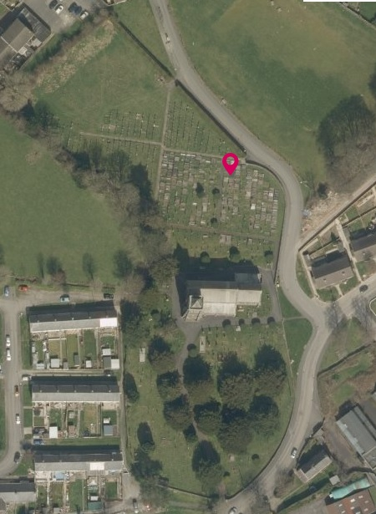
Figure 3 - A Grave Cross (SN 57551 48410)
Some of the more impressive headstones that can be seen in St. Peter’s graveyard are the obelisks. There are several meanings behind an obelisk, beginning in Ancient Egypt, however the most likely meaning for obelisks in a church graveyard is that they symbolise power and fatherhood. Obelisks also have the added benefit of having four sides, so the whole family can be included on one headstone. The obelisk I investigated was that of the Williams family (Shown below)
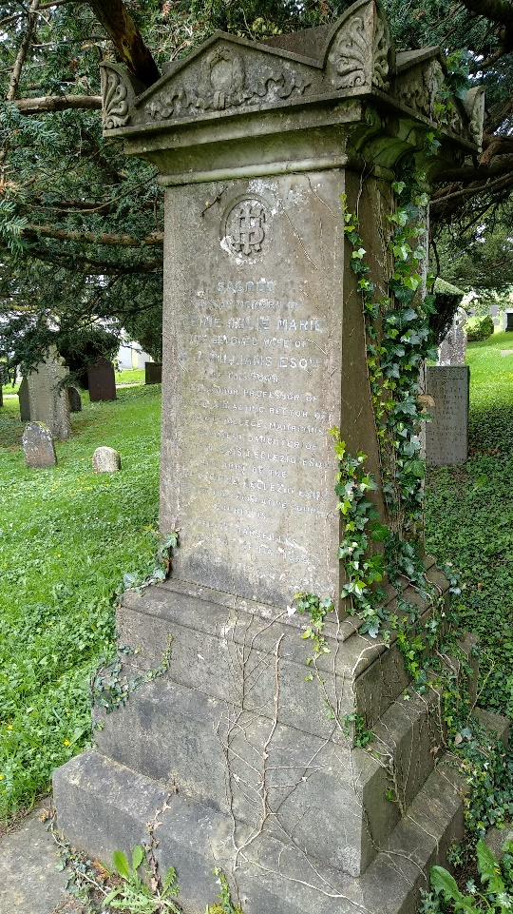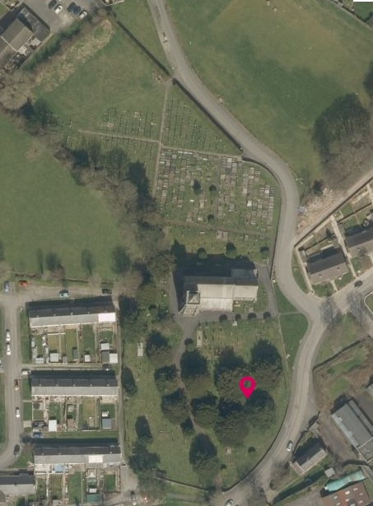
Figure 4 - Obelisk headstone of the Williams Family and location (SN 57757 48309)
The headstone contains the names of both William John Williams and his wife Egerie Julie Marie Williams. The family have used the space to show how powerful the family were. We know that Egerie was a senior professor of classics at The Royal College in Mauritius she was part of the LeClezio family in Mauritius. There isn’t as much information about William however, leading me to believe that the obelisk was paid for by a member of Egerie’s family.
Another type of headstone is a carved headstone, whereby the headstone is carved from the rock in the shape of something. The most popular carved stone in St. Peter’s is the scroll (Figure 5)
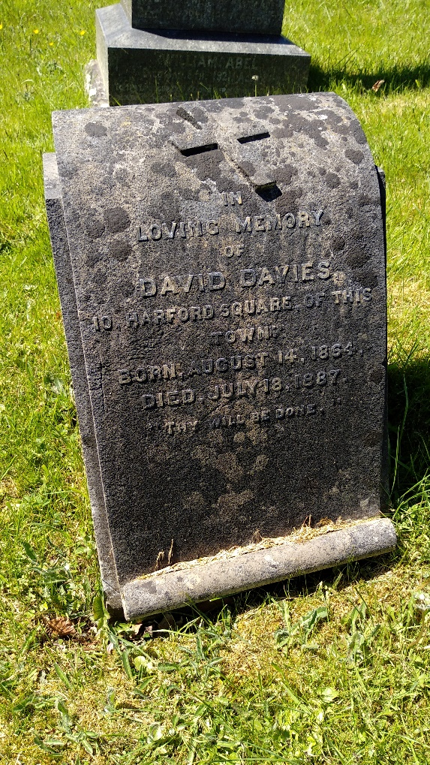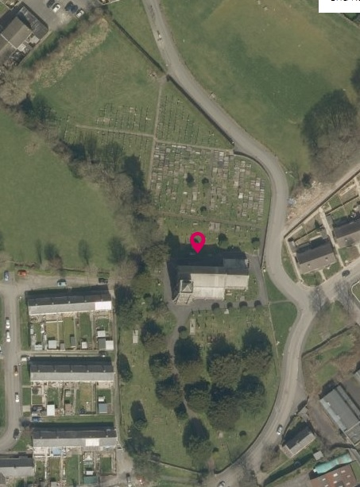
Figure 5 - A Scroll Headstone (SN 57540 48370)
The scroll represents the unfurling of life and time. Both ends being covered up indicate that the future and past are hidden, and being made of stone, indicate an unchanging future, perhaps one that will not be uncovered. David Davies died aged 23, so perhaps his future was cut short and will remain forever uncovered.
Some families choose to have their headstone carved into something that represents the profession of the person. For example Figure 6 shows the grave of David Davies; which is in the shape of 4 logs of wood shaped into an arch. From this grave, we can infer that Mr Davies was a wood worker of some kind.
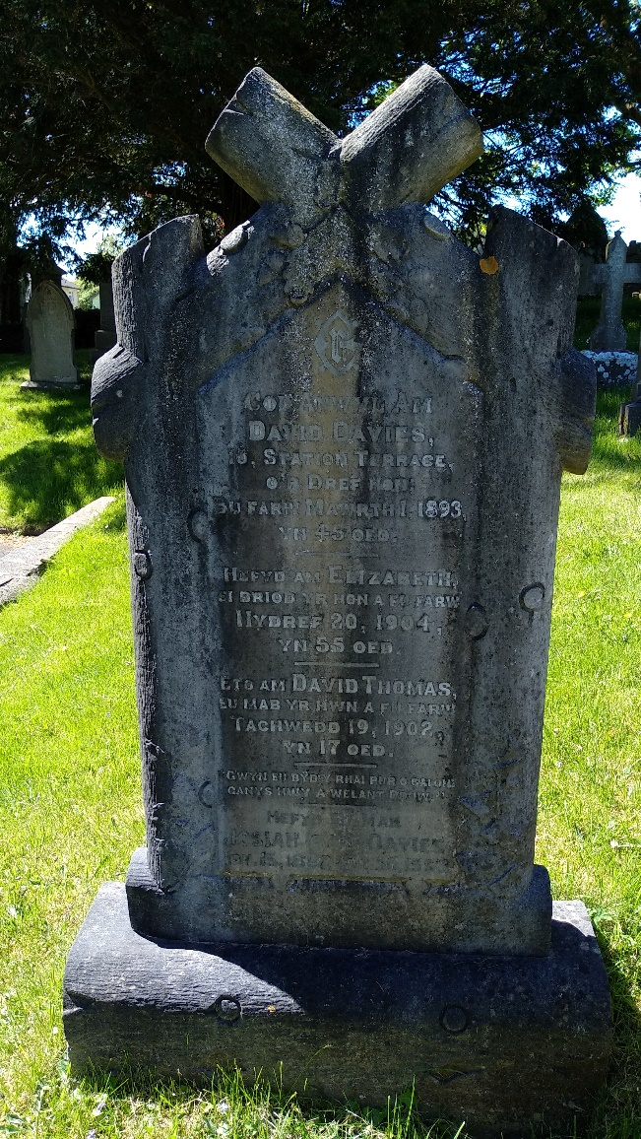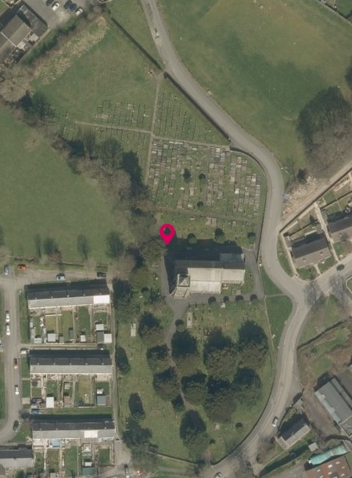
Figure 6 - The Grave of the Davies Family and its location
Stone Types
The type of stone chosen represents both the trends and availability of the stone at the time, however it also represents the person’s wealth. There are 5 main types of stone used throughout St. Peters church: Slate, Limestone, Granite, Marble and Balmoral Granite. The most common type in St. Peters graveyard is Granite. This however, has not always been the case. From my survey, I have found that slate was the most common stone from the mid-nineteenth century, up until the mid-twentieth century, at which point granite takes over, and remains popular to this day. If we look at the maps of both slate and granite quarries, we can see that while both types of quarry are primarily situated to the north of Wales, there are a number of slate quarries nearer to Lampeter. This would account for the lack of granite headstones in the mid-nineteenth century. The cost of transporting such a heavy stone would have meant that not everyone could afford it. With the increase of motorways and cars in the mid to late twentieth century, granite became a more easily available stone. In the early to mid-nineteenth century, only the wealthy could afford to have granite imported.

Figure 7 - A pie chart to show the occurrence of stone types in St. Peters Church
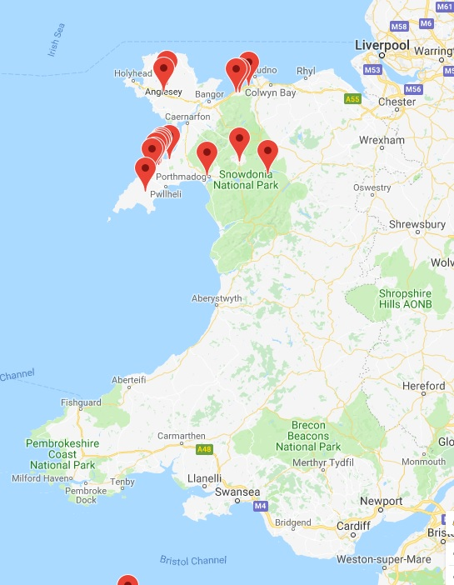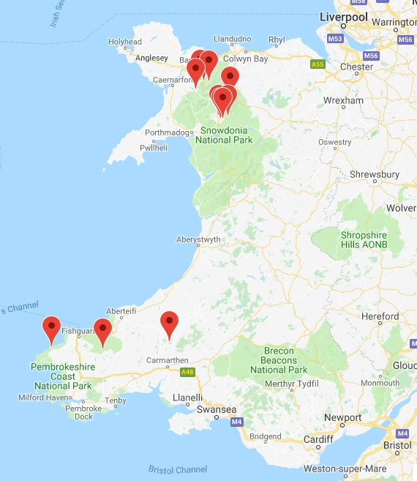
Figure 8 - A Map of Granite Quarries in Wales Figure 9 - A Map of Slate Quarries in Wales
Another type of stone that is common is Limestone. Similar to Slate, Limestone was both easier to work and ship to the local area than granite. Today, a granite headstone is much cheaper than it was in the nineteenth century, due to the decrease in transportation costs. This means that as time has passed, the material out of which your headstone is carved tells you less and less about the person. However, we can still use this to learn about people from the nineteenth century. For example, we can infer that a person with a slate headstone did not have as much money as someone with a granite headstone.
In this regard, I would like to explore the grave of Anne Price. This is a grave situated at SN 57553 48308, and dates from the year 1842. The text on the grave reads:
Lieth the body of ANNE
Daughter of John and Anne Price
of Ship-Inn in this Town, who
departed this life February 24
in the year 1842. Aged 4 Months.
At first glance, this is an ordinary grave, for a child, however, there are a number of interesting things about its appearance. There are not many graves in St. Peters graveyard for children under one year old. This tells us that John and Anne Price loved their daughter immensely, however they were also a poorer family. Comfortable enough to afford a burial for their daughter, however not wealthy enough to afford a granite headstone. Another interesting feature of this headstone is that on the reverse side of the text, there is an alphabet, written in a script. One can infer that this piece of slate was used as a test piece so that the carver could test their script.
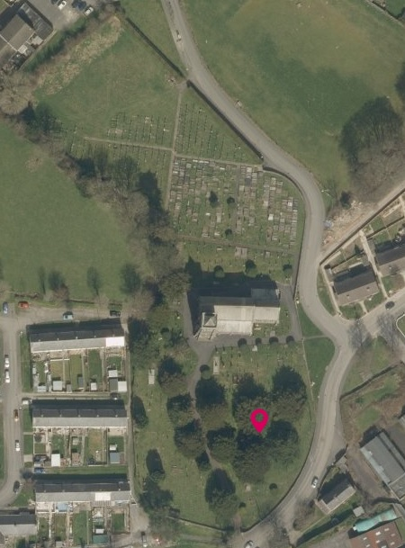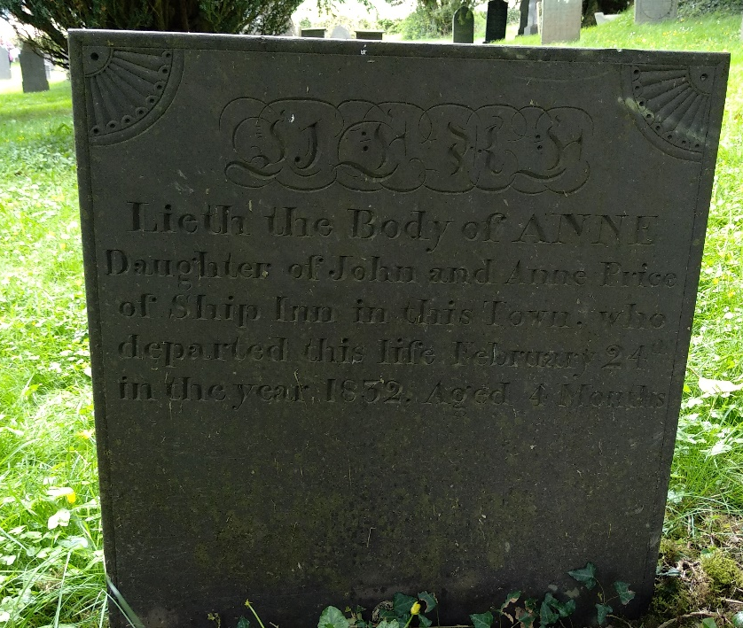
Figure 10 - The grave of Anne Price and Location
This grave was created to symbolise the love that John and Anne Price held for their Child, which shows. Even though they were poor, they still wanted the world to know about their child.

The Language of Flowers
Upon surveying the graves, I soon discovered that the most common type of decoration was flowers. There were many different types of flowers that were used, and all correspond with the language of the flowers, or Floriography. Floriography was the communication of words through the use of flowers and floral arrangement. In graveyards, one only has to look at a few graves to swiftly see the different types of flowers that were popular.
Most common is the lily, often found on female graves, the Lily was used to represent sweetness, and elegance. On children’s graves, the lily can represent purity and happiness.
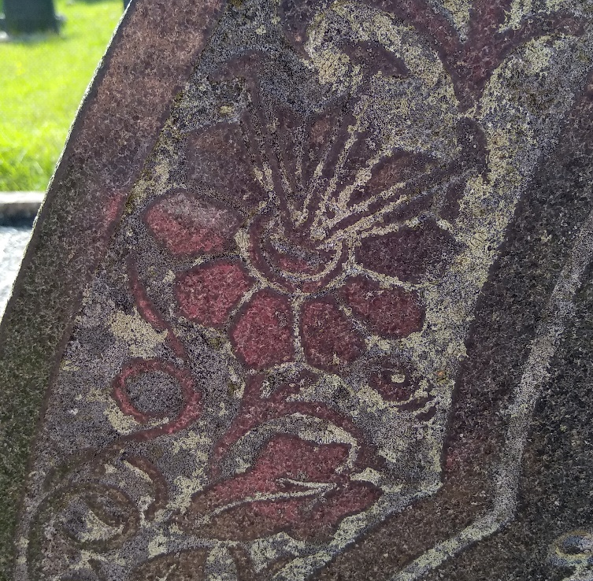
Figure 11 - A Carving of a Lily
Another flower that is common, especially in St. Peters is the Welsh Poppy. On its own, the poppy symbolises peace in death, and resurrection and eternal life. It also symbolises beauty and success. Most notably, the poppy is used on Remembrance Day, to symbolise the remembering of those who have fallen in war. The Welsh poppy however, symbolises all of the above, however it also represents the love of Wales, and someone’s pride in their nationality.
Figure 11 shows the carved image of a bouquet of flowers on the grave of William Richards, a child who died at the age of 3, in the year 1885. The bouquet contains welsh poppies, a partially bloomed rose, and what I believe to be primrose. There is a lot that can be learnt from the flowers. For example, the welsh poppies tell us that the family was welsh, but that the child was loved and the family wished for peace in death. The half bloomed rose symbolises a child that passed away before he was able to fully bloom. If we are to assume that the rose is the traditional red rose, then we can also understand that as a symbolism of the parent’s devotion and love for the child. The primrose symbolises youth, again reminding us of the young age of the child.
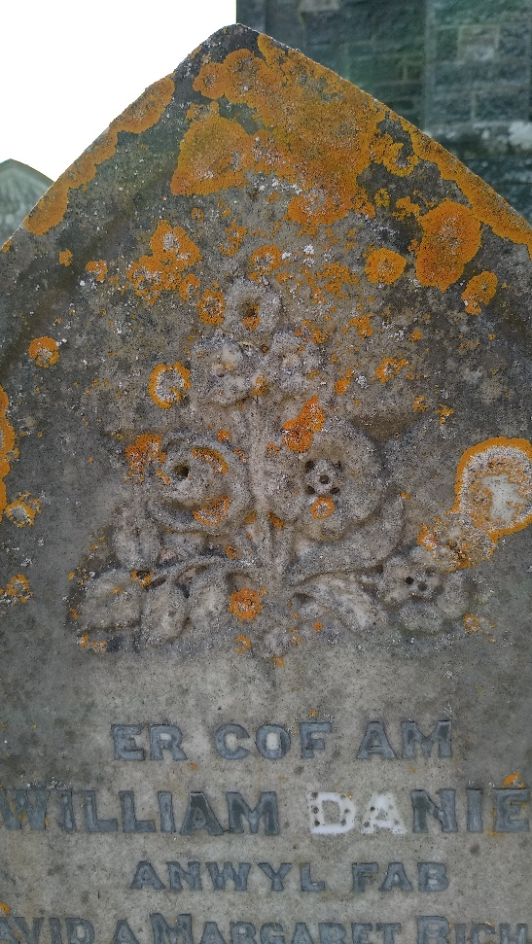
Figure 12 - A Bouquet of flowers on the grave of a 3 year old child
Carved Objects
The final form of icons that I wish to explore is the use of carved objects. By this, I mean the carving of for example, an urn, or a book, to symbolise your life. The urn represents a burial urn, one you may have your ashes placed in after you are cremated for example. It symbolises the passing from life to death. Often you will see the urn partially covered by a draped cloth, which represents protection for the soul. Together, a draped urn represents the protection of the deceased’s soul as it passes from into the afterlife.
Another common carved object is the book. The book represents a learned individual, someone who has been educated. It can also represent the Book of Life, the book in which God writes the names of those who are destined for heaven. A final interpretation of the book is that it contains a story, and when a name is carved onto the book, it becomes a story about that person’s life.
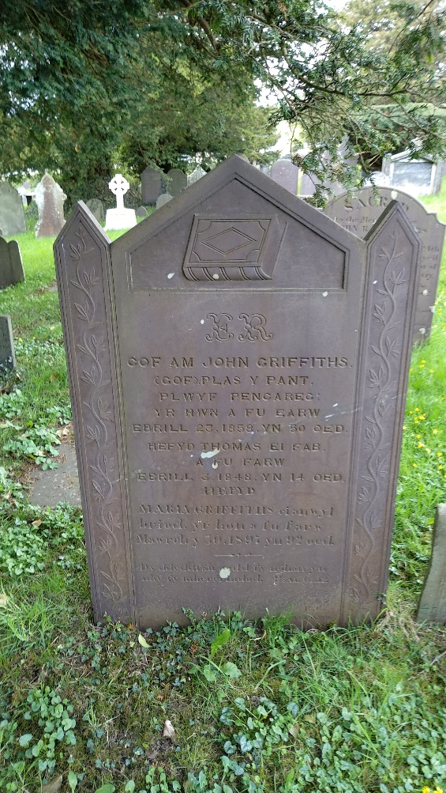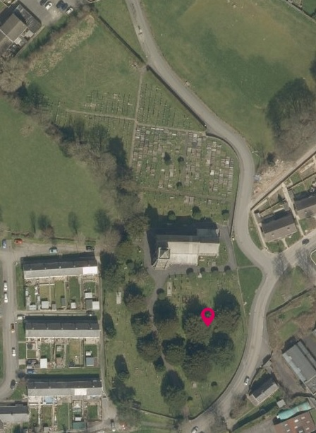
Figure 13 - A Grave showing a carved book and its location (SN 57556 48316)

Bibliography

"Drapes / Drapery/Draped Urn", Symbolsproject.Eu<https://symbolsproject.eu/explore/others/objects0/drapes-/-drapery/draped-urn.aspx> [Accessed 22 May 2018]
"Gravestoneshq | Definitive Guide To Choosing A Gravestone Or Headstone", Gravestones HQ, 2018 <http://www.gravestoneshq.co.uk/#materials> [Accessed 22 May 2018]
"Language Of Flowers - The Most Accurate, Authentic Flower Meanings And Flower Sentiments Online...Including More Than 600 Flowers And Plants.", Languageofflowers.Com, 2014 <http://www.languageofflowers.com/> [Accessed 22 May 2018]
"Lists And Maps Of UK And International Mines And Quarries", Aditnow.Co.Uk, 2018 <https://www.aditnow.co.uk/Database/> [Accessed 22 May 2018]

Ordnance Survey, Lampeter (SN 57542 48356) (2018)< https://osmaps.ordnancesurvey.co.uk/52.11512,-4.08193,18/pin> (Accessed 21 May 2018)
"Lists And Maps Of UK And International Mines And Quarries", Aditnow.Co.Uk, 2018 <https://www.aditnow.co.uk/Database/> [Accessed 22 May 2018].
Ibid.
"Gravestoneshq | Definitive Guide To Choosing A Gravestone Or Headstone", Gravestones HQ, 2018 <http://www.gravestoneshq.co.uk/#materials> [Accessed 22 May 2018].
"Language Of Flowers - The Most Accurate, Authentic Flower Meanings And Flower Sentiments Online...Including More Than 600 Flowers And Plants.", Languageofflowers.Com, 2014 <http://www.languageofflowers.com/> [Accessed 22 May 2018].
"Drapes / Drapery/Draped Urn", Symbolsproject.Eu<https://symbolsproject.eu/explore/others/objects0/drapes-/-drapery/draped-urn.aspx> [Accessed 22 May 2018].

