3/24/2025
University of Wales Trinity Saint David
London campus
Module Name: Scripting and Programming Concepts
Module Code: ACCA 5036

Student Name: Eric Fabricio Ferro Fernandes
Student ID: 2414945

Lecturer’s Name: Koushik Modak

SPC Assignment on
Student Equipment Booking System
Code Link: https://github.com/eferrofernandes/assessment1_id2414945

Table of Contents
Introduction 2
Main Body 2
1. Analysis 2
1.1 Requirements Analysis 2
2. Software Design and Development 4
2.1Design 4
Flowcharts 5
Pseudo-code 7
2.2 Implementation Decisions 11
2.3 Source Code 13
3. Testing and Debugging Report 13
3.1 Importance of Testing 14
3.2 Error Types and Fixes 14
3.3 Test Cases Table 15
4. Evaluation 17
4.1 Challenges Faced 17
4.2 Future Improvements 18
4.3 Self-Reflections 19
Conclusion 20
References 20
Appendices 21

Introduction
This report details the development of a Python-based Student Equipment Booking System for Bright Minds Academy, fulfilling the requirements of the Scripting and Programming Concepts (ACCA5036) module. The project adheres to a structured Software Development Life Cycle (SDLC) approach, encompassing analysis, design, implementation, testing, and evaluation [1]. The primary objective is to create a console-based application that allows for the management of various equipment types, facilitates student bookings, and provides functionalities for viewing and searching booking records. This system aims to demonstrate fundamental programming concepts, including data structures, control flow, and error handling, within a practical context.
The development process has been meticulously documented, reflecting the iterative nature of software engineering. Each phase, from initial requirement gathering to final testing, has been approached with a focus on clarity, efficiency, and adherence to best practices. The subsequent sections will elaborate on the system's architecture, the rationale behind key design decisions, the implementation details, a comprehensive testing report highlighting encountered issues and their resolutions, and a critical evaluation of the project's outcomes and potential for future enhancements.

Main Body

1. Analysis
The analysis phase is crucial for understanding the problem domain and defining the scope of the software solution. For the Bright Minds Academy Equipment Booking System, the core problem is the manual and potentially inefficient process of managing equipment loans to students. This system aims to automate this process, providing a clear, accessible, and reliable method for tracking equipment and bookings. This section outlines the functional and non-functional requirements derived from the project brief, forming the foundation for the subsequent design and implementation phases.

1.1 Requirements Analysis
A thorough understanding of both functional and non-functional requirements is paramount for developing a system that not only works but also meets user expectations and operational standards. Functional requirements define what the system does, while non-functional requirements specify how the system performs its functions [2].

Functional Requirements
    - Add new equipment: The system must allow an administrator to add new equipment items to the inventory. For each item, the system should record its name (e.g., "Dell XPS 15"), type (e.g., "laptop", "projector", "tablet"), and the initial available quantity. If an equipment item with the same name and type already exists, the system should update its available quantity rather than creating a duplicate entry.
    - Record bookings: The system must enable the recording of equipment bookings by students. This involves specifying the student's name, the equipment item being booked, and the booking date. The system must verify that the requested equipment is available in stock before confirming a booking. Upon successful booking, the available quantity of the booked equipment must be decremented.
- View booking records: The system must provide a functionality to display all currently recorded bookings. Each booking record should clearly show the student's name, the equipment booked, and the booking date. If no bookings exist, the system should inform the user accordingly.
- Simple Search: The system must allow users to search through existing bookings. The search functionality should be able to filter bookings based on either the student's name or the equipment's name. The search should be case-insensitive to enhance usability.
- Main Menu Interface: The system must present a clear, console-based main menu that allows users to navigate between the different functionalities (add equipment, record booking, view bookings, search bookings, exit).
- Exit Functionality: The system must provide an option for the user to gracefully exit the application.

Non-Functional Requirements
In addition to functionality, the system must meet several quality criteria:
- Reliability: The system must be robust and handle various user inputs gracefully. This includes validating numerical inputs (e.g., quantity) and ensuring that equipment types are within predefined categories. Error messages should be informative and guide the user towards correct input. The system should not crash due to invalid user actions.
- Performance: Given the scope of a simple console application without a database, the system is expected to perform operations (add, book, view, search) efficiently for a small to medium number of records. The use of Python's built-in list and dictionary data structures is deemed appropriate for this level of performance [3].
- Security: As a console application without user authentication or persistent storage, the security requirements are minimal. Data is held in memory for the duration of the program's execution. No sensitive personal data is stored, mitigating significant security risks.
- Usability: The system must be user-friendly, featuring a clear menu-driven interface and intuitive prompts for user input. The language used in prompts and messages should be straightforward and easy to understand for the target audience (Bright Minds Academy staff).
- Maintainability: The code should be well-structured, modular, and include comments to facilitate future modifications and understanding by other developers. Adherence to Python's PEP 8 style guide will contribute to code readability.
- Portability: The system should be executable on any operating system that supports Python 3, as it relies solely on standard Python libraries.

2. Software Design and Development
The design phase translates the identified requirements into a structured plan for software construction. This involves defining the overall architecture, data structures, and algorithmic logic for each system component. A well-conceived design ensures that the implementation phase is efficient and results in a robust, maintainable system. This section details the design choices, including visual representations of the program flow and pseudo-code for core functionalities, followed by an explanation of the implementation decisions made.
2.1Design
The system's design prioritises modularity and clarity, making it easier to understand, test, and extend. The core of the application is a menu-driven interface, which directs control to specific functions based on user input. This approach aligns with the principles of structured programming, where complex problems are broken down into smaller, manageable sub-problems.

Flowcharts
Flowcharts provide a visual representation of the program's logic and control flow. They are instrumental in understanding the sequence of operations and decision points within the system. The following flowcharts illustrate the main menu's operation and the logic for adding and booking equipment.

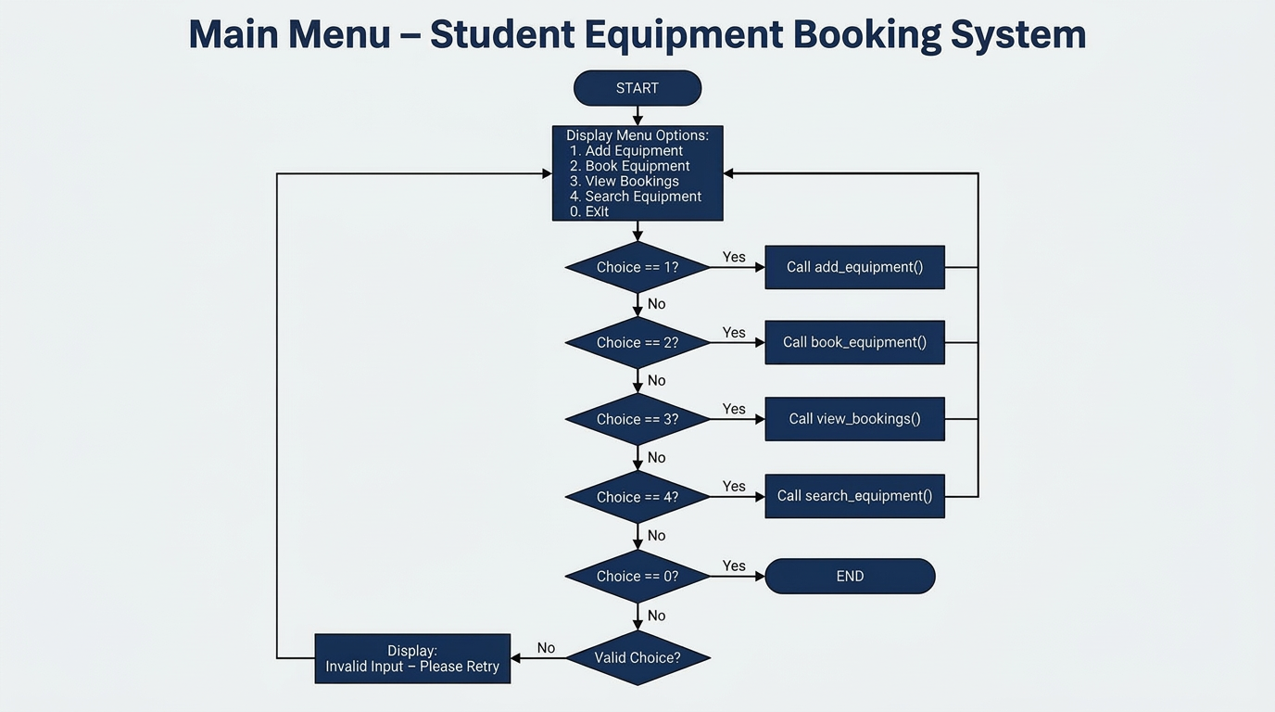
The main menu flowchart depicts the continuous loop that presents options to the user, processes their choice, and invokes the corresponding function. It also illustrates the exit condition, which terminates the program.
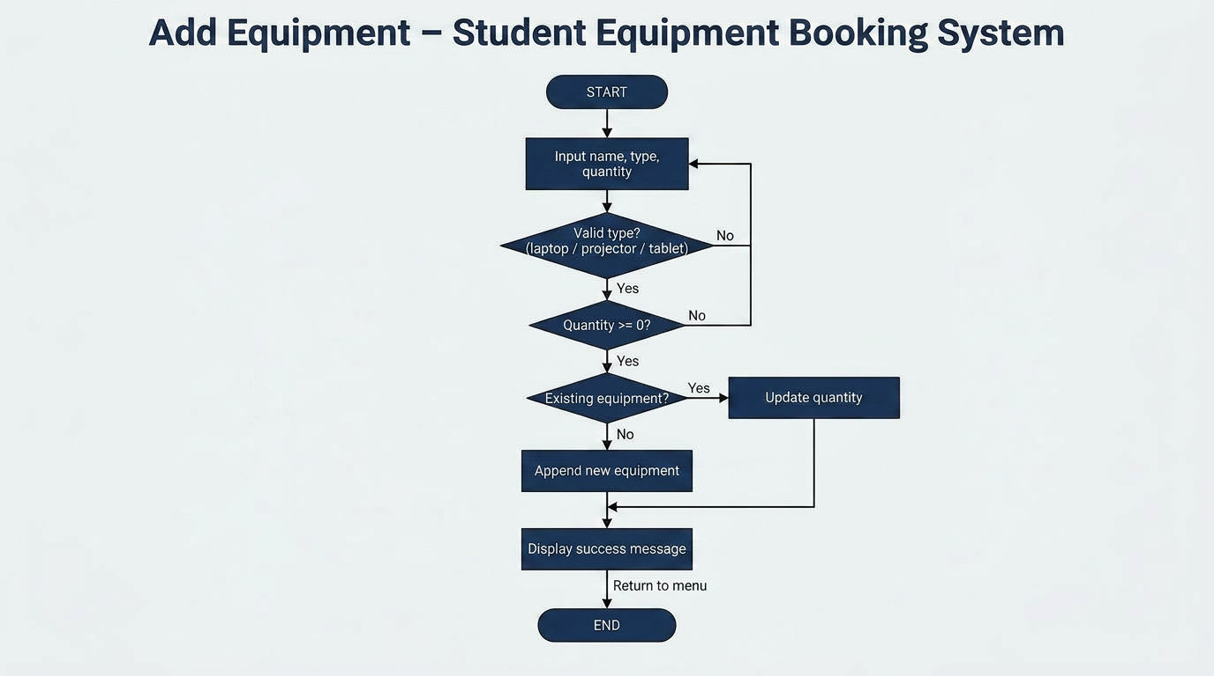
The add equipment flowchart details the steps involved in adding a new item or updating an existing one. It includes input validation for equipment type and quantity, ensuring data integrity.

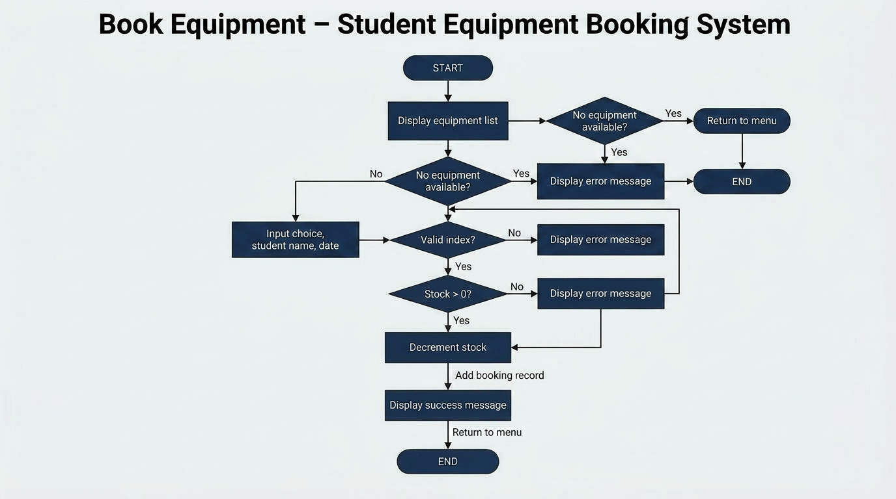
The book equipment flowchart outlines the process of recording a booking, including checking for equipment availability and decrementing the stock. It also covers error handling for invalid selections or insufficient stock.

Pseudo-code
Pseudo-code offers a high-level, language-agnostic description of algorithms, bridging the gap between design and actual code. It helps in outlining the logic without getting bogged down in syntax specifics. The following pseudo-code blocks describe the main functions of the system.
Pseudocode for Core Functionalities
FUNCTION main_menu():
# Step 1: Display system header and navigation options
WHILE TRUE:
DISPLAY "Student Equipment Booking System"
DISPLAY "1. Add Equipment"
DISPLAY "2. Book Equipment"
DISPLAY "3. View Bookings"
DISPLAY "4. Search Bookings"
DISPLAY "0. Exit"

# Step 2: Capture user choice
GET choice

# Step 3: Route to specific functionality based on input
IF choice IS "1":
CALL add_equipment()
ELSE IF choice IS "2":
CALL book_equipment()
ELSE IF choice IS "3":
CALL view_bookings()
ELSE IF choice IS "4":
CALL search_bookings()
ELSE IF choice IS "0":
DISPLAY "Exiting the system."
BREAK LOOP
ELSE:
DISPLAY "Invalid choice. Please try again."

FUNCTION add_equipment():
# Step 1: Input and Category Validation
DISPLAY "Valid categories: laptop, projector, tablet"
WHILE TRUE:
GET equipment_type (convert to lowercase)
IF equipment_type IS IN ["laptop", "projector", "tablet"]:
BREAK LOOP
ELSE:
DISPLAY "Invalid category! Please try again."

# Step 2: Quantity Validation
TRY:
GET quantity_to_add (convert to integer)
IF quantity_to_add < 0:
DISPLAY "Error: Quantity cannot be negative!"
RETURN

# Step 3: Logical check to update existing stock (Avoid Duplicates)
FOR EACH item IN equipment_list:
IF item["type"] IS equipment_type:
# Update existing record
item["available"] = item["available"] + quantity_to_add
DISPLAY "Inventory updated successfully!"
RETURN

# Step 4: Add New Category Record
ADD {"type": equipment_type, "available": quantity_to_add} TO equipment_list
DISPLAY "New equipment category added successfully!"

CATCH ValueError:
DISPLAY "Error: Please enter a valid numeric value for quantity."

FUNCTION book_equipment():
# Step 1: Initial availability check
IF equipment_list IS EMPTY:
DISPLAY "No equipment available to book."
RETURN

# Step 2: Display available inventory for selection
DISPLAY "Available Equipment List"
FOR EACH index, item IN equipment_list:
DISPLAY (index + 1) + ". " + item["type"] + " - Available: " + item["available"]

# Step 3: Equipment selection and validation
TRY:
GET choice_number
SET selected = equipment_list[choice_number - 1]

# Step 4: Stock and identity validation
IF selected["available"] <= 0:
DISPLAY "No stock available for this equipment."
RETURN

GET student_name
GET quantity_to_book (convert to integer)

# Step 5: Final booking execution and stock update
IF quantity_to_book > 0 AND quantity_to_book <= selected["available"]:
selected["available"] = selected["available"] - quantity_to_book
ADD {"student": student_name, "type": selected["type"], "quantity": quantity_to_book} TO booking_list
DISPLAY "Booking confirmed for " + student_name
ELSE:
DISPLAY "Invalid quantity requested."

CATCH ValueError OR IndexError:
DISPLAY "Selection error. Please enter a valid number."

FUNCTION view_bookings():
# Step 1: Check for existing records
IF booking_list IS EMPTY:
DISPLAY "No bookings found."
RETURN

# Step 2: Iterate and display all records
DISPLAY "All Bookings List"
FOR EACH booking IN booking_list:
DISPLAY "Student: " + booking["student"] + ", Equipment: " + booking["type"] + ", Quantity: " + booking["quantity"]

FUNCTION search_bookings():
# Step 1: Capture search criteria
IF booking_list IS EMPTY:
DISPLAY "No data to search."
RETURN

GET query (convert to lowercase)

# Step 2: Filter and display matches (Case-insensitive)
DISPLAY "Search Results:"
FOR EACH booking IN booking_list:
SET student_lower = booking["student"].to_lowercase()
SET type_lower = booking["type"].to_lowercase()
IF query IS IN student_lower OR query IS IN type_lower:
DISPLAY "Student: " + booking["student"] + ", Equipment: " + booking["type"] + ", Quantity: " + booking["quantity"]

# To run the system:
CALL main_menu()

2.2 Implementation Decisions
The implementation phase translates the design into executable code. Key decisions regarding data structures, programming constructs, and module usage were made to ensure the system's functionality, maintainability, and adherence to Pythonic principles. The choice of Python as the programming language was driven by its readability, extensive standard library, and suitability for rapid prototyping of console applications [4].

Data Structures
For managing equipment and booking records, Python's built-in `list` and `dictionary` data structures were chosen. These are highly versatile and efficient for the scale of this project, which does not require persistent storage or complex database operations. The `equipment_list` is a list where each element is a dictionary representing an equipment item. Each equipment dictionary contains keys such as `"name"` (string), `"type"` (string), and `"available"` (integer). This structure allows for easy access and modification of equipment attributes. Similarly, `booking_list` is a list of dictionaries, with each booking dictionary containing `"student"` (string), `"equipment"` (string), and `"date"` (string) keys. This approach provides a clear and organised way to store heterogeneous data for each record [5].

Programming Constructs
The system extensively utilises fundamental programming constructs to control program flow and handle user interactions:
- `while` loops: Employed for the main menu to ensure continuous operation until the user chooses to exit, and for input validation loops (e.g., ensuring a valid equipment type is entered).
- `if`/`elif`/`else` statements: Used for decision-making, such as processing user menu choices, validating input conditions (e.g., negative quantity, sufficient stock), and determining search outcomes.
- `try`/`except` blocks: Crucial for robust error handling. These blocks are used to catch potential `ValueError` exceptions (e.g., when converting non-numeric input to an integer) and `IndexError` exceptions (e.g., when a user selects an equipment number outside the valid range). This prevents the program from crashing and provides informative feedback to the user.
- Functions: The system is modularised into distinct functions (`main_menu`, `add_equipment`, `book_equipment`, `view_bookings`, `search_bookings`). This promotes code reusability, improves readability, and simplifies debugging by isolating specific functionalities.

Python Modules
The project relies exclusively on Python's built-in functionalities and standard library, requiring no external modules. This decision aligns with the assessment's focus on core scripting concepts and simplifies deployment, as no additional dependencies need to be installed. Input/output operations are handled using `input()` and `print()`, while string manipulation (e.g., `.lower()`, `.strip()`) and list/dictionary operations are intrinsic to Python's core language features.

2.3 Source Code
The full, annotated source code for the Student Equipment Booking System is hosted on the GitHub repository, with the link provided on the title page of this report. The repository contains the `equipment_booking_v2.py` file, which includes all the functionalities discussed in the design and implementation sections. The code adheres to Python best practices, featuring clear variable names, consistent indentation, and comprehensive comments to explain complex logic and design choices. This approach ensures high readability and maintainability, allowing other developers to easily understand and potentially extend the system.
The GitHub repository also includes additional documentation, such as a `README.md` file, which provides instructions on how to run the application and an overview of its features. Screenshots demonstrating the application's execution and various test cases, including error scenarios, are also available within the repository, offering a visual complement to the testing report presented in this document. This comprehensive approach to source code management and documentation is vital for collaborative development and long-term project viability.

3. Testing and Debugging Report
Testing and debugging are integral phases of the software development lifecycle, ensuring that the developed system functions as intended and is free from defects. This section outlines the importance of testing, discusses various error types encountered during development, and presents a detailed report of test cases executed to validate the Student Equipment Booking System.

3.1 Importance of Testing
Software testing is a critical process for verifying and validating that a software application meets its specified requirements and operates correctly. It serves multiple purposes, including detecting bugs and defects early in the development cycle, improving software quality, and enhancing user satisfaction [6]. For the Student Equipment Booking System, thorough testing ensures that equipment is added correctly, bookings are recorded accurately with proper stock management, and search functionalities yield expected results. Without adequate testing, the system could lead to incorrect inventory counts, double-bookings, or data inconsistencies, undermining its reliability and usefulness. Furthermore, testing helps to identify edge cases and unexpected user behaviours, allowing developers to implement robust error handling mechanisms, thereby increasing the system's overall resilience.

3.2 Error Types and Fixes
During the development and testing of the Student Equipment Booking System, several types of errors were encountered, which are common in programming. Understanding these error types and their resolutions is crucial for effective debugging and producing reliable software.
Syntax Errors: These are errors that occur when the rules of the programming language are violated. A common example encountered was the `IndentationError: unexpected indent`. Python is highly sensitive to indentation, and incorrect spacing (e.g., an extra space at the beginning of a line) can lead to such errors. This was typically resolved by carefully reviewing the code for inconsistent indentation, often caused by copy-pasting code from different sources, and correcting it to adhere to Python's strict indentation rules (typically four spaces per level).
Runtime Errors: These errors occur while the program is executing, often due to unexpected conditions or invalid operations. A frequent runtime error was `ValueError`, particularly when attempting to convert non-numeric user input into an integer (e.g., `int("abc")`). This was addressed by implementing `try-except` blocks around input conversion operations. For instance, when asking for `available quantity`, a `try-except ValueError` block ensures that if the user enters text instead of a number, the program catches the error, prints an informative message ("Invalid quantity! Enter a number."), and prompts the user again or allows them to retry, rather than crashing. Another runtime error, `IndexError`, could occur if a user tried to select an equipment item using an index outside the valid range of the `equipment_list`. This was handled by checking the validity of the `eq_index` within the `book_equipment` function.
Logical Errors: These are the most challenging errors to detect as they do not cause the program to crash but produce incorrect or unexpected results. An example of a logical error could be incorrect stock management (e.g., not decrementing stock after a booking or allowing booking when stock is zero). Another logical issue identified was the initial lack of validation for equipment types, allowing any string to be entered, which could lead to inconsistent data. This was fixed by implementing a `while` loop with an `if` condition to check if the entered type was one of the predefined valid types (`laptop`, `projector`, `tablet`), prompting the user to re-enter if invalid. Similarly, ensuring that negative quantities could not be added or booked was a logical validation implemented to maintain data integrity.

3.3 Test Cases Table
A comprehensive set of test cases was developed and executed to verify the functionality and robustness of the Student Equipment Booking System. Each test case targets a specific feature or potential error scenario, documenting the expected outcome and the actual result. Screenshots were captured during the execution of key test cases to provide visual evidence of the system's behaviour, particularly for error handling and successful operations. These screenshots are referenced in the table below and are available in the GitHub repository.
Test Case ID | Description | Expected Result | Actual Result | Status | Screenshot Reference
TC001 | Run main menu | Main menu options displayed correctly. | Menu with options 1-4 and 0 displayed. | Pass | [Screenshot 1]
TC002 | Add new equipment (valid) | 'laptop' added with quantity 5. | "Added 5 laptop(s)." | Pass | [Screenshot 2]
TC003 | Update existing equipment | 'laptop' qty updated from 5 to 8. | "Updated laptop quantity to 8." | Pass | [Screenshot 3]
TC004 | Add invalid type | System rejects types like 'chair'. | "Invalid equipment type. Must be laptop..." | Pass | [Screenshot 4]
TC005 | Add negative quantity | System rejects values like -5. | "Quantity must be >= 0." | Pass | [Screenshot 5]
TC006 | Add non-numeric quantity | System handles 'abc' via except block. | "Invalid quantity. Must be an integer." | Pass | [Screenshot 6]
TC007 | Book available stock | Book 1 laptop for 'Eric'. | "Booked 1 laptop(s) for Eric." | Pass | [Screenshot 7]
TC008 | Book more than available | Attempt to book 10 when stock is 7. | "Invalid quantity. Must be > 0 and <=..." | Pass | [Screenshot 8]
TC009 | Book with zero stock | Reject booking if available is 0. | "No stock available for this equipment." | Pass | [Screenshot 9]
TC010 | View empty bookings | Message when no bookings exist. | "No bookings found." | Pass | [Screenshot 10]
TC011 | View existing bookings | Display list of recorded bookings. | "All Bookings: Student: Eric, Equipment..." | Pass | [Screenshot 11]
TC012 | Search (match found) | Search for 'Eric' or 'laptop'. | Displays matching student/equipment. | Pass | [Screenshot 12]
TC013 | Search (no match) | Search for 'printer' or 'John'. | "No matching bookings found." | Pass | [Screenshot 13]
TC014 | Invalid menu choice | Input '9' or 'x' in main menu. | "Invalid choice. Select one number..." | Pass | [Screenshot 14]
TC015 | Exit system | Option 0 terminates program. | "Exiting the system." | Pass | [Screenshot 15]

4. Evaluation
The evaluation phase critically assesses the project's outcomes, reflecting on the challenges encountered, identifying areas for future improvement, and summarising personal learning experiences. This self-assessment is vital for continuous professional development and for understanding the practical implications of theoretical concepts.

4.1 Challenges Faced
Developing the Student Equipment Booking System presented several challenges, primarily related to ensuring robust input validation and managing data consistency within a console-based application. One significant challenge was handling `IndentationError` during the initial stages of coding, particularly when integrating code snippets. Python's strict reliance on indentation for defining code blocks meant that even minor inconsistencies, often introduced during copy-pasting, led to syntax errors. This required meticulous attention to code formatting and reinforced the importance of using a consistent development environment like Thonny, which helps visualise and manage indentation effectively. Overcoming this involved a systematic approach to debugging, line by line, and understanding the root cause of such errors rather than merely fixing the symptom.
Another challenge was implementing comprehensive input validation to prevent runtime errors and ensure data integrity. Initially, the system was prone to `ValueError` if a user entered non-numeric data where an integer was expected (e.g., for quantity). This was addressed by strategically placing `try-except` blocks, which required careful consideration of all possible invalid inputs for each prompt. Furthermore, ensuring that equipment types were restricted to predefined categories and that quantities could not be negative or lead to over-booking required iterative refinement of the validation logic. This process highlighted the importance of anticipating diverse user behaviours and designing the system to gracefully handle erroneous inputs, thereby enhancing its reliability and user experience.

4.2 Future Improvements
While the current system successfully meets the core requirements, several improvements could enhance its functionality, usability, and robustness:
- Persistent Data Storage: The most critical improvement would be to implement persistent data storage. Currently, all equipment and booking data is lost when the program terminates. This could be achieved by saving data to a simple text file (e.g., CSV or JSON) or by integrating a lightweight database (e.g., SQLite). This would allow the system to retain information across sessions, making it practical for real-world use.
- Enhanced User Interface: While a console interface is suitable for this assessment, a graphical user interface (GUI) using libraries like Tkinter or PyQt would significantly improve usability. A GUI could offer a more intuitive and visually appealing way to interact with the system, reducing the learning curve for new users.
- User Authentication: Implementing a basic user authentication system would allow for different levels of access (e.g., administrator for adding equipment, student for booking). This would enhance security and control over system operations.
- Advanced Search and Filtering: The current search is basic. Future improvements could include filtering by date range, equipment availability, or student ID, and allowing for more complex queries.
- Booking Management: Features such as modifying or cancelling existing bookings, viewing a student's booking history, or generating reports on equipment usage would add significant value.
- Error Logging: Implementing an error logging mechanism would help in tracking and diagnosing issues that occur during runtime, providing valuable insights for maintenance and debugging.

4.3 Self-Reflections
This project has been an invaluable learning experience, providing practical application of the theoretical concepts covered in the Scripting and Programming Concepts module. The structured approach of the SDLC, from analysis to testing, proved to be an effective framework for managing the development process [7]. I gained a deeper understanding of how to translate abstract requirements into concrete software design and then into functional code. The emphasis on modularity and function-based programming significantly improved my ability to write cleaner, more maintainable code.
The debugging process, particularly resolving `IndentationError` and implementing robust `try-except` blocks for `ValueError`, was particularly insightful. It underscored the importance of meticulous attention to detail in Python and the necessity of anticipating potential user errors. This experience has strengthened my problem-solving skills and my ability to systematically identify and rectify issues. Furthermore, documenting the entire process, including design choices, implementation details, and test results, reinforced the importance of clear communication in software engineering. The creation of flowcharts and pseudo-code was instrumental in visualising the program's logic before writing actual code, which saved time and reduced errors during implementation. Overall, this assignment has significantly enhanced my practical programming skills and my understanding of the software development lifecycle, preparing me for more complex projects in the future.

Conclusion
The Student Equipment Booking System successfully addresses the core requirements outlined in the assessment brief, providing a functional console-based application for managing equipment inventory and student bookings at Bright Minds Academy. Through a systematic application of the Software Development Life Cycle, the project moved from a detailed analysis of functional and non-functional requirements to a modular design, a robust implementation using Python's fundamental data structures and control flow, and a comprehensive testing phase. The system effectively allows for adding and updating equipment, recording bookings with stock validation, viewing all current bookings, and performing simple searches.
The development process highlighted the critical importance of error handling, with `try-except` blocks proving essential for creating a resilient application that can gracefully manage invalid user inputs. The iterative nature of testing and debugging, including the resolution of common syntax and runtime errors, was fundamental to achieving a stable and reliable system. While the current implementation is memory-based, the project lays a solid foundation for future enhancements, such as persistent data storage and a more advanced user interface. This assignment has not only demonstrated proficiency in scripting and programming concepts but also provided valuable practical experience in developing a complete software solution from conception to evaluation.

References
[1] Sommerville, I. (2015). Software Engineering. 10th ed. Pearson. ISBN: 978-0133943030.
[2] Pressman, R. S., & Maxim, B. R. (2019). Software Engineering: A Practitioner's Approach. 9th ed. McGraw-Hill Education. ISBN: 978-1259872976.
[3] Lutz, M. (2013). Learning Python. 5th ed. O'Reilly Media. ISBN: 978-1449355739.
[4] Downey, A. B. (2015). Think Python: How to Think Like a Computer Scientist. 2nd ed. O'Reilly Media. ISBN: 978-1491939369.
[5] Python Software Foundation. (2024). The Python Standard Library. Available: https://docs.python.org/3/library/index.html
[6] Myers, G. J., Sandler, C., & Badgett, T. (2011). The Art of Software Testing. 3rd ed. John Wiley & Sons. ISBN: 978-0470409383.
[7] IEEE Computer Society. (2014). Guide to the Software Engineering Body of Knowledge (SWEBOK). IEEE Press. ISBN: 978-0769551668.

Appendices
This section contains supplementary materials that support the main body of the report, including detailed screenshots of the system's operation and error handling, as referenced in the Testing and Debugging Report.
Screenshot 1: Main menu interface upon program execution.
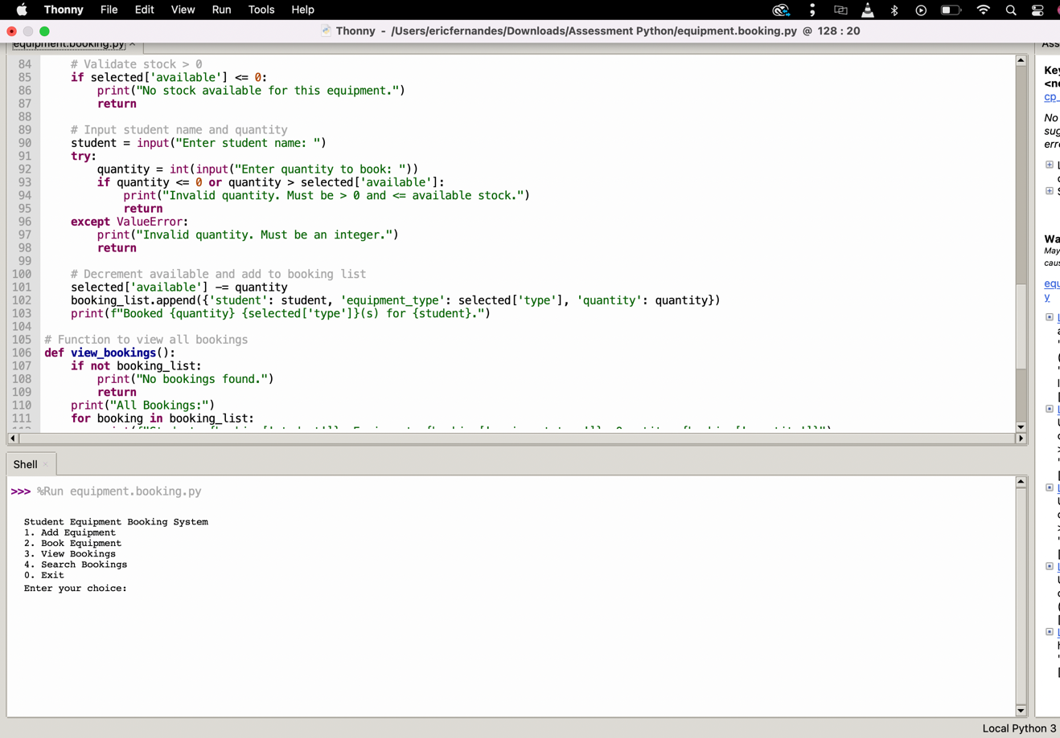

Screenshot 2: Successful addition of new equipment.
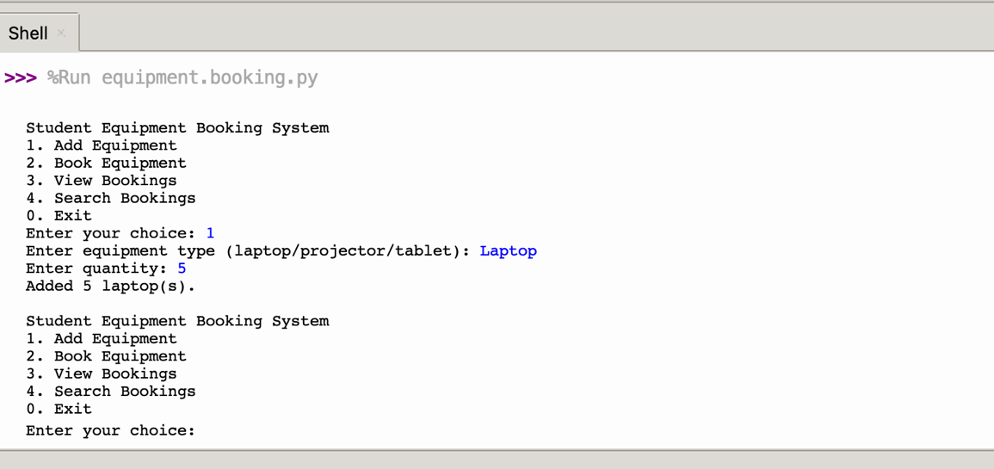
Screenshot 3: Add existing equipment (update quantity)
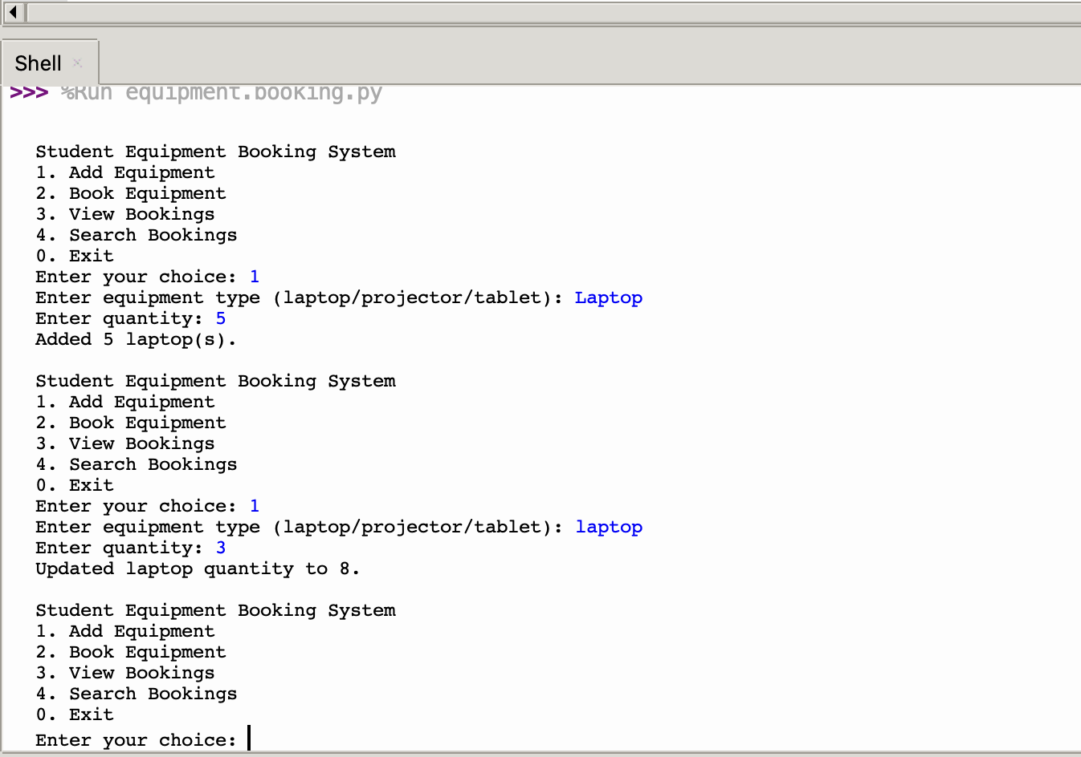

Screenshot 4: Handling of non-numeric input for quantity (ValueError).
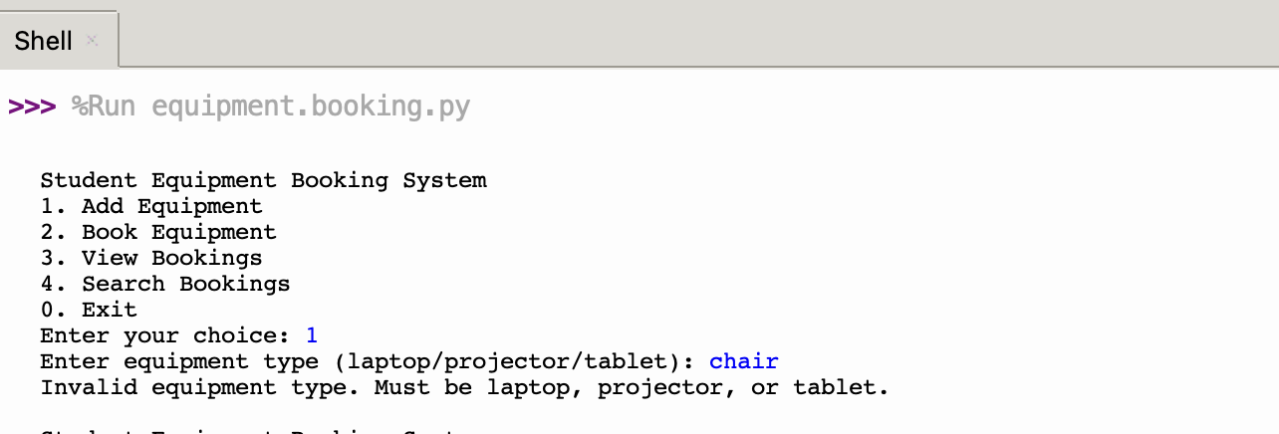

Screenshot 5: Handling of negative quantity input.
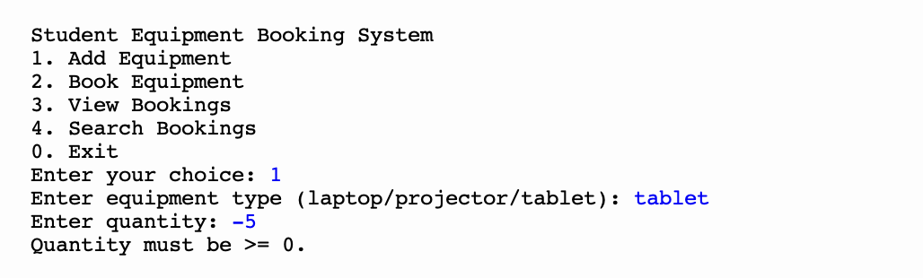

Screenshot 6: Add non-numeric quantity.
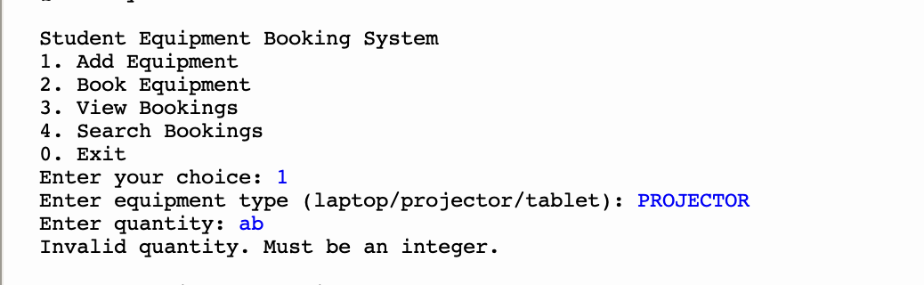

Screenshot 7: Book available stock.
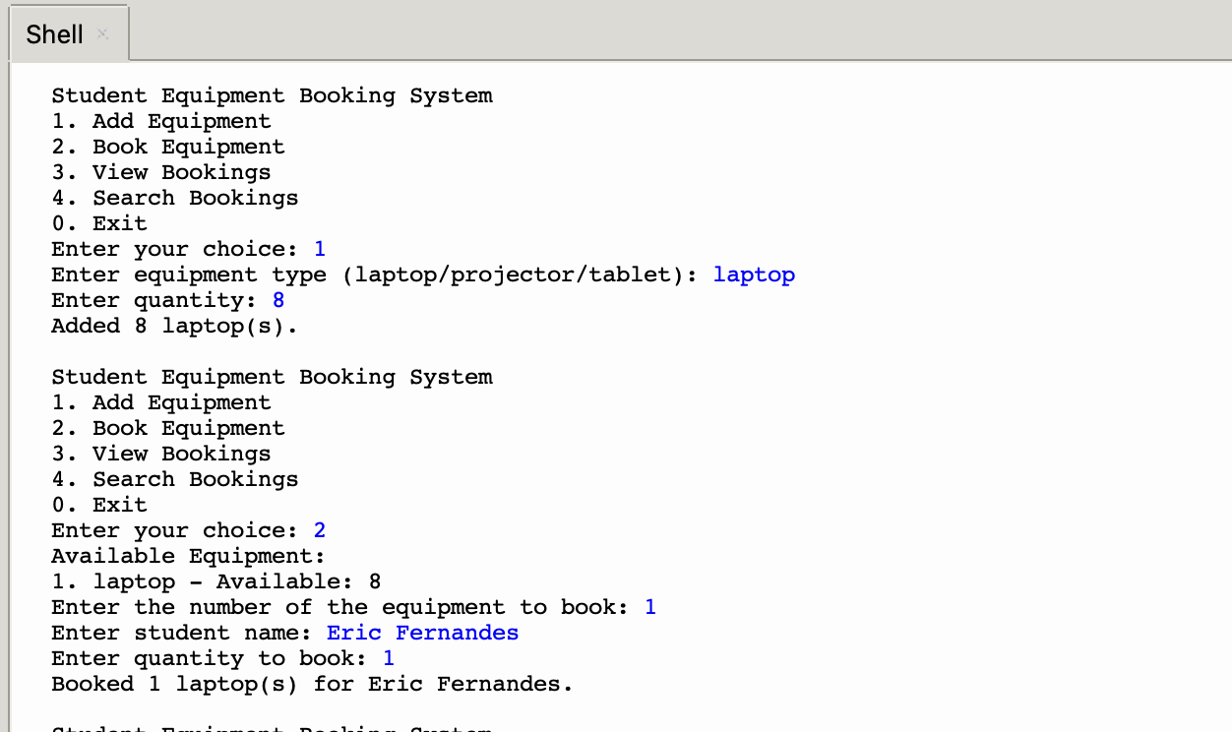

Screenshot 8: Book more than available
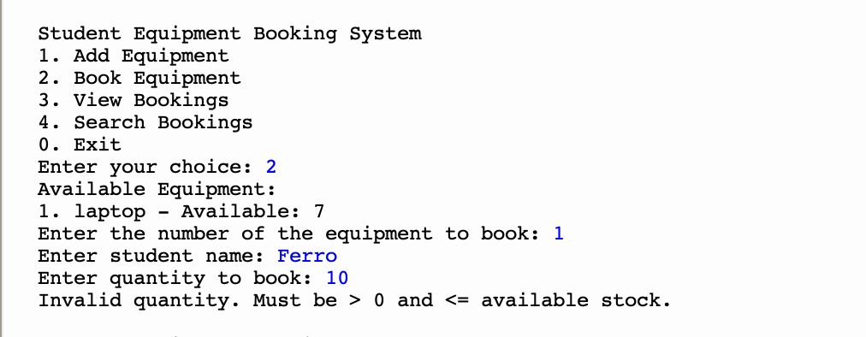
Screenshot 9: Attempt to book equipment with no available stock.
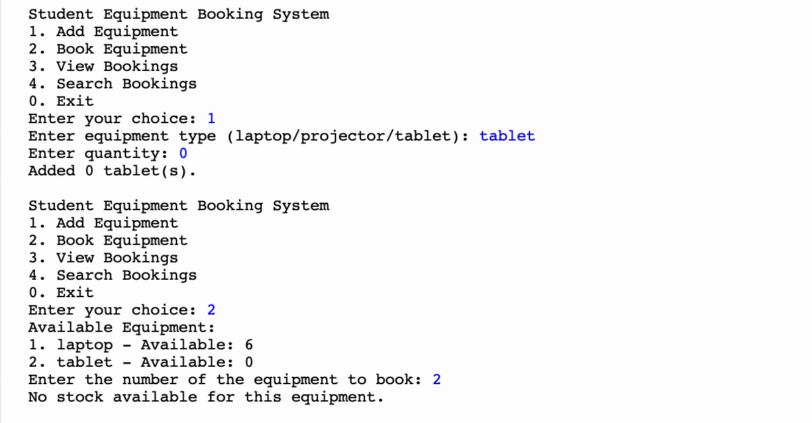
Screenshot 10: Display when no bookings have been recorded.
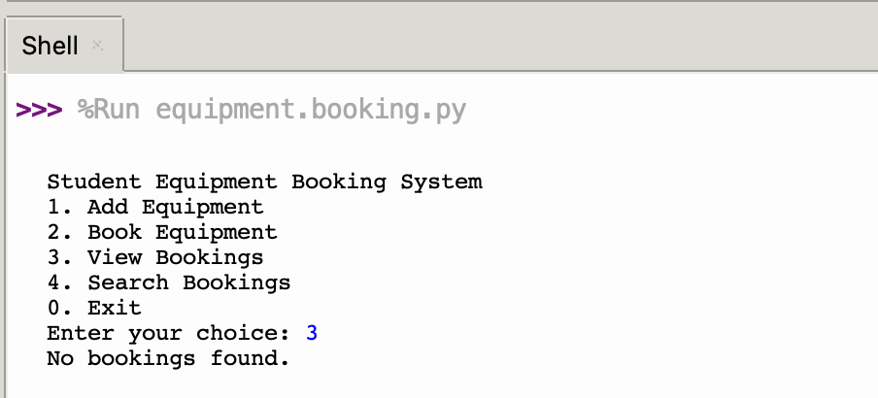

Screenshot 11: View existing bookings
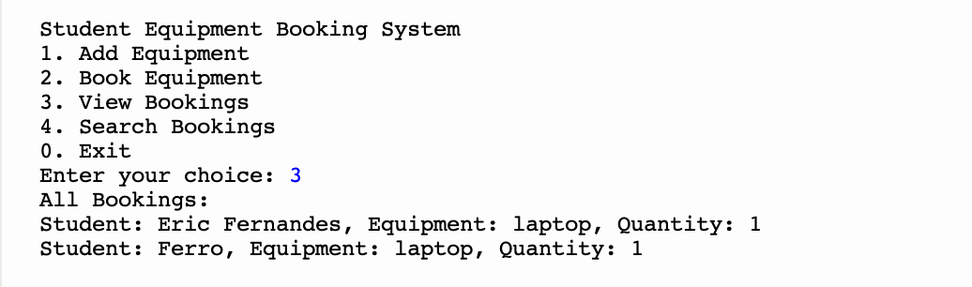

Screenshot 12: Search results for a specific student name.
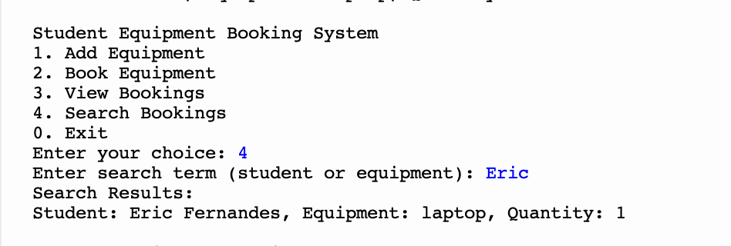

Screenshot 13: Display when no search matches are found.
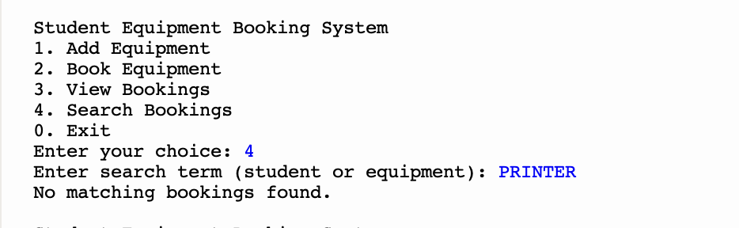

Screenshot 14: Display invalid menu choice
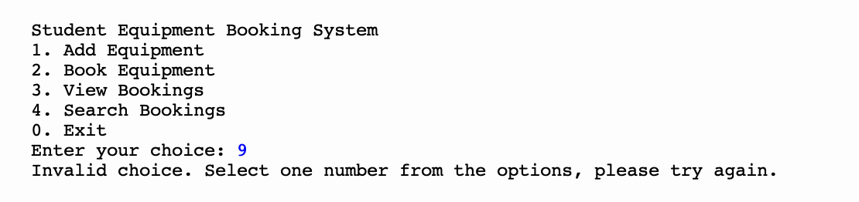
Screenshot 15: Exit system


