DS2 Scenario 2: River Fitness

You are helping a local gym called River Fitness. They collected customers feedback and want a simple, clear summary.

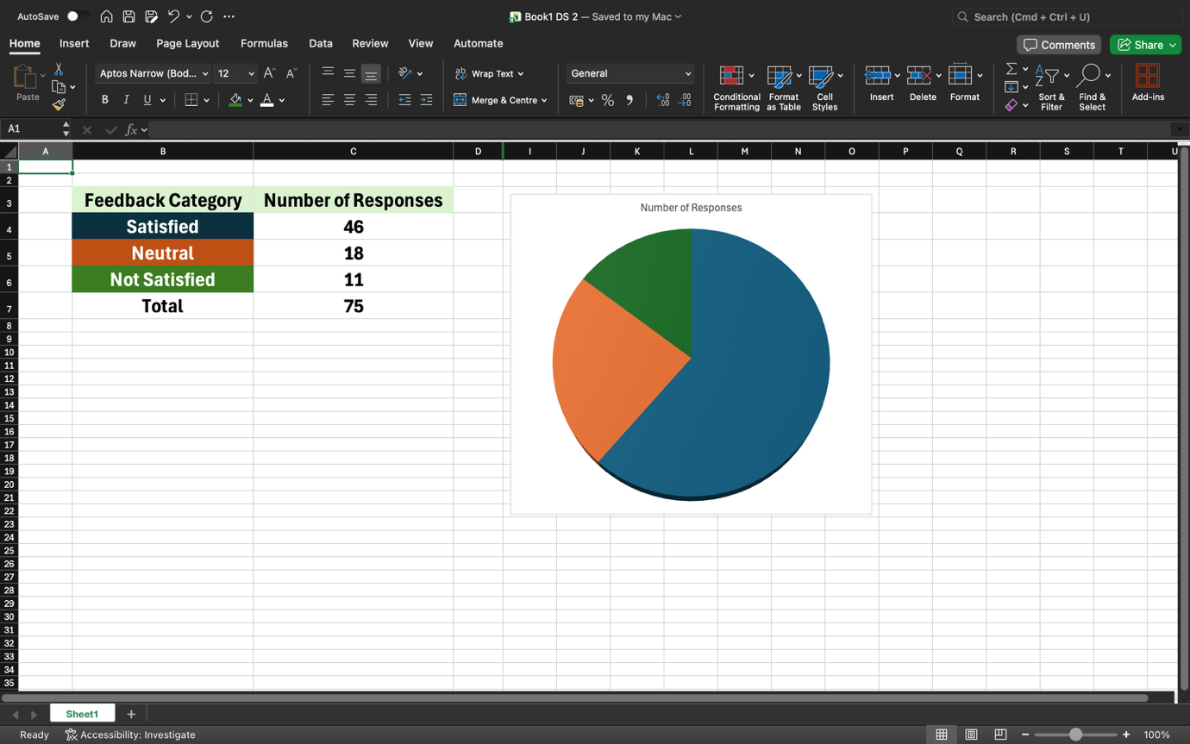

Why you chose your tool?
I chose Excel because it is very easy to make tables and charts for numbers. It helps me to put different colours to identify the feedback category.
What information you used?
I used the customers feedback numbers provided by River Fitness: 46 Satisfied, 18 Neutral, 11 Not satisfied.

What changes you made?
I put all the numbers into a clear table, so they are easy to read. Then, I added a pie chart with matching colours to show the data in a simple, visual way.
How you improved your work?
I carefully double-checked all the numbers to make sure my totals and calculations were accurate. I also formatted the layout to keep it clean, professional, and very easy for anyone to read quickly.

