Experiential Learning Essay
By Scott Beckett

As humans, we are unique in the sense that our primary adaptive specialisation in not any particular skill or physical form but rather in identification with adaption itself, meaning our specialty is the process of learning. (Kolb 2014)
Outdoor Adventure Education or OAE Strongly differs from what we refer to as “Traditional” or “didactic” Learning as unlike these classical methods of teaching, OAE relies strongly on Experiential learning or learning by doing. This approach to teaching can be used as an Alternative or Complementary approach to traditional education.
When wanting to teach someone how to rock climb, is it best to tell them in meticulous detail everything they’ll ever need to learn, in a classroom? Or would it be more beneficial to take them out to a crag and get them to put on a harnes, set up the ropes themselves (with guidance), then learn from the experience and the mistakes they make along the way? We use Experiential Learning Theory so much in OAE because it ensures that we are constantly learning and improving as educators and educatees.

The Experiential Learning theory as described by David A Kolb was first published in 1984, Strongly influenced by the works and material of John Dewey, with one section of the book being called “Experiential Learning in Higher Education: The Legacy of John Dewey” (Kolb, 2014, P.36).
The relation between experiential learning and Higher education is extremely relevant to this essay. In this section of his writings, Kolb Talks about Experiential education being a way to modernise the University Curriculum, as at the time he was writing the book, education was changing in such a way that higher education was becoming more accessible to ‘the poor and minorities’ so there was a need for a way to translate the information from complex academia into “concrete practical realities of these people’s lives” because these people hadn’t been exposed to the traditional classroom/textbook way of learning. (Kolb, 2014, P.38)

Kolb’s Experiential learning theory is based heavily off of other learning theories, using the Lewinian Experiential learning model as a starting point (Miettinen, 2000, P.57), Dewey’s Model of Experiential Learning and Piaget’s Model of Learning and Cognitive Development. (See diagrams below).

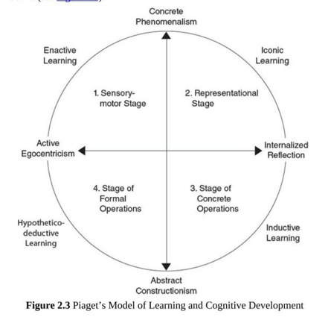
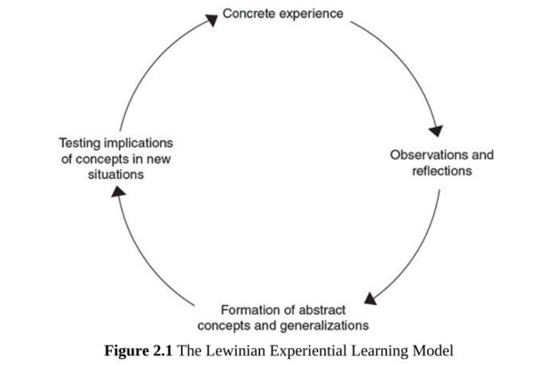
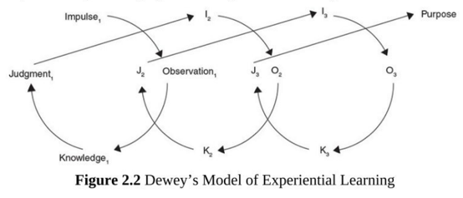
Figures Taken From: (Kolb, 2014, P.69-74)
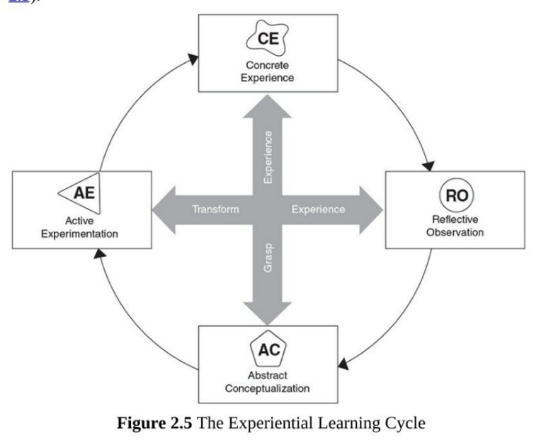
The Diagram on this page, shows the experiential learning cycle (by Kolb and Kolb, 2013) where learning is defined as “The process whereby knowledge is created by the transformation of experience”.
Based on 4 main stages, this cycle can start at any point of the circle, With the concrete explanation and Abstract conceptualisation helping you to grasp the experience, and the reflective observation and active experimentation contributing to the transforming of the experience to help improve it for next time, and there will always be a next time, as the point of it being a cycle/circle means that it is constantly evolving, and we never stop learning from our experiences.

There have been many times I have used past and present experiences to learn and better myself in the outdoors, some of which where I have actively reflected upon my actions, looking to improve, and some where I haven’t been trying to learn any lessons, but nonetheless have ended up coming out of the experience having learned something extremely valuable.

Concrete Experience
One lesson that I am constantly trying to learn is how to cope with is the Welsh Weather Ecosystem. Climate change is causing a significant increase in the frequency of extreme weather events across Europe including heatwaves, flooding; prolonged rainfall; and heavy snowfall. (Griffiths and Evans 2015) This means that when on a day out walking in the mountains, I have found myself dealing with all of the above conditions at different times, therefore finding one list of suitable kit for all conditions to put in my bag has proved challenging. Exposure is the biggest killer in the mountains, this can work both ways, both getting too warm or cold can be life threatening if not properly dealt with.

One particular instance where my lack of kit co-ordination came back to bite me was when walking up Pen-Y-Fan recently on a day out as an introduction to the Ecology of Adventure module. Despite Checking the weather before-hand, both in the days leading up to the walk and on the morning of, the expectations and what the conditions were actually like when I got there were vastly different.

Reflective Observation
According to the Weather Forecast for that day, it was meant to be 6 degrees Celsius whilst mostly clear and dry when looking at the met office, therefore I was wearing my Fleece lined walking trousers, a t-shirt, jumper/fleece, a body warmer and a coat, expecting it to be uncomfortably cold out and whilst it was quite cold in the car park but as soon as we started walking and elevation started increasing, I got far too warm far too quickly.

I had also opted to carry my 35L rucksack instead of my 18L one due to the fact the kit list for this walk was quite large, needing a full change of clothes etc. however even with the full kit list in the bag, there was still a lot of space in the bag so rather compacting what I had into my smaller rucksack, or leaving the empty space, I filled it with more extra clothing “just in case” meaning I had more weight to carry and less space as a backup. This made taking off layers on the ascent of Pen-Y-Fan difficult as there was less room to pack away any layers that I wanted to take off.
The extra weight I was carrying also didn’t help my back, which I have problems with. Whilst not severe, after hours of wearing the bag on my back it did start to ache, reducing my enjoyment of the walk.

Abstract Conceptualisation
Looking at what I could have done better, I needed to improve upon my layering system to make my warmth/breathability/carry weight more efficient. The British Mountaineering Council recommends 3 layers those being a Base layer, Mid layer and Outer layer. The base layer is there primarily to wick moisture away from your skin, the mid layer to insulate you and prevent loss of heat and the outer layer is to protect you and your inner layers from the environmental elements such as rain or snow. Its then recommended that you carry an extra insulation layer as when you stop walking, your body temperature rapidly drops. (Burnside, 2015)

Keeping my carry weight at a minimum is essential, as according to a study published from Columbia in 2019 conducted on 10-12-year olds, there is a “significant statistical association between NSLBP (Non-Specific Low Back Pains) and backpack weight to body weight percentage”. The Prevalence Ratios more than doubled (from 1.12 to 3.01) when the perception was the bag was very heavy which I have translated as the heavier the bag, the more pain the subject felt. (Angarita-Fonseca et al. 2019)
Whilst this study was aimed at and conducted on 10-12-year olds, reading further into the study says “older children tend to show greater sensitivity to pain as a result of puberty. Burton et al. 55 found an increase of NSLBP after 12 years of age, which is possibly a reflection of puberty growth and the greater tension of the spine with greater time spend at school.” Meaning the results would be similar if not, worst if conducted on older subjects.

Active Experimentation
Since Pen-Y-Fan, I have made sure I have stuck to the BMC’s Layering system, wearing a tech t-shirt, a fleece and my shell coat, then also brought my down jacket and or body warmer depending on conditions. Regarding trousers, I now know that the fleece lined ones are far too warm to wear out normally now, purely from how good they are at trapping body heat, so in future I am going to wear non fleece lined trousers so that I can add my waterproofs on top as wind/water protection if needed but still have the option to take them off if too warm.

When walking for myself, there are considerably fewer things I need to carry with me, so in future I will opt for my 18L rucksack wherever possible, only carrying equipment for me as an individual. I have been on a few walks since Pen-Y-Fan and used my lighter bag and noticed a considerable improvement in comfort from it, walking several miles and several hours before it even started to become uncomfortable. Despite having less stuff, I was still completely adequately prepared, with room to spare even when obviously bringing all rubbish/litter I produced home with me.

Overall, I have learned that packing lighter is better when and where possible, but there is a balance between the classic mantras “you bring it, you carry it” and “You can always take it off if you have it.” And in future I am going to experiment to find the middle ground. I also will look at more weather forecasts and pay more attention to factors other than temperature and precipitation chance.

  - Bibliography

Angarita-Fonseca, A. et al. 2019. Factors associated with non-specific low back pain in children aged 10–12 from Bucaramanga, Colombia: A cross-sectional study. Journal of Back & Musculoskeletal Rehabilitation 32(5), pp. 739–747.
Burnside, P. 2015. Would you just look at those layers. Available at: https://www.thebmc.co.uk/layering-clothes-winter-equipment [Accessed: 19 November 2020].
Griffiths, R. and Evans, N. 2015. The Welsh Marches: resilient farmers? Exploring farmers’ resilience to extreme weather events in the recent past. (18)
Kolb, D.A. 2014. Experiential Learning. Pearson Education.
Miettinen, R. 2000. The concept of experiential learning and John Dewey’s theory of reflective thought and action. International Journal of Lifelong Education 19(1), pp. 54–72. doi: 10.1080/026013700293458.

