Cybersecurity Challenges

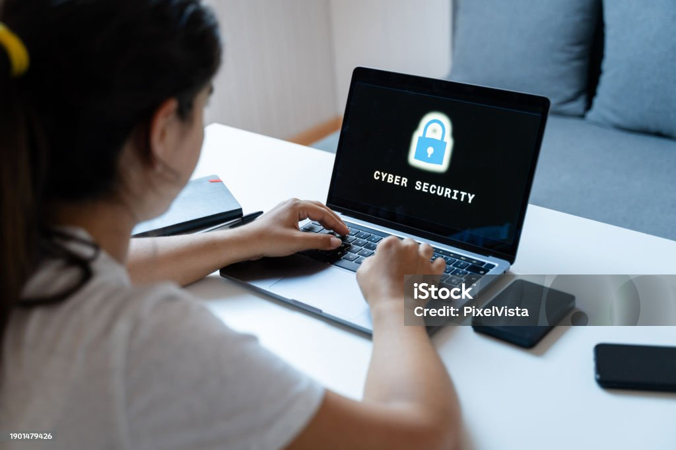

Prepared by:

Student Name: Farzana Khan
Student ID: 2508956

Table of Contents

- Introduction ---------------------------------------------------------------------- 03

- Task --------------------------------------------------------------------------------03

2.1 Identification of Modern Threats --------------------------------------------03

2.2 Modern Cybersecurity Policies ----------------------------------------------05

2.3 Technical Mitigation Measures ----------------------------------------------07

2.4 Proactive Monitoring and Incident Response ----------------------------08

2.5 Continuous Training and Awareness ---------------------------------------09

- Conclusion -------------------------------------------------------------------------09

References ---------------------------------------------------------------------------------10

Appendix (Presentation Slides) ------------- ------------------------------------------11

Introduction

A SteelForm Manufacturing (SFM) mill today operates in a digital environment where cybersecurity challenges are becoming increasingly complex. With production systems, design data, and customer information stored and shared across connected networks, the company is exposed to both internal risks, such as accidental data mishandling and external threats from cybercriminals targeting industrial operations. Any breach could disrupt manufacturing, damage equipment, or compromise sensitive business information. To remain secure and competitive, the mill must strengthen its cyber defence strategy through continuous employee awareness, strict access controls, and advanced threat detection tools. Building a proactive security culture is now essential for protecting operations and ensuring long-term business continuity.

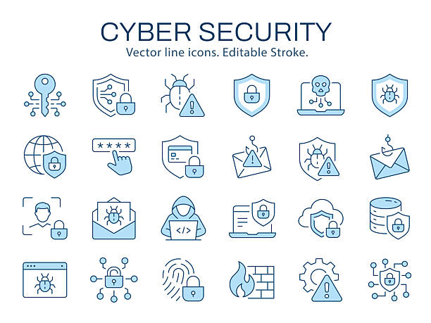
Figure 1: Cybersecurity Challenges in Computers [1]

TASK

A SFM Ltd, facing rising cybersecurity threats must protect both its operational technology and production systems. With machines connected to networks, even a small breach can disrupt manufacturing or expose sensitive data. Human error is often the weakest link, so continuous awareness training is essential. Short microlearning sessions help workers recognise phishing attempts, handle suspicious devices safely, and follow security protocols. Simulated attacks and role specific guidance strengthen vigilance, helping the mill build a resilient security culture that reduces the risk of costly cyber incidents.

2.1 Identification of Cyber Security Threats

A SFM Ltd, facing internal threats, such as employee negligence, insider attacks, misconfigurations, and accidental data leaks, as well as external threats from cybercriminals, nation state actors, and hacktivists. These threats can cause financial loss, data breaches, and reputational damage. To minimise these risks, organisations should implement strong access controls, regular security awareness training, multi factor authentication, and software updates. Using cyber threat intelligence also helps detect emerging threats and improve overall cybersecurity resilience.

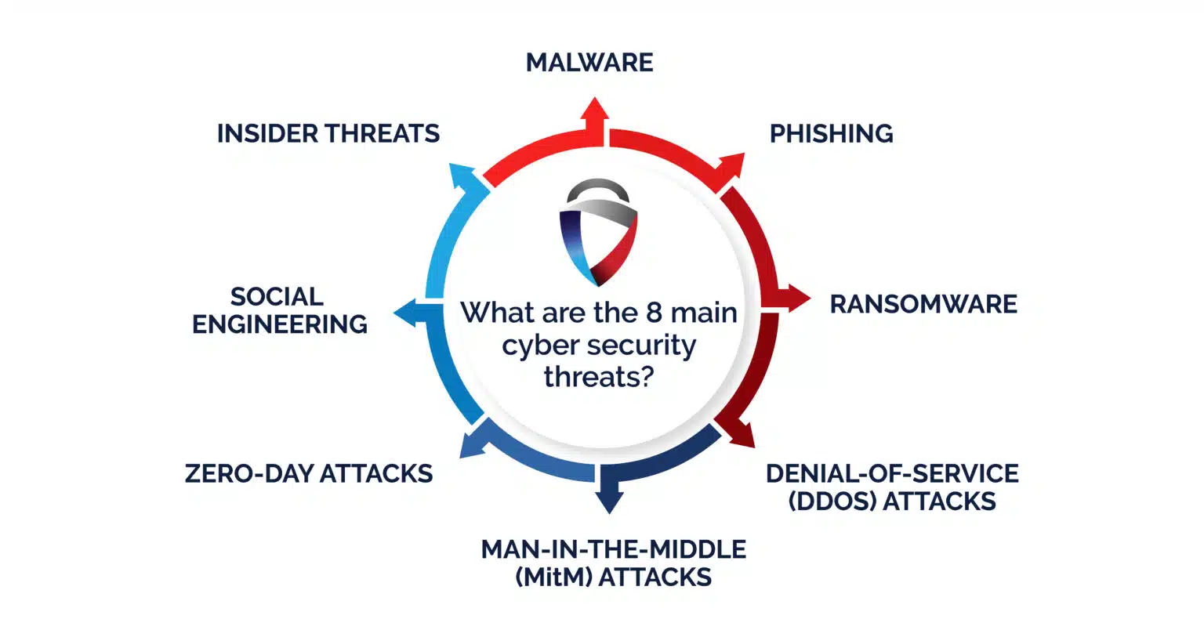

Figure 2: Internal and externa cybersecurity threats

Insider Threats

An insider is any person who has or had authorised access to knowledge of an organization’s resources, including personal, facilities, information, equipment, networks, and system [2].

Social Engineering

Social Engineering is one of the most effective ways for criminals to gain information and access, and you have likely been targeted through social engineering strategies whether you realised it or not [3].

Zero-Day Attacks

A zero-day attack exploits an unknown software vulnerability before the vendor releases a security patch. Because no defence is available, these attacks have a high success rate and can cause significant damage. Regular updates and threat monitoring help reduce the associated risks.

Man-In-The-Middle Attack

A man in the middle (MitM) attack occurs when a cybercriminal intercepts communication between two parties to steal or alter sensitive information. Organisations can reduce this risk by using encrypted connections, secure networks, multi factor authentication, and updated cybersecurity software.

Denial-of-service-Attack
A Denial-of-Service attack overwhelms a server with illegitimate traffic, often using fake return addresses, disrupting normal operations and preventing legitimate users from accessing essential services.

Ransomware
Ransomware is a type of malware which prevents you from accessing your device and the data stored on it, usually by encrypting your files. A criminal group will then demand a ransom in exchange for decryption.

Malware
Malware is malicious software that disrupts systems, steals data, and gains unauthorised access. Cybercriminals use it to infect devices, capture banking details, spy on users, and exploit computing resources for further attacks.


Figure 3: Virous in computers [4]

The Steel Form Manufacturing Ltd Company facing all above Cybersecurity threats.
Clearly identify current and emerging internal and external threats, including Ransomware-as-a-Service (RaaS), AI-powered social engineering (vishing), supply chain compromises, and risks associated with cloud adoption and hybrid work.

2.2 Modern Cybersecurity Policies

The proposed security policies are developed in line with recognised industry standards such as ISO 27001, the NIST Cybersecurity Framework, and GDPR compliance guidelines to ensure effective information security and regulatory compliance. Each policy is also assessed using the CIA Triad Confidentiality, Integrity, and Availability to ensure that security measures protect sensitive data, maintain data accuracy, and keep systems and services accessible to authorised users. Cybersecurity Policy, Emerging Threats, Digital Resilience, Regulatory Challenges, International Cooperation [5], [6].

Cybersecurity policy framework

Cybersecurity policy framework Aligned with NIST CSF & ISO 2700. This security policy applies to all organisational systems, employees, and third-party vendors. It defines the responsibilities of key stakeholders, including the CISO, IT staff, and all employees, in maintaining information security. The policy is committed to protecting the confidentiality, integrity, and availability (CIA) of information, complying with all relevant legal and regulatory requirements, and supporting continuous improvement through regular reviews and updates.

Risk Management Policy

The organisation will conduct regular risk assessments to identify and classify information assets. Risks will be recorded in a risk register and managed through mitigation, acceptance, transfer, or avoidance. The risk register will be reviewed annually, or whenever significant changes occur, to maintain security and compliance.

Access Control Policy

Access to organisational systems will follow the principle of least privilege using Role Based Access Control (RBAC). Multi-factor authentication (MFA) and strong password policies will protect user accounts. User access will be promptly updated as roles change, ensuring only authorised individuals can access organisational systems and data.

Asst Management Policy

The organisation will maintain a complete inventory of all hardware and software assets, with each asset assigned to a responsible owner. Information and assets will be classified based on their sensitivity and importance, and all employees must follow the acceptable use policy to ensure organisational resources are used securely and responsibly.

Data Protection & Privacy Policy

The organisation will protect sensitive data through encryption during storage and transmission. Data will be retained only for the required period and securely disposed of when no longer needed. Regular backups will be performed and tested to ensure data can be recovered in the event of loss or disruption. All data management practices will comply with applicable legal and regulatory requirements.

Cybersecurity Monitoring & Logging Policy

The organisation will implement centralized logging to collect and manage security events across all systems. Logs will be retained for a defined period to support monitoring, investigations, and compliance requirements. Continuous monitoring will be used to detect potential threats, with clear alerting and escalation procedures in place to ensure timely response to security incidents.

Cybersecurity Awareness & Training Policy

All employees must complete mandatory cybersecurity awareness training annually to maintain a strong security culture. Regular phishing simulations will be conducted to improve employees' ability to identify and respond to cyber threats. In addition, role-based cybersecurity training will be provided to ensure staff understand the specific security responsibilities associated with their job roles [7].

2.3 Technical Mitigation Measures

Propose specific, feasible technical and administrative measures to mitigate identified threats, detailing how each measure will be implemented (e.g., MFA, SIEM, CSPM). As stated in research: Cloud Risk Mitigation through Proactive Security Posture Management [8].

MFA (multi-factor authentication) strengthens account security by requiring users to verify their identity using two or more authentication methods, such as a password and a verification code or fingerprint. This reduces the risk of unauthorised access, even if a password has been compromised.

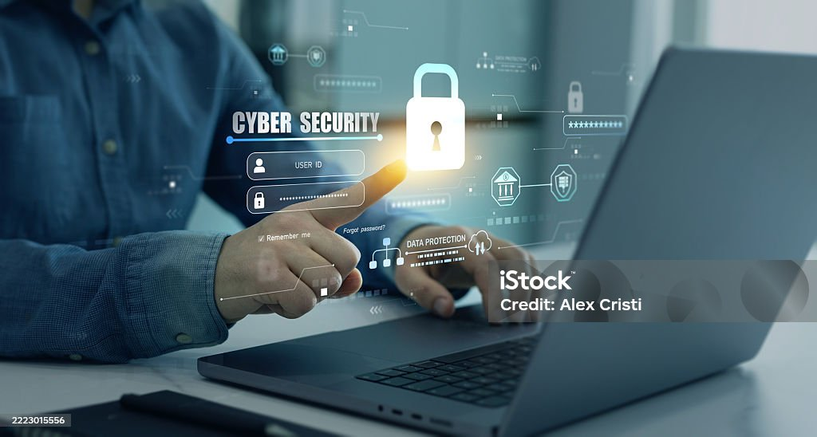

Figure 4: Showing MFA

SIEM (Security Information and Event Management) solution provides real-time monitoring by collecting and analysing security data from multiple sources. It detects unusual activity, identifies potential threats, and generates alerts, giving organisations a centralised view to improve incident detection and cybersecurity response.

SaaS The organisation will implement security controls across network devices, servers, applications, cloud services, and Software-as-a-Service solutions. These systems will be regularly monitored, maintained, and updated to protect against cyber threats, ensure reliable performance, and maintain compliance with organisational security policies.

CSPM (Cloud Security Posture Management) is a solution that helps organizations monitor and enhance the security of their cloud and automating by identifying misconfigurations, ensuring compliance, and automating remediation. CSPM is important in preventing cloud security breaches and maintaining strong security across could infrastructures like Laas, and PaaS.

All four measures are entirely realistic and achievable for SFM Ltd, with no technical barriers, manageable costs, and flexible rollout options to suit your operational needs:

Cybersecurity threats such as ransomware, insider threats and social engineering continue to evolve, posing significant challenges to organization. Real world incidents demonstrate that no organisation is immune. However, by adopting proactive security measure, investing in employee training and leveraging advance monitoring tools, organisations can significantly reduce their risk exposure. A comprehensive and adaptive cybersecurity strategy is essential to safeguard critical assets for Steel Form Mill. These mitigation measures are highly realistic, achievable, and reflect the absolute gold standard of currently Cybersecurity best practices for Steel Form Mill.

2.4 Proactive and Monitoring and Incident Response

Proactive incident management is a strategic approach that focuses on identifying potential issues and implementing measure to prevent them from occurring. Unlike reactive methods that address problems after they happen, proactive management aims to predict the next big incident before it is happens-using early detection to stay one step ahead. This approach leans on real time data, historical trends, and automation to spot trouble before it starts, it’s

Log360 to the rescue

We suggest to Steel Form mill to adopt Log 360 rescue to and above protective measure to Detect, investigate, and resolve security incidents and threats using a single, scalable SIEM solution: Log360 [9]. It provides you with actionable insights and analytics-driven intelligence for real-time security monitoring, advanced threat detection, incident management, and behavioural analytics-based anomaly detection. Additionally, Log360 includes predefined reports and alert templates that help address compliance and privacy mandates.

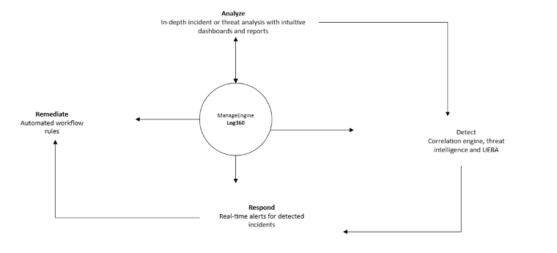

Figure 5: Diagram of Log360

  - Continuous Training and Awareness

Cybersecurity is only as strong as the people behind it, and despite significant investments in firewalls, monitoring tools, and advanced software, human error remains the most common source of vulnerability. Continuous, automated security awareness training has proven to be one of the most effective ways to reduce these risks. Research such as the Cybersecurity Awareness Training Model (CATRAM) case study in Canada highlights that traditional annual training sessions have limited impact because employees quickly forget what they learned. By adopting a continuous learning approach, organisations reinforce essential concepts identifying phishing attempts, protecting sensitive information, and following security policies on an ongoing basis [10]. Microlearning, delivered in short 5–10-minute modules weekly or even daily, helps employees internalise secure behaviours without disrupting productivity. Simulated phishing and social engineering exercises further strengthen awareness by exposing employees to realistic attack scenarios in a safe environment. When employees respond incorrectly, immediate feedback helps them recognise warning signs and improve future decision making. Scenario-based learning also prepares staff to handle real workplace situations, such as suspicious phone calls or unknown USB devices. Tailoring training to specific job roles ensures that executives, finance teams, and IT administrators receive guidance relevant to their responsibilities and risk exposure. To measure effectiveness, organisations track phishing simulation results, reported suspicious emails, and assessment scores. Regular reinforcement through refresher sessions, newsletters, and threat updates helps maintain a strong security culture. Ultimately, treating security awareness as an ongoing process rather than a one-time activity significantly reduces the likelihood of cyber incidents caused by human error.

- Conclusion

Cybersecurity requires a combination of technical controls and continuous employee awareness to effectively reduce cyber risks. Based on these findings, organisations should implement regular security awareness training, conduct phishing simulations, enforce strong access controls, and keep systems updated to strengthen their overall security posture. Future work should focus on evaluating the effectiveness of emerging technologies, such as artificial intelligence and automated threat detection, alongside improved training methods. Further research could also examine how evolving cyber threats and employee behaviour influence the long-term success of cybersecurity awareness programmes.

References

[1] | Eric A Fischer, "Cybersecurity issues and challenges," 2017.
[2] | Sunitha and Thompson, Nik Prabhu, "A primer on insider threats in cybersecurity," vol. 31, pp. 602--611, 2022.
[3] | Fatima and Kaabouch, Naima Salahdine, "Social engineering attacks: A survey," vol. 11, p. 89, 2019.
[4] | Vitalii and Lisnyak, Andrey Falkevych, Internal and external threats in cyber security and methods for their prevention., 2023.
[5] | Nick and Barati, Mehdi and Lee, Sarah Rahimi, "Evolving Cybersecurity Policy: Addressing Modern Threats and Enhancing Resilience in a Digital Age," 2025.
[6] | Juha-Matti Muikku, "Improving Cyber Security Situational Awareness with Log and Network Security Monitoring," 2020.
[7] | Temitayo Oluwaseun and Farayola, Oluwatoyin Ajoke and Kaggwa, Simon and Uwaoma, Prisca Ugomma and Hassan, Azeez Olanipekun and Dawodu, Samuel Onimisi Abrahams, "Cybersecurity awareness and education programs: a review of employee engagement and accountability," pp. 100--119, 2024.
[8] | PN and Jana, DB and Basu, A Ranganathan, "Cloud Risk Mitigation through Proactive Security Posture Management," 2022.
[9] | K and Krishnan, Hiranmayi Varun, "CYBERSECURITY METRICS, BUDGETING, AND LEADERSHIP".
[10] | Regner and Serra-Ruiz, Jordi and Cavaller, Victor and others Sabillon, "An effective cybersecurity training model to support an organizational awareness program: The Cybersecurity Awareness TRAining Model (CATRAM). A Case Study in Canada," pp. 174--188, 2021.

Annexures/ Appendix



