BMSW4009 Effective Team-working and Communication (Report)
Student ID: 2325440
Student Name: Andrei-George Teodorescu

Executive Summary
The following report discusses the main factors of the look at the way to work as a crew to achieve organisational success. There are thoughts from Belbin's Team Roles, Tuckman's Stages of Group Development, and the Thomas-Kilmann Conflict Mode Instrument that are emphasised. Building and maintaining excessive-performing groups is crucial for lengthy-term fulfilment. The summary stresses the significance of assigning roles, making sure there are clean transitions between group boom stages and the usage of the proper struggle resolution methods.

Table of Contents
Introduction 4
Theoretical Framework 5
Team Roles 9
Understanding Team Development 12
Managing Conflict in the Workplace 14
Conclusion 17
References 18

Introduction
Effective teamwork is critical for the achievement of any corporation because it results in partnership, solidarity, and attaining goals. In the trendy rapid-paced commercial enterprise world, groups that work together tend to do better than individuals. This leads to creativity and the capability to modify. The foremost goal of this study is to study a few critical theoretical models which are had to apprehend and improve teamwork in businesses. The look appears at Belbin's Team Roles, Tuckman's Stages of Group Development, and the Thomas-Kilmann Conflict Mode Instrument to try to deliver thoughts and tips on how to create and hold groups that work well collectively.

Theoretical Framework
Introduction to Key Theoretical Models
The idea framework talks about three important trends: the Thomas-Kilmann Conflict Mode Instrument, Tuckman's Stages of Group Development, and Belbin's Team Roles. Each model gives exceptional information about how teams work, which is vital for improving teamwork in groups.
Belbin's Team Roles
Overview: Belbin's version shows 9 jobs that people generally play in a group setting. The Plant, Resource Investigator, Coordinator, Shaper, Monitor Evaluator, Team worker, Implementer, Completer Finisher, and Specialist are a number of those jobs (De Brún and McAuliffe, 2020).
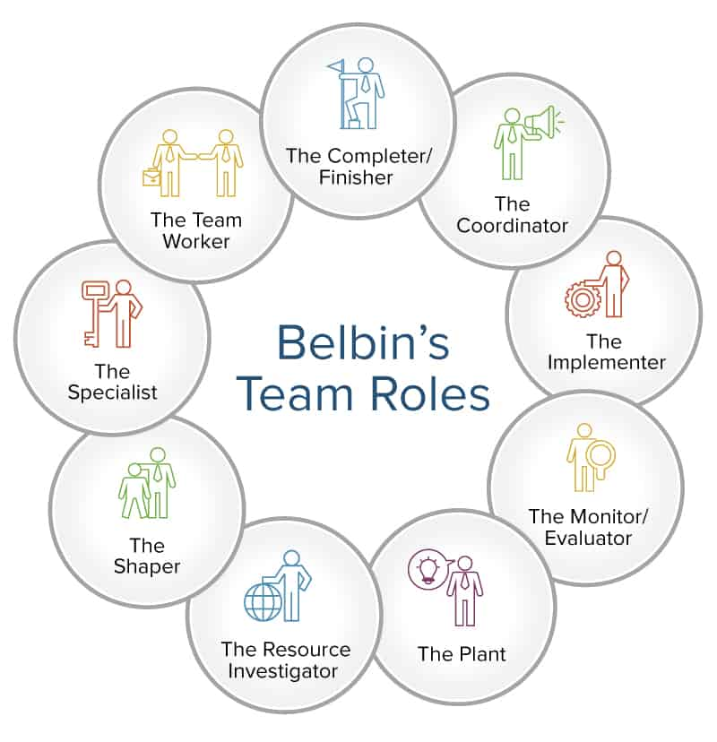
Figure: Belbin's Team Roles
Source: (García-Ramírez, 2020)
Main Ideas: Each job has its abilities and flaws that may be used. For instance, the Plant is creative but won't be useful, and the Shaper is active however is probably frightening.
Relevance: Knowing those jobs allows managers to supply obligations to group contributors that healthy their skills, which improves the performance of the entire organization. For instance, a Plant is probably exquisite for arising with ideas, even as an Implementer is probably exquisite at setting plans into movement (García-Ramírez, 2020).
Tuckman's Stages of Group Development
Overview: Tuckman's model suggests how groups develop through 5 ranges: Forming, Storming, Norming, Performing, and Adjourning.
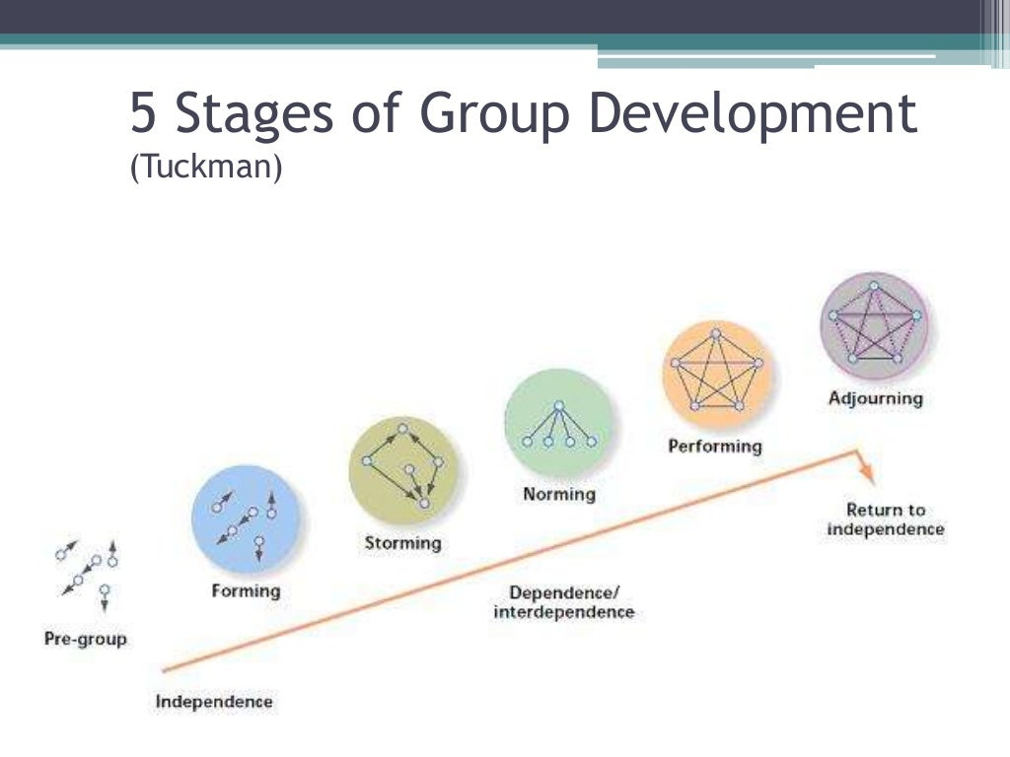
Figure: 5 stages of group development
Source: (García-Ramírez, 2020)
Main Concepts: Every degree suggests a various stage of the group's growth. During Forming, humans get to understand each other, for the duration of Storming, there's a conflict of words, all through Norming, people start to work collectively, in the course of Performing, things work at their high quality, and all through Adjourning, humans break up.
Importance: Leaders could make transitions less difficult and take care of disagreements more successfully if they understand those steps. For example, at some stage in the Storming level, a leader would possibly work on approaches to assist the group get past disagreements on the way to move ahead (De Brún and McAuliffe, 2020).
Thomas-Kilmann Conflict Mode Instrument
Overview: The Thomas-Kilmann model charges how people deal with struggle by putting them into five groups: competing, cooperating, compromising, heading off, and accommodating.
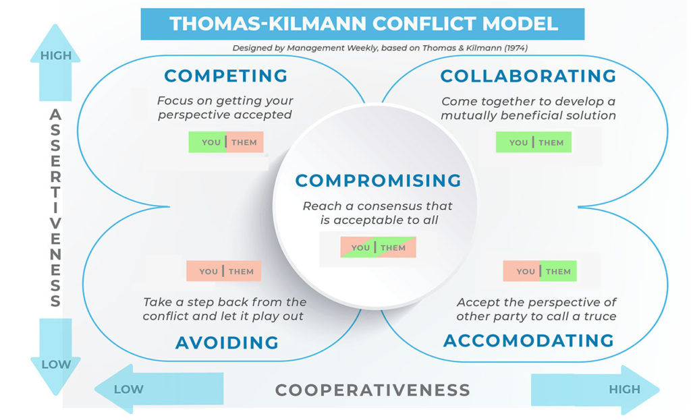
Figure: Thomas-Kilmann Conflict Mode Instrument
Source: (De Brún and McAuliffe, 2020)
Ideas that count: Each mode shows a specific way to clear up a trouble, that is tormented by how assertive or beneficial someone is. Collaborating, alternatively, is excessive in both boldness and cooperativeness, even as Competing is low in each (García-Ramírez, 2020).
Relevance: Companies can educate their employees on a way to take care of disagreements better by understanding those styles. This will improve teamwork and productivity. Promoting a collaborative approach, for instance, can cause new ideas that work for all.

Team Roles
Explaining the Belbin Model and Its Goal
The Belbin version, created through Dr. Meredith Belbin, aims to improve group overall performance by identifying the various elements that human beings play within a team. The aim is to make sure that those roles are balanced so that the crew works nicely collectively and may use each member's capabilities and flaws to their benefit (De Brún and McAuliffe, 2020).
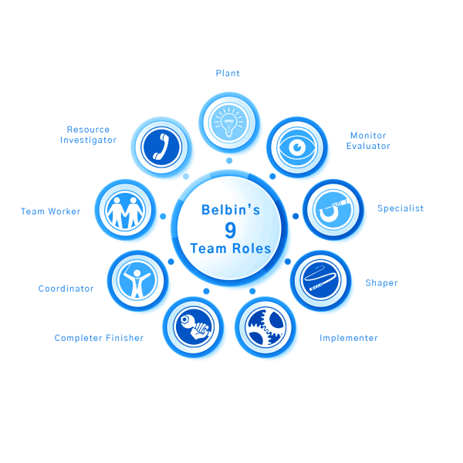
Figure: Belbin Model
Source: (García-Ramírez, 2020)
Belbin found nine roles for teams
Plant: Innovative and creative; comes up with thoughts and solutions.
Resource Investigator: Outgoing and keen, appears for possibilities and makes connections.
Coordinator: Confident, proper at delegating, makes goals clean, encourages making choices.
Shaper: Tough and converting, pushes the group to attain its dreams.
Monitor Evaluator: Thinks strategically and thoroughly, and makes decisions based totally on logic and analysis (Dumond, 2022).
Team worker: Works properly with others, sees matters honestly, and allows the group to get along and solve troubles.
Implementer: Useful and dependable, turns the mind into plans that can be achieved.
Completer Finisher: Careful and interested in elements, make certain jobs are executed completely and on time (Ivanova et al., 2020).
Specialist: Hardworking, knowledgeable, and brings several enjoy.
Real-World Uses
The Belbin version has been used correctly by corporations to enhance the makeup of teams and the distribution of tasks. As an instance:
Tech Companies: A software program improvement company would possibly place a Plant on the cost of developing ideas for new functions, a Shaper on the price of placing the challenge's agenda, and an Implementer on the price of overseeing the writing and implementation levels. This makes it positive that new ideas are created, goals are met fast, and duties are done correctly (Dumond, 2022).
Marketing Agencies: A Resource Investigator should look for new advertising possibilities as part of an advertising marketing campaign, a Coordinator should manage contacts with clients, and a Completer Finisher may want to make certain that each marketing campaign materials are completed and given on time.
Healthcare Teams: In a hospital, a Team worker should assist the medical team of workers in communicating with each other, a Monitor Evaluator ought to take a look to see if treatment plans are operating, and a Specialist ought to deliver recommendations based totally on their substantial knowledge in sure clinical regions.

Understanding Team Development
Introduction to the Tuckman Model:
Bruce Tuckman came up with the Tuckman version, which indicates how groups grow via five tiers: Forming, Storming, Norming, Performing, and Adjourning. This model gives a manner to consider how groups develop and the way they exchange over the years.
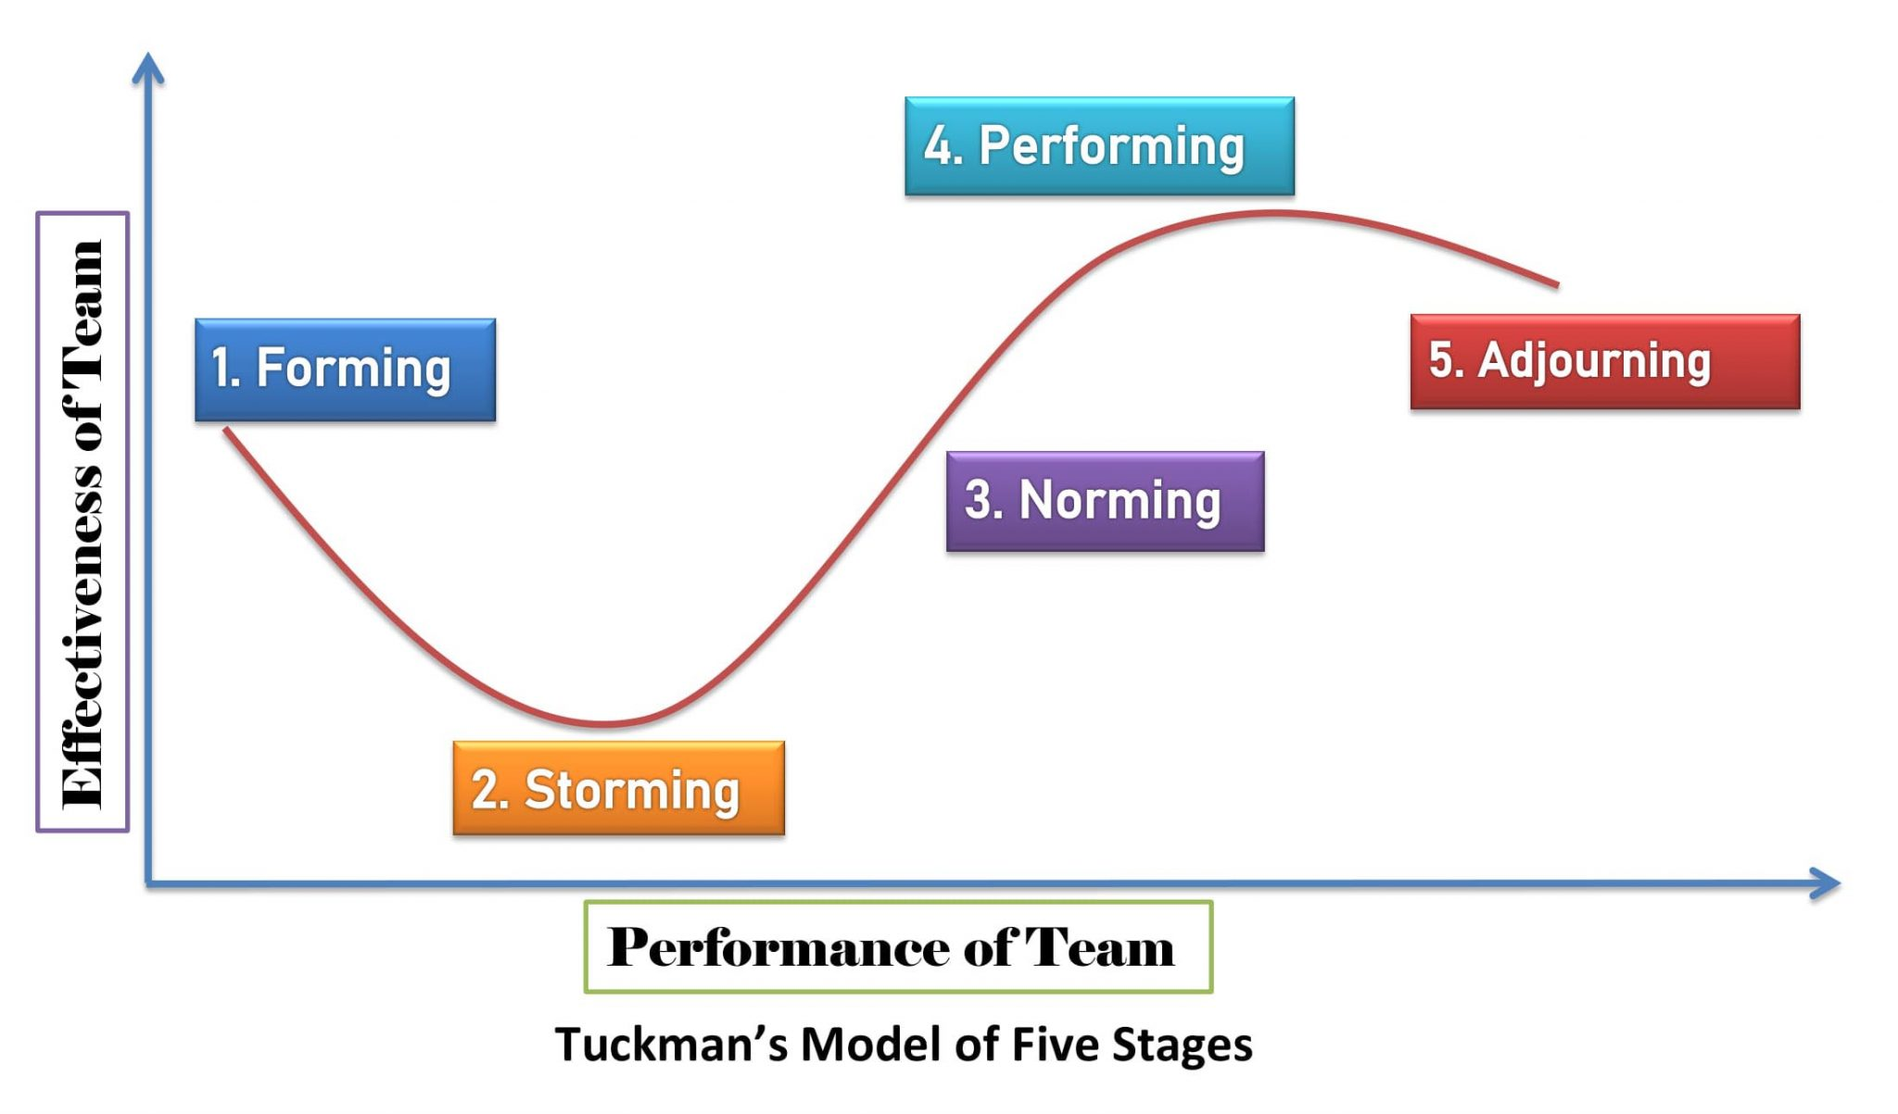
Figure: Tuckman model
Source: (Dumond, 2022).
Stages of Team Development
Forming
Description: The first step is for crew members to get to realize every difference and learn about the venture and their jobs (Dumond, 2022).
Challenges: Not knowing what to do and being irritating about relationships and jobs.
Opportunities: Setting clean desires and getting humans to trust in the beginning.
Example: A new project team might preserve instructions and icebreakers to talk about their dreams and get to recognise each other.
Storming
Description: Members of the group have disagreements while they are trying to voice their thoughts and perspectives.
Problems: Personality clashes, strength battles, and variations approximately what desires to be carried out (West and Borrill, 2023).
Opportunities: Talking about disagreements freely can help humans get alongside higher and apprehend each other better.
Example: An advertising crew might argue plenty about advertising and marketing techniques, however, they can use techniques for mediation to return to a settlement.
Norming
Description: The team starts to set guidelines and make sure everybody works properly collectively.
Challenges: The risk of groupthink and laziness are issues.
Opportunities: Better running together, developing useful structures, and developing an admiration for each other.
Example: To live on the identical page, a team operating on a product might give trendy techniques and schedule normal test-ins (Adamis et al., 2023).
Performing
Description: The team works well collectively to reach its dreams.
Challenges: Keeping up appropriate performance and handling more strain.
Opportunities: Using skills, being very productive, and coming up with new ideas.
Example: A properly installed studies crew regularly meets targets and dreams while running together to print groundbreaking research.
Adjourning
Description: The team breaks up due to the fact the project is over (Cardiff et al., 2020).
Problems: Loss of emotions and now not knowing what role they will play in the future.
Opportunities: Thinking approximately what people achieved properly and what person may research for future initiatives (Hell, 2022).
Example: Before participants flow on to new jobs, a task crew at a consulting organisation holds a final assessment meeting to have a good time wins and write down lessons discovered.

Managing Conflict in the Workplace
The five conflict-managing styles in the Thomas-Kilmann model are:
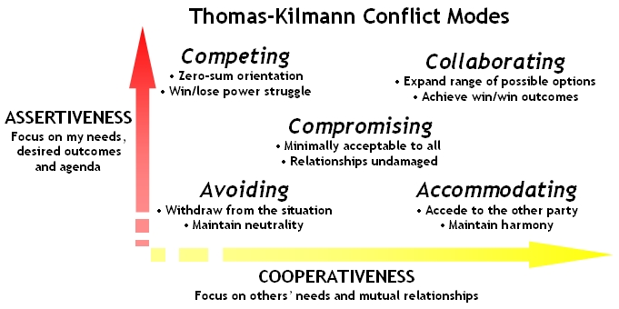
Figure: Thomas-Kilmann model
Source: (Hell, 2022)
Competing
Description: Being cussed and unwilling to work with others, placing their own needs in advance of others.
Example: In an excessive-stakes discussion, a manager sticks to their plan and does not listen to what the group has to say to make a quick decision (Adamis et al., 2023).
Collaborating
Description: Strives for win-win outcomes by using coping with all and sundry's problems.
Example: An undertaking group has a making plans session to come up with a complete plan that everyone is happy with.
Compromising
Description: People with this character type are moderately forceful and cooperative, and they try to discover answers that work for all (Cardiff et al., 2020).
Example: Two teams conform to share-constrained sources using switching once they use them. This makes it positive that everybody has equal get entry.
Avoiding
Description: Lacks assertiveness and cooperation, and avoids war of words in place of going through it.
Example: An employee puts off communicating approximately a way to divide up the work in the hopes that the trouble will leave on its very own over time.
Accommodating
Description: Lacks confidence and is inclined to work with others, placing their wishes beforehand of their own.
Example: Someone in the group decides to work greater hours to assist a coworker meet an aim, even though they have already got lots of work to do.
Significance of Understanding These Styles
Teams and leaders can handle disagreements higher after they understand these types and can choose the first-rate manner to address the situation. Being aware of this makes the workplace greater peaceful and effective (Adamis et al., 2023).
Examples of Organizational Utilisation
Technology startups: To deliver together people with different varieties of capabilities and drive introduction, a startup may use the Collaborating style in go-functional teams.
Healthcare Facilities: Hospitals can use Compromising to assist team of workers members who have timetable issues and to balance the needs of individuals with the needs of the commercial enterprise (Cardiff et al., 2020).
Corporate Training: Businesses preserve lessons to educate managers on the way to spot and use different war styles, which makes them higher leaders and helps groups work collectively higher.

Conclusion
The maximum critical ideas from Belbin's Team Roles, Tuckman's Stages of Group Development, and the Thomas-Kilmann Conflict Mode Instrument are emphasized in this observation. Teamwork that works nicely is crucial for the fulfilment of any business because it boosts creativity, efficiency, and employee happiness. Organisations have to supply people jobs based on their strengths, ensure that crew boom ranges go easily, and use top warfare resolution strategies. They can build and preserve excessive-acting groups that cause long-term achievement and a competitive part in this manner.

References
Adamis, D., Krompa, G.M., Rauf, A., Mulligan, O. and O’Mahony, E., (2023). Belbin’s Team Role Balance and Team Effectiveness in Community Mental Health Teams in an Area of Northwest Ireland: Implications for Leadership. Merits, 3(3), pp.604-614.\
Cardiff, S., Sanders, K., Webster, J. and Manley, K., (2020). Guiding lights for effective workplace cultures that are also good places to work. International Practice Development Journal, 10(2).
De Brún, A. and McAuliffe, E., (2020). Identifying the context, mechanisms and outcomes underlying collective leadership in teams: building a realist programme theory. BMC Health Services Research, 20, pp.1-13.
Dumond, P., (2022). Exploring Virtual Methods for Teaching Engineering Teamwork. Proceedings of the Canadian Engineering Education Association (CEEA).
García-Ramírez, Y., (2020), October. Roads project: the relationship between team roles and their performance. In 2020 XV Conferencia Latinoamericana de Tecnologias de Aprendizaje (LACLO) (pp. 1-6). IEEE.
Hell, P., (2022). Integrating individual differences to build team synergy during merger and acquisition (Doctoral dissertation, The College of St. Scholastica).
Ivanova, S., Dimitrov, L., Ivanov, V. and Scvorcova, S., (2020), October. Search Correspondence Between the Roles of the Brainstorming Participants and Belbin's Team Roles. In 2020 III International Conference on High Technology for Sustainable Development (HiTech) (pp. 1-5). IEEE.
Morgan, G. and Scriven, A., (2023). Working Effectively With Other People. Ewles and Simnett’s Promoting Health: A Practical Guide-E-Book: Ewles and Simnett’s Promoting Health: A Practical Guide-E-Book, p.135.
West, M. and Borrill, C., (2023). The influence of team working. In Understanding doctors' performance (pp. 106-122). CRC Press.

