Problem solving and decision making – bmsw4004
The decline of the High Street: Report

Ancuta Nutu - 1918834
University of Wales Trinity Sant David – Skills for Workplace

Contents
1.0 Introduction 2
2.0 Main Findings 2
2.1 SWOT 3
2.2 PESTLE 4
3.0 Conclusion 5
4.0 Recommendations 7
5.0 Monitoring, Reviewing, and Communicating the Solution 8
6.0 Appendices 10
7.0 Reference list 14

1.0 Introduction

The purpose of this report is to present one of the issues that High Street is facing now, which is the pandemic. Due to the devastating effects that it has had on all shopping malls and more, we easily assume that the emergence of covid-19 is indicative of the nature of the decline of the high street. This phenomenon has triggered several events during this pandemic that have led to the closure and bankruptcy of many companies and even the loss of many jobs. During this period, few individuals had the chance to start a new chapter, working from home, due to the lack of knowledge of digital skills, which had become a disadvantage for both employers and employees and many other individuals looking for work.
In the main findings, you will find a brief presentation of the nature, scope, and impact of this issue along with a SWOT and PESTLE analysis in which more information will be highlighted regarding the decline of the High Street.

2.0 Main Findings

A major problem for High Streets in recent years has been the pandemic, hence the subject of this presentation and a short description of the Nature, Scope, and Impact of the problem.
In the first half of this year, 8,700 chain stores closed in British high streets, shopping centers, and retail parks, while just 3,488 opened. COVID-19 and the government restrictions that followed created the longest recession in the history of the United Kingdom. Government support for businesses in affected sectors has not kept pace with the loss of more than 8,700 chain stores (Economics and strategy research consultancy, 2022).
Nature
The government has implemented many restrictions on city centers since the onset of the pandemic that forced many shops to close. MarketLine (2021) estimates the vacancy rate in the second quarter of 2021 to be 14.5%. In addition, due to Covid-19, consumers now purchase almost everything they need online, including groceries, clothing, appliances, and more.
Scope
Companies and businesses in the local market were most affected since they shut down for long periods or slowed down their operation. Consequently, it became more difficult for them to make money or even remain open. Moreover, the pandemic has caused devastation to the local economies in towns and cities because of the negative impact on the country’s economy.
Impact
Many of the small businesses have not survived after the first lockdown, during which all non-essential businesses have been ordered closed. Many reopened when allowed to, but not all have. Despite losing jobs and reducing the workforce, the pandemic hit the economy hard. Individuals had to take the consequences of the economy consuming more than it produced. Furthermore, it has been difficult for workers and business owners to maintain their mental health during the pandemic, with many individuals becoming anxious, fearing going to work, and experiencing poor physical health as a result.

2.1 SWOT

Among the most victimized by the pandemic were businesses located on high streets, and it is not just retailers that have been hit. Despite the public health emergency, a pandemic will cause substantial economic damage, also changes are occurring in how people work and exchange, affecting the future of High Streets.
Below will be presented 4 conversion strategies looking at nature, scope, and impact of the covid on the High Street.
- Opportunities - Strengths
In many aspects of daily life, technologies have replaced in-person interactions and physical connections, as the pandemic has reignited interest in the community and what's localized. With the development of technological advancements, the digital divide will widen between generations and groups with different socio-economic backgrounds. As the population is aging, healthcare and social services are in demand, adding to the risks of digital divides (techUK, 2021).
- Opportunities – Weaknesses
Urgent action must be taken now to prevent the worst effects of climate change. A circular economy of recycling, reusing, and waste management will require the adaptation of high streets and town centers. It will be necessary to adapt public transportation infrastructure and conveyance logistics to low-carbon modes.

- Threats – Strengths
A strategy based on quantitative and qualitative evidence should guide high street resilience over the medium and long term. Local governments must have relevant knowledge and experience to develop a local high street strategy. High street strategies, which protect green spaces and heritage assets, can make use of planning policies, such as local plans and neighborhood plans. A high street strategy should guide policy decisions. As with any financing, projects intended to improve and strengthen high streets need to be economically achievable and have a clear social benefit. Poor financial planning may undermine the benefits of investments that local authorities can make on high streets (Build Back Better High Streets, 2021).

- Threats – Weaknesses
Using the internet, Internet-based training enables knowledge to be shared from any location worldwide to targeted audiences looking to learn a specific subject also online education is available free and paid. Students who are willing to take online classes are given the chance to study with professionals who excel in their fields. In addition to the training modules, PDFs, Word documents, video tutorials, and assessments are part of the package. That way, students learn more quickly and more easily. As well, various organizations highly value some qualifications and diplomas available to reward applicants for their understanding abilities. Online training may be preferred by some individuals, while face-to-face training may be preferred by others. In comparison to free online courses, online training is without a doubt a cost-saving option for both businesses and individuals (Ali, 2018).
- The appendices contain the full SWOT analysis.

2.2 PESTLE

Many factors determine how the business will be affected by external factors, and Pestle analysis is one of the most useful tools in finding these factors. These factors include political, economic, social, technology, legal and environmental.
Political
There may be a prorogation in Parliament, but the high street still fights for its life. Figures published last week showed that Britain's 500 top high streets lost 1,234 shops in the first half of this year, an increase from the same period last year. To reimagine the high street, the government must devise innovative strategies. Having a disrupting strategy that challenges the status quo would be the only way to save the high street since the model is not just flawed, but completely broken. Community spirit and cultural integration in the UK have eroded, and because the high street serves as the gateway to both, more than just the economy is at stake (Todaro, 2019).

Economic
To meet consumer demand, residents must improve their skills. Local demand for goods and services will increase as skilled residents have higher wages. A key component of economic success is local skill sets. Skills should always be addressed in local growth plans, including how to increase the local skills profile. Some places may see fewer office spaces required if more people work from home. In response to that, interventions that increase the quality of business offices, for instance, would be called 'supply-side' interventions. However, they require new demand to be successful (What Works Centre for Local Economic Growth, 2022).

Social
Since the 1960s, ethnic diversity in the United Kingdom has been growing consistently. As gentrification and cultural appropriation become more common, local authorities and businesses need to foster more culturally diverse spaces without excluding communities. A family, a community, the socio-economic status of the individual, and religion are among the factors that determine a person's lifestyle. Retailers should take a holistic approach to client acquisition; they should not only pay attention to demographic trends, but also look at how their client base lives, and how this affects their relationship with you (Shpak, 2019).
Technology
To address these challenges, many small and high street businesses in the UK have adopted digital technologies. As a result, many businesses found it advantageous to expand their online presence during the pandemic. Consequently, many new products have been introduced during this time. However, businesses cannot adopt technology alone. Apart from the changes in the business environment, local governments and organizations that manage high streets have an opportunity to better serve their local economies and communities by leveraging technology (techUK, 2021).
Legal
It is imperative to follow the prevailing labour laws, taxation regulations, and other business laws in a retail store because it operates within the legal environment of a country. The rules and regulations become much more complex when a brand plans to expand internationally. Business owners who decide to ignore local rules and regulations of certain countries may be banned, subject to restrictions, bankrupted, or face foreclosure. Businesses must obey the laws of their respective countries (Ali Shaw, 2020).
Environmental
Despite the growing impact of such matters, individuals will continue to place different values on environmental and ethical credentials. Youthful high streets and town centers will be encouraged to prioritize low-carbon conversions, while others might be advised to focus on different demands in the coming years. In certain countries, taxes are applied to the sale of soda or fatty food, and a retailer must follow local legal and economic factors. In addition to expiration dates and removing contaminated stock, some companies face expiration issues related to environmental issues. When sales staff place the rackets on the racks, they get products with different expiration dates from their suppliers. There is a mix-up between the products, which product arrived first or will expire first (Ali Shaw, 2020).
- The appendices contain the full PESTLE analysis.

3.0 Conclusion

As a result of this report shows how the High Street faced Pandemic period and how multiple areas continue to develop, also brings several advantages, including working from home as well as opportunities created by online media and technology.
Inflation or local decisions by their authorities affect a great many communities. The traditional High Street is no longer what it used to be; however, others see this as an opportunity to recreate it and reinvent it in a better way.
This report presents many solutions to help facilitate the recovery of high streets, but it is a slow process, however, the local authorities and the government help, they manage to create more leisure facilities and outdoor activities, local authorities want to make them more appealing.

4.0 Recommendations

Next will be presented 5 recommendations/ options that can restore the problem affecting the High Streets now.
- A change in social expectations and habits
Planning, designing, coordinating, and curating high streets and town centers will maximize social interaction, cultural experiences, and authentic experiences. Increasing the number of people stopping, sitting, and socializing on high streets can be achieved by improving the high street's infrastructure for walking and cycling (Greater London Authority, 2019).
- Consumer culture is evolving
Businesses that were once located in business parks can return to town centers by taking advantage of vacant retail units and rent adjustments. Many types of services cannot be obtained online that can be offered in greater store size, including stores, artist studios, coffee shops and bars, fitness classes, education classes, and stylists. Night-time uses for high street units add value to the space in comparison to their daytime uses (Greater London Authority, 2019).
- Information management, digitization, and technology
Among other things, this information includes information regarding property owners, businesses, development proposals, and planning applications. As a data storage tool, such a tool can be implemented as a considered planning tool for authorities and communities also the use of mobile applications and websites is another area where innovation can alter our relationships with city centers and high streets (Greater London Authority, 2019).
- Social infrastructure is being destroyed due to economy
Inequality due to broad economic frameworks contributes to these social issues. Income inertia, health and food issues, part-time jobs opportunities are some of the factors affecting the workforce. As a result of austerity, public spending has declined over the past decade, particularly for those in most need (Greater London Authority, 2019).
- Pollution and congestion at unacceptable levels
By developing better freight management procedures and reducing traffic, as well as by shifting to no- or low-emission transport, we can reduce traffic congestion. People can track pollution and make better choices about their routes and activities thanks to increasing public awareness and the use of digital tools and apps. If air quality does not improve, this could negatively affect high street use (Greater London Authority, 2019).

5.0 Monitoring, Reviewing and Communicating the Solution

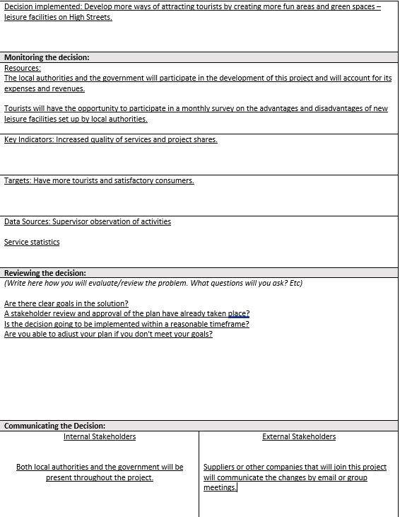

6.0 Appendices

6.1 SWOT Analysis
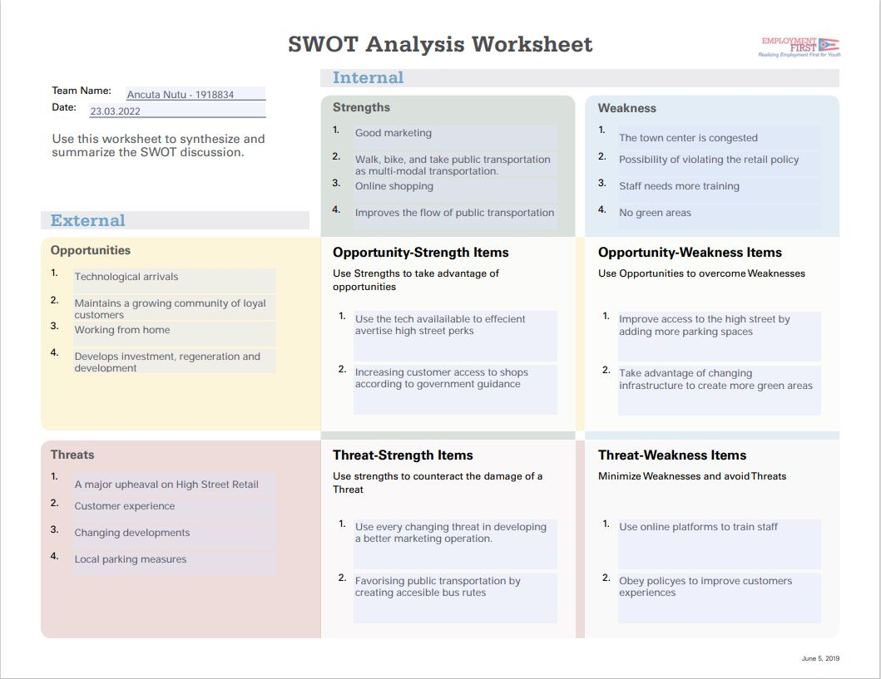

6.2 PESTLE Analysis

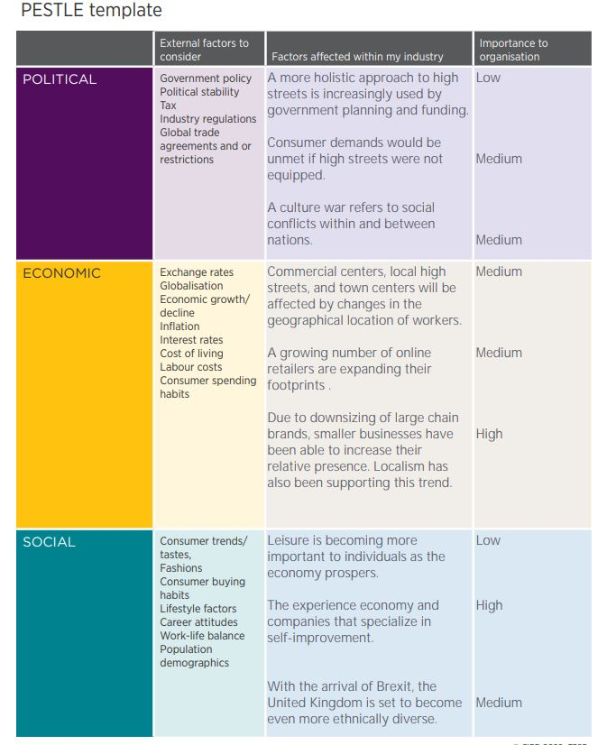

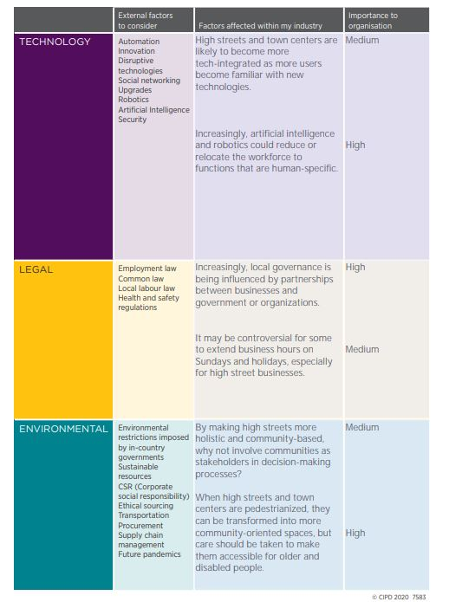

6.3 Decision-making Matrix

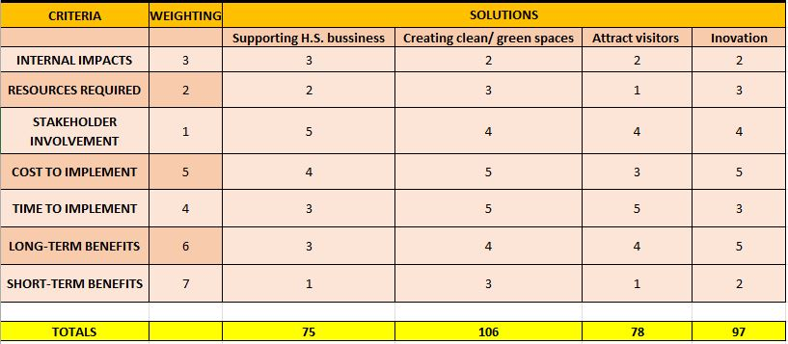

7.0 Reference list

- Ali Shaw, Ahsan. “PESTLE Analysis of the Retail Industry.” Marketing Tutor, 19 Mar. 2020, www.marketingtutor.net/pestle-analysis-of-the-retail-industry/. Accessed 24 Mar. 2022.
- Ali, Jasmin. “9 Advantages of Online Training.” ELearning Industry, eLearning Industry, 24 Jan. 2018, elearningindustry.com/advantages-of-online-training-9. Accessed 24 Mar. 2022.
- Build Back Better High Streets. “Build Back Better High Streets.” GOV.UK, 15 July 2021, www.gov.uk/government/publications/build-back-better-high-streets/build-back-better-high-streets#innovative-delivery-models-and-development-corporations. Accessed 24 Mar. 2022.
- Economics and strategy research consultancy. “Creating Resilient and Revitalised High Streets in the ‘New Normal’ | Local Government Association.” Www.local.gov.uk, 24 Jan. 2022, www.local.gov.uk/publications/creating-resilient-and-revitalised-high-streets-new-normal. Accessed 23 Mar. 2022.
- Greater London Authority. “ADAPTIVE STRATEGIES.” ADAPTIVE STRATEGIES, Jan. 2019, www.london.gov.uk/sites/default/files/ggbd_high_streets_adaptive_strategies_web_compressed_0.pdf. Accessed 24 Mar. 2022.
- MarketLine. “The Pandemic Has Sped up the Demise of the UK High Street.” Www.retail-Insight-Network.com, 2 Aug. 2021, www.retail-insight-network.com/comment/pandemic-uk-high-street/.
- Shpak, Scott. “Social Factors Affecting Retail Business.” Chron.com, 25 Jan. 2019, smallbusiness.chron.com/social-factors-affecting-retail-business-71662.html. Accessed 24 Mar. 2022.
- techUK. “Technology and the Future of the UK High Street.” Www.techuk.org, 13 Dec. 2021, www.techuk.org/resource/technology-and-the-future-of-the-uk-high-street.html. Accessed 24 Mar. 2022.
- Todaro, Daniel. “How Politics Is Affecting the High Street: There’s More at Risk than Just Economics.” The Drum, 19 Sept. 2019, www.thedrum.com/opinion/2019/09/19/how-politics-affecting-the-high-street-there-s-more-risk-just-economics. Accessed 24 Mar. 2022.
- What Works Centre for Local Economic Growth. “Evidence Briefing: Improving High Streets and Town Centres | What Works Centre for Local Economic Growth.” Whatworksgrowth.org, 24 Mar. 2022, whatworksgrowth.org/resources/evidence-briefing-improving-high-streets-and-town-centres. Accessed 24 Mar. 2022.

