Daniel Adam Carlson (2001079)
Networks and Cyber Security Essentials (ACCA4024) School of Applied Computing, Wales Institute of Science and Art
Assignment 1 - Synthesize a solution to a potential real life scenario

Table of Contents
- Title Page – Cover Page
- Table of Contents – Page 1
- Introduction – Page 2
- Related Work – Pages 3-5
    - Networks and its types – Page 3
    - Threats and Attacks – Page 4
    - Mitigation – Page 5
- Demonstration – Pages 6-9
    - Weak Points and Vulnerabilities – Page 6
    - Attack Demonstration – Pages 6-9
- Recommendations, Strategies and Conclusion – Page 10
    - Importance of Secure Policies and Strategies – Page 10
    - Updating Che-Si’s Policies – Refer to Annexure 1/Page 12
    - Conclusion – Page 10
- References – Page 11
- Annexures – Page 12

Introduction
For us to clearly understand and diagnose any problems within a specific network environment, we must first understand what a network is but also why security is an integral part of every network. A simple definition for what a network is, is stated by Dr. Roy Winkelman:
A network consists of two or more computers that are linked to share resources (such as printers and CDs), exchange files, or allow electronic communications. The computers on a network may be linked through cables, telephone lines, radio waves, satellites, or infrared light beams [1].
We use networks for everything within our modern age, from telephone communication to banking, a network can and is used in every sector worldwide. But within each network there is a necessity for security, we need security to ensure that all data that is being created/stored within that network can be secure and unable to be accessed by other networks. But why is network security so important? The ECPI University states that
While there is no network that is immune to attacks, a stable and efficient network security system is essential to protecting client data. A good network security system helps business reduce the risk of falling victim of data theft and sabotage [2].
A secure network within specific businesses is essential to protect every employee but also every client and other businesses that work or approach you. Within this report I aim to identify the key policies that require adjusting without compromising any productivity or security aspects. I aim to achieve this in steps by first identifying the main policies, then how these could lead to a specific breach/attack but also then how we could go about rectifying this problem with a clear demonstration and policy changes.
By the end of this report, I will clearly show that there were some weaknesses in the policies but also a clear and detailed explanation on what is required for Che-Si to undertake for them to secure those weaknesses and to avoid any future breaches of their data and policies.

Related Work
Networks and its Types.
Within networking there are a countless number of different networks that are interconnected with different devices. NFON [3] notes what network is used within mobile phones but also landline connections, but also that mobile networks have a variety of functions but provide the essential foundation required for mobile networks that are used by every other mobile phone provider but also that there is a unique access point that every mobile user connects to connect with other users.
There is a difference between both mobile communication and Landline telephone communication, both landline and mobile use a network for communication but the key difference is that landline phones require a wired network connection in comparison to mobile networks which connect to a network using wireless. But there are more than just mobile phones used within our day to day lives for example our PC’s and Tablets. But what network is used for these?
For a Laptop or Desktop Pc to connect to the internet it requires specific network access, there are several different networks used worldwide, but the most common are LAN (Local Area Network), WAN (Wide Area Network) and WLAN (Wireless Local Area Network). There are many pros and cons related to each network while being used for each device, normally in our modern day the most used network for businesses is a LAN. Every LAN is controlled by a singular entity but is also connected in some form to the Internet which is its own WAN. According to an essay created by Capella University:
A Local Area Network (LAN) is a computer network based in a small geographical area usually located at a residence, building or several small buildings relatively close to each other. LAN computer networks can be connected via physically connected Ethernet cable “hardwire” or wirelessly connected “WLAN” [4] .
In our modern age we now use cloud storage for us to access several different files and folders within our selected organisation. Clous storage are a vast variety of different systems and protocols designed to store and let you access your data from any devices from any location. For the cloud storages to work they require different facilities to house all this data, these are called Data Centres. We use these to connect our cloud storage servers to the internet or the WAN. As stated by Jonathan Strickland, “At its most basic level, a cloud storage system needs just one data server connected to the Internet. “ [5].

Threats and Attacks
Within each network there are always chances for attacks and threats, in a network there are always vulnerabilities that can be exploited to compromises the security of that network. There are a few possible attacks that can be used to compromise the integrity of Che Si Network, there are 3 main network attacks that are the most damaging within this network that could happen:
- Denial-of-service attack (DoS)
Cisco notes the definition of a DoS attack as “A denial-of-service attack floods systems, servers, or networks with traffic to exhaust resources and bandwidth. As a result, the system is unable to fulfil legitimate requests. [6]” In essence a massive number of files and pings are sent by a malicious device into that specific server to stop all other requests and files from being accepted and accessed, this causes major productivity issues and several file issues, this can cause the entire organisations servers to shut down.
- Structured Query Language (SQL) injection
As noted by PortSwigger [7] an SQL Injection attack allows malicious users to infiltrate a specific servers database by interfering with the commands sent to it from other connected users, because of this that malicious user now has the ability to view data within that server which is normally inaccessible by normal users, this user is able to see data such as personal organisation information, different connected users information and also all files within that server. This breach can cause a massive amount of problems as that malicious user can easily modify and even delete those files causing major disruptions and damage to the internal server database of the organisation.
- Sniffing/Spoofing Attacks
A Sniffing attack is where a device called a Packet Sniffer is implemented within the network which captures all data sent to the organisations database. A Packet sniffer monitors all files sent to and from the server and can capture all details such as usernames and passwords which can then be used to access that organisations database. The use of packet sniffers has caused several problems for organisations by using them to breach different data. As the EC Council comments:
Malicious attackers employ the use of these packet sniffing tools to capture data packets in a network. Data packets captured from a network are used to extract and steal sensitive information such as passwords, usernames, credit card information, etc. Attackers install these sniffers in the system in the form of software or hardware. [8]

Mitigation
These different cyber attacks have been around for a little while and because of this we have begun to find ways to combat these problems. There are fixes to different vulnerabilities within the network systems, but these fixes are not permanent, as we evolve our prevention methods so do the attackers and therefore the ways of breaching our network.
How do we reduce/mitigate these attacks?
- Denial-of-service attack (DoS)
There are many ways to combat DoS attacks, some are easy while others take a bit of preparation and planning to use effectively. The main mitigation is to make sure all your DNS servers have some sort of Redundancy. The EC Council states that to help avoid DoS Attacks we should “spread your servers across various multiple data centres if you want to give the attackers a really hard time successfully launching a DDoS attack against your servers. [9]”. By spreading out each different DNS server it would ensure that each DoS attack could only target a little area of the organisations network and only part would be compromised.
- Structured Query Language (SQL) injection
The most obvious fix to prevent SQL Injections is to keep all your software updated to the latest versions, this will ensure that all the latest patches in security against these specific attacks will be installed on your database/website etc. But also, the most secure way is to use the appropriate privileges, by this I mean not to login to the system using admin privileges every time, only login with a guest profile, this would help with reducing the chance that any hacker could do anything damaging to the system without privileges.
- Sniffing/Spoofing Attacks
Stopping Sniffing attacks has a common fix, one of the easiest ways to avoid this problem is by using encryption. Using encryption would help to change all the document words into gibberish until it is decrypted. This ensures that any sensitive information within that data/document is unreadable. There is also a second mitigation possible, we could use these “sniffing devices” to find the vulnerabilities within the network and patch them, these can be used by professionals to help identify any potential flaws or weaknesses in the systems security.

Demonstration
Weak Points/Vulnerabilities
Within Che-Si’s network are the basic policies used within any networking service. These policies are what is used to communicate over video conferencing, but within these policies are some crucial vulnerabilities that are mostly down to the network topology used. The main 2 policies which I have identified as a vulnerability in this network are Information Security Policy and the Remote Access Policy.
But why? Well, both policies rely on a network topology that only uses a single server and no backup, but also due to the remote access policy there is no way for that organisation to fully monitor every device that is accessing that server, because of this if a breached device enters the system then there would be no way to identify it and this could lead to several other breaches and attacks such as a DoS attack. Their Remote Access policy allows personal devices on any network to be connected to the cloud server from any location which is a potential vulnerability within their system.
Attack Demonstration
For this scenario I will be using a DoS attack to show what would happen to the server if this were to occur based on the flaws in the above policies. A DoS attack is where a malicious attacker infiltrates the network and attempts to disrupt a selected device in this case our DHCP server and floods that selected device with packets and commands to either overload or to stop any other commands from being accepted from other network devices.
I have used a basic configuration on packet tracer for this example where there is one main hub is connected to the server through a packet sniffer and then another hub is connected to the main hub which corresponds to an office setting where the breached pc is located as shown below:
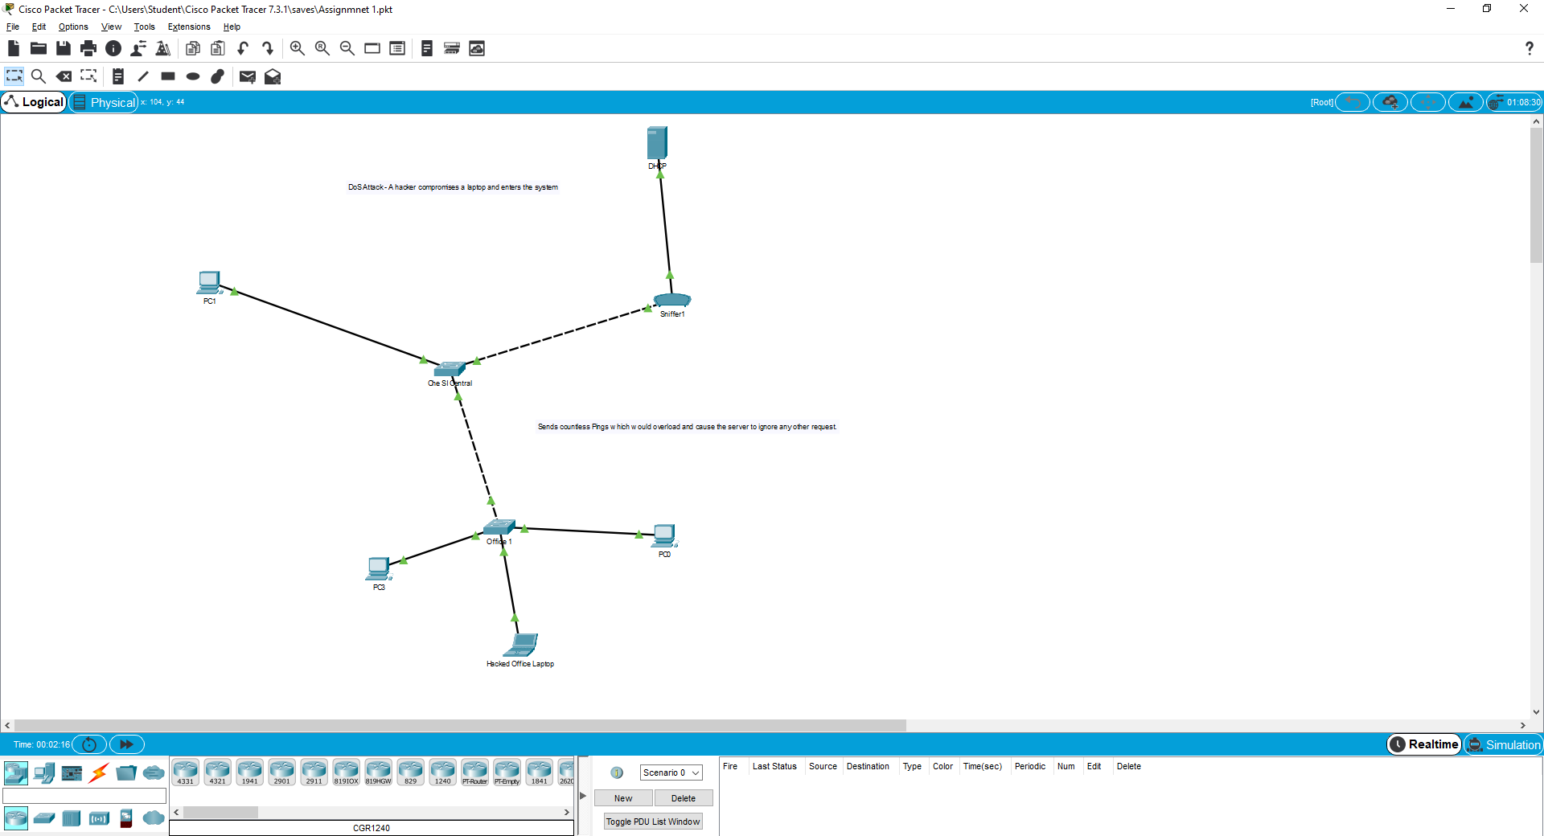
Step by Step Instructions/Screenshots
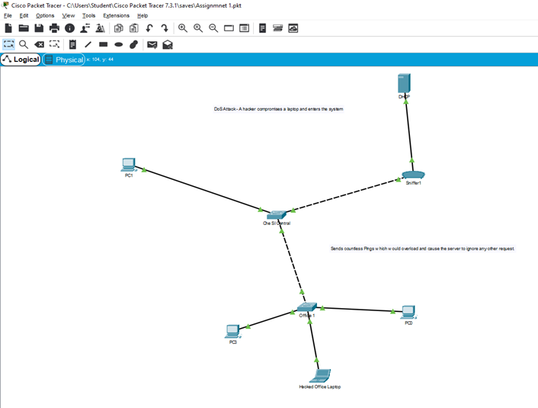
- Build the topology shown below:

- Configure the Server to allow DHCP.
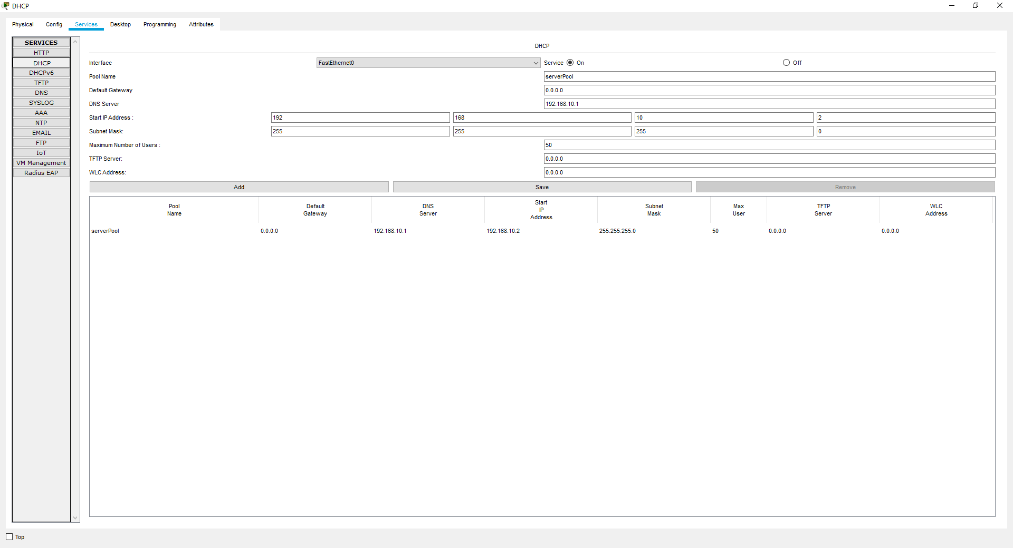
- Connect all pc’s and laptops and request an IP address. 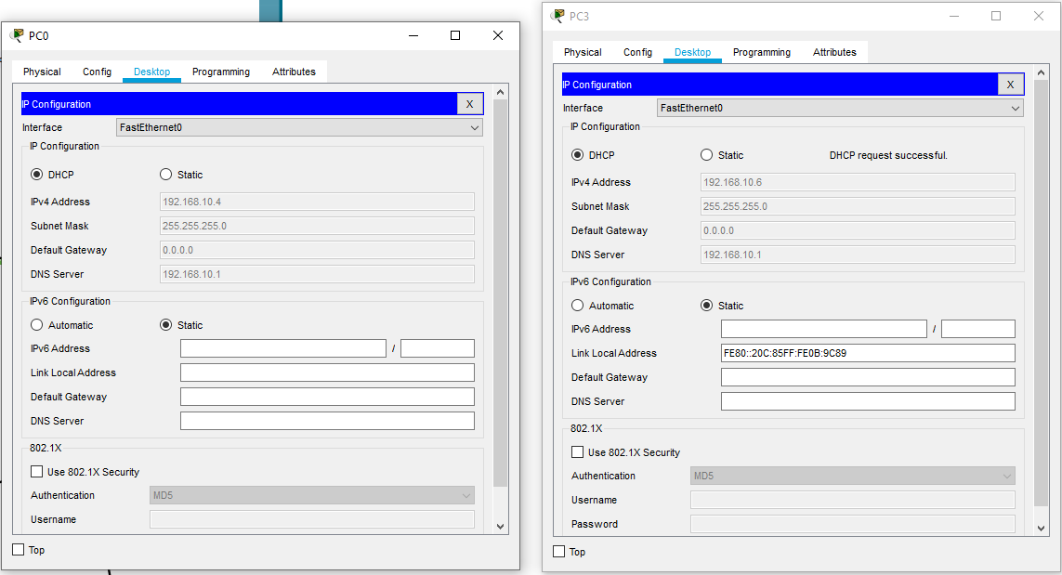
- Access the Packet Sniffer GUI and filter it for ping traffic or ICMP.
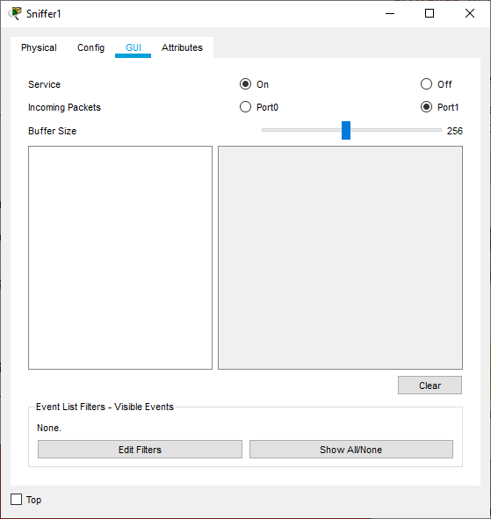
- Access the Breached Laptop and open Command Prompt.
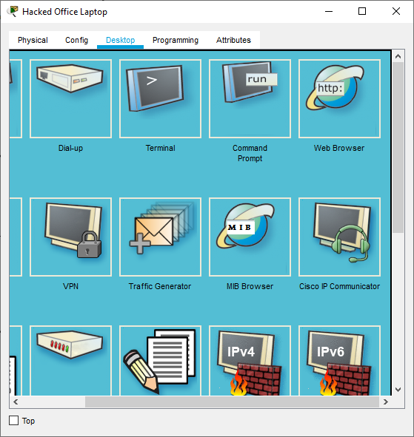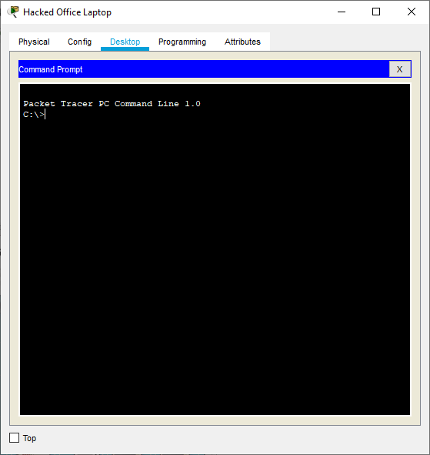

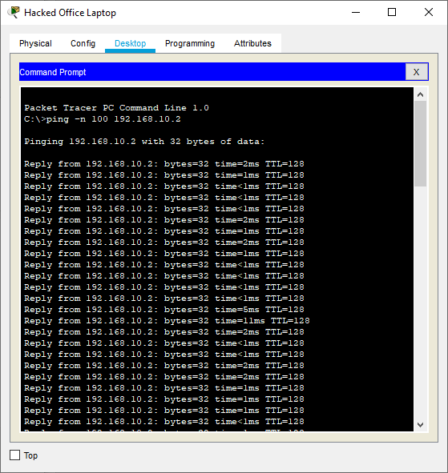
- Use the ping -n command to send a specific number of requests to the server IP (Mine is 192.168.10.2). This will show what a DoS attack does.
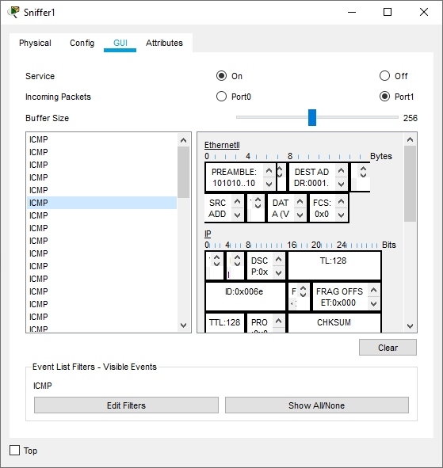
- Observe on the Sniffer that the server is being send a numerous number of requests which would cause all others to be delayed and possibly ignored.

Recommendations and Strategies
Importance of Secure Policies and Strategies
Within an organisation it is essential that you have the relevant training and strategies in place to stay secure. These policies for every user are implemented to protect every user within that organisation. Without these it would be impossible for any IoT devices to ever be secure while accessing data through the cloud. Payam Pourkhomami clearly states:
A cyber security policy identifies the rules and procedures that all individuals accessing and using an organization’s IT assets and resources must follow. So why do we need to have IT Security Policies? The goal of these network security policies is to address security threats and implement strategies to mitigate IT security vulnerabilities, as well as defining how to recover when a network intrusion occurs. Furthermore, the policies provide guidelines to employees on what to do and what not to do. They also define who gets access to what, and what the consequences are for not following the rules. Regardless of size, it is important for every organization to have documented IT Security Policies, to help protect the organization’s data and other valuable assets. [10]
Digital Signatures and Encryption
Digital signatures are a form of security encryption when creating a document. Each document or file created has its own unique digital signature, when a file is tampered with by a malicious user that digital signature is altered and then the original creator of that document can identify that the signature has changed. Each digital signature requires a certain type of encryption. As noted by howstuffworks.com “Encryption is the process of taking all the data that one computer is sending to another and encoding it into a form that only the other computer will be able to decode. [11]”. There are many methods of encryption but the most common and secure are Triple DES, RSA, and Blowfish. These 3 encryption methods are deemed to be the most secure and easiest to use and some are even said to be unbreakable.
Updating Che-Si’s Policies
Refer to Annexure 1.
Conclusion
To conclude this report, I believe the recommendations and strategies outlined above will help Che Si to be secure and reduce the chance of a major cyber-attack. The strategies I have suggested will help Che-Si to improve their security without change to productivity. With regards to future improvements, I aim to research into more depth on more complex network policies based on network communication but also, I aim to use a wider variety of resources to prove my reasoning and points that I have referred to within answering this scenario.

References

[1] | D. R. Winkelman, “What is a Network?,” Florida Center for Instructional Technology, 2013. [Online]. Available: https://fcit.usf.edu/network/chap1/chap1.htm. [Accessed 06 January 2021].
[2] | ECPI University, “Importance of Network Security Saftey in the Digital World,” [Online]. Available: https://www.ecpi.edu/blog/importance-of-network-security-safety-in-the-digital-world. [Accessed 06 January 2021].
[3] | NFON Telecommunications, “Mobile Phone Network,” [Online]. Available: https://www.nfon.com/en/service/knowledge-base/knowledge-base-detail/mobile-phone-network. [Accessed 07 January 2021].
[4] | Capella University, “Operating System and Networks,” Minnesota, 2017.
[5] | J. Strickland, “How Cloud Storage Works,” 30 April 2008. [Online]. Available: https://computer.howstuffworks.com/cloud-computing/cloud-storage.htm#pt1. [Accessed 07 January 2021].
[6] | Cisco, “What is a Cyber Attack?,” [Online]. Available: https://www.cisco.com/c/en_uk/products/security/common-cyberattacks.html#~types-of-an-attack. [Accessed 07 January 2021].
[7] | PortSwigger, “SQL injection,” [Online]. Available: https://portswigger.net/web-security/sql-injection. [Accessed 07 January 2021].
[8] | EC Council, “WHAT ARE SNIFFING ATTACKS AND THEIR TYPES?,” 04 June 2020. [Online]. Available: https://blog.eccouncil.org/what-are-sniffing-attacks-and-their-types/#:~:text=Packet%20sniffing%2C%20a%20network%20attack,a%20tool%20such%20as%20Wireshark.. [Accessed 07 January 2021].
[9] | EC Council, “TYPES OF DDOS ATTACKS AND THEIR PREVENTION AND MITIGATION STRATEGY,” 18 December 2019. [Online]. Available: https://blog.eccouncil.org/types-of-ddos-attacks-and-their-prevention-and-mitigation-strategy/. [Accessed 07 January 2021].
[10] | P. Pourkhomami, “T Security Policies: Why Every Organization Must Have Them,” 03 May 2018. [Online]. Available: https://www.osibeyond.com/blog/it-security-policies-every-organization-must-have-them/. [Accessed 08 January 2021].
[11] | HowStuffWorks.com., “What is a digital signature?,” 14 August 2008. [Online]. Available: https://computer.howstuffworks.com/digital-signature.htm. [Accessed 08 January 2021].

Annexures

Annexure 1
As previously identifies above there were two main policies that had vulnerabilities but also that the network topology needed some adjusting to compensate for this problem. I found that these policies were both interconnected based on this scenario where all work was done remotely, and their information security was put at risk. I demonstrated this by showing what would happen if a breached laptop or Pc were present on your network and that one breach could cause mass chaos within accessing that information remotely by using a DoS attack. Because of this it would cause all requests for files to be rejected but also this would allow the breached pc to access the network and download whatever files they wanted.
My recommendation to resolve this is to give out the company administrated devices and not allow personal devices to be used. This would ensure that the IT Administrator of Che Si can monitor the employees but also can easily see if any unregistered devices enter the system and can easily prevent any major disruption from occurring. I Believe that doing this would help reinforce he information security policy and remote access police by giving out secure organisation run devices to ensure security without compromise to productivity and performance it would also ensure that all client and user data would be more secure.
Another final recommendation is to use a VPN which requires a licence key to activate that is randomised based on each user and organisation. This would allow the users to have an extra added layer of security within their data and their organisation.

