
Student Name: Nirav Kanubhai Patel
Student ID:2540451

Module Name: financial Management
Module Code: LCMB7002

Select company: Marriott international
Lecturer’s Name: M.D.Kalam

Word count : 4888
Submission date : 13-Aug-2026

Executive Summary
This report analyses Marriott International's investment decision, restructuring choices and working capital situation for its FY2021-FY2025 performance. Analysis indicates strong recovery of revenue, profitability, asset utilisation and cash generation although a weak liquidity profile and higher rate of leverage is observed. Marriott's current and quick ratios fell short of some of the selected peers, whereas the debt-to-assets increased greatly, reflecting lower financial flexibility. There is also continued negative net working capital, albeit due to better working with receivables. The report accordingly suggests to improve the debt maturity, increasing free cash flow retention and monetizing non-core assets selectively. Using the various investment appraisal techniques identified below, the Projects A, B, and C are compared in terms of their strengths and weaknesses, with project C coming out as the best option because of its positive NPV and IRR exceeding the 8% significance level. With capital limitations of £100 million, project C is the best value maximising decision.
TABLE OF CONTENT
Executive Summary 2
1. Introduction 5
2. Financial Health Check 5
2.1 Five-Year Financial Performance 5
2.2 Profitability 7
2.3 Liquidity and Industry Benchmarking 9
2.4 Efficiency, Gearing and Cash Flow 10
3. Working Capital Management Analysis 11
4. Strategic Financial Restructuring Plan 13
4.1 Recommended Restructuring 13
4.2 Shareholder Value and Operational Flexibility 14
4.3 International, ESG and Ethical Considerations 14
5. Investment Appraisal and Capital Budgeting 15
5.1 Appraisal Methods and Results 15
5.2 Relationship to Marriott's Financial Position 17
5.3 Capital Rationing 17
6. Critical Reflection on Artificial Intelligence Usage 19
7. Conclusion 20
References 21
Appendices 25
Appendix A: Five-Year Financial Statements 25
Appendix B: Ratio Calculations 26
Appendix C: Industry Benchmark Data 27
Appendix D: Investment Appraisal Calculations 28
Appendix E: Additional Tables and Graphs 29

1. Introduction
Marriott International is a leading international hospitality company in the globe with a largely asset light model in terms of management, franchising and licensing. This model produces the fee based revenues and constrained direct ownership of hotel real estate even though it does not exclude the exposure to the economic cycles, debt, constraint of liquidity, risk of foreign exchange and shifting consumer demand. The global travel and tourism industry has remained in its post-pandemic recovery but at the same time is undergoing structural changes related to artificial intelligence, customer preferences, business travel and experience-led tourism (WTTC, 2025). The financial performance of a hospitality company should not, however, be analyzed in terms of one accounting measure. According to Sampaio, Reginio and Sebastian (2025), hotel business performance is multidimensional, but Arnejo and Sarsale (2025) find that profitability, revenue management and financial indicators are the key themes in the hotel financial-performance studies. This report assesses the financial standing of Marriott in the upcoming FY2021 2025, working-capital status, financing requirements and strategic reorganization options and then analyzes three investment ventures suggested. It has incorporated an analysis of the financial statement trends, ratios, liquidity benchmarking, capital budgeting and ESG factors and finished with a critical reflection on the application of artificial intelligence.

2. Financial Health Check

2.1 Five-Year Financial Performance
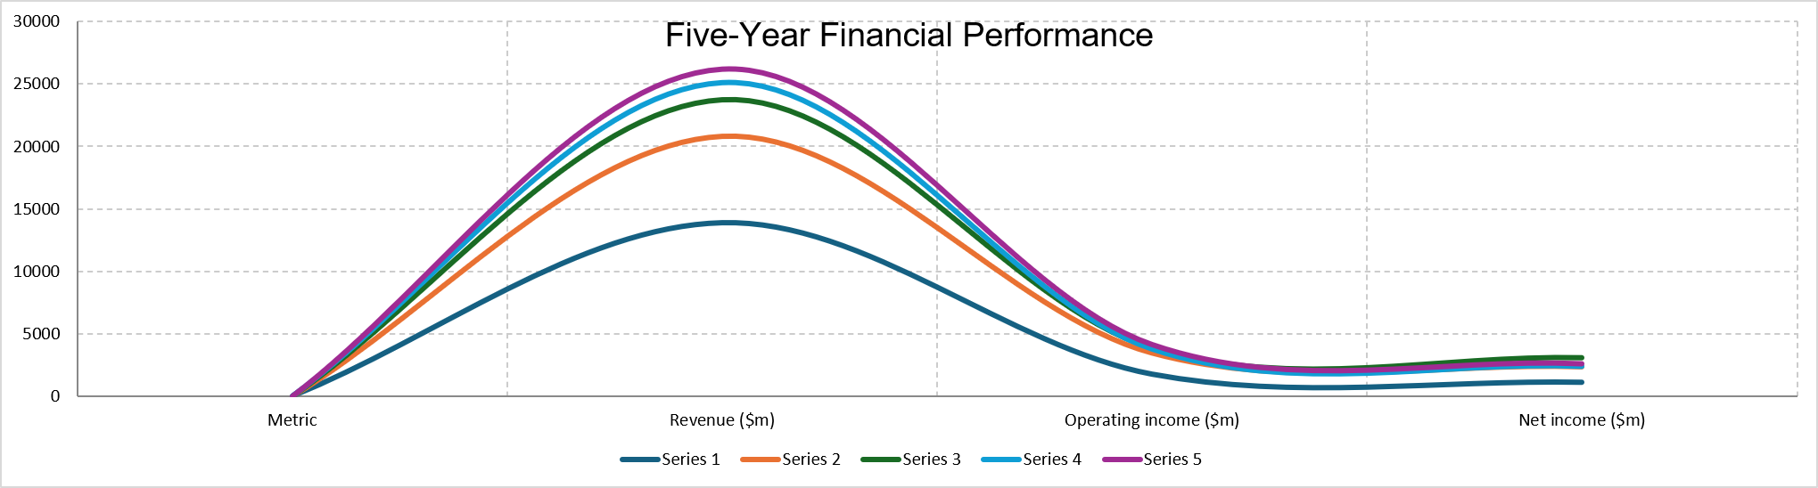
Figure 1: Financial performance (2021-2025)
Marriott had an excellent financial recovery period in 2021-2025. Revenue increased to $26.186 billion in 2025 compared to $13.857 billion in 2021, an increase of around 89% and this will be at an approximate 89% growth and an annualised growth rate of 17%. The operating income rose up to $4.141 billion compared to $1.750 billion and net income rose up to $2.601 billion compared to 1.099. The period between 2021 and 2023 was mainly characterized by a robust recovery as the net income registered at $3.083 billion. The 2023 report confirms revenue of $13.857 billion, $20.773 billion and $23.713 billion for 2021–2023 respectively, with corresponding net income of $1.099 billion, $2.358 billion and $3.083 billion (Marriott International, 2024).
Table 1: Marriott International: selected five-year financial performance, US$ million
Measure | 2021 | 2022 | 2023 | 2024 | 2025
Revenue | 13,857 | 20,773 | 23,713 | 25,100 | 26,186
Operating income | 1,750 | 3,462 | 3,864 | 3,767 | 4,141
Net income | 1,099 | 2,358 | 3,083 | 2,375 | 2,601
Total assets | 25,553 | 24,815 | 25,674 | 26,182 | 27,540
Current assets | 3,626 | 3,313 | 3,311 | 3,485 | 3,584
Current liabilities | 6,407 | 7,339 | 7,762 | 8,649 | 8,398
Total debt | 10,138 | 10,064 | 11,873 | 14,447 | 16,204
Operating cash flow | 1,177 | 2,363 | 3,170 | 2,749 | 3,212
Free cash flow | 994 | 2,031 | 2,718 | 1,999 | 2,608
Source: Author's calculations from Marriott International (2024; 2025a; 2026). The 2025 statements report revenue of $26.186 billion, operating income of $4.141 billion and net income of $2.601 billion, together with operating cash flow of $3.212 billion.
The trend is however to be read critically. Net income fell from $3.083 billion in 2023 to $2.375 billion in 2024 before recovering to $2.601 billion in 2025. Accordingly, the growth of revenues without an equivalent increase in the bottom line has been observed since 2023. Matias et al. (2024) indicate that the financial performance of hotels is a product of both the macroeconomic environment and the specifics of the firms; thus, the performance of Marriott cannot be viewed entirely because of the internal operations. Financial reporting comparability is also a matter of significance since there are industry specific revenue and cost classifications in the hospitality accounting. According to Elston, Coelho and Peixinho (2025), there are still a lot of problems with financial transparency and use of homogeneous reporting in the hospitality sector, and it is preferable to employ a number of ratios to assess the information instead of just headline revenue.

2.2 Profitability
Marriott experienced increase in its operating margin in 2021, with the operating margin rising to 12.63% but later it has since fluctuated between about 15 and 16.3% in 2022. An operating margin of 2025 of 15.81% shows that Marriott was left with a significant percentage after operating expenses in its global system that was growing bigger. Net margin similarly increased from 7.93% in 2021 to 13.00% in 2023 before declining to 9.46% in 2024 and recovering modestly to 9.93% in 2025.
Table 2. Selected Marriott financial ratios
Ratio | 2021 | 2022 | 2023 | 2024 | 2025
Operating margin | 12.63% | 16.67% | 16.29% | 15.01% | 15.81%
Net margin | 7.93% | 11.35% | 13.00% | 9.46% | 9.93%
ROA | 4.37% | 9.36% | 12.21% | 9.16% | 9.68%
ROCE | 9.14% | 19.81% | 21.57% | 21.49% | 21.63%
Current ratio | 0.57 | 0.45 | 0.43 | 0.40 | 0.43
Quick ratio | 0.53 | 0.42 | 0.39 | 0.37 | 0.39
Asset turnover | 0.55 | 0.82 | 0.94 | 0.97 | 0.97
Debt/assets | 39.67% | 40.56% | 46.25% | 55.18% | 58.84%
Interest coverage | 4.17x | 8.59x | 6.84x | 5.42x | 5.12x
Operating cash-flow ratio | 0.18x | 0.32x | 0.41x | 0.32x | 0.38x
Source: Author's calculations using Marriott International (2024; 2025a; 2026).
ROA increased from 4.37% to 9.68% between 2021 and 2025, while ROCE increased from 9.14% to 21.63%. These findings are a sign of significant restoration of productivity of the capital base of the firm. Toker (2025) highlights how the analysis of operating profit flow form is superior to the use of individual earnings and Cengiz et al. (2025) identify that advanced cost systems are correlated with high hotel profitability. The margin pattern of Marriott, therefore, indicates both a healthy underlying profitability and at the same time indicates that the high post-pandemic greediness realised as at 2023 has normalised. In the case of Marriott, ROE is not so helpful. Stockholders' equity became a $682 million deficit in 2023, deteriorating to deficits of $2.992 billion in 2024 and $3.771 billion in 2025. A traditional ROE then is distorted economically. This supports the argument of Sampaio, Régio and Sebastian (2025) not to measure the performance of hotels using the narrow metric and focus more on ROA, ROCE, cash creation and leverage.

2.3 Liquidity and Industry Benchmarking
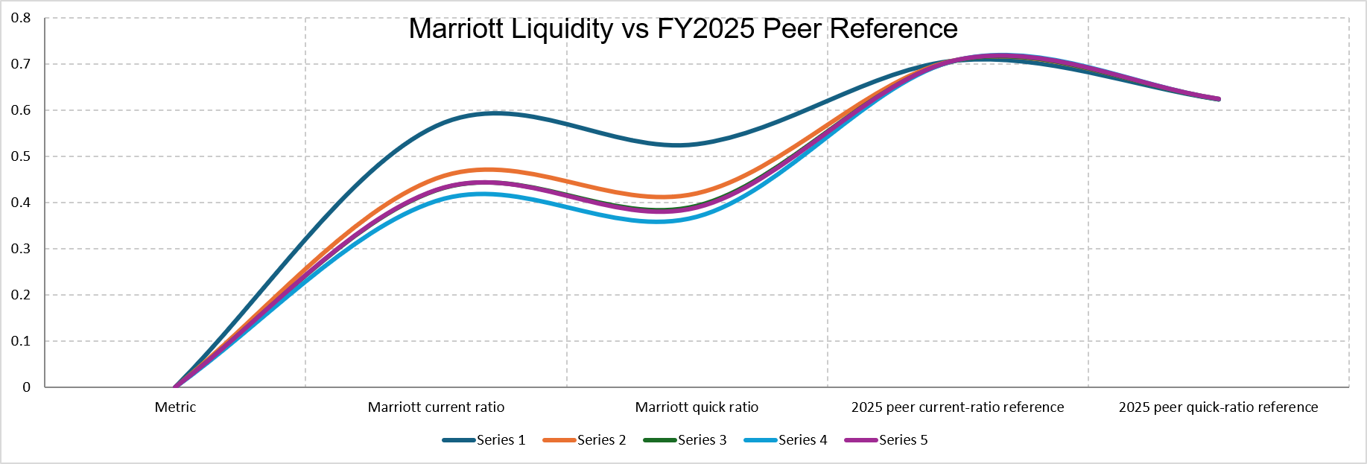
Figure 2: Marriott Liquidity vs FY2025 Peer Reference
The most evident that defines the financial weakness of Marriott is Liquidity. Its current ratio was not higher than 1.0 during the five-year period and its current ratio is lower at 0.40 in 2024 than it is in 2021, before increased marginally to 0.43 in 2025. The current ratio also decreased to 0.53 to 0.39. Unlike in 2024 where Marriott is shown to have only $3.584 billion of current assets in contrast to $8.398 billion of current liabilities which generate negative working capital of about $4.814 billion (Marriott International, 2026), in 2025 Marriott still has negative working capital of about $4.814 billion. The absolute ratio in itself should never be considered as manifestation of impending distress since the asset light, fee generating operating structure of Marriott is not like inventory-based businesses. However, benchmarking proves that Marriott has worse liquidity in comparison to similar hospitality groups listed on the market.
Table 3: FY2025 liquidity benchmark
Company | Current ratio | Quick ratio
Marriott International | 0.427 | 0.389
Hilton Worldwide | 0.665 | 0.579
Hyatt Hotels | 0.752 | 0.669
Hilton–Hyatt peer average | 0.708 | 0.624
Marriott gap versus peer average | −39.8% | −37.6%
Source: It is calculated using the figures of Marriott International (2026), Hilton Worldwide Holdings Inc. (2026) and Hilton Hotels Corporation (2026). Both Hilton and Hyatt publish annual reports on FY2025 on their respective investor-relations portals. The current ratio of Marriott is thus roughly 40% lower than the two-company peer average and its quick ratio is roughly 38% less than it. Tewari and Arya (2024) show that the efficiency of the hotel can differ significantly among the firms, exemplifying why the relative benchmarking can give more information in comparison to an independent ratio. It is in part due to the recurring fee revenue, the loyalty liabilities and the well-established access to finance that enables Marriott to maintain a low current ratio as opposed to this ratio in a conventional operating hotel. Nonetheless, the presence of a poor liquidity and growing debt decrease financial flexibility and must directly affect capital-budgeting and restructuring choices.

2.4 Efficiency, Gearing and Cash Flow
There was increased efficiency in terms of operations. The ratio of asset turnover improved to about 0.97x in 2025 as compared to 0.55x in 2021 and indicates that Marriott is now earning nearly one-dollar of annual revenue (in terms of assets) per dollar of average assets. The receivable days were reduced to around 39.8 days in comparison to around 49.4 days, which means the recorded receivables are converted to cash at higher rates. Such an improvement aligns with the fact that firm-specific operating traits have a significant impact on hospitality performance (Soni, Arora and Le, 2022). The same is established by Neves et al. (2026), who report that the hotel performance depends, among other things, on the firm-specific conditions and regional conditions and implicates the need to interpret ratios in the context of the global operating environment of Marriott but not in the world operating relying on generic corporate norms. The opposite has however been the direction gearing has taken. It recorded a growth in total debt of about $10.138 billion between the years 2021 and 2025 and a growth in the debt to assets of 39.67 days to 58.84 days. The highest interest coverage (8.59x) was experienced in 2022 but the value decreased to 5.12x in 2025 when annual interest expense increased to $809 million. Marriott has the capacity to cover operating profit related interest, yet the trend will lower resilience. Ashraf et al. (2025) demonstrate that the capital structure of the hospitality businesses was changed substantially due to the circumstances of the pandemic and that the matter of finance decisions was especially crucial in this context. Part of this risk is alleviated by cash generation. The cash flow grew to operate with a value of $1.177 billion in 2021 to $3.212 billion in 2025, whereas free cash flow has a present value amounted to $2.608 billion after a capital and technology spending of 604 million. The 2025 cash-flow statement also indicates that there were dividend payments and treasury-stock purchases of $718 million and $3.3 billion respectively in the year. It is a strategic matter: Marriott creates a lot of cash, but high shareholder distributions are accompanied by increasing leverage and negative share. There is thus a cross sectional financial strength as opposed to a homogenous strong financial strength. All in all, Marriott, despite its improved cash flow and increased asset utilisation, has a liquidity crunch that does not go away, an increasing debt load and negative stockholders deficit on its balance sheet. These results confirm the opinion of Arnejo and Sarsale (2025) that the financial performance of hotels needs a comprehensive group of financial indicators, instead of one profitability indicator.

3. Working Capital Management Analysis
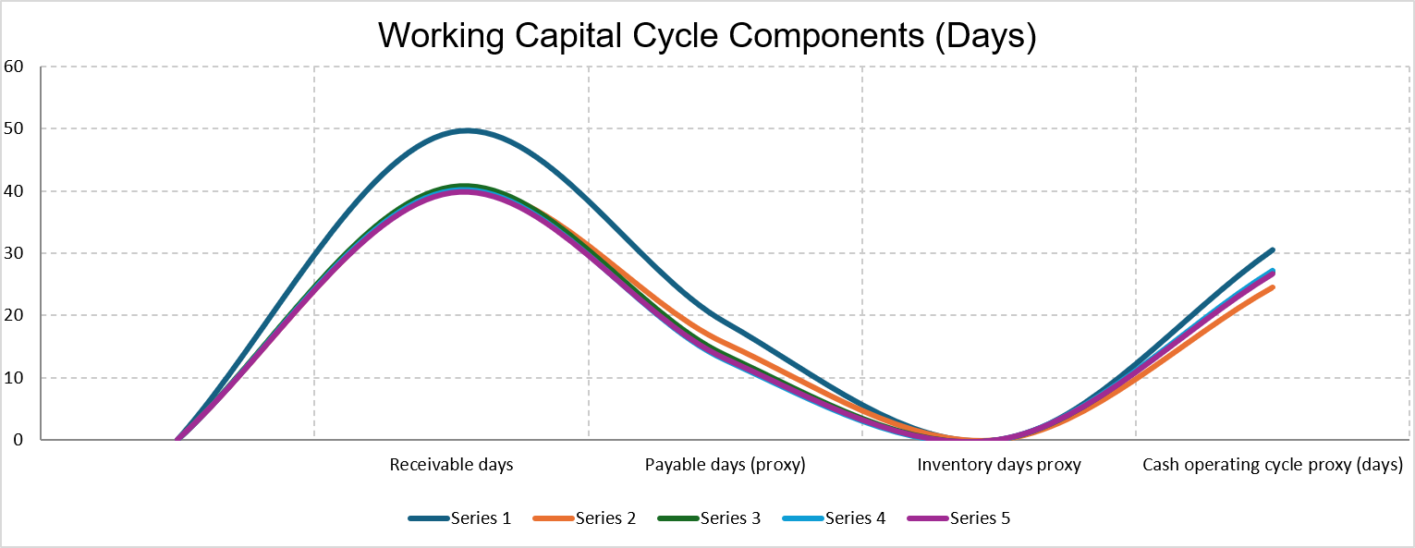
Figure 3: Working Capital Cycle Components (Days)
The unusual working-capital arrangement at Marriott is that it does not separately report a material conventional inventory balance that is like those of a retailer or manufacturer. The resulting Excel model accordingly does express a transparent (though dummy) zero-day inventory proxy merely to affect the recommended cash-operating-cycle formula. Also included are payable days which are based on average account payables/division by operating costs since the separate purchases are not regularly reported. Such limitations are to be declared, but not to be hidden as Elston, Coelho and Peixinho (2025) highlight the importance of a transparent hospitality financial reporting.
Table 4: Marriott working-capital analysis
Measure | 2021 | 2022 | 2023 | 2024 | 2025
Net working capital ($m) | −2,781 | −4,026 | −4,451 | −5,164 | −4,814
Receivable days | 49.4 | 40.0 | 40.7 | 40.0 | 39.8
Payable days – proxy | 18.9 | 15.5 | 13.6 | 12.8 | 13.1
Inventory days – proxy | 0.0 | 0.0 | 0.0 | 0.0 | 0.0
Cash operating cycle – proxy | 30.5 | 24.5 | 27.0 | 27.2 | 26.7
Source: Author's calculations from Marriott International annual reports and the accompanying Excel model (Marriott International, 2024; 2025a; 2026).
The proxy cycle was almost doubled in 2021 to 24.5 days in 2022, but then it became stable at around 27 to 26.7 days. Collection of receivables thus seems to be under reasonable control; more problematic is the amount of current liabilities in terms of current assets. Initially, Marriott must further enhance centralised receivable monitoring, automated collection and credit-control procedures. Second, the treasury management must have rolling cash forecasts by geography and currency since temporary cash surpluses can be pooled against deficits where legal and taxation structures can allow such pooling. Third, supplier conditions are to be agreed upon as a strategic level as opposed to a mere hastening: the payable days decrease implies that Marriott obtains less spontaneous supplier-finance than in 2021. The working capital is also affected by revenue management since high prices, demand forecast and channel management bring in higher cash flows without necessarily ensuring a corresponding increase in balance sheet investment. Lima Santos et al. (2024) illustrate how revenue-management capabilities are relevant in hotel financial survivability when a hotel is subjected to disruption. The cost information also needs to be able to make quick operational decisions; Cengiz et al. (2025) associate a higher level of cost-system sophistication and hotel financial performance. In terms of financing, short-term facilities like revolving credit, and commercial papers are suitable when timing difference is temporary in nature but not to finance permanent negative working capital or long-term strategic investment. The Long-term debt has an added advantage in that it offers more refinancing stability; however, Marriot already has significant leverage. Equity would enhance balance-sheet strength but would dilute current shareholders and might not need to be expensive and free cash flow is good. A preferable policy is then a matched financing approach: maintain dedicated short-term liquidity to meet seasonal uses and finance structure needs, through operating cash flow held in reserve, as well as a managed long-term financing. This minimizes the roll over risk and needless escalating equity dilution.

4. Strategic Financial Restructuring Plan

4.1 Recommended Restructuring
Restructuring should not aim at fixing a business that is not profitable, Marriott is a profitable business that generates cash. Instead, it ought to focus on putting flexibility in its balance-sheet but maintain its asset-light growth model. The inherent issue is the combined existence of a 58.84% debt-to-assets ratio, lowering interest coverage, negative stockholders’ equity and sub-peer liquidity.
Debt refinance and maturity management should however be of the priority. Marriott ought to aim to refinance the right maturities, ahead of time, before they turn into short-term liabilities, favour fixed-rate or reasonably hedged funding that is economically warranted, and shun vigorous incremental borrowing to satisfy discretionary shareholder distributions. Ashraf et al. (2025) reveal that capital structure is especially vital in the case of hospitality with a shock that can suddenly change the cash generation. Meanwhile, a non-selective de-leveraging programme would be inefficient since the operating cash flows of Marriott are sound.
The second component should be greater retention of free cash flow. Marriott had around $2.608 billion cash flow in 2025 without any expense, yet they used it on treasury stocks purchasing. Curtailing purchases during times of high leverage would enhance liquidity, decelerate the increase of debt and steadily restore balance-sheet equity without the need to issue new stock. This is better than immediate bulk equity injection that may have a diluting effect on the shareholders even when there are healthy operations.
Third, Marriott ought to consider informative divestiture or monetisation of non-core owned/leased assets, as well as equity interests, which will not impair strategically relevant brands or markets. This would be appropriate to its asset-light model and transform rather illiquid capital into cash. A key merger should not be the leading restructuring technique since it would contribute to integration expenses, implementation risk and additional financing requirements at a time when the priorities should be the balance-sheet consolidation.

4.2 Shareholder Value and Operational Flexibility
There is a short-term trade-off of the proposed strategy. Reduced buybacks of shares can pay off in the form of less immediate capital returns, but shareholder wealth is eventually determined by how much sustainable cash the business can generate and how much risk-adjusted financing ability the business has as opposed to the highest possible distribution each year. Soni, Arora and Le (2022) reveal that firm-specific financial features contribute to deciding on the hospitality-company performance, whereas the Neves et al. results (2026) indicate that the effects on the performance also depend on the governance and the geographic setting. An act of debt reduction would reduce the sensitivity to interest and enable a higher ability to fund appealing developments in case of future recessions. Any selective divestiture would only reinforce the asset-light model, but selling strategic assets so that what would otherwise be poor short-term ratios could be enhanced would be counterintuitive. Board is then supposed to consider every disposal on the basis of cash freed, lost profits and delegation of authority. The profitability perspective of Toker (2025) is applicable as the restructuring should not disrupt the flows of operating-profit that generate shareholder value, whereas Tewari and Arya (2024) indicate that the operational efficiency varies significantly in hotel firms. Marriott is thus not to be taken up in general cost cuts which ruin brand standard, service delivery or customer loyalty. The budget should be made more flexible (capital allocation and financing options) instead of random kind of operation reduction.

4.3 International, ESG and Ethical Considerations
International diversification brings with it a financial risk and opportunity. A negative adjustment of foreign currencies in the 2025 comprehensive-income statement of Marriott of a $442 million was recorded, representing a positive adjustment of $437 million in 2024, and the magnitude and direction-changing aspect of currency effects were evident. Financing structures and location of investment should therefore be based on inflation, local interest rates, taxation, geopolitical instability as well as varying consumer demand. Other features of the changing global tourism environment described by WTTC (2025) include the transformation of consumer preferences, artificial intelligence (AI), business travel and hotel-industry trends. Financing must include ESG considerations as opposed to a different form of philanthropy. Het al. (2024) directly investigates the relationship between various dimensions of ESG and hotel cost of debt, whereas Lu et al. (2025) compare ESG ratings and financial performance of the entire hotel industry around the world. Kaminskyi et al. (2025) also study ESG and the hotel financial performance in the context of a severe external shock and explain why resilience and sustainability are important areas that must be considered in addition to short-term returns. The Serve 360 frame of Marriott encompasses responsible operations, communities, opportunity and human rights, and its 2025 Report (Marriott International, 2025b) shows performance that will be mainly related to the year-end 2024. Bogdan, Radic and Gajic (2025) discover that the association between financial strength and ESG risk is subtle, and not mechanical, and Da Hyun et al. (2024) demonstrate that the ESG-performance relationship is mediated by national economic development. Marriott, therefore, ought to keep the global principles of sustainability but to customize it to the local economic circumstances in terms of implementing and capital investments patterns. The structure appropriate in terms of ethics must further secure the employees, franchisees, suppliers and communities against unnecessary damages instead of saddling them with most of the financial modification expenses.

5. Investment Appraisal and Capital Budgeting

5.1 Appraisal Methods and Results
It will need an initial investment of £50 million in three projects. Project A generates annual inflows of £10m, £12m, £14m, £10m and £8m; Project B generates £11m annually; and Project C produces £5m, £10m, £20m, £25m and £5m. The discount rate that is required is 8 percent and a straight-line depreciation up to zero will provide the depreciation of the project in every year of at least 10m. Payback Period (PBP) evaluates how long it took to recuperate the cash outlay. Accounting rate of Return (ARR) is used to judge the average profit of accounting against investment; average investment of £25m has been taken as the main denominator in this report. NPV discounts the cash flows at a rate of 8%, Profitability Index (PI) uses the present value of inflows, divided by the £50m investment and Internal Rate of Return (IRR) calculates the rate at which NPV is equal to the zero discounted cash flow. Darmansyah, Ali and Parveen (2025) conclude that more complex capital-budgeting strategies can enhance financial performance and assist in tackling solvency-related judgements, albeit with lower effectiveness of its own in eliminating liquidity risk. This difference matters to Marriott: a project, standalone, might be viable financially but cause strain when pursued within a highly leveraged and moderately illiquid capital structure.
Table 5: Investment appraisal results
Method | Project A | Project B | Project C | Preferred
Payback period | 4.50 years | 4.55 years | 3.60 years | C
ARR* | 3.20% | 4.00% | 12.00% | C
NPV at 8% | −£6.54m | −£6.08m | £0.86m | C
Profitability Index | 0.869 | 0.878 | 1.017 | C
IRR | 2.72% | 3.26% | 8.59% | C
ARR calculated using average investment of £25m.
Source: Author's Excel calculations based on the project data prescribed in the assessment.
The five approaches result in a very anomalous ranking. Project C has the least payback of 3.6 years, which is profitable to the Marriott considering its low current and quick ratios. Project C will result in the highest ARR, although there should be no ARR dominating due to its foundation on accounting profit and lacks timing of cash flows. NPV offers the highest most shareholder-value consideration. At an 8% discount rate, project A and B annihilate around £6.54m, as well as a value of £6.08m respectively. Project C creates approximately £0.86m. PI confirms this conclusion: Both A and B only give 0.869 and 0.878 of present value per pound invested, and C gives 1.017. The IRR of C is near to the required 8% which is 8.59, whereas the IRRs of A and B are well below the hurdle rate. Thus, Project C is the most suitable individual project to be chosen. Its positive NPV is however low in the face of the 50m capital commitment. The proposal can and indeed must be termed as affordable and not exceptionally appealing. Marriott increasing debt-assets ratio, poor liquidity, and reducing interest cover imply that there is little reason to accept projects which do not create values to keep the expansion going.

5.2 Relationship to Marriott's Financial Position
The cash-flow trend of project C is considered especially. It only gives it £5m and £10m in Years 1 and 2 and £20m and £25m in Years 3 and 4. This project thus generates a comparably tardy concentration of worth. The low current ratio indicates that the project will be financed without compromising short-term liquidity because the current ratio of Marriott is low, and the strong annual operating cash flow enables it to manage the profile of this project. A and B might seem safer since they inflow is more evenly distributed especially B at meaning of £11m per year. However, both are below the necessary 8% return. To accept them due to their predictability in cash flows would be against financial management that is value maximising. The Board is supposed to differentiate cash-flow stability and economic value creation. This conclusion has been consistent with the larger literature on hotel-finance. Matias et al. (2024) demonstrate that hotel performance is dependent on economic conditions as well as the firm-level and Lima Santos et al. (2024) emphasize the role of the financial sustainability in the unfamiliar operating conditions. These considerations reinforce, rather than weaken the NPV conclusion in the case of Marriott since the balance sheet of the company does not warrant the acceptance of sub-hurdle projects. There is still a need of evaluating non-financial risks. The project C may lose its appeal when its later period inflows are high and greatly sensitive to the fluctuation in political jurisdictions, customer adoption or reputational provisions. The entity of customer loyalty can be dealt with particularly when it comes to a hotel group, the brand, and loyalty ecosystem can be used to cater to recurring demand. Sampaio, Rregio and Sebastiano (2025) state that the effectiveness of a hotel is not only financially based, therefore, strategic alignment, service delivery, customer confidence and environmental impact should be included in financial assessment.

5.3 Capital Rationing
The upper limit of capital available is £100 M and two projects of £50m can be undertaken in case of deployment of the entire budget.
Table 6: Capital-rationing comparison
Combination | Investment | Combined NPV | Combined PI | Ranking
A + B | £100m | −£12.62m | 0.874 | 3
A + C | £100m | −£5.69m | 0.943 | 2
B + C | £100m | −£5.22m | 0.948 | 1
Source: Author's Excel calculations.
The optimal combination of B+C is possible since it results in the least-negative overall NPV and maximum overall PI of all pairs of possible projects if the question wants Marriott to choose between two projects and invest the entire amount of £100m. Nonetheless, the combination will still wipe out about £5.22m worth of value. This generates a significant difference between estimating combinations that can work and a rational capital-allocation choice. Since the brief indicates that the maximum amount of money to be invested is £100m as opposed to spending the entire amount, the more economical decision made by the CFO is Project C of £50m alone. The inclusion of A or B decreases the shareholder value since both have negative NPVs. Capital rationing must be able to maximise value within a budget ceiling; it is not maximising money. Darmansyah, Ali and Parveen (2025) advocate the responsible application of advanced appraisal standards, as opposed to the use of basic measures of investment amount. The advice is thus two-valved: B+C is the most desirable combination of two projects and meets the literal each other-comparison of potential combinations but C is the most desirable value-maximising portfolio within a £100m upper bound.

6. Critical Reflection on Artificial Intelligence Usage
The use of artificial intelligence in the production of this report was mainly to facilitate the structuring of the report, organisation of financial facts, the rationality of the ratios, help with the design of functions in the Excel spreadsheet and enhance the readability of the written interpretation. It was not regarded as an authoritative source of financial-data. Dote-Pargo et al. (2025) demonstrates that AI became more and more powerful in the financial decision-making process with the development of machine learning, data analytics and automation and it introduces ethical, regulatory and governance issues. The entire verification process consisted primarily of matchup to AI-aided output with official annual reports of Marriott. Indicatively, the 2025 report prepared by Marriott directly validates 2025 revenue of $26.186 billion dollars, operating income of $4.141 billion dollars and Net income of $2.601 billion dollars, and the balance sheet confirms that the company has current assets of $3.584 billions of dollars and current liabilities of $8.398 billions of dollars (Marriott International, 2026). The older ones were verified with Marriott International (2024; 2025a). This was significant since AI may otherwise give possible, yet erroneous business numbers or muddle calendar and fiscal periods. Monetary computations were exercised autonomously as real-time Excel rules instead of adopting AI-generated figures as the ultimate figures. Internal consistency was checked using NPV, IRR, PI, payback, ARR as well as ratio results. It was a process that also revealed issues of analysis that demanded human connotations. As an example, the negative equity of Marriott renders the usual ROE and debt-to-equity ratios deceiving. And in the same vein, the lack of a reported conventional inventory balance that, in turn, does not reflect the disclosed proxy of the cash operating cycle as opposed to a synthetic figure. These are not robot, but human, financial judgement.
The main roles of AI then were in the organisation, supporting computations, and drafting, but the ratios, the interpretation of negative equity of Marriott, the analysis of liquidity risk, a restructuring suggestion, the treatment of capital rationing, and ultimate project selection were to be evaluated by a critical judgement. Elston, Coelho and Peixinho (2025) assert that financial transparency is a crucial element in hospitality reporting; and the same concept applies to the AI-assisted analysis. In terms of ethical view, AI has the potential of enhancing efficiency but poses threats in the areas of privacy, hallucinated data, the bias of the algorithm and over-reliance on managers. Dote-Pardo et al. (2025) outline ethical and regulatory issues, as well as the use of AI in a financial context. The analysis did not need any confidential information of Marriott to complete the analysis; the analysis was based on publicly reported information. Sensitive forecasts, information on staff or transaction data are not supposed to be inputted in an AI system in a real-life CFO environment unless it possesses proper governance and data-protection rules. Finally, the responsibility of any decision made on financing or an investment lies on the financial professional and Board, not the AI tool.

7. Conclusion
The FY2021-2025 performance of Marriott reflects high performance in terms of recovery and ability to generate cash. Revenue nearly doubled, operating profitability increased and asset utilisation increased. However, liquidity ratios are significantly lower than that of Hilton-Hyatt, debt rose to about $16.2 billion, interest coverage diminished compared with 2022 and stockholders’ equity turned into a negative value. Marriott must hence focus on the management of debt maturity levels, holding a higher percentage of free cash flow and selective non-core asset disposal as opposed to drawing in more leverage or a dilutive capital infusion.
In terms of investment appraisal, Project C is by far superior to Projects A and B, with payback of 3.6 years, ARR of 12 percent, NPV of £0.86-million, PI of 1.017 and IRR of 8.59 percent. B+C is optimal two-project choice when it is required to spend at least £100m, yet since the maximum expenditure is just £100m, then it follows that Project C is the value maximising choice.

References
Arnejo, A. and Sarsale, M., 2025. Measuring hotel financial performance: A bibliometric review. Менаџмент у хотелијерству и туризму, 13(2), pp.117-135.https://cyberleninka.ru/article/n/measuring-hotel-financial-performance-a-bibliometric-review
Ashraf, S., Sarhan, A.A., de Almeida, A.M.M. and Teles, S., 2025. Capital structure of hospitality and tourism-related firms: Unveiling the impact of COVID-19 pandemic on European firms with different size and ownership structure. International Journal of Hospitality Management, 126, p.104067.https://www.sciencedirect.com/science/article/pii/S0278431924003797
Bogdan, S., Radić, M.N. and Gajić, A., 2025. Financial strength meets sustainability: How profitability and company size elevate ESG ratings in the hospitality industry. European journal of tourism, hospitality and recreation, 15(2), pp.267-279.https://reference-global.com/download/article/10.2478/ejthr-2025-0019.pdf
Cengiz, E., Kaynakci, E., Nanu, L. and Cavusoglu, M., 2025. Optimizing hotel profitability: How cost system sophistication drives financial performance in the hotel industry. Journal of Quality Assurance in Hospitality & Tourism, pp.1-15.https://www.tandfonline.com/doi/abs/10.1080/1528008X.2025.2601706
Da Hyun, S.H., Song, H.J., Lee, S. and Kang, K.H., 2024. The moderating role of national economic development on the relationship between ESG and firm performance in the global hospitality industry. International Journal of Hospitality Management, 120, p.103788.https://www.sciencedirect.com/science/article/pii/S0278431924001002
Darmansyah, A., Ali, Q. and Parveen, S., 2025. Sophisticated capital budgeting decisions for financial performance and risk management—A tale of two business entities. Journal of Risk and Financial Management, 18(6), p.297.https://www.mdpi.com/1911-8074/18/6/297
Dote-Pardo, J.S., Cordero-Díaz, M.C., Espinosa Jaramillo, M.T. and Parra-Domínguez, J., 2025. Leveraging artificial intelligence for enhanced decision-making in finance: trends and future directions. Journal of Accounting Literature.https://gredos.usal.es/bitstream/10366/169161/1/Leveraging%20artificial%20intelligence%20for%20enhanced%20decision-making%20in%20finance.%20Trends%20and%20future%20directions.pdf
Elston, J.N., Coelho, L.M.R. and Peixinho, R.M.T., 2025. Show me the money: A systematic literature review on financial transparency and USALI’s global adoption challenges. International Journal of Hospitality Management, 131, p.104312.https://www.sciencedirect.com/science/article/pii/S027843192500235X
He, Y., Qi, R., So, K.K.F. and Li, Y., 2024. Which ESG dimensions matter in the hotel industry? Evidence from the cost of debt. International Journal of Hospitality Management, 122, p.103866.https://www.sciencedirect.com/science/article/pii/S0278431924001786
Hilton Worldwide Holdings Inc. (2026) 2025 Annual Report. McLean, VA: Hilton Worldwide Holdings Inc. Available at: https://ir.hilton.com/financial-reporting/annual-reports (Accessed: 10 August 2026).
Hyatt Hotels Corporation (2026) 2025 Annual Report on Form 10-K. Chicago, IL: Hyatt Hotels Corporation. Available at: https://investors.hyatt.com/financials/annual-reports/default.aspx (Accessed: 10 August 2026).
Kaminskyi, A., Osetskyi, V., Almeida, N. and Nehrey, M., 2025. Investigating the relationship between ESG performance and financial performance during the COVID-19 pandemic: Evidence from the hotel industry. Journal of Risk and Financial Management, 18(3), p.126.https://www.mdpi.com/1911-8074/18/3/126
Lima Santos, L., Gomes, C., Malheiros, C., Crespo, C. and Bento, C., 2024. Factors influencing hotel revenue management in times of crisis: Towards financial sustainability. International Journal of Financial Studies, 12(4), p.112.https://www.mdpi.com/2227-7072/12/4/112
Lu, K., Onuk, C.B., Xia, Y. and Zhang, J., 2025. ESG ratings and financial performance in the global hospitality industry. Journal of Risk and Financial Management, 18(1), p.24.https://www.mdpi.com/1911-8074/18/1/24
Marriott International, Inc. (2024) 2023 Annual Report. Bethesda, MD: Marriott International, Inc. Available at: https://marriott.gcs-web.com/static-files/ac930e85-f477-4fa8-b873-bf4d2e09ca33 (Accessed: 10 August 2026). The report is also listed in Marriott’s official annual-report archive.
Marriott International, Inc. (2025) 2024 Annual Report. Bethesda, MD: Marriott International, Inc. Available at: https://marriott.gcs-web.com/static-files/a7664c0f-5bd1-4066-9fc9-b05eb6c93772 (Accessed: 10 August 2026).
Marriott International, Inc. (2025) 2025 Serve 360 Report: Global Progress. Bethesda, MD: Marriott International, Inc. Available at: https://serve360.marriott.com/wp-content/uploads/2025/07/2025GlobalProgress.pdf (Accessed: 10 August 2026).
Marriott International, Inc. (2026) 2025 Annual Report. Bethesda, MD: Marriott International, Inc. Available at: https://marriott.gcs-web.com/static-files/9cf0e9b0-bbfa-48a6-9e21-ffbdbc4b2d78 (Accessed: 10 August 2026).
Matias, F., Rebelo, S., Andraz, G. and Guerreiro, J., 2024. The influence of firm characteristics and macroeconomic factors on financial performance: Evidence from the Portuguese hotel industry. Economies, 12(11), p.306.https://www.mdpi.com/2227-7099/12/11/306
Neves, M.E., Nóbrega, I., Proença, C. and Guedes, R., 2026. Determinants of performance in the Portuguese hotel industry: a dynamic panel data analysis across key tourism regions. Journal of Hospitality and Tourism Insights, pp.1-22.https://www.emerald.com/jhti/article/doi/10.1108/JHTI-11-2025-1309/1355781
Sampaio, C., Régio, M. and Sebastião, J.R., 2025. Beyond financial metrics: A systematic and bibliometric review of hotel business performance. Administrative Sciences, 15(5), p.179.https://www.mdpi.com/2076-3387/15/5/179
Soni, T.K., Arora, A. and Le, T., 2022. Firm-specific determinants of firm performance in the hospitality sector in India. Sustainability, 15(1), p.554.https://www.mdpi.com/2071-1050/15/1/554
Tewari, S. and Arya, A., 2024. Analyzing the efficiency of the Indian hotel industry using the Malmquist DEA approach. Benchmarking: An International Journal, 31(9), pp.2839-2870.https://www.emerald.com/bij/article/31/9/2839/1222113
Toker, T., 2025. The operating profit flow method as a profitability analysis tool for hospitality enterprises. International Journal of Hospitality Management, 125, p.103997.https://www.sciencedirect.com/science/article/pii/S0278431924003098
World Travel & Tourism Council (WTTC) (2025) Travel & Tourism Economic Impact 2025: Global Trends. London: World Travel & Tourism Council. Available at: https://researchhub.wttc.org/product/travel-tourism-economic-impact-2025-global-trends (Accessed: 10 August 2026).

Appendices

Appendix A: Five-Year Financial Statements
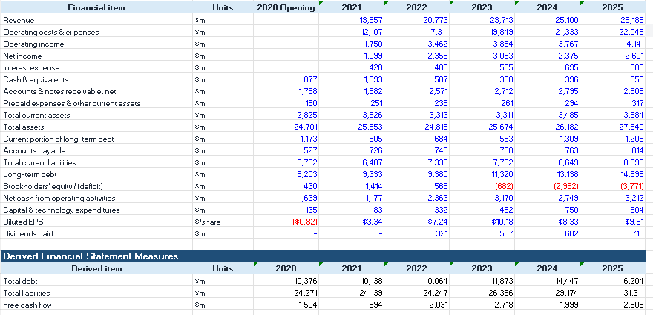

Appendix B: Ratio Calculations
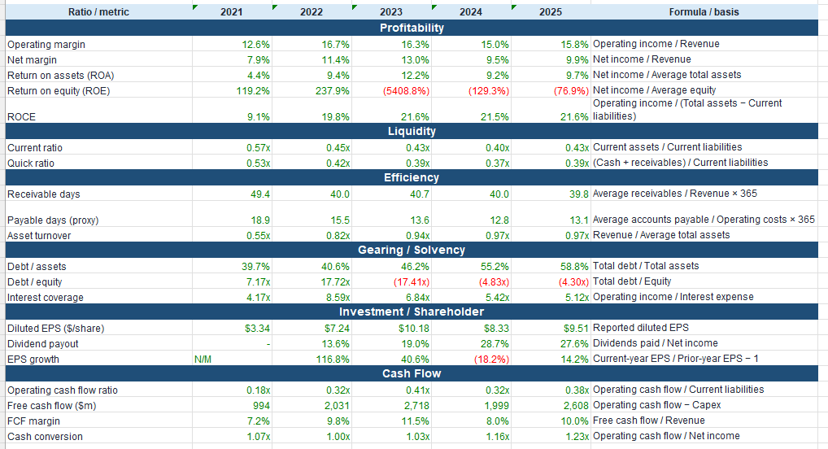

Appendix C: Industry Benchmark Data
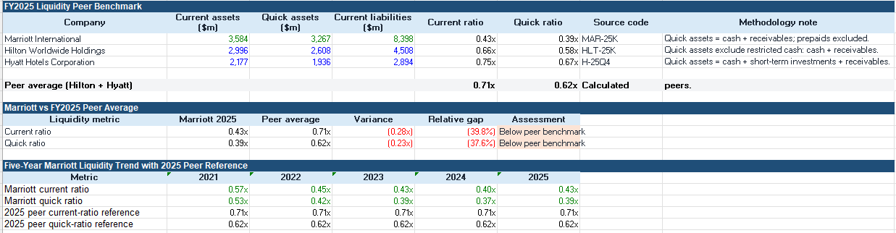

Appendix D: Investment Appraisal Calculations
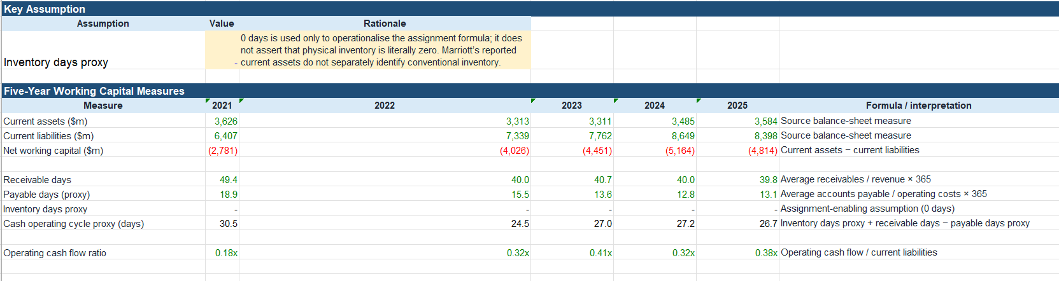
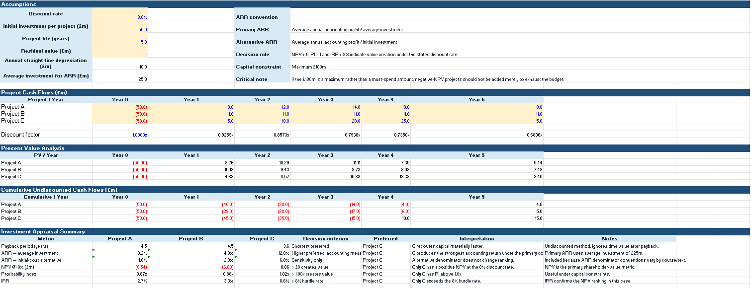

Appendix E: Additional Tables and Graphs


