With reference to educational theories and classroom observation and practice, demonstrate an understanding of at least three educational theories. Clear guidelines will be provided regarding the compilation of an appropriate standard of academic scrapbook.

Behaviourism
Behaviourists teaching approaches have established most positive in areas where there is a right reaction or effortlessly learnt material.


www.indiehiphop.net

From a behavioural viewpoint, the transmission of data from teacher to pupil is basically the transmission of the reaction fitting to a specific jolt. The purpose of instruction is to give the pupil the suitable collection of behavioural reactions to boots and to fortify those reactions through a viable support plan. A successful fortification timetable requires predictable reiteration of the material; little, dynamic arrangements of errands; and consistent uplifting feedback. Without encouraging feedback, learned reactions will rapidly wind up plainly terminated. This is because pupils will keep on modifying their conduct until the point when they get some uplifting feedback. A pupil who gets verbal praise and decent marks for accurate answers (positive reinforcement) is probably going to take in those answers effectively. One who gets little or no optimistic response for the same answers (negative reinforcement) is less likely to learn them successfully. pupils tend to evade replies that are related with punishment or unfriendly penalties for example unsatisfactory results or opposing comments. Behaviourist showing techniques tend to depend on alleged “skill and drill” exercise to deliver the regular repetition required for effective strengthening of response designs. Different strategies incorporate questions and answers outlines in which queries are slowly increasing trouble; guided practice; and normal audits of material. Behaviourist strategies additionally commonly depend intensely on the utilization of uplifting comments, for example, verbal acclaim, decent evaluations, and prizes. Behaviourist survey the level of picking up utilizing strategies that measure detectable conduct, for example, exam execution. Behaviourist showing techniques have demonstrated best in ranges where there is a “right” reaction or effectively remembered material. For instance, while behaviourist strategies have turned out to be fruitful in instructing organized material, for example, realities and formulae, logical ideas, and remote dialect vocabulary, their adequacy in showing appreciation, structure, and expository capacities is questionable.
Skinner, B, F. (1976). About Behaviourism. New York: Vintage Books.
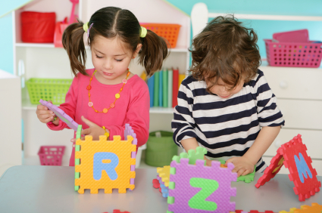

Cognitive
Cognitivism concentrates on the mind, and more particularly, mental processes, for example, considering, knowing, memory, and critical thinking, with the objective of opening the “black box” of the human mind, the procedure of which is regarded profitable and vital for figuring out how to happen. Information is drawn nearer as pattern developments, and learning is an adjustment in the pupil’s schemata, or reclassifying of earlier learning. The most ideal for a teacher to approach utilizing cognitive in the classroom is to enable pupils to refine their reasoning and perceive where they might not be right. Some incredible cases of cognitivism in instructive innovation can be found in online games and reinforcement activities, for example, arranging recreations, puzzles, and flash cards. These amusements will often present prior knowledge schema in different approaches, along these lines making disequilibrium and a need to adjust and take in the new data to continue. For instance, the online asset Quizlet makes methods for posting vocabulary, pictures, and even numerical strategies and after that taking that rundown and delivering a few methods for rehearsing the beforehand known schemata, including the joining of sound and video.

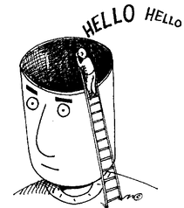

Each experience and interaction has an influence on advancement in early childhood. According to Swiss biologist and psychologist Jean Piaget recognised this when he studied and researched his own theories of cognitive development. Jean Piaget’s states theories impact learning in many ways, nevertheless, remembering the educational modules you are instructing, and in addition how you are showing it, straightforwardly applies to the basic of child development. For the phases of child development and the primary powerful factors.

Constructivism
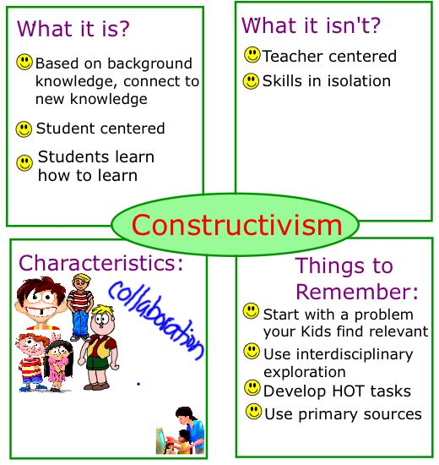www.pinterest.com

In the constructivism classroom, the concentration tends to move from the teacher to the pupils. The classroom is not any more a place where the teacher (“expert”) empties learning into detached pupils, who hold up like discharged vessels to be filled. In the constructivist model, the pupils are asked to be effectively engaged with their own procedure of learning. In the constructivist classroom, both teacher and students consider learning a dynamic, regularly changing perspective of the world we live in and the capacity to effectively extend and investigate that view- not as inert factoids to be remembered. The key presumptions of this point include-
- What the pupil as of now accepts, regardless of whether right or wrong, is significant.
- Notwithstanding having similar learning experience, every individual will construct their learning with respect to the understanding and importance individual to them.
- Understanding or building an importance is a dynamic and constant process.
- Learning may include some reasonable changes.
- At the point where pupils develop another importance, they may not trust it but rather give it a temporary acknowledgement or even dismissal.
- Learning is a dynamic, not a passive, process and relies upon the pupils assuming liability to learn.
The main action in a constructivist classroom is taking care of issues. Pupils use review strategies to make inquiries, research a subject, and utilize an assortment of assets to discover arrangements and answers. As pupils investigate the subject, they reach determinations, and, as investigation proceeds with, they return to those conclusions. Investigation of inquiries prompts more inquiries. There is a lot of cover between a constructivist and social constructivist classroom, except for prominent accentuation put on learning through social association, and the esteem put on social foundation. For Vygotsky, culture gives the youngsters the psychological apparatuses required for improvement. Grown-ups in the pupil’s conditions are conductors for the devices of the way of life, which incorporates dialect, social history, social setting, and more as of late, electronic types pf data to get. In social constructivist classrooms community orientated learning is a procedure of associate that is interceded and organized by the teacher. Dialog can be advanced by the introduction of ideas, issues, or situations, and is guided by methods for viably coordinated inquiries, the presentation and illumination of ideas and data, and references to beforehand learned material.
Role of the teacher- constructivist teachers don’t play the part of the “sage on the stage” instead, teachers go about as a “guide on the side” giving pupils chances to test the ampleness of their present understandings.
Theory | Implication for classroom
The teacher should consider the knowledge and experiences pupils bring to the class.
Students build their insight through a procedure of dynamic enquiry.
Disclosure is swayed by giving the essential assets.
Information is effectively built and learning is introduced as a procedure of dynamic disclosure.
Help with absorption of new and old information.
Learning system ought to be adequately to allow improvements along lines of pupil enquiry.
Because of its interpretivist nature, every pupil will decipher data in various ways.
Make circumstances where the pupils feel safe addressing and considering their own procedures.
Show genuine undertakings to contextualize learning through true, case-based learning conditions.
Bolster coordinated effort in building information, not competition.
Support advancement through intersubjectivity.
Giving scaffolding at the ideal time and the correct level.
Give chances to master and less master members to gain from each other.

Role of the pupil-The desire inside a constructivist learning condition is that the pupils assumes a more dynamic part in, and acknowledges greater obligation regarding their own learning.

Theory | Implication for classroom
The role of the pupil to effectively take an interest in their own instruction.
Pupils need to oblige and absorb new data with their present comprehension.
One essential part of controlling their own learning process is considering their encounters.
Pupils start their examination with pre-considered thoughts.
Pupils are extremely hesitant to surrender their set-up pattern/thought and may dismiss new data that difficulties earlier learning
Pupils may not know about the reasons they hold such solid thoughts/schemata
Pupils need to utilize and test thoughts, aptitudes, and data through important exercise.
Pupils need to know how to learn or change their reasoning/learning style.
Since information is so publicly based, pupils merit access to learning of various groups.
For pupils to learn they have to get diverse ‘focal points’ to see things in new ways.
Pupils require direction through the ZDP
In social constructivism coaches and peers assume an imperative part in learning.
http://www.ucdoer.ie/index.php/Education_Theory/constructivism

By understanding theories, learning becomes clearer. UCD (no date) explains that learning is modelled around the environment and a person’s inner self. Applying theory into practice allows children to reach their full potential by understanding the influences and attributes based on how one learns.

References
https://edtechtheort.weebly.com/cognitivism.html
https://funderstanding.com/educators/jean-piaget-cognitive-development-in-the-classroom/.
https://www.ucdoer.ie/index.php/education_Theory/constructivism_and_social_constructivism_in_classroom

