BA International Hotel Management

Financial Management for the Hotel Industry

Assignment 1 – Title: Business Report – Comparison of Two Hospitality Organisations

Student Name: Antonia Lupas
Student ID: 2210502
Lecturer Name: Tristan Hawkins

Executive Summary
This report has elaborated on the two renowned hotel businesses’ overall comparability related to revenues; and factors related to declination of both hotels’ revenue. The report also includes the position of the market for the specific groups of the hotel and expansion strategies related to the businesses with potential future opportunities to make the business more sustainable in the upcoming future. The CSR initiatives of the businesses include the overall organisation's commitment to ethical practices of the businesses. The report also includes social responsibility including a Commitment to finance with best practices of business ethics. The report also discussed the overall report sustainability based on the overall suggestions of the market essentials.

Table of Contents
Introduction 4
Overview of Corinthia Hotels 5
Overview of Ibis Hotels 6
Comparison of Total Revenue 7
Total revenue of Corinthia Hotels 7
Total revenue of Ibis Hotels 8
Identifying final results 9
Comparison of current Market Position 10
Total assets and liabilities owned by Corinthia Hotel 10
Total assets and liabilities owned by Ibis Hotels 11
Identifying final results 12
Elucidating the Comparison of the Organisations’ Growth Potential including the organisation’s strategic Expansion, prospects within the market and development of Potential Barriers 13
Elucidating Proper analysis based on the CSR of both Hotels including Commitment to the Finances 16
Recommendations 18
Conclusion 19
References 20

Introduction
Corinthia Hotels is a chain of heritage hotels known for its luxury hospitality services all across Europe. Ibis Hotels is an international hotel chain that provides a luxury and affordable category of hospitality services. Both the hotel groups are very much successful in building an audience base and achieving a good amount of financial revenue. The report will conduct a brief comparison of both hotels in terms of total revenue, current market position, future growth potential as well. The financial commitment of both the business to fulfill its corporate social responsibility will be compared in the business report.

Overview of Corinthia Hotels
Corinthia Hotels is known for its luxury buildings, vintage interior decoration and authentic cuisine as well. People are very much attracted by the respective hotel services due its authentic British culture. The respective hotel was established in 1962 and the founder was Alfred Pisani. Currently the respective business operates in more than 23 locations throughout the globe.
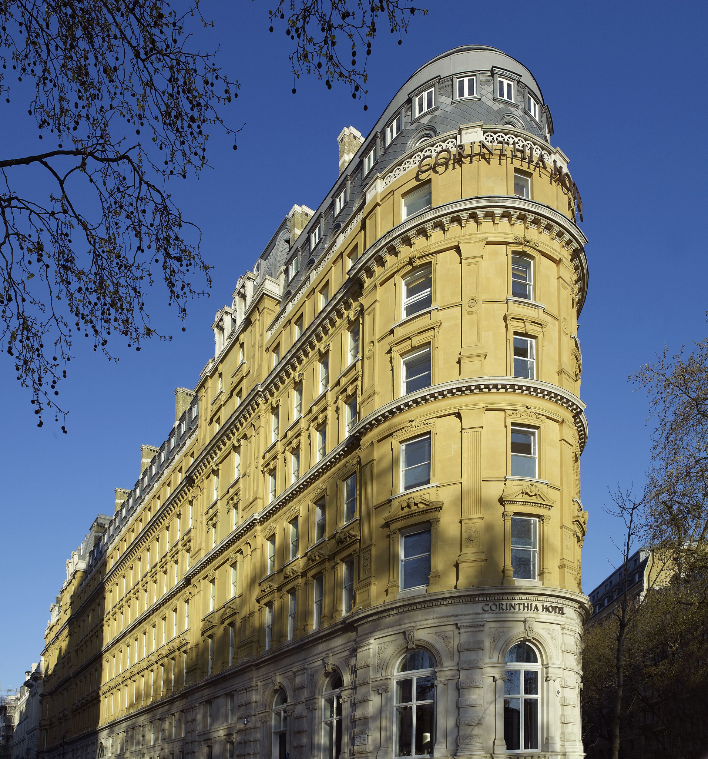
Figure: Corinthia Hotel in London
Source: (Corinthia, 2024)

Overview of Ibis Hotels
Ibis hotel is an international hotel chain that was founded in the year of 1974. The first outlet of the hotel was established in France and within a very short span of time the respective business has become a multinational business. Luxury staying experience, spa services and wide food operations are the main attraction of the respective hotel chain.
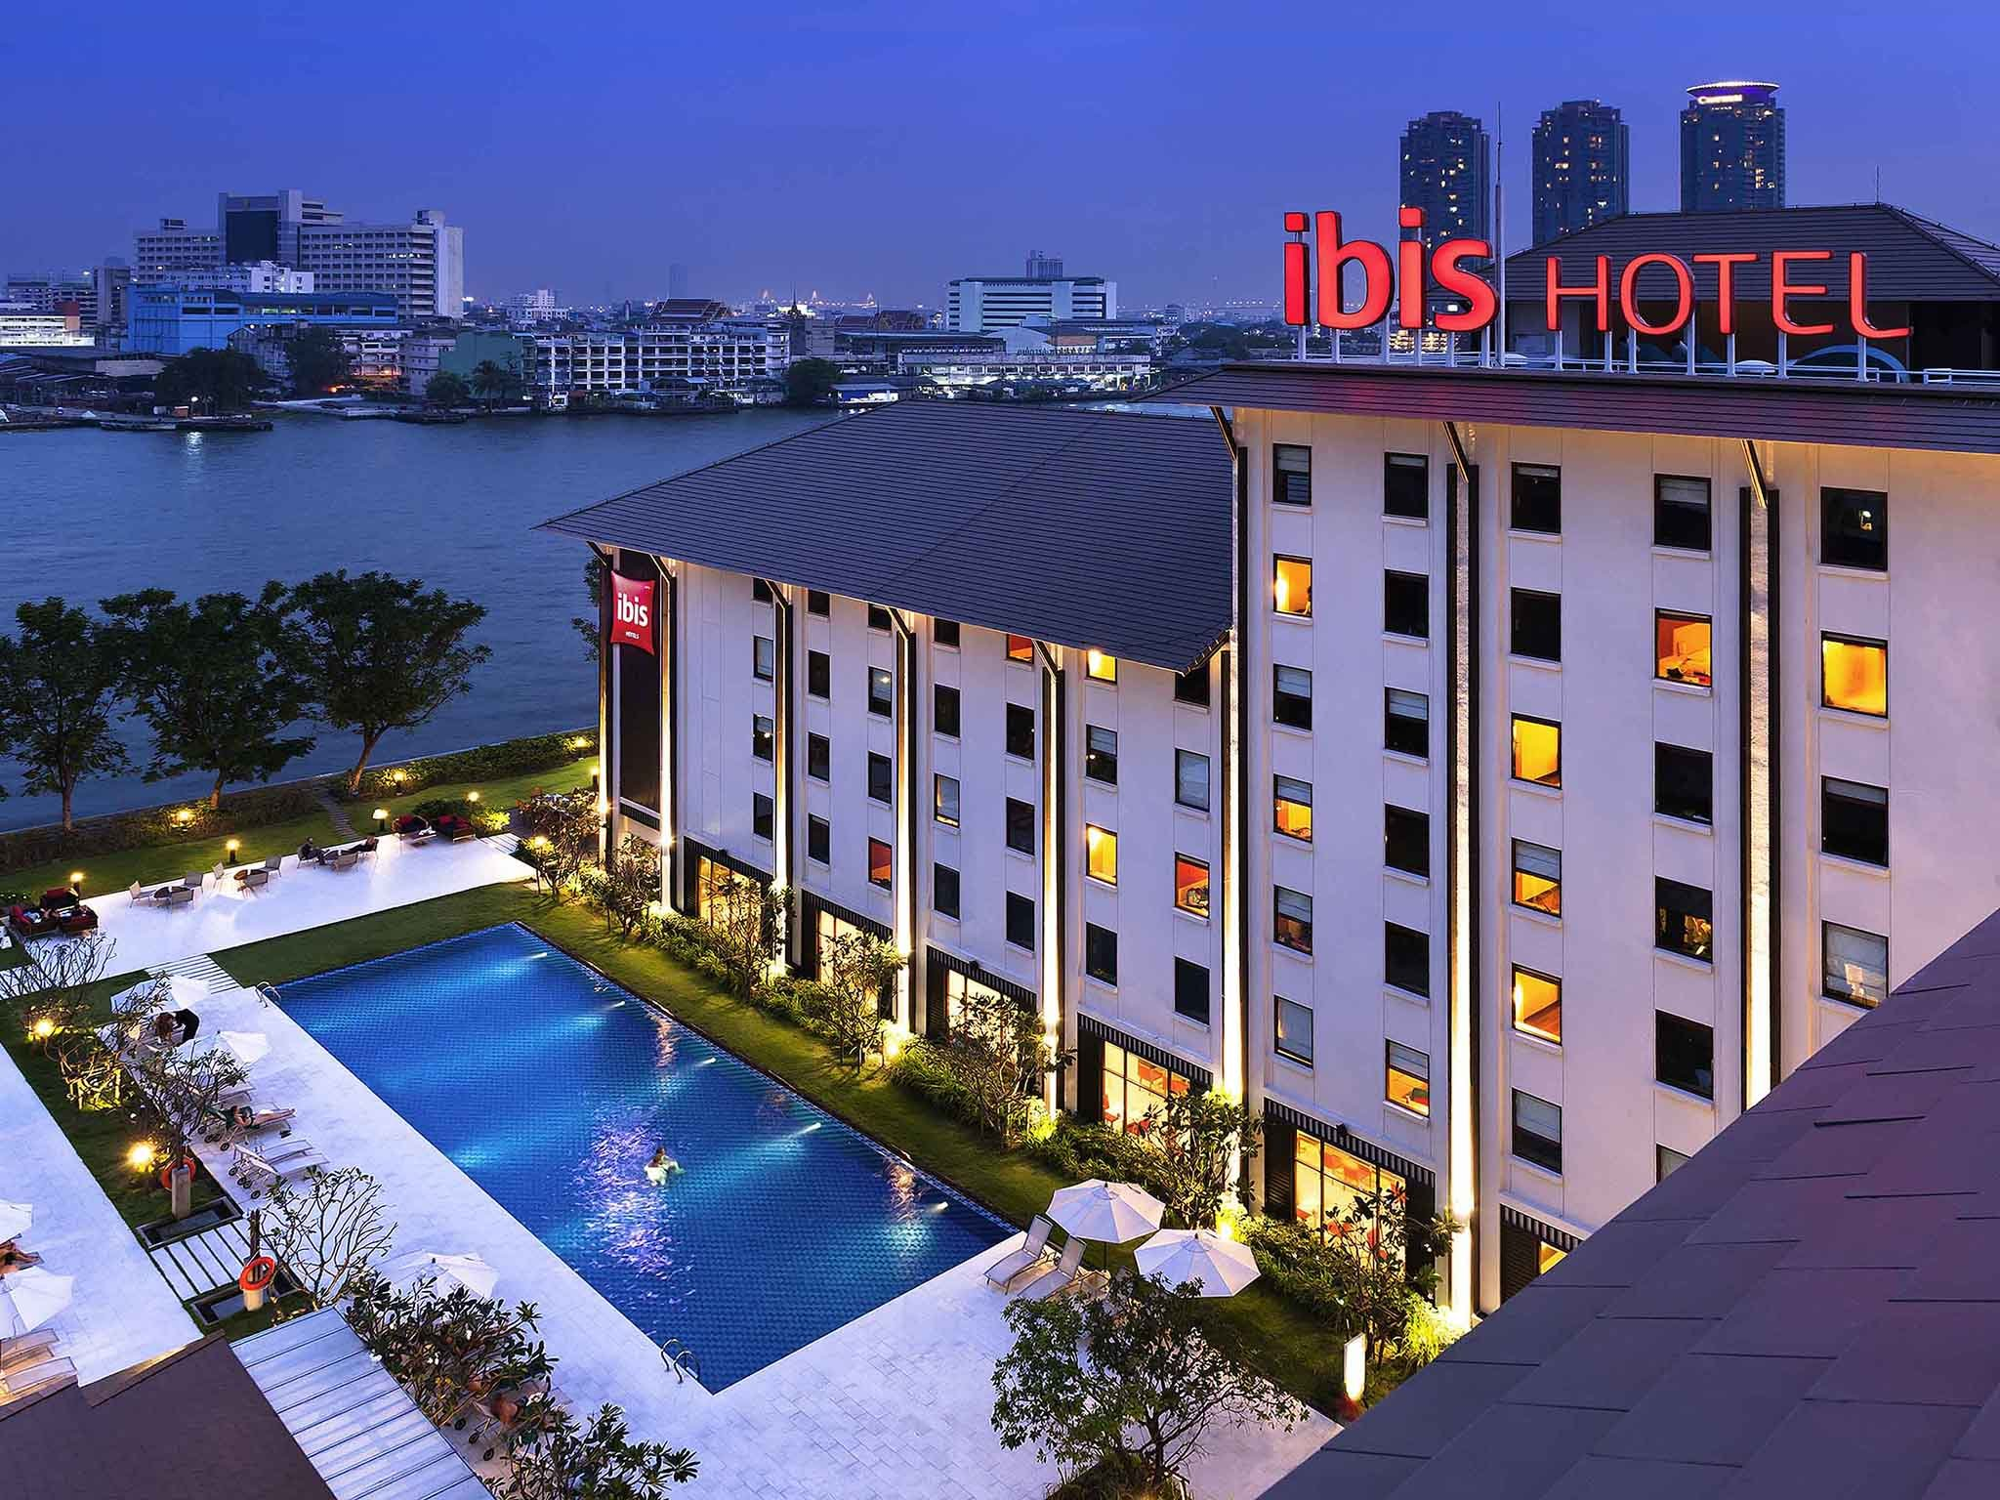
Figure: Ibis Hotel
Source: (Ibis, 2024)

Comparison of Total Revenue

Total revenue of Corinthia Hotels
In the year of 2022, Corinthia Hotel has secured a yearly revenue of €69.8 million and the respective business is aiming for further performance improvement. Total revenue for the year of 2021 was increased to €238.2 million from €129.3 million in the year 2020, an increase of 84%. In the information, total Revenue actually represents 89% of revenue figures of 2019. It indicates that the respective business has a huge potential of future growth (Baker et al., 2020). After the pandemic, in the year of 2021, the business has successfully continued its recovery from its recognized property which is more than €79.7 million. Moreover, it can be identified that in spite of the pandemic the respective business has achieved a good amount of revenue due to its high brand positioning and high-quality services.
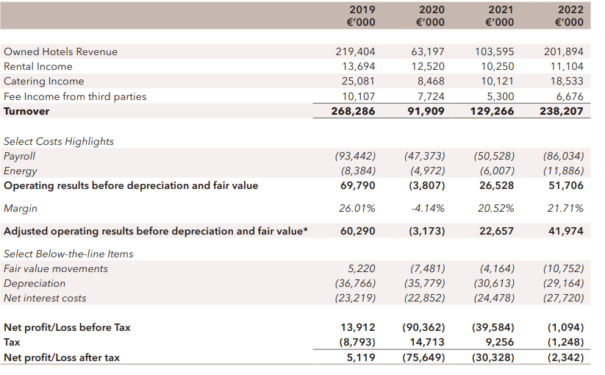
Figure: Total revenue of Corinthia Hotel in different year
Source: (Corinthia, 2024)

Total revenue of Ibis Hotels
Ibis hotel group has secured a total revenue of €1,149 million in the year of 2021. It indicates that the respective business has seen 84% growth from last year due to the pandemic. Additionally, the subsidiary business of Ibis has received more than €308 million revenue in the year of 2021. Sharp improvement was noticed in the total revenue of the respective business in the recent years. Moreover, the respective business has generated the highest amount of revenue from south Europe. The respective business is also aiming towards increasing its chains of hotel.
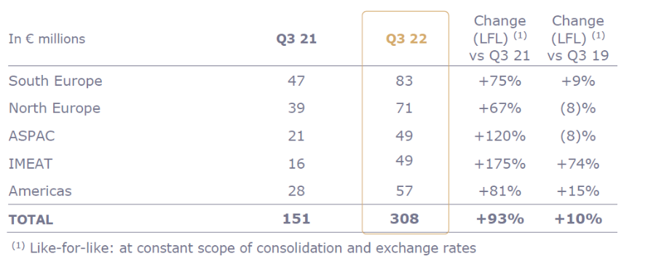
Figure: Total revenue of Ibis hotels
Source: (Ibis, 2024)
The total amount of revenue earned by the respective company is capable of developing the business in future times as well (Binesh et al., 2021). The retaining earnings of the business can be efficiently used for future business funding. Moreover, trying to build a new hotel in locations that have high demands like south Europe will help the business to earn more revenue.

Identifying final results
The above-mentioned data of both the business has successfully highlighted that the revenue of Ibis is a lot more than Corinthia Hotel (Petricek et al., 2021). The core reason for the financial success is the respective business has a lot of other fully owned subsidiary business which is missing in the case of Corinthia Hotel. Businesses like Corinthia Hotel were unable to get the same amount of profit as Ibis through a number of 23 hotels.

Comparison of current Market Position

Total assets and liabilities owned by Corinthia Hotel
Corinthia Hotel is a very popular hotel chain that has been running its business for more than 80 years now (Petricek et al., 2021). The respective business owned assets of more than €1,695,229. It indicates that the respective business has a good amount of assets for enhancing the future path of business development. On the other hand, the respective business has liability of €844,140. It indicates that the current market position of the respective business is very much good.
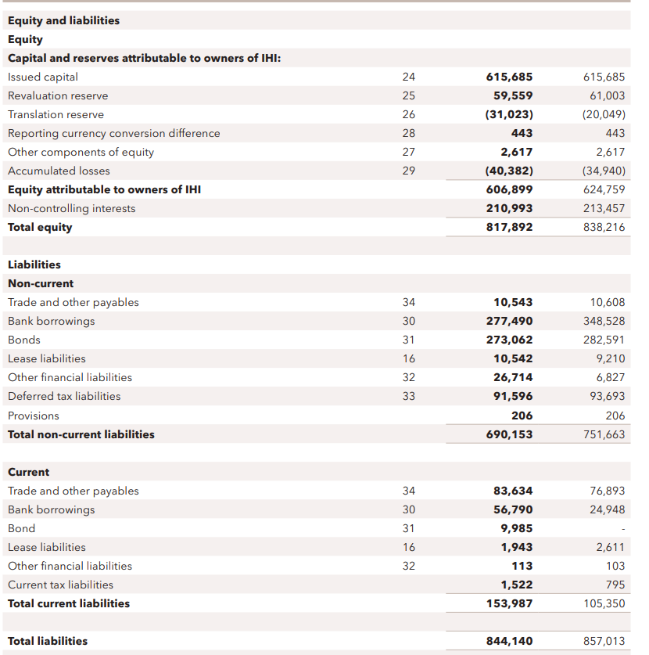
Figure: Market position of Corinthia Hotel
Source: (Corinthia, 2024)

Total assets and liabilities owned by Ibis Hotels
Ibis hotel is a multinational business with current assets of more than €40 million and the liabilities of the respective business is worth €11,740. It indicates that the liabilities of the respective business are very much lower than its total amount of assets. It indicates that the respective business belongs to a very good market position. The respective business to develop hugely in upcoming years by using assets for generating future business funds. Running a multinational business and establishing a huge number of subsidiary businesses is the sole reason for the good financial performance of Ibis hotel group.
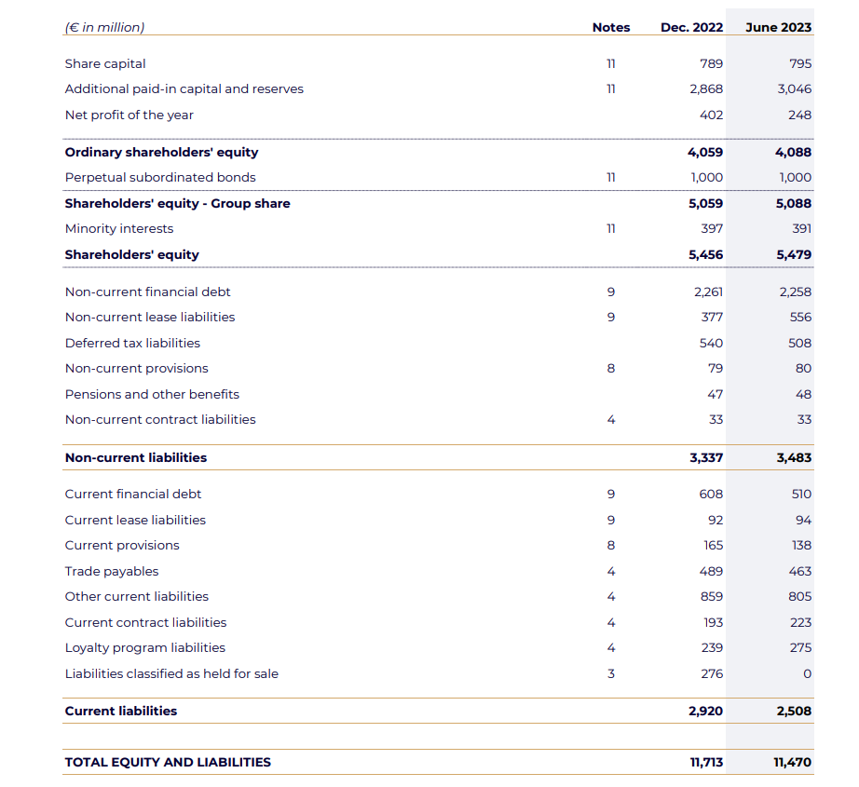
Figure: Financial position of Ibis hotel
Source: (Ibis, 2024)
It can be examined that the existing market potential of Ibis group is very much high. The total amount of revenue, brand reputation of the respective business will increase a lot in the future. Moreover, the high amount of assets can be used as future business funding.

Identifying final results
The aforementioned data analysis has shown light on the fact that the current market position of Ibis hotel is way better than Corinthia Hotel. High amount of business revenue has enabled the respective business to build high valued assets. On the other hand, Corinthia Hotel has to improve its revenue rate to build more assets (Tomislav et al., 2020). Hence, the data has successfully represented that Ibis hotel has more future potential of growth. However, the financial results of Corinthia Hotel can be improved further by generating a sufficient amount of business funding. The funding will help the respective business to earn more potential profit by improving the service quality and number of hotels as well.

Elucidating the Comparison of the Organisations’ Growth Potential including the organisation’s strategic Expansion, prospects within the market and development of Potential Barriers
Hotel Group Corinthia
Elucidating Business Expansion Strategies
The expansion strategy of the Corinthia Group is based on some specific principles. The organisation always tries to choose some prime locations with specific significance related to some global resorts and cities. The developing portfolio is based on steadiness and sensibility and looks at the proper sighting of the buildings in appropriate locations.
Discuss Opportunities Related to the Market
Expand in the potential upgraded market including the Asia and U.S. that are stressed on the overall luxury hotel demand. The alliance of this international hotel includes leverage based on loyalty programmes including retaining customers’ attraction. The unique offering includes authentic experiences based on competitive differentiation which is an appealing feature of travellers in the post-pandemic situation (Sakovska et al., 2021).
Discuss the organisation’s Obstacles for Developing the business
The organisation has faced obstacles related to risks and challenges, for example, the growth related to high costs and operation, the recovery of the post-pandemic situation, the luxury brands’ competition and geopolitical issues of the potentiality and many factors of the environment that hamper the destination’s natural beauty.
Ibis Hotel
Discuss Strategies of Ibis’ Business Expansion
The international hotel chain business Ibis Hotel needs to offer the comfortable and affordable travelers’ accommodations that implement strategies based on business expansion. The growth of the organisation is possible because of their innovative hotel room design to cater for the needs of diverse markets and preferences of consumers. The new priorities open important destinations and cities, for example, multiple destination hotels in Europe and Asia’s famous organisations. The distribution network related to Accor Group’s marketing can be leveraged based on network distribution with consumers’ reach (Economics Times, 2023).
Elucidating Market Opportunities Related to the Business
The opportunities related to Ibis Hotel need moderate elucidation related to the target of the network, consciousness of the budget, and consumers for value orientation. The comfortability is based on the loyal base of the consumers including resource expertise. The business of hotel networks also faces multiple threats with obstacles, for instance, declined profitability, per per-per-room profits declination (Dumoulin and Giacomel, 2020).
Discuss Organisation’s Obstacle Strategies
The threats and challenges are faced by the overall elucidation related to revenue profitability including per-room revenue. The fragmentation of the budget with the segmentation of the budget includes global and domestic brands with pandemic effect including restriction travel with occupancy demand (Bacari et al., 2021).
Comparison of Both Organisation
Both organisations follow different strategies and financial management practices including segmentation of multiple market reflection, proposition of the value and particular market segmentation. The developing strategy includes the Corinthia Hotel’s prime location. The expansion of the business of hotel chains for Ibis needs to be preferred based on the economy hotels’ significance (Maqalika, 2021).

Elucidating Proper analysis based on the CSR of both Hotels including Commitment to the Finances
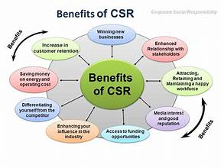
Source: (Lagarias et al., 2022)
Corinthia Hotels
This specific hotel group has fourteen locations including Africa, Europe and Middle Eastern Countries. The substantial policy related to CSR policy includes the four specific pillars colleagues nurturing process, community upliftment, and delivering experiences related to outstanding experiences of the guests.
1. Assistance in local causes and charities, for example, help the Ursuline Sisters who provide residential homes to disabled children and adults in Malta (Lagarias et al., 2022).
2. Provide measures related to energy-saving for example, solar panels, LED lighting, and systems of waste management in their various properties.
3. Providing customised services to the guests to enhance the consumers' experiences.
Ibis Hotel
The organisation is part of the Accor Group in one hundred and ten countries. The strategy related to sustainability includes Planet 21 which achieves the target in 2020 with positive hospitality. The financial commitment includes initiatives of CSR in the year 2019 that cost more than six million.
1) Decreasing the footprint of the environment by decreasing the plastics that are single-use, promoting a proper circular economy with sources of renewable energy (Kirui and Siddig, 2023).
2) Local communities’ assistance by implementing opportunities for employment and fostering inclusion of the society and encouraging travel responsibility.
3) Offering guest well-being with sustainable and good options of foods that assure the security and safety of the consumers (Kosmas, 2022).
Both the organisation is committed to the initiatives of CSR including multiple approaches related to transparency levels. The delivering focus of the Corinthia Hotel includes excellence and luxury delivery. The hotel brands have a specific aim to generate value to the stakeholders including the contribution of the development of sustainability.

Recommendations
1. Trying to build a new hotel in locations that have high demand like South Europe will help the Ibis to earn more revenue.
2. The financial results of Corinthia Hotel can be improved further by generating a sufficient amount of business funding.
3. Supporting the donations related to local communities, partnerships and volunteering process. Establishing the sustainable foods’ promotion to build the sourcing, management of waste and efficiency in energy.
4. Try to collaborate with investors and third-party collaborators and include a loyalty programme to retain the old customers of the hotels.

Conclusion
This assignment concludes the choice of the project of the firm based on the indicators related to the option of the investment. The ARR, NPV, including IRR can stress on the overall possibility to choose specific options related to Project A and B. The discussion proves the points to choose Project B based on their value of NPV and resolve the capital costs transformation problem related to the overall current value of the project. The discussion also has stated the overall elucidation related to the overall limitations and usefulness of using these methods for options of investments.

References
Bacari, C., Séraphin, H. and Gowreesunkar, V.G., (2021). Sustainable development goals and the hotel sector: Case examples and implications. Worldwide Hospitality and Tourism Themes, 13(1), pp.9-21.
Baker, T., Eziz, A. and Harrington, R.J., (2020). Hotel revenue management for the transient segment: taxonomy-based research. International Journal of Contemporary Hospitality Management, 32(1), pp.108-125.
Binesh, F., Belarmino, A. and Raab, C., (2021). A meta-analysis of hotel revenue management. Journal of revenue and pricing management, pp.1-13.
Corinthia, (2024). About Us. [Online] Available at: https://www.corinthia.com/ [Accessed 20 January 2024].
Dumoulin, R. and Giacomel, A., (2020). Disruption and the strategy of hotel groups. Shapes of Tourism Employment: HRM in the Worlds of Hotels and Air Transport, 4, pp.9-21.
Economics Times, (2023). Ibis expects 25% growth in top-line at Rs 1,000 cr this year. [Online] Available at: https://economictimes.indiatimes.com/industry/services/hotels-/-restaurants/ibis-expects-25-growth-in-top-line-at-rs-1000-cr-this-year/articleshow/98670867.cms [Accessed 15 March 2024].
Ibis, (2024). About Us. [Online] Available at: https://ibis.accor.com/india/index.en.shtml [Accessed 20 January 2024].
Kirui, O.K. and Siddig, K., (2023). 2022 annual research and policy conference: Agricultural transformation and food security in Sudan (Vol. 3). Intl Food Policy Res Inst.
Kosmas, P.C., (2022). European SME Going Green 2030 Report: Review and analysis of policies, strategies and instruments for boosting sustainable tourism in Europe.
Lagarias, A., Zacharakis, I. and Stratigea, A., (2022). Assessing the coastal vs hinterland divide by use of multitemporal data: Case study in Corinthia, Greece. European Journal of Geography, 13(2), pp.001-026.
Maqalika, L.R., (2021). Corporate Social Responsibility (CSR) implementation in the KwaZulu-Natal hotels-barriers and drivers.
Petricek, M., Chalupa, S. and Melas, D., (2021). Model of price optimization as a part of hotel revenue management—stochastic approach. Mathematics, 9(13), p.1552.
Sakovska, O., Kozhukhivska, R., Kustrich, L., Gomeniuk, M. and Podzihun, S., (2021), November. Improvement of the Marketing Management System of Tourism and Hospitality Industry Enterprises based on Innovations. In International Conference on Business and Technology (pp. 881-895). Cham: Springer International Publishing.
Tomislav, C.A.R. and STIFANICH, L.P., (2020). Mobile technology: a tool to increase hotel sales and revenue. Economics Business and Organization Research, pp.454-465.

