The Learner: who am I teaching?
Module code ECAD6007

A critical evaluation and the identification of next teaching and learning steps focusing on a case study of an individual learner or a group of learners, based on an observed critical incident.

- Introduction

Effective teaching is the cornerstone of any successful education system. With the challenges of ever evolving outside influences such as social, cultural, economic, political and technological changes, teaching is a complex and multifaceted process wherein teachers must continuously exercise judgement in order to ascertain how to act (Pollard, 2014, p. 68). This essay will firstly explore the role of critical reflection as a means of informing future decisions. Secondly, an investigation of an observed critical incident will be undertaken. Thirdly, a contextual analysis of literature will be carried out in order to provide a framework within which to reflect on the critical incident. Finally, an evaluation of next steps will be considered in order to inform future teaching practices.

- The role of critical reflection

In the wake of the most recent Initial Teacher Education reforms in Wales, critical reflection and research in the classroom is seen as an important weapon in the arsenal of teacher training and continual development (Furlong, 2015, page 17). It is so important, that it is now enshrined in the Professional Standards for Teaching and Leadership in Wales (“the Standards”) in particular the pedagogy and continuing professional learning standards. Moreover, there is encouragement to reflect on experiences by utilising the Education Workforce Council Professional Learning Passport (Welsh Government, 2019).

These changes come in light of the increasing popularity of the use of reflective practice which has come following the development of several models over the years. A brief analysis of three of these models will be undertaken in order to compare the differing approaches taken to critical reflection.

Schön (1983, p. 56) stated that as well as reflection taking place in retrospect, that is, reflecting on an event that has happened in the past, reflection can also take place ‘in action’ that is, live during the course of a lesson itself. It can be particularly effective in view of the element of surprise and how a teacher can make decisions thinking on his or her feet. Zwodiak-Myers (2012, p.38) highlights that reflection in action although often effective, is of most use to more experienced teachers and professionals. She puts forward her own model consisting of 9 dimensions of reflective practice which can be seen in her framework of reflective practice at Appendix 1 (2012 p. 5). Fundamentally, Zwodiak-Myers (2012, p.16) considers that reflective practice is a process of investigation whereby actions, opinions and theories are structured in order to inform future practice and professional development. Schön’s reflections on actions and reflections in action sit within dimension 2 of the framework. Zwodiak-Myers draws upon other theories of reflective practice in order to complete the total of 9 dimensions. This holistic approach of drawing on different approaches in one framework is arguably more robust and effective than Schön’s simplistic analysis of reflective practice.

Brookfield (2017, p. 61-77) devised an interesting view of critical reflection which encourages reflection through four lenses, and essentially comprises of viewing ourselves from the perspectives of other including: the student, our colleagues, personal experiences and theories in literature. To Brookfield, critical reflection assists teachers to keep the classroom engaged and it serves to increase trust between the pupils and teachers (Brookfield, 2017, p. 95).

In summary, the ability to identify critical incidents and develop a greater level of self-awareness for future development is of pivotal importance for trainee teachers and even the most experienced teachers alike. Brookfield’s model will be used and considered in the evaluation section below.

- Observation

I observed a reception class with children aged between 4 to 5 years old in a Welsh Middle school for children aged 3-19. There were 25 children in the class on the day that I observed them. I was advised that the children came from predominantly middle-class families. The most recent Estyn report for the school in 2017 shows that approximately 8% of pupils are eligible for free school meals and 9% of the pupils have Additional Learning Needs (ALN) (Estyn, 2017). Up-to-date figures were requested however, these have yet to be received.

- The critical incident

Please read the document at Appendix 2 entitled ‘Nodiadau maes- Cofnod 1’ before reading this section further for the contextual background information as well as a description of the events leading to the critical incident. The content has not been repeated below owing to the restrictive word count.

In short, the critical incident centred around Child A, a child with ALN who was disengaged and frustrated. The teacher used Picture Exchange Communication System (PECS) cards in order to communicate with Child A and ascertain what he wanted and that was, to go outside. I observed Child A interacting happily in activities outside which resulted in him being engaged in the remainder of the lesson through to lunch time.

The teacher advised me that Child A is often unsettled which primarily stems from an inability to communicate effectively. It is suspected that Child A has Autism Spectrum Disorder (ASD). He was most likely upset in this lesson because he is usually allowed to ride outside however because of the rain, the support staff initially informed him that he could not go outside. This was a disruption to his routine and what he thought was going to happen which in turn, lead him to disengage and become withdrawn and upset. The Estyn Report for this school states that the arrangements for pupils with ALN is thorough and proficient and that was certainly what I witnessed (Estyn, 2017, p. 7). The website for the school is currently being renewed and so I was unable to access a copy of the ALN policy online however, I have requested a physical copy of the same.

In order to fully evaluate its significance, this critical incident needs to be considered in light of the major changes afoot in the Education system in Wales, namely, the new National Curriculum for Wales (“the New Curriculum”) which will need to be implemented in all schools in Wales by September 2022 (Welsh Government, 2020, p. 52). The cornerstone of the New Curriculum are the four purposes which can be viewed at Appendix 3. The New Curriculum was devised following a review of the Welsh Education System by Graham Donaldson which suggested that a curriculum should be flexible and he actively encouraged schools to decide on the most effective implementation strategies of the four purposes in order to meet the needs of Children with ALN and emphasised that a multi-disciplinary approach should be taken for children who have the most complex needs (Donaldson, 2015, P. 91).

Applying this approach and two of the four purposes to the critical incident, I witnessed how the teacher’s use of visual aids and understanding the need to preserve Child A’s routine was vital for his health and well- being because of his ALN and need for structure and routine. The teacher adapted her approach to meet his individual needs and recognised the need to change his learning environment to outdoors and ensured that he was still included in the class. Actions such as this will help build Child A into an ambitious capable learner in that his needs are being understood so that he can thrive and reach his potential. Had it not been for the teacher’s intervention in this way, Child A would likely have become more upset and unsettled and so her intervention was critical.

- Literature Review

In order to provide a contextual foundation for a literature review connected to the critical incident, we need to explore the concept of ALN further including an analysis of the legislative framework that underpins the ALN system and thereafter the model of disability that has been adopted in Wales. Consideration will them be afforded to a variety of learning theories and how these specifically apply to children with ALN.

The Welsh Government identified that there were 92,688 school pupils requiring support with ALN in Wales in 2020/21 measured against a total school population of 423,190 this equates to 22% of the population of schools (StatsWales, 2021). Broadly, this means that almost 1 in 4 pupils have ALN in Welsh Schools. However, the true figure could be higher in view of the school closures in 2020/21 caused by the global Covid-19 pandemic (“the Pandemic”) coupled with the fact that teachers had much less face-to-face contact with pupils in order to identify any ALN. In addiction owing to the Pandemic, it follows that there will also be delays in diagnosing some pupils.

Importantly, there are major changes afoot in Wales associated with ALN by virtue of the Additional Learning Needs and Education Tribunal (Wales) Act 2018 (“the Act”) which seeks to support children from birth to the age of 25. The Act overhauls the old Special Educational Needs system and introduces major changes to ALN provisions in Wales that will be explored further below. Owing to these changes and for consistency, the term ALN (as previously abbreviated) will be used throughout this paper in reference to Special Educational Needs.

ALN is defined broadly in section 2 of the Act as a person with a learning difficulty or a disability and that the learning difficulty or disability requires additional learning provision. The Act is supplemented by the Additional Learning Needs Code for Wales 2021 (“the Code”) with paragraph 1.1 placing the views and feelings of the child at the centre of the process to enable them to learn and reach their potential. Fundamentally, the Code sets out the principles underpinning the ALN system which can be seen at Appendix 4.

Notably, the emphasis of the concept of ‘inclusion’ and person-centred planning within the principles of the Code are in place in order to support children with ALN to participate in the education system. This aligns with the social model of a disability which sees disability as an experience where society has failed to make adjustments or remove barriers (Peer and Reid, 2021, p. 50). In other words, it is society that creates the disability in the way that it responds to an individual’s differences.

Conversely, the medical model of a disability focuses on the individual and views the impairments and differences as inherently part of that individual as opposed to attributing the issues to the wider society. Rieser (2000, p.119) criticises this model arguing that by focusing on the individual’s impairment and seeing the disabled person as the issue, a cycle of dependency which leads to exclusion is created. On the contrary, Rieser (2000, p. 120) strongly advocates for the social model of disability arguing that the medical model perpetuates prejudicial attitudes and stereotypes and hinders the fight for inclusion. That said, Riser’s opinion was given in 2000 before the onset of a move towards the social model in legislation and policy as explained further below. It must also be noted that Riser himself has a physical impairment which is likely to have influenced his point of view.

The conflicting positions between the two models are evident. According to Peer and Reid (2021, p. 77) each has its place and its own inherent value, by way of an example, if the social model were applied strictly, all pupils would have to learn braille. In that sense we can see the helpfulness in the medical model in that it would not see this as necessary. In reality, it is important that teachers and schools are aware of both modes and adopt a holistic approach by combining a hybrid of both approaches in order to encourage inclusion, equality and diversity.

That said, as can be seen with the Act, the increasing current trend nationally and internationally is to shift away from the ‘medical model’ whenever possible in favour of a socially construct model. By way of an example, internationally, the United Nations Convention on the Rights of Persons with Disabilities 2008 endorses the concept of an inclusive education system and equal opportunities under Article 24. Importantly, further rights of children with ALN were enshrined in law by virtue of the Equality Act 2010 which places a legal obligation on schools to promote equality and inclusion of disabled students.

According to Howard et al (2017, p.119) the inclusion of all children in schools is vital in order to sustain their health and well-being and in particular this can be said of children with ALN who have been historically marginalised. The importance of well-being is noted in the Children’s Society’s latest annual report (“the Report”) which shows a decrease in children’s happiness in schools. Similarly, the Report (Children’s Society, 2020, p. 5) highlights the correlation between the inequality in the education system and children’s comparatively poor well-being currently. The findings of the Report are reliable in that it uses predominantly quantitative data together with qualitative information from national and international sources that investigate children’s self-reported well-being.

Similarly, the need to preserve the health and well-being of children was noted in further legislation, namely, the Well-being of Future Generations (Wales) Act 2015 (“The Well-being Act”). The Government states that it’s approach to curriculum reform supports the Well-being Act’s objective of sustainable development and encourages schools to design curriculum’s around the well-being needs of the pupils (Welsh Government, 2020). According to Glazzard (2010, P. 3) curricula approaches with an emphasis on assessment often marginalise and, on that basis, exclude pupils with ALN. It follows that the shift to the emphasis of nurturing children’s health and well-being in legislation and the New Curriculum and less emphasis on assessments will benefit those children with ALN.

This is analogues to the humanist approach to psychology which places the primary needs of an individual at its core. Maslow (1943, p.22) sought to examine and explain what influenced human behaviour which led to his renowned study that created the concept of the ‘Hierarchy of Needs’ of all humans from the most basic ‘psychological needs’ including eating, drinking and sleeping to ‘personal accomplishment’ which appears at the top of the hierarchy (see Appendix 5 for the full hierarchy). Importantly, Maslow stated that each level of need needed to be satisfied before moving up to the next level. Criticisms of Maslow’s theory point out that as the study was carried out on wealthy Western populations, the results might not transfer so easily to other areas of the world that could place higher priority on different needs (Cadiat, 2015, p. 11). Stoianov (2017, p.43) notes that even though his work has drawn criticism, it is still relevant today as noted further in the evaluation section below.

According to the humanist Holt (1995, p.210), children should be given the freedom to become the architects of their own learning and they ought to be supported emotionally which in turn would preserve their well-being. This is of particular significance in the context of children’s mental health and well- being which as noted above, is vital particularly for children with ALN. With the push towards the emphasis on health and well-being in the New Curriculum, the humanist school aligns strongly with the purpose that the education system should be building healthy and confident individuals and is therefore still relevant today.

In order to inform and develop pedagogies further, it is important to carry out a review of other theoretical perspectives of child development with a particular focus of the same in the context of ALN. During the 19th century the first group of theorists to explore cognitive development were the behaviouralist theories of Pavlov, Watson and Skinner. Glazzard (2010, p. 30) points out that these theories rely on observed behaviours as a means of development and therefore disregard mental capacity and ALN. Given the limited word count, focus will therefore be placed on other relevant theories.

The renowned constructivist Piaget claimed that cognitive development occurred in stages by itself and that peer-to-peer learning in particular was crucial to child development (Gary and MacBlain, 2012, P. 82). However, from an ALN perspective, like the behaviouralists, it is striking that Piaget can be criticised in that he fails to take into account the differing abilities of children and that some children may have ALN meaning that they do not fit into the stages of development.

Vygotsky, a fellow constructivist, proposed that cognitive development was a social procedure in that children develop as a result of social interaction. Vygotsky championed the idea that children learn best with a more capable individual and that this creates a zone of proximal development (ZPD) within which a child plays above what he or she is ordinarily capable of and as such, develops (Vygotsky, 1978, p. 102). Vygotsky also recognises the difference in learners and their levels of ability as a result of varying internal factors, such as ALN. That said, Gary and MacBlain (2012, p. 109) highlight specific criticism of Vygotsky’s theory in that he conducted very limited studies to substantiate his findings and that translations of his work have allegedly led to mistakes in its interpretation. Although Vygotsky’s uses qualitative research it is arguably as valuable as quantitative research in that there is additional flexibility to explore theories initially and develop these thereafter perhaps with quantitative data. This is supported by that fact that the concept of the ZPD has been pioneering in paving the way top the development of further pedological concepts including that of ‘scaffolding’ proposed by Wood et al (1976, pages 89 to 100) which describes the tutoring process whereby support is provided in learning. This concept is crucial in the context of ALN and will be considered in further detail in the evaluation section.

Bronfenbrenner recognises that schools have a significant role to play in the upbringing of children as unique individuals. Going further than Vygotsky’s theory, Bronfenbrenner considered that we must take account of the wider environment when considering child development. Appendix 6 shows an illustration of Bronfenbrenner’s theory of an ‘ecological model of individual development’ with each layer of influence being named and the closest to the centre being the most influential on the child with the child as an individual at its core (Bronfenbrenner, 1996, p.3). Each layer has interconnections with the other creating an ecosystem between individuals, settings and environments. The education system sits in the microsystem layer. In this layer the child draws connections between the school and home life (Gary and MacBlain, 2012, p. 125). In the context of ALN, Bronfenbrenner outlines that there are resource characteristics that may limit or extinguish a child’s ability to sustain certain interactions within the ecosystem (Halpenny and O’Toole, 2017, p.21) including any impairments that they may have causing ALN. Linking this to the social model of disability, Brewster notes that the environment can disable a child more than the impairment itself (Brewster, 2004, p.48) highlighting how important an inclusive classroom is. Teachers should also work with outside agencies in the ‘Exosystem’ layer such as Special Educational Psychologists and Speech and Language therapists in order to support children with ALN. This multi layered approach will support the notion of inclusion of children with ALN in schools and increase equality and diversity.

Based on the above literature review, it is clear that the concepts of inclusion and move towards the social model of disability encourages equality and diversity in schools. Equally, the need to safeguard the health and well-being of children is currently at the forefront of educating children with ALN and will need to be considered when evaluating next steps following the above-mentioned critical incident which will be explored in the next section.

- Reflection Evaluation and next steps

Applying the literature review to the critical incident and reflecting on the same using Brookfield’s ‘four lenses’ I have found the following from the varying points of view:

- The student

The student’s marked change in engagement following the critical incident was evident and the approach taken to change the lesson structure was beneficial for Child A’s health and well-being and would mean that he is better placed to achieve his potential. Arguably, Maslow’s hierarchy of needs is drawn upon in that when the basic need was met, Child A moved up the hierarchy and his psychological state improved. Glazzard (2010, p.25) states that listening to the children’s voice is crucial in order to promote engagement and foster a positive relationship between pupils and teachers that will create an environment to thrive and this is certainly what I will consider in future practice.

- Colleagues

Before the teacher’s intervention, Child A was sat distressed at the periphery of the class and as such, was not included within the class. Although the support staff were unsure of how to engage Child A and ultimately it was the teacher’s actions that changed the situation, their input was vital in that they were able to tell the teacher what they had tried to do with Child A after the event and also discuss what generally triggers Child A and so this information was useful in informing the teachers next steps. Howard et al (2017, p.119) argues that inclusion is an ongoing process and in order to meet the varying and diverse needs of learners, teachers need to adopt a responsive set of pedagogies that constantly evolve. To that end in sculpting a portfolio of pedagogies a colleague’s point of view is crucial. Further, one of the Standards is to promote collaboration with colleagues in order to enhance learners’ experiences (Welsh Government, 2019) and so seeking their input is essential.

- Self-reflection (from the teacher’s perspective)

The teacher’s use of PECS as a means of communication is a form of scaffolding as a visual representation of next steps was used in order to assist Child A to understand and progress. This also meant that Child A’s lack of speech did not become a barrier to learning therefore increasing inclusion. As noted above, scaffolding is a powerful strategy and requires patience and repetition with ALN pupils before it can be withdrawn with pupil progress.

In addition, the flexibility afforded by the New Curriculum means that learning objectives for each child can be aligned to their learning ability in line with the progression steps as opposed to being set against any ‘key stage’ in development (Donaldson, 2015, p 115). Being a reflective teacher and learning from past experiences means that proactive steps can be taken to draw on past experiences to meet the diverse needs of children with ALN which can include setting tasks at the level of ability of each child using any resources at their disposal in order to meet their diverse needs. By way of an example, for many children with ALN writing can be a barrier to learning which can be overcome by utilising new technologies such as computer-based technology.

Applying this analysis to the critical incident, I believe that the teacher took the correct steps in this incident in using the PECS cards as a tool to communicate effectively given her previous experience using these cards. In practice, I would want to take this further by supporting children with ALN in the wider classroom with useful resources such as visual timetables for visual learners in order to adopt an inclusive classroom model in practice. Taking Bronfenbrenner’s ecology model of individual development, the microsystem layer and in particular the school, should adapt its practices and environment in order to allow the child to flourish and reach his/her potential.

- Theoretical literature

As explored above, a review of relevant theoretical literature is vital in developing diverse strategies in order to inform next steps and meet the needs of a diverse range of learners.

- Conclusion

In summary, it is crucial that teachers develop a greater self-awareness and adapt pedological approaches in order to champion each child regardless of their ability so that they can access the New Curriculum and ensure that it remains learner centred. As can be seen from the literature review and evaluation above, critical reflection by teachers will assist in dismantling barriers to inclusion in order to maximise the achievements of all students. Additionally, by undertaking the exercise of reflective practice, teachers can elevate their teaching abilities in line with the Standards, by way of one example, there is a need to reflect on authentic real experiences in order to advance pedagogies (Welsh Government, 2019).

In view of the above and the fact that almost 1 in 4 children have ALN, it is of pivotal importannce that teaching practices are adapted in order to deliver an education to all children regardless of their ability or ALN. By critically reflecting on incidents such as noted above and analysing the same in order to inform development, through a holistic approach, we can make children with ALN feel safer in their learning environments so that they can thrive.

Reference list

Books

- Bronfenbrenner, U. (1996) The ecology of human development experiments by nature and design. Cambridge, MA: Harvard University Press.

- Brookfield, S. (2017) Becoming a critically reflective teacher. 2nd edn. San Francisco, California: Jossey-Bass.

- Cadiat, A-C (2015) Maslow’s hierarchy of needs Namur: Lematire Publishing.

- Gary, C. and MacBlain, S. (2012) Learning Theories in Childhood. London: Sage.

- Glazzard, J (2010) Teaching Primary Special Needs Exeter: Learning Matters

- Halpenny A and O’Toole L (2017) Introducing Bronfenbrenner: a guide for practitioners and students in early years education. London: Routledge.

- Holt, J. (1995) How Children Learn. Reading, Massachussetts: Addison-Wesley Pub.Co. Revised Edn.

- Howard, C et al (2017) Children’s Mental Health and Emotional Well-being in Primary Schools. London: Sage Publications

- Maslow, A H (1943) A theory of human motivation. Virginia: Wilder Publications Inc.

- Peer, L and Reid, G (2021) Special Educational Needs a guide for inclusive practice. 3rd edn. London: Sage Publications

- Pollard, A. (2014) Reflective teaching in schools. 4th edn. London: Bloomsbury

- Rieser, R (2000) Disability Discrimination, the final frontier; disablement, history and liberation in M Cole, Education Equality and Human Rights: Issues of Gender, ‘Race’, Sexuality, Special Needs and Social Class. London: Routledge

- Stoianov Stoian (2017) An analysis of Abraham Maslow’s a theory of human motivation. London, England: Routledge

- Schön, D A. (1983) The Reflective Practitioner. New York: Basic Books

- Zwodiak-Myers, P (2012) The teacher’s reflective practice handbook: becoming an extended professional through capturing evidence- informed practice. New York: Routledge.

Journals

- Brewster, S. (2004) Insights from a social model of literacy and disability. Oxford, UK: Blackwell Publishing. Literacy (Oxford, England), 04, Vol.38 (1)

- Lev S Vygotsky (1978) Mind in Society. Cambridge, MA: Harvard University Press

- Wood, D. and Burner J S. and Ross, G. (1976) The Role of Tutoring in Problem Solving Child Psychology, Volume 17. Great Britain: Pergamon Press

Legislation

- Additional Learning Needs and Education Tribunal (Wales) Act 2018, Chapter 1. Available at https://www.legislation.gov.uk/anaw/2018/2/section/2/enacted
(Accessed: 23 September 2021)

- Equality Act 2010, Chapter 15. Available at https://www.legislation.gov.uk/ukpga/2010/15/contents (Accessed: 25 September 2021)

- The Additional Learning Needs Code for Wales 2021 Chapter 1. Available at https://gov.wales/sites/default/files/publications/2021-03/210326-the-additional-learning-needs-code-for-wales-2021.pdf
(Accessed: 23 September 2021)

- United Nations Convention on the Rights of Persons with Disabilities 2008. Available at https://www.un.org/development/desa/disabilities/convention-on-the-rights-of-persons-with-disabilities/article-24-education.html
(Accessed 2 October 2021)

- Well-being of Future Generations (Wales) Act 2015, Chapter 2. Available at https://www.legislation.gov.uk/anaw/2015/2/contents
(Accessed 9 October 2021)

Websites

- Donaldson, G (2015) Successful Futures . Available at https://gov.wales/sites/default/files/publications/2018-03/successful-futures.pdf
(Accessed 20 September 2021)

- Estyn Report available https://www.estyn.gov.wales/system/files/2020-08/Ysgol%2520Llanhari%2520en.pdf
(Accessed on 30 September 2021)

- Furlong, J (2015) Teaching Tomorrow’s Teachers Accessed through the following link: https://gov.wales/sites/default/files/publications/2018-03/teaching-tomorrow’s-teachers.pdf
(Accessed: 4 October 2021)

- The Children’s Society The Good Childhood Report (2020)Accessed through the following link: https://www.childrenssociety.org.uk/sites/default/files/2020-11/Good-Childhood-Report-2020.pdf (accessed on 13 October 2021)

- Welsh Government (2020) Curriculum for Wales Guidance. Available at https://hwb.gov.wales/storage/b44ad45b-ff78-430a-9423-36feb86aaf7e/curriculum-for-wales-guidance.pdf
(Accessed 20 September 2021)

- Welsh Government (2019) Professional Standards for teaching and leadership accessed through the following link: https://hwb.gov.wales/api/storage/19bc948b-8a3f-41e0-944a-7bf2cadf7d18/professional-standards-for-teaching-and-leadership-interactive-pdf-for-pc.pdf
(Accessed: 4 October 2021)

- Welsh Government (2021) StatsWales https://statswales.gov.wales/Catalogue/Education-and-Skills/Schools-and-Teachers/Schools-Census/Pupil-Level-Annual-School-Census/Special-Educational-Needs/pupilssen-by-localauthorityregion-provision
(Accessed: 25 September 2021)

APPENDIX 1

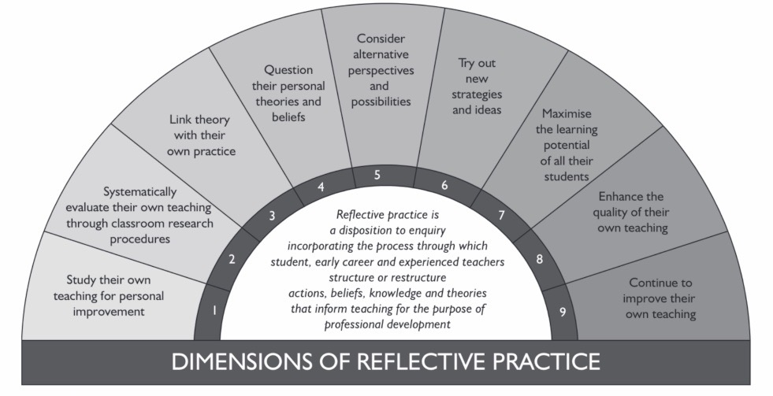

Zwodiak-Myers, P (2012) The teacher’s reflective practice handbook: becoming an extended professional through capturing evidence- informed practice. New York: Routledge. Page 5.

APPENDIX 2

ARSLYWAD / NODIADAU MAES

Cofnod 1
Dyddiad ac amser, grŵp blwyddyn: 23 Medi 2021 ar 11.00yb, Dosbarth Derbyn

Ble a phryd : Cyd-destun y digwyddiad – pwnc/MDaPh, cyd-destun cyffredinol y dosbarth

Roedd fy arsylwadau wedi digwydd mewn Ysgol Ganol Gymraeg 3-19 blwydd oed. Ar yr ail ddiwrnod mynychais a ddosbarth derbyn gyda 25 o blant yn bresennol yn ogystal ag athrawes a dau aelod o staff cymorth. Roedd y plant yn dod o gymysgedd o deuluoedd dosbarth gweithiol a dosbarth canol.

Beth ddigwyddodd – disgrifiad manwl (gorau po fwyaf y manylion er mwyn cyfeirio atynt yn ddiweddarach yn eich gwaith)

Ymunais â'r dosbarth yn ystod ail wers y dydd am 11yb. Cafodd y plant eu grwpio ac roeddent yn cymryd rhan mewn amrywiaeth o wahanol weithgareddau gan gynnwys: Lliwio gyda phensiliau, paentio, chwarae gyda lego a chwarae dychmygus yn y ‘caffi’. Roedd yr awyrgylch yn swnllyd gyda rhai plant yn croesi drosodd rhwng grwpiau. Symudais yn llyfn rhwng y grwpiau gan arsylwi ar y ddeinameg wahanol rhwng y plant a'r ffordd yr oeddent yn rhyngweithio â'i gilydd. Roedd mwyafrif y plant yn fodlon ac yn hapus yn cymryd rhan yn y gweithgareddau penodol.

Sylwais fod ‘Plentyn A’ yn ansefydlog iawn ac yn ymddangos fel bod e wedi cael ddigon gyda’r holl weithgareddau. Sylwais arno yn cerdded yn ôl ac ymlaen i'r drws mynediad cefn y tu allan i'r ystafell ddosbarth sawl gwaith o fewn 2 funud yn dod yn fwy a fwy rhwystredig. Ceisiodd staff cymorth ymgysylltu â Phlentyn A ond anwybyddodd yn weithredol eu bod yn dewis edrych i'r cyfeiriad arall i'w syllu. Daeth yn amlwg mai ffynhonnell rhwystredigaeth Plentyn A oedd ei fod eisiau mynd y tu allan. Sylwais ar yr athrawes dosbarth yn mynd ato ac egluro iddo gan ddefnyddio cardiau gweledol PECS (Picture Exchange Communication Syetem) a oedd ynghlwm wrth y lanyard o amgylch ei gwddf. Esboniodd y gallai chwarae ar feic y tu allan am 10 munud ac ar ol hynny y byddai'n bryd dod i mewn i eistedd ar y mat i ganu caneuon cyn amser cinio.

Gwelais ymarweddiad Plentyn A yn newid yn llwyr cyn gynted ag y byddai'n deall yr hyn yr oedd hi'n ei ddweud. Gofynnodd yr athrawes dosbarth i aelod o'r staff cymorth fynd gyda Phlentyn A y tu allan (ynghyd ag ychydig o blant eraill a oedd erbyn hyn yn dangos diddordeb i fynd allan!) A chael ei gôt oherwydd ei bod hi'n bwrw glaw yn ysgafn. Sylwais ar Blentyn A yn hapus gyda'r plant eraill ar y beic yn yr awyr iach am y 10 munud llawn. Bu hefyd yn cymryd rhan yn y gweithgaredd allanol trwy gyfrif y teiars ar y llawr wrth iddo farchogaeth o gwmpas. Pan ddaeth yn amser mynd yn ôl y tu mewn, fe wnes i glapio’n ysgafn gan ystumio ei fod yn edrych yn hwyl ac ymunodd Plentyn A â mi i glapio a rhoi cyswllt llygad da iawn. Yna roedd Plentyn A yn cymryd rhan fawr yn y gweithgaredd canu dilynol ar y mat. Fe lanwodd fy nghalon i weld Plentyn A yn cymryd rhan yn llawn mewn gweithgaredd ar ôl pa mor rhwystredig yr oedd wedi bod o'r blaen.

Gofynnais am gefndir Plentyn E a dwedodd yr athrawes ei fod yn aml yn ansefydlog sy'n dod yn bennaf o’r ffaith bod e ddim yn gallu cyfathrebu yn effeithiol. Mae'r ysgol yn mynd i ofyn am gymorth ychwanegol ar gyfer y plentyn maes o law gan fod yn cael anghenion dysgu ychwanegol ond doed dim diagnosis ganddo ar hyn o’r bryd. Mae ei rhieni yn cefnogi Plentyn A adref ac yn cefnogi y cymorth mae’r ysgol yn ceisio rhoi yn ei lle ar gyfer Plentyn A.

Meysydd y gellir eu harchwilio – yr hyn rydych chi’n meddwl allai fod “o dan y bonet” yn y digwyddiadau hyn

Anghenion Dysgu Ychwanegol gwahanol dulliau a adnoddau i helpu plant efo ADY i cynyddu (scaffaldi ayyb).
Iechyd a Lles- sut helpu nhw gallu ymdopi yn yr ystafell dosbarth a cynhwysiant.

Safonnau professiynol- Addysgeg - Rheoli’r amgylchedd dysgu a gwahaniaethu.
Ac efallai bydd arleosi ohwreydd bydd modd defnyddio ffyrdd gawhanol i helpu’s plant gyda ADY yn enwedig datblugu technegau newydd.

Cwriciwlm newydd i Gymru- 2 diben- (1) unigolion iach a hyderus a (2) Dysgwyr uchelgeisiol a galluog.

Nodiadau-

Cofnod 2
Dyddiad ac amser, grŵp blwyddyn: 22 Medi 2021 ar 10.30yb, Blwyddyn 1

Ble a phryd : Cyd-destun y digwyddiad – pwnc/MDaPh, cyd-destun cyffredinol y dosbarth

Gwled cofnod 1.

Beth ddigwyddodd – disgrifiad manwl (gorau po fwyaf y manylion er mwyn cyfeirio atynt yn ddiweddarach yn eich gwaith)

Esboniodd yr athrawes bod 5 rheol dosbarth a system goleuadau traffig yn y dosbarth i’r plant weld i ceisio rheolu ymddygiad.

Digwyddodd y digwyddiad critigol yn syth ar ôl yr ‘amser egwyl’ cyntaf y dydd. Grwpiodd yr athrawes y plant yn grwpiau o 4-6 i wneud tasgiau llawysgrifen a darllen o amgylch y dosbarth.

Chlywais Plentyn A a Phlentyn B yn anghytuno gyda’i gilydd. Roedd yr athrawes wedi siarad efo’r plant a darganfod bod Plentyn A wedi tynnu pensil o law Plentyn B ac nid hwn oedd y tro cyntaf i hynny ddigwydd. Roedd y digwyddiad yn torri un o reolau’r dosbarth. Cymerodd yr athrawes 5 munud i ffwrdd o amser chwarae Plentyn A a gosodwyd ei henw ar y golau ambr.

Meysydd y gellir eu harchwilio – yr hyn rydych chi’n meddwl allai fod “o dan y bonet” yn y digwyddiadau hyn

Edrych ar wahanol ffyrdd o reoli ymddygiad - Lee a Marlene Canter- Dull disgyblaeth bendant.

Meddwl am y theorïau ac astudiaethau seicolegol. Yr un sy’n sefyll allan yw’r theoriau behaviouralist. Mae dysgu'n digwydd pan fydd newid mewn ymddygiad. Theori seicolegydd- B.F. Skinner - Gall rhieni a gofalwyr effeithio ar ymddygiad plentyn trwy ddefnyddio adborth cadarnhaol a negyddol.

Nodiadau

Cofnod 3

Dyddiad ac amser, grŵp blwyddyn: 23 Medi 2021 ar 9.30yb, Blwyddyn 3

Ble a phryd : Cyd-destun y digwyddiad – pwnc/MDaPh, cyd-destun cyffredinol y dosbarth

Gweld cofnod 1.

Beth ddigwyddodd – disgrifiad manwl (gorau po fwyaf y manylion er mwyn cyfeirio atynt yn ddiweddarach yn eich gwaith)

Wers 1af- wers Saesneg - ferfau.

Dasg - parau i ddarganfod berf ar gyfer pob llythyren o'r wyddor.

Cerddais o amgylch y dosbarth yn mynd rhwng grwpiau yn helpu’r plant ac yn gwrando ar eu dewisiadau anhygoel o ferfau (y ferf ohonom ni’n hoffi fwyaf ac mae’n rhai i fi cyfadde’ o ni heb glywed e o’r blaen ond ‘ghostbusting!’ Mae ghostbusting yn ferf!)

Pan oedd y plant wedi gorffen y dasg roedd dewis ganddynt o naill darllen neu gwblhau chwiliad gair o ‘berfau’. Gofynnodd ‘Plentyn C’ a ‘Plentyn D’ os oedden nhw’n gallu darllen eu hoff lyfr Saesneg sef y BFG gan Raold Dahl a gwneud rhestr o’r berfau oedden nhw’n gallu ffeindio yn y llyfr. Roeddwn i’n gallu clywed y plant yn sgwrsio am ferfau a chywiro ei gilydd. Roedd ên profiad da gweld y plant yn defnyddio eu mentrau eu hunain i gwblhau tasg.
Meysydd y gellir eu harchwilio – yr hyn rydych chi’n meddwl allai fod “o dan y bonet” yn y digwyddiadau hyn

Theorïau seicolegol – constructive theory – gan fod gwaith grŵp a dysgu gweithredol. Hefyd gallwn i ystyried yr ‘humanist theori’ gan gynnwys John Holt achos maent yn ystyried dewisiadau'r plant.

Uwch fentro
Cwricwlwm - dysgwyr galluog uchelgeisiol

Ynglyn a’r Safonnau professiynol- yr un sy’n ymddangos yn yr digwyddiad yma yn benodol yw addysgeg a dilyniant mewn dysgu.

Nodiadu-

APPENDIX 3
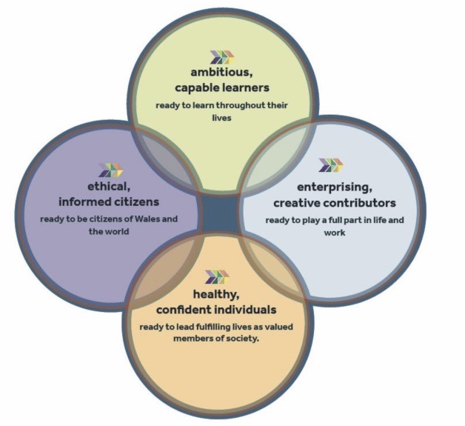

Welsh Government document (2015) Successful futures: Independent Review of Curriculum and Assessment Arrangements in Wales. A report on responses to the great debate. Available at https://gov.wales/sites/default/files/publications/2018-03/a-report-on-responses-to-the-great-debate.pdf (Accessed on 1 October 2021)

APPENDIX 4
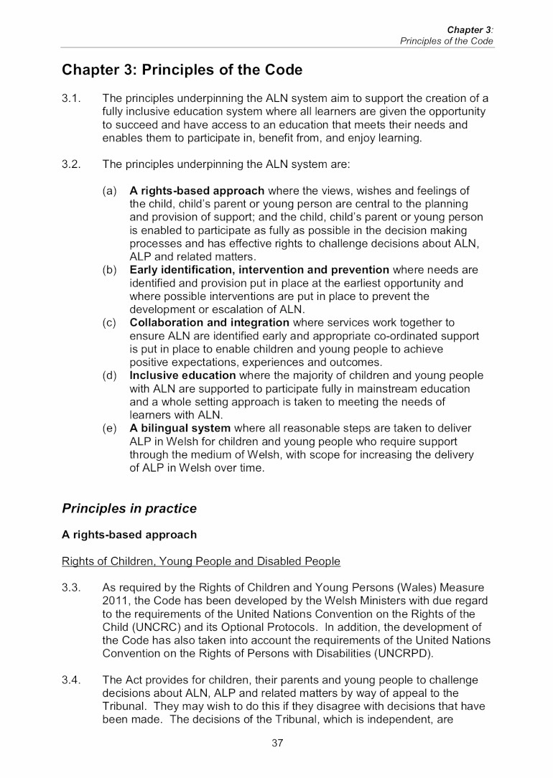

The Additional Learning Needs Code for Wales 2021 Chapter 3 paragraph 3.2(a)-(e) Available at https://gov.wales/sites/default/files/publications/2021-03/210326-the-additional-learning-needs-code-for-wales-2021.pdf (Accessed: 23 September 2021). Page 37.

APPENDIX 5

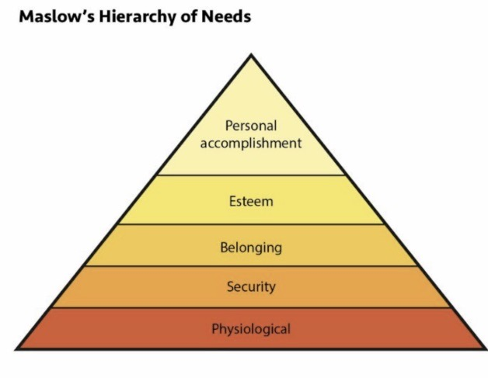
Cadiat, A-C (2015) Maslow’s hierarchy of needs Namur: Lematire Publishing. Page 8.

APPENDIX 6

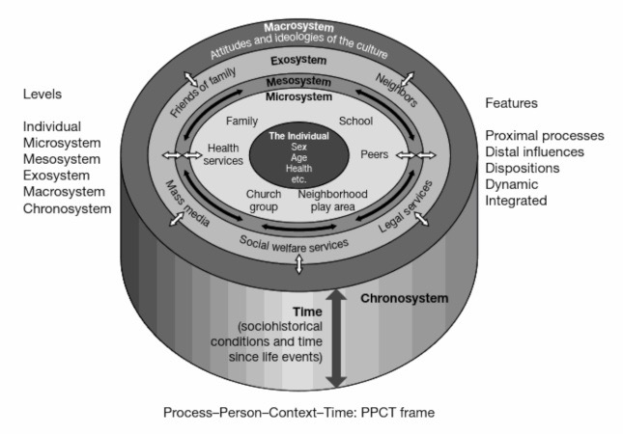

Halpenny A and O’Toole L (2017) Introducing Bronfenbrenner: a guide for practitioners and students in early years education. London: Routledge. Page 14.

