Augustus Prima Porta (fig.1) is a defining piece of art from the Augustan period. The art is symbolic of the greatest ruler of Ancient Rome and a great maverick when regarding art and propaganda in regard to highlighting himself as a ruler. The carving has multiple pieces of work promoting Augustus. Firstly, the imagery from an overall view, the image is depicting a young, prime and strong image of Augustus, adorned in decorated armour and a robe, it symbolises a great figure for even the least knowledgeable viewer of the contemporary world.
The breastplate is engrossed with detail and aside from the stance is one of the primary areas to which catches the eye. The scene is depicting the Parthian king returning the Standards from the campaigns in 53 B.C. to a Roman Officer. Other authors such as Peter J. Holliday say that the image is regarding multiple individuals of potential symbolisation, Holliday surmises that the imagery could be stating the ‘Officer’ could be Romulus, Tiberius, Mars or Aeneas. The interpretation would in all cases be a typical link to a divine figure of Roman History to show his legitimacy to rule as Emperor. The final form Holliday says the image could simply be that of a Roman Officer symbolising the Roman army as they were the driving force of all his success and the reason he was able to conquer Parthia as that is the essence of the images shown. But realistically my view would be that the link would be towards a link of Divine right to rule while also promoting his successes regarding his campaigns.

The Other images show Augustus patron God Apollo riding his chariot and the heavens with Diana and Earth also being depicted. Augustus always believed in his divinity to rule and had associated himself to his divinity to rule. The statue shows him barefoot and was normally a style reserved for the Gods and heroes, so even through his imagery he associates himself on the level of the epic figures of Roman society. With the image of a Cupid riding a Dolphin, which signifies two things. The first is his triumph at Actium, giving him supreme rule and the second is his heritage to Venus, linking back to Aeneas. Then followed by this example of Propaganda linking Augustus to the divines is the work of Virgil’s Aeneid in Book 6. He uses an Epic poem to further promote his heritage and right to rule.

The stance of the Statue is a pose which captures the attention of the viewer, it can be either regarded as a salute or just him addressing a crowd, or most likely according to the Museum Augustus communicating with his troops. Then his refrained hand is holding either a spear or club in the hand next to his body, symbolising Augustus as being back from war, most likely the Parthian War as that is the main theme depicted within this statue.

In conclusion, the statue resembles the iconography of Augustus. Resembling within the statue his successes where Crassus failed in Parthia and the decorated cuirass, promoting the Parthian Campaign. Then we see his linking to his divinity as a ruler, and the victory of Actium. All which embodied him as a ruler and symbolised his iconic reign as Emperor.

Appendix
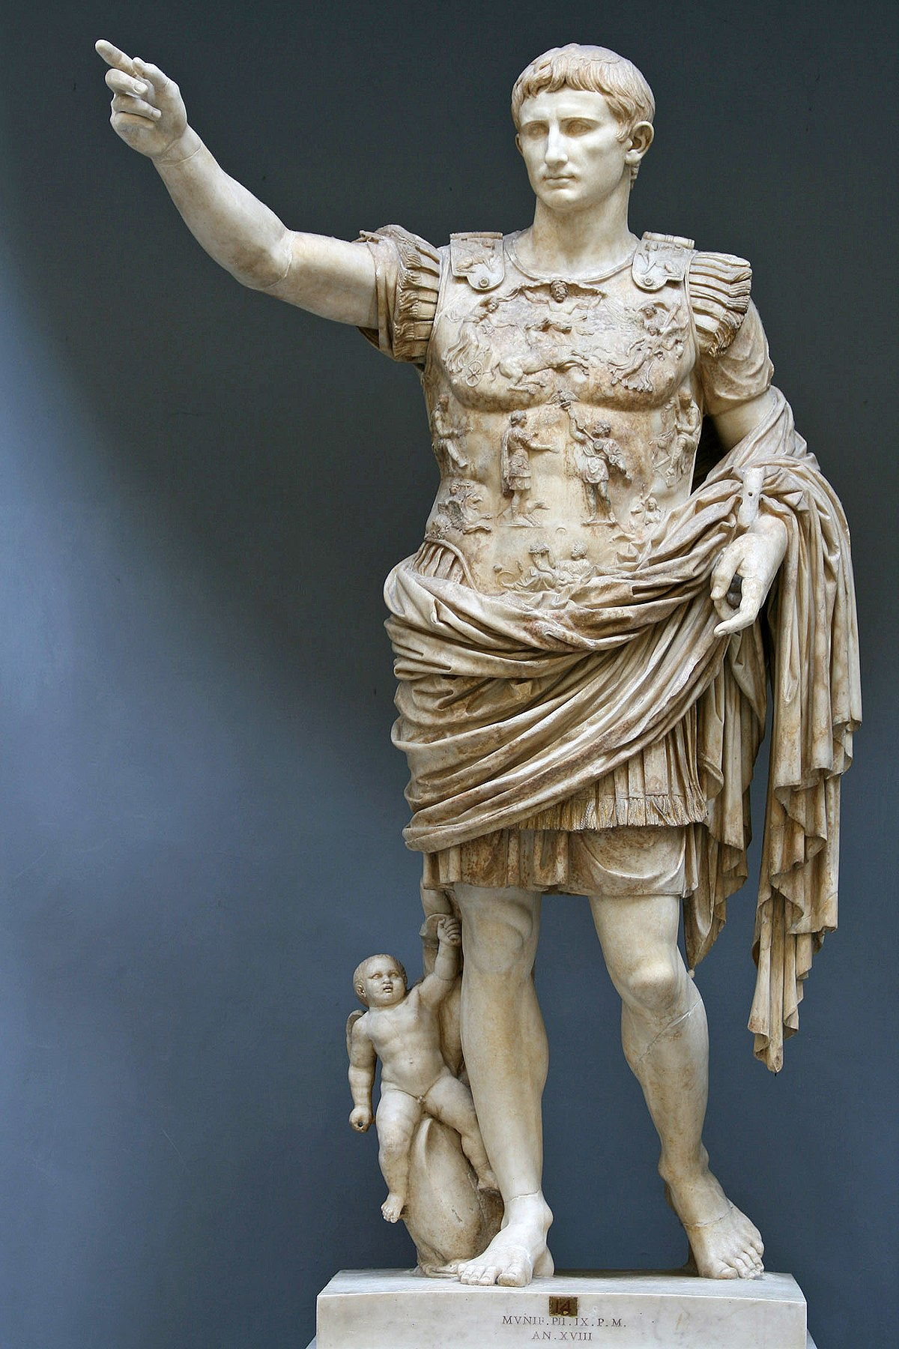

Figure 1. Augustus of Prima Porta, 1st C. CE. Vatican Museum

Bibliography
Ancient sources
Virgil, The Aenied. D. West (trans). 2003. London, Penguin Books Ltd.: The Penguin Group

Modern sources
Holliday, P, J. 2015. A Companion to Roman Art. Chichester: John Wiley & Sons Ltd.

Online sources
Fischer, J. ‘Augustus of Primaporta’ 2015. Smarthistory.org. https://smarthistory.org/augustus-of-primaporta/ [Accessed 7th Janurary]
Musei Vaticani. ‘Augustus from Prima Porta’ http://www.museivaticani.va/content/museivaticani/en/collezioni/musei/braccio-nuovo/Augusto-di-Prima-Porta.html#lnav_info [Accessed 7th January]

Holliday 2015: 205
Holliday 2015: 205
Fischer 2015.
Virg. Aeneid. 6.

