UNIVERSITY OF WALES
TRINITY SAINT DAVID

STUDENT: MARIN HANU
STUDENT NUMBER: 1915952
MODULE: LEADERSHIP AND MANAGEMENT, THEORY AND PRACTICE
ASSIGNMENT: ASSESSMENT 1
LCBB6003
PROGRAMME: BA BUSINESS MANAGEMENT
LEVEL 6/TERM 2/GROUP 2
LECTURER: ANITA NAN

Table of Contents
1.0 Introduction 2
2.0 Background of the company 2
3.0 Main body 4
3.1 Review of leadership and management theories and models 4
3.2 Application of these theories and models of Octopus Energy UK 7
3.3 Review own experience with leadership 8
Conclusion 9
Reference list 10
Appendix 14
Leadership development plan 14

1.0 Introduction
This report describes the importance of the leadership and management process for an organization and the implication it has in the work relations and progress of business environment. This also demonstrates the major roles of the leadership in better managing the work floor hazard and the employee’s problems. The study critically evaluates the implementation and the designs of the strategies’ which are focused on enhancing the effective leadership and managing for fulfilling the actual and future organizational needs. The effective leadership styles are also elaborated on in this report which is helpful for knowing the skills and the attributes for better organizational growth and infrastructure management. This study also describes the application of these theories and models on to the chosen organization Octopus Energy and reviews its own experience in leadership and the leadership development plan. Here some of the important roles of an effective leader are also demonstrated.

2.0 Background of the company
Octopus Energy UK was developed in August 2015; it is a subsidiary company of Octopus Capital Limited. The company made energy procurement and they also deal; with Shell Plc a British Multinational oil and gas. The company manages more than 198000 customers by giving energy procurements. The company has turn over in the year 2020 amount 1.5 billion. (Globaldatabase.com, 2022) The company takes a total of 1 million customers' trust by giving them apocopate good service. The company acquires flow energy and the GB energy to operate the accounts of the co-operation energy. The company had spared their business in more than 13 countries all over the world. They also have 23 million accounts licensed worldwide to green technology platforms. The mission of the company is to bring cheaper greener power to all. Octopus Energy Company is also a trading investor in the wind and the solar energy (Octopus. energy, 2022).

3.0 Main body

3.1 Review of leadership and management theories and models
Leadership and the leadership skills
Leadership is the capacity of a person or a body of people to affect and conduct supporters or different details of a company. Leadership concerns driving the business overall growth and handling periodically challenging determinations, developing and communicating a precise vision, setting achievable purposes and supplying supporters with the understanding and instruments required to reach these goals (Shufutinsky et al. 2020). Leaders are located and directed in most characteristics of the community, from industry to politics to territory to community-based institutions.
Leadership management
Leadership management is the effective theoretical framework that is important for managing the employees of the Octopus Energy Company. The response of the employees and the organization needs to manage the business successfully (Kurdi et al. 2020). The employee’s manager is important Leadership standards deliver a functional design for determining the controlling modes that fit the designation style and character. Understanding the personality and the skill of the employee is an effective skill of leadership (Hear, 2021). The skill improvement process helps to maximize the efficacy and impact. Leadership standards don’t live in an emptiness; yet, the company can pull features from better than one process, among various leadership models over time or in additional locations. Leadership standards are equivalent to administration styles, these are two different concepts. In the time the model functions as the notional structure to describe the features of making a leader great, the style of the leaders describes the practice of supervision conducts they parade in the purpose of that bigness. The octopus energy company can use three leadership models these are transformational, Transactional and the Servant. (Littlechild, 2021)
Transformational model
Integrity and imagination are essential qualities of transformational managers. The transformational leader can achieve the organization’s goals via their open strings of contact with attendants, showing the innocence and affection the leaders maintain for the entourage’s understanding and learning (Livingstone, 2022). This reciprocal consideration guides improvements in workers' satisfaction and worker retention, both directed to enhance the overall care and safety of the organization. The transformational model is important to encourage and motivate the employees to perform to create the revolutionary changes in the organization. The octopus Energy Company can use this model to boost up the confidence of employees to improve the production and handling of the employees. (Alilyyani,2018)
Transactional model
The transactional leadership model is the Street forward model that works on the concept of the employee’s own interest. This model motivates the employees’ interest so, that they should perform to maintain the goals of the company. The company is using this model; for rapid development and for increasing its business for a long time (Little child, 2021). The model is effective for improved the technological backgrounds of the leaders that they could effectively handle. This theory influences the organizational technological issuers and the train their employees correctly for better future aspect.
Ethical leadership
Ethical supervision is necessary for a combination of explanations, for employees, customers, and the company. Management masteries are essential to support and create a flattering moral culture in a business. Administrators can enable investors discern that the company is a fine, responsible one (De Nobile, 2018). In the short-term, honorable directors can support growth employee enthusiasm and enable them to behave enthusiastic regarding their administration and their work. 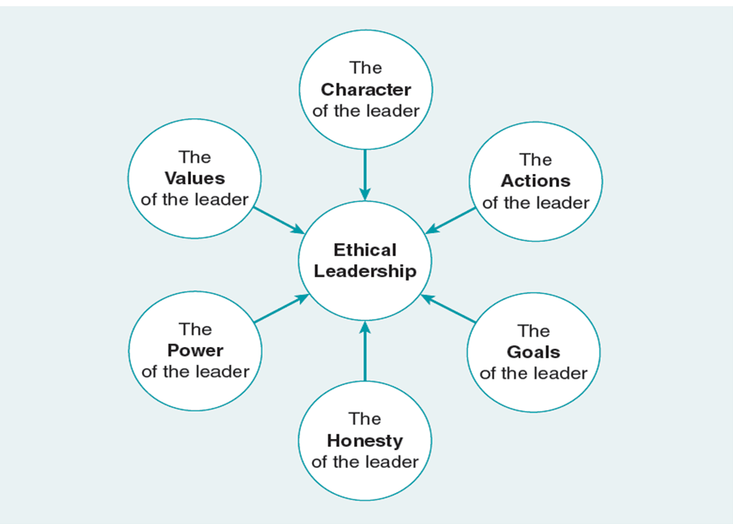
Figure 1: Ethical leadership importance
(Source: PowerPoint slides)
Theories for better leadership management
Contingency Theory
The contingency theory proposes that is the single process or method of leading an institution. Exterior and interior elements recreate a key function in determining the most suitable method to guide an institution to victory (Zama et al. 2018). According to the Austrian psychologist Fred Edward Fiedler and the contingency theory there is no alternative best option rather than collaboration in managing the organization activity. The practical application of theory is to determine the best candidate for a given set of requirements. The contingency approach remarks that the exemplary captain should check the correct position. (Azmi,2018)
Situational Leadership Theory
This approach emphasizes the value of problems and assumes that a manager needs to adjust to the changing conditions to achieve objectives and drive conclusions (Greenhalgh and Abimbola, 2019). The author of the Situational Leadership Theory is Dr. Paul Hersey, the practical application of the SLT supplies the management with the flexibility to set the crisis and adopt a supervision style that agreeably serves the needs of the devotee, managers should acclimate their supervision styles established on the enthusiasm, present skills and developmental group of group members. (Gumus,2018) These managers can adjust their administration styles established on the competency and responsibility group of the workers in their group.
Behavioral Theory
This approach demonstrates that an individual's background is accountable for their administration rates. Practical administration effects from further intellectual skills. Defiant to the "great man theory”. The author of Behavioral theory is John B. Watson; the workplace application of the Behavioral theory is according to the quality and capability of the employees; this theory is able to apply appropriate technique and tool regarding motivation. The behavioral theory believes that managers are created and taught, not reached. The natural features do not keep the leader's success because it is the behavior that drives leadership qualities (Age et al. 2021). Via proper apprenticeship and education, any person can be a leader. The approach supports that manager need to be self-aware of their conduct to boost their team's productivity and confidence.

3.2 Application of these theories and models of Octopus Energy UK
The application of the models is useful for effectively managing the organizational development of the company. The Contingency Theory is important for managing the interior and the exterior contracts of the organization. These are important for managing the organization's internal and external development. The behavioral theory is important for managing the leaders' and the employees' behaviors that are important for managing the organizational conflicts and are the better relationship between the leaders and the employees of the organization (Gums et al. 2018). The Octopus capital Limited company can maintain their goals and productivity by developing the transactional model. This model is effective for developing the leadership model that is important for mediating the overall growth of the company.
Application of contingent theory in management of the octopus energy company is able to find out the appropriate employees that are able to handle a particular situation. This theory is applicable to recognize the proper person for managing a particular hazard in management (Horiatis and Tjahjadi, 2018). Situation Management theory applied improves the organization employees to adopt the different situations in the business environment and is able to meet the organization hazard of Octopus Energy UK. (Haar,2021)

3.3 Review own experience with leadership
Gibbs reflection model is used to describes own experience.
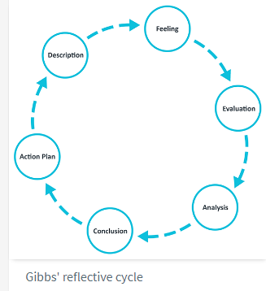
Figure 2: Gibbs reflection model
(Source: https://www.ed.ac.uk/reflection/reflectors-toolkit/reflecting-on-experience/gibbs-reflective-cycle)
Feeling
Observing the general manager of the Octopus Energy Company, I felt that the experiences help me learn various things about managing the workers in the company in a different department. A good level promotes higher-level positions. The leaders are important for managing the organization's project. My leadership experiences help to boost my knowledge to inspire the workers of the company that they should be more productive for maintaining the sustainability of the organization. I was managing leadership in an organization from 2005 to 2013, in these periods of time I had learned various things for being an effective leader.
Evaluation
This experience enhances by the ability to guide a team on a project from start to finish this helps to manage the initiative to boost up the potential for making organizational development. The leadership experiences give me chances to pursue my goals and maintain the initiative to lead the occasion (Oc, 2018). The organization needs to develop a good trading module that is effective in building up the good organizational strategies that help to develop the productivity of the company. As a leader of the organization, I have gained an opportunity to learn various kinds of software management processes that should be helpfully for handling risk. These also give me and opportunities for enhancing the goals the plans of the organization. (Hariyati,2018) I am thinking to complete the first individual expansion goal by meeting the leadership growth agenda.
Conclusions
As the conclusion schedule the knowledge will donate to my administration understanding and will allow me to develop more precise recommendations for the organization’s workers and, hence, add to their productivity and implementation in the workplace As experiences help to know that leaders are needs to be more flexible and the understand the worker's stability. This gives me opportunities to develop the related risk of the organization and the managing the workflow of the company. I have explored some organization hazards.

Description
During a time of my leadership, I faced communication problems is a major issue in managing the good relationship between employees and the leaders. A manager needs to be effective for communicates the procedures and designs to the associates to create the position. A manager encourages the workers by providing them with economic and non-financial motivations and brings the position done efficiently. Including a straightforward concept, the power to convey the image to group members, the power to manage actually and efficiently, inspiring associates towards the satisfaction of the community's destinations, and counteracting the conflict for the good of all assistants and stakeholders. (Purwanto,2021).
Action plan
As a team leader I need to understand the working potential of the workers and the needs to motivate them constancy to manage. The workers also need to follow their leader’s words to manage the working environment of the work floor. As leader I needs to try to solve the problems of the workers after listing them carefully.

Conclusion
It has been concluded that this report is useful and concluded that the leaders are important for managing the organization's project. The most important roles of the leaders are motivating the employees to better manage the organizational goals and maintaining the right direction that is essentially fermenting the successes of the Octopus Energy Company. As per the analysis, it has been found that the Octopus Energy Company needs to develop their leadership strategies for developing the organizational management procedure’s. The self-reflection and awareness' are important for increasing personal purpose and the balance of the work-life for managing workplace initiatives. In this model, the leaders are constantly monitoring the work recedes of the employees to notice their faults and instantly correct them for clear and neat work.

Reference list
1. Agi, M.A., Faramarzi-Oghani, S. and Hazır, Ö., (2021). ‘Game theory-based models in green supply chain management: a review of the literature’. International Journal of Production Research, 59(15), pp.4736-4755. Available at: https://www.tandfonline.com/doi/pdf/10.1080/00207543.2020.1770893 (Accessed 25th July 2022)
2.Alilyyani, B., Wong, C.A. and Cummings, G., (2018). ‘Antecedents, mediators, and outcomes of authentic leadership in healthcare: A systematic review’, International journal of nursing studies, 83, pp.34-64. Available at: https://www.vumc.org/faculty/sites/default/files/Antededents%2C%20mediators%2C%20and%20outcomes%20of%20leadership%20in%20healthcare.pdf (Accessed 25th July 2022)
3. Azmi, R., Tibben, W. and Win, K.T., (2018)’ Review of cybersecurity frameworks: context and shared concepts’, Journal of cyber policy, 3(2), pp.258-283.Available at: https://www.tandfonline.com/doi/abs/10.1080/23738871.2018.1520271 (Accessed 22th July 2022)
4. Company-information.service.gov.uk, (2022). OCTOPUS INVESTMENTS LIMITED. Available at: https://find-and-update.company-information.service.gov.uk/company/03942880 (Accessed:25th June 2022)
5. De Nobile, J., (2018) ’Towards a theoretical model of middle leadership in schools’ School Leadership & Management, 38(4), pp.395-416. Available at: https://www.edcomm.org.au/assets/ALN/Journeys-to-Leadership/DeNobile-J-2018-Towards-a-theoretical-model-of-middle-leadership-in-schools.pdf (Accessed 25th July 2022)
6. globaldatabase.com, (2022) Financial statements of OCTOPUS CAPITAL LIMITED. Available at: https://uk.globaldatabase.com/company/octopus-capital-limited (Accessed 25th July 2022)
7. Greenhalgh, T. and Abimbola, S., (2019) ‘The NASSS framework-a synthesis of multiple theories of technology implementation’ Stud Health Technol Inform, 263, pp.193-204. Available at: https://ebooks.iospress.nl/pdf/doi/10.3233/SHTI190123 (Accessed 25th July 2022)
8.Gumus, S., Bellibas, M.S., Esen, M. and Gumus, E., (2018) ‘A systematic review of studies on leadership models in educational research from 1980 to 2014’ Educational Management Administration & Leadership, 46(1), pp.25-48.Available at: https://www.llse.org.uk/uploads/datahub/4567ceb%5E03in-03/2018-08-23-Research%20%20EMAL%20%20Review%20of%20studies%20on%20leadership%20models%20in%20educational%20research%201980%20-%202014.pdf (Accessed 25th July 2022)
9. Haar, L., (2021) ‘The competitive disadvantages facing British assets electricity retailers’ Energy Policy, 155, p.112323. Available at: https://www.sciencedirect.com/science/article/abs/pii/S0301421521001920?via%3Dihub [Accessed 25th July 2022)
10. Hariyati, H. and Tjahjadi, B., (2018) ‘Contingent factors affecting the financial performance of manufacturing companies: The case of East Java, Indonesia’, Asian Journal of Business and Accounting, 11(1), pp.121-150. Available at: http://borneojournal.um.edu.my/index.php/AJBA/article/download/12151/7928 (Accessed 22nd July 2022)
11. Kurdi, B., Alshurideh, M. and Alnaser, A., (2020). ‘The impact of employee satisfaction on customer satisfaction: Theoretical and empirical underpinning’ Management Science Letters, 10(15), pp.3561-3570. Available at: http://m.growingscience.com/msl/Vol10/msl_2020_216.pdf (Accessed 25th July 2022)
12. Littlechild, S., (2021) ‘The evolution of competitive retail electricity markets’ In Jean-Michel G et al.(ed.) Handbook on Electricity Markets (pp. 111-155). Edward Elgar Publishing. Available at: https://www.elgaronline.com/view/edcoll/9781788979948/9781788979948.00011.xml (Accessed 26th July 2022)
13. Livingstone, G., (2022) ‘Oil and the Falklands/Malvinas: oil companies, governments and Islanders’ The Round Table, 111(1), pp.91-103. Available at: https://www.tandfonline.com/doi/full/10.1080/00358533.2022.2037235 (Accessed 27th July 2022)
14. Oc, B., (2018) ‘Contextual leadership: A systematic review of how contextual factors shape leadership and its outcomes’ The Leadership Quarterly, 29(1), pp.218-235.Available at https://www.sciencedirect.com/science/article/pii/S1048984317300413 (Accessed on: 28th July 2022)
15. Octopus.energy, (2022). Octopus.energyMeet the team. Available at: https://octopus.energy/press/meet-the-team/ (Accessed 1 of August 2022)
16. Paais, M. and Pattiruhu, J.R., (2020) ‘Effect of motivation, leadership, and organizational culture on satisfaction and employee performance’, The Journal of Asian Finance, Economics and Business, 7(8), pp.577-588. Available at: https://www.koreascience.or.kr/article/JAKO202026061031735.pdf (Accessed 22nd July 2022)
17.Purwanto, A. and Sudargini, Y., (2021) ‘Partial least squares structural squation modeling (PLS-SEM) analysis for social and management research: a literature review’, Journal of Industrial Engineering & Management Research, 2(4), pp.114-123. Available at: https://jiemar.org/index.php/jiemar/article/download/168/130 (Accessed 25th July 2022)
18. Shufutinsky, A., DePorres, D., Long, B. and Sibel, J.R., (2020) ‘Shock Leadership Development for the Modern Era of Pandemic Management and Preparedness’ International Journal of Organizational Innovation, 13(1). Available at: https://www.ijoi-online.org/attachments/article/267/20%20Final.pdf (Accessed 25th July 2022)

Appendix

Leadership development plan
Objectives | Action | Success measure | Target dates
To future develop leadership and managerial skills | Completing the leadership developing program  Delegating the take to subordinates during the meetings | Complete the assessment survey and provide a superior of the assessment report | 31st January 2023
To contributes the abilities to set up the vision to achieve the objectives | Complete the leadership developing programs | Completing the survey assessment that helps to provide support for the assessment reports. | 28th February 2023
 | Communicate about the strategies of the company with the subordinates. Improve the trains modules for developing reskills of the employees. | This helps to covey a survey among the team members.  contingency approach remarks that the exemplary captain should check the correct position. | 31st March 2023
To boost the productivity of the company | manager need to be self-aware of their conduct to boost their team's productivity and confidence | The company needs to develop organizational skills and productivity to measure the goals. | 30st April 2023
proper apprenticeship and education | This helps to maintain a good relationship between the workers and the managers of the employees. | The appreciation is important for managing the education system to improve the knowledge and skills of the employees. The organization needs to maintain. | 31st May 2023
To widen my understanding of employees | Observe the learning more from the leaders fore managing the meeting to resolve previous problems of the organization. This helps to measure the successes of the organization. | Understanding of emotion employees is important for managing the organization's development. The leader area is liable to take responsibility for the workers. | 30st June 2023
Build a personal connection for the network and the channels. | Join in the meeting to solve the problems of the organization and update the profile for managing the specific industrial connection. | Octopus energy company creates standing for funding in the development and growth of workers often evolves into industry executives and employers of preference. They are capable to entice various groups created up of the best prospects for steady advancement. | 31st July 2023

