

NAVIGATING THE AI GOVERNANCE FRONTIER

A Strategic Advisory Report on IBM's Risk Management, Regulatory Compliance and Competitive Positioning in the United Kingdom and the United States

Sharmin Jahan Bithy

ID: 2439522

Module: BMMB7006 Global Business Challenges
Programme: MBA
27 April 2026

Word Count: 5091

Executive Summary
The report is prepared on behalf of RFD Global as part of the internship application. It provides a strategic advisory report on International Business Machines Corporation (IBM) as the rapid development of artificial intelligence unfolds in the backdrop, and what it may bring for risk management, data governance, regulatory compliance, and customer trust. The case study is based on the operations of IBM in the United Kingdom and the United States - two jurisdictions with radically different regulatory philosophies towards AI, and offers a two-way compliance framework.
The report identifies regulatory differences between the UK and the US as the most significant near-term external threat to IBM, and technological displacement by generative AI competitors and growing scrutiny of algorithmic responsibility in society as the second and third-ranked threats, respectively, through the use of PESTLE analysis, Porter's Five Forces, and a systematic risk register.
The report suggests an implementation plan comprising three horizons over 36 months and an approximate total investment of USD 9.3 million. The short-term objectives are a company-wide AI governance audit, a specialised regulatory intelligence office with an augmented outside law firm, and a mandatory AI literacy platform. In the medium term, IBM must institutionalise an independent AI Ethics Board, conduct periodic independent third-party reviews of AI, and implement automated bias detection across the WatsonX deployment pipeline. A client-facing Responsible AI Certification programme and investments in quantum-safe infrastructure can help IBM convert its governance leadership into a sustainable competitive advantage over the long term.
The recommendations below are intended to be proactive, as per the regulations, rather than reactive to current needs. IBM's institutional positions are credible, which allow it to establish the rules of good governance in the industry, and this report believes that strong AI governance is not a cost burden but a strategic differentiator.

Table of Contents
Executive Summary 2
1. Introduction 4
2. Main Findings 5
2.1 Political and Regulatory Landscape: Diverging Transatlantic AI Governance 5
2.2 Macroeconomic Pressures and the Global AI Technology Market 5
2.3 Societal Expectations, Workforce Disruption and Public Trust 6
2.4 Technological Transformation: Generative AI, Watson and Hybrid Cloud 7
2.5 Legal Accountability: Data Protection, Liability and Cross-Border Compliance 9
2.6 Environmental Responsibility and the Carbon Cost of AI 10
2.7 AI Risk Management: Governance Gaps, Ethical Exposure and Reputational Risk 11
3. Implementation Plan 13
3.1 Short-Term Actions (0–6 Months): Governance Audit and Foundation Building 13
3.2 Medium-Term Strategy (6–18 Months): Ethics Formalisation and Independent Verification 14
3.3 Long-Term Vision (18–36 Months): Competitive Advantage and Future-Proofing 15
4. Conclusion 19
5. Bibliography 20

Introduction
AI is no longer an up-and-coming technology but a strategic necessity of multinational companies. McKinsey and Company (2023) projects that generative AI alone has the potential to drive between USD 2.6 trillion and USD 4.4 trillion in economic value to industries annually - a number not merely indicative of how big the opportunity is, but the extent of organisational change needed to realise it. In the context of IBM, where the commercial path is now pegged on enterprise AI, this gives rise to a mammoth source of competitive potential and a matchingly daunting set of governance issues.
The report is written in the context of RFD Global, which is being applied to as an internship. It will guide IBM's top management on the strategic impact of AI development, specifically in risk management, data governance, ethical AI use, regulatory compliance, and the preservation of customer trust. The analysis focuses on IBM's activities in the United Kingdom. The United States analysed in the context of conceptual frameworks the central concepts of this module, i.e. PESTLE analysis, Porter's Five Forces, and structured risk management, as the means of contextualising AI strategy in the context of the larger business environments (World Economic Forum, 2024; Haenlein and Kaplan, 2019).
IBM is one of the oldest and most important technological enterprises in the world, with an annual revenue of about USD 61.9 billion in 2023 and more than 288,000 employees worldwide (IBM, 2023). Its AI shift, based on the WatsonX platform and multifaceted cloud system, is a conscious rebranding at the edge of business intelligence. Wirtz, Weyerer, and Geyer (2019) note that governance is exceptionally strong in complex institutional settings for AI applications, as it may affect the organisations and people it serves, which also directly applies to the case of IBM, with its client base in the public sector and financial services.
The report continues as follows. Section 2 introduces the key findings of the environmental and competitive analysis and risk management implications. Section 3 establishes an implementation plan that has a detailed, costed plan. Section 4 summarises the main findings and limitations.

Main Findings

Political and Regulatory Landscape: Diverging Transatlantic AI Governance
The political environment surrounding AI has become one of the most influential external factors shaping IBM's strategic decisions. The United Kingdom government is pro-innovation, principles-focused, and does not advocate a single, binding law to regulate the use of AI applications; rather, it urges industry regulatory agencies to exercise their existing powers to regulate AI applications (UK Government, 2023). This framework is both flexible and ambiguous in its interpretation for businesses whose products are based on AI and span several regulated sectors.
America has followed an alternative route. In October 2023, the Executive Order on the Safe, Secure and Trustworthy Development and Use of Artificial Intelligence was signed, establishing a federal standard on AI safety and security, and developers of the most effective AI models are compelled to share the findings of safety tests with government agencies (White House, 2023). NIST has also published its AI Risk Management Framework 1.0 as a voluntary guideline that has gained tremendous popularity (NIST, 2023). It looks much more like a patchwork at the state level, which translates into a compliance patchwork that Loucks et al. (2019) report as a tangible barrier to a consistent approach to introducing AI into the enterprise system among multinationals that conduct business in the US.
This is strategically important to IBM. Kim and Park (2025) note that trust is becoming an infrastructural component of AI governance, and businesses with plausible systems across various jurisdictions are more likely to win public-sector procurements and retain enterprise clients. Non-alignment risk can be interpreted as a realistic and material threat to governance: Rasouli and Binaian (2024) propose that in case AI becomes a geopolitical issue, regulatory non-compliance in a particular jurisdiction can impact the perceived reliability of a company in others, but the extent of the impact will depend on the nature of the failure and the publicity of the deployment in question.
It also considers regulatory spillover in the medium term. Though it does not directly apply to the EU AI Act, it is almost certain that IBM's enterprise clients in regulated industries do fall under it. As shown by Veale and Zuiderveen Borgesius (2021), the EU's risk-based classification system will tend to introduce new procurement standards worldwide; i.e., products created by IBM must comply with these standards even in markets where they are not yet legally obligatory.

Macroeconomic Pressures and the Global AI Technology Market
IBM is operating in an economic environment where opportunities are high and structural competitive pressure is high. The worldwide AI market is growing rapidly. According to Bughin et al. (2018), AI may contribute up to USD 13 trillion to global economic performance by 2030, whereas PwC (2025) indicates that productivity gains will be most significant in technology-intensive markets. The IBM WatsonX platform is poised to share in this growth, especially in the financial services, healthcare, and public sector verticals, where explainability and governance are highly valued.
An essential analytical warning is given by Acemoglu and Restrepo (2018): the economic benefits of AI-driven automation are not equally distributed. They may not be realised quickly at the firm level. This is supported by Manyika et al. (2017), who show that organisations that reap the greatest productivity gains from automation are those with strong pre-existing process interlinkages and complementary workforce capabilities, i.e. the areas where IBM has a structural advantage in its enterprise relationships. According to Furman and Seamans (2019), AI implementation in enterprise markets is more likely to favour incumbents with these attributes, though only when IBM can demonstrate that its governance-quality products are more effective than lower-cost alternatives on aspects that regulated purchasers consider important.
This is because the OECD (2021) indicates that decisions on enterprise AI procurement are increasingly influenced by total cost of ownership and regulatory compliance burden, a trend that IBM's sales and pricing strategy must respond to directly, especially as regulatory requirements in the UK and the US become ever stricter.

Societal Expectations, Workforce Disruption and Public Trust
AI systems have risen in the public's trust. According to the Edelman Trust Barometer (2024), a further decrease in trust in technology companies by the population in both the United States and the United Kingdom is recorded, and enterprise buyers are becoming more concerned about the way organisations manage AI systems that influence the hiring, lending, healthcare and other public services. In the case of IBM, where AI is implemented in all these fields, the lack of trust has direct commercial implications.
In a strict analysis of the kinds of social harms that may be generated by poorly regulated AI, Acemoglu (2021) claims that the automated decision-making systems that are implemented without care will tend to concentrate economic benefits in the hands of capital owners and add adjustment costs on the employees. This is the case with IBM where its AI solutions are sold on the basis of attaining operational efficiency improvements at the cost of lowered staffing rates within client organisations. These social licence dilemmas linked to this dynamic can be navigated by proactively involving the respective communities and regulators instead of being passive in following the new demands.
Algorithms bias is proven to be one of the social risks. Obermeyer et al. (2019) showed that popular algorithmic systems can encode and reinforce preexisting inequalities and does not always seek to discriminate them. The researchers do not recommend technical solutions to the Ethics of algorithms but suggest to reconstrue the regulation in terms of continuous processes and transparency (Mittelstadt et al., 2016). The UNESCO Recommendation on the Ethics of Artificial Intelligence (2022) provides international standards about inclusivity, accountability, and redress that ought to be achieved in the governance frameworks of IBM.

Technological Transformation: Generative AI, Watson and Hybrid Cloud
Generative models and generative AI has turned technology upside down. They constitute a qualitative advancement in the ability of AI, according to Bommasani et al. (2021), in which a single large model can be fine-tuned to many downstream tasks with a relatively low marginal cost. This literally calls into question the competitive standing of IBM: WatsonX will have to compete with OpenAI, the open-source LLaMA models offered by Google and Meta which can all be used to execute most of the underlying enterprise work.
IBM has endeavored a strategic position by ensuring WatsonX stands out in terms of governance, explainability, and enterprise-grade reliability. It is quite a justifiable stand: Rai (2020) shows that explainability is especially appreciated in the regulated industries because the responsibility of the decisions made is not only a legal obligation but also a legal one. Admittedly, as it is stated by LeCun, Bengio and Hinton (2015), it is extremely difficult to make complex neural networks interpretable and still maintain their performance and the IBM research programme has to work on it by investing more in explainable AI tools. The hybrid cloud infrastructure used by IBM to assist enterprise clients in implementing AI to their respective systems can solve the security-related issues, especially with the growing importance of data sovereignty in the UK GDPR framework.
Makridakis (2017) preempts the turmoil that IBM is already seeing and argues that those companies that are unable to develop the infrastructure of governance and technological capability will lose competitiveness and reputation as well. The latter can be justified by the study by Duan et al. (2019), who clarify that AI decision-making systems in enterprise systems must be constantly monitored as opposed to deployed, which is exactly what IBM will achieve in its implementation.
Table 1: Porter's Five Forces IBM Competitive Environment source: Author's own construction.
Force | Assessment for IBM | Intensity | Strategic Implication
Competitive Rivalry | Intense competition from Microsoft Azure AI, Google Cloud and Amazon AWS; watsonx faces substitution from generative AI platforms with substantially greater research investment | Very High | Differentiate through governance-grade AI and sector-specific explainability, not raw capability.
Threat of New Entrants | High capital and trust barriers limit new entrants; well-funded AI startups are nonetheless penetrating adjacent enterprise segments at a pace. | Medium | Leverage 112-year institutional credibility and depth of existing enterprise system integrations
Bargaining Power of Buyers | Large enterprise clients are increasingly multi-cloud and vendor-agnostic; procurement sophistication and regulatory awareness are both rising. | High | Build switching costs through deep governance integration and client-facing certification programmes.
Bargaining Power of Suppliers | Semiconductor supply concentration (TSMC, NVIDIA) creates vulnerability; AI engineering talent scarcity continues to inflate labour costs across the sector. | Medium-High | Invest in proprietary chip research capacity; expand graduate AI pipeline partnerships.
Threat of Substitutes | Open-source LLMs, including LLaMA and Mistral, provide low-cost alternatives, reducing IBM's premium pricing power in non-regulated enterprise segments. | High | Position Watson explicitly on regulatory compliance and auditability rather than generative capability

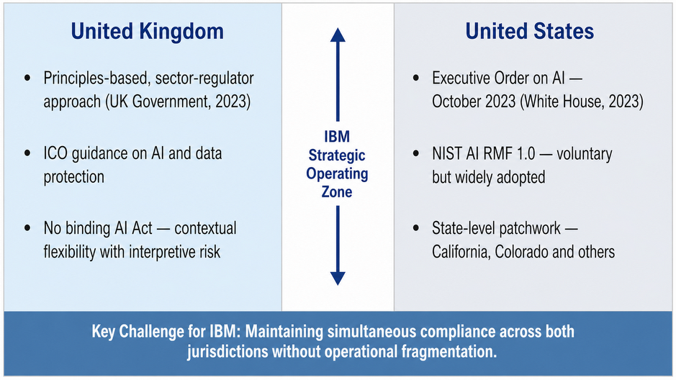
Diagram 1: Transatlantic AI Regulatory Divergence - IBM Strategic Operating Zone. Source: Author.

Legal Accountability: Data Protection, Liability and Cross-Border Compliance
The legal context for AI activities at IBM is intricate and constantly evolving. In the United Kingdom, the ICO (2024) has provided comprehensive advice based on the UK GDPR principles of transparency, limited purposes and individual rights to AI systems, including automated decision-making. Wachter, Mittelstadt, and Floridi (2017) also point out a critical caveat: any right to explanation under Article 22 is legally contestable, creating permanent uncertainty for companies that use AI to make significant decisions about people.
The legal landscape of AI is not unified at the federal level in the United States. Scherer (2016) offers a teach-back analysis of the structural reasons why it is challenging to regulate AI systems, arguing that current legal frameworks were not designed to address the opacity, velocity, and magnitude of algorithmic decision-making. The authors state that the more rigorous regulatory standard, which in practice would be equivalent to the EU AI Act, should be actively embraced as the internal compliance standard, as it is a more effective long-term compliance strategy than jurisdiction-specific systems (Goodman and Flaxman, 2017). The given strategy addresses the seeming conflict between the UK-US dual compliance and EU-compliant standards: by focusing on the most demanding requirement as the internal design standard, IBM can meet the requirements of all three jurisdictions simultaneously, rather than dealing with disjointed parallel systems.
The source of a deeper legal tension, according to Zarsky (2016), is the obscurity that renders complex AI systems powerful while simultaneously making them inaccessible to audit and challenge mechanisms on which legal accountability systems are based. Binns (2018) suggests relying on traditions of fairness theory of political philosophy to create more principled legal standards - a practice that has already started to come into regulatory thought on both sides of the Atlantic, and which IBM internal governance structures should expect.

Environmental Responsibility and the Carbon Cost of AI
Regulators, investors, and civil society have been paying increasing attention to the environmental aspects of AI development. Strubell, Ganesh, and McCallum (2019) calculated that a single large natural language processing model can emit as much carbon as five cars over its lifetime, a figure that has risen with the scale of models. Patterson et al. (2021) provide a more detailed evaluation, indicating that AI can be significantly cheaper in terms of carbon costs with an efficient model architecture and renewable energy sourcing in data centres; however, only when organisations make conscious strategic investments in energy efficiency and do not treat it as a by-product.
According to Schwartz et al. (2020), computational efficiency must be considered an explicit design goal alongside capability improvement, which they have dubbed green AI. The published net-zero target of the company (IBM Corporation, 2023) puts IBM in a fairly good position on this dimension, although to remain credible it will need to report on the net energy consumption of the watsonx platform and the data centre infrastructure transparently and in granular detail and compare it to the Paris Agreement (UNFCCC, 2015) and have it evaluated by institutional investors as part of standard ESG
Table 2: IBM PESTLE Analysis Summary. Source: Author.
Factor | Key Issues for IBM (2024–2026) | Risk Level | Primary Source
Political | Diverging UK/US regulatory philosophies; EU AI Act spillover risk via enterprise client obligations; geopolitical AI competition | High | UK Government, 2023; White House, 2023; Kim & Park, 2025
Economic | Global AI market growth offset by hyperscale competitive pressure; enterprise procurement shaped by regulatory compliance burden | Medium-High | Bughin et al., 2018; Manyika et al., 2017
Social | Declining public trust in AI; algorithmic bias backlash; workforce displacement concerns among IBM client organisations | Medium | Acemoglu, 2021; Edelman, 2024
Technological | Generative AI disruption; watsonx competition from OpenAI and Google; open-source substitution risk from LLaMA and Mistral | High | Bommasani, 2021; Makridakis, 2017
Legal | UK GDPR obligations; US state AI patchwork; explainability requirements in automated decisions affecting individuals | High | ICO, 2024; Wachter et al., 2017; Scherer, 2016
Environmental | Energy demands of large-scale AI training; IBM's net-zero 2030 commitment; growing ESG scrutiny from institutional investors | Medium | Strubell et al., 2019; Patterson et al., 2021

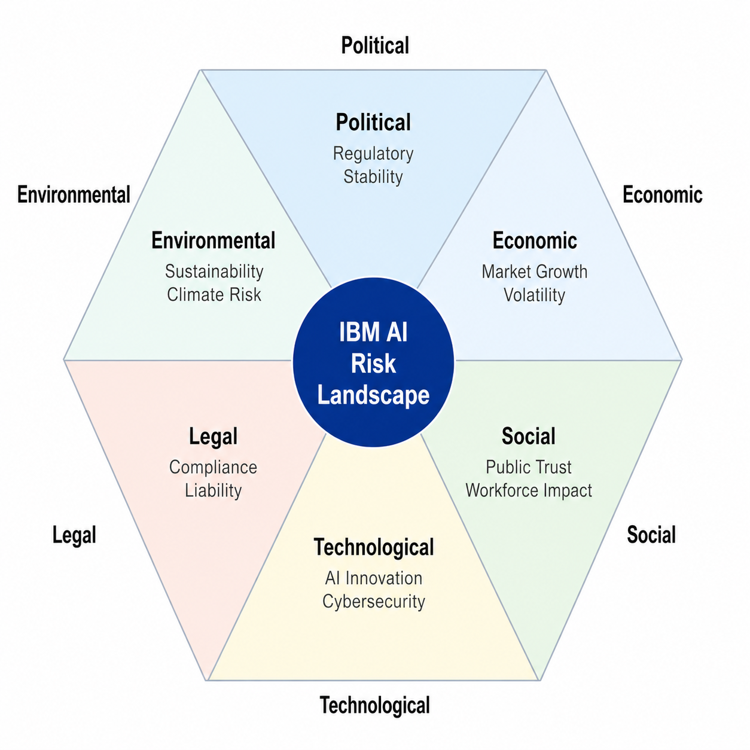
Diagram 2: IBM AI Governance Hexagon - PESTLE Environmental Scan. Source: Author

AI Risk Management: Governance Gaps, Ethical Exposure and Reputational Risk
Throughout the dimensions mentioned above, there is one common denominator that is, the major strategic threats facing IBM are not technical but of the governance nature. Amodei et al. (2016) include such problems in AI safety as reward hacking, distributional shift and unsafe exploration, which, although models are effective in evaluation settings, are still not well solved when used in deployed systems. In the case of IBM, such technical risks should be converted to organisational governance risks by means of formal rather than informal management.
Brundage et al. (2018) provide the malicious use of AI as a particular category of risk, which states that the same features that become commercially valuable can be used to abuse AI systems by opponents. This is of particular relevance to the cybersecurity of IBM and its applications in the government. An elaborate code of ethics put forward by Floridi et al. (2018) based on the notions of beneficence and non-maleficence, autonomy, and justice can provide IBM with a normative basis of its internal governance practices. Lepri et al. (2017) assume that algorithmic fairness, transparency and accountability are practical requirements that must be enforced through particular mechanisms, as opposed to aspirational ideals. This logic is to be operationalised in the IBM implementation plan in Section 3.
Table 3: IBM AI Risk Register Key Exposures and Mitigations
Table 3: IBM AI Risk Register. Source: Author's own construction.
Risk Category | Description | Likelihood | Impact | Mitigation
Regulatory Non-Compliance | Failure to meet diverging US/UK AI obligations leading to fines and operational restrictions | High | Severe | Regulatory Intelligence Team; Chief AI Compliance Officer; external counsel retainer
Algorithmic Bias | Biased model outputs in hiring or healthcare AI are causing legal liability and reputational damage. | Medium | High | Mandatory pre-deployment bias audits; diverse training datasets; annual fairness reporting
Data Breach | Unauthorised access to client AI training data triggering GDPR penalties and class litigation | Medium | Severe | Zero-trust architecture; encryption-at-rest; independent third-party security audit annually
Reputational Exposure | High-profile AI failure in a public-sector contract erodes trust in IBM's governance-grade positioning. | Low-Med | High | Contractual AI performance guarantees; independent third-party model auditing (annually)
Talent Attrition | Loss of senior AI researchers to competitors undermines WatsonX's development roadmap. | High | Medium | Competitive equity packages; PhD pipeline partnerships; AI centre-of-excellence investment

Implementation Plan
The three-horizon implementation plan below converts the analytic results from Section 2 into actionable, costed recommendations. The plan is staged to create the foundational governance structures initially, develop systematic processes next, and exploit the structures to gain competitive advantage over time - in line with governance maturity models of AI adoption at scale (McKinsey and Company, 2023).

Short-Term Actions (0–6 Months): Governance Audit and Foundation Building
The first task IBM will need to undertake is to get a clear picture of its current AI governance across all product lines and client deployments. The first sixty days should also see the commissioning of an enterprise-wide AI Governance Audit, undertaken by the Chief AI Officer and Legal Counsel. Each deployed AI system should, in turn, be evaluated against the two-fold compliance requirements of the UK GDPR (ICO, 2024) and the NIST AI Risk Management Framework (NIST, 2023) to create a prioritised risk register of the type described in Table 3. The USD 180,000 to USD 250,000 range is a small price to pay, considering the potential litigation costs it aims to detect and reduce.
In parallel, IBM ought to employ a specialised AI Regulatory Intelligence Team of four full-time equivalents with legal, policy, and technology experience, as well as an external legal counsel retainer of about USD 200,000 per year. One must admit that there is a certain contradiction between the need to define regulatory divergence as the biggest external threat to IBM and the rather small budget allocated to the intelligence function; this is not accidental. The team's main role is to provide advanced intelligence and escalation, but not to deliver full compliance; the latter is provided under the wider legal and engineering programmes of the plan. According to Setianingrum (2025), the development of AI and antitrust regulation is taking different national paths, underscoring the need for a specialised monitoring system that can detect changes in real time rather than react.
The third respect in which AI Literacy Training needs to be introduced in the short term is a mandatory course about the regulatory provisions, ethical decision-making frameworks, and client-facing personnel escalation procedures at IBM. This programme should extend much more than technical awareness. This programme should extend beyond technical awareness, based on the findings of Jobin, Ienca and Vayena (2019) who are finding that there is always a disconnect between AI ethics principles and how they are manifested in practice in organisations. This would be a USD 400,000 investment with a one-time cost that directly tackles the human-error exposure in the risk register and aligns with the result of the Edelman Trust Barometer (2024) that found employee behaviour to be the biggest contributor to trust in organisations with AI implementation.

Medium-Term Strategy (6–18 Months): Ethics Formalisation and Independent Verification
Once the baseline audit and monitoring frameworks are in place, medium-term should be to institutionalise the rules of the governance of AI ethics at IBM in frameworks that should be credible with outside stakeholders. The most important recommendation in this step is the establishment of an autonomous AI Ethics Board which would involve external academic participants, civil society members and lawyers. According to Floridi et al. (2018), governance frameworks are most effective when they reflect principles of transparency and accountability in their operations, not only in the systems they govern. Costing USD 150,000 annually, the structure can serve as a significant credibility indicator to regulators, enterprise purchasers, and institutional investors.
One crucial change to this step - and one that explicitly tackles the lack of an external verification mechanism in previous versions - is commissioning an independent third-party AI audit, which will be performed once a year, and will be compared to NIST AI RMF 1.0 and UK ICO guidance. According to Cath (2018), voluntary transparency mechanisms have much greater credibility when parties with no business connection to the company under evaluation check them. This audit, whose findings are reported in an Annual Transparency Report, is estimated to cost USD 220,000 to USD 300,000 per year and will change IBM's self-assessed governance claims into those verified by an independent party. The difference is becoming increasingly tangible to enterprise procurement assessors. It is likely to be a regulatory requirement in both the UK and the US in the medium-term planning horizon.
The most significant technical implication of this phase is the integration of automated bias-detection tooling into the WatsonX model deployment pipeline. This tooling, based on Obermeyer et al. (2019) 's evidence of algorithmic bias in deployed systems, should require that every model published by WatsonX meet specified fairness levels before deployment. The long-term reduction in bias-related legal liability and reputational exposure is worth USD 500,000-USD 750,000, providing significant justification. Taddeo and Floridi (2018) reaffirm that AI can truly be used as a force for good, but only when those affected by AI systems can meaningfully access information about how such systems work. The transparency dashboard that will be integrated with this tooling will help operationalise this concept for the IBM enterprise clients.

Long-Term Vision (18–36 Months): Competitive Advantage and Future-Proofing
The governance infrastructure established during the first 18 months must be leveraged to create a sustainable competitive advantage in the long term. The most strategically important recommendation of this horizon is the introduction of an IBM Responsible AI Certification programme, a formal certification system of enterprise clients who implement IBM AI systems in a way that establishes governance frameworks. Calo (2017) believes the organisations best positioned to influence the nature of regulatory outcomes are those with the longest operational experience in controlling AI on a massive scale. This programme, costing USD 1.2 million to develop and launch, establishes a certification ecosystem that strengthens IBM's governance leadership, creates switching costs as part of client relationships, and generates an additional revenue stream in professional services.
The most futuristic suggestion in this plan is investment in quantum-safe AI infrastructure and the creation of cryptographic protocols resistant to future quantum computing capabilities, estimated at USD 2.5-4 million. With the increased integration of AI systems into critical infrastructure, security assumptions about their use will need to be revised to reflect advances in quantum computing, which are projected to become practically relevant in the next decade. IBM already has the technical foundation and the reputation to be credible in making this investment, as it is a leader in quantum computing research.
Lastly, long-term operational efficiency cannot be achieved without the development of a cross-border AI data governance architecture. This common technical and policy framework allows IBM to process client data consistently and to use the most challenging standard as the internal baseline, as described in the compliance strategy presented in Section 2.5. This architecture will eliminate jurisdiction-specific compliance systems and costly duplication, at an estimated cost of USD 1.8 million, and place IBM in a position to pursue the most data-sensitive AI contracts in the UK, US and European markets without operational fragmentation.
Table 4: IBM AI Governance Implementation Plan with Indicative Cost Estimates. Source: Author's own construction
Phase | Action | Owner | Est. Cost (USD) | Expected Outcome
Short-Term (0–6 Mo.) | Enterprise-wide AI Governance Audit across all product lines and client deployments | Chief AI Officer + Legal | $180K–$250K | Baseline compliance gap report; prioritised risk register
Short-Term (0–6 Mo.) | Appoint an AI Regulatory Intelligence Team (4 FTE) supplemented by an external legal counsel retainer to monitor US and UK legislative developments | CHRO + Legal | $320K p.a. + $200K retainer | Real-time regulatory dashboard; early legislative warning system
Short-Term (0–6 Mo.) | Deploy mandatory AI Literacy Training covering regulatory obligations and ethical escalation procedures for 50,000+ client-facing staff | L&D + Ethics Office | $400K one-time | Certified AI-aware workforce; reduced human-error liability
Medium-Term (6–18 Mo.) | Establish an independent AI Ethics Board with external academic, civil society and legal representation; publish the board mandate and meeting outcomes | Board of Directors | $150K p.a. | External credibility signal: verifiable accountability to regulators and investors
Medium-Term (6–18 Mo.) | Commission independent third-party AI audit (annually) against NIST AI RMF 1.0 and UK ICO guidance; publish results in Annual Transparency Report | Chief AI Officer + External Auditor | $220K–$300K p.a. | Verified accountability; differentiation from competitors; reduced litigation risk
Medium-Term (6–18 Mo.) | Integrate automated bias detection tooling into the WatsonX model deployment pipeline; require fairness threshold passage before release | IBM Research + Engineering | $500K–$750K | Target 70% reduction in bias-related incidents within 12 months of deployment
Long-Term (18–36 Mo.) | Launch the IBM Responsible AI Certification programme for enterprise clients across the UK and US markets | Strategy + Marketing | $1.2M (dev + launch) | New professional services revenue stream; governance-based competitive moat
Long-Term (18–36 Mo.) | Build quantum-safe AI infrastructure addressing post-quantum cryptography requirements for critical client deployments | IBM Research | $2.5M–$4M | First-mover advantage in quantum-resistant enterprise AI security
Long-Term (18–36 Mo.) | Develop a cross-border AI data governance architecture compliant with UK GDPR, EU-aligned standards, and US state requirements as a unified baseline | Global Compliance + Eng. | $1.8M | Seamless multi-jurisdiction operations; material litigation risk reduction

Conclusion
In this report, the intersection of fast AI development and an ever-challenging global governance environment has been analysed in the context of IBM. The PESTLE analysis shows that a company is exposed to strong forces imposed by the external environment at the political, technological, legal, and social levels, yet has unique institutional resources that, when properly mobilised, can turn these forces into sustainable competitive advantage.
Using Porter's Five Forces analysis, it is evident that IBM faces intense competitive rivalry, with hyperscale competitors having a greater advantage in raw resources. The governance-first strategic logic of IBM's differentiation can be justified, but only if it is supported by material practice. A positioning that cannot be substantially checked by mechanisms of accountability that are independently verifiable will not pass the test of an ever more complex enterprise buying community - and this is precisely the reason why the independent third-party audit mechanism suggested in Section 3.2 is the most important structural addition to this plan.
The risk register notes that the biggest exposure of IBM is governance gaps - the gap between what the policies of IBM promise and what is actually provided by the deployed systems. This is systematically done in the implementation plan, starting with audit and foundation-building, progressing to formalised ethics governance and independent verification, and culminating in long-term competitive advantage. The approximate USD 9.3 million investment over 36 months is commensurate with the size of the IBM AI project and the scope of the risks it is meant to address.
There are certain limitations to this analysis. The estimate costs are approximate and are based on the industry standards and not on the internal IBM data, the implementation cost will actually be identified on the current governance infrastructure of the company of IBM and the speed of the change in the regulations. The comparison is UK- and US-based as well, and it is not fully indicative of the effects of the EU AI Act on the European customer base of IBM. There must be more special advisory work in this field.
The strategic direction is quite impressive in spite of these disadvantages. IBM has the institutional power, technical capability and business connections to be the evidently governance-quality AI company of the following decade. When done rigorously and vetted, responsible AI governance is not a cost center; it is the basis of the IBM competitive identity, and will be very hard to move to less governance-mature competitors once they are set up.

Bibliography
Acemoglu, D. (2021) Harms of AI. National Bureau of Economic Research. doi: https://doi.org/10.3386/w29247.
Acemoglu, D. and Restrepo, P. (2018) Artificial Intelligence, Automation and Work. National Bureau of Economic Research. doi: https://doi.org/10.3386/w24196.
Amodei, D., Olah, C., Steinhardt, J., Christiano, P., Schulman, J. and Mane, D. (2016) Concrete Problems in AI Safety. arXiv:1606.06565 [cs]. Available at: https://arxiv.org/abs/1606.06565.
Binns, R. (2018) Fairness in Machine Learning: Lessons from Political Philosophy. Proceedings of Machine Learning Research. Available at: https://proceedings.mlr.press/v81/binns18a.html.
Bommasani, R. (2021) On the Opportunities and Risks of Foundation Models. arXiv:2108.07258 [cs]. Available at: https://arxiv.org/abs/2108.07258.
Brundage, M., Avin, S., Clark, J., Toner, H., Eckersley, P., Garfinkel, B., Dafoe, A., Scharre, P., Zeitzoff, T., Filar, B., Anderson, H., Roff, H., Allen, G.C., Steinhardt, J., Flynn, C., hEigeartaigh, S.O., Beard, S., Belfield, H., Farquhar, S. and Lyle, C. (2018) The Malicious Use of Artificial Intelligence: Forecasting, Prevention, and Mitigation. arXiv.org. Available at: https://arxiv.org/abs/1802.07228.
Bughin, J., Seong, J., Manyika, J., Chui, M. and Joshi, R. (2018) Notes from the AI Frontier: Modelling the Impact of AI on the World Economy. McKinsey and Company. Available at: https://www.mckinsey.com/featured-insights/artificial-intelligence/notes-from-the-ai-frontier-modeling-the-impact-of-ai-on-the-world-economy.
Calo, R. (2017) Artificial Intelligence Policy: A Roadmap. SSRN Electronic Journal. doi: https://doi.org/10.2139/ssrn.3015350.
Cath, C. (2018) Governing artificial intelligence: Ethical, legal and technical opportunities and challenges. Philosophical Transactions of the Royal Society A: Mathematical, Physical and Engineering Sciences, 376(2133). doi: https://doi.org/10.1098/rsta.2018.0080.
Duan, Y., Edwards, J.S. and Dwivedi, Y.K. (2019) Artificial intelligence for decision making in the era of big data: evolution, challenges and research agenda. International Journal of Information Management, 48(1), pp. 63–71. doi: https://doi.org/10.1016/j.ijinfomgt.2019.01.021.
Edelman (2024) 2024 Edelman Trust Barometer. Available at: https://www.edelman.com/trust/2024/trust-barometer.
Floridi, L., Cowls, J., Beltrametti, M., Chatila, R., Chazerand, P., Dignum, V., Luetge, C., Madelin, R., Pagallo, U., Rossi, F., Schafer, B., Valcke, P. and Vayena, E. (2018) AI4People: An Ethical Framework for a Good AI Society. Minds and Machines, 28(4), pp. 689–707. doi: https://doi.org/10.1007/s11023-018-9482-5.
Furman, J. and Seamans, R. (2019) AI and the Economy. Innovation Policy and the Economy, 19(1), pp. 161–191. doi: https://doi.org/10.1086/699936.
Goodman, B. and Flaxman, S. (2017) European Union Regulations on Algorithmic Decision-Making and a Right to Explanation. AI Magazine, 38(3), pp. 50–57. doi: https://doi.org/10.1609/aimag.v38i3.2741.
Haenlein, M. and Kaplan, A. (2019) A brief history of artificial intelligence: On the past, present, and future of artificial intelligence. California Management Review, 61(4), pp. 5–14. doi: https://doi.org/10.1177/0008125619864925.
IBM (2023) Explore the 2022 IBM Annual Report today. Available at: https://www.ibm.com/annualreport.
IBM Corporation (2023) IBM Impact: Environment. Available at: https://www.ibm.com/impact/environment.
Information Commissioner's Office (2024) Guidance on AI and data protection. Available at: https://ico.org.uk/for-organisations/uk-gdpr-guidance-and-resources/artificial-intelligence/guidance-on-ai-and-data-protection.
Jobin, A., Ienca, M. and Vayena, E. (2019) The Global Landscape of AI Ethics Guidelines. Nature Machine Intelligence, 1(9), pp. 389–399. doi: https://doi.org/10.1038/s42256-019-0088-2.
Kim, D.-H. and Park, H. (2025) The UK's AI Governance Strategy: Building Trust as Infrastructure. Society for Standards Certification and Safety, 15(3), pp. 79–94. doi: https://doi.org/10.34139/jscs.2025.15.3.79.
LeCun, Y., Bengio, Y. and Hinton, G. (2015) Deep Learning. Nature, 521(7553), pp. 436–444. doi: https://doi.org/10.1038/nature14539.
Lepri, B., Oliver, N., Letouze, E., Pentland, A. and Vinck, P. (2017) Fair, Transparent, and Accountable Algorithmic Decision-making Processes. Philosophy and Technology, 31(4), pp. 611–627. doi: https://doi.org/10.1007/s13347-017-0279-x.
Loucks, J., Hupfer, S., Jarvis, D. and Murphy, T. (2019) Future in the balance? How countries are pursuing an AI advantage. Deloitte Insights. Available at: https://www2.deloitte.com/us/en/insights/focus/cognitive-technologies/ai-investment-by-country.html.
Makridakis, S. (2017) The Forthcoming Artificial Intelligence (AI) Revolution: Its Impact on Society and Firms. Futures, 90, pp. 46–60. doi: https://doi.org/10.1016/j.futures.2017.03.006.
Manyika, J., Chui, M., Miremadi, M., Bughin, J., George, K., Willmott, P. and Dewhurst, M. (2017) Harnessing automation for a future that works. McKinsey and Company. Available at: https://www.mckinsey.com/featured-insights/digital-disruption/harnessing-automation-for-a-future-that-works.
McKinsey and Company (2023) The state of AI in 2023: Generative AI's breakout year. Available at: https://www.mckinsey.com/capabilities/quantumblack/our-insights/the-state-of-ai-in-2023-generative-ais-breakout-year.
Mittelstadt, B.D., Allo, P., Taddeo, M., Wachter, S. and Floridi, L. (2016) The Ethics of Algorithms: Mapping the Debate. Big Data and Society, 3(2), pp. 1–21. doi: https://doi.org/10.1177/2053951716679679.
NIST (2023) AI Risk Management Framework (AI RMF 1.0). doi: https://doi.org/10.6028/nist.ai.100-1.
Obermeyer, Z., Powers, B., Vogeli, C. and Mullainathan, S. (2019) Dissecting Racial Bias in an Algorithm Used to Manage the Health of Populations. Science, 366(6464), pp. 447–453. doi: https://doi.org/10.1126/science.aax2342.
OECD (2021) Artificial Intelligence, Machine Learning and Big Data in Finance. Available at: https://www.oecd.org/finance/artificial-intelligence-machine-learning-big-data-in-finance.htm.
Patterson, D., Gonzalez, J., Le, Q., Liang, C., Munguia, L.-M., Rothchild, D., So, D., Texier, M. and Dean, J. (2021) Carbon Emissions and Large Neural Network Training. arXiv:2104.10350 [cs]. Available at: https://arxiv.org/abs/2104.10350.
PricewaterhouseCoopers (2025) Reinvention on the edge of tomorrow. Available at: https://www.pwc.com/gx/en/issues/analytics/assets/pwc-ai-analysis-sizing-the-prize-report.pdf.
Rai, A. (2020) Explainable AI: From Black Box to Glass Box. Journal of the Academy of Marketing Science, 48(1), pp. 137–141. doi: https://doi.org/10.1007/s11747-019-00710-5.
Rasouli, M. and Binaian, A. (2024) Artificial Intelligence in Geopolitics: Opportunities and Challenges for National Power. Digital Transformation and Administration Innovation, 2(4), pp. 141–155. doi: https://doi.org/10.61838/dtai.2.4.16.
Scherer, M.U. (2016) Regulating Artificial Intelligence Systems: Risks, Challenges, Competencies, and Strategies. Harvard Journal of Law and Technology, 29(2). doi: https://doi.org/10.2139/ssrn.2609777.
Schwartz, R., Dodge, J., Smith, N.A. and Etzioni, O. (2020) Green AI. Communications of the ACM, 63(12), pp. 54–63. doi: https://doi.org/10.1145/3381831.
Setianingrum, R.B. (2025) Artificial Intelligence and Antitrust Regulation: Lessons from the European Union, United States and China. Indonesian Comparative Law Review, 8(1), pp. 44–60. doi: https://doi.org/10.18196/iclr.v8i1.28832.
Strubell, E., Ganesh, A. and McCallum, A. (2019) Energy and Policy Considerations for Deep Learning in NLP. Proceedings of the 57th Annual Meeting of the Association for Computational Linguistics, pp. 3645–3650. doi: https://doi.org/10.18653/v1/p19-1355.
Taddeo, M. and Floridi, L. (2018) How AI can be a force for good. Science, 361(6404), pp. 751–752. doi: https://doi.org/10.1126/science.aat5991.
UK Government (2023) A pro-innovation approach to AI regulation. Department for Science, Innovation and Technology. Available at: https://www.gov.uk/government/publications/ai-regulation-a-pro-innovation-approach.
UNESCO (2022) Recommendation on the Ethics of Artificial Intelligence. Available at: https://unesdoc.unesco.org/ark:/48223/pf0000381137.
UNFCCC (2015) Paris Agreement. United Nations. Available at: https://unfccc.int/sites/default/files/english_paris_agreement.pdf.
Veale, M. and Zuiderveen Borgesius, F. (2021) Demystifying the Draft EU Artificial Intelligence Act. Computer Law Review International, 22(4), pp. 97–112. doi: https://doi.org/10.9785/cri-2021-220402.
Wachter, S., Mittelstadt, B. and Floridi, L. (2017) Why a Right to Explanation of Automated Decision-Making Does Not Exist in the General Data Protection Regulation. International Data Privacy Law, 7(2), pp. 76–99. doi: https://doi.org/10.1093/idpl/ipx005.
White House (2023) Executive Order on the Safe, Secure, and Trustworthy Development and Use of Artificial Intelligence. Available at: https://www.whitehouse.gov/briefing-room/presidential-actions/2023/10/30/executive-order-on-the-safe-secure-and-trustworthy-development-and-use-of-artificial-intelligence.
Wirtz, B.W., Weyerer, J.C. and Geyer, C. (2019) Artificial Intelligence and the Public Sector: Applications and Challenges. International Journal of Public Administration, 42(7), pp. 596–615. doi: https://doi.org/10.1080/01900692.2018.1498753.
World Economic Forum (2024) Global Risks Report 2024. Available at: https://www.weforum.org/reports/global-risks-report-2024.
Zarsky, T. (2016) The Trouble with Algorithmic Decisions. Science, Technology, and Human Values, 41(1), pp. 118–132. doi: https://doi.org/10.1177/0162243915605575.

