

How mental health affects front line officers in doing their daily duties and attending incidents? What issues they face when coming forward and if support available is enough to support them.

Name of student: Lewis HORTON
Student number: 2134582
Word Count: 8056 (This is including the ethics form and proposal sheet)

Acknowledgements
I would like to express my gratitude towards my supervisor who has protected my Private Learning Time even when it has been busy in the area that I work. Their patience and encouragement throughout this year has been beneficial in helping me to succeed. I would also like to give thanks to my colleagues who have provided continued guidance and support throughout.

I am also sincerely thankful to my family and partner who have provided support and their unconditional love throughout. They have pushed and supported me not only In my last year but all through my three years of university.

This dissertation is a reflection of the contributions and encouragement of all of those mentioned above and I am extremely thankful for all of them.

Table of Contents

Chapter 1 - Introduction 6
1.1 Background 6
1.2 Aim and Objectives 6
1.3 Rationale 7
1.4 Research Structure 7
1.5 Conclusion 8
Chapter 2 - Literature Review 9
2.1 Introduction 9
2.2 The Psychological Demands of Policing 9
2.3 Barriers to Seeking Help 10
2.4 The Impact of Mental Health on Police Officer’s Performance 11
2.5 Support Systems and their Effectiveness 12
2.6 Conclusion 13
Chapter 3 - Research Methodology 14
3.1 Introduction 14
3.2 Research Objectives 14
3.3 Research design 14
3.3.1 Justification for Quantitative Approach 15
3.4 Sample and Targeted Area 15
3.5 Questionnaire 15
3.5.1 Development of the Questionnaire 15
3.6 The Procedure of Data Collection 16
3.7 Data Analysis 16
3.8 Conclusion 16
Chapter 4 – Analysis 17
4.1 Analysis of Data Collected 17
4.2 Demographics and Descriptive Statistics 17
4.3 Mental Health and Front-Line Police Officers 18
4.4 Mental Health Diagnosis 18
4.5 Support Systems in Gwent Police 18
4.6 Impact and Changes 19
4.7 Conclusion 19
Chapter 5 – Conclusion and Recommendations 20
5.1 Main Findings 20
5.2 Recommendations 21
5.2.1 To Normalize Mental Health Conversations 21
5.2.2 Mandatory Mental Health Training 21
5.2.3 Early Intervention Programs 21
5.2.4 Improved Resource Allocation 21
5.2.5 Leadership Accountability 21
5.3 Conclusion 22
Bibliography 22
Appendices 23

Declaration
This work has not previously been accepted in substance for any degree and is not being concurrently submitted in candidature for any degree.
Signed: Lewis Horton
Date: 26/01/2025

STATEMENT 1
This dissertation is being submitted in partial fulfilment of the requirements for the degree of BA.
Signed: Lewis Horton
Date: 26/01/2025

STATEMENT 2
This dissertation is the result of my own independent work/investigation, except where otherwise stated.
Other sources are acknowledged by footnotes giving explicit references. A bibliography is appended.
Signed: Lewis Horton
Date: 26/01/2025

STATEMENT 3
I hereby give consent for my dissertation, if accepted, to be available for photocopying and for interlibrary loan, and for the title and summary to be made available to outside organisations.
Signed: Lewis Horton
Date: 26/01/2025

STATEMENT 4
I hereby give consent for my dissertation, if accepted, to be available on the university’s IT system to those who have consent to use the system.
Signed: Lewis Horton
Date: 26/01/2025

Chapter 1 - Introduction

1.1 Background
There have been multiple incidents whereby officers have attended a traumatic incident which has affected their mental health. Due to the complexity and stressors of traumatic incidents, this would affect an officers mentality and could affect the way they deal with another incident.
The role can have a mentally taxing stress on an officer and any incident can be disturbing. This can leave emotional scars on officers which could affect the way they deal with the next incident whether its traumatic or not (Broughton-McKinna, 2024).
After dealing with so many incidents, an officer can show symptoms of emotional fatigue, which could result in the officer leaving their role. Results from a study show that 1 in 5 police officers show symptoms of Post Traumatic Stress Disorder (PTSD) and can be unaware of it (Broughton-McKinna, 2024). This shows that organisations could be lacking the right support for officers to help them through traumatic incidents.
By putting the right support and systems in place for officers wellbeing, this could then help officers build their resilience to traumatic incidents and to help do their daily duties.

1.2 Aim and Objectives

The aim of this dissertation is to investigate and evaluate the mental health in officers and how incidents affect their mental health and carrying out their daily duties.
There are multiple objectives that I will be looking to target.
- Objective 1: To research and analyse current data and research in relation to studies conducted into the mental health of officers and how support systems in place are helping or failing the officer.

- Objective 2: To conduct a questionnaire and share it amongst serving officers so they can share their views and results around their mental health and their feelings.

- Objective 3: To analyse the data collected via my questionnaire and to compare it with already researched results to see if there is an improvement or decline in mental health of officers and if support available is enough.

- Objective 4: To provide recommendations of ways to put support in place, what can be done to improve and changes that could be made within the force and public perception of officers.

1.3 Rationale
The rationale behind my study is due to the ever-increasing numbers of officers that have attended incidents and have either gone on the sick due to their mental health or have left their role as a police officer’s due to the stressors of the role and feeling that the current support provided by the organisation is insufficient.
Traumatic incidents don’t always have to be physical. Officers can also deal with verbal abuse directed towards them, which could affect how they deal with their daily duties. Suicides also play a part in officers mental health and well-being as there is nothing that can prepare you for that moment which could lead onto PTSD, anxiety and depression.
If older colleagues provide stories of incidents that have been traumatic, this could increase the anxiety of newer officers that may have not dealt with a traumatic incident yet, which could affect how they handle situations and their own well-being (MIND, 2022).

1.4 Research Structure

The dissertation will be split up into 5 sections explaining the role of each. Each chapter will be explained in detail.
Chapter 1 – Introduction
This area covers the introduction of the dissertation whereby it goes into the background of the question asked, outlining the aims and objectives of the research conducted. The research will primarily be based on primary and secondary data through a questionnaire based on questions asked around the topic and a literature review.
Chapter 2 – Literature Review
This area covers the literature review which is based on mental health of officers when attending when attending incidents and if there is enough support available for them. This will help the reader to understand the stressors of front-line policing through the psychological demands, the barriers to seeking help, the impact on officers’ mental health and support systems and their effectiveness.
Chapter 3 – Research Methodology
This will be based around a questionnaire that will be presented to officers within the police force that can submit their answers around their mental health. This will help to analyse the effects on mental health of officers through the answers they provide
Chapter 4 – Analysis
This area will cover the analysis of the results from the questionnaire. It will also look at already researched data to compare results and whether poor mental health of officers has increased or decreased throughout the years. Also to see if the current support for officers regarding mental health is sufficient to help them do their daily duties.
Chapter 5 – Conclusion, findings and recommendations
This area will cover the conclusion of the dissertation, the findings of the research as a whole and the recommendations presented.

1.5 Conclusion
The first chapter has presented the background into the research topic surrounding the dissertation and topic of mental health of police officers, traumatic incidents and how it affects them in doing their daily duties. This has been summarized by the objectives and aims, the research structure and model that ill be using and the rationale and background of the subject. To follow will be the literature review surrounding my topic.

Chapter 2 - Literature Review

2.1 Introduction
Mental health of police officers is critical yet an overlooked factor and is often neglected by the force. Incidents and traumatic events puts officers under a lot of strain, tension and pressure and can often lead to sickness or wrong decisions when attending incidents. These factors can affect their daily duties and put further pressure on their mental health. This literature review looks at how mental health impacts front line officers in doing their daily tasks and their reaction to incidents. Research will also be completed around the difficulties officers encounter when trying to get help and whether the systems in place are providing the correct support for their mental health needs. By reviewing already existing data and research, this literature review will focus on important findings, if there are any gaps in the current knowledge and suggest areas for improvement for future research. This section will focus on the first objective of the dissertation:
To research and analyse current data and research in relation to studies conducted into the mental health of officers and how support systems in place are helping or failing the officer.

2.2 The Psychological Demands of Policing
The role of front-line police officers is stressful, as they are routinely exposed to traumatic incidents and life-threatening situations which often requires vital decision making, situations as such can lead to psychological distress. There is a lot of research available that looks into mental wellbeing of police officers from all over the world. This research is important to find out how colleagues can be connected by their ways of coping with difficult psychological incidents and also create a better understanding of the role. For example, research from New York City police which explains that police officers in the New York City Police Department, throughout an average length career, are exposed to an estimated 900 traumatic experiences (Rudofossi, 2009). Although, it is fair to say on the other hand that regulations and laws in America are different than the UK. Especially when comparing the availability of weapons such as firearms and the high level of murder. Further suggests that exposure to such incidents can lead to officers experiencing serious mental health issues such as anxiety, depression and post-traumatic stress disorder (Hartley, T. A et al, 2019). According to research conducted by the University of Cambridge, rates of Post Traumatic Stress Disorder (PTSD), in UK police forces are five times higher within the UK population, when compared to that of the average person who does not bear police responsibility. The research shows that a staggering one in five police officers experience symptoms consistent with PTSD. The Police Federation (PolFed) explains that in the UK, police officers average between 600-800 experiences of trauma in their careers. When the general public would only average 4-6 experiences of trauma in their entire lifetime (PolFed, 2022).
As well as being exposed to traumatic incidents, police officers face a number of other daily stressors including long hour shift work, public scrutiny and pressure from the organisation. One specific pressure from the organisation which police officers are facing is an increase in lone working. Findings from a survey conducted by the Police Federation (2019) indicate that over 76% of front-line officers or often or always single crewed. Results from the survey also show that 79% of police officers said they have experienced feelings of stress or anxiety within the last 12 months.
It is important to also understand that traumatic experiences are personal. What may be traumatic for some officers, may not be as traumatic to other police officers. This can be as a result of experience in the job and personal struggle with sensitivity such as being empathetic. It is well known that police officers, in general, are considered to have a higher level of mental resilience than the general public (Galatzer-Levy et al, 2013), but this can also be used to compare the resilience between officers. For example, officers from some areas may see traumatic events more often than those who are based in other areas due to the type of crime that each area has. There has been research that shows, for example, that rural areas have up to 70% more fatal road traffic collisions that city roads (Kidby, 2022). This means that officers in cities are exposed to less fatal car crashes compared to officers in the countryside. Therefore, it is reasonable to suggest that rural officers, having been exposed to more of this trauma, can be deemed more resilient to these incidents.
Not only is there incident trauma to deal with, but police officers are also exposed to deep amounts of pressure for the decisions they make. Every decision that is made there is an expectation for a detailed explanation to support the decision that was made. There is a constant risk that some decision may result in scrutiny, disciplinary action or even losing the job. This level of pressure is a daily battle for a police officer. There are systems in place that are designed to help decision making, such as the National Decision-Making model, NDM (College of Policing, 2024) that allows for an approach to decision making that is methodical.

2.3 Barriers to Seeking Help
Many police officers face barriers when it comes to seeking help or support. Stigma is a well-documented barrier to seeking treatment or support for mental health (Watson & Andrews 2018), as often officers may fear that disclosing mental health issues within the workplace could lead to negative repercussions such as a lack of confidentiality, job loss or perceived weakness.
Cultural norms are considered as a barrier when it comes to officers asking for support. The role of a police officer’s often emphasises on toughness, resilience and being emotionally strong. Often, officers are conditioned to supress their emotions and deal with their stress alone. According to (TenEyck, 2023), certain personality traits are assumed to merge forming a distinct “Police Personality.” This consists of a number of different personality characteristics including bravery, courage and self-assertiveness. Having personality traits as such, could contribute to officers fearing that they will tarnish their reputation, therefore decide to stay silent about their mental health struggles.
Furthermore, there is a distinct difference between the likelihood of seeking help when looking male and female officers. There is a social stigma that men do not require a certain amount of support or that men are more likely to just get on with things, which causes a delay in them seeking help for their mental wellbeing when compared to women (Galdas et al, 2005). This study reviewed the literature available at the time and was unable to conclude the actual reasoning behind the delay. It has called for further researched to be conducted to find out why. That being said, this does not take away the fact that there is indeed a continued issue for men seeking help for their mental health. A more recent study continued the approach to identify the difference between male and females seeking help for mental health and discovered that women have a higher tendency to seek help compared to men and suggested that personal stigma and a higher level of emotional awareness were the root cause of this (Judd, Komiti and Jackson, 2008).
According to the College of Policing (2024), police forces are advised to provide signposts to support for police officers via occupational health, staff associations and outside organisations, meaning officers are able to reach out for mental or emotional support easily and anonymously if they wish to do so. Though, even when police officers are willing to seek support, there is often a lack of awareness regarding the resources which are available to them. Many police forces provide limited information about mental health resources leading to officers not knowing how to access them (Bennett & Williams, 2018).

2.4 The Impact of Mental Health on Police Officer’s Performance
Research suggests that police officers performance and ability to make decisions can be significantly affected by mental health issues such as depression, anxiety and Post Traumatic Stress Disorder (PTSD). A study by Violanti et al (2017) discovered that officers that have experienced high levels of stress and challenges with their mental health are more inclined to errors in their judgement which can lead to dangerous incidents whilst on duty. The high demand of police work, along with exposure to traumatic incidents has shown to increase these mental health concerns within front line policing. In addition, the stigma surrounding mental health in policing often deters front line police officers from acknowledging their everyday struggles with their mental health. This begins a cycle of untreated mental health concerns that effects their ability to perform their daily duties efficiently.
After numerous traumatic incidents, and repeated contact, this can lead to prolonged mental health issues. This could not only affect the performance if the individual officer but also the team that they work on and the relationship within the community they work in.
The influence of poor mental health on police performance extends beyond the individual officer to the police force as a whole. Poor mental health can lead to an increase in non-attendance of officers of shift and lower job satisfaction. This in turn, affects the efficiency of policing. Additionally, when officers are struggling to cope with their mental health issues, they are more likely to develop negative coping processes such as substance abuse, self-harm and a possibility of suicide.
Mental health challenges can have a negative impact on the relationship that police officers have with their colleagues. Research indicates that officers struggling with their mental health often have strained relationships with other officers and have decreased teamworking skills. According to a study led by the University of Cambridge (2022), high levels of trauma related mental health conditions in police forces around the UK are partly the result of bad working conditions. Including, having too little time, sexual harassment in the workplace, and dealing with tricky situations without support. Findings from the study also suggest that officers who said they could not rely on their colleagues for support were most likely to suffer with complex PTSD.

2.5 Support Systems and their Effectiveness
Due to the rise of mental health conditions in police officers, police forces have had to establish various support systems in order to address the needs of police officers.
Many police forces around the United Kingdom provide access to Employee Assistance Programmes which can provide mental health support, financial advice as well as confidential counselling. For an example, Gwent Police (2025) state that their Employee Assistance Programme is provided by CareFirst, which is a free service available 24 hours a day, every day throughout the year.
Gwent police also offer an occupational health and welfare unit to provide extra help and maintain officers physical and psychological health.
As a result of being a police officer, further benefits include the subscription to Blue Light Card. Blue Light Card owners have teamed up with the service, Calm. Calm is an online mental health app and provided to officers for free for a period of 6 months to a year. The app contains mental health support for around the clock support. Research shows the effectiveness of Calm has proven to be a valuable tool in improving the mental wellbeing of its users which is evidenced by having over 5 million people subscribed to the app in 2022 (Business of Apps, 2024). Calm is a clearly popular app. That being said, after the free subscription trial is over for police officers, there is a monthly fee. It is a well-known bereavement that police officers have issue with the amount of annual pay. Therefore, it is reasonable to suggest that once the subscription to Calm becomes a payable fee, less officers are likely to continue their subscription. As a result, this support is almost nullified, after the initial free period, to officers given the barrier of cost. Further to this, the app reported having lost around 500,000 subscribers the following year in 2023 (Business of Apps, 2024). Though, there is no way to see how many of these are police officers.

2.6 Conclusion
The mental health of front-line police officers is a critical aspect as poor mental health can significantly impact an officers ability to perform their duty and respond to police incidents. The difficulties of the role of an officer and their exposure to distressing incidents can lead to serious stressors to the mental health of officers. The barriers to reaching out for help such as stigma, fear of any repercussions by officers higher up and unaware of any support systems that may be in place can stop officers from opening up to support. Some forces have made progress with implementing support systems and projects to help officers with their mental health, however, there are gaps in resources from mental health within policing and further research must be done to better officers and their daily struggles.

Chapter 3 - Research Methodology
- This chapter aims to achieve the following objective: To conduct a questionnaire and share it amongst serving officers so they can share their views and results around their mental health and their feelings.

3.1 Introduction
The impact of mental health on frontline officers has gathered increasing attention in recent years. Officers are continuously exposed to traumatic incidents and this exposure could significantly affect their well-being and ability to perform their daily duties effectively.
Despite the growing awareness, there are still concerns regarding the adequacy of mental health support systems and the barriers officers face when seeking help.
The purpose of this research is to explore how mental health affects frontline officers, their ability to identify and overcome challenges and to carry out their daily duties. It will also evaluate the existing support systems that are currently in place and if they are sufficient enough to support officers after dealing will any incident not just traumatic. This will be carried out via a questionnaire that will be handed to officers.

3.2 Research Objectives
There will be four objectives that I will be looking to achieve when carrying out my research.
- To examine the mental health challenges that front line officers face when trying to carry out their daily duties
- To identify any barriers that front line officers face when asking and seeking support for their mental health.
- To evaluate the sufficiency of the existing support systems that are in place for front line officers mental health and well-being.
- To examine the impact of mental health issues that affect front line officers and their ability to attend incidents.

3.3 Research design
The research that I will be carrying out will be adopting a quantitative approach using a questionnaire collecting primary data. This will be by sending the questionnaire to serving members of the police force across different departments. The questionnaire will include both open and closed questions so this can show not only the quantitative side but also the qualitive side by responders giving their opinions.

3.3.1 Justification for Quantitative Approach
The quantitative approach is appropriate for this study as it allows for the collection of data that can be analysed through statistics from submissions of persons responses. This will help to provide a clear insight into the prevalence of mental health issues among frontline officers and their view of existing support systems. This approach also makes sure that data can be generalised across a larger area of officers which will give a better understanding of the daily challenges that they face.

3.4 Sample and Targeted Area
The target area for this research method will consist of front-line officers working in different departments within Gwent Police, including response, CID and Neighbourhood. These targeted areas are involved directly in dealing with traumatic incidents. The sample consists of twenty responses from officers of different departments, showing a mix of experience levels, age and background. This sample will provide diversity, and a broad perspective of the issues faced by front line officers.

3.5 Questionnaire
The collection of primary data will be administered via a questionnaire, this will be sent out electronically to ensure accessibility for all officers and to maintain anonymity of the participants when talking about sensitive issues such as mental health.

3.5.1 Development of the Questionnaire
This questionnaire will consist of several sections:
- Demographic information: Questions in this section will collect background information including age and rank of the participating officer. This information provided will allow the division of responses to help to identify any trends among different groups of officers.
- Mental health challenges: This section will include questions that will assess the challenges faced by officers in regards to their mental health. Questions will cover mental health areas such as anxiety, PTSD and depression.
- Barriers to seeking help: This area will explore why officers may or may not seek mental health support. Examples of barriers would include stigma, lack of trust and previous support has proved insufficient.
- Causes and factors of poor mental health: This final area will cover the underlying reasons of why officers’ mental health is in decline, either from insufficient support or the demand of their current role.

3.6 The Procedure of Data Collection
The questionnaire will be distributed to serving members of Gwent Police through an online link where responses will be able to be submitted to the questions provided. There is no time limit on the questionnaire, only that when twenty submissions have been completed the link will expire. The participants will be explained the purpose of the study, and personal details of the participants will be kept confidential.

3.7 Data Analysis
All of the data collected will be analysed through Survey Monkey for the purposes of quantitative data. This can then provide statistical data which can be shown through different graph forms. I will also consider conducting research for qualitative data in order to compare previous findings.

3.8 Conclusion
This research methodology outlines the design area data collection and techniques to analyse data in exploring how mental health affects front line police officers in performing their duties and attending incidents. The findings of this research will contribute valuable knowledge about the challenges faced by front line police officers’ mental health and provide evidence to suggest policy changes and improvements in support systems for mental health in policing.

Chapter 4 – Analysis
This chapter will look to achieve objective 3: To analyse the data collected via my questionnaire and to compare it with already researched results to see if there is an improvement or decline in mental health of officers and if support available is enough.

4.1 Analysis of Data Collected
This chapter aims to achieve the third objective: To analyse the data collected via my questionnaire and to compare it with already researched results to see if there is an improvement or decline in mental health of officers and if support available is enough.
The researcher chose to use Survey Monkey as a way of collating data from serving officers of Gwent Police. This platform allows the data collected to be seen visually through the use of different graph models (see appendix). The researcher will now explore the findings of the questions asked in the survey. Ten questions were asked in total regarding officers’ mental health and the support systems currently available in the workforce.

4.2 Demographics and Descriptive Statistics
Participants of the questionnaire were categorised by different roles and departments within Gwent Police. The questionnaire was completed by 20 respondents ranging from fourteen police constables, three detective constables and three police community support officers. Throughout those departments, the age range varied from aged 18 to 54 years old. 20% of these respondents were aged between 18 and 24, 45% ranged from aged 25 to 34, and 30% ranged from age 35 to 44, additionally 5% were age between 45 and 54 years old. All twenty respondents answered ‘yes’ to question 1, indicating that they are currently a serving member of Gwent Police.

4.3 Mental Health and Front-Line Police Officers
When analysing the responses of the questionnaire, it was clear that 65% of the respondents have suffered with their mental health whilst working in their current role, all of these 65% of respondents stated they were working as police constables. One out of the twenty respondents stated that they have suffered with mental health, however this was as a result of working in a previous role. This respondent stated that at the time of completing the questionnaire they were working as a detective constable, but they suffered with their mental health as a result of working as a police constable.
30% of the respondents highlighted ‘no’ to the question, suggesting that they have not suffered with their mental health due to working in the police force, half of these respondents that have not suffered mentally are police community support officers.

4.4 Mental Health Diagnosis
For this question, respondents were asked whether they had been previously diagnosed with any mental health conditions, with the option to select a condition, type their own answer or state no diagnosis.
Out of the twenty respondents, eleven stated that they had previously been diagnosed with a mental health condition. Out of eleven, five have a diagnosis of PTSD, four with anxiety and two with depression, making up 55% of the overall total.

4.5 Support Systems in Gwent Police
The researcher input a question into the questionnaire regarding support systems in place in Gwent Police. The researcher wanted to gather information regarding if officers have sought help through work and whether or not they would opt to seek help again.
When analysing the twenty responses, it was clear that 70% of respondents have received help through the workplace. This is either from receiving a Traumatic Response Incident Management (TRIM), an appointment with Occupational Health, or by receiving counselling through work. 20% of the respondents have not needed support, whilst 10% have sought help for their mental health via their General Practitioner (GP).
Additionally, the researcher received responses suggesting that 40% of the respondents who have previously sought help, would opt to seek help through work again. The remaining 60% of the respondents said that the question was not applicable or that they would choose not to receive support again from work. Reasons for this include responses such as officers felt that they were being judged by other serving officers as they were struggling after attending a traumatic incident whereby no one else who attended were struggling. Other responses suggested that Occupational Health were contacting officer’s over the phone which contributed towards their anxiety getting worse. Additionally, two respondents stated that they did not find TRIM sessions useful, due to the assessor not finding signs of trauma however the officer later being diagnoses with PTSD.
When asked, 55% of respondents stated that they do not believe that there is enough support available through work. Respondents specified that support through occupational health was limited, whereby they were offered six counselling sessions and after a slight improvement with their mental health they were not offered any more. Also, many respondents stated they there was little support from the workplace until officers were at their lowest. One respondent also stated that they were working on their current team for nine months and still had not had a one-to-one meeting with their sergeant.

4.6 Impact and Changes
When analysing the results of the questionnaire, 20% of respondents have not had a negative impact on their mental health in work. However, 80% of respondents have. Ranging from attending traumatic incidents, being single crewed, feeling like they have little support from their line manager, struggling with their work/life balance and suffering from a high workload.
All twenty respondents stated that there should be changes to the support systems within the force in order to improve officers’ mental health. 60% believe that officer’s should be double crewed, 30% made their own suggestions such as more support from line managers including frequent one to one meetings and having time to debrief after attending traumatic incidents. 5% of respondents believe lunch breaks should be implemented, and a further 5% believe there should be changes to the pattern of shifts worked.

4.7 Conclusion
This chapter has achieved the third objective and has shown that change needs to be implemented for support systems and that mental health in front line police officers affects them in doing their daily duties. The study has identified that the majority of police officers in different departments do struggle with their mental health and have been diagnosed with a mental health condition. Also, that they believe that the current systems in place are insufficient and will look outside of the workplace to seek support through external means. This area has provided the statistical data and demographic data on officers struggling with their mental health.

Chapter 5 – Conclusion and Recommendations
This chapter has achieved objective 4: To provide recommendations of ways to put support in place, what can be done to improve and changes that could be made within the force and public perception of officers.

5.1 Main Findings
The results of this study and research show the significant and complex relationship between mental health and the operational effectiveness of front lines police officers. By using a questionnaire which was handed out electronically among police officers around various departments, it became apparent that mental health challenges are not only widespread but also can seriously impact an officers’ ability to carry out their daily duties and respond to incidents effectively.
The data received from respondents via the questionnaire has also revealed a large amount of officers reluctance to seek help due to the stigma surrounding mental health. One of the main factors and issues which has come from the questionnaire is that how many officers are diagnosed with a mental health condition such as PTSD, Anxiety and depression. These conditions not only affect the well-being of the officer but can also put them in serious situations when attending an incident, I they are not in the right frame of mind, especially during traumatic incidents.
The questionnaire also revealed that there are a considerable amount of officers that feel prevented to talk about their mental health as they believe the support systems in place are insufficient and are more reactive than proactive. It also shows that respondents feel that there should be more support in regards to officers mental health and well-being and that double crewing while attending incidents is the main change that should be implemented from the question asked.

5.2 Recommendations
There are a number of recommendations that could be provided as a result from the findings and research provided from the study.

5.2.1 To Normalize Mental Health Conversations
A shift in culture among front line policing is needed to destigmatise mental health. Leadership must take an active role in the well-being of front-line police officers and make sure that discussions are conducted on a daily basis. This can either be done via 1-1 discussions so that they are private and confidential, regular team briefings after a traumatic incident or referrals to support systems keeping an updated record.

5.2.2 Mandatory Mental Health Training
To ensure that there is regular training around mental health within front line policing to help officers to recognised early signs of mental distress either in themselves or their colleagues. It can also include stress management techniques and ways to help to build emotional resilience.

5.2.3 Early Intervention Programs
Police forces should adopt proactive strategies such as optional counselling sessions provided by the force after a traumatic incident. To have routine mental health check ups with officers on shift and to check the officers well-being during reviews. This should be done even if the officer doesn’t immediately request support so that the systems are already in place for them.

5.2.4 Improved Resource Allocation
It is necessary that officers attend traumatic incidents with another officer to ensure support throughout and that any issues are addressed immediately. This will help to maintain officers on the frontline and help to improve their confidence and resilience to emotional distress which will help to bring the number of officers on the sick down. This will then help to maintain a health amount of officers on shift allowing for the distribution of calls evenly so that one officer is not attending a traumatic incident one after another.

5.2.5 Leadership Accountability
Lastly, senior leadership must be held accountable for officer mental health issues and outcomes. This could help then incorporate mental health support into different departments with ease so that all officers are aware of the challenges and issues and to always speak up.

5.3 Conclusion
In conclusion, While progress has been made to recognise the impact of mental health of front-line policing, this research and study highlights a clear gap between awareness and action. Front line police officers perform some of the most demanding roles within society and their mental health is crucial in both their own safety and the safety of those they serve.
By addressing the stigma around mental health, improving the support systems and implementing new ones and changing the culture around mental health, this can provide a healthy work force while building their resilience. The recommendations provided above are necessary in ensuring the well being of officers and to ensure that they can conduct their daily duties and attend incidents, traumatic or not.

Bibliography

Violanti, J. M., et al (2017) Police stressors and health; A longitudinal study of police officers. International journal of emergency mental health and human resilience, 19(1), 1-8.
https://www.gwent.police.uk/police-forces/gwent-police/areas/careers/join-us/police-officers2/police-officers/ (GWENT POLICE 2025)
Rudofossi, D., (2009) A cop doc’s guide to public safety complex trauma syndrome: Using five personality styles (Death, value and meaning). Amityville, NY: Baywood Publishing Company.
Kidby, S (2023). Available at: Alarming stats reveal country roads are 70% deadlier than urban highways - Farmers Guide Accessed on 27th January 2025.
Galatzer-Levy I. R., Brown A. D., Henn-Haase C., Metzler T. J., Neylan T. C., Marmar C. R. (2013). Positive and negative emotion prospectively predict trajectories of resilience and distress among high-exposure police officers. Emotion, pp. 545-553.
Business of Apps (2024). Calm App Subscribers. Available at: Calm Revenue and Usage Statistics (2024) - Business of Apps. Accessed on 27th January 2025.
Galdas, P., Cheater, F., and Marshall, P. (2005). Men and health help-seeking behaviour: literature review. Leading Global Nursing Research. 49, pp. 616-623
Judd, F., Komiti, A., and Jackosn, H. (2008). How Does Being Female Assist Help-Seeking for Mental Health Problems. Australian and New Zealand Journal of Psychiatry. 42.
Links:
Mental Health in the Police - PMAC
Coping with what you experience in the police - Mind

Appendices

This area will show the questions for the Questionnaire.
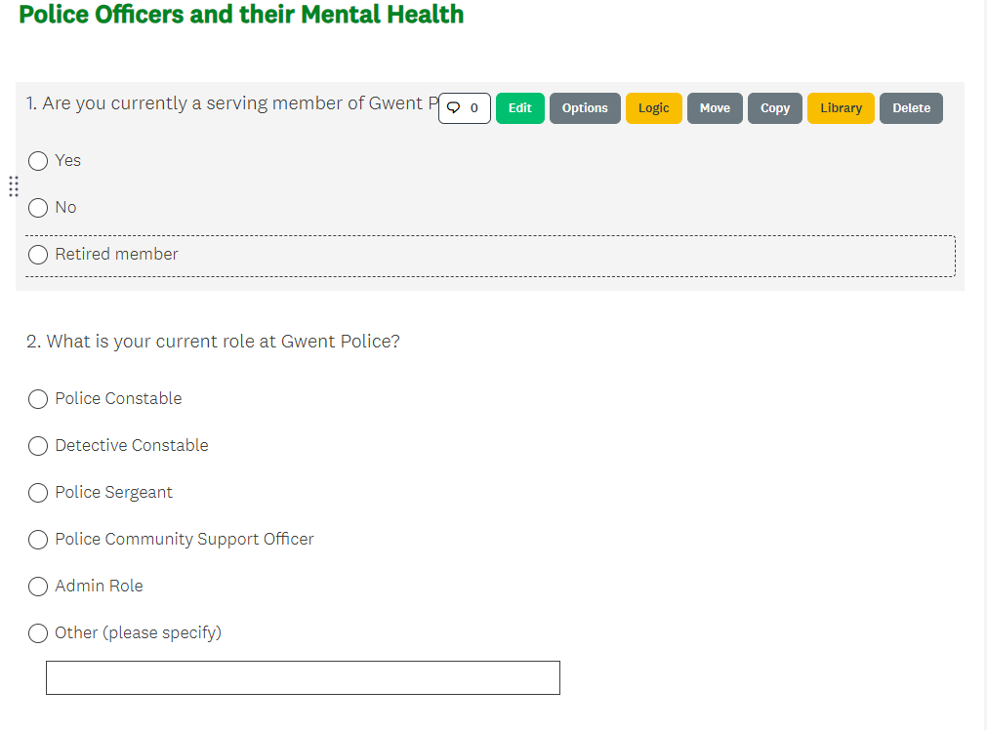
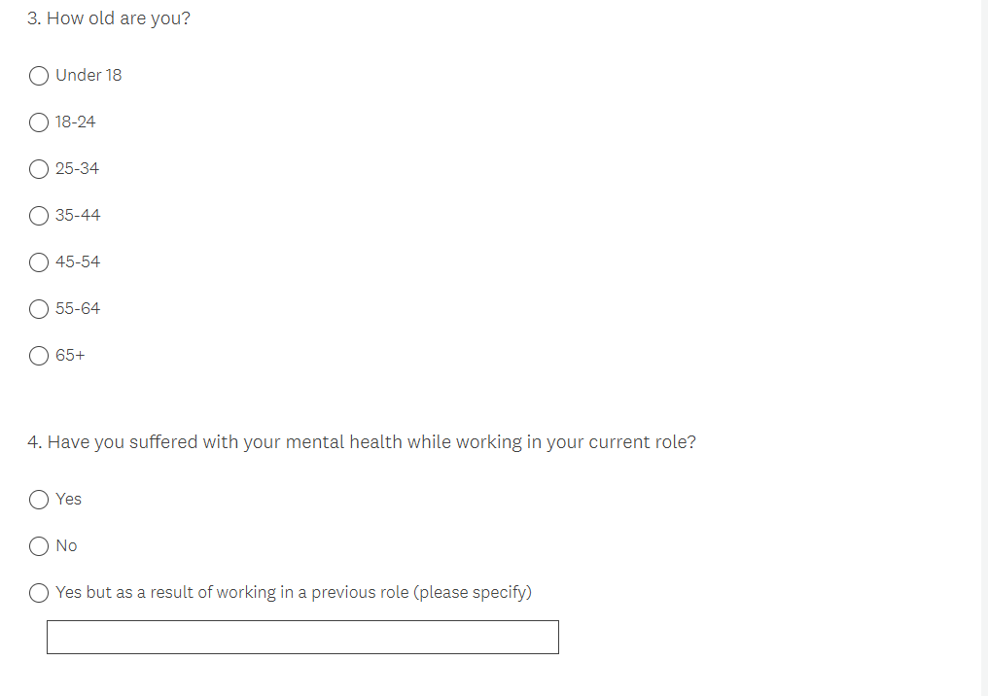
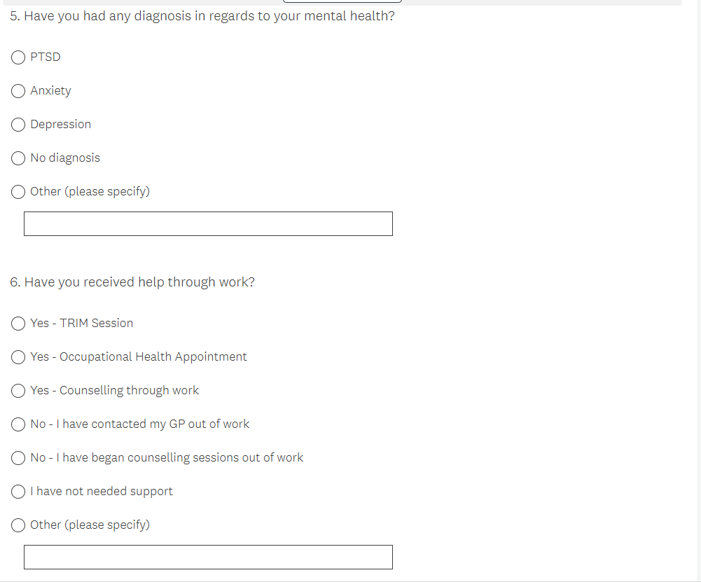

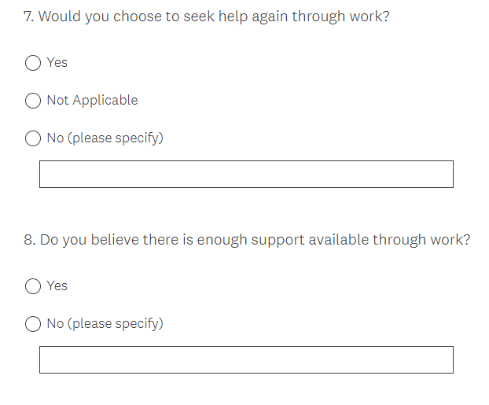

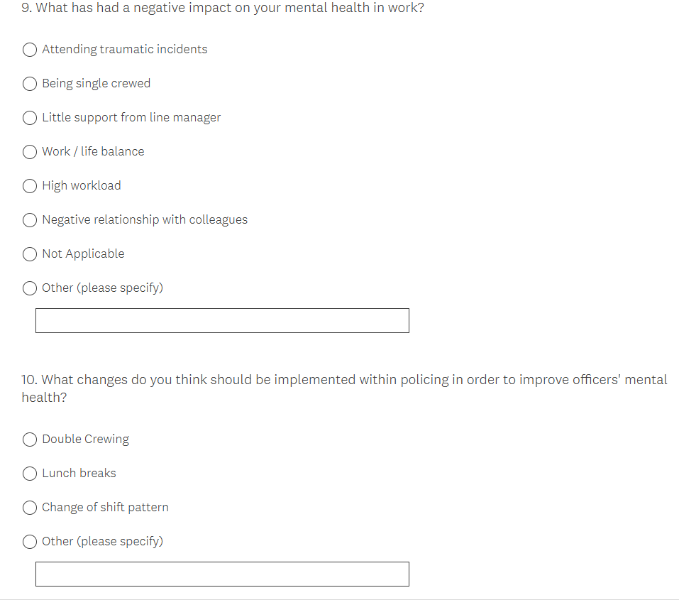

This area will cover the results of thee questions asked above showing it in pie charts and bar graphs.



