Civil Protection in the United Kingdom

1. Introduction

On the morning of 7 July 2005, four suicide bombs were detonated at locations across London. Three bombs were detonated on tube trains at Edgware Road tube station, between Aldgate and Liverpool Street stations and between Russell Square and Kings Cross stations. A further bomb was detonated on a double decker bus on Upper Woburn Place near Tavistock Square. 56 people, including the four bombers, were killed in the blasts and over 700 hundred people were injured (Report of the 7 July Review Committee 2006).

In order to examine civil protection in the UK in the context of this incident I will pay particular attention to the following:

a. The range of statutory and non-statutory guidance that supports the Civil Contingencies Act 2004 (CCA), and how this would have contributed to the planning arrangements for a co-ordinated response to this incident.

b. Analysis of the impact that the Act and guidance related to it has had on the response and recovery to this emergency.

c. Characteristics of this emergency (what defines it as an emergency), and how this incident is categorised on the National Risk Register

d. The duties placed on the different types of official responders by the Act, who these organisations are and what their respective (including coordinated) responsibilities are.

2. References

I have drawn from the following to complete this assignment and much of what I have written and concluded is based on information provided by them.

a. Civil Contingencies Act 2004: a short guide (revised). This document gives a brief overview of the main provisions of the Civil Contingencies Act 2004.

b. Emergency Response and Recovery Non statutory guidance accompanying the Civil Contingencies Act 2004 (Revised October 2013). This guidance document is designed to complement Emergency Preparedness, which sets out how the duties under the Civil Contingencies Act 2004 (CCA) and its supporting Regulations should be implemented.

c. Emergency Preparedness (Cabinet Office Guidance), Chapter 5, Emergency Planning (Revised October 2011). This document lays out guidance on what is expected of Emergency Responders in terms of maintaining plans for preventing emergency, maintaining plans for reducing or mitigating its effects and maintaining plans for taking other action in connection with the emergency.

d. National Risk Register 2020. This document sets out the range of risks and challenges that the UK faces which may have the potential to cause significant disruption to the UK and explains what the government and partners are doing to mitigate these risks and how we all can prepare for and respond to them.

e. Review of Persistent Lessons Identified Relating to Interoperability from Emergencies and Major Incidents since 1986 by Dr Kevin Pollock, October 2013. This report was commissioned by the Civil Contingencies Secretariat of the Cabinet Office to identify persistent issues that affect emergency responder interoperability as they are reported in a selection of recent inquiries, reviews, and other pertinent materials.

f. Report of the 7 July Review Committee, June 2006. This review was conducted in order to identify lessons that can be learned from the events and aftermath to the terrorist attacks in London on 7 July 2005.

g. London Emergency Services Liaison Panel (LESLP) Major Incident Procedure Manual Version 10.1 (July 2019). This document provides information about the London Resilience Partnership’s approach to a generic major incident, and additional capabilities needed to respond to specific incidents.

h. Emergency Preparedness – Working in Partnership by Simon Lewis. This article was written by Simon Lewis who, at the time was Head of UK Emergency Planning and Response for the British Red Cross. It was published in 2012 in Volume 3, Issue 1 of the Journal of Terrorism Research and provides an excellent overview of the emergency preparedness arrangements that were in place in London at the time of the 2005 terror attacks.

I have also used the following websites to gather information and form conclusions that I have made throughout this document.

a. The London Assembly Website -
https://www.london.gov.uk

b. The Metropolitan Police Website - https://www.met.police.uk

c. London Councils Website - https://www.londoncouncils.gov.uk

It is also worth pointing out that a large amount of the information contained within this document is based on my own personal experiences and knowledge. I am currently employed as an Emergency Management Officer at Swansea Council and most of my work involves emergency preparedness, response and recovery. This has given me an excellent insight into how this work in conducted by Local Authorities in partnership with other agencies across a range of work streams.

Prior to that, I spent 23 years in the British Army during which time I fulfilled a wide range of roles and functions including working alongside various Local Resilience Forums in response functions and also as a Military Liaison Officer sitting at Tactical Coordination Groups. I was also part of Op FRESCO which covered the fire strikes in 2002/2003 during which time we built extremely close working relationships with the Police and Ambulance services. These experiences and the knowledge I have gained give me a good level of understanding which allows me to form experience based opinions on the subject matter.

3. Background

The Civil Contingencies Act was introduced in 2004 as a result of a review of emergency planning arrangements within the UK announced by the Deputy Prime minister after a number of large scale incidents that had occurred in the UK in quick succession. These incidents were the fuel crisis and severe flooding in the autumn and winter of 2000 and the Foot and Mouth outbreak in 2001.

The Civil Contingencies Act and accompanying guidance provide a framework for civil protection in the UK and is separated into two parts:

a. Part 1 focuses on local arrangements for civil protection and establishes a statutory framework of roles and responsibilities for responders.

b. Part 2 focuses on special legislative powers that could be implemented in response to the most serious emergencies.

The Civil Contingencies Act changed the way the responder agencies planed for and responded to emergencies. For the first time, it listed all of those agencies that would be most likely to respond to an emergency and split responders into two categories; Category 1 Responders (or Core Responders) and Category 2 Responders (or Cooperating Responders).

a. Category 1 Responders include (among others); Police Forces, Ambulance Services, Fire Authorities, Local Authorities, Maritime and Coastguard Agency and Local Health Boards and the Civil Contingencies Act lays out specific responsibilities for them:

i) Assess risk in order to inform emergency planning.

ii) Produce emergency plans.

iii) Produce agency specific Business Continuity plans.

iv) Make emergency plans available to the public and put in place arrangements to warn and inform the public in the event of an emergency.

v) Share information and cooperate with local partner agencies in order to enhance the coordination and efficiency of any response.

b. Category 2 Responders include (among others); Water, Gas and Electricity companies, Network Rail, Airport Operators, Train Operating Companies and the Health and Safety Executive.

4. Emergency Response and Recovery

In order to effectively plan for and prepare for emergencies, all responder agencies maintain an emergency planning capability in some form who are responsible to maintaining the agencies emergency plans and ensuring that its statutory responsibilities are met. The Civil Contingencies Act 2004 gives clear and specific details on the activities that should be carried out by emergency planners in order to effectively plan for and respond to emergencies.

Alongside the Civil Contingencies Act there is also non-statutory guidance such as Emergency Response and Recovery, Non statutory guidance accompanying the Civil Contingencies Act 2004 which is published by the Civil Contingencies Secretariat of The Cabinet Office that assists responder agencies in the process of identifying risk, planning for emergencies and responding to incidents. This guidance lays out the following underpinning principles that can be used to assist emergency planners:

a. Anticipation. Responder agencies that are categorised under the Civil Contingencies Act have a responsibility to scan the horizon in order to identify and analyse risks. Agencies will jointly work in producing a risk register for their specified area which will list the risks identified within this area, usually defined by geographical area, and prioritise these risks in terms of both their likelihood and there potential impact.

In order to assist responder agencies, the UK Government produce a National Risk Register which is based on the National Security Risk Assessment. This document outlines risks facing the UK and assesses these risks according to the likelihood of the risk occurring also the potential impact level.

The likelihood of a risk occurring are divided into the following probabilities; less than 1 in 500 chance, 1 to 5 in 500 chance, 5 to 25 in 500 chance, 25 to 125 in 500 chance and greater than 125 in 500 chance.

The potential impact of an identified risk is placed in a band from A to E (A being the lowest impact and E being the highest impact) depending on the assessed impact to the following indicative impact scale indicators; economic impacts, fatalities, evacuation and shelter and public perception, environmental damage or contamination, essential services, electricity supply and international relations. It is important to point out that a risk would not need to meet all of the specified thresholds within each band in order to be categorised at the specified potential impact level.

In order to illustrate this method, a copy of the risk matrix and a copy of the indicative impact scales taken from the UK National Risk Register 2020 can be found below.

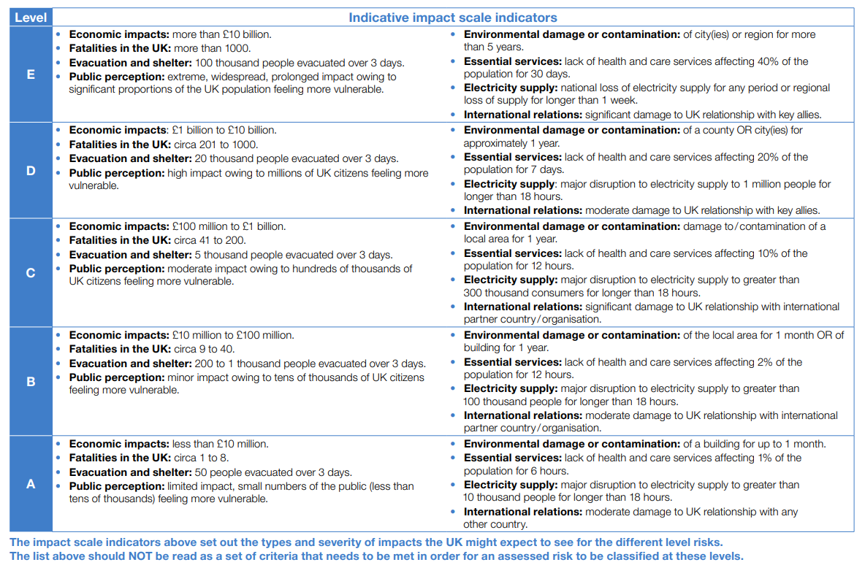

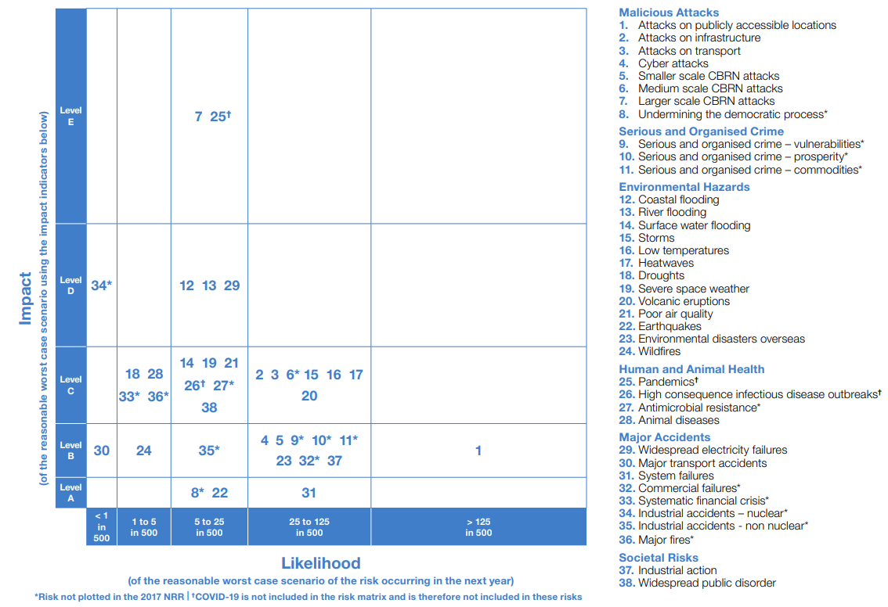

Responder agencies will use the information contained within the National Risk Register to inform their own risk assessment process and form risk registers based on geographical area. This will duplicate many of the risks contained in the National Risk Register but will take account of geographical and local specifics when identifying and prioritising risks, for example when prepared by a Local Resilience Forum. This register will be inherently locally focussed given that local partner agencies making up these organisations will know the area far better than nationally based organisations. However, risks that are identified in the National Risk Register and then duplicated in the local risk registers should be referenced as such. This information is then published so that it is available to all those within this geographical area as part of the responsibilities to warn and inform members of the public laid down in the Civil Contingencies Act 2004.

b. Preparedness. The Civil Contingencies Act 2004 gives clear roles and responsibilities for each of the categorised organisations in terms of emergency preparedness and these organisations are responsible for understanding what these roles and responsibilities are. They must also ensure that they collaborate with other responder agencies across planning and preparation for each of the risks identified in the risk register to ensure that any emergency response can be delivered quickly and efficiently using the existing multi-agency framework.

A key part of preparedness is the production of plans and organisations should produce plans to cover their role in a response to or recovery from any of the risks identified in the risk register. It is important that these plans are effective and fully understood by all those who are given a role or responsibility within it so that if a plan needs to be put into action during the response to an emergency, members of that organisation will be able to fulfil their specified roles effectively.

Plans should be regularly reviewed so that they are kept current and meet the most up to date needs of any response. The key method for ensuring that plans are kept up to date is by testing them through an exercise. This can take the form of a simple table top exercise where members of relevant organisations gather to work through a fictional scenarios using the plan as a guide to the emergency response or it could be in the form of a large scale live exercise involving a real time emergency response to a fictional scenario. A method that has been used in recent time is Microsoft Teams which has enabled partner agencies to conduct table top exercises of major incident plans in a virtual environment where COVID restrictions would not allow face to face training to take place.

Once the review or exercise has taken place, it is vitally important that any lessons learned or amendments required are implemented and incorporated as soon as possible so that the plan remains up to date and effective.

c. Subsidiarity. Effective emergency planning come from a knowledge and understanding of risks at a local level. The UK Government takes an approach that allows individual local emergency responder agencies and local organisations, such as Local Resilience Forums to make decisions based on their unique knowledge of the geographical areas that they serve.

This freedom of movement empowers local responder agencies and organisations to develop working practices to identify and respond to risk in a far quicker and more effective way as it allows responders to react to and deal with local emergencies without the need to involve government.

d. Direction. In order for an emergency response to be successful, it requires effective command and control at all levels and this is especially important at the strategic level. In order to provide this clear chain of command predesignated structures are put in place so that during an incident response, members of responder agencies can come together at the various levels of command to provide the required direction. These structures are based on local organisations made up of categorised responders such as Local Resilience Forums and the command structure is designated as follows:

i) Strategic Coordinating Group. Also referred to as the Gold level of command, The Strategic Coordinating Group will consist of senior representatives from all of the responder agencies contributing to the emergency response and will be positioned well away from the location of the response. It is responsible for setting the strategic direction of the response, prioritising resources and coordinating the actions of responders to ensure economy of effort and effectiveness of the response.

ii) Tactical Coordinating Group. Also referred to as the Silver level of command, the Tactical Coordinating Group will also consist of representatives of each of the agencies involved in the emergency response and is subordinate to the Strategic Coordinating Group. They are responsible for interpreting the direction given by the Strategic Coordinating Group, developing a plan at the tactical level and ensuring that assets provided by the Strategic Coordinating Group are utilised effectively.

iii) Operational Officers. Also referred to as the Bronze level, the Operational Officers are at the very frontline of any operational response. As there was in the case of the terror attacks in London on 7 July 2005, there may be multiple incident locations at which Operational officers are deployed and it would be the responsibility of the Tactical Coordinating Group to support and control all of these incident locations.

Through all levels of the command and control structure, responders share a common set of objectives. Emergency Response and Recovery (Non statutory guidance accompanying the Civil Contingencies Act 2004) Version 5: October 2013 states that the common objectives for all emergency responders should be:

- Saving and protecting human life
- Relieving suffering
- Containing the emergency – limiting its escalation or spread and mitigating its impacts
- Providing the public and businesses with warnings, advice and information
- Protecting the health and safety of responding personnel
- Safeguarding the environment
- As far as reasonably practicable, protecting property
- Maintaining or restoring critical activities
- Maintaining normal services at an appropriate level
- Promoting and facilitating self-help in affected communities
- Facilitating investigations and inquiries (e.g. by preserving the scene and effective records management)
- Facilitating the recovery of the community (including the humanitarian, economic, infrastructure and environmental impacts)
- Evaluating the response and recovery effort
- Identifying and taking action to implement lessons identified

e. Information.

Information is critical for maintaining situational awareness through an emergency response. The flow of information in to the Tactical and Strategic Coordinating Groups needs to be managed and processed effectively in order to build an accurate and useful Common Recognised Information Picture of what is unfolding on the ground. Without an accurate and up to date Common Recognised Information Picture, an effective emergency response cannot take place.

Information also needs to flow out of the Tactical and Strategic Coordination groups in the form of situation reports for the chain of command at sub national or national level but also in the form of updates for members of the public. Keeping members of the public updated with developments is crucial and will require a coordinated and highly effective media strategy.

f. Integration.

In order to ensure an effective multi-agency response it is essential that all responders initiate integration in the planning phase. By training and exercising together during peace time, agencies can ensure that live response operations are effective.

Organisations achieve this through a number of different means:

i) A common response framework for all responder agencies that gives a single set of guiding principles.

ii) Bringing responder agencies together in formal multi-agency groupings such as Local Resilience Forums to ensure integration across not just Police, Fire and Ambulance Services, but all categorised responders.

iii) Multi-agency groupings conduct joint planning and training activities routinely during peacetime. Exercises are also conducted in order to test and validate these plans to ensure that they are fit for purpose and will work effectively under response conditions.

Alongside the Local Resilience Forums and other groups that encompass responder agencies within a specified geographical area, joint working is also routinely conducted with neighbouring Local Resilience Forums. This joint working is essential to ensure that an effective response can be delivered should a cross-boundary emergency occur.

g. Cooperation.

The operational effectiveness of any emergency response depends on partner agencies understanding how each other operates. This understanding comes from open and effective joint working during the planning, training and exercising which enables agencies to understand how each other works. Fully understanding the capability and limitations of each agency allow shared aims and objectives allow a common working framework to be formed and developed.

h. Continuity.

All responder agencies that are categorised under the Civil Contingencies Act have a duty imposed by the act to plan and prepare for emergencies as part of their day to day role. Emergency response delivered by these agencies should, wherever possible, be based on their normal structures and working practices. Where an emergency response requires members of agencies to be deployed in roles outside of their normal responsibilities these should be practiced and exercised in order to ensure that members of staff can deliver these roles and responsibilities effectively during any response.

5. Emergency Preparedness

Because the July 2005 terrorist attacks occurred in London, I will examine the implications of the Civil Contingencies Act and accompanying guidance on emergency planning in London using the response to and lessons learned from this incident as a backdrop.

London, as with other areas of the UK has processes and organisations in place in order to plan for and respond to emergencies. In the case of London, emergency preparedness has been coordinated by a number of different organisations including London Resilience, the London Resilience Forum the London Emergency Services Liaison Panel.

Each of these organisations represent different responder agencies and deliver different services in terms of emergency planning, response and recovery. It is important to point out however, that they all share a common working practice; interoperability. By linking in and working together at all stages of the emergency preparedness, response and recovery process, these groups ensure that any emergency in London is planned for and responded to together and in the most efficient way possible.

The London Emergency Services Liaison Panel was formed in 1973 and was initially made up of the Police, Fire Brigade and Ambulance Service. It has since expanded its membership and now includes representatives from the Metropolitan Police, British Transport Police, City of London Police, London Fire Brigade, London Ambulance Service, Local Authorities, Port of London Authority, Maritime and Coastguard Agency, the Military and the Voluntary Sector.

The panel produced a Major Incident Procedure Manual that provides guidance for major incident response including detailed roles and responsibilities for emergency responders and also provides clear command and control structures. These command and control structures, known as Gold, Silver and Bronze, allow organisations to overcome the possible cultural differences between different responder agencies by designating clear roles and responsibilities for Commanders of each agency at all response levels. It does not provide guidance for every emergency that could occur but instead provides a generic framework that can be used to initiate a coordinated emergency response.

In addition to the London emergency Services Liaison Panel, the London Resilience Group are also involved in ensuring that London is prepared for emergencies. Initially formed in 2002 as the London Resilience Team which was part of the Government Office for London and included representatives from the emergency services, local authorities, health authorities, utility companies and transport organisations. The organisation had actually already been in existence prior to 2002 as an informal, multi-agency team that had been involved in planning for the risks that were seen at the time to be associated with the year 2000. In 2010 the London Resilience Team transferred from the Government Office for London to the Greater London Authority in order to facilitate greater local oversight of resilience matters that related specifically to London and to fulfil the Mayor of London’s responsibilities for resilience and emergency preparedness.

The London Resilience Team merged with the London Fire Brigade Emergency Planning Team in 2016 to form the London Resilience Group which now works to ensure that London is prepared for emergencies on behalf of the Mayor of London, the 33 Local Authorities in London and London Fire Brigade.

Finally, the London Resilience Forum provides a means for all responder agencies to collaborate at a pan-London level ensuring that there is a link between those responsible for resilience at the local and national levels. It is made up of Category 1 and Category 2 responders from across London and manages a number of work streams to ensure that all pan-London plans are exercised and reviewed to ensure that London is prepared for an emergency. In the event of an emergency where a coordinated, multi-agency response is required at a strategic level (also referred to as ‘Gold’), a Strategic Coordination Group will be formed. The Strategic Coordination Group will normally be chaired by a senior member of the either the Metropolitan Police, City of London Police or British Transport Police. It could, however, be chaired by a senior member of any responding agency depending on the nature of the incident but would be chaired by a senior Police Officer. The role of the Strategic Coordination Group is to coordinate the response to any emergency. Once this response has transitioned to recovery a Recovery Coordination Group would then be formed from Local Resilience Forum partners and would normally be chaired by a senior officer from the Local Authority that has been affected by the emergency.

Alongside the planning and preparation for emergencies and prior to the terrorist attacks of July 2005, emergency responders in London were well practiced in coordinated response to major incidents and had already responded to a number of high profile terrorist attacks in London including the Irish Republican Army bombings at the Baltic Exchange in 1992, Bishopsgate in 1993 and Docklands in 1996. Although these attacks caused loss of life and injured many, they were perpetrated by an organisation that issued coded warnings prior to the bombs detonation which gave the Police and other responder agencies time to evacuate the area around the bomb in order to prevent significant loss of life.

5. Emergency Response – 7 July 2005

The Civil Contingencies Act 2004 defines and emergency as:

“an event or situation which threatens serious damage to human welfare; an event or situation which threatens serious damage to the environment; or war, or terrorism, which threatens serious damage to security”

In order to examine an incident response in the context of the Civil Contingencies Act 2004, we must first examine the nature of the incident and decide whether or not it satisfies the above definition of an emergency.

The London terrorist attacks that occurred on 7 July 2005 can definitely be classified as an emergency in the context of the Civil Contingencies Act 2004 and I will examine each aspect of the definition on an emergency in order to further understand how the classification applies in this case.

a. Is it an event or situation that threatens serious damage to human welfare?

52 people were killed, 700 people were injured and many other individuals who were caught up in these traumatic incidents suffered irreparable damage to their mental health. Given the high numbers of people affected by this incident I would say that it most definitely meets the classification criteria above.

b. Is it an event which threatens serious damage to the environment?

This incident did not have an immediate and direct impact on the environment however, it caused a huge amount of damage and the clean-up operation would have taken a huge amount of time and resource to complete.

c. Is it an act of war or terrorism which threatens serious damage to security?

This was an act of terror that was unprecedented on UK soil and had a huge impact on the security of the not just London, but the entire UK. Previous terror attacks in mainland UK had been, in the main, large single attacks that had been targeted against members of the security forces or had been designed to cause large scale damage to specific areas.

Based on the analysis above, I have confirmed that this incident most definitely meets the criteria for classification as an emergency in the context of the Civil Contingencies Act 2004 and now that I have confirmed that this incident fulfils the criteria to be classified as an emergency, I can examine the response.

Although emergency responders in London were well practiced in the coordinated response to terrorist incidents, they had never faced an incident off the type and scale that occurred on the morning of 7 July 2005. Below is an extract from the Report of the 7 July Review Committee, June 2006 that gives us an indication of the sheer complexity of this incident and the huge challenge that any emergency response would have faced in order to save life and reduce harm to those involved:

The first explosion on 7 July took place at 8.50 am on eastbound Circle Line train number 204, travelling from Liverpool Street to Aldgate station. Within one minute, a second explosion took place on a Circle Line train number 216, travelling westbound from Edgware Road to Paddington. A third bomb was detonated approximately two minutes later, on a southbound Piccadilly Line train number 311. At 9.47 am, a fourth bomb was detonated, on the top deck of the Number 30 bus at Tavistock Square.

In order to examine the response, I will do so in the context of the eight underpinning principles of effective response as listed in the Emergency Response and Recovery, Non statutory guidance accompanying the Civil Contingencies Act 2004. I have covered preparedness of emergency responders in London in a previous section of this assignment and as so I will begin with subsidiarity:

a. Subsidiarity. This was a key aspect of the initial emergency response given the number of separate incident locations that required support from responders. Although a Strategic Coordinating Group was set up to direct and manage the overall response, communications between individual locations and control rooms were severely disrupted meaning that many decisions had to be made at the operational or tactical level. According to the report of the 7 July Review Committee, June 2006, many operational commanders had to rely on mobile phones in order to communicate with their respective control rooms. Had operational commanders not been confident or practiced in rapid, independent decision making, the response would potentially not have been as effective as it was.

b. Direction. The Strategic Coordinating Group did not meet until 1030hrs and given that the first 999 call from any of the locations was at 0851hrs, the overarching aims and directions were not being set at the strategic level for the first 90 minutes of the incident. A major incident was not declared until 0932hrs and due to there being multiple incident locations, it was then the responsibility of the control room of each responder agency to provide this direction in the initial response period. Interoperability between responder agencies was well established within the London area and part of this was the sharing of agreed strategic aims which was crucial to the effectiveness of the initial response prior to the formation of the Strategic Coordinating Group. It is interesting to note that after its first meeting at New Scotland Yard, the Strategic Coordinating Group was then moved to Hendon and due to the location outside of central London this potentially caused a delay in the next meeting due to the difficulties of reaching this new meeting location.

c. Information. Information is key to delivering a targeted and effective emergency response and in the case of the terror attacks in July 2005 there were four separate incident locations with a large geographical spread that required a response meant that the gathering of information was more important than ever. The information gathering process during these incidents was hampered initially by the sheer volume of information being received by the control rooms of each responder agency. Processing the high levels of incoming information so that it could be used to shape the response effectively. As previously stated, the passage of information between operational responders and their respective control rooms was also severely affected by the nature and location of the incidents meaning that many responders had to relay important information via mobile phones. The networks supporting these mobile phones were under unprecedented pressure during these incidents which further restricted the ability of emergency responders to pass on crucial, time-sensitive information.

d. Integration. At the time of this incident, emergency responders in London were well practiced in delivering an effective and integrated response to major incidents of various different natures. There were a number of organisations and frameworks in place and by bringing responders together in organisations such as the London Local Resilience Forum, they are able to share emergency plans at all stages of the planning process which provides the opportunity for exercising and validating these plans. Integration by emergency responders at all stages of the emergency planning, response and recovery process ensures that any response is delivered in an effective and coherent manner.

e. Cooperation. Police, Fire and Ambulance services in London have been cooperating formally since the formation of the London Emergency Service Liaison Panel in 1973 and the Major Incident Procedure Manual that this organisation produces is now on its 10th version. Because this partnership working framework has been in place for so long and given that the emergency responders in London had dealt with terrorist incidents in the past, it definitely assisted in ensuring that the response to this incident was effective.

