I have not included the bibliography nor word count. This will be at the bottom of the final dissertation.
I haven’t not yet gone through this with a fine tooth comb in regards to my grammar either.
I an dyslexic and entitles to an extra 7 days for my submissions but would rather submit asap. Although I am 8 would late submitting this.

Analysis chapter
Introduction
This chapter analyses and presents the findings from the survey that police officers were given regarding their experiences and recommendations for handling situations involving mental health emergencies. The objective of the research is to provide an understanding of the current state of police responses to mental health incidents by emphasising trends, challenges, and potential for progress. By analysing the qualitative and quantitative data gathered, this chapter will look to present an inside picture of the perceptions of serving officers. From these perceptions and insights, I will look to develop evidence-based suggestions for policy and practical changes.
After considering several possible platforms available for creating the survey I chose to use Google forms. The main reasoning for this was its user-friendly interface, easy distribution capabilities and its didn't cost anything to use. I distributed the questionnaire to serving police officers from a number of different forces in an effort to encourage differences in opinions and as many participants as possible to take part. I asked officers who serve in numerous forces to share the survey using a sharable link as widely as they could by sending it to them via emails, police group chats.
There were twenty-two questions in the survey. This was divided into five open questions, which allowed participating officers to answer the respective question in more detail, and seventeen closed questions. Every single question on the survey was answered by the 43 participants.
Participants were informed at the beginning of the survey that all answers would be kept private, anonymous, and securely stored in compliance with the General Data Protection Regulation, or GDPR (Government of UK, 2018). Participants were also informed that their participation was entirely voluntary.
Quantitative Data Summary
Question 1 – What is your Gender?
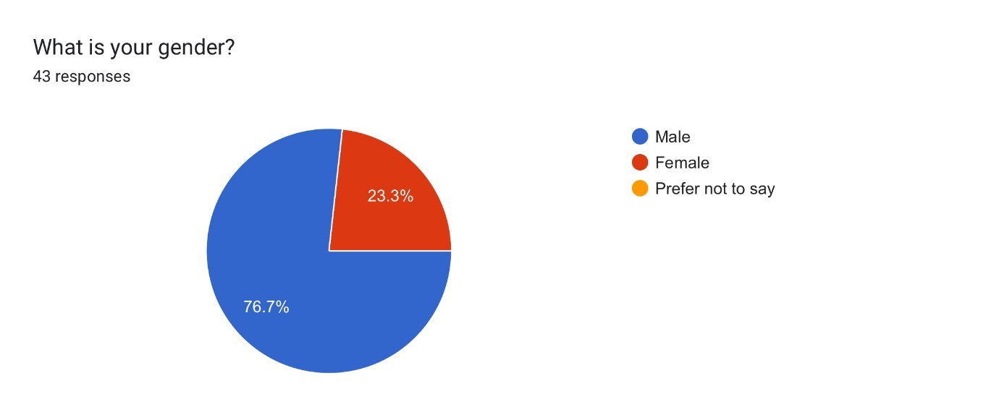
To identify any trends that were related to gender, I asked the participants to specify their gender. The results indicated that the majority of respondents were male, with 76.7% being male and 23.3% female.

Question 2 – Are you a serving police officer?
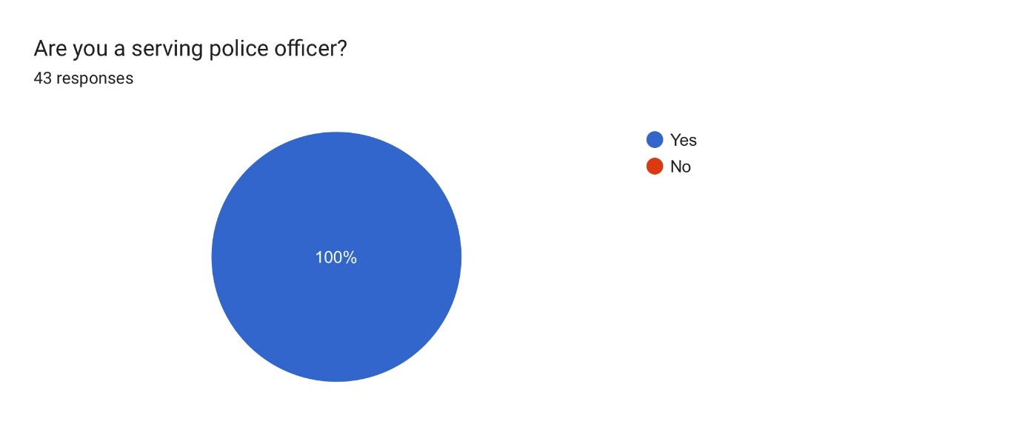
To ensure that the study reflects the views of active police officers, this question confirmed that 100% of the participants were currently serving officers.
Question 3 – What is your rank?
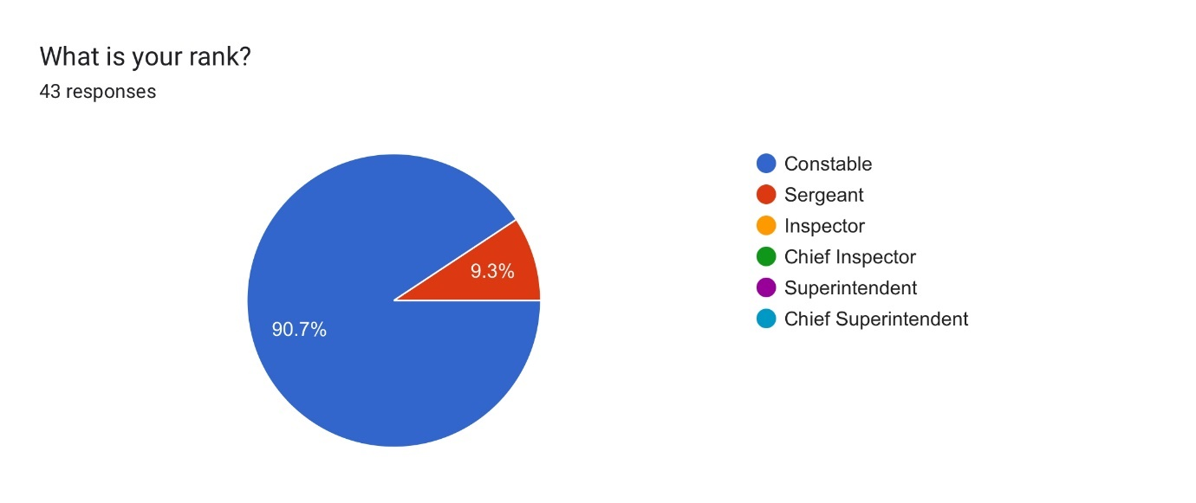
This question was aimed at establishing the rank of participants. Over 90% of respondents were constables, while the remaining participants were sergeants. No officers above the rank of sergeant participated.
Question 4 – What is your length of service?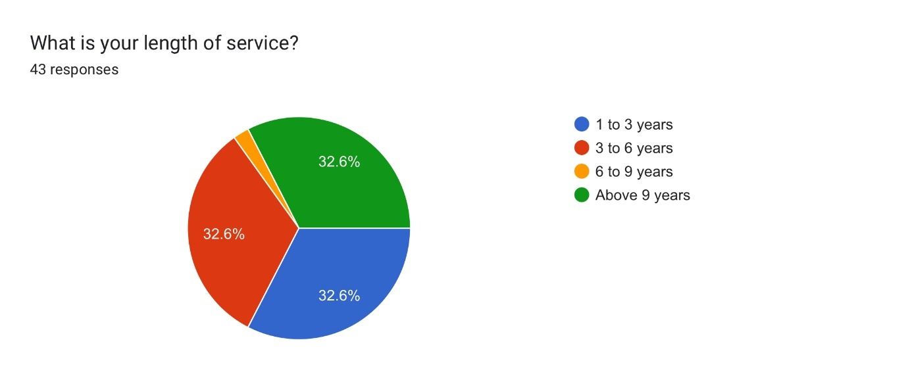
The responses showed a good distribution of levels of service among the officers. Each of the categories—1 to 3 years, 3 to 6 years, and above 9 years—represented 32.6% of participants. Only 2.2% of officers fell into the 6 to 9 years bracket.
Question 5 – How frequently do you attend mental health related incidents?
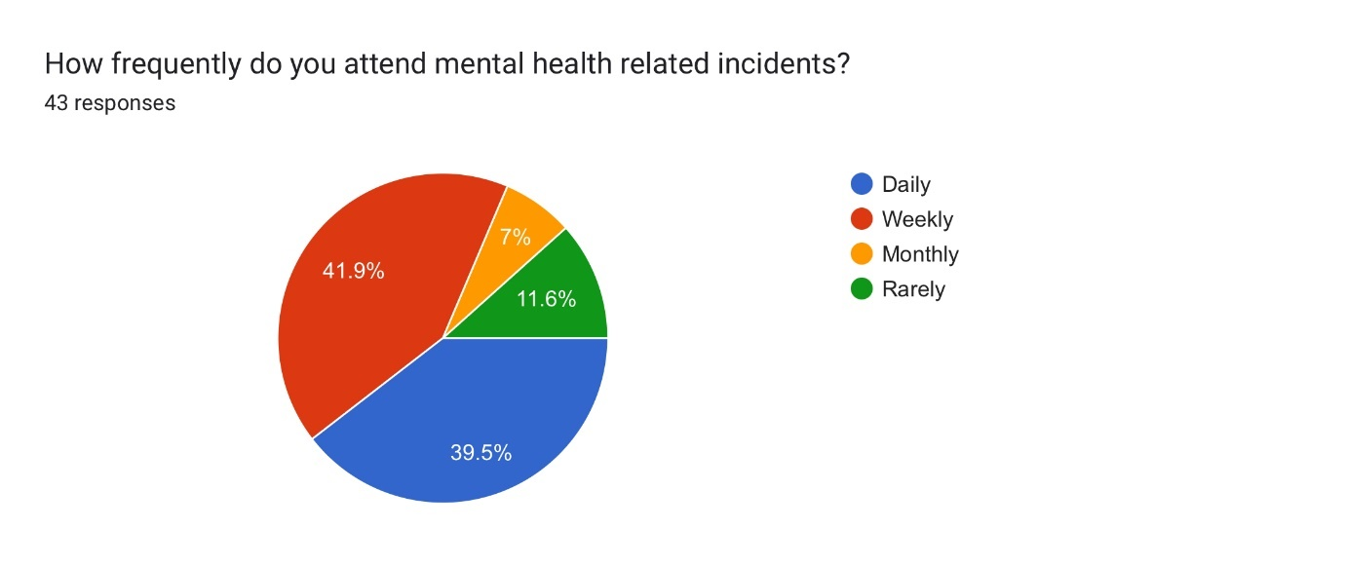
The aim of this question was to ascertain the respondent’s exposure to mental health type incidents. Over 80% of participants expressed that they attend mental health-related calls on either a weekly or daily basis, meaning that the majority of respondents had a good level of exposure to mental health related incidents.
Question 6 – Have you had specific training on handling individuals going through a mental health crisis? 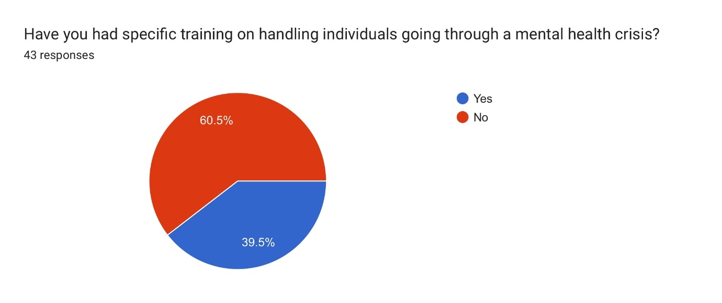
The results revealed that 60.5% of participants had never received training on handling mental health incidents, while 39.5% had. This aligns with the length of service, suggesting that newer officers might receive more training during initial training than those already in active duty.
Question 7 – How often do you receive training in relation to your response to mental health type incidents?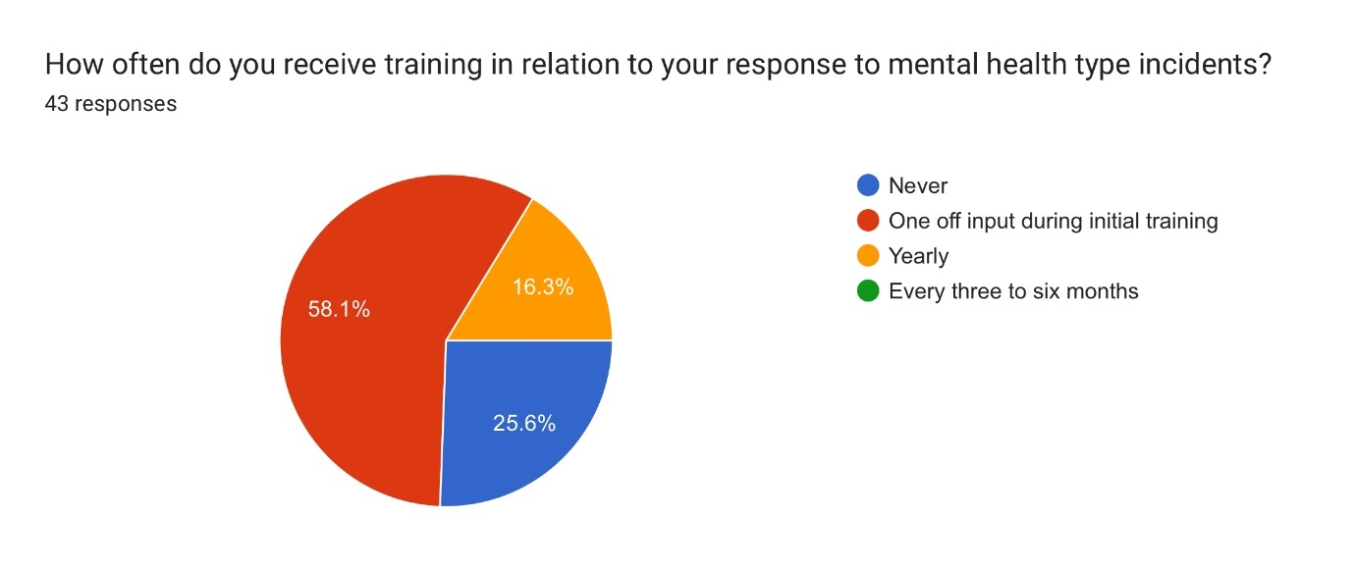
More than half of the participants indicated that they had only received training during their initial induction, which for some could have been over 9 years ago.
Question 8 – The training that you received is adequate for handling the mental health incidents you attend? 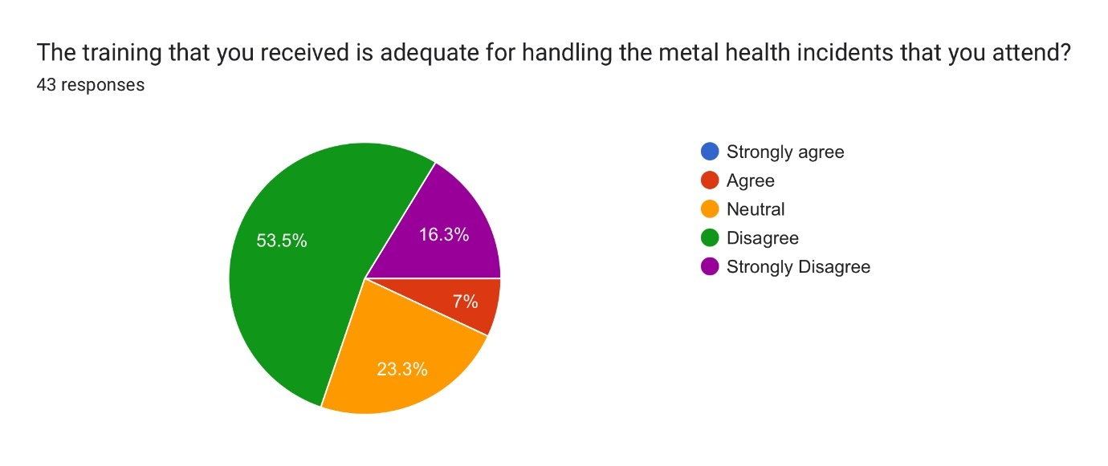
When asked about the adequacy of their training, 69.8% of officers felt that they were not adequately trained to handle mental health incidents. Only 7% believed their training was sufficient.
Question 9 – You believe additional training around handling mental health incidents would improve your ability to handle them. 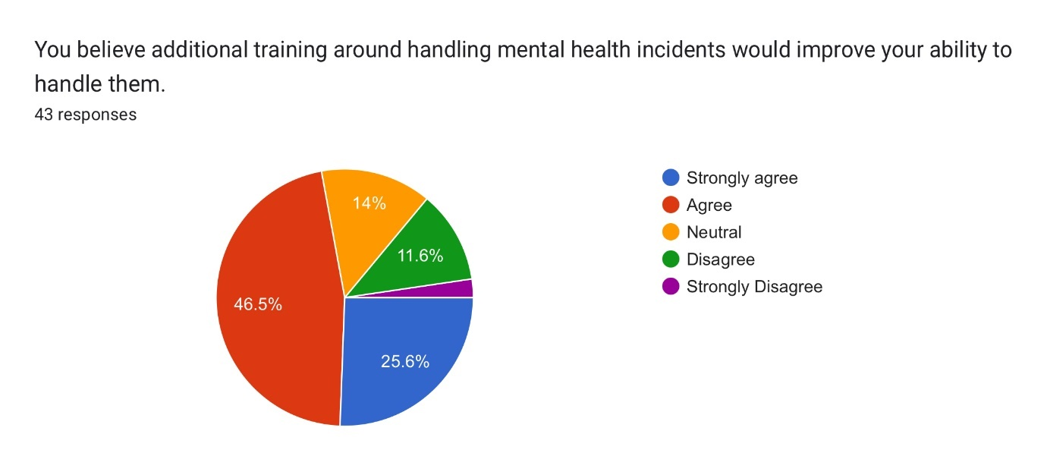
72% of respondents, agreed that additional training would enhance their ability to manage mental health incidents. Only 13.9% disagreed, with the remaining 14% being neutral.
Question 10 – You believe mental health professionals should accompany police on mental health related calls as standard? 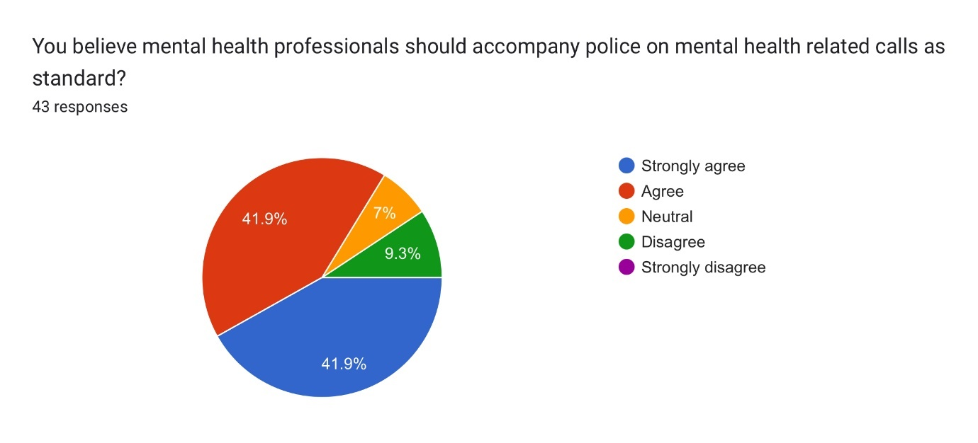
Most officers (83.8%) supported the idea that mental health professionals should accompany police on these calls. Only 9.3% disagreed, while 7% remained neutral.
Question 11 – Do you believe that police should be the first emergency service to attend mental health incidents?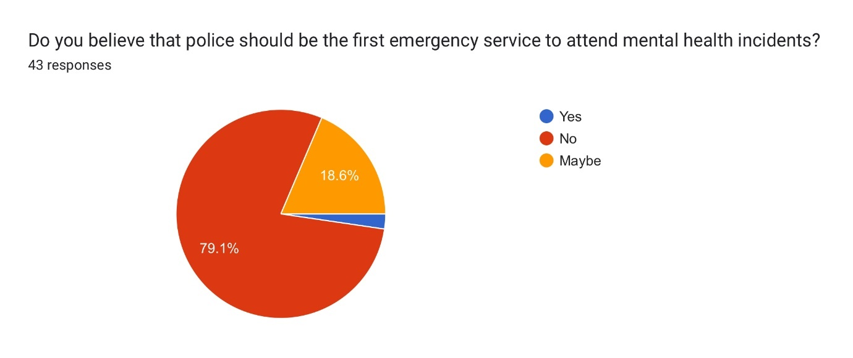
A large majority, 79.1%, did not believe that police should be the first responders to mental health incidents. Only 2.4% felt they should and 18.6% were uncertain.
Question 12 – How often do you encounter resistance or aggression during mental health related incidents? incidents. 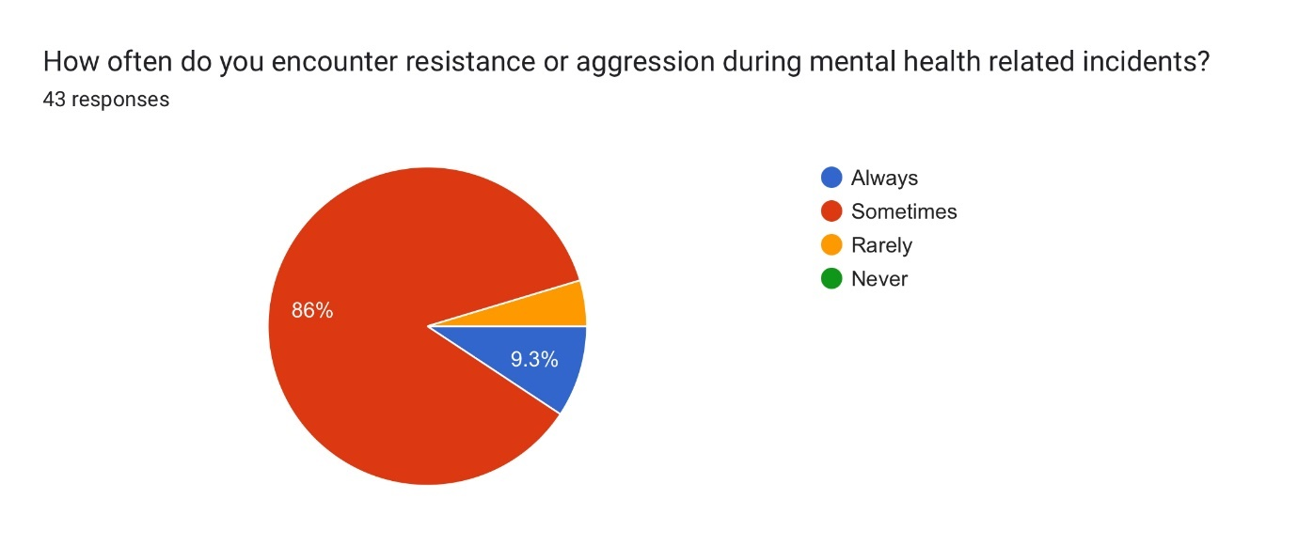
Resistance or aggression was frequently encountered, with 86% of officers stating it happened sometimes, 9.3% always, and 4.7% rarely. No officers reported never encountering aggression.

Question 13 – How often do you feel adequately supported by mental health professionals during incidents. 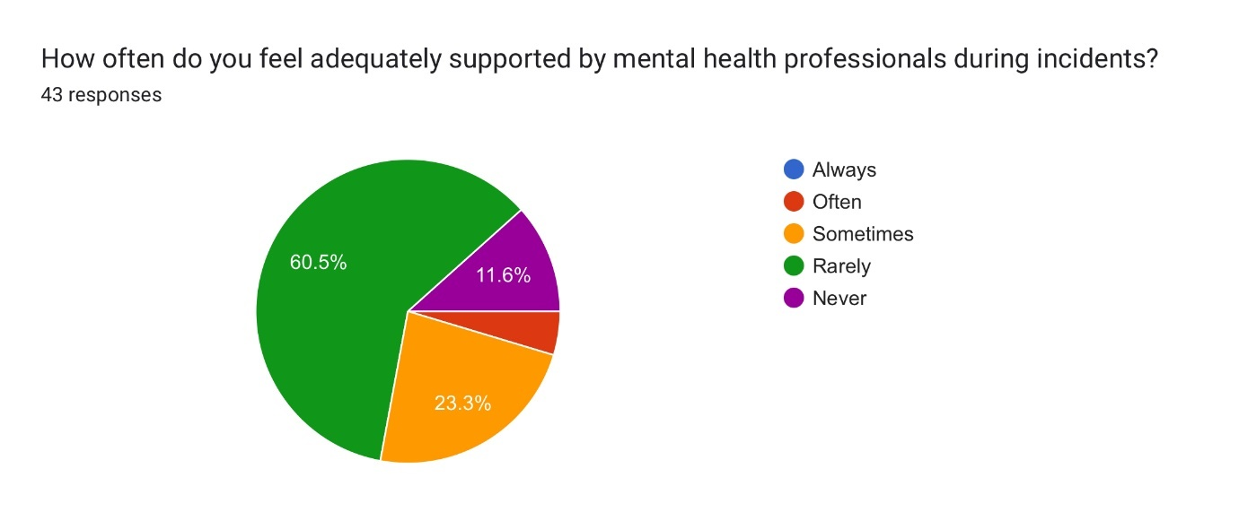
Most officers felt unsupported, with 60.5% stating they were rarely supported and 11.6% never supported. Only 23.3% felt sometimes supported and 4.6% often supported, with no one feeling always supported.

Question 14 – How often do you believe that mental health incidents divert resources away from other policing duties?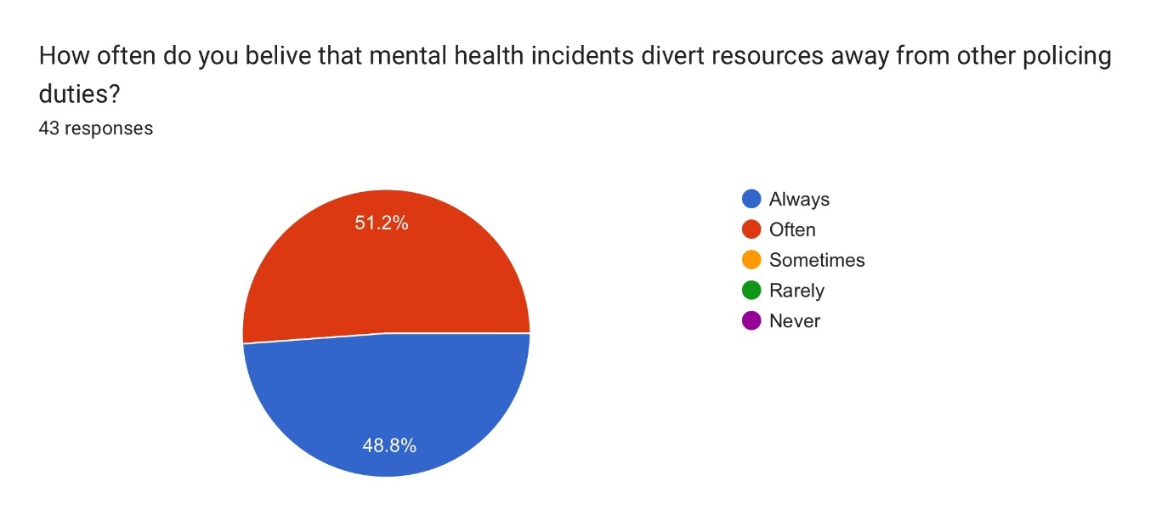
All respondents felt that mental health incidents diverted them from other duties, with 51.2% saying often and 48.8% always. No officers felt that these incidents did not impact their other duties.

Question 15 – As a whole do you think there is enough (time, personnel, equipment) to handle mental health incidents effectively?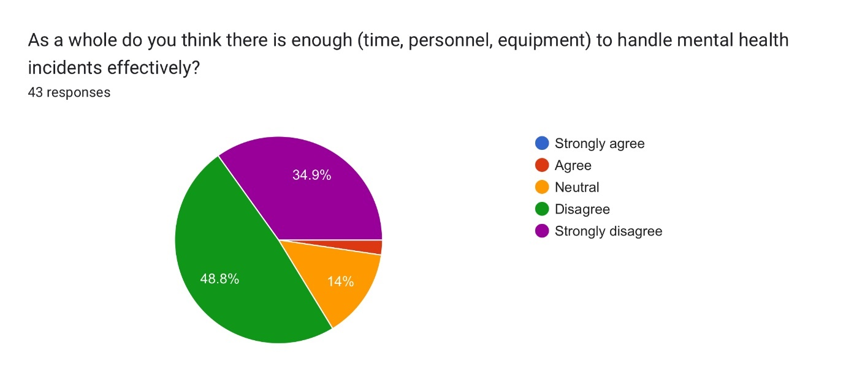
The majority disagreed that there were sufficient resources, with 34.9% strongly disagreeing and 48.8% disagreeing. Only 2.3% agreed, while 14% were neutral.

Question 16 – have you ever sectioned someone under section 136 of the Mental Health Act?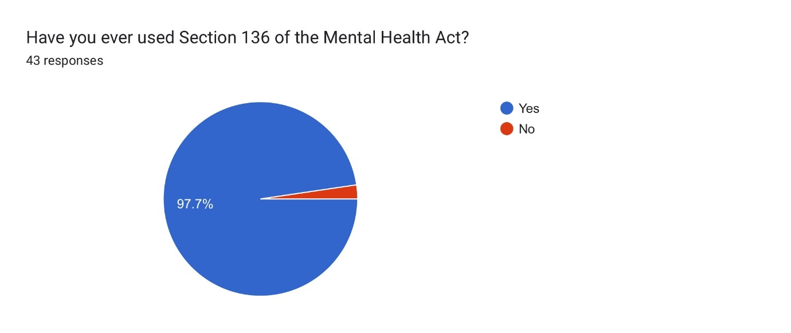
A vast majority (97.7%) of officers had used their powers under Section 136, with only 2.3% having never done so.
Question 17 – The current legal framework like Section 136 is effective in dealing with mental health incidents? 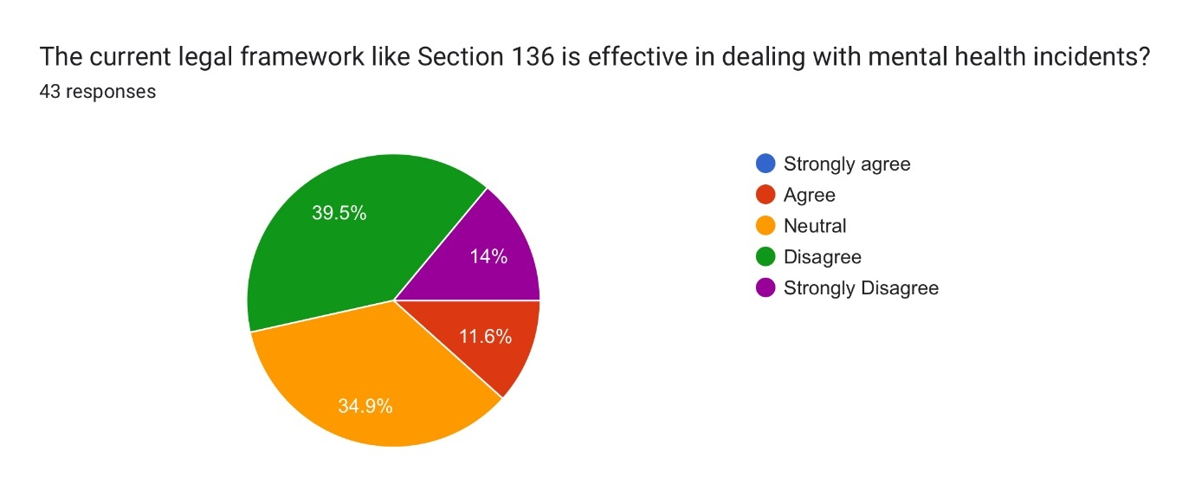
Most officers did not find the current framework effective, with 14% strongly disagreeing and 39.5% disagreeing. Meanwhile, 34.9% were neutral, and only 11.6% agreed.

Qualitative Data Summary
Below is a summary of the responses to each open-ended question along with percentages representing the relative frequency of similar responses.
Question 1 - How do you think inter-agency working between police and healthcare providers could be improved?

Better Communication and Collaboration (40%)
- Example: "Better communication and attendance at certain mental health calls."
- Example: "By communicating better with agencies."
Training (18%)
- Example: "Training done alongside each other so opinions and ideas could be shared."
- Example: "By more in-depth training and for services to be aware of the challenges police face when attending a MH-related incident."
Greater Responsibility by Healthcare Providers (16%)**
- Example: "Greater ownership by health agencies."
- Example: "Health care do something."
Dedicated Mental Health Teams/Units (14%)
- Example: "Have a number of mental health vehicles that could assist police."
- Example: "Joint response units. Paramedics, police, and social workers or AMPs."
Systemic Changes (12%)
- Example: "Less politics."
- Example: "Clear set plans."

Question 2 - What impact do you believe that mental health incidents have on your overall workload and stress levels?

Significant Increase in Workload and Stress (42%)
- Example: "They consume a large amount of time and increase workload of actual crimes as you are dealing with MH incidents instead."
- Example: "Mental health calls are extremely frequent but also very time-consuming."
Diverts Attention from Other Duties (28%)
- Example: "Mental health calls take time and divert officers from dealing with workload and other crime/calls."
- Example: "Takes officers away from their other duties such as preventing crime."
Emotional and Psychological Impact (16%)
- Example: "Increases stress and anxiety, especially when assessed inappropriately and serious harm occurs."
- Example: "It can lead to increased stress and anxiety and make it hard to maintain concentration and motivation."
Inconsistent Impact (14%)
- Example: "Doesn’t affect me personally but I know it might affect some."
- Example: "No effect as don’t deal with them."

Question 3: What improvements or changes would you suggest for handling mental health incidents more effectively?

Increased Role of Healthcare Providers (35%)
- Example: "Mental health services take primary responsibility. They should attend in the first instance."
- Example: "Mental health professionals attending incidents instead of police."
More Training for Police Officers (20%)
- Example: "More training."
- Example: "Better training, more support from agencies and NHS."
Dedicated Mental Health Response Teams (18%)
- Example: "A new and dedicated emergency service for mental health."
- Example: "A mental health car attend with the ability to transport the patient to the hospital if required."
Clearer Policies and Procedures (14%)
- Example: "The implementation of a clear policy/procedure set in place which Police, NHS, and MH services follow."
- Example: "Further funding so that partner agencies take primacy in dealing with mental health incidents."
Better Resource Allocation (13%)
- Example: "More funding for mental health services."
- Example: "Crisis teams to respond to calls in the community."

Question 4: Do you feel that transporting someone who has been sectioned in a fully marked police vehicle even though they are not suspected of committing a crime is an appropriate means of transport?

No (79%)
- Example: "Absolutely not. Most individuals are not violent, they are in crisis and need support."
- Example: "No, should be a mental team."
Depends on the Situation (12%)
- Example: "Can be. Depending on the circumstances. Violent/Intoxicated etc."
- Example: "Situation depending, I believe someone in a state of crisis who shows a lot of emotion can feel somewhat embarrassed in a marked police vehicle."
Yes (9%)
- Example: "Yes - if it is the only way to get a person to help but it does divert resources from where they should be."
- Example: "Yes, if necessary. Ambulance wait times are not appropriate at all."

Question 5: In your opinion, what are the biggest challenges you face when dealing with mental health incidents?

Lack of Support and Responsibility from Healthcare Providers (33%)
- Example: "Lack of assistance from health services."
- Example: "Medical staff refusing to take ownership or being difficult in the process of taking responsibility."
Lack of Training and Resources (23%)
- Example: "Lack of training when using MH-related police powers."
- Example: "Not enough policies around how to deal with certain scenarios."
Time and Resource Constraints (20%)
- Example: "Lack of time and ambulance resource time."
- Example: "The waiting times for assessment."
High Volume of Calls (14%)
- Example: "The sheer quantity of calls that other trained services are passing on to us."
- Example: "Too much dependence on police to deal."
Emotional and Psychological Challenges (10%)
- Example: "Not being able to show empathy or understanding."
- Example: "Understanding the specific needs of each individual."

Conclusion
The results of the survey provide a comprehensive overview of police officers' experiences and perceptions regarding mental health incidents. The data gathered indicated that a substantial amount of serving police officers lack training when it comes to dealing with incidents involving mental health. Over 60% of the survey’s participants have never received any form of mental health training. The evident gap in training corresponds with officers feeling inadequately prepared, as evidence by the 69.9% of respondents who stated that their training was not sufficient. The overwhelming consensus that the survey results highlight is that ongoing training is essential from improving officers’ confidence and ability to deal with mental health incidents effectively. In addition, most officers felt that mental health professionals should accompany them on calls and that generally police should not be the first responders to mental health type incidents. These findings suggest that a more collaborative approach from police and mental health services is required to provide those going through mental health crises to receive the level of care that they deserve.
In addition, the qualitative date gathered by the open-ended questions highlights significant challenges. These involve a lack of immediate support from mental health services, legal and procedural complexities and the emotional toll this all takes on the attending officers. The suggestions for improvements point to a need for systemic changes, including better inter-agency collaboration, increased resources, and dedicated mental health response teams. These insights underscore the necessity for policy reforms and enhanced training programs that not only equip police officers with the skills they need but also ensure that mental health professionals are actively involved in crisis situations. Implementing these changes could lead to more effective and humane handling of mental health incidents, ultimately benefiting both the individuals in crisis and the officers who respond to these calls.

