Rachel Vetter 1708006
Implementation Plan
Internship and Volunteerism
BMSP6003
Davina Evans
October 2019

Introduction
As Part of the third-year level 6 Business Management Degree, the students must undertake an internship lasting no less than twenty days. An internship as described in Internships Theory and Practice, is a managed introductory business opportunity conceived between two sources, in this case an academic institution and professional organisation. It offers its participants practical experience while contributing new opportunities and disciplines (Sides & Mrvica, 2017). As students we are responsible for engaging, organising and arranging these Internships. This essay will describe the processes taken in order for me to begin my internship with UWTSD. As well as studying the progression I wish to attain within my personal skills.
In April 2019, I signed up to ‘NUS for Good’ a new initiative established by the National Union of Students in 2018. This service acts as an intermediary, allowing likeminded students and forward-thinking sustainable businesses to connect, while offering all participants the support and development needed before, during and after their placements. The programme is still in its infancy and so during its pilot year they have limited the number of universities signed up to three, they are the University of South Devon, Solent University and UWTSD-Carmarthen Business School (NUS , 2018). Through this programme the NUS have acknowledged the importance of sustainability within business today along with businesses of the future.
The process of applying through this medium includes, writing a cover letter outlining your qualities and skills, together with a detailed up-to-date CV. Both were then uploaded to the NUS for Good data base. Once the application was submitted then I had to wait to be matched to a business that shared my visions.
As of May 2019, NUS for Good had referred me to a number of possible positions including one for UWTSD - Carmarthen Business School, where I currently study. The position would fit perfectly within my current availability and family schedule, allowing me to work on individual days throughout the summer holidays and into the winter. The position would also offer the personal support needed by me at this time because of my current health issues.
The main focus of the position will be the promotion of the business school’s new one-year, level four, Certificate of Higher Education, Social Enterprise Management Course. With a final objective to see a minimum of ten participants signing up. During the internship I will also be expected to promote all current business school courses.
The Carmarthen Business School is part of the University of Wales Trinity Saint David or UWTSD. Formed by the merging of the University of Wales Lampeter and Trinity University Carmarthen in 2010 (UWTSD, 2019). The Business school itself offers its students an advanced progressive curriculum, presenting its study modules with an underpinning of sustainability and social change within a changing business environment (Carms Business School, 2019) Confirmed by its mission statement which can be found in Appendix 3
“Rethinking business in a changing world”.
This is underpinned by the University’s Mission Statements as seen in Appendix 2 ,
“ To deliver meaningful relevant studies to its students while promoting social responsibility.”
At the end of May 2019, I met with Jessica Shore, my workplace supervisor for the Business school on the UWTSD campus in Carmarthen. During this meeting Jessica outlined the positions available, what would be required and what would be expected of me should I accept the position available. The meeting was also used to examine and complete essential house-keeping documents. These included a full risk assessment, Health and Safety assessment along with a Placement Provider agreement. Copies of all of these forms can be found within appendix 4 to 7.
In order to commence the placement, I was also asked to set out my goals and objectives using a SMART system, as well as producing a basic marketing plan and skills audit. These were used to establish whether I have the aptitudes needed to complete the task set, as well as ascertaining which areas I will need to improve on. It will also further support my knowledge of the assignment, what is expected of me and any resources I may require in order to successfully carry out and complete this placement. Completion of SMART goals as seen in Appendix 8 and can be used as a guide to help direct my development (Jung, 2007). The SMART model can be seen as a valued resource used by many businesses as a tool for managing and evaluating performance (Blaine Lawlor & Hornyak, 2012). The SMART system (appendix 8) has allowed me to break down the job description, determining whether it could be achievable. This has given me an insight into the people, departments and resources that are required to efficiently undertake my role. SMART has also allowed me to identify the skills needed to complete the internship. These can then be linked up to my skills audit.
The completed skills audit, as found in appendix 9 , has allowed me to reflect on my strengths and weaknesses in a number of fields. Areas discovered, that are relevant to my internship, include weaknesses within oral and written communication skills, when placed in specific situations. Communication is one skill that will form the base of my work during the internship, so it is essential that I focus on this area. The audit also highlighted a tendency to act in a reactive manner to situations, rather than proactive, this is one skill I believe can be addressed during the internship.
The final piece of pre work undertaken before I commence my placement fully is a Marketing plan. Placement supervisor Jessica Shore asked me to write a simplified marketing plan that I could use alongside my SMART and skills audits in order to lay out what I am going to do in order to achieve my goals. A marketing plan is a powerful tool and when used correctly can offer a detailed understanding of the various factors that could affect a project’s success, while offering its user a sense of control (Australian Government, 2018). I have included a copy of my plan within the appendix (appendix 10). Along with the Marketing plan is a detailed Gantt chart that includes a breakdown of tasks to undertake and timings involved. The Gantt chart is available in Appendix 11.
Over the next few days I will commence my internship, with the desired aim of successfully promoting the Carmarthen business school’s new social enterprise course, along with its other business degree. I will follow the guidance offered by Jessica Shore my placement coordinator, Meg Baker from NUS for Good, along with people from the various organisations I will connect with.

References
Australian Government. (2018, August 14). Why do I need a marketing plan. Retrieved October 2019, from Department of Industry, Innovation and Science: http://business.gov.au
Blaine Lawlor, K., & Hornyak, M. J. (2012). SMART GOALS: HOW THE APPLICATION OF SMART GOALS CAN CONTRIBUTE TO ACHIEVEMENT OF STUDENT LEARNING OUTCOMES. Developments in Business and Experiential Learning, 39, 267. Retrieved from https://absel-ojs-ttu.tdl.org/absel/index.php/absel/article/view/90
Carms Business School. (2019). Carmarthen Business School. Retrieved from UWTSD: https://www.uwtsd.ac.uk/carmarthenbusiness/
Jung, L. (2007). Writing SMART Objectives and Strategies That Fit the ROUTINE. Council for Exceptional Children , 39(4), 54-58. Retrieved from https://journals.sagepub.com/doi/pdf/10.1177/004005990703900406?casa_token=RZXxcR591XMAAAAA:V7ZPCO8dArsjqrKf7ro-my6APJ9PkwSM8PDqSUPYRkwM06PhLlNPG694N8nA_0S7PNCkkSK5ssau
NUS . (2018). Placements. Retrieved from Nus for Good: https://forgood.nus.org.uk/
Sides, C. H., & Mrvica, A. (2017). Internships- Theory and Practice. Abingdon, Oxon, UK: Routledge. Retrieved October 4, 2019, from file:///C:/Users/User/AppData/Local/Packages/Microsoft.MicrosoftEdge_8wekyb3d8bbwe/TempState/Downloads/9781315224305_googlepreview%20(1).pdf
UWTSD. (2019, september). The University. Retrieved from University of Wales Trinity Saint David: https://www.uwtsd.ac.uk

Appendix 1 - NUS for Good, Missions and Values 2018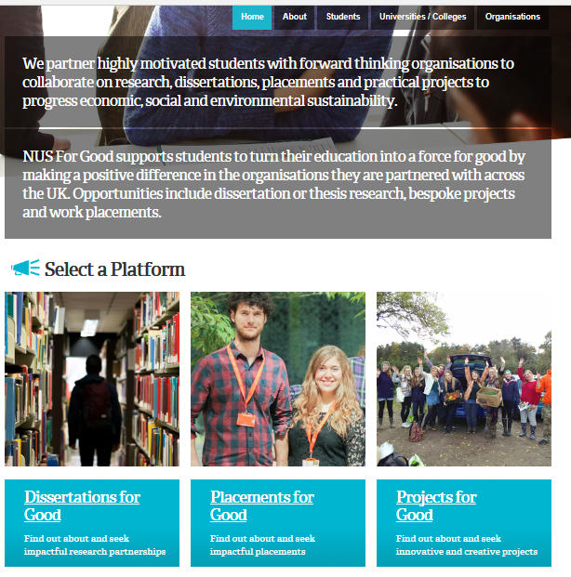

Appendix 2 - UWTSD Missions and Values 2019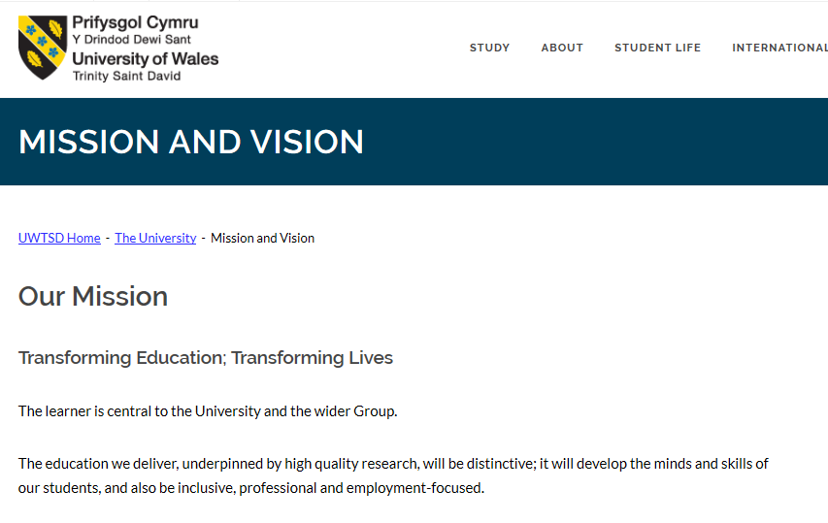
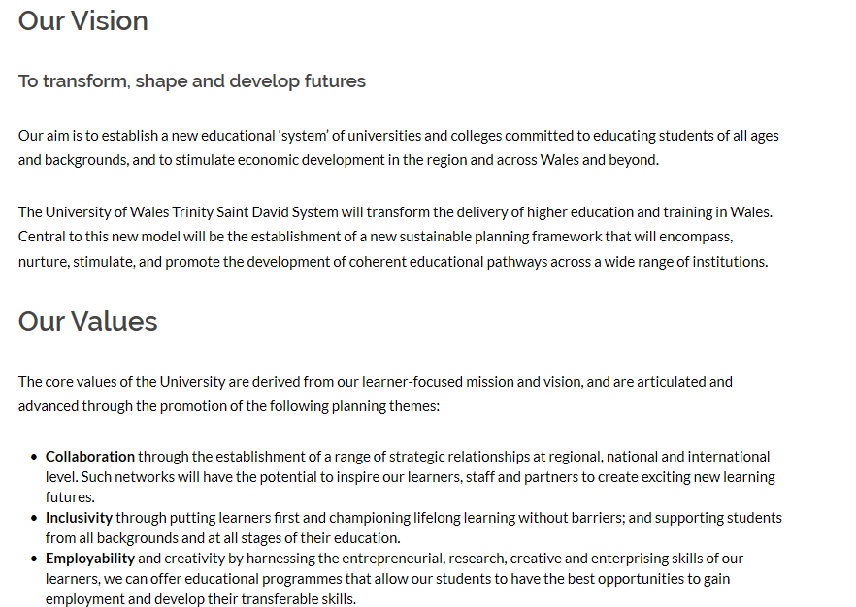
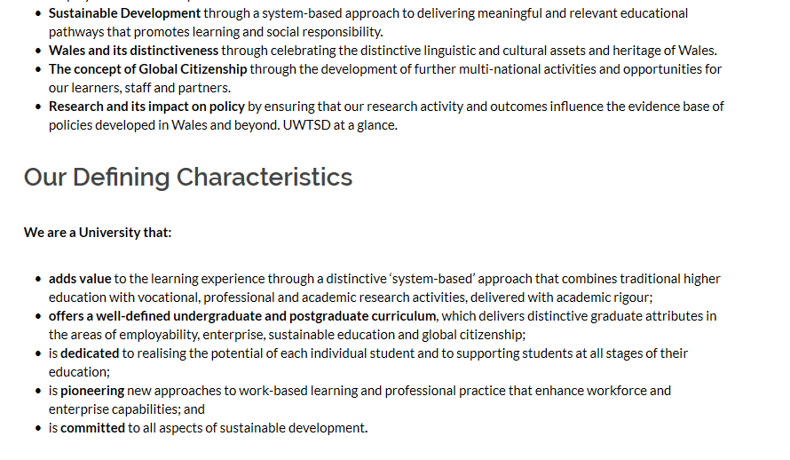

Appendix 3 - Carmarthen Business School Mission
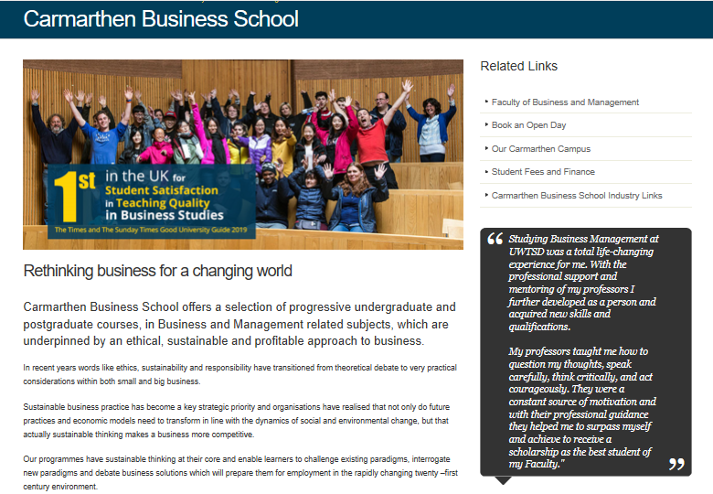

Appendix 4 - Placement Provider Agreement
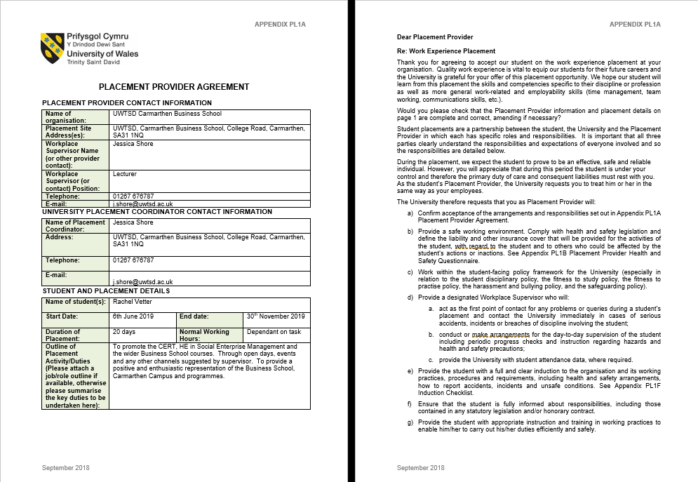

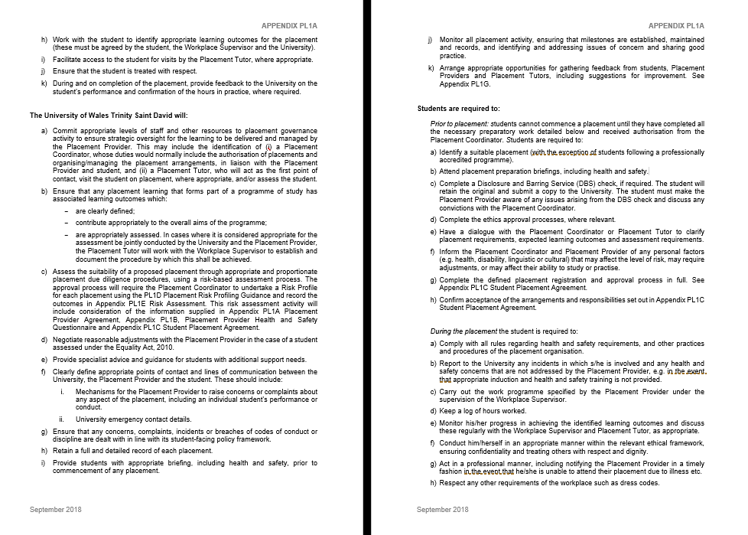

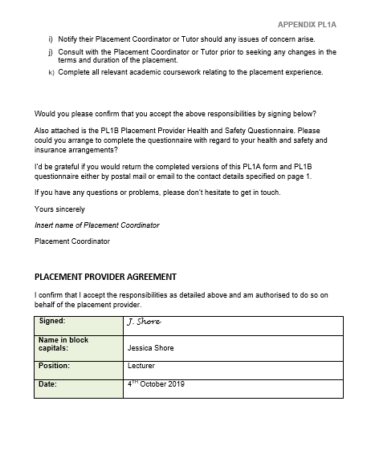

Appendix 5 – Health & Safety Questionnaire
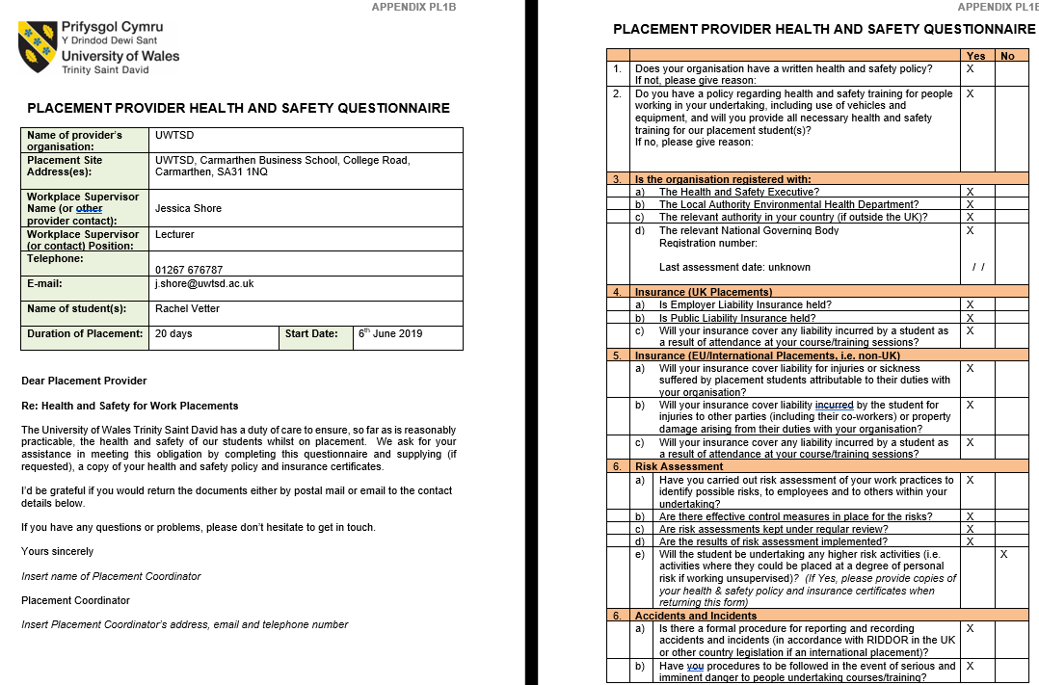

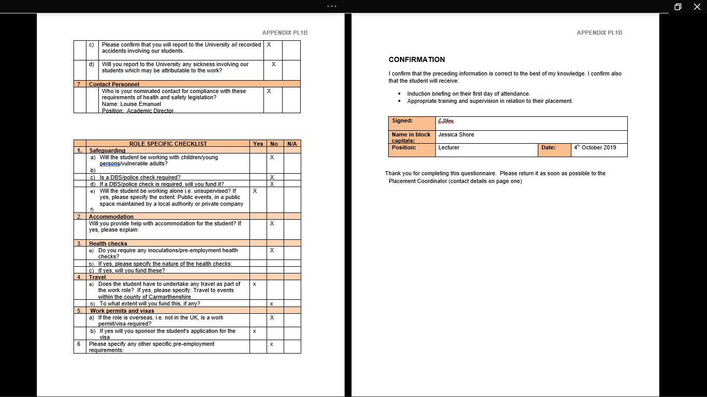

Appendix 6 – Risk Assessment
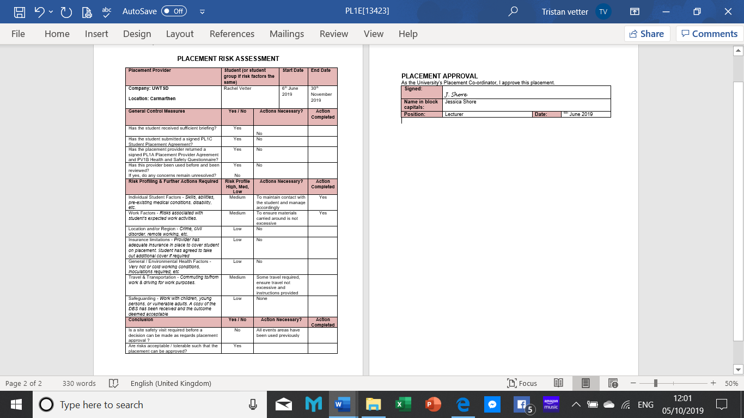

Appendix 7 – Induction Check List
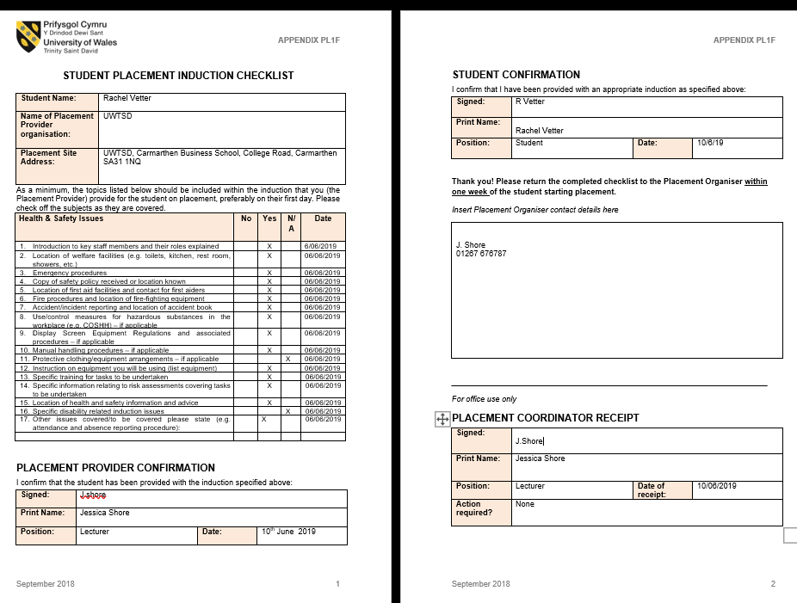

 |  | Appendix 8 SMART GOALS
Objective = To sign up a minimum of ten participants to the new one-year Business course
 | Action | Yes/No | How | Audit Skills Needed
Specific | Is this task specific | Yes | I have been given a defined outline of what is expected and what targets I need to hit. | This will use my oral and written communication skills. these are one of the areas my skills audit has shown these are in need of building
Measurable | Is the objective Measurable | Yes | Figures are recoded so will be able to see final numbers signed up | Because I will be left to do a majority of this work by myself I will need to be innovative and adaptable within a number of potential situations
Achievable | Is this objective Achievable. | Yes | As long as I have all the resources I need this will give me realistic chance, and reduce any limitations or restrictions | During the duration of this task I will also be expected to act as an effective networker. This is another skill I have noted as in need of a lot of work.
Realistic | Is this realistic, is there enough time and resources | Yes | The placement has backing of Carmarthen business school, lecturers , marketing Department | A number of resources will be required to undertake the internship, these must be sourced through the Marketing department.
Timely | Is the objective Timely | Yes | Specific time limits are in place for students wishing to start this September. | A number of dates can be added to my diary in advance of me starting my internship. An end date of 9th November has been agreed

Appendix 9
INTERNSHIP & VOLUNTEERISM
Assessment 1 – Pre-Placement Skills Audit
Name: Rachel Vetter

Placement Provider:

Date: 1 June 2019
The purpose of this skills audit is to assess your skills set prior to you undertaking your placement to establish what skills you need to improve on during your placement. Please be honest, take some time for self-reflection and when responding to each skill try to think of an example of when you may have done this.
Skill | Already there | Well on the way | Gathering speed | Not currently
I think about the whole system when working to solve problems and developing ways of doing things |  |  | X
Example: achieved regularly during my time as a cinema manger but lacking any experience in the past few years.
I have the ability to ability to address current and future problems creatively |  |  | X
Example: As an executive member Carmarthen Amateur Operatic society committee for the past two years, I have been responsible for solving several major financial issues as well as looking to the future to prevent these from occurring again.
I am confident in assessing and critiquing a range of information sources |  |  | X
Example: These skills have started growing through my studies especially through referencing

I have a critical understanding of connections between environment, social and economic factors |  | X
Example: This is something that has grown in strength over the duration of my undertaking the degree course. Through lectures, guest speakers as well as home study.

I am capable of engaging in self-reflection and analysis |  |  | X
Example: this is one of my weaker skills as I am too self-critical to reflect and analyzes effectively.
I have a commitment to life-long |  | X
Example: I Have a strong life-long commitment to my family. As well as my own lifelong learning.
I am committed to supporting and encouraging others with life-long learning |  |  | X
Example: this skill is growing due to my participation with PASS (Peer Assisted student support) and my desire to teach in the future.
I am innovative and adaptable, proactive rather than reactive |  |  |  | X
Example: This is a recognized weakness of mine. I am very adaptable a skill learnt from my time as a cinema manager, but I still feel I lack in innovative and proactive skills required. This skill could be improved on through my internship.
I am an engaging and dynamic communicator (written) |  |  |  | X
Example: I use my learning difficulties including dyslexia as an excuse for holding back when I comes to engaging with people. Not wanting to look stupid if I write something incorrectly. I will need to email various businesses though internship this may help to build this skill.
I am an engaging and dynamic communicator (oral) |  |  |  | X
Example: I can be quiet when first meeting people, I feel nervous starting a conversation especially if I do not know the other participant involved. This in something that I am constantly working on to improve. My uni journey has helped me a little to build my communication skills, but I have a long way to go.
I am an effective networker |  |  |  | X
Example:
This is an area again where I believe that my poor skills as a dynamic communicator hold me back. This skill is needed for internship.
I am an effective facilitator |  | X
Example: this skill has grown over the past two years due to my participation as a PASS leader.
I work well in cooperation with others |  | X
Example:
I am a well-practiced and effective active listener |  | X
Example: Whether as part of a uni project or as a member of the committees I sit on, I always work well with others and allow everyone to have their voice.
I can organize myself and manage my time effectively |  | X
Example: Working as a cinema manager time management was a necessity. Everything had to be completed in a timely manner. This is a skill that has followed me in the years since. This will be important during my internship.
I understand how to act as a responsible citizen | X
Example:

I have a clear vision of forthcoming change and how to act to realise a sustainable future |  | X
Example: this is a subject in which my knowledge has grown over the duration of the business course
I feel competent in leading on change for social, environmental and/or economic benefit
Example: This is another subject in which my knowledge has grown immensely over the past two years. I believe it to be such a vast subject that my learning to date has only just touched the surface.
I feel comfortable speaking openly about my values |  |  | X
Example:
I can lead with integrity driven by my own values |  | X
Example:

Appendix 10
Social Enterprise Marketing Plan

Objective
To sign up a minimum of 10 participants to study the new social enterprise level 4 certificate in higher education either online or classroom based and promoting Current Business Degree courses.
Who is it target audience?
Potential managers or those staff member with an interest in management within a social enterprise. (Can also include social based group that is looking to become a social enterprise)

Description
Course to be held within the Carmarthen business school and/or online over one year. This course offers the participants an accredited certificate of higher education in Social Enterprise Management. Subject covered will include. Developing social Enterprise, Distinctiveness and regeneration, Finance and Funding for Social Enterprise, Social and Digital Marketing and contemporary management approaches. Graduates from this programme may also go on to study level 5 BA Business Management or BA Rural Enterprise Management.
Contact
My contact during the placement will be Jessica Shore, but all communications will be forwarded to Louise Emanuel.
Strategy
In order to find potential candidate, it is essential for me to establish who and were the social enterprises are based.
Task: my initial job is to compile a list of social enterprises within
- Carmarthenshire
- Pembrokeshire
Expanding into Wales and the UK if needed

Contact businesses with known links to social Enterprises including

: Business Wales
: Spice Innovations LTD : Becca Rosenthal
: Prime Cymru- Paolo

Initial contact will be made via Email.
Task: Compose an email that can be sent to all social enterprises outlining the course, its benefits to their employees and business, costs, grants, course length. Also include the opportunity to progress onto the full degree once completed.
After two weeks send a second email or phone confirming they received the details and offering to answer any concerns or questions they may have. Invite the to the open day on July 6th or offer to come and discuss with them in person .
Other Methods
Plan days and events to advertise the course along with the Business Management Degree.
Task: Find key dates and events when promotional stand etc can be utilised.
Open day - Saturday 6th July Carmarthen, Saturday 29th June Lampeter (Required: ask Jess to book us a space).
River festival – Saturday 13th July. (Required: contact to book place)
Merlin walk – 2 days Date tba (Permission Required contact directly, stall & leaflets )
Clearing Carmarthen 12th - 18th August (Required, ask Jess to book space)
Llanelli 2-3 days (Permission Required local council, stall and leaflets)
Tenby 1 Day (leaflet drop)
Other items to include :- Timeline - Gannt Chart and SMART chart…

Appendix 11 – Gant Chart
Dates set for Marketing |  |  |  | 1st - | 1st - | 1st - | 8th | 15th | 22nd | 1st | 7th | 13th | 25th | 1st - | 16th | 1st - | 1st -
 |  |  |  | 31 | 30th | 7th | 14th | 21st | 31st | 6th | 12th | 21st | 31st | 15th | 30th | 31st | 30th | Completed
 |  |  |  | May | Jun | July | July | July | July | Aug | Aug | Aug | Aug | Sept | Sept | Oct | Nov
Activity | Start Date | Duration | End Date
Induction | 31st May | Half Day | 31st june | 31st |  |  |  |  |  |  |  |  |  |  |  |  |  | YES
NUS for Good Training Day | 12th June | Whole Day | 12th June |  | 12th |  |  |  |  |  |  |  |  |  |  |  |  | YES
Skills Audit | 1st June | Half Day | 12th June |  | 11th |  |  |  |  |  |  |  |  |  |  |  |  | YES
Marketing Plan | 1st June | Whole Day | 12th June |  | 6th |  |  |  |  |  |  |  |  |  |  |  |  | YES
Collecting Resources | 1st June | Half Day | 12th June |  | 7th
Open Days | 6th July | Whole Day | 9th Nov |  |  | 6th |  |  |  |  |  | 17th |  | 7th |  |  | 9th
Admin Days | 1st June | Whole Day | 30th Nov |  |  |  | 14th |  |  | 3rd |  |  | 27th |  |  | 22nd | 5th
Leaflet distribution | 1st June | Whole Day | 30th Nov |  |  |  |  |  |  |  |  |  |  |  |  |  |  | ongoing
Promotion Day Swansea | 7th July | Whole Day | 7th July |  |  | 7th
Promotion days Carmarthen | 1st July | Whole Day | 31st Aug |  |  |  |  |  |  | 1st & 2nd
Promotion days Llanelli | 1st July | Whole Day | 31st Aug |  |  |  |  |  |  |  | 8th & 9th
Clearing Week Promotions | 10th Aug | Whole Day | 16th Aug |  |  |  |  |  |  |  |  | 13/14/15
Registration Day | 18th Sept | Half Day | 18th Sept |  |  |  |  |  |  |  |  |  |  | 18th

