University of Wales Trinity Saint David
Cyrille Tounoudjou (1914188) 07/04/2023

BMSW6103_SWAN: Report: Major changed: NHS Wales
Lecturer: Maria Heffenen

Executive Summary
This report will evaluate the proposed digital change at NHS, Wales. It is based on the implementation of a digital app for better connectivity with the customers. It is also expected to improve the experience of the customers along with efficient management of services that are offered by this entity. There is a detailed overview of NHS, Wales with its financial review, operational capabilities, and the historical developments before evaluating the proposed change. The digital change will impact the mode of operation for this entity as the customers are looking for online appointment, test reports before reaching out physically to their health service providers. Similarly, the expected impact on the coverage of the NHS is analysed that is combined with the recommendations to manage the potential challenges. These recommendations are based on the type of change, scale of operations at NHS, and the market developments in the healthcare sector.

Contents
Executive Summary 1
1.0 Introduction 3
2.0 Findings 3
2.1 Historical Development 3
2.1.1 Sector it Operate in 3
2.1.2 Overview of Services 3
2.1.3 Size and Scale of the Organization 3
2.1.4 Location of the Business Unit where Change is Focus 3
2.1.5 Financial Review 3
2.1.6 Description of the Proposed Change 3
2.1.7 Nature of Change 3
2.2 Change Agents in this Moment. 3
2.3 Micro Influences – SWOT 3
2.3.1 Strength. 3
2.4 Impact of Changed 3
2.4.1 Operational Capabilities 3
2.4.2 Improvements Related to Coverage 3
2.5 Leadership – Management in Relation to Changed 3
3.0 Conclusion 4
4.0 Recommendation 5
References 6

Introduction
NHS Wales is a healthcare system that is a part of combined healthcare infrastructure of the United Kingdom (UK). The UK is covered by four public healthcare service providers based on geographic locations as England, Northern Ireland, Scotland, and Wales. These are publicly funded organizations as government focuses to provide free healthcare services to the population (Ham, 2020). It impacts the larger population of the country.

Findings

Historical Development
The National Health Service act was implemented in 1946 however; NHS Wales was established in the year 1969. There were twenty-two local health board, and seven trusts were created in the year 2003. This transformation outlined the specific responsibility and geographic area for each health board. The outlined was provided for emergency services, primary and secondary services along with specialist services in this sector. These specific smaller health bodies were assigned the local area and population to tackle the medical needs.
However, this system was too complex to manage by the central body because each of the 4 NHS had multiple local boards in the four countries that are part of the UK (Kerr et al, 2019). So, in the year 2009, the existing system of twenty-two local boards and seven trusts were dissolved and was replaced with a seven board and three trusts which are in use till now.

Sector it Operate in
The services that are offered by NHS, Wales are divided into three categories Primary care, secondary care, and Tertiary care. These are available at every NHS centre. However, the major focus has been on providing timely healthcare support because of clinical need and not because of ability to pay of the patient. Primary care is the first point of contact which includes pharmacists, dentists, and general physician (GPs). It also includes the routine health check-up and long-term medicine intake of the patients without any meaningful change in the medication soon. The basic facility to continue with the same treatment for years is also considered a primary care but only after the secondary and Tertiary care related processes are done. Secondary care offered by NHS; Wales include two types of treatments. First is planned or elective care which is appointment based and at a pre-determined time (Liddle et al, 2014). For example, a cataract operation or a dental surgery is pre-planned so comes under elective or planned. Similarly, the tertiary care is about emergency and long-term treatment. Which required physical presence of the patients and doctors. This is different from the other categories as it requires multiple visits or treatment.

Overview of Services
NHS Wales provides healthcare services to three million population of the country as it operates on national level. The major aspect of healthcare responsibility of Welsh government is categorized as consultation and treatment. The patients can raise their concerns to the consultants before finalizing the required treatment. It maintains the records of each activity, so the prior consultations are also available to refer the medical history of the patients by current consultant (Carson-Stevens et al, 2016).
Apart from health and social care strategy, NHS Wales also has its publications, and statistics & research domain where it reviews the existing data and develop the pattern or trends in the diseases and cures. It follows the healthcare strategy set by Welsh government and ensure it is implemented across the different geographical areas of country. NHS Wales implements and monitor this strategy through seven medical board and three trusts. NHS, Wales has 88,638 employees as per September 2021 review (Ahmed et al, 2021). However, there is additional staff on contract for short term needs in a particular location. The medical camps and emergency support to a remote area usually sees a deployment of local people as short-term employees. So, it is a well-established organization that is large in both size and scale of business operations. It is the biggest employer in the Wales so provide the economic boost to the economy through the indirect money supply along with meeting the primary goals of effective and efficiency healthcare services.
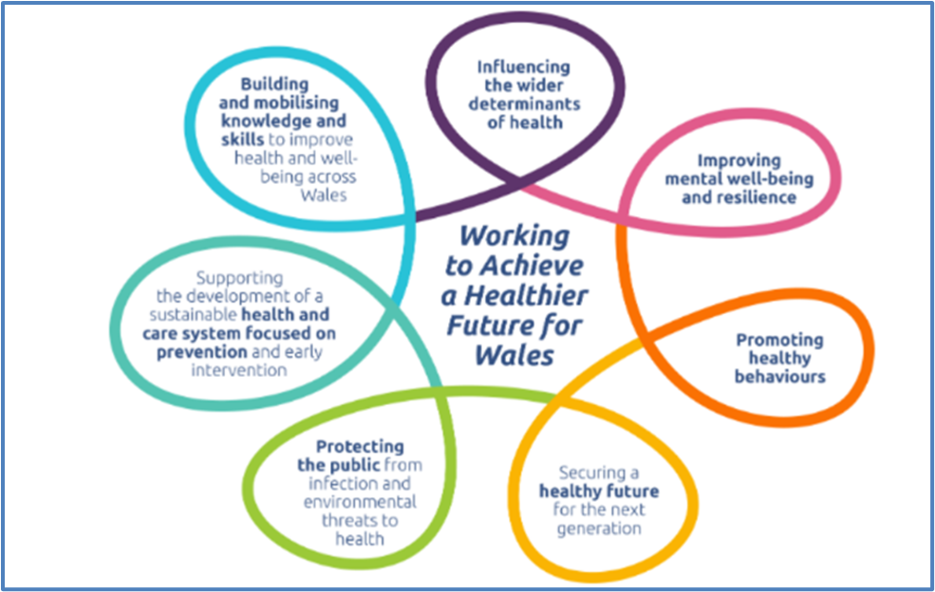Figure 1: Focus areas for NHS, Wales: Source: NHS, Wales (https://phw.nhs.wales/about-us/our-priorities/)

Size and Scale of the Organization
NHS Wales provides healthcare services to three million population of the country as it operates on national level. The major aspect of healthcare responsibility of Welsh government is categorized as consultation and treatment. The patients can raise their concerns to the consultants before finalizing the required treatment. It maintains the records of each activity, so the prior consultations are also available to refer the medical history of the patients by current consultant (Carson-Stevens et al, 2016).
Apart from health and social care strategy, NHS Wales also has its publications, and statistics & research domain where it reviews the existing data and develop the pattern or trends in the diseases and cures. It follows the healthcare strategy set by Welsh government and ensure it is implemented across the different geographical areas of country. NHS Wales implements and monitor this strategy through seven medical board and three trusts. NHS, Wales has 88,638 employees as per September 2021 review (Ahmed et al, 2021). However, there is additional staff on contract for short term needs in a particular location. The medical camps and emergency support to a remote area usually sees a deployment of local people as short-term employees. So, it is a well-established organization that is large in both size and scale of business operations. It is the biggest employer in the Wales so provide the economic boost to the economy through the indirect money supply along with meeting the primary goals of effective and efficiency healthcare services.

Location of the Business Unit where Change is Focus
The proposed change is not limited to any one local board or the three trusts of the NHS, Wales. The digital app of NHS will be available across the Wales, so the entire geographic area of the country is covered by this service. However, the community centre or physical service delivery centre are not feasible in each corner of every city. So, the digital mode of operation will be helpful to register the health issue by the patients and receive immediate consultancy through their smart phones (Prowle, 2013). The proposed change will replace the queue-based system at every NHS centre across the country as their will be App based appointment and relegation of basic services. However, the secondary care services are not possible to deliver through this app as the patients need to visit the NHS centre for their treatment. So, the limitation of proposed change will not be location driver, but it will be service driven. The primary care serviced will be fully aligned with the digital mode of operation while the secondary and tertiary care services will continue to be rendered at NHS centre though; the follow-on consulting process will be easier using the proposed App.

Financial Review
NHS, Wales has an annual budget of GBP 8.3 billion which is reviewed and revised each year. The financial summary is provided for each unit separately as seven boards and three trusts are evaluated based on their deficit and surplus. NHS, Wales is not for profit organization, but the break breakeven is the basic need to keep it operational. However, the long-term sustainability is based on the combined resources, so the consolidated statement reflects that NHS is not able to break even in the year 2021 (Rowley et al, 2020). Also, two boards overspent their budget fifth time consecutively as their receipts were overshadowed by their spent during the year 2021 as well. However, the positive aspect of current one year review reflects that the deficit has come down to GBP48 million from GBP89 million. Also, there was additional funding during the Covid-19 pandemic which resulted more expenditures. The classification of expenses is as follow:
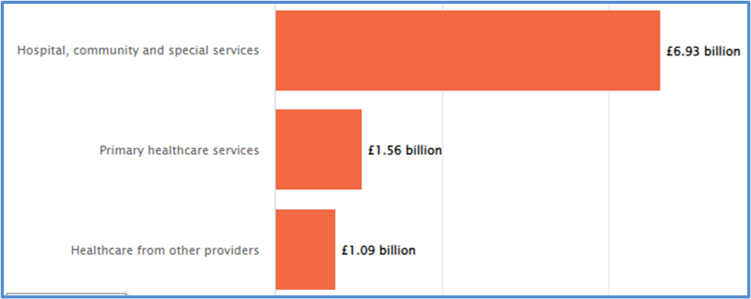Figure 2: Classification of expenses

Description of the Proposed Change
The NHS Wales aims to transform the healthcare services through digital applications. The service providers in this sector go through a lengthy process of understanding the issues of patients that are combined with several tests and reports. So, it takes considerable time to provide the required prescriptions and consultancy to the patients (Phillips et al, 2016). This process of consultancy and test reports will be optimized with limited human resources required as there will be app-based activities.

Nature of Change
The nature of change is operational as the management aims to replace the traditional process of business operations with a digital process without any physical movement of the patients or doctors. This operational Change will reduce the time taken into the administrative part of the medical process so a greater number of patients can be treated in each time.

Change Agents in this Moment.
Movement to app-based services will enable the NHS to increase operational efficiency. However, the technical knowhow that is required in the healthcare sector will be a challenge as the digital interaction between the doctors and the patients are limited. The companies in the healthcare sector need to ensure complete end to end medical care and support to the patients, which is not feasible through the digital mode, only (Ahmed et al, 2021). So, the movement towards digital platforms is to achieve efficient processes which are part of complete medical treatment. However, there are basic Medicare services which can be closed using the digital app only. These include tracking the medical history of patients, self-understanding or monitoring by patients, and the planning of their meeting with doctors. So, the current motive of this app covers the information to the customers to personalize their health journey, to effectively monitor their health conditions, share, and receive that information to/from the service providers as it results to stay healthy for longer time, take an active part of healthcare planning and wellbeing. So, the patients can take control of their healthcare journey.

Micro Influences – SWOT

Strength.
Skilled and experienced management is considered a major strength for any organization. The specific skills and area of expertise help to align the strategic implementation with the objectives of the organization. NHS, Wales enjoys ample support from the government which ensures that there is enriched experience and skill set with the management of it. The boards and trusts are constituted based on the specific goals of each program and health service. So, there is an initiative-taking approach for the potential issues at operational and strategic level.
Vast but focused coverage is another significant aspect that provides a competitive edge to NHS over its competitors. The availability of multiple products or services provides constructive interaction to the overall organizational setup (Cylus et al, 2015). So, the coverage of multiple healthcare needs of the patients provides increased potential for NHS to attract more patients. It is easier to maintain and track the progress by the patients if the healthcare services are availed from a common service provider. However, it is complex to manage multiple products for any business because it requires optimization of available resources. NHS, Wales has vast coverage to counter and minimize this risk of complexity because the “economies of scale” for each service offered help it to maintain the cost barriers under check.
Clinical efficiency for decision making is another major factor for healthcare related services providers. There are multiple reasons such as intense compliances and low margin of errors. These companies need to adhere to each regulatory obligation which are more vital in this industry as it directly affects the wellbeing of the customers (patients). The large-scale operations of NHS combined with deep understanding of the geographical needs of the population make the board of NHS a sustainable one overall. The expertise level in this setup is unmatched as reflected by the preference of the citizen of Wales. The clinical efficiency is certainly a strength for the company.
However, an inconsistent flow of operations or the demand is a weakness for a business irrespective of its sector and industry classification. It hampers the organizational planning and strategic implementation. NHS, Wales has the target population from diverse geographic location and cultural background. The healthcare needs and approach of such diverse population implies that the demands will not be standardize across the communities and locations of business units (Pitchforth et al, 2019). So, it is a weakness because uncertainty around the expected demand implies ineffective planning and budgeting.
Time bound process for any business operations limit the potential solution and effectiveness. However, the standard procedures and frequency of processes provides necessary support to improve on the time bound activities. NHS, Wales has this weakness that it covers the complete geographic territory so there is limited time to respond to patients’ needs. The resource optimization is not possible if there are emergency in the operations. However, the digital movement at NHS is supposed to help the planning and implementation of the healthcare services.
Furthermore, the major threat for NHS is based on the changing market dimension and customers’ preferences. Change of market dimensions is about more specialist demands and smaller but specialist players in the market. The companies in each sector need to develop their product or service to align the changing dimension of market. So, NHS Wales also needs to understand the post pandemic awareness about self-health care and specific preferences of the patients. However, the scale and size of NHS coverage implies that it might not be feasible to focus on specific demand and preferences of the customers. Although, it needs to be feasible eventually because these changes in the patients’ awareness are generational and stable for future so the management at NHS, Wales need to manage and eliminate this threat. However, the increased awareness about the digital operations leads to the fact that there are increased number of people who prefer online connectivity and communication with their healthcare service provider. The appointment, tests’ results and progress are monitored online which shows the importance and potential impact of this change at NHS, Wales.

Impact of Changed

Operational Capabilities
There are different improvements in the operational processes at NHS, Wales post the implementation of digital changes. The classification of patients’ demands, and needs are easier and efficient. Similarly, the allocation of resources as per the classified demands needs is expected to improve which will result in cost saving. However, the risk of missing any key information about patients or their medical history is also visible as this will be a new experience for both the parties (Ahmed et al, 2021). The app-based healthcare services will enable to take the minor details into consideration because these are expected to be stored in each patients’ data base or account. However, the classification of information is vital to capture and record all the information related to health and medical history.
The change will provide the patients with the access to their health-related information so there will be newer ways to use that information and take corrective action. The responses are not limited to the healthcare experts because the patients and their care takers can act on the available information about general health. Similarly, the diet planning will be easier as the food history will be combined with the medical treatment history so the patients, themselves, can take the appropriate diet that goes with their current medical treatment and history of treatment.

Improvements Related to Coverage
The challenge for NHS, Wales has been to provide healthcare support to total population of three million. However, the offline mode of operations lacks to meet this objective as there were compulsory regulatory obligations to follow and fulfil. It helps to increase the coverage for NHS as the time consumed in the manual appointments and consultancy hours will be replaced by the online booking and discussion with the experts for basic needs of patient. So, the digital change will enhance the coverage as the staff at NHS will be freed from appointment and managing the queues at the business units.
Furthermore, the digital change will increase the number of physical units of NHS that serves the people of Wales. The digital change implies that there is reduced need of physical store. The healthcare sector is governed by multiple compliances, so the companies need to adhere to the meet those compliances which is additional burden on the overloaded demand of coverage (Cylus et al, 2015). The app-based transformation of the operational process enables to automate the required compliances and regulatory obligations. So, it will reduce the human resource required during the service process or the treatment of patients if the regulatory obligations are automatically managed based on information available on the digital app. The support staff at NHS, Wales need not to contact the patients or their care takers for the basic details as it will readily be available on the App.

Leadership – Management in Relation to Changed
The management style is also a significant driver for the planning and implementation of change. The Handy’s theory about organizational culture reflects that the management approach in any organization leads to distinct cultures. These are classified as person, task, role, and power culture. NHS, Wales is a public body with which is driven by the tasks based on the location-based operations. The person culture is not applicable for this digital change as it is not driven by the person but by the ease of completing the task (Alhiddi, 2022). However, the advantages of this change will also include the reduction in the human resource requirements in the operations of NHS. Similarly, the role culture is not associated with the management structure of NHS as it has standard operating procedures in place. The changes based on the individual or departmental roles is not related to this digital change at NHS. So, the power distribution is low as the individual capacity to drive such change is low. However, the level of cooperation is not poor as there is effective coordination among the different units as the resource allocation is also based on the internal communication. Thus, the appropriate management style that is applicable for this digital change comes with low power distribution and prominent level of cooperation. The task culture is the visible management style at NHS, Wales.

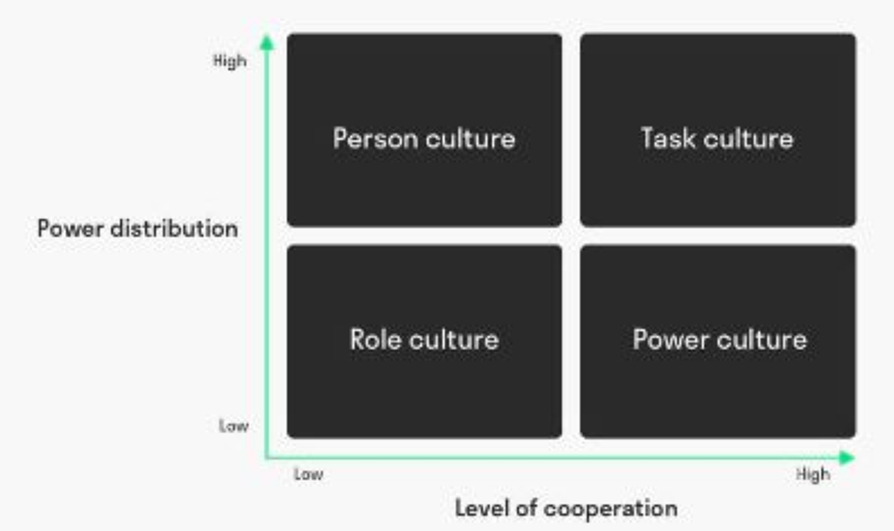
Figure 1: Handy's model of management style

Furthermore, the change agents can be identified as heads of each unit of NHS, Wales. The boards compile the periodical review of each unit and evaluate the improvement areas. However, the individualistic approach is not reflected in the digital change as the decision making is not concentrated. So, the driver of changes is identified as the processes or the tasks at NHS rather than the top management. The concentration of periodical review provides the larger picture of NHS so the decision making about the potential change is easier. It helps to understand the current trends in the market and development in the customers’ preferences. The introduction of NHS app is a result of such evaluation as the organization focuses to optimize the operations.

3.0 Conclusion
The impact of this change will be positive based on the above evaluation so it can be concluded that the digital shift in the NHS, Wales operations will increase its sustainability. The federal and state government in each country focuses on the timely improvement in public health, education, and safety along with basic survival for their policy formulation and implementation. The government funded medical boards and other institutions serve as information providers for the policy related decision making by the government and other regulatory bodies. The NHS, Wales has frequent reviews of the performance for each of its board and trust. The resource allocation along and the required changes are finalized based on these periodical reviews. However, the contribution of management style is significant as it is focussing on operational processes along with taking the current market trend and technological advancements into consideration. The power distribution is not concentrated so it helps to eliminate individual or functional bias. The cooperation among the units and the target population coverage will decide the success level of this app. These challenges are easily outnumbered by the benefits of digital change at NHS but these need to be eliminated for optimized outcome in operational efficiency and comfort of the target customers.

4.0 Recommendation
The below table depicts the PDP recommendations for this digital change at NHS, Wales:
Table 1: PDP recommendations
Recommendation Objective | Measures-What action will be undertaken to resolve/improve | Priority  High/Medium/Low | Support & Development-  External/Internal | Review dates | Other comments
Effective system of red flags for any deviation from the planned developments | Evaluation by top management based on the number of red flags identified by the operational teams | High | Internal management will track and maintain the records of red flags and their solutions | Every month after since the implementation begins | It is required to for cost control of this change as the timely detection of problem areas will lead to initiative-taking solutions with least cost
Change agents should decision making power to fix operational issues | The level of hierarchy crossed by/ involvement of senior management in an operational issue | High | Internal processes need to record and report this data | Every three months | It will help to increase the efficiency in the implementation process. The operations post this digital change will also have positive impact due to efficient decision making
Training and development session for the workforce to align their approach with the digital change | HR team will maintain the skills set and sessions completed by the employees | High | External trainers and resources are required along with internal systems | Weekly | Understanding of digital change will help to balance the objectives of workforce and organization.
Phase based implementation and adjusted the following phases’ implementation on the actual experience and outcome from first phase | Functional managers will evaluate the implementation of their respective departments | Medium | Internal management will monitor the implementation | Monthly | Reduce the risk of significant failures will enable effective implementation

References:
Ahmed, M.U., Tannous, W.K., Agho, K.E., Henshaw, F., Turner, D. and Simmons, D., 2021. Prevalence and burden of diabetes-related foot disease in New South Wales, Australia: evidence from the forty-five and Up Study survey data linked with health services data. International Journal of Environmental Research and Public Health, 18(21), p.11528.
Alhiddi, A.M., 2022. Building better together: the relationship between organisational culture and stakeholder critical success factors in construction projects (Doctoral dissertation, Northumbria University).
Carson-Stevens, A., Hibbert, P., Williams, H., Evans, H.P., Cooper, A., Rees, P., Deakin, A., Shiels, E., Gibson, R., Butlin, A. and Carter, B., 2016. Characterising the nature of primary care patient safety incident reports in the England and Wales National Reporting and Learning System: a mixed-methods agenda-setting study for general practice. Health Services and Delivery Research, 4(27), pp.1-76.
Cylus, J., Richardson, E., Findley, L., Longley, M., O'Neill, C., Steel, D. and World Health Organization, 2015. United Kingdom: health system review.
Harrison, S., 2013. Managing the National Health Service: shifting the frontier?. Springer.
Kerr, M., Barron, E., Chadwick, P., Evans, T., Kong, W.M., Rayman, G., Sutton‐Smith, M., Todd, G., Young, B. and Jeffcoate, W.J., 2019. The cost of diabetic foot ulcers and amputations to the National Health Service in England. Diabetic Medicine, 36(8), pp.995-1002
Pitchforth, J., Fahy, K., Ford, T., Wolpert, M., Viner, R.M. and Hargreaves, D.S., 2019. Mental health and well-being trends among children and young people in the UK, 1995–2014: analysis of repeated cross-sectional national health surveys. Psychological medicine, 49(8), pp.1275-1285.
Phillips, C.J., Humphreys, I., Fletcher, J., Harding, K., Chamberlain, G. and Macey, S., 2016. Estimating the costs associated with the management of patients with chronic wounds using linked routine data. International wound journal, 13(6), pp.1193-1197.
Prowle, M.J., 2013. Re-balancing the roles of public and private health sectors in Wales. International Journal of Public and Private Healthcare Management and Economics (IJPPHME), 3(3), pp.29-43.
Rowley, S. and Clare, S., 2020. How widely has ANTT been adopted in NHS hospitals and community care organisations in England and Scotland?. British Journal of Nursing, 29(16), pp.924-932.

