University Of Wales Trinity Saint David

PGCERT Professional Practice (Leadership in Emergency Services)
Leadership and Change

Part I
“Critically evaluate the organisational culture and its influence in the context of change initiatives.”
“A critical examination of the complex nature of challenges for the leadership role within times of organisational change.”

Part II
“A change idea - The benefits of feedback on clinical practice.”

Module Code: BMPF7023
Student Number: 2241355
Date of Submission:
Word Count: 5450
Tutors: Julie Crossman
Cohort: 5

Table of Contents

Table of Contents Page 2
Summary of Abbreviations Page 3
Introduction Page 4 - 5
Part I Page 6 - 18
Part II Page 19 - 26
References Page 27 - 32
Appendix Page 33 - 38

Summary of Abbreviations
CG Clinical Governance
CPD Continuous Professional Development
EMT Emergency Medical Technician
HBCL Health Board Clinical Lead
MTC Major Trauma Centre
NQP Newly Qualified Paramedic
ODN Operational Department Network
RTN Regional Trauma Network
SP Senior Paramedic
TU Trauma Unit
WAST Welsh Ambulance Services NHS Trust

Introduction:
I am currently employed within the UK ambulance service, as a Senior Paramedic specifically assigned to the trauma network as a trauma desk senior clinician. This has been my current role since 2021. My paramedic career began in 1996 beginning as an Emergency Medical Technician (EMT), then qualified as a paramedic in 1999.
My career has been varied yet rewarding throughout, my knowledge skills and expertise has developed allowing me to care for my patients. I am also a paramedic placement educator working with the university supporting the educational and clinical needs on an operational basis for student paramedics.
My specific role is unique as it provides a dual function for the Regional Trauma Network (RTN) and the ambulance service. For the trauma network, the trauma desk is based within the ambulance control room overseeing trauma calls, where I provide remote specialist advice to ambulance clinicians pre-hospital, nurses and doctors within hospitals who are involved with the care of major trauma patients. Clinical management, patient movements and hospital destinations have evolved over recent years, depending on the specialty needs of the patients. This will mean bypassing their nearest hospital to reach a Major Trauma Centre (MTC), in doing so, will spend a longer time with a critically ill patient and l aim to empower them to do so. I have a close working relationship with other healthcare professionals most notably hospital consultants. I can facilitate conference calls between hospital teams to discuss trauma patients and provide remote clinical support to ambulance clinicians regarding clinical practice guidelines and patient group directives.
As a senior paramedic for the ambulance service, as part of the clinical leadership team I am at the forefront of clinical practice, clinical leadership, guidance and
ensuring adherence to established clinical practice and future updates. As a specialist ambulance response, it allows me to be tasked to the most appropriate incidents to provide not only patient care but clinical leadership also. Staff engagement, empowering, patient care, learning and adapting to change is at the forefront of pre-hospital emergency medicine (Bjorklund et al, 2022).
The author will research, critique, and appraise three organisational culture theories. As new culture theories and styles have been introduced and adopted, with the evidence available alongside personal experience and behaviours will help identify the benefits and risks in introducing them into practice. The chosen theories will be evaluated with specific relevance to the pre-hospital workplace and critically examine the effectiveness of each cultural change style. Each theory will be considered on its own merits and the suitability each theory brings to cultural management including internal changes. To conclude the author, relevant to cultural changes will highlight a change idea within the ambulance service, with the rationale, findings and recommendations and the benefits to staff and the leadership teams.

Part I:
A M Pettigrew (1979) can be credited with the concept of organisational culture following his 1979 article ‘On Studying Organisational Culture’. Pettigrew explored the processes with organisational cultures which he identified with the inception of organisations, with this in mind he went on to describe culture as rituals, myths, beliefs, and identity. Over the years, these terms have been modernised, and to this day still used widely (Sminia, 2017).
In more recent years, organisational culture is described as values, beliefs, and attitudes and how these beliefs can influence behaviours, psychological and social contributions (Akpa et al, 2021). Culture within organisations that promote such values reflect a strong culture, with improved performance which can also naturally evolve over time (Carvalho et al, 2019).
The Welsh Ambulance Service (WAST) set out its revised core behaviours and beliefs in 2022, which underpins the foundation of the organisation. All staff, no matter what position they hold are expected to uphold and promote these behaviours. The following seven behaviours have a direct influence on the way colleagues uphold themselves and re-enforces the organisational culture expectations for those that wish to aspire to (Welsh Ambulance Service, 2022).
These behaviours are; Firstly, to take ownership, secondly, to broaden understanding, thirdly, to respect others, fourth, to show belief in each other, fifth, to practice ethically, sixth, to continually improve our service, and lastly, to be inclusive of the whole team (Welsh Ambulance Service, 2022).
Sackmann (1991) stated that every organisation culture will develop over time by practises and behaviours which mature, and subsequently adopt a normal feeling, and then, de facto, become the culture of an organisation. Similarly, leaders of an organisation can introduce behaviours and practices which again become the culture over time. Sackmann (1991) describes this as the iceberg effect, whereby only small parts of the culture are visible compared to what lies below the waterline (Stanley & Swann, 2021).
Exploring Sackmann’s theory further, Edgar Schein (1992) stated that an organisations culture is not formed in a single day, rather it is forged over time as employees adapt to multiple changes. Historical experiences are reflected upon, which transfer to form the new culture of the workplace. It takes all grades of staff to implement change. Learning and adapting from previous experiences, reflecting on the negative and positives, together bond as a group to form the cultures within an organisation (Warrick, 2017).
Edgar Shein (1992), a Swiss born psychologist argued that existing culture is the primary reason of resisting change. Shein, further adds that there needs to be a clear understanding of the dynamics within an organisation, and that culture is commonly the biggest hurdle of resistance to change (Anderson-Wallace & Blantern, 2017). Schein’s theory stresses that organisational culture is a significant barrier to change and to succeed in effective leadership, this culture must be understood. To understand effective leadership, Schein created three levels of culture (Coghlan, 2020).

Schein’s three levels of culture theory which underpins effective leadership are, firstly, artifacts which describe any overt, visible, or describable aspects of an organisation. For example, branding, uniform, policies or tools, the things you can visibly see. Secondly, espoused values, which staff would describe the organisation in current or aspirational status. For example, value and mission statements. Thirdly, assumptions that are underlying, those unconscious feelings that are unspoken and difficult to put forward. Especially from within (Gagliardi, 2017).
Ambulance services across the world are all recognisable, which fits well within Schein’s culture theory. Ambulance staff wear uniforms with emblems and specific wording identifying them. Ambulance vehicles are instantly recognisable with their blue lights, box like shape and reflective colours. At a local level, WAST as an organisation, are patient facing staff and other operational staff wear the same branded green uniform, matching vehicle livery, and staff adhere to policies and guidelines as set out by the organisation. This would meet Schein’s artifact culture (Gagliardi, 2017).
Recently, there has been an update to WAST’s trust’s behaviours. Senior management have approached staff to find out what is important to them as an employee, therefore relating to Schein’s espoused value. The behaviours are visible across the service, in trust vehicles, posters, emails and the organisations intranet. Senior paramedics are well placed within the ambulance service to promote and encourage the trust behaviours (WAST, 2022).
Schein’s underlying assumptions are apparent subconsciously in the workplace. It can be seen as an unwritten rule or mutual understanding between staff. Examples of this is, is that it is commonplace for staff to arrive early for shift, which would allow for an on-time finish, and this would be reciprocated. Taking care of another
crew's patient at hospital to allow the staff to finish work and not be too late finishing. This would reduce fatigue and promote wellbeing amongst colleagues. Again, this would be reciprocated. The willingness to offer or assist colleagues without the need to be asked, knowing that the help would make their day that little bit easier. A silence, unwritten rule is that the ‘Q’ word is not mentioned as the verbalising of the word ‘quiet’ usually brings about a busy or significant incident. It can be argued that Schein’s theory is well suited to the ambulance service.
Geert Hofstede (1980), an expert in the field of psychology undertook one of the most detailed studies of how values in the workplace can be influenced by culture and institutionalism. Hofstede (1980) quantified four national culture dimensions, originally taken from a study of IBM employees working across more than fifty countries (Sent & Kroese, 2022).
With co-operation, a decade passed and in 1990 led by the duo of doctors, Bond and Minkov a further two dimensions were added, thus creating Hofstede’s six cultural dimensions. This framework is used in a variety of fields such as international business, cross-cultural management, and psychology (Hofstede & Minkov, 2010).
These six dimensions are firstly, power distance index, which considers the curve of which power and inequality are tolerated. The higher the index score would deem that culture accepts both power differences and inequity and promoted bureaucracy with a higher proportion in respect for rank and authority. In contrast, a lower score means that culture promotes flat organisational structures, decentralises decision making ability and has a greater emphasis on power distribution (Bruyneel, 2019).
Then collectivism versus individualism, considers the degree to which societies are integrated into groups and their perceived obligations and dependence groups. Collectivism indicates a greater emphasis on goals and wellbeing, in contrast to collective backgrounds whereby prioritising relationships and loyalty over others. In comparison, individualism focuses on personal achievements, oneself, and one’s immediate family (Fatehi et al, 2020).
Followed by the uncertainty avoidance index, which looks at how the unknown situations and unexpected events including uncertainty unfold. Obtaining a high score indicates a lower tolerance for risk taking ambiguity and uncertainty. The unknown is minimalised through strict rules and policies and employing vigorous rules and regulations. At the other end of the scale, there is high tolerance. The unknown is more openly accepted, with more relaxed rules and policies, and those will feel at ease with a lack of structure with fluctuating environments (Watts et al, 2020).
Next is femininity versus masculinity, or gender role differentiation, exploring the extent to which traditional roles are valued in society. A high femininity score holds significant value within society, such as improved maternity benefit and more accessible childcare services. Compared to a low score indicated an increased female representation in leadership roles and entrepreneurs. Masculinity characterises distinct gender roles, assertiveness, strength, and competition (Crowley and Sandhoff, 2017).
Then there is short term versus long term orientation, which details how society views its time horizon. Emphasise is on short term orientation focusing on the near future and will aim to deliver short term success or praise. There is greater concentration on the present rather than the future. Quick results and respect are sought. In contrast, long term orientation looks for taking centre stage, embrace values like endurance, persistence, and sustaining growth (Figlio et al, 2019).
Lastly, restraint versus indulgence, which explores desires and how impulses are controlled in society. Restraint indicated that society suppresses gratification and regulates it through social normality, and indulgence allows an element of gratification with enjoying life and having fun. A high indulgence score is those that spend more or have more luxuries, enjoy freedom, and explore leisure activities. Conversely, a restrained society incline more towards savings, thriftiness and thrive on practicalities (Sun et al, 2019).
Hofstede’s dimensions require certain nuances to become effective. Jackson (2020) states that those countries with strong cultural similarities will score well, like those where countries border each other as they have an understanding and appreciation for each other (Jackson, 2020). Minkov (2017) argues that Hofstede’s dimensions can still shed light on cultural differences even with the world become more diverse as behaviours can be explored and contrasted, even though through diverse cultures (Minkov et al, 2017).
There has been significant criticism of Hofstede’s theory, as Moonen (2017) suggests that the questionnaire used was haphazard and not designed to evaluate cultural values, but rather to determine job satisfaction at IBM. Moonen (2017) also argued that Hofstede’s IMB conclusions were based on inadequate sampling from forty countries, however just six countries had more than a thousand respondents and fifteen further countries had fewer than two hundred responses. Kasa et al (2021) concluded that it is no way appropriate or acceptable for two hundred people to speak on behalf of a country of millions (Kaasa et al, 2021).
Most notably Eriksson (2021) stated the world we live in has changed, along with cultures and beliefs, reinforcing the consensus of Hofstede’s original idea being out of date and out of touch from reality, and not relevant in the twenty first century. It is puzzling that Hofstede’s cultural theory will continues to receive the popularity that it does. More so, that researchers have made several attempts to replicate Hofstede’s findings and have struggled make it succeed (Eriksson, 2021).
To reflect, staff engagement is key in establishing culture change within the ambulance service. Without staff input, concerns, and ideas a shift in culture will not work. Communication between stakeholders, senior management, clinicians, and staff of all grades need to break down previous barriers to enable effective communication. Culture and behaviours are historically embedded and improving staff relationships and welfare is key to creating long lasting and trusting relationships. WAST are continually moving forward with culture changes through engagement, support, feedback, taking onboard staff's ideas and their thoughts. It is about breaking down barriers and empowerment of staff to enable those to thrive and embrace WAST’s behaviours and beliefs (Welsh Ambulance Service, 2022).
Kurt Lewin’s (1951) model is heavily regarded as the classic or fundamental approach to manage change (Lewin 1951). Lewin, a social scientist in the 1950’s devised and implemented a simple model with foundational significance. Lewin titled his model in three stages or Changing as Three Steps (CATS). These stages are, stage one is to unfreeze, followed by change and then refreezing (Hussain, 2018).
To achieve and reach the final goal, the process can be long and complex and require several steps to transition, challenge and overcome resistance, then leading to implementation (Hussain, 2018). Management textbooks open their discussions on how managing change developed with Lewin’s classic model. Up to a point where Edgar Schein (1996) supports Lewin’s insight, concepts, and methods and how he has enriched the understanding of how change happens, and the role those involved need to undertake (Schein, 1996).
The unfreezing stage is the critical stage, where transition and informing are the foundations of the basis for success in the entire process. Burnes (2020) stated, those affected need to be included, accept that change will improve and benefit which will in turn enable those to become invested in the change. This could involve a change to current practices, familiarities, or comfort zones. There needs to be clear benefits for change, which can improve clinical practice, motivation, and patient outcomes (Burnes, 2020).
Now that the status quo has been disrupted, the next phase of change can now take place. Bakari (2017) says that implementation of the change can take place, which is achieved by an interactive and agile approach that will incorporate staff feedback to smoothen the transition. To lessen the chance of uncertainty, careful planning and keeping a regular flow of information will keep the affected staff engaged and informed (Bakari et al, 2017).
Harrison (2021) also states that this transition is not a smooth process. There are many variables of which can be reduced by maintaining an open approach with change workshops to empower staff to deal proactively with change as visible results will motivate a team. It is key to be ready for challenges and be open to questions which will provide a channel to dispel rumours, thus gaining the correct support (Harrison et al, 2021).
The last phase is refreezing. According to Lewin (1951) staff have successfully moved through the transition to the implementation phase. The change in question is now fully embedded with staff and the team are now working in the new way, which will return to a new stability. Cummings (2020) reinforces this stage that it is important to accept change and that the positive change was worthwhile. Also change is likely to happen again in the future, and staff can reflect on the positives that change can be good. Support should still be available to aid the team in managing the new change, this can be achieved by providing ongoing support, engaging in feedback and positive communication of the benefits and success already seen due to the change (Cummings et al, 2020).

Burnes (2020) adds that it is vital to be motivated and to celebrate the implementation of the change as this will help to re-enforce the original decision for introducing it. Staff or the team affected will then empower each other, knowing the benefits and the success it can bring. It can often be described as refreezing the mould to get ice formed into a new shape, such as a sphere (Burnes et al, 2020).
The Institute of Leadership (Leadership (2023) states that engaging with stakeholders is equally as important as engaging with staff. As all stakeholders are different, it is important to understand their objectives and the role they play. One's approach should have an element of flexibility based upon their individual requirements. Engaging with the right stakeholders, at the right time, with an open channel of communication that suits them is of utmost importance (Leadership, 2023).
Furthermore, the Institute of Leadership (2023) wholeheartedly agrees that effective communication is vitally important as relationships are built. Communication takes many forms from consulting and listening to gaining support, approval and negotiating. Stakeholder engagement relies on clear objectives and develop understanding of the impact it can have on an organisation (Leadership, 2023).
Conversely Kujala (2022) states change can be challenging, the engagement process may need to be adapted along the way. One must be realistic about goals with an element of compromise along the way, including lessons learned for next time. Stakeholder strength will also have an influence over an organisation also (Kujala et al, 2022).

Lewis (2019) states that Lewin’s model concepts are easy to understand and with little jargon which re-enforces the model's strength over others. There is a risk, that being simple to understand it can be seen as a weak structure and could make a change project difficult to implement. The more complicated the idea, the more difficult it would be to implement successfully. Lewin’s model is simple and would help the author with the change project (Lewis, 2019).
In relation to the change project, part of my role as a senior paramedic is to provide support and empowerment to pre-hospital clinicians. Support their clinical skills, decision making, and the ability to facilitating hot debriefs operationally to ambulance crews. Being able to provide these key elements, staff can see that change to practises in supporting colleagues is a positive step toward for change, and to develop a better and cohesive working practice. The author can overcome the challenges faced due to already established positive relationships with staff.
Other change models had been considered, however discounted for several reasons. Firstly, Jeff Hiatt (2003) created the ADKAR model of change, which breaks down into Awareness, Desire, Knowledge, Ability and Reinforcement. (Hiatt and Creasey, 2003). Tang (2019) states, that the ADKAR model suits small teams for change, but challenging for larger organisations with variations of departments and staffing to negotiate. With WAST falling into a large establishment, it would be challenging to introduce change using the ADKAR method (Tang & Tang, 2019).
The change the author plans to implement is within a certain genre of patients, however, there are many clinicians that need to be included and engaged with. Based on this, the author has discounted the ADKAR method. By introducing a change with specific criteria initially, it is likely to be willingly and widely accepted (Tang and Tang, 2019).
Secondly, McKinsey 7S model was quickly discounted due to its complexity. Developed Robert Waterman and Tom Peters in the late 1970s entitled ‘In Search of Excellence’. Having previously been former consultants at McKinsey and Company, they created seven internal elements that need to be met for any organisation to succeed in cultural change (Waterman & Peters, 1982).
The seven elements can be categorised into two elements; hard and soft. The hard elements are made up of structure, strategy, and systems, with the soft elements being style, shared values, staff, and skills. These elements can be utilised in any sequence depending on the effect the elements have on each other, thus identifying the strengths and weaknesses (Cox et al, 2019).
Demir and Kocaoglu (2019) identified that a major issue with McKinsey’s model is there no methodical approach to following the seven steps. As the steps are implemented depending on use for a certain structure or leadership change, the elements can be aligned with use of an iterative, which is a time-consuming process. The elements ca then be reanalysed to see the impacts of the remaining elements. Templates can be created to aid the process (Demir & Kocaoglu, 2019). For this longwinded and complex process, the McKinsey model was discounted for this reason.
Lastly, Kotter’s model of Leading Change (1996) states that implementing change can prove challenging, ranging from a lack of teamwork, strong attitudes and long-standing workplace cultures which are opposed to change. Kotter’s model is based on an eight-stage process. Some elements were attractive such as enabling action by removing barriers and generate short term wins, however a theory with eight steps would be too complex and unnecessary to implement (Tang & Tang, 2019).
Salman and Broten (2017) go on to say that Kotter’s model is a sound model for bringing in change but struggles to keep momentum and can eventually lead to opposition and resistance (Salman & Broten, 2017). This model was also discounted based on this finding.
For the author, it is important to engage with staff, and to deliver a change that will benefit each clinician overall, whilst encountering positive feedback and minimal resistance. With Lewin’s change model being simplistic with only three stages of unfreeze, change, and refreeze to negotiate, there runs minor risk of resistance and continue to retain staff’s interest and engagement during the change process.

Part II:

The organisational change idea I would like to implement is how good, structured feedback improves and promotes clinical practice. This will naturally increase the level of patient care with the potential to improve patient outcomes. When clinicians are exposed to high pressure situations, communication and decision making are a key part to patient cantered care. All grades of pre-hospital clinicians can be involved from community first responders, urgent care teams, emergency medical technicians and paramedics.
Hot debriefs are already in place and are undertaken shortly after a critical incident primarily to support staff welfare and to facilitate a structured team dialogue regarding the incident, also more detailed feedback would be beneficial once further details have been obtained post admission to hospital.
My senior paramedic role for the South Wales Trauma Network allows a close working relationship with consultants in the emergency departments and major trauma practitioners involved in the care of trauma patients. With their feedback, access to the trauma databases I am well placed to share and feedback to clinicians the pathways patients are on.
From experience, clinicians always welcome constructive feedback providing it is relevant and given in the correct manner. Whatever the outcome of the patient has been, feedback is an important part of pre-hospital care as clinician's always have in the back of their mind ‘did I do the right thing or could I have done anything better or different.’
At present, feedback is provided informally. This is done verbally either via a phone call or by chance in-person. It is commonplace for clinicians to follow a patient up during a shift if they have the chance, although usually as days pass then this is unlikely.
There is currently in place across our Welsh hospitals a ‘red letter box’, where staff can leave a note to request feedback and a hospital clinician will do their best to find out information regarding a particular patient. This feedback system has been around for many years, it is informal and a relatively easy method, however from experience and feedback from staff, sometimes they often hear nothing back, and when they do the feedback is not relevant or missing information which would be of benefit to the staff member. This is not currently effective, monitored, or optimised.
The common theme which arises from this style of feedback is that it is of a basic nature, not comprehensive enough and not always relevant to the pre-hospital process in support of decisions being made, and sometimes no feedback is offered at all.
Another common theme reported is feedback is only usually provided when a patient complaint is received, or an investigation has revealed poor clinical standards and sub-optimal clinical care. Feedback and the sensitive content of this nature, although needs to be provided, understandably can be difficult for the clinician to hear. Honest feedback as well as bad is equally important. WAST have produced a GREATIX form to allow staff to receive informal feedback for good practice or where recognition is due.
Learning through feedback is as important as any other part of the care of a patients journey in the pre-hospital setting and is something that needs to be encouraged and gratefully received. If provided correctly it can improve and re-in force excellent clinical care (Locock, 2020).
Archer (2018) states that medical evidence literature supports evidence to suggest, that effective feedback should focus on the task at hand at not the individual involved. It should be specific to the event and can be used for personal development plan content. Archer goes on further to say that feedback to healthcare professionals has some improvement in patient care, has positive influences on staff engagement and staff’s mental health. The latter is a great benefit due to the high numbers of mental health disorders currently experienced amongst emergency medical service staff (Archer, 2018).
Another fundamental benefit to clinical feedback is the contribution to education and development as staff are required to maintain a comprehensive ongoing Continuous Personal Development Plan (CPD) portfolio. WAST also have a significant amount of newly qualified paramedics (NQP) who are at the initial stages of pre-hospital career and would benefit from clinical feedback to support their clinical decisions.
Clinical feedback is an element of paramedic practice that is not always thought about; however, it can be informative, reassuring, and motivational. There will on occasion be a need to provide not as expected or critical feedback. This element of feedback is already in place through the guidance of the senior clinical team within WAST and is usually at the request of patient complaints, coroners' inquests, and clinical concern investigations. My change proposal does not include this patient group.
Feedback is usually only given when requested and the four main reasons for requests are firstly, patient outcome, secondly, clinical curiosity, thirdly, by the desire for reassurance and praise, then finally, closure. Operational SPs in the requestor's locality can also be included in the feedback, as this can be discussed during a clinical ride-out.
A small quantitative study by Wilson (2022). indicated that historical and current feedback provision was inadequate due to the feeling of intimidation and the feeling of only receiving negative feedback. Wilson also Identified that there was a consistent desire for more feedback. This was prompted by staff saying that the thought of not knowing is worse. Staff also revealed that patient confidentiality was also an obstacle in being provided with feedback. Only clinicians who operate in a specialist role felt that the feedback they received was only due to their niche role (Wilson et al, 2022).
Being a specialist senior paramedic within the trauma network, specifically involved with patients who have suffered moderate to severe trauma, I have noticed an upward trend of staff requesting feedback and my ability in being able to provide feedback voluntarily also. The discussions I have had by staff have been all positive and appear grateful not only for the feedback, but also for taking the time to provide it. The feedback they receive is relevant, and concise, whist being mindful of data protection, GDPR and not releasing personal, confidential information without consent (NHS Choices, 2022).
The first point of contact I have with staff is when the crews contact the regional major trauma desk to clinically discuss the care and management of their patient from an early stage. The process will determine if set criteria is met for specific patient pathways to certain hospitals, for example Trauma Unit’s (TU) or travelling further to a Major Trauma Centre (MTC). From that point on, I will have awareness of that patient from the pre-hospital setting to arrival in the emergency department, through to results of tests and scans, treatments such as surgical procedures and progress with rehabilitation. As a WAST SP I can bring forward the change idea of “The benefits of feedback on clinical practice.”
To improve the feedback process, I have created a feedback request form, and a feedback reply form (as shown in appendix one). This form is where staff can provide some basic details about the request which will allow the trauma senior paramedic to search and locate the details on the trauma database. Only basic details would be required such as the crews call sign at the time, name, or location of an incident. Also, how they would like to receive the feedback. This form would take no more than a couple of minutes to complete.
The feedback reply form (as shown in appendix two) can be quite comprehensive, and would contain details of injuries found, management plan including definitive procedures, and images of scan reports with summary. If possible, depending on the time limit an update of how the patient is recovering. If the member of staff agrees their SP can be copied in for further discussion on a face-to-face basis. The feedback reply form can also be sent without request to staff, especially if the trauma desk SP feels that a request is not necessary for feedback to be given.
To create and implement my idea for organisational change, I decided on using the five why’s method (as shown in appendix three). The five why’s is an iterative interrogative technique. When a problem presents itself, one must drill down its root cause by asking why, five times. When a solution or remedy becomes known, it is followed to prevent the same issue from recurring. In theory, following this method, my idea can succeed, and improve staff’s confidence and clinical practice, which will subsequently benefit all grades of staff, clinical leadership team and stakeholders (Serrat, 2017).
For an organisational change to succeed, support of the change from those that will be affected by it. In this case it will be operational clinicians of all grades who are patient facing. Cummings & Worley (2023) states that implementations leaders who approach change, and are unique in their approach, must share with others to be successful. Those implementing the change must be motivated, and in turn, that motivation will have a positive effect on others, the same would apply for any enthusiasm to the project. A change project is necessary, and that is why the status quo is challenged (Cummings & Worley, 2023).
In relation to my change idea, I am approachable and open to discussion and criticism also. I am passionate about the change proposed, and in the back of my mind realising that not everyone will welcome change, I understand that an open mind is needed to accommodate staff and the need to include clinical leadership teams and stakeholders. The focus will be on an open channel of communication, promote motivation and showing staff how accepting this change will bring personal rewards (Freeman et al, 2018).
Implementation with the aid of a stakeholder map (as shown in appendix four) will better visualise the evolving relationship with key stakeholders throughout the implementation process. These process steps are typically, how their needs are met, what and who needs to be managed closely, and those who need to be accountable and the keep informed group. Depending on where those fall into the map will determine the level of engagement, including the intensity and frequency of engagement (Freeman et al, 2018).
To conclude, I have critically appraised organisational culture, and its impact on change initiatives. The author has critically examined the complexity of the challenges ahead in a leadership position, whilst implementing a change project. Hofstede (1980) cultural dimension was evaluated in relation to the author’s workplace. Change models have been considered and some discounted and evaluated to rationalise the suitability within the author’s workplace.
As an SP with both WAST and the major trauma network, I am required to support not just a local cohort of staff, but all grades of staff within the Southwest, Mid and South Wales regions who are involved within the pre-hospital care of trauma patients. I must be empathetic, understanding and encouraging. Also, when working clinically, to provide clinical leadership and critical care to the sickest people in Wales. I am required to work both patient facing, and remote clinical support and advice in the control room supporting staff and doctors who contact the regional trauma desk.
I have the respect of my peers prior to becoming an SP, and that has continued. The new role and my additional skills, I look forward to looking after patients and support my colleagues and been able to be the best clinician I can be. The staff who I work with know me for who I am, which makes my role as an SP much easier, as I have no hurdles or boundaries to negotiate. Now that the SP role has been in place for the last couple of years, it is now a valuable position within WAST, which is a success, and is reflected in the considerable number of applicants when new SPs are required.
The staff who I have discussed my change idea, my trauma desk colleagues and my critical care, have all shown support to the initiative and would welcome the change. Those staff very rarely receive feedback of any form and would embrace the feedback. It can be entered into their portfolios and would be a discussion point with their peers, their respective SPs, and their wider colleague network.
Changes within WAST have proven to take a prolonged time period. I hope to challenge this based on the simplicity and ease of creating the feedback forms. Providing I have the support, there is no reason why historically long procedures are avoided. Plus, the model only involves a small percentage cohort of patients.
Staff engagement will include them in the change process, to ensure they feel that they are part of the project itself, and not just enforced on them. This will lead to less barriers and resistance to change and diffuse any issues that potentially lie between staff and those within the clinical leadership team.
Challenges are commonplace and will be expected, but confident leadership and leading by example will smooth out any underlying issues and concerns. By being open and communicating effectively, by being at the forefront both clinically and professionally and being open to constructive criticism will pave the way for a successful change project. Those who are affected by the change, must have trust in that person for recommending the change in the first place.

References:

Ajike, Emmanuel.O. et al. (2021) ‘Globalization and performance of small and Medium Scale Enterprises in Nigeria’, Caleb Journal of Social and Management Science, 04(01), pp. 47–69. doi:10.26772/cjsms/2018040103.
Anderson-Wallace, M. and Lantern, C. (2017) ‘Working with culture’, Organisational Development in Healthcare, pp. 187–204. doi:10.1201/9781315376271-10.

Bakari, H., Hunjra, A.I. and Niazi, G.S. (2017) ‘How does authentic leadership influence planned organizational change? the role of employees’ perceptions: Integration of theory of planned behavior and Lewin’s three step model’, Journal of Change Management, 17(2), pp. 155–187. doi:10.1080/14697017.2017.1299370.

Berry, J. (1983) ‘In search of excellence, by Thomas J. Peters and Robert J. Waterman, Jr.. New York: Harper & Row, 1982, $19.95’, Human Resource Management, 22(3), pp. 329–333. doi:10.1002/hrm.3930220315.

Björklund, K. et al. (2022) ‘Learning from patients’ written feedback: Medical students’ experiences’, International Journal of Medical Education, 13, pp. 19–27. doi:10.5116/ijme.61d5.8706.

Bruyneel, L. et al. (2019) ‘Power distance and physician–nurse collegial relations across 14 European countries: National culture is not merely a nuisance factor in international comparative research’, Journal of Nursing Scholarship, 51(6), pp. 708–716. doi:10.1111/jnu.12514.

Burnes, B. (2019) ‘The origins of lewin’s three-step model of change’, The Journal of Applied Behavioral Science, 56(1), pp. 32–59. doi:10.1177/0021886319892685.

Carvalho, A.M. et al. (2017) ‘Operational excellence, organisational culture and agility: The missing link?’, Total Quality Management &amp; Business Excellence, 30(13–14), pp. 1495–1514. doi:10.1080/14783363.2017.1374833.

Choices, N. (2022) Protecting patient data, NHS choices. Available at: https://digital.nhs.uk/services/national-data-opt-out/understanding-the-national-data-opt-out/protecting-patient-data (Accessed: 08 January 2024).

Coghlan, D. (2020) ‘Edgar Schein on change: Insights into the creation of a model’, The Journal of Applied Behavioral Science, 57(1), pp. 11–19. doi:10.1177/0021886320924029.

Cox, A.M., Pinfield, S. and Rutter, S. (2019) ‘Extending McKinsey’s 7s model to understand strategic alignment in academic libraries’, Library Management, 40(5), pp. 313–326. doi:10.1108/lm-06-2018-0052.

Creasey, T. and Scott Ross, D. (2015) ‘Measurement to determine the return on change management’, Practicing Organization Development, pp. 211–219. doi:10.1002/9781119176626.ch12.

Crowley, K. and Sandhoff, M. (2016) ‘Just a girl in the Army’, Armed Forces &amp; Society, 43(2), pp. 221–237. doi:10.1177/0095327x16682045.

Cummings, S., Bridgman, T. and Brown, K. (2020) Unfreezing change as three steps: Rethinking Kurt Lewin’s Legacy for Change Management [Preprint]. doi:10.26686/wgtn.12735971.v1.

Cummings, T.G. and Worley, C.G. (2023) ‘Applying management and organization theory to organization change: More than meets the eye’, Research in Organizational Change and Development, pp. 129–154. doi:10.1108/s0897-301620220000030007.

Demir, E. and Kocaoglu, B. (2019) ‘The use of McKinsey S 7s framework as a strategic planning and economic assestment tool in the process of digital transformation’, Pressacademia, 9(9). doi:10.17261/pressacademia.2019.1078.

Fatehi, K., Priestley, J.L. and Taasoobshirazi, G. (2020) ‘The expanded view of individualism and collectivism: One, two, or four dimensions?’, International Journal of Cross Cultural Management, 20(1), pp. 7–24. doi:10.1177/1470595820913077.

Figlio, D. et al. (2019) ‘Long-term orientation and educational performance’, American Economic Journal: Economic Policy, 11(4), pp. 272–309. doi:10.1257/pol.20180374.

Freeman, R.E., Harrison, J.S. and Zyglidopoulos, S. (2018) Stakeholder theory [Preprint]. doi:10.1017/9781108539500.

Gagliardi, P. (2017) ‘Artifacts as pathways and remains of Organizational Life’, Symbols and Artifacts, pp. 3–38. doi:10.4324/9781315130538-1.

Harrison, R. et al. (2021) ‘Where do models for Change Management, improvement and implementation meet? A systematic review of the applications of Change Management Models in healthcare’, Journal of Healthcare Leadership, Volume 13, pp. 85–108. doi:10.2147/jhl.s289176.

Hofstede, G. and Hofstede, G.J. (2021) Geert Hofstede and Gert Jan Hofstede on culture, Geert Hofstede. Available at: https://geerthofstede.com/ (Accessed: 02 November 2023).

Hofstede, G. and Minkov, M. (2010) ‘Long- versus short-term orientation: New perspectives’, Asia Pacific Business Review, 16(4), pp. 493–504. doi:10.1080/13602381003637609.

Hussain, S.T. et al. (2018) ‘Kurt Lewin’s change model: A critical review of the role of leadership and employee involvement in organizational change’, Journal of Innovation &amp; Knowledge, 3(3), pp. 123–127. doi:10.1016/j.jik.2016.07.002.

Jackson, T. (2020) ‘The legacy of Geert Hofstede’, International Journal of Cross Cultural Management, 20(1), pp. 3–6. doi:10.1177/1470595820915088.

Kaasa, A. (2021) ‘Merging hofstede, Schwartz, and Inglehart into a single system’, Journal of Cross-Cultural Psychology, 52(4), pp. 339–353. doi:10.1177/00220221211011244.

Kotter, J.P. (2012) Leading change. Boston, MA: Harvard Business Review Press.

Kuhn, M.H. (1951) ‘Lewin, Kurt. field theory of social science: Selected theoretical papers. (edited by Dorwin Cartwright.) pp. XX, 346. New York: Harper & Brothers, 1951. $5.00’, The ANNALS of the American Academy of Political and Social Science, 276(1), pp. 146–147. doi:10.1177/000271625127600135.

Kujala, J. et al. (2022) ‘Stakeholder engagement: Past, present, and future’, Business &amp; Society, 61(5), pp. 1136–1196. doi:10.1177/00076503211066595.

Leadership, I. of (no date) Stakeholder engagement, The Institute of Leadership & Management. Available at: https://leadership.global/resourceLibrary/stakeholder-engagement-done-right.html (Accessed: 17 November 2023).

Lewis, R.D. (2019) ‘The Cultural Imperative: Global Trends in the 21st Century’, Training Language and Culture, 3(3), pp. 8–20. doi:10.29366/2019tlc.3.3.1.

Locock, L. et al. (2020) ‘Understanding how front-line staff use patient experience data for service improvement: An exploratory case study evaluation’, Health Services and Delivery Research, 8(13), pp. 1–170. doi:10.3310/hsdr08130.

Minkov, M. et al. (2017) ‘A reconsideration of Hofstede’s Fifth Dimension: New flexibility versus Monumentalism data from 54 countries’, Cross-Cultural Research, 52(3), pp. 309–333. doi:10.1177/1069397117727488.

Moonen, P. (2017) ‘The impact of culture on the innovative strength of nations’, Journal of Organizational Change Management, 30(7), pp. 1149–1183. doi:10.1108/jocm-08-2017-0311. \

Nickerson, C. (2023) Hofstede’s Cultural Dimensions Theory & Examples, Simply Psychology. Available at: https://www.simplypsychology.org/hofstedes-cultural-dimensions-theory.html (Accessed: 02 November 2023).

Pettigrew, A.M. (1979) ‘On studying organizational cultures’, Administrative Science Quarterly, 24(4), p. 570. doi:10.2307/2392363.

Sackmann, S.A. (1991) ‘Uncovering culture in organizations’, The Journal of Applied Behavioral Science, 27(3), pp. 295–317. doi:10.1177/0021886391273005.

Salman, Y.P. and Broten, N. (1997) ‘Leading change: A conversation with John P. Kotter’, Strategy &amp; Leadership, 25(1), pp. 18–23. doi:10.1108/eb054576.

Schein, E.H. (1996) ‘Kurt Lewin’s change theory in the field and in the classroom: Notes toward a model of managed learning’, Systems Practice, 9(1), pp. 27–47. doi:10.1007/bf02173417.

Sent, E.-M. and Kroese, A.L. (2020) ‘Commemorating Geert Hofstede, a pioneer in the study of culture and institutions’, Journal of Institutional Economics, 18(1), pp. 15–27. doi:10.1017/s174413742000051x.

Serrat, O. (2017) ‘The five WHYS technique’, Knowledge Solutions, pp. 307–310. doi:10.1007/978-981-10-0983-9_32.

Sminia, H. (2017a) ‘Andrew M. Pettigrew: A groundbreaking process scholar’, The Palgrave Handbook of Organizational Change Thinkers, pp. 1033–1049. doi:10.1007/978-3-319-52878-6_53.

Sminia, H. (2017b) ‘Andrew M. Pettigrew: A groundbreaking process scholar’, The Palgrave Handbook of Organizational Change Thinkers, pp. 1–17. doi:10.1007/978-3-319-49820-1_53-2.

Stanley, P. and Swann, B. (2021) ‘Organisational culture and its impact on service delivery’, The Handbook of Forensic Learning Disabilities, pp. 169–190. doi:10.4324/9781315378459-10.

Sun, J. et al. (2018) ‘Indulgence versus restraint: The moderating role of cultural differences on the relationship between corporate social performance and Corporate Financial Performance’, Journal of Global Marketing, 32(2), pp. 83–92. doi:10.1080/08911762.2018.1464236.

Tang, K.N. (2019) ‘Change management’, Leadership and Change Management, pp. 47–55. doi:10.1007/978-981-13-8902-3_5.

Warrick, D.D. (2017) ‘What leaders need to know about organizational culture’, Business Horizons, 60(3), pp. 395–404. doi:10.1016/j.bushor.2017.01.011.

Welsh Ambulance, N. (2023) Welsh Ambulance Services NHS Trust. Available at: https://ambulance.nhs.wales/ (Accessed: 02 November 2023).

Wilson, C. et al. (2022) ‘The role of feedback in emergency ambulance services: A qualitative interview study’, BMC Health Services Research, 22(1). doi:10.1186/s12913-022-07676-1.

Appendix:

Appendix 1: Feedback Request Form
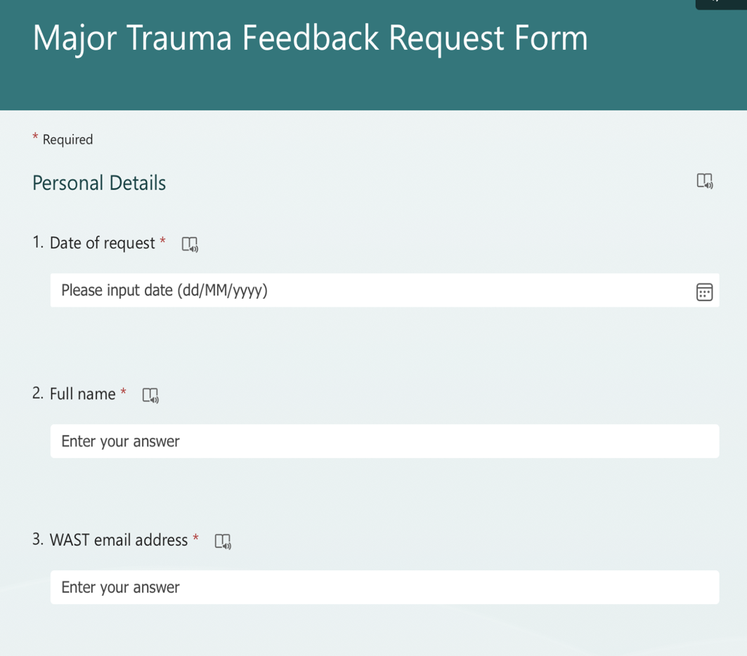

Appendix 1 cont.: Feedback Request Form
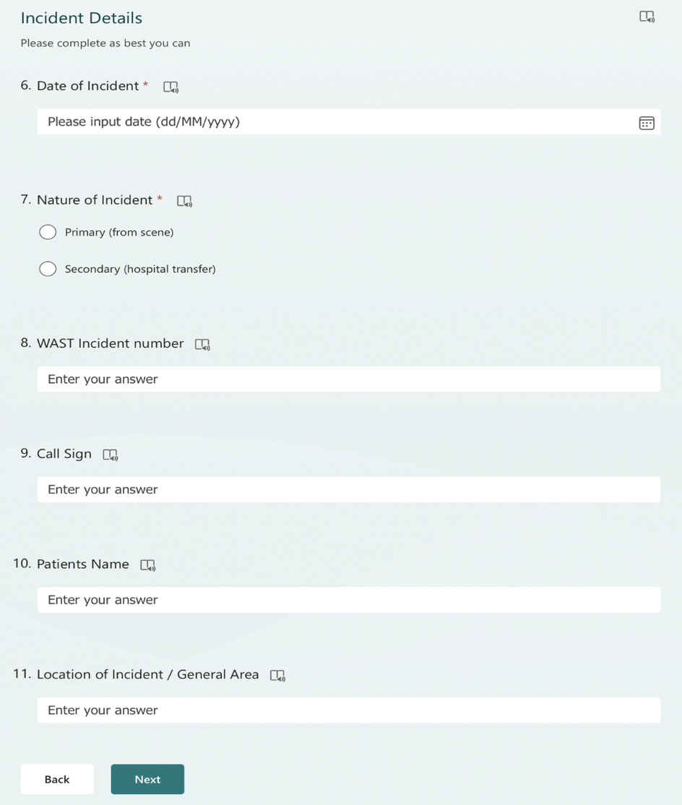
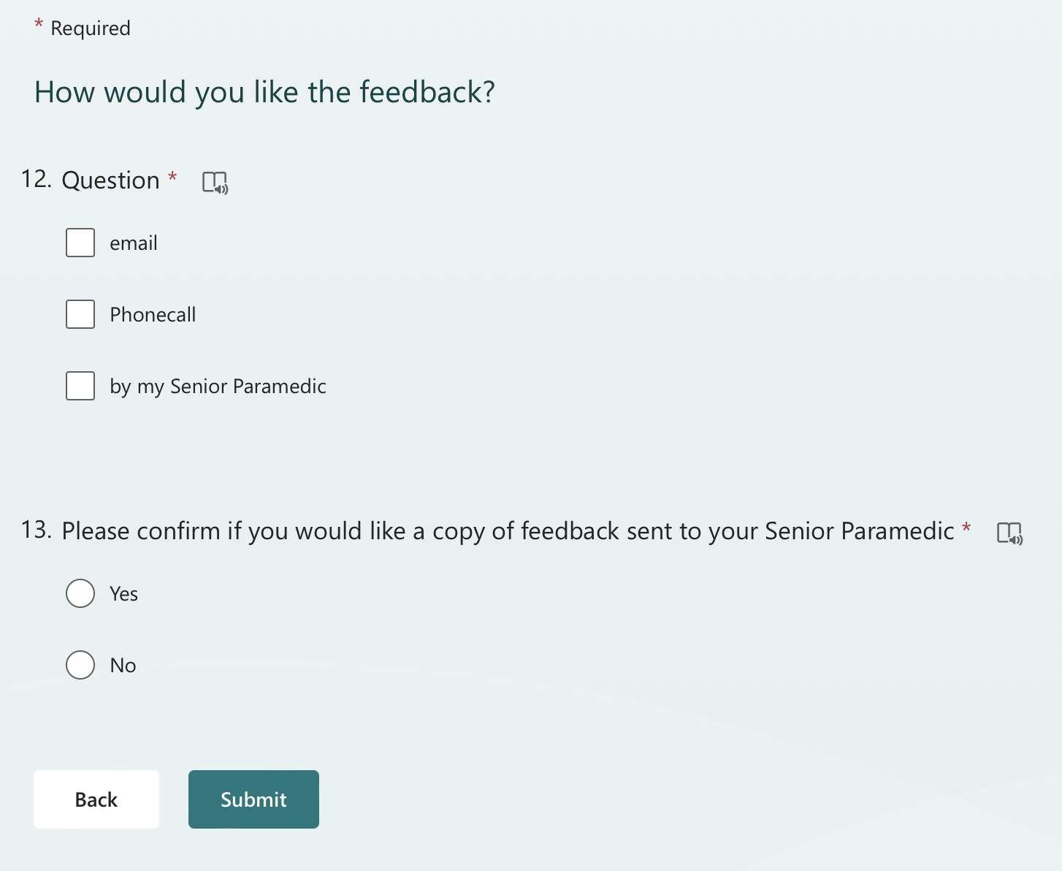

Appendix 1 cont.: Feedback Request Form
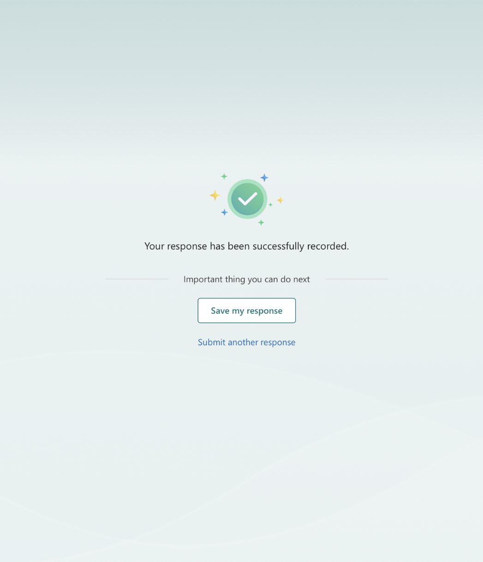

Appendix 2: Feedback Reply Form
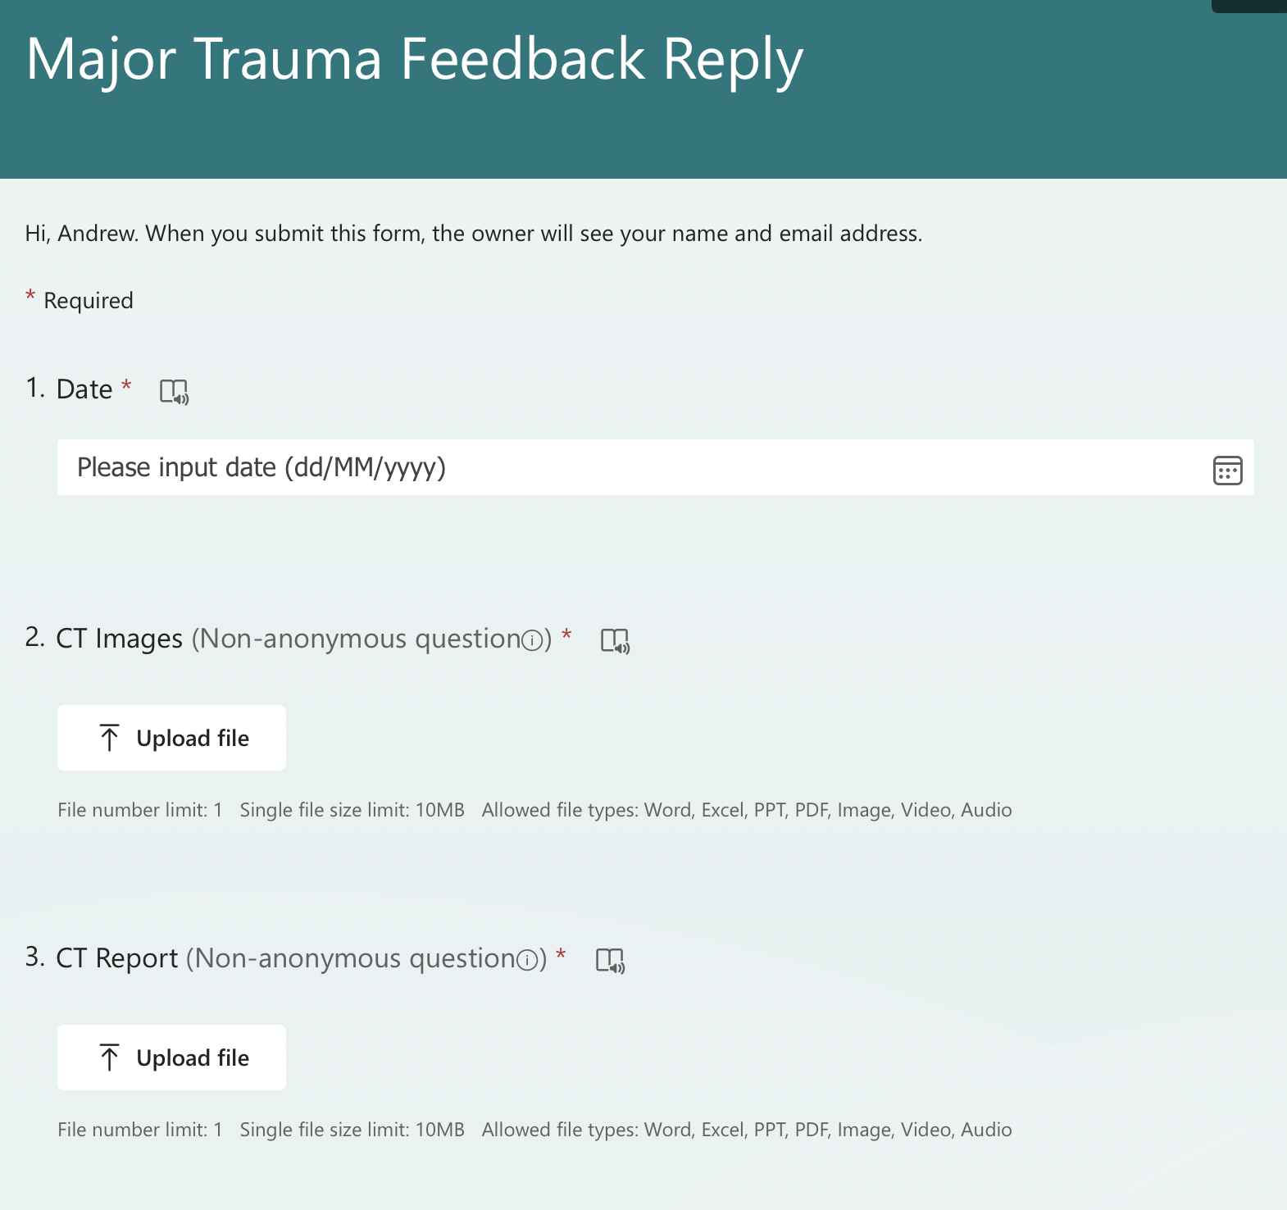
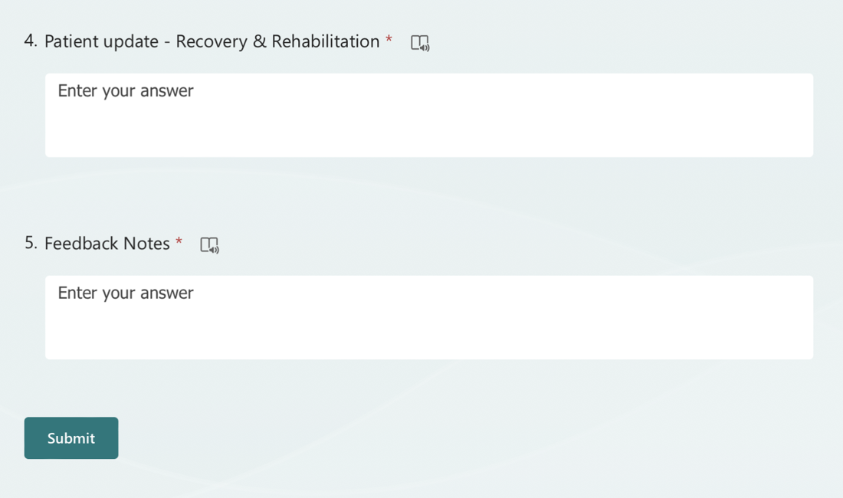

Appendix 3: The Five Whys – Effective Feedback on Clinical Practice
Effective Feedback in Clinical Education

 | Materials | Actions
Why? | I do not have time to request feedback, I must go looking for nurses or doctors | Relentless workload and pressure, affects the time and ability to seek out feedback
Why? | Feedback is always usually negative | Previous experience of receiving feedback, historical methods of feedback
Why? | Problems with information governance and patient confidentiality | The fear of asking in case of being told ‘I can’t tell you because it is confidential’
Why? | There is a lack in the acknowledgement in ‘good’ work | Very rarely do staff receive praise from managers, feels like what is the point now
Why? | Poor communication | Occasionally feedback is provided inappropriately or not relevant.
What Action | Develop and introduce a feedback request / feedback content form | Provide verbal, written (email) feedback, to include local SPs for awareness of good practice / if support required

Appendix 4: Stakeholder Map

