How to Share your PowerPoint Presentation:

- Click on the Share icon:

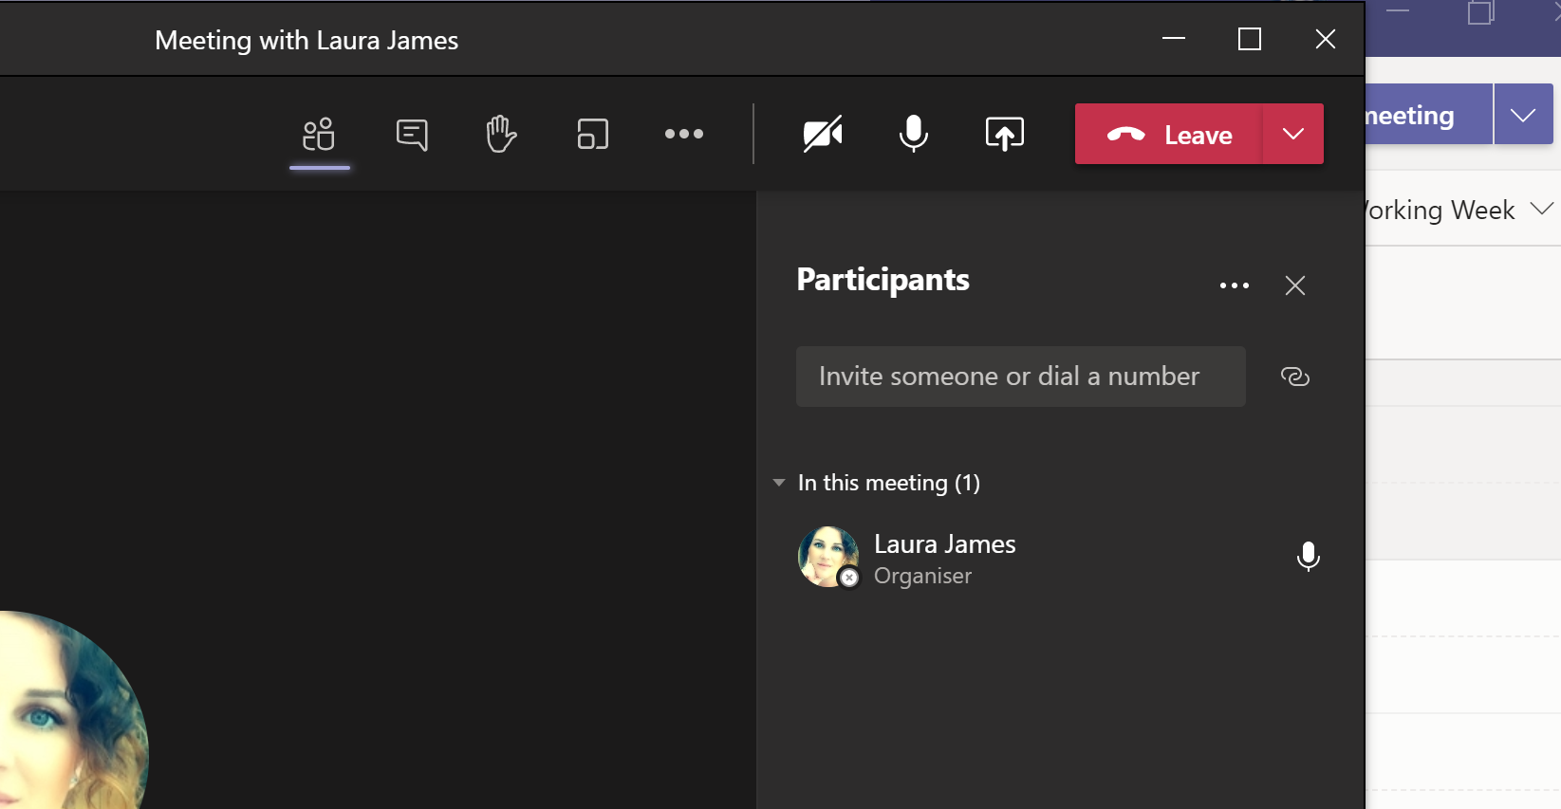

The choose what you want to share. You can either share your screen (if your PowerPoint is all ready to go on your screen) by clicking on ‘Desktop’:

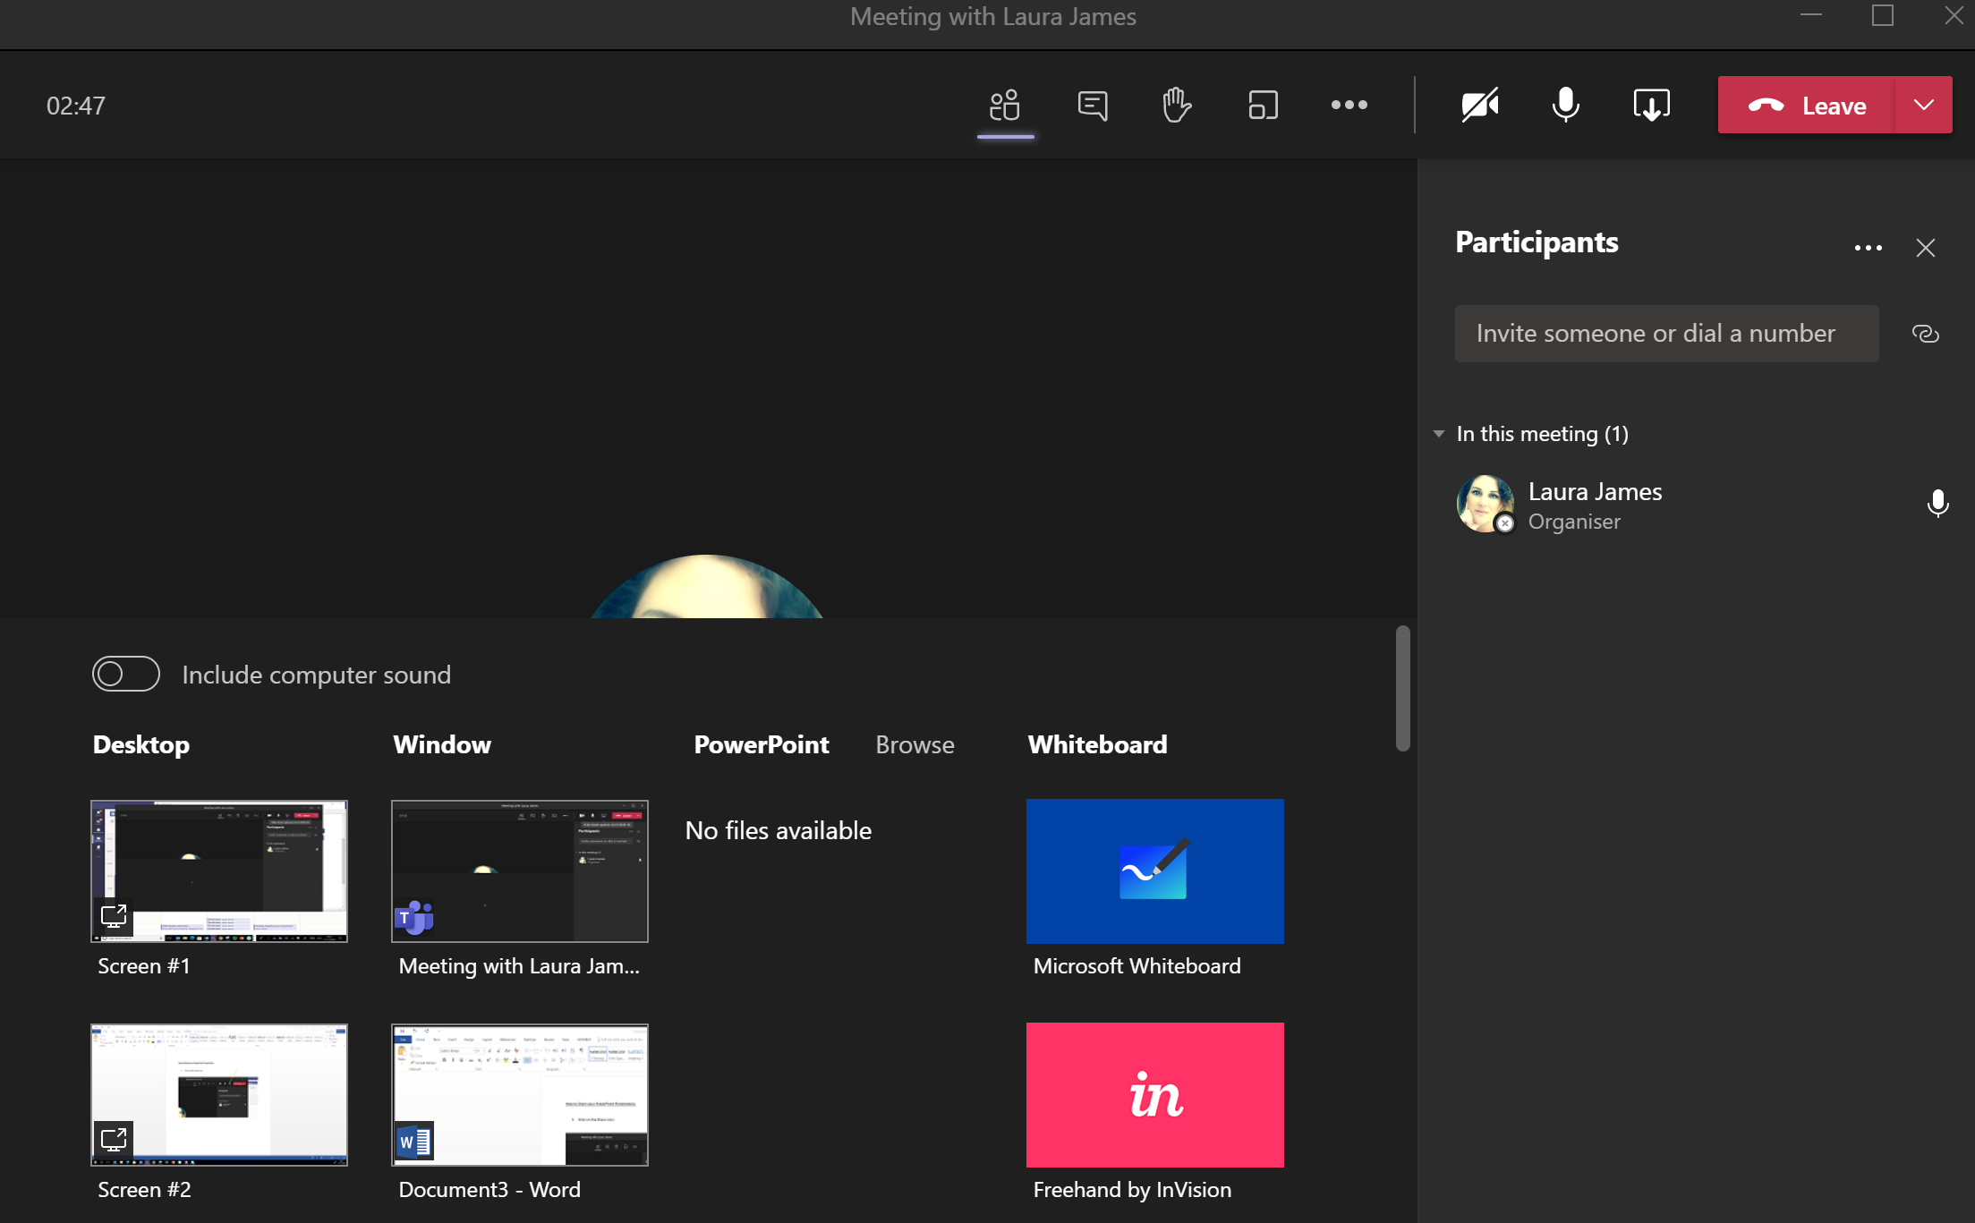

Or you may be given the option to share the PowerPoint:
You would usually need the Powerpoint to be downloaded and open for it to show here.
Either way is fine- there is no better way. However, please be aware that if you share your screen then everything on that screen will be seen by the class.

Once you are sharing your screen then a red box will appear around your screen to show that you are presenting.
You then present as normally hitting the ‘Enter’ key whenever you want to move forward through the presentation.

When you are finshed, you need to stop presenting/sharing.
To do this, hit the Share button again which will now look like this:
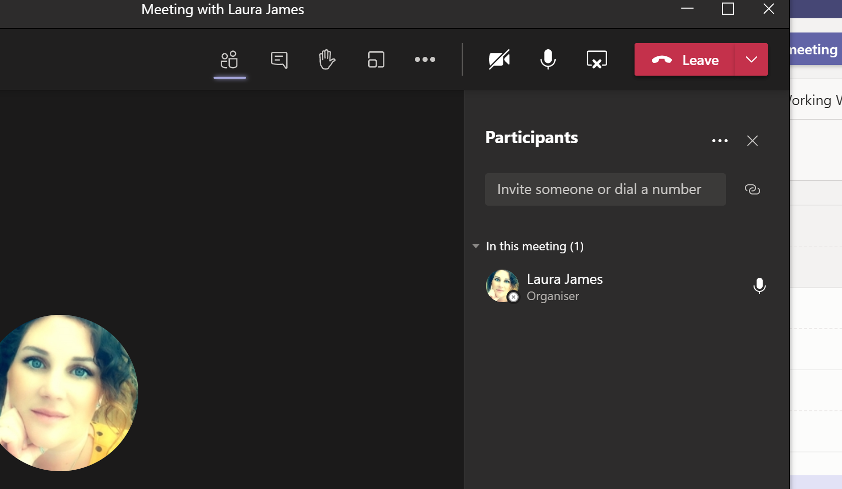

Once the icon returns to it’s normal form :
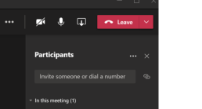Then that means you are back to normal and not presenting anymore!

