
Damian Walczak (2015478)
Custom Controller with RS232 Communication for an Industrial Oven Testing Bench

By
Damian Walczak
Supervisor: Jenifer Prince Deveraj

Project submitted as part of the requirements for the award of

BEng (Hons) Electrical and Electronics Engineering

October 2025

Contents
1. Introduction 2
2. Aim and Objectives 3
2.1 Aim: 3
2.2 Objectives: 3
2.2.1 Ensure compliance and implement safety mechanisms 3
2.2.2 Design and implement reliable output control 3
2.2.3 Integrate and test sensor monitoring and data acquisition 3
2.2.4 Develop PC communication 3
2.2.5 Evaluate system expandability/cost-effectiveness 3
3. Background Research 4
3.1 PLCs in industrial automation 4
3.2 Limitations of PLCs 4
3.3 Alternatives: PCs and Embedded Controllers 4
3.4 Research gap for test benches 4
4. Project Desing 5
4.2 Firmware and Software Design 6
4.3 Safety and Compliance 6
4.4 Testing Methodology and Risk Management 7
4.5 Ethical Implications 7
4.6 Environmental and Societal Impact 7
4.7 Data Analysis and Result Evaluation 7
5. Planning 8
6. Planning 10
7. Expected Outcome 13
8. Reference 14
9. Appendix 16

Introduction
PLCs, which are integrated into commercial test rigs, have always been a major component of such testing infrastructure[1]. PLC-based systems have a number of disadvantages despite their shown robustness[2]. They frequently limit scalability and adaptation to the particular requirements of oven specific testing due to their high upfront cost, reliance on vendor specific software, and complex maintenance[3]. For businesses that need flexibility, cost effectiveness, and functionality that is specifically adapted to their needs, relying on general purpose industrial solutions leads to wasteful spending.
By challenging the dependence on PLC-only solutions and suggesting the creation of a unique controller intended especially for oven testing applications, this study aims to overcome these constraints. Crucially, this method offers a number of clear benefits, including a substantial cost reduction, hardware and software customisation, the addition of oven specific features like direct MCB feedback and thermocouple interfacing, and the ability to expand in response to changing needs.
Up to nine outputs will be supported by the suggested system architecture with real-time MCB status tracking, emergency stop functionality, and sensor integration. Feedback will be provided via voltage sensors, current transformers, and a Type-K thermocouple. Through monitoring, system is able to identify overloads or overheating and immediately switch to a safe shutdown mode.
The controller will use RS232, which is widely used[9], to communicate and control with a PC. Operators will be able to watch and control oven testing in real time thanks to the PC program. An DC-DC converter stage will regulate the 24 V supply power to 5 V and 3.3 V for the controller's circuitry.
Architecture and functional goals will be validated by the successful design, construction, and testing of the Stage 1 controller. In terms of flexibility and cost-effectiveness, this stage shows that a microcontroller-based solution may successfully duplicate and outperform PLC.
Stage 1 will highlight a number of areas that needs work. In particular, signal noise in the analogue inputs needed to be reduced, power circuit design was not ideal for manual soldering. During testing, connection issues were also found. These results serve as the basis for the Stage 2 controller, which will include RC filters to lower electrical noise, an enhanced PCB layout, and a reworked power circuit design for simpler soldering.
The goal is to provide an oven specific testing solution that is modular, safe, and economical. Offers alternative to PLC-based systems by combining affordability and expandability, which makes it a desirable small-to-medium businesses.

Aim and Objectives
2.1 Aim:
Designing, building and testing a custom embedded controller for an industrial oven testing station is the aim of this project. The Stage 1 controller, which integrates sensor monitoring, RS232-based PC communication for data exchange, and contactor control that directs load to sockets chosen by the PC, has been successfully finished and tested.
Building on the outcomes of Stage 1, the upcoming Stage 2 controller seeks to provide a better hardware design with improved solderability, decreased electrical noise, and refined PCB tracking while including automatic fault protection and adhering to pertinent UK and US electrical and safety standards.

2.2 Objectives:

2.2.1 Ensure compliance and implement safety mechanisms
By monitoring emergency stop signals, adding watchdog protection, and ensuring adherence to PUWER 1998[10], BS EN 61439[11], IEC 60204-1[12], and IEC 62061/ISO 13849[13].

2.2.2 Design and implement reliable output control
By implementing a reliable output control system for the controller. And use N-channel MOSFET drivers to ensure safe, reliable switching.
In order to provide safe and reliable operation, the power circuitry will be changed in Stage 2 for better DC-DC handling for simpler manual soldering, and decreased noise transmission. Also errors will be fixed.

2.2.3 Integrate and test sensor monitoring and data acquisition
By interfacing with current, voltage, and temperature sensors, applying signal conditioning, and enabling real-time measurement.
In order to reduce electrical noise and improve measurement accuracy and signal reliability, Stage 2 will implement RC filters and optimised PCB layout.

2.2.4 Develop PC communication
To enable real-time transfer of sensor data, system status, and control commands.

2.2.5 Evaluate system expandability/cost-effectiveness
Use a modular architecture to support additional oven channels or future functional upgrades.
Keep total system cost within reasonable budget while ensuring reliability, robustness, and long-term serviceability.

Background Research
3.1 PLCs in industrial automation
PLC’s have long been the cornerstone of industrial automation, providing durability, modular design, and strong vendor support[1]. They enable reliable operation under demanding conditions through standardized input/output modules, built-in diagnostics, and programming via ladder logic[5]. PLCs continuously monitor input signals from devices such as sensors, execute programmed logic, and control actuators or other equipment based on these inputs[2][3]. Inputs from sensors are processed, outputs drive actuators, motor starters. Industrial protocols allows PLCs to communicate with other PLCs or HMIs. Control logic can be programmed in different way, offering flexibility in implementation[3][5]
3.2 Limitations of PLCs
In many scenarios, the full functionality of a PLC is not required, leaving much of the system not used. High hardware costs, software licensing fees, and vendor specific support increase the initial investment. Closed architectures reduce interoperability and can lead to complex maintenance requirements[3]. These limitations have motivated my research into alternative control solutions for industrial test benches.

3.3 Alternatives: PCs and Embedded Controllers
PCs and controllers are emerging as cost-effective, flexible alternatives. PCs offer higher computational power, large-scale data storage, and versatile software development platforms, allowing integration of multiple serial communications and fully integrated HMI solutions[6][7]. However, PCs do not have internal relays or switches to control components such as contactors, which are required for testing station power distribution.
For instance, Ahshan et al. developed a microcontroller-based control system for a small induction-generator wind turbine. The study highlighted that while a PLC could have been used, an embedded solution was more cost-effective, met computational requirements, and avoided unnecessary hardware complexity. While embedded systems are highlighted as cost-effective in specific study[8], most existing research is not addressing safety interlocks and PC-based monitoring.
3.4 Research gap for test benches
PLCs remain the dominant choice in industrial automation[1], their high cost, limited flexibility, and complexity make them less suitable for specialized appliance testing environments[3]. Existing literature shows a lack of modular, low-cost controllers that combine real-time monitoring, PC-based connectivity, safety interlocks, and appliance-specific functionality.

Project Desing
The suggested system was designed in Stage 1 as a controller that is integrated into a testing bench. Hardware architecture, software development, safety and compliance protocols, testing procedures, and risk assessment are all covered in the project design. The Stage 2 controller, which will have better hardware design, increased ability to solder, and less electrical noise, will be based on the useful data gathered from the conclusion of Stage 1.
4.1 Hardware Architecture
The PIC18F46J50 is the main part of the controller in Figure 1 Hardware Architecture. It was chosen due to sufficient I/O ports, and UART functionality for RS232 connection[14]. The I/O expander will be used to get around its limited number of I/O pins, communicating via I²C. MOSFETs control the controller's outputs by powering contactors and relays. The input signals consist of three current transformer analogue inputs, three voltage sensor analogue inputs, one Type-K thermocouple input, six auxiliary MCB feedback inputs that have been scaled from 24 V to 3.3 V via voltage dividers, and one emergency stop input that has also been reduced to 3.3 V. The 24 V system input will be stepped down into 5 V and 3.3 V rails for the controller and peripherals using an DC-DC converter.
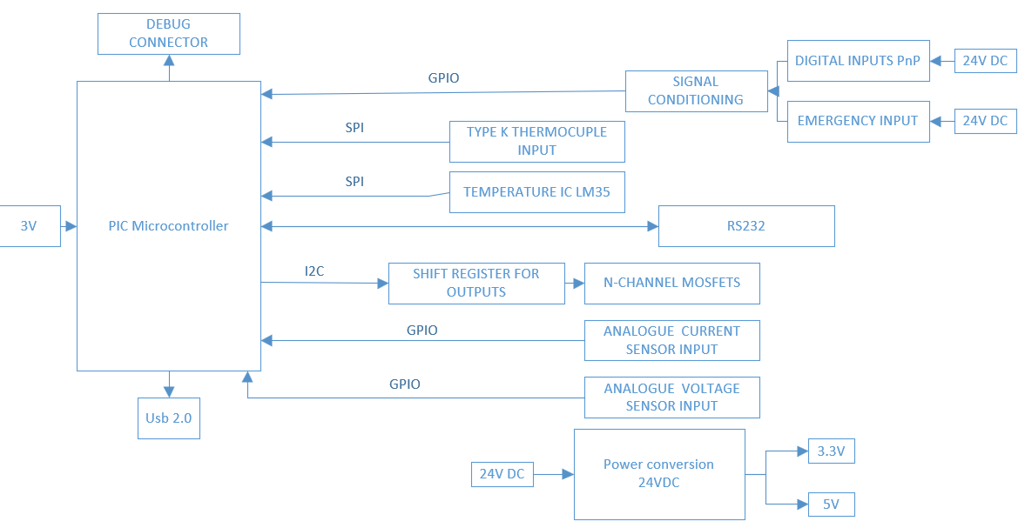
Figure 1 Hardware Architecture
The original power circuit design was found to be unsuitable for manual soldering, which led to difficulties with assembly. This circuit will be modified for Stage 2 in order to simplify hand soldering and increase easy manufacturing. Significant signal noise in analogue inputs was also found, along with a number of routing and connection issues. In order to improve signal stability and reduce disruption, Stage 2 will implement RC filtering and better PCB layout techniques.

4.2 Firmware and Software Design
Using the MPLAB X IDE, firmware will be created in C to handle functions including input monitoring, socket switching logic, communication, and emergency shutdown procedures. Figure 2 Firmware flowchart shows how it should operate.
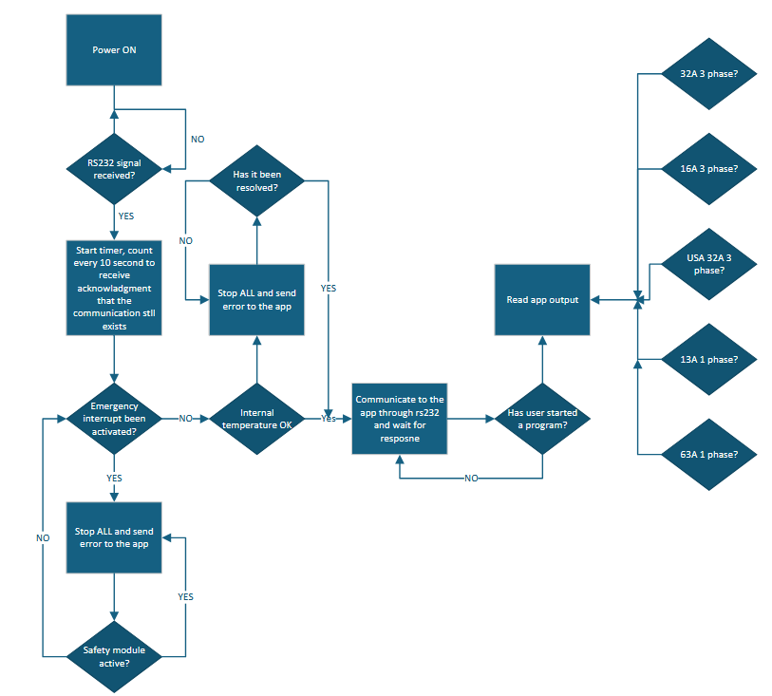
Figure 2 Firmware flowchart

4.3 Safety and Compliance
Compliance with PUWER[10], BS EN 61439[11], and IEC 62061[13] will act as the foundation for safety design, guaranteeing that all systems meet accepted safety requirements. By monitoring on MCBs through their auxiliary terminals, the controller will be able to quickly identify and address any issues. The emergency stop feature will instantly stop controller functioning and put the system in a safe state, going beyond software-based shutdowns.

4.4 Testing Methodology and Risk Management
Socket and contactor switching will be verified by bench testing, and reference meters will be used to calibrate sensors for precise readings. MCB tripping and emergency stop activations will be simulated in safety tests, and the dependability of RS232 communication will be evaluated under load. A watchdog and repeated testing will be used to control firmware failures, thermal hazards will be minimised by thermocouple monitoring, and electrical hazards.

4.5 Ethical Implications
Operators of testing station are protected from electrical risks by internal fuse and emergency stop mechanisms that will shut down whole system when needed. Accurate measurements, sensor calibration, dependable firmware, and strong RS232 connection are all necessary to guarantee data integrity. Clear warnings, documentation, and adherence to standards all help to promote responsible use.

4.6 Environmental and Societal Impact
Industrial ICs with low power consumption and optimised switching, such as MOSFETs and DC-DC converters, are used in the system to save energy and reduce components necessary. Electronic waste can be reduced by choosing durable parts and ICs with built in features. In terms of society, the controller improves oven safety by avoiding accidents and offers accurate testing data that supports safer industrial products with better output.

4.7 Data Analysis and Result Evaluation
Digital inputs, RS232 communication logs, and analogue measurements (temperature, voltage, and current) are all part of the data collection. The relationship between the controller and PC will be evaluated using analysis.
By comparing outcomes with those from calibrated reference devices, the accuracy of the thermocouple will be confirmed. Sensor outputs will be summarised through data analysis. The evaluation also includes performing repeated reliability tests, confirming measured values against expected ranges, and assessing RS232 performance under load.

Planning
Table 1 BOM shows all resources used in the project. With the commercial discount, the cost is £60.48. For comparison, the cheapest PLCs on the market are typically priced between £300-£500[15], representing a saving of approximately 80%.
Table 1 BOM
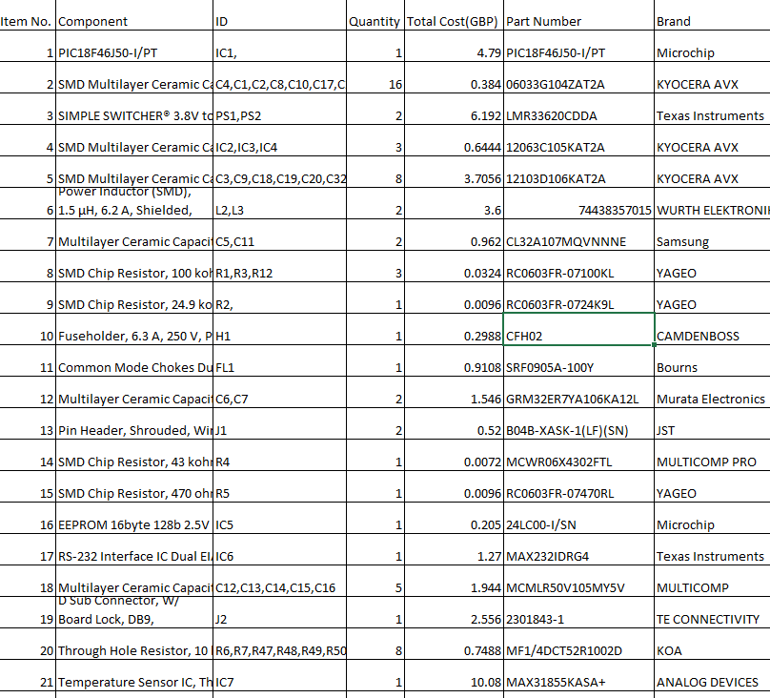
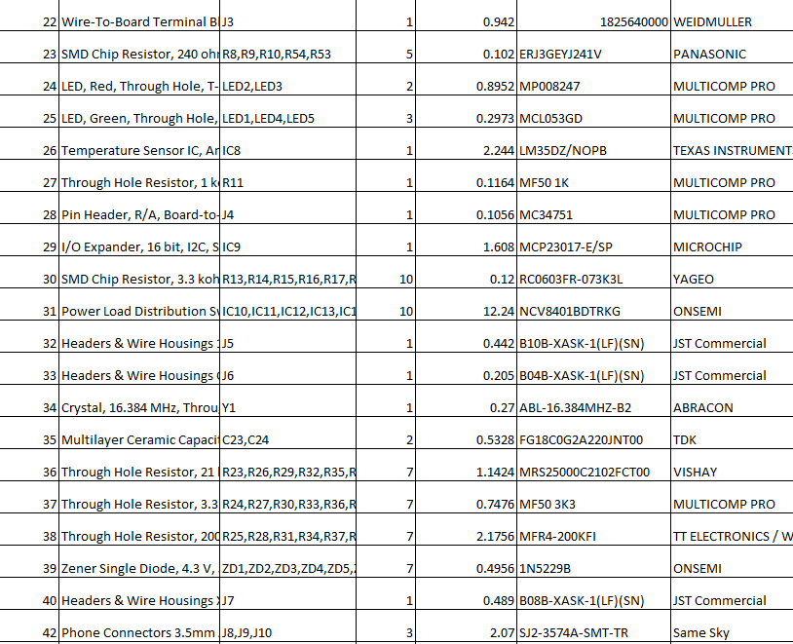
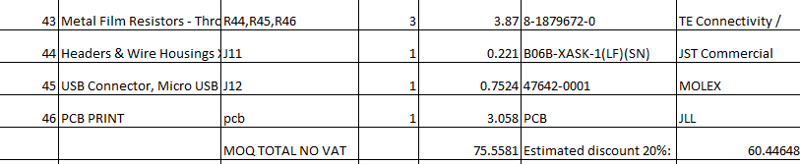

Planning
Table 2 Gannt chart table, outlines the finished Stage 1 milestones and the next Stage 2 tasks.
Table 2 Gannt chart

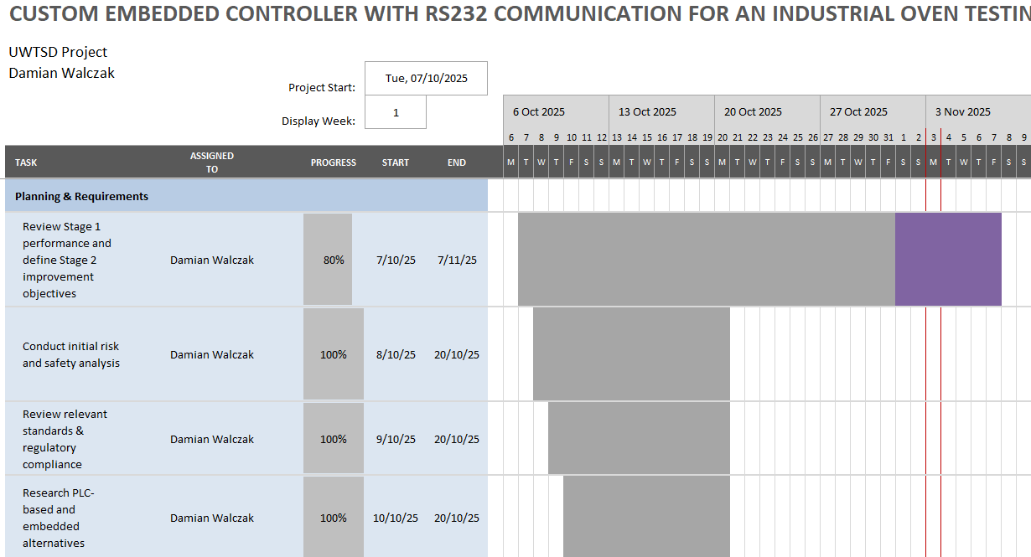
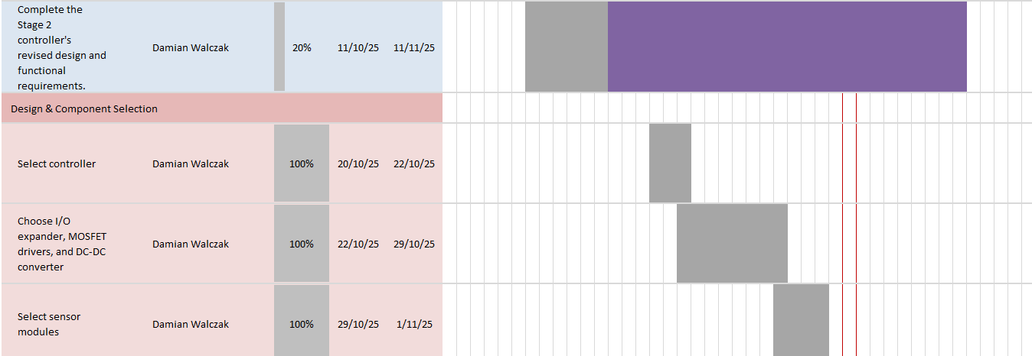
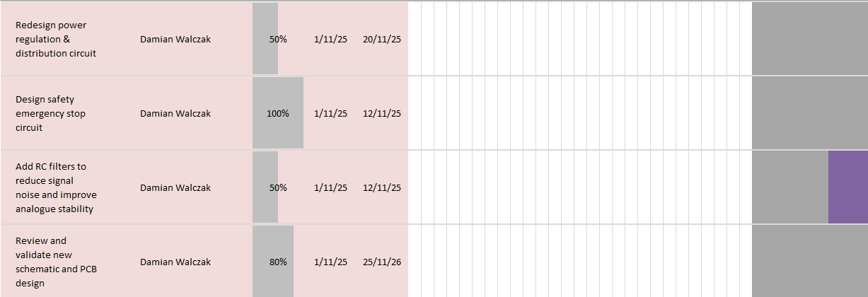
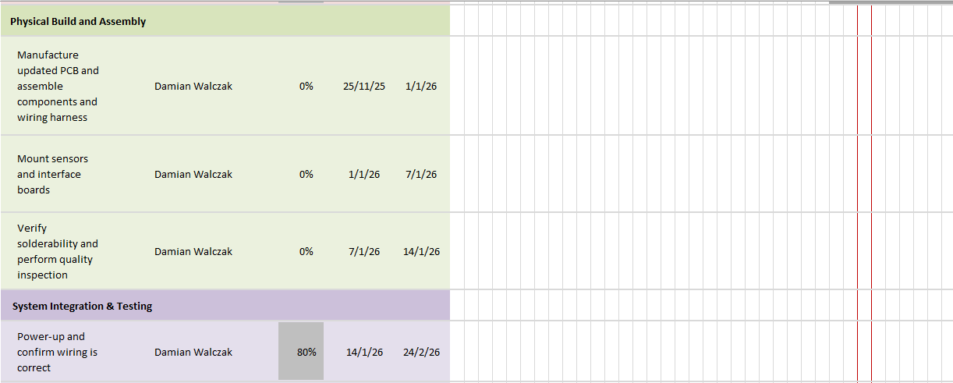
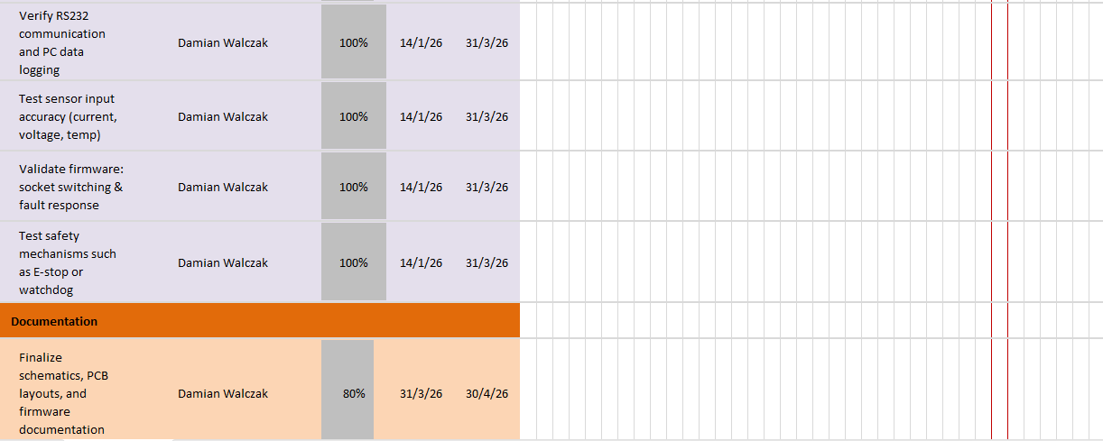
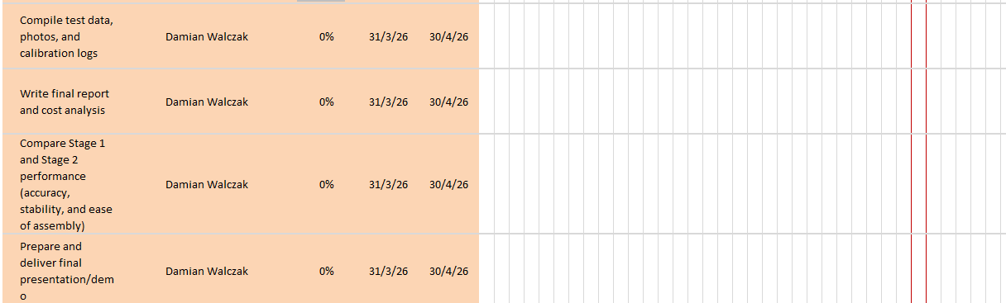

Expected Outcome
The completion of Stage 1 has resulted in a fully functional controller prototype. System includes MCB auxiliary input detection, emergency stop functionality, and safety temperature monitoring. With specialised PC software for data recording and control, real-time temperature, voltage, and current monitoring has been effectively implemented.
RS232 communication will demonstrate efficiency in connection between the controller and external systems. The project's profitability will be proven by a thorough cost analysis, and the Stage 1 prototype achieved cost savings of almost 80% when compared to PLC.

All of the knowledge gained from Stage 1 will be included into the next Stage 2 controller to create a better, production-ready design.
Table 3 Stage 2 enhancements shows a list of modifications needed.
Table 3 Stage 2 enhancements
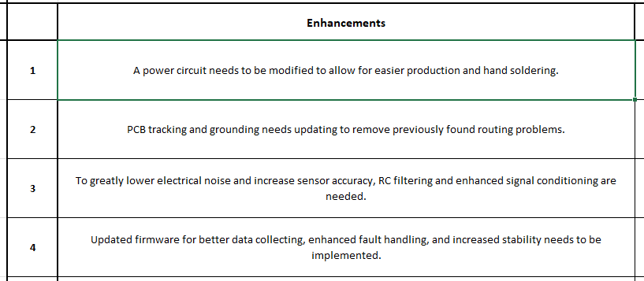
In the end, the project will show that for industrial oven testing applications, a microcontroller-based controller can offer a reliable, adaptable, and reasonably priced substitute for PLC systems that provide similar or better performance in areas where customisation, scalability, and affordability are crucial priorities.

Reference

[1]
D. W. Staff, “PLCs Automate Reliability Testing,” Design World, Jun. 15, 2012. https://www.designworldonline.com/plcs-automate-reliability-testing/ (accessed Sep. 23, 2025).

[2]
K. Standing, “Beginner’s View: Key PLC Advantages and Disadvantages Explored,” Industrial Electrical Warehouse, May 27, 2025. https://industrialelectricalwarehouse.com/blogs/news/plc-advantages-and-disadvantages?srsltid=AfmBOopF4MqvrNGX0PgXTrrOkf2gKb3wl-vpsB18NMEllmeevRt0Yzqs (accessed Sep. 23, 2025).
[3]
P. Lemay, “Programmable Logic Controller: What Is a PLC and How Does It Work?,” Tulip, Jul. 31, 2022. https://tulip.co/blog/programmable-logic-controller-what-is-a-plc/
[4]
Pilz GmbH, “What does PUWER Regulation 18 (Control Systems) Cover? | PUWER FAQs - Pilz GB,” Pilz.com, 2025. https://www.pilz.com/en-GB/services/puwer/puwer-faq/articles/232296 (accessed Sep. 23, 2025).

[5]
M. Koondhar, G. Kaloi, A. Junejo, A. Soomro, S. Chandio, and M. Ali, “THE ROLE OF PLC IN AUTOMATION, INDUSTRY, AND EDUCATION PUR- POSE: A REVIEW,” Pakistan Journal of Engineering Technology and Science (PJETS), vol. 11, pp. 22–31, 2023, doi: https://doi.org/10.22555/pjets.v11i2.975.
[6]
Agustín Rullán, “Programmable logic controllers versus personal computers for process control, Computers & Industrial Engineering” Volume 33, Issues 1–2, 1997, Pages 421-424,
https://doi.org/10.1016/S0360-8352(97)00127-7.
[7]
Ephrem Ryan Alphonsus, Mohammad Omar Abdullah, “A review on the applications of programmable logic controllers (PLCs),”Volume 60, 2016, Pages 1185-1205,
https://doi.org/10.1016/j.rser.2016.01.025.
[8]
Ahshan, R., Iqbal, M.T. and Mann, G.K., 2008. Controller for a small induction-generator based wind-turbine. Applied Energy, 85(4), pp.218-227
https://doi.org/10.1016/j.apenergy.2007.07.005

[9]
W. J. Buchanan, “RS-232,” Springer eBooks, pp. 239–274, Jan. 2004, doi: https://doi.org/10.1007/978-1-4020-7870-5_11.

[10]
HSE, “Provision and Use of Work Equipment Regulations 1998 (PUWER) - Work equipment and machinery,” Hse.gov.uk, 2024. https://www.hse.gov.uk/work-equipment-machinery/puwer.htm

[11]
“GAMBICA Technical Guide LOW-VOLTAGE POWER SWITCHGEAR AND CONTROLGEAR ASSEMBLIES,” 2013. Available: https://www.gambica.org.uk/static/uploaded/7cce7df9-efb8-42bb-a7aba6bb1a7b824a.pdf

[12]
“BS EN 60204-1:2018 | 31 Jul 2021 | BSI Knowledge,” Bsigroup.com, Jul. 31, 2021. https://knowledge.bsigroup.com/products/safety-of-machinery-electrical-equipment-of-machines-general-requirements-2

[13]
“ISO 13849 and IEC 62061 - Manufacturing and Machinery,” TÜV SÜD, 2025. https://www.tuvsud.com/en-us/services/functional-safety/iso-13849-iec-62061

[14]
“PIC18F46J50 Data Sheet 28/44-Pin, Low-Power, High-Performance USB Microcontrollers with nanoWatt XLP Technology.” Accessed: Oct. 16, 2025. [Online]. Available: https://ww1.microchip.com/downloads/en/DeviceDoc/39931d.pdf

[15]
RS Components, “RS Components,” Rs-online.com, 2025. https://uk.rs-online.com/web/

Appendix

DECLARATION

I, Damian Walczak declare that I am the sole author of this Project; that all references cited have been consulted; that I have conducted all work of which this is a record, and that the finished work lies within the prescribed word limits.

This work has not previously been accepted as part of any other degree submission.

Date : 16/10/2025

