

APPENDIX GA36b

LEVEL 5 ASSESSMENT SPECIFICATION
Student name: |  | Student ID number:
Programme: | HND Electrical / Electronic Engineering
Module: | Signals & Digital Comms
Module code: | SGEE5005 | Contribution to Overall Module Assessment (%): | 50%
Lecturer: | M Hall | Internal Verifier: | Rob Jenkins
Assignment Title: | Signals and Modulation | Word count (or equivalent): | 2500
Submission deadline: |  | Return date of provisional marks & written feedback:
Submission method: | All written assessments, where practical and possible, must be submitted via Turnitin unless otherwise instructed by the Lecturer. (Please DO NOT put this assessment specification into Turnitin or it will match many similarities with other students’ submissions.)  Late submission of the assessment will result in a late penalty mark:  Work which is submitted up to 1 week late will be capped at 40% for the first attempt and will be awarded a mark of 0% for re-assessment. Late submission penalties may be lifted only if there is an approved extenuating circumstances claim.  Work submitted more than 1 week late will be considered as a non-submission and will not be marked. The work may be considered as a submission for reassessment if offered by an Examining Board or if there is an approved extenuating circumstances claim.
Academic honesty / referencing: | Academic honesty is required. In the main body of your submission you must give credit to authors on whose research and ideas your work is based. Append to your submission a reference list that indicates the books, articles, etc. that you have used, cited or quoted in order to complete this assessment.
Module Learning Outcomes
(from module syllabus)
1. Demonstrate a systematic understanding of the principles of signal processing as used in analogue and digital communication systems.

2. Critically analyze the theoretical principles of electronic communications systems by practical experimentation.

TASK DESCRIPTION

Aims and Objectives
The aim of this assignment is to investigate analogue and digital signal processing as used in modern communication systems

The objectives are:
- To investigate Frequency Modulation (FM) techniques through research, theoretical calculation and practical experimentation
- To investigate Analogue to Digital Convertors (ADCs) through research and practical experimentation

- Research
You will need to carry out appropriate research to inform your investigations, when required you should research the following topics:

- The technical characteristics of amplitude and frequency modulation
- The technical characteristics of ADCs with particular reference to the number of bits, the sampling rate and the voltage range

- Planning and Reflection
Write a short plan of how you will approach this assignment. When the assignment is complete, reflect on what you achieved and state how it may influence your lifelong learning.

- Experiment 1 Method - Frequency Modulation

A 455kHz carrier has an amplitude of 375mV and is frequency modulated by a 10kHz sine-wave signal of amplitude 2V.

- If the modulator has an FM transfer characteristic of 20kHz per volt, then:

- Calculate the maximum frequency deviation
- Calculate the modulation index
- Calculate the component amplitude values using the Bessel Table below

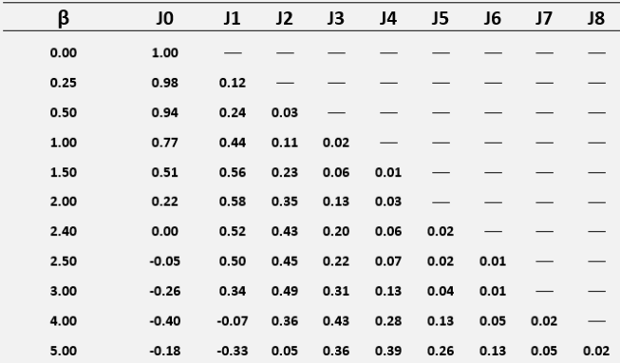

- Sketch the frequency spectrum and indicate on the diagram the bandwidth of the waveform

- Carry out a practical investigation of the above system using the Feedback Instruments equipment shown in Figure 1

  - Display the side frequencies using the spectrum analyser feature of a PicoScope and determine the bandwidth
  - Measure the Bessel co-efficients
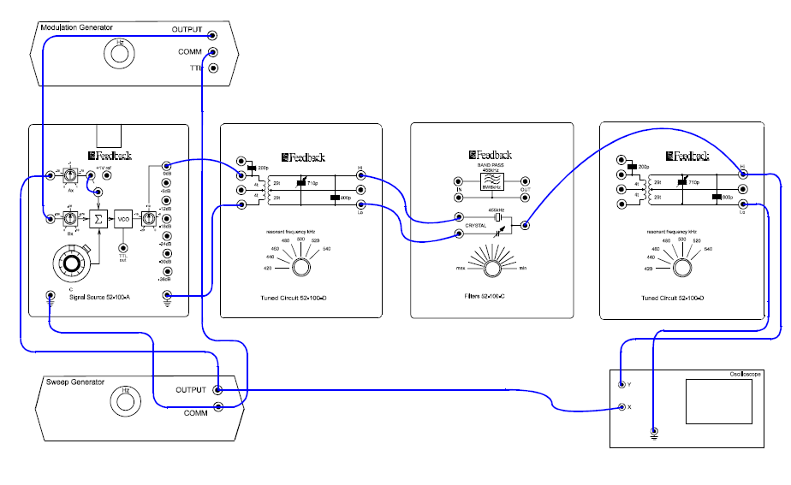
Figure 1

- Experiment 2 Method – Analogue to Digital Conversion
Using the Feedback experimental kit as shown in Figure 2, carry out an investigation into the behaviour, requirements and limitations of ADCs. For this task you will critically analyse the following:

- The differences in the quality of conversion between 4-bit and 8-bit convertors

- Why it is important to match the amplitude of the input signal to the range of an ADC

- Why the relationship between the input signal frequency and the sampling rate of the ADC is important and consequently investigate the validity of the Nyquist Criterion
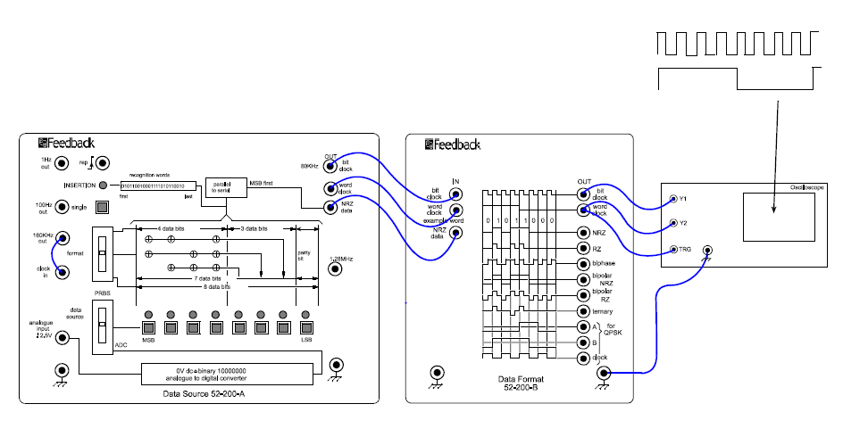
Figure 2

Specification of ADC: Sample rate = 10,000 samples/second and Range = 5Vp-p

- Results
Include the results of all your tests in a succinct and appropriate format (list, tabular, graphical etc). Excessive screenshots and photographs of handwritten results should be avoided. Ensure all results are correctly labelled and referred to in the analysis.

- Analysis
Quantitatively interpret the results at each stage by critically analyzing the data.

- Evaluation
Use your analysis to assess the quality of your design against the specification at each stage. State any strengths, identify any limitations in the methods and data and make recommendations as to what could be done to improve the outcome.

- Conclusion
Write a conclusion to create a lasting impression on the reader by highlighting the findings and stressing the major points one last time. The conclusion should not include anything new as it merely summarizes what has already been said.

- Executive Summary
Write an executive summary of the report. It must be written in the past tense, but placed at the beginning of the report. An executive summary is an overview of the entire report and is meant to be read by busy managers who do not have time to read a full report. Use no more than 10% of the word count and do not include this in your total word count.

GUIDANCE FOR Students IN THE COMPLETION OF TASKS

You are required to present an electronic report containing detailed observational notes of your work. The report must not exceed the word count shown on Page 1 and should be laid out in the following sections preceded by a title page and a table of contents:-

Your title page for the report must be in the following format:

Your Name:
University Number:
Module Code: SGEE xxxx
Assignment Title:
Date Submitted: DD/MM/YYYY
Word Count: ???? words

- Planning and reflection
- Research (if required)
- Methodology
- Results
- Analysis
- Evaluation
- Conclusion
- Citation list
- Appendices

Further guidance:
- Do not use a styled document (template) and don’t add your company logo.
- Do not include photographs of course notes or formative classroom work.
- All pages and figures must be numbered and listed in the Table of Contents and List of Figures
- Do not include whole datasheets; simply cite their source or include a “snip” of the relevant information.
- Write all sections in the third person.
- Note which sections of your report have been identified above as places where the marks will be awarded and use your word allocation wisely.
- Save your report as a .pdf with your university number as the file name.

Permitted Use of Generative AI:

Idea Generation: You are encouraged to use generative AI tools to brainstorm and generate ideas for your assignment. These tools can help you explore different concepts, perspectives, and angles that you might not have considered otherwise.

Structural Assistance: Feel free to utilize generative AI to assist in creating the structure and organization of your assignment. These tools can help you outline your content and ensure a logical flow of ideas.

Language Enhancement: You can employ generative AI to improve the clarity and eloquence of your writing. It can help suggest appropriate vocabulary, sentence structures, and grammar enhancements.

Restricted Use of Generative AI:

Direct Content Generation: While you can use generative AI for idea generation, do not use it to generate entire sentences or paragraphs that directly contribute to your final work. Your assignment should primarily reflect your own understanding and analysis.

Citation and Referencing: Generative AI should not be used to create citations, references, or bibliographies. These should be based on genuine sources you've consulted, following appropriate citation styles.

Copying External Content: Do not use generative AI to paraphrase or rephrase existing external content to make it appear original. Plagiarism is still a violation of academic integrity.

Best Practices:

Understand the Generated Content: If you decide to use any content generated by AI, make sure you thoroughly understand it. Do not include anything in your assignment that you cannot explain or discuss if asked.

Edit and Revise: If you choose to incorporate AI-generated content, ensure that you edit and revise it to align with your own voice and style. This will help integrate the AI-generated content seamlessly with your original work.

Document AI Use: In your assignment, provide a brief note mentioning that you used generative AI tools for idea brainstorming or structural assistance. This demonstrates transparency and honesty.

Going Over the Word Limit
If you are found to have exceeded the specified word limit for an assessment, your work may be subject to a penalty:
  - Up to 10% over length - No deduction off final mark
  - 11% or more over length - Deduction of 5 marks off final mark (but cannot reduce mark below 40%)

To measure the word count, DO NOT use Turnit-In and do not include the following:
  - Assignment brief
  - Index, Table of Contents and Table of Figures
  - Executive Summary
  - Planning and Reflection
  - Formula and calculations (use MSEquation or text boxes to contain these)
  - Citation list
  - Annexes used for large results tables, data sheet extracts and any other 3rd party information.

NOTE: The guidance offered below is linked to the five generic assessment criteria overleaf.

- Engagement with Literature Skills
Your work must be informed and supported by scholarly material that is relevant to and focused on the task(s) set. You should provide evidence that you have accessed an appropriate range of sources, which may be academic, governmental and industrial; these sources may include academic journal articles, textbooks, current news articles, organisational documents, and websites. You should consider the credibility of your sources; academic journals are normally highly credible sources while websites require careful consideration/selection and should be used sparingly. Any sources you use should be current and up-to-date, mostly published within the last five years or so, though seminal/important works in the field may be older. You must provide evidence of your research/own reading throughout your work, using a suitable referencing system, including in-text citations in the main body of your work and a reference list at the end of your work.

Guidance specific to this assessment: This will be assessed by your research and use of credible sources

- Knowledge and Understanding Skills
At level 5, you should be able to demonstrate: sound knowledge and critical understanding of the well-established concepts and principles of the subject area and the way in which those principles have developed; knowledge of the main methods of enquiry in the discipline. Knowledge relates to the facts, information and skills you have acquired through your learning. You demonstrate your understanding by interpreting the meaning of the facts and information (knowledge). This means that you need to select and include in your work the concepts, techniques, models, theories, etc. appropriate to the task(s) set. You should be able to explain the theories, concepts, etc. meaningfully to show your understanding. Your mark/grade will also depend upon the extent to which you demonstrate your knowledge and understanding.

Guidance specific to this assessment: This will be assessed by your descriptions and explanations of the experimental process and justification for any arbitrary decisions.

- Cognitive and Intellectual Skills
You should be able to critically analyse information, and propose solutions to problems arising from that analysis, including the critical evaluation of the appropriateness of different approaches to solving problems. Your work must contain evidence of logical, analytical thinking, evaluation and synthesis. For example, to examine and break information down into parts, make inferences, compile, compare and contrast information. This means not just describing what! But also justifying: Why? How? When? Who? Where? At what cost? At all times, you must provide justification/evidence for your arguments and judgements. Evidence that you have reflected upon the ideas of others within the subject area is crucial to you providing a reasoned and informed debate within your work. Furthermore, you should provide evidence that you are able to make sound judgements and convincing arguments using data and concepts, with an understanding of the limits of knowledge, and how this influences analyses and interpretations. Sound, valid conclusions are necessary and must be derived from the content of your work. Where relevant, alternative solutions and recommendations may be proposed.

Guidance specific to this assessment: This will be assessed by the depth of your analysis, persuasiveness of any argument and credibility of your conclusions.

- Practical Skills
At level 5, you should be able to use/deploy a range of established techniques within the discipline, and apply underlying concepts and principles outside the context in which they were first studied, including, where appropriate, the application of those principles in an employment context. You should be able to demonstrate how the subject-related concepts and ideas relate to real world situations and/or a particular context. How do they work in practice? You will deploy models, methods, techniques, and/or theories, in that context, to assess current situations, perhaps to formulate plans or solutions to solve problems, or to create artefacts, some of which may be creative. This is likely to involve, for instance, the use of real world artefacts, examples and cases, the application of a model within an organisation and/or benchmarking one theory or organisation against others based on stated criteria. You should show awareness of the limitations of concepts and theories when applied in particular contexts.

Guidance specific to this assessment: This will be assessed by demonstrating your ability to use hardware, software and experimental apparatus to achieve rigorous results.

- Transferable Skills for Life and Professional Practice
Your work must provide evidence of the qualities and transferable skills necessary for employment requiring the exercise of personal responsibility and decision-making. This includes demonstrating: professional development to advance existing skills and acquire new competences that will enable you to assume significant responsibility within organisations; that you can initiate and complete tasks and procedures, whether individually and/or collaboratively; that you can use appropriate media to effectively communicate information, arguments and analysis in a variety of forms to specialist and non-specialist audiences; fluency of expression; clarity and effectiveness in presentation and organisation. Work should be coherent and well-structured in presentation and organisation.

Guidance specific to this assessment: This will be assessed by the written and presentational quality of your report including page numbering, figure quality, figure numbering and listing, writing style, punctuation, grammar and spelling. (All sections)

Achieving the PLOs for IET/IEng Accreditation

The following PLOs have been targeted to be satisfied or partially satisfied by this assignment. The marking scheme on the next page will also be used to record your PLO achievements and comments will be found on the Turnit-in rubric.

C1 - Science, mathematics and engineering principles
Apply knowledge of mathematics, statistics, natural science and engineering principles to the
solution of complex problems. Some of the knowledge will be at the forefront of the particular
subject of study.
This will be achieved by the depth of knowledge demonstrated throughout the assignment in your research, the accuracy of your calculations and the validity of your conclusions.

C2 - Problem Analysis:
Analyse complex problems to reach substantiated conclusions using first principles of
mathematics, statistics, natural science and engineering principles.
This will be achieved by your explanation of the experimental and theoretical calculations and the validity of your evaluation and conclusions.

C3 - Analytical tools and techniques:
Select and apply appropriate computational and analytical techniques to model complex
problems, recognizing the limitations of the techniques employed.
This will be achieved by your use and evaluation of all necessary analytical tools and design techniques such as the PicoScope and its relevant analytical features.

C12 - Practical and workshop skills
Use practical laboratory and workshop skills to investigate complex problems.
This will be achieved by the use of all necessary features of the Feedback experiment kit and the PicoScope software to achieve comprehensive results and the analysis of that datum will satisfy this outcome.

C17 - Communication
Communicate effectively on complex engineering matters with technical and non-technical
audiences.
This will be achieved by your written report which will satisfy the technical communication and your Executive Summary which will satisfy the non-technical audience.

C18 - Lifelong learning
Plan and record self-learning and development as the foundation for lifelong learning/CPD.
This will be achieved by evidence of planning throughout the assignment and your reflection on what was achieved.

Student FEEDBACK FORM

This section details the extent to which the assessment criteria are demonstrated by you, which in turn determines your mark. The marks available for each category of skill are shown. Lecturers will use the space provided to comment on the achievement of the task(s), including those areas in which you have performed well and areas that would benefit from development/improvement.

Generic Assessment Criteria | Marks available
1. Engagement with Literature Skills
Citation list contains an appropriate range of sources [3]
Correct referencing conventions consistently applied [2]
Sound knowledge and critical understanding of subject is evident from research [5]

 | 10
2. Knowledge and Understanding Skills
Sound knowledge and critical understanding of modulation is evident from explanation of the experimental process [15]
Sound knowledge and critical understanding of ADCs is evident from explanation of the experimental process [15]

 | 30
3. Cognitive and Intellectual Skills
Evidence of comprehensive critical analysis [15]
Sound, valid conclusions relating results with theory [15]

 | 30
4. Practical Application Skills
Implementation of experimental process [12]
Use of appropriate test equipment for testing [4]
Ability to solve problems creatively and with minimal help [4]

 | 20
5. Transferable Skills for Life and Professional Practice
Executive summary is structured and coherent [5]
Report is well structured and grammatically correct [5]

 | 10

Assessment Mark (Assessment marks are subject to ratification at the Exam Board. These comments and marks are to give feedback on module work and are for guidance only until they are confirmed. ) | Late Submission Penalties (tick if appropriate) |  | %
 | Up to 1 week late (40% Max) |  | %
 | Over 1 week late (0%) |  | %

GENERIC ASSESSMENT CRITERIA

Level 5
In accordance with the Framework for Higher Education Qualifications, at the end of Level 5 students will be expected to have developed sound knowledge and critical understanding of the well-established concepts and principles in their field of study, and of the way in which those principles have developed. They will have learned to apply those concepts and principles more widely outside the context in which they were first studied, including, where appropriate, the application of those principles in an employment context. They will have knowledge of the main methods of enquiry in the subject area, and ability to evaluate critically different approaches to problem solving. They will possess an understanding of the limits of their knowledge, and how this influences their analyses and interpretations. They will be able to use a range of established techniques to initiate and undertake critical analysis of information, and to propose solutions to problems arising from that analysis. They will be able to effectively communicate information, arguments and analysis in a variety of forms to specialist and non-specialist audiences, and deploy key techniques of the discipline effectively. They will be able to undertake further training, develop existing skills and acquire new competences that will enable them to assume significant responsibility within organisations. They will have the qualities and transferable skills necessary for employment requiring the exercise of personal responsibility and decision-making.

Level 5 | FAIL | MARGINAL FAIL | SATISFACTORY  (3rd / Pass) | GOOD  (2.2 / Pass) | VERY GOOD  (2.1 / Merit) | EXCELLENT  (1st / Distinction) | EXCEPTIONAL  (1st / Distinction)
Category | 0-29% | 30-39% | 40-49% | 50-59% | 60-69% | 70-84% | 85-100%
Engagement with literature (including reading, referencing,  academic conventions and  academic honesty) | Little or no evidence of reading and/or reliance on inappropriate sources.  Views and findings mostly unsupported and non-authoritative.  Referencing conventions used incoherently or largely absent. | Poor engagement with essential reading. No evidence of wider reading. Reliance on inappropriate sources, and/or indiscriminate use of sources. Heavily reliant on information gained through class contact. Inconsistent and weak use of referencing. | Engagement with a limited range of mostly relevant and credible sources. Some omissions and minor errors.  Referencing conventions evident though not always applied accurately or consistently. | Engagement with an appropriate range of literature, including sources retrieved independently. Some over-reliance on texts. Referencing may show minor inaccuracies or inconsistencies. | Engagement with a wide range of literature, including sources retrieved independently.  Selection of relevant and credible sources. Very good use of referencing, with no/very few inaccuracies or inconsistencies. | Engagement with an extensive range of relevant and credible literature. Consistently accurate application of referencing. | Exceptional engagement with an extensive range of relevant and credible literature. High-level referencing skills consistently applied.
Knowledge and understanding (Sound knowledge and critical understanding of the well-established concepts and principles in their field of study; knowledge of the main methods of enquiry in the discipline.) | Major gaps in knowledge with unsatisfactory, uncritical understanding of the subject matter. Much irrelevant material. Substantial inaccuracies. Significantly flawed understanding of the main methods of enquiry in the discipline. | Fragmentary knowledge, with only superficial critical understanding. Some significant inaccuracies and/or irrelevant material. Incomplete or partially flawed understanding of the main methods of enquiry in the discipline. | Limited but adequate knowledge and critical understanding of the well-established concepts and principles within the subject area, with a few gaps in the selection of material. A narrow critical understanding of the main methods of enquiry. | Knowledge is reasonably detailed and accurate. A good critical understanding of the well-established concepts and principles and the main methods of enquiry, with minor gaps in the selection of material. | Knowledge is reasonably extensive. Exhibits very competent critical understanding of the well-established concepts and principles of the subject and the main methods of enquiry. Breadth and depth of knowledge. | Excellent, detailed knowledge and highly critical understanding of the well-established concepts and principles of the subject and the main methods of enquiry. | Exceptionally detailed knowledge and outstanding critical understanding of the well-established concepts and principles of the subject and the main methods of enquiry. May go beyond established theories.
Cognitive and intellectual skills  (Critical evaluation and analysis of concepts and principles; argument and judgement; the limits of their knowledge, and how this influences their analyses and interpretations.) | Wholly or almost wholly descriptive work. Little or no critical evaluation and analysis of concepts and principles.  Failure to develop arguments, leading to illogical or invalid judgements. Unsubstantiated generalisations or opinion, made without use of any credible evidence. | Largely descriptive work, with superficial use of critical evaluation and analysis of concepts and principles. Weak development of arguments and judgements. Information accepted uncritically, uses generalised statements made with scant evidence and unsubstantiated opinions. Ideas sometimes illogical and contradictory. | Limited attempt at critical evaluation and analysis of concepts and principles, tending towards description.  Some evidence to support arguments and judgements but these may be underdeveloped, with a little inconsistency / mis-interpretation or failure to fully recognise limits of knowledge. | Some critical evaluation and analysis of concepts and principles, though descriptive in parts.  An emerging awareness the limits of their knowledge and ability to use evidence to support the argument though with some tendency to assert/state opinion rather than argue on the basis of reason and evidence.  Mostly valid arguments and logical judgements. | Sound critical evaluation and analysis of concepts. Is selective in the range of evidence used and synthesises rather than describes. Ability to devise arguments that show awareness of different stances, and use evidence convincingly, to support appropriate and valid judgements. | Excellent critical evaluation and analysis of concepts and principles leading to logical, evidence-based, reasoned arguments and judgements. Explicit recognition of other stances and a strong awareness of the limits of their knowledge.  A capacity for independent thought and ability to ‘see beyond the question’, suggesting some grasp of the broader field and wider concepts. | Outstanding critical evaluation and analysis of concepts and principles. Uses evidence exceptionally well to connect ideas, and support highly logical and persuasive, arguments and judgements. Evidence of independent thought and ability to ‘see beyond the question’, suggesting a clear grasp of the broader field and wider concepts. Perceptive recognition of the limits of their knowledge, and how this influences their analyses and interpretations.
Practical skills  (Apply underlying concepts and principles more widely outside the context in which they were first studied; use a range of established techniques; propose solutions to problems arising from analysis.) | Limited or no use of established methods, materials, tools and/or techniques.  Little or no appreciation of the context of the application.  Limited understanding of the application of theory to practice or making appropriate links between the two.  Very weak problem-solving skills outside the context in which they were first studied. | Rudimentary application of established methods, materials, tools and/or techniques but without consideration and competence. Flawed appreciation of the context of the application.  Weak understanding of the application of theory to practice, with only occasional evidence of making appropriate links between the two. Weak problem-solving skills outside the context in which they were first studied. | An adequate awareness and mostly appropriate application of established methods, materials, tools and/or techniques.  Basic appreciation of the context of the application. Theoretical knowledge and understanding applied in practice, but not always making logical links between the two.  Can identify problems and propose basic solutions outside the context in which they were first studied. | A good and appropriate application of established methods, materials, tools and/or techniques.  Clear appreciation of the context of the application. Mainly consistent, accurate and logical application of theory to practice, making appropriate links between the two.  Can identify problems and propose mostly appropriate solutions outside the context in which they were first studied. | A very good application of a range of established methods, materials, tools and/or techniques.  Very good consideration of the context of the application, with perceptive insights. Consistent, accurate and logical application of theory to practice, making appropriate links between the two. Can identify problems and propose appropriate solutions outside the context in which they were first studied.  Evidence of some creativity. | An advanced application of a range of established methods, materials, tools and/or techniques.  The context of the application is well considered, and insightful.  Consistent, accurate and logical application of theory to practice, making well-developed links between the two. Can identify problems and propose excellent, creative solutions outside the context in which they were first studied. | Exceptional levels of application and deployment skills using established methods, materials, tools and/or techniques. Consistent, accurate and logical application of theory to practice, making highly developed links between the two. Can identify routine and non-routine problems and propose quite sophisticated, creative solutions outside the context in which they were first studied.
Transferable skills for life and professional practice  (Effectively communicate in a variety of forms  to specialist and non-specialist audiences; the qualities and transferable skills necessary for employment requiring the exercise of personal responsibility and decision-making.) | Communication medium is inappropriate or misapplied.  Work is poorly structured, disorganised and/or confusingly expressed. Very weak use of language and/or very inappropriate style. Failure to work effectively as part of a group. Little or no evidence of the skills for employment requiring the exercise of personal responsibility and decision-making. | Communication medium is poorly designed and/or not suitable for the audience.  Work is poorly presented in a disjointed manner. It is loosely, and at times incoherently, structured, with information and ideas often poorly expressed. Weak use of language and/or inappropriate style. Flawed approach to group work, meeting only partial obligations to others. Limited evidence of the skills for employment requiring the exercise of personal responsibility and decision-making. | Can communicate in a suitable medium for the audience but with some room for improvement.  Mostly ordered presentation and structure in which relevant ideas / concepts are reasonably expressed. Work may lack coherence in places. Can work as part of a group, meeting most obligations to others but perhaps with limited involvement in group activities.  Demonstrates the basic skills for employment requiring the exercise of personal responsibility and decision-making, with some areas of minor weakness. | Can communicate effectively in a suitable medium for the audience, but may have minor errors.  Mostly coherent, organised work, in a suitable structure and is for the most part clearly expressed. Can work effectively independently and/or as part of a team, with clear contribution to group activities.  Demonstrates the skills for employment requiring the exercise of personal responsibility and decision-making, with some areas of strength and some of minor weakness. | Can communicate well, confidently and consistently in a suitable medium for the audience.  Work is coherent, fluent, well-structured and organised. Can work very well autonomously and/or as part of a team, with very good contribution to group activities.  Demonstrates very good skills for employment requiring the exercise of personal responsibility and decision-making, with just occasional minor weakness. | Can communicate professionally confidently and consistently in a suitable medium for the audience.  Work is coherent, very fluent and is presented proficiently. Can work autonomously with initiative. Where relevant can work professionally within a team, showing leadership skills as appropriate, and meeting obligations. Demonstrates excellent skills for employment requiring the exercise of personal responsibility and decision-making and an appetite for further development. | Can communicate with an exceptionally high level of professionalism, highly suitable for the audience.  Work is exceptionally coherent, very fluent and is presented professionally. Can work exceptionally well within a team, showing leadership skills. Demonstrates exceptional skills for employment requiring the exercise of personal responsibility and decision-making and an appetite for further development.

THIS DOCUMENT IS ALSO AVAILABLE IN WELSH

