Drawing on one of the establishments visited, how is both material (‘tangible heritage’) and non-material (‘non- tangible heritage’) aspects of Welsh life represented and how might it develop such representations in the future?

I visited St Fagans on Monday 26th February 2018. St Fagans is an open-air museum which started out as the Welsh Folk Museum, and is best known for the buildings which have been painstakingly taken down from their original locations, rebuilt and preserved in the museum grounds. These buildings are open to the public, selected as examples of Welsh culture and furnished to appear as they would have in their heyday. St Fagans opened on July 1st, 1948, and is currently celebrating its 70th birthday. It is completing a £30 million redevelopment project to extend the focus of the museum, incorporating experimental archaeology and the prehistoric story of Wales.
It is based in the village of St Fagans, located four miles west of the centre of Cardiff. The Welsh Folk Museum became the Museum of Welsh Life in 1995. It is part of the National Museums and Galleries of Wales network.
It's year-round programme of events tie into local intangible heritage.
St Fagans has been accused of using a selective and romantic view on Wales (Mason cites Dicks and Jenkins, a former curator.) and of Anglicising and Europeanising visual culture (Mason quotes Lord). Mason cites several others who criticise SF for prioritising rural culture above all others. At the museum, this shows in the abundance of rural buildings, and in the isolation of buildings which would have been in a city or built up area, like Rhyd-y-car and Oakdale, and the upcoming Vulcan Hotel. Mason also reports criticism of the harmonised display of community in the museum; it lacks conflict or dissension, an odd feature when miner's cottages and World War era buildings are prominent displays.
Material heritage, also called tangible heritage, are those aspects of heritage which can be touched and interacted with on a physical level. This includes objects, buildings, and monuments. This is distinct from non-material heritage, often called intangible heritage, which does not exist on a physical level. This is comprised of tradition, knowledge and cultural practises such as performing arts, rituals and festivals. UNESCO have published a definition of intangible cultural heritage as part of their push to preserve it, which is explained below..
St Fagans does tangible heritage well, but the presence of intangible heritage connected to the physical museum could do with improving. This report will discuss three specific buildings and their representation of tangible and intangible aspects of welsh life. They are the Gwalia Stores building, Oakdale Workmen’s Institute and the Rhyd-y-car terrace.
The primary recommendation for St Fagans is to increase the presence of intangible heritage at its reconstructed buildings, and to make events based around intangible heritage better publicised at the museum.

Criticisms of the Museum
The dispersal of buildings at the museum creates a sense of isolation and rurality, disconnected. Mason also reiterates the lack of orientation upon arrival as a problem: there is no way to contextualise what they see outside. Mason suggests that the critical missing ingredient at St Fagans is a history of the museum itself, to contextualise it within contemporary issues of Welsh identity.
I would disagree: the primary ingredient the museum is missing is interconnectivity: let visitors conceive of the buildings preserved there within their original contexts, busy streets or industrious farms, and provide a stronger sense of the buildings in-use, rather than the static sense they give off now, the physical equivalent of a still and lifeless image.

St Fagans and Intangible Heritage

Tangible and intangible aspects of heritage are both important but are distinct. Tangible heritage is physical, easier to preserve and to perceive. St Fagans excels here, with buildings and furniture. Intangible cultural heritage, according to UNESCO, is the concept that cultural heritage goes beyond monuments and objects, and encompasses oral traditions, performing arts, social practises, rituals, festivals, crafts and attitudes towards nature.
Intangible heritage is an important part in maintaining cultural identity, and understanding it can encourage mutual respect and dialogue. However, intangible heritage is often fragile and easily lost. Intangible heritage is in danger of being lost via population dispersal, modernisation and economic factors.
It is valuable in social and economic contexts and as knowledge and skills transmitted through generations. Intangible cultural heritage encompasses both traditions and contemporary practises. They evolve in response to environment and contribute to both identity and continuity, linking us to both past and future. It aids social cohesion, encouraging responsibility and a sense of identity which allows individuals to feel part of society and feel connected to one or more communities.
Intangible cultural heritage depends on knowledge and customs being passed onto the rest of the community, and on their acceptance. it is only heritage when it is recognised as such by the communities it lives in- "without their recognition, nobody else can decide for them that a given expression or practise is their heritage."
Intangible heritage is more elusive and fragile than tangible heritage, and as such it presents unique problems for museum curators. Some examples in St Fagan’s context are welsh wool patterns and recipes. Food heritage is one which St Fagans addresses with the bakery and the communal bread oven by Rhyd-y-car.

St Fagans has multiple ways to preserve intangible heritage on site, but they are generally disconnected. Traditional craftsmen demonstrate traditional skills, and many products are on sale. The Gwalia Stores sells a variety of Welsh foods. The Derwen Bake house makes bread and cakes daily. The clogmaker's workshop uses traditional techniques to make custom clogs. The 1760 Woollen mill produces traditional Welsh shawls and blankets from fleece. The 18th century smithy has a resident blacksmith. Native livestock are kept in the fields, and farming tasks are often demonstrated.

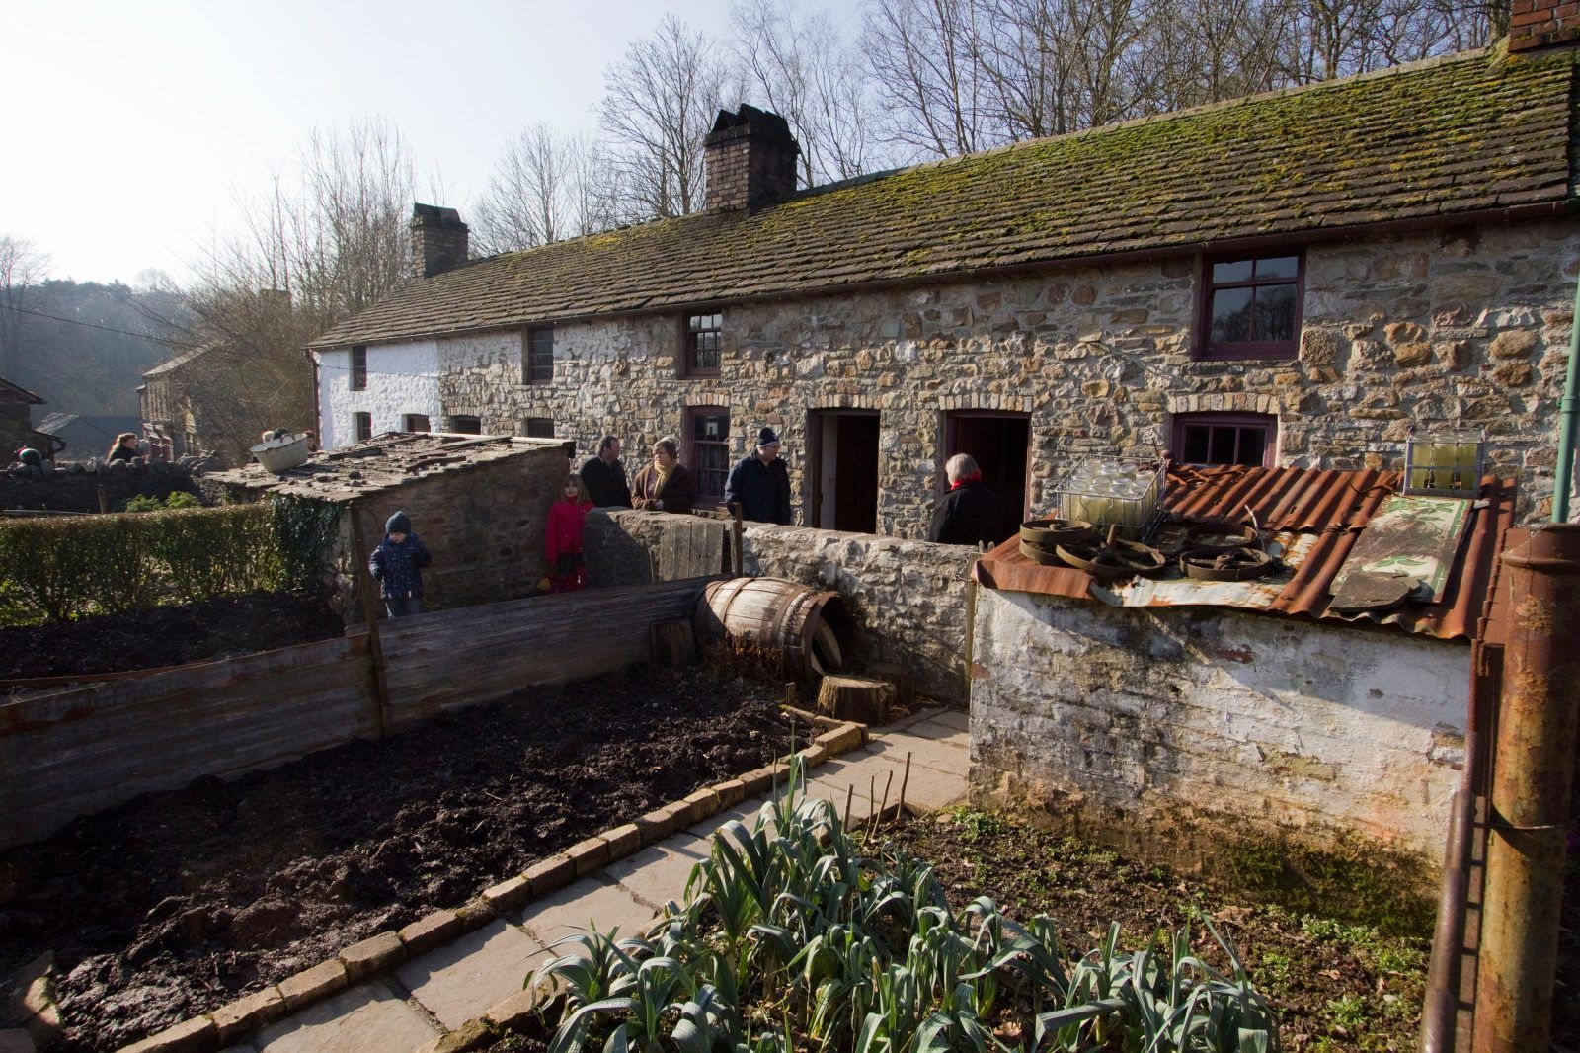
National Museum Wales. Rhyd-y-Car Terrace Houses.

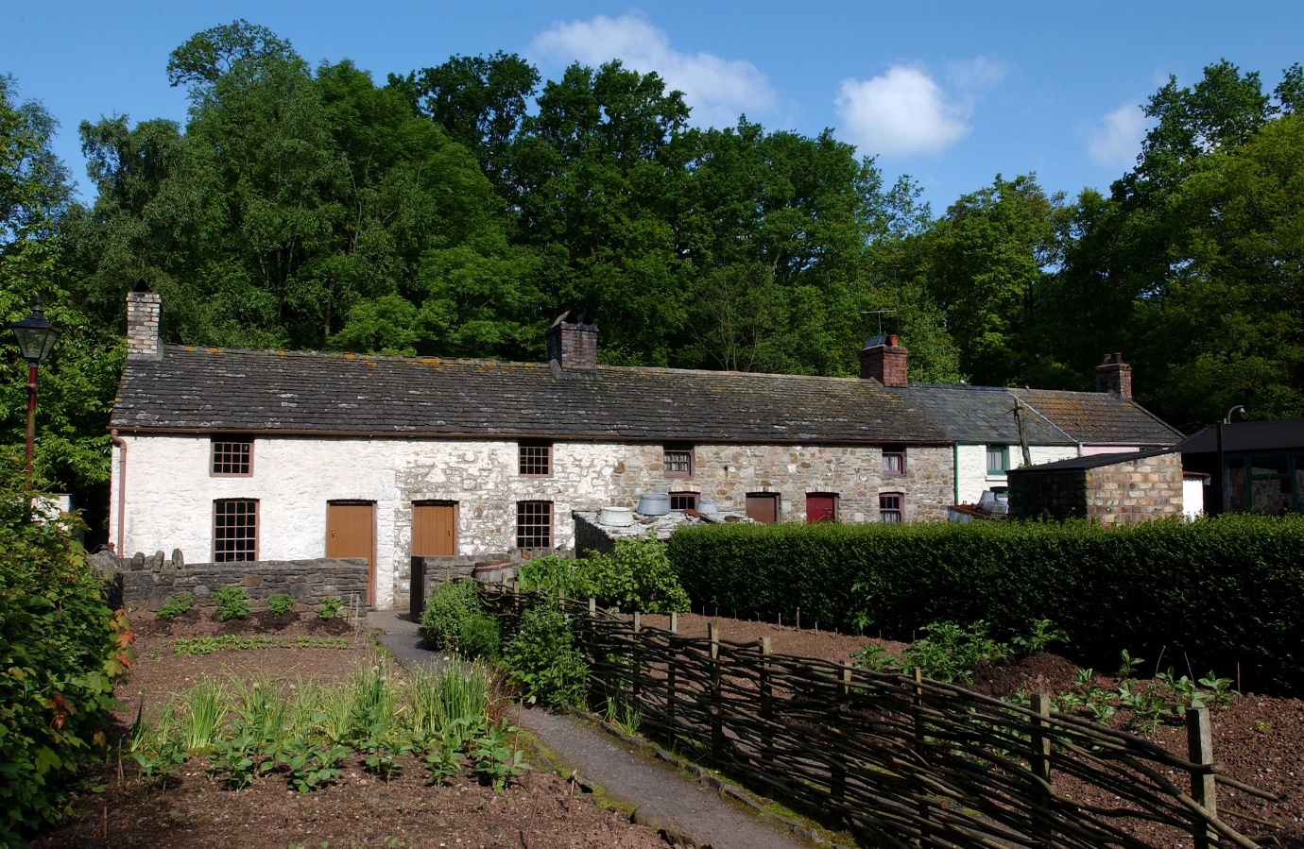
National Museum Wales. Rhyd-y-Car Terrace Houses.

Rhyd-y-Car Terrace Houses
Rhyd-y-car, a row of six mineworker’s cottages, has been amongst the most popular attractions at the Museum of Welsh Life since its opening in 1987. Rhyd-y-Car Terrace was built in 1795 to provide housing for mine workers. It comes from Merthyr, which between 1800 and 1860 was the largest town in Wales. Though a tangible object, intangible heritage in the form of oral history and anecdotes was used to create the display; Wiliam asserts that “the Museum’s curatorial staff interviewed former residents to enable the building to be rebuilt and furnished accurately."
Wiliam lays out the significance of the terrace. "The re-erection and refurbishment of the Rhyd-y-car houses broke new ground in the world of open air museums. For the first time, people were able to view, not only a period interior, but also to see how that interior - furnishings and décor - changed over the course of nearly two hundred years. Externally too, visitors could see the changes in window design, roofing materials, colours and wall finishes."
The six houses in the terrace are displayed at different points in their history: 1805, 1855, 1895, 1925, 1955 and 1985. This shows the changes in the buildings, contents and gardens over time. Each house has a living room and an upstairs bedroom, as well as a smaller back bedroom and a small pantry. The upstairs is accessed by a circular staircase by the fireplace.
Eurwyn Wiliam records that the intent of the displayed Rhyd-y-Car terrace is to show the changes made to a buildings fabric over nearly two centuries, giving the educational advantage of showing that culture is not static, and to help present day identification with the subject of the display by bringing it up to the near present, with objects familiar to many of the people who visit. This is the reasoning behind extending the display past the 1980 relocation of the terrace, and past the 1930 condemnation of the houses. The displays are based upon extensive research. Including oral histories, and intends to record 2some of the vibrant life of a Welsh mining village.
Nearly 400 houses of the type forming this terrace existed across the valleys, most relating to ironworks connected to the Crawshay family. These particular examples are the smallest built by the Crawshay family, and so demonstrate the minimum acceptable standard of living, which contrasted with the "extremely poor quality of dwellings in Merthyr at that time.
Much of the background evidence for the re-erection and furnishing of the houses has been published in Wiliam’s book. The six different time periods allow the development of building techniques and living styles to be seen, by about 1850 theses houses were being overtaken in standards by newer terraces built nearby. This also illustrates local intangible history, in customs of furnishing and living arrangements.
The 1855 house has no improved ventilation or sanitation, which contributed to deaths during the cholera epidemics of 1949 and 1854. The 1855 house was the residence of widowed milkwoman and her 19-year-old son, as well as a 14-
house, while the inside has been thoroughly redecorated. This house “could be anywhere in Britain; it no longer has a clear link with the past".

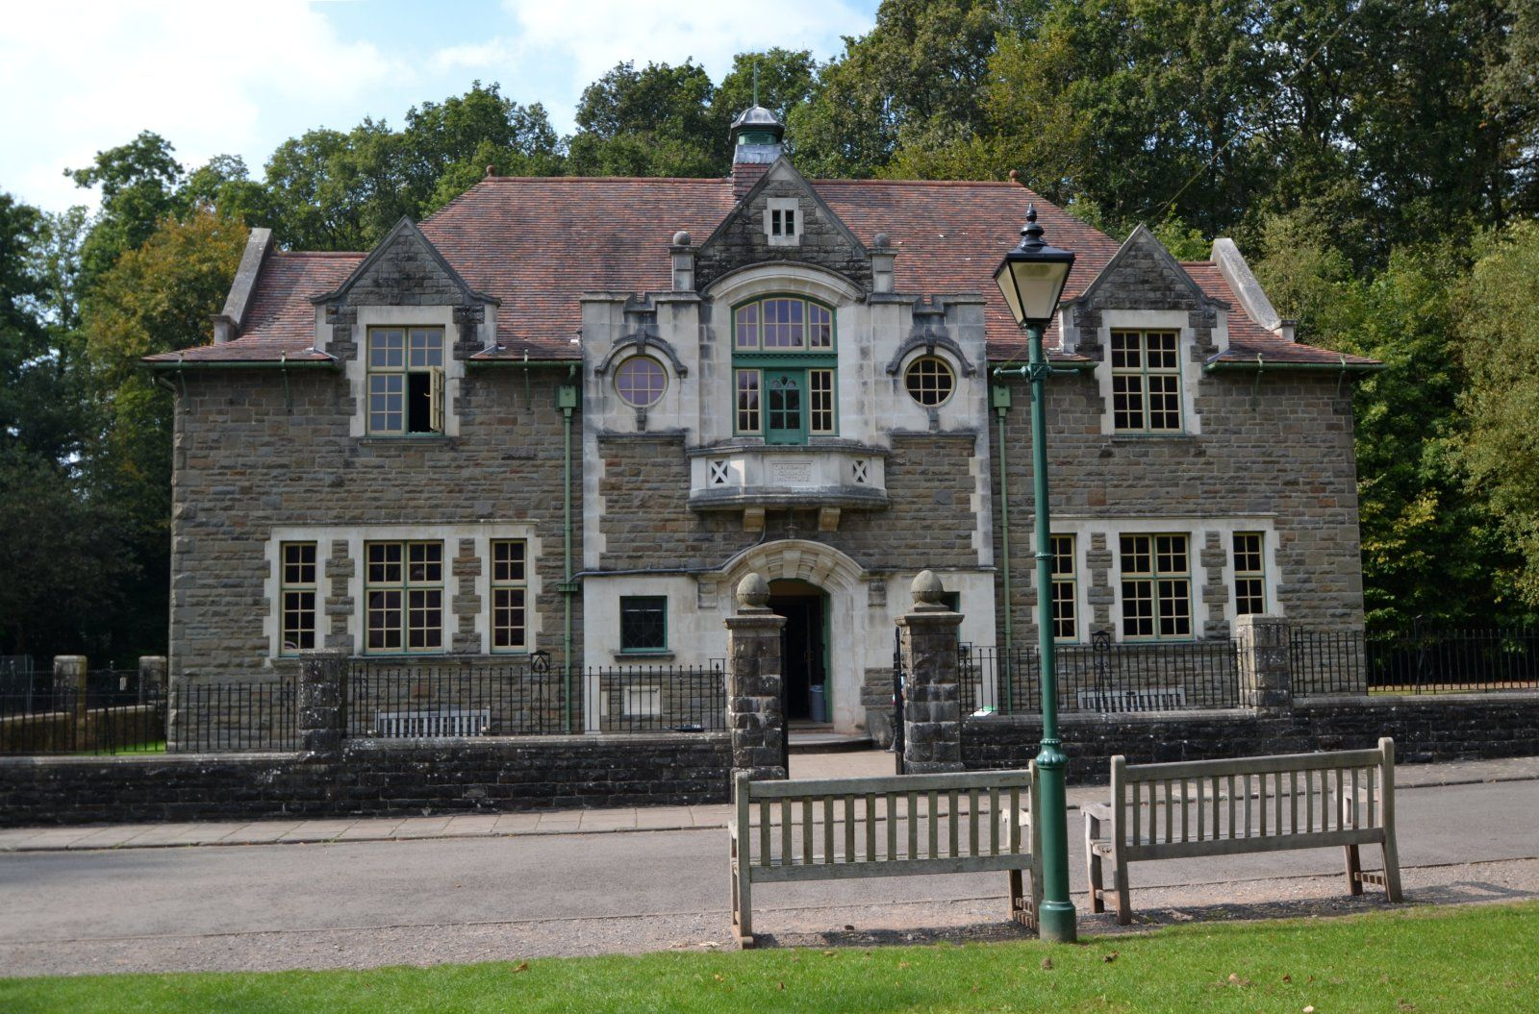
1National Museum Wales. Oakdale Workmen’s Institute

Oakdale Workmen's Institute
This building came from Oakdale in Gwent (Monmouthshire) It was opened to the public in 1995. In 1987 the Institute closed and it was dismantled and transported to St Fagans in 1989. The website has audio recordings of related oral history, and an animation called "The 'Stute". This was made by two pupils from South Wales schools and the animation company Cinetig. It uses oral testimony from the archives at St Fagans and celebrates the role the Institute had in the mining community.
Oakdale Workmen's Institute was built in 1916-1917 to serve the newly established coal mining community as a focus for social, educational and cultural life.
The Oakdale Workmen's Institute had its 100th anniversary in 2017. St Fagans used social networks (and the tag #Oakdale 100) and events at the museum to “bring the building alive once again”, including making oral history tapes available to the public.

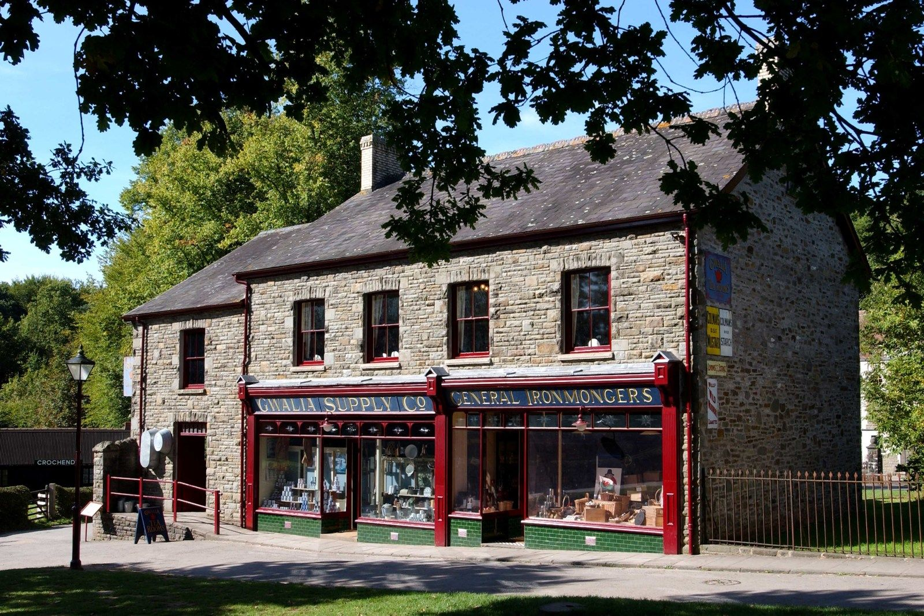
National Museum Wales. Gwalia Stores.

Gwalia Stores
The Gwalia was a family store which served the community of Ogmore vale for nearly a century. The Gwalia represents one of the larger and more imposing of the valley’s stores. The Museum’s book on Gwalia sets out the history of the store, intertwined with the aspirations of its founder and created with the use of photographs and recorded interviews with former employees, customers and the family. It aims to set the Gwalia in the context of the community it once served.
From the South Wales industrial valleys, this typical general store is divided into three sections over two floors, including ironmongery and grocery displays. The shop was built in 1880 as a way for William Llewellyn to develop his grocery business: it was originally the central section, flanked by Llewellyn’s house and the storeroom. The store in its lifetime was compared to Harrods for the breadth of goods it sold.
By 1912 the ground floor of the house had been turned into a drapery. The shop expanded to include the ground floor and the upper floor of the three connecting houses, and by 1926 Gwalia stores had a bakery, ironmongery, grocery, gentleman's outfitters, chemist and an animal feed shop. Staff members were paid 8 shillings a week and slept in the attics.
The shop was moved to the museum in 1988 from its original location on Commercial Street, in Ogmore Vale in Glamorgan. It closed in 1973. The shop is shown in its late 1920s incarnation, shortly after the death of Llewellyn in 1924 and his sons' inheritance of the shop.
The website has oral testimony from the archive available regarding Gwalia Stores: one recording from a Mr Arthur Tuck of Ogmore Vale describing its ideal position opposite the railway station, and another from the grandson of the founder, Rev. Canon Dillwyn Llewellyn Jones, describing his grandparents’ arrival in Ogmore Vale and creation of their grocery business.

Conclusion
St Fagans does both tangible and intangible heritage well, but the primary source for intangible is the website; the museum grounds remain disconnected and the buildings are not used to their full advantage; the three discussed here are the best served in that regard.
The primary recommendation for St Fagans is to increase the presence of intangible heritage at its reconstructed buildings, and to make events based around intangible heritage better publicised at the museum. The second would require signposting in the museum grounds and displays in the main building publicising upcoming and reoccurring events at the museum, or signs and posters by the displayed buildings advertising relevant events.
One simple way to do the first would be to make audio guides available, with oral history samples, examples of audio context such as street or village sounds, and traditional songs accessible. This would let visitors conceive of the buildings preserved there within their original contexts, busy streets or industrious farms, and provide a stronger sense of the buildings in-use, rather than the static sense they give off now, the physical equivalent of a still and lifeless image. Some imagery of the buildings in their heyday and their original context would also help with this.

Bibliography
Mason, R. 2007. Museums, nations, identities: Wales and its national museums. Cardiff: University of Wales Press.
National Museum Wales. Date Unknown. A Living Museum. https://museum.wales/stfagans/living-museum/ [Accessed 13/03/18].
National Museum Wales. Date Unknown. Gwalia Stores. https://museum.wales/stfagans/buildings/gwalia/ [Accessed 22/03/18].
National Museum Wales. Date Unknown. Making History. https://museum.wales/stfagans/makinghistory/ [Accessed 13/03/18].
National Museum Wales. Date Unknown. Oakdale Workmen’s Institute. https://museum.wales/stfagans/buildings/oakdale/ [Accessed 22/03/18].
National Museum Wales. Date Unknown. Rhyd-y-Car Terrace Houses. https://museum.wales/stfagans/buildings/rhydycar/ [Accessed 13/03/18].
National Museum Wales. Date Unknown. St Fagans 70: A Year to Celebrate. https://museum.wales/stfagans/stfagans-70/ [Accessed 13/03/18].
Tibbott, S.M., Thomas, B. and Welsh Folk Museum (1991) The Gwalia: the story of a Valleys shop. Cardiff: National Museum of Wales.
UNESCO. Date Unknown. Frequently Asked Questions - intangible heritage. https://ich.unesco.org/en/faq-00021 [Accessed 09/03/18].
UNESCO. Date Unknown. Tangible and Intangible Cultural Heritage. http://www.unesco.org/new/en/natural-sciences/priority-areas/sids/tangible-and-intangible-cultural-heritage/ [Accessed 09/03/18].
UNESCO. Date Unknown. What is Intangible Cultural Heritage? https://ich.unesco.org/en/what-is-intangible-heritage-00003 [Accessed 09/03/18].
Wiliam, E. and National Museums & Galleries of Wales (2003) Rhyd-y-car: a Welsh mining community; the life, death and re-creation of a Welsh mining community, 1800-1980. Cardiff: National Museums & Galleries of Wales.
Williams-Davies, J. (1989) The Preservation and Interpretation of Traditional Rural Crafts at the Welsh Folk Museum. Journal of Design History, 2(2/3), 215–218.
Williams, S. 2016 Building on strong foundations: Oakdale Workmen’s Institute https://museum.wales/blog/2016-07-01/Building-on-strong-foundations-Oakdale-Workmens-Institute-/ [Accessed 1/04/18].

National Museum Wales. Making History
Mason. 2007, 19
Mason. 2007, 20
Mason. 2007, 21
Mason. 2007, 21
Mason. 2007, 26-27
Mason. 2007, 28
UNESCO. What is Intangible Cultural Heritage?
UNESCO. What is Intangible Cultural Heritage?
UNESCO. What is Intangible Cultural Heritage?
UNESCO. What is Intangible Cultural Heritage?
National Museum Wales. A Living Museum.
Wiliam, 2003, back cover blurb.
National Museum Wales. Rhyd-y-Car Terrace Houses.
Wiliam, 2003, 33
National Museum Wales. Rhyd-y-Car Terrace Houses.
Wiliam, 2003, 2
Wiliam, 2003, 4
Wiliam, 2003, 24
Wiliam, 2003, 32
National Museum Wales. Oakdale Workmen’s Institute.
National Museum Wales. Oakdale Workmen’s Institute.
Williams, 2016
Tibbott 1991, 5
National Museum Wales. Gwalia Stores.
Tibbott 1991, 15
National Museum Wales. Gwalia Stores.
National Museum Wales. Gwalia Stores.

