Computer Aided Engineering
George Goddard

Glossary

CAE – computer aided engineering
CAD – Computer aided design
CAM – Computer aided manufacture
FAE – Finite element analysis
CFD – Computational fluid dynamics
CNC – computer numerical control
EDM – Electrical discharge machining

Table of figures
Figure 1 Shows F1 car aerodynamics [3] 5
Figure 2 shows half a shaped charge being modelled to reduce simulation time [8] 7
Figure 3 Shows the deflection of the validation study beam 11
Figure 4 Shows the stress of the validation study beam 11
Figure 5 shows radius arm six with the deformed scale at 1 18

Table of tables
Table 1 shows the results from different mesh sizes 12
Table 2 Shows the initial radius arm 13
Table 3 Shows the first radius arm design 14
Table 4 Shows the second radius arm design 15
Table 5 Shows the third radius arm design 15
Table 6 Shows the fourth radius arm design 16
Table 7 Shows the fifth radius arm design 17
Table 8 Shows the sixth radius arm design including a deformed result 18

Contents
Glossary 2
Table of figures 2
Table of tables 2
Introduction 4
Background 4
Modelling 4
FEA 5
CFD 5
CAM 6
Thermal simulation 6
Modelling techniques 6
Literature review 7
Software 8
Validation study 8
Manual calculation 9
CAE model 10
Model 12
Initial model 12
Radius arm 1 13
Radius arm 2 14
Radius arm 3 15
Radius arm 4 15
Radius arm 5 16
Radius arm 6 17
Limitations of CAE 18
Conclusions & Future study 19
Bibliography 20

Introduction

Computer aided engineering (CAE) enables engineers to take a design from concept through to manufacture or build. It does this through the use of software platform that enables the user to analyse the model without a physical component or structure having to be manufactured. There are many advantages to the use of CAE, these include cost and time savings as components can be tested and analysed without costly manufacture and test schedules. However, CAE also has its disadvantages which include initial cost, complicated software, and the time it takes to run simulations.
This report shows how CAE will be used to improve the performance of a load bearing arm connected to a tracked tank suspension system by modelling the component, applying a motion study, and analysing the forces applied. From these results the component will be redesigned to achieve targets set by the customer on weight and overall factor of safety.

Background

CAE can be broken down into individual components, each delivering a different aspect of computational modelling. Applications of CAE include car crash simulations, thermal analysis, production of injection moulding tools, and explosive damage modelling. CAE can be used to design, model, and analyse most problems.
There are numerous CAE software packages on the market with each one offering different features and functions all at different price points. 3D modelling software can be downloaded for free, but this software has very limited functionality compared to the paid for brands. Most CAE software is paid for on a monthly rolling contract, this will give the user access to all updates Depending on how many computers are using the software costs can vary from £246 for a single seat of AUTO CAD [1] to thousands of pounds a month for multiple seats of high-end software such as LS Dyna or Siemens NX10.

Modelling

In its most basic form CAE is used to model components and designs. These start with a 2D sketch which is then converted to a 3D model using extrude or sweep features. Extra details and features such as fillets, holes, threads, and additional geometry can be added using more sketches and features. This 3D model can be turned into an engineering drawing using a drafting feature. This drawing then be sent to a workshop to have the component manufactured.
Multiple components can be assembled to model an entire design. Each component is brought into the assembly and mated with other components. Depending on what is being modelled degrees of freedom can be left within the model If modelling a building most components will be fixed in place to not allow movement. However, if modelling an engine, components need to move in certain directions. For example, the pistons should only move up and down and not rotate, but the flywheel should only rotate and not move in any other direction.
These components and models form the basis for any analysis, simulation, or CAM that the CAE software can perform.

FEA

Finite element analysis (FEA) is used to model how components or assemblies interact with other components, assemblies, or the environment. This is done by breaking large numerical calculations down into smaller manageable calculations. Uses of FEA include modelling how bridges withstand loading, car crash simulation and how effective tank armour is against anti-tank munitions. One of the biggest advantages of FEA is the cost saving of running a simulation vs running a physical test.

CFD

The way that fluids and gases interact can be modelled using computational fluid dynamics (CFD), this enables the engineers to study incompressible fluids along with laminar and turbulent flows. As with FEA, CFD breaks a large mathematical problem down into small manageable equations that the computer can solve. One of the main uses of CFD is to study how air flows over and around different structures and vehicles. Figure 1 shows a Formula 1 car undergoing aerodynamic simulation, this allows engineers to view and analyse data without the expense of manufacturing a prototype and testing it in a wind tunnel. It also allows the engineers to change the model and rerun the simulation without having to re manufacture or modify the prototype. CFD is also used to model how wind can affect bridges. Had CFD been available in the 1930’s the Tacoma Narrows bridge collapse could have been avoided. The bridge collapsed when wind blew at a specific speed causing the bridge to sway and fail [2].

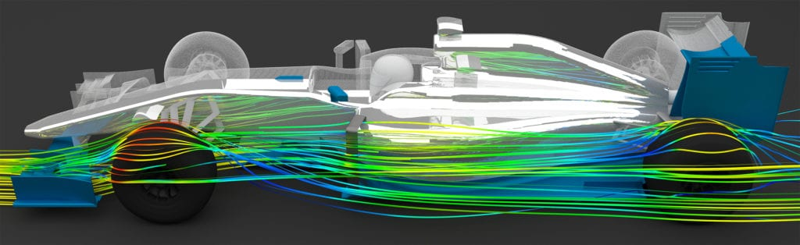
Figure 1 Shows F1 car aerodynamics [3]

CAM

CAM is used to take the model from the computer to the shop floor and is used to program CNC machines. The use of CAM enables programs to be written in the office and transferred to the required machine ready for manufacture saving time spent programming on the shop floor. CAM programs can be written for lathes, milling machines, additive manufacture machines and EDM machines. CAM can also be used to program robots, this could be to load stock material into a CNC machine or perform welding or assembly tasks [4].

Thermal simulation

Another use for CAE is simulating how components are affected by thermal loads and stresses. This can be useful for simulating engine components through cold start to operating temperature and overheating. The use of this simulation is used to view how components expand and contract under different temperatures and check components have acceptable clearances through temperature cycles.

Modelling techniques

With complex simulations taking up to a week to solve there are techniques that CAE modellers use that reduce the run time and reduce the required computing power. If a model is symmetrical then the simulation can be run over half or a quarter of the model. Doing this reduces the number of calculations the software has to complete therefore reducing the run time of the simulation. Figure 2 shows the detonation wave forming in shaped charge, this shows how half the shaped charge was simulated to reduce the solve time. This result can be mirrored to view the full charge. As this simulation was a full cylinder a quarter of the charge could have been run to further reduce the time and computing power required to run. The use of this technique to reduce run time can be used to improve model accuracy by increasing the mesh density but this has the effect of increasing the run time.
The time taken to run a simulation can also be reduced by increasing the mesh size. Doing this reduces the number of calculations the software has to solve. However, this in turn can affect the quality of the simulation and how each node interacts with other nodes and could give a less accurate result.

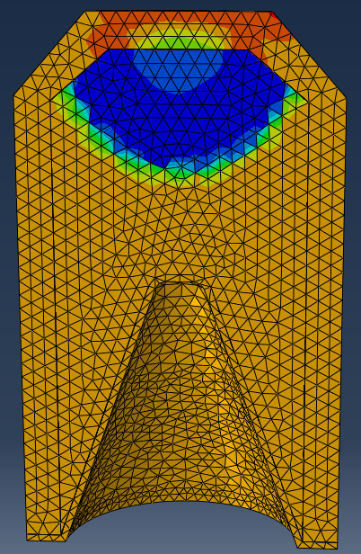
Figure 2 shows half a shaped charge being modelled to reduce simulation time [8]

Literature review

Kim, Kubota & Yamanaka carried out a study titled ‘Application of CAE in cold forging and heat treatment processes for manufacturing of precision helical gear part’ [5] In this study they modelled and simulated a helical gear from an automotive steering component using DEFORM-3D/HT software. The areas of interest from the simulation were stress and strain distribution, pressures, forming load and heat transfer. The simulations were compared to the manufactured part and the simulation predicted a slightly higher forming load. The report concludes that CAE can be used as an effective tool to improve the manufacturing process of this component.
Modern defence systems identify incoming threats and decide on an appropriate response before the threat causes any damage. To aid with this decision process FEA was used to simulate how a warhead fragments with these results being fed into the defence software. Felix, Colwill & Harris [6] used FEA to simulate how a warhead fragments and compared the results to witness plates from explosive trials. They concluded that the simulation and live trial produced similar results with the simulation showing less fragments. It was assessed that the simulation did not include small fragments. When compared to a second explosive trial both results gave the same angle of projection for the fragments. Felix et al noted that changing the impact points in the simulation from points to craters would improve the accuracy of the simulation.
CFD is widely used in the motorsport industry and Lotus used intensive CFD and simulation to design the car for the 2013 24 hours Le Mans race. Steven Ferguson [7] writes how CFD is used to filter out poor designs before prototype wind tunnel testing. Using CFD to weed out inferior designs saves money as wind tunnel testing is very expensive and time consuming. Over 50 designs were simulated during the design of the car with the best three taken forward to the wind tunnel. The lotus designers used the wind tunnel to fine tune the aerodynamics of the car and to validate the simulations they had run.

Software

The software used to model and simulate the components of the suspension system was SolidWorks 2021. SolidWorks is a general CAE software package owned by Dassault systems. As with most CAE software SolidWorks allows the user to sketch and 3D model, with many other add-ons available for model interrogation, including motion analysis, thermal loading, and CDF.

Validation study

To ensure that any CAE package is giving accurate and reliable results a validation study must be carried out. This could be in the form of checking results against standards or a live test such as wind tunnel testing. Manual calculations can also be carried out as a sanity check to validate the software.
For this validation study a simple cantilever beam was modelled in SolidWorks and a manual hand calculation carried out to verify the software.
A mesh study was also carried out on the simple beam at this initial stage to find the mesh density that gives the most accurate results compared to the manual calculation. These validation studies are carried out before any modelling is carried out. This ensures the best mesh density is being used for any simulations and gives the user confidence that any results are true and valid.

Manual calculation

Beam length = 1000mm
Beam width = 200mm
Beam height = 100mm
Youngs modulus = 210000 Mpa
Force applied 2000 N

$$I= \frac{{BH}^{3}}{12}$$
$$I= \frac{{200*100}^{3}}{12}$$
$$I =16666666.67$$

Beam deflection
$$δ max= \frac{{FL}^{3}}{3EI}$$
$$δ max= \frac{{2000*1000}^{3}}{3*\left({210*10}^{3}\right)*16666666.67}$$

$$δ max= 0.19mm$$

Stress

$$σ= \frac{ym}{I}$$

$$m= F*L$$
$$m= 2000*1000$$
$$m= 2000000$$

$$σ= \frac{50*200000}{16666666.67}$$
$$σ= 5.99 {N/mm}^{2}$$
$$σ= 5.9*{10}^{6} {N/m}^{2}$$

CAE model

The simple beam was modelled and given the same material property as the calculated beam above. The model was meshed and given the appropriate fixed end and load at 1000mm; the FEA simulation study was then run. The initial mesh size was not altered from the auto calculated size. Table 1 shows the results from the initial run and the other experimented mesh sizes and the manual calculation. As can be seen in Table 1 the manual calculation was very close to the initial simulation on stress and beam deflection. It can be concluded that the mesh size does not greatly affect the beam deflection as the greatest variation over all the runs is 0.001mm. However, the mesh density does have a large effect on the stress applied to the beam. As the mesh density decreases in size to a fine mesh the accuracy of the stress calculation decreases. With a very fine mesh the stress is calculated at 7.05*10⁶ where the hand calculation is 5.99*10⁶. By adjusting the mesh size, the model output can be brought close to the calculation using a mesh slightly smaller than the suggested size, this is the optimum mesh density and will be used when modelling the radius arm.

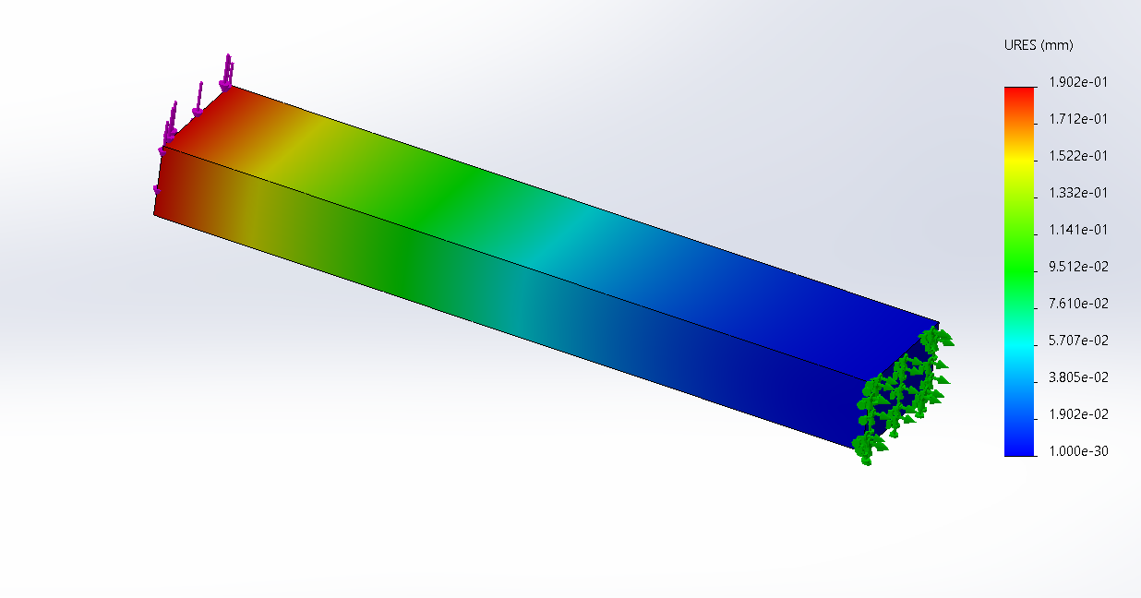
Figure 3 Shows the deflection of the validation study beam

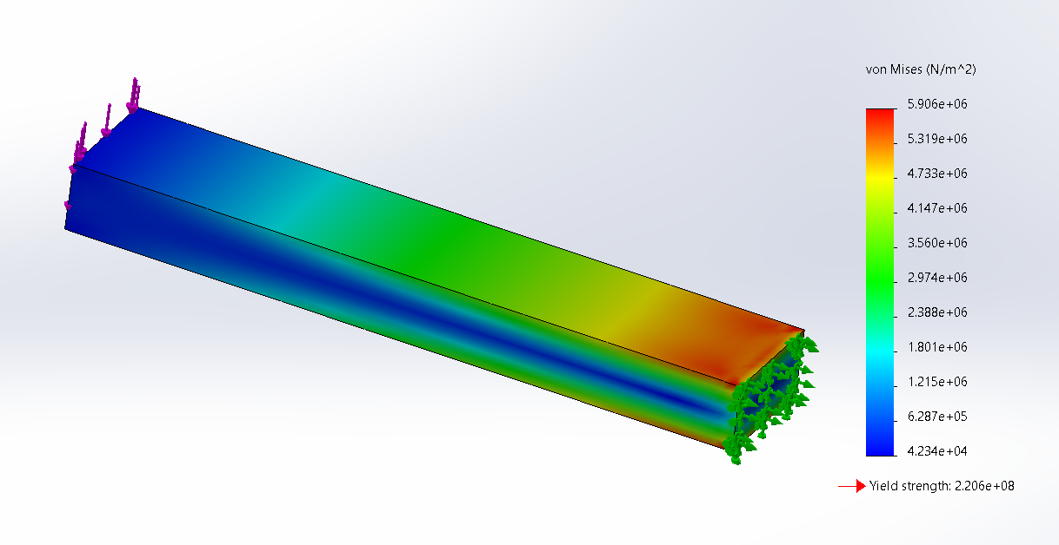
Figure 4 Shows the stress of the validation study beam

Mesh size | Deflection mm | Stress
Calculated results | 0.19 | 5.99
Suggested mesh | 0.19 | 5.88
Coarse | 0.189 | 5.77
Fine | 0.19 | 7.05
1/4 | 0.189 | 5.73
½ | 0.19 | 5.73
3/4 | 0.19 | 6.14
Suggested plus a little | 0.19 | 5.906
Table 1 shows the results from different mesh sizes

Model

The wheel, tyre, wheel spacer and radius arm were modelled from the supplied engineering drawings, all other components were supplied pre modelled. These components were assembled to give the full suspension system. Using the motion analysis add-in, the damper was given a spring with a free length of 550mm and a spring rate of 800N/mm, and a damper with a rate of 250 N/33/s. Gravity was added to the whole system with solid body contact added between the tyre and the road surface. The system was oscillated through 200mm of travel at a frequency of 1Hz. This oscillation is what moved the system up and down and applied forces to the radius arm.

Graph 1 shows the forces applied to the mate between the radius arm and the lower damper. From this graph it can be seen where the highest force is applied. Using a time frame from where the most stress is applied import motion loads was used to view the forces and the factor of safety plot applied to the radius arm.

Initial model

The initial model as drawn by the supplied engineering drawing weighed 118.67Kg and had a very poor factor of safety with a factor of safety distribution of 0.089. The model also performed poorly under stress with high stresses seen around the mounting point. Without redesigning or altering any other components the radius arm needed to be redesigned to achieve set parameters as set by the customer. These parameters were an overall factor of safety of 1.5 and a maximum overall weight of 110Kg.

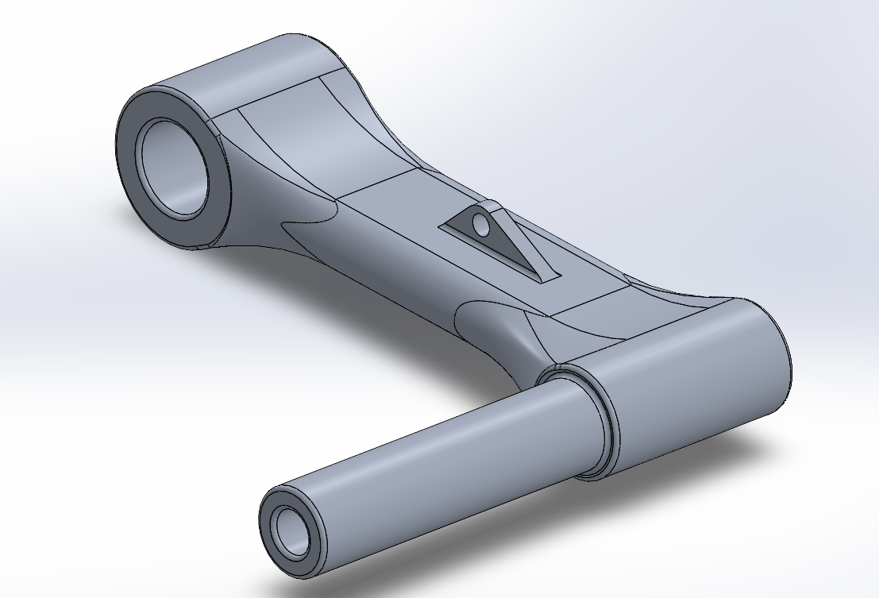 | 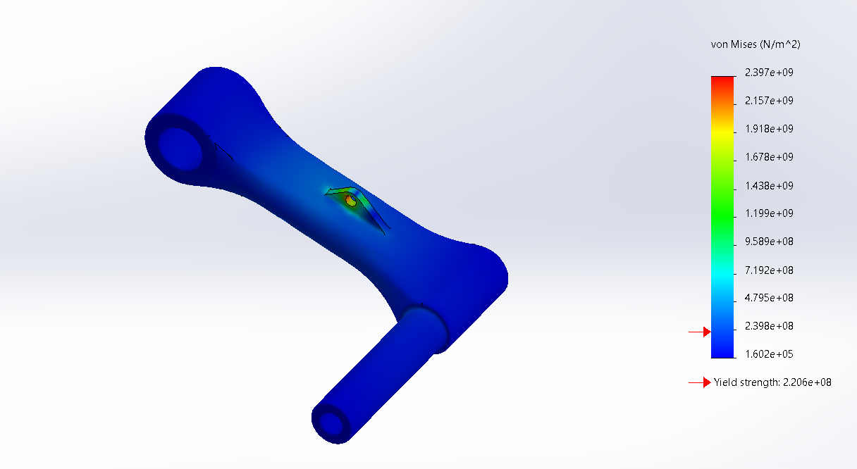
Radius arm | stress
Factor of safety
Table 2 Shows the initial radius arm

Radius arm 1

Radius arm 1 was designed around the idea of an I beam to reduce the overall weight and increase strength along the beam. An extension was added to the mounting point to spread some of the load away from the small bracket in the initial design. This design decreased the weight by 15% to 102.37Kg however the mounting point still performed poorly when viewing the stress applied and the factor of safety.

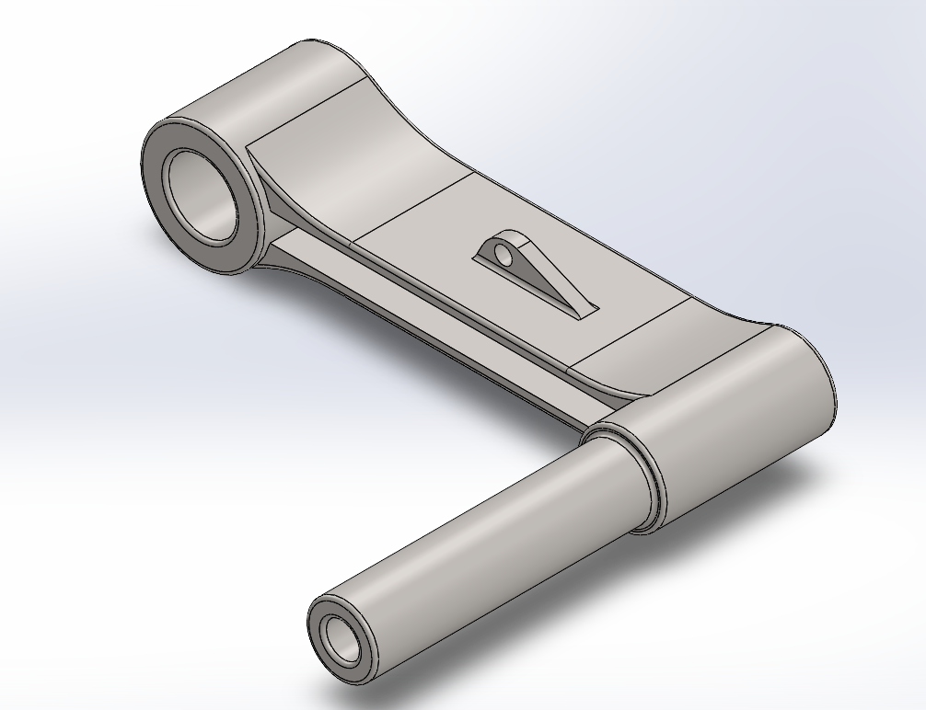 | 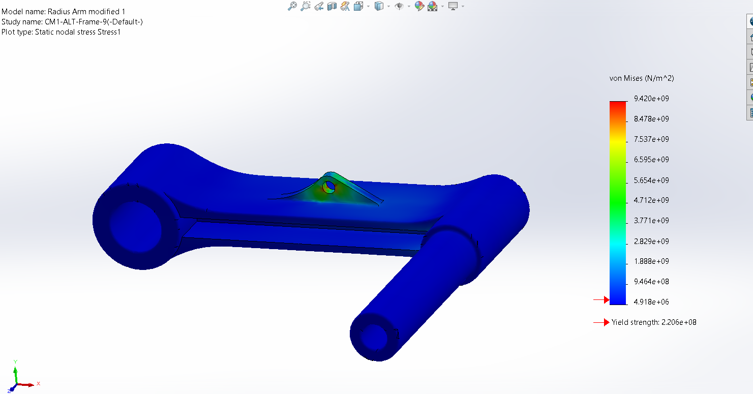
Radius arm 1 | stress
Factor of safety
Table 3 Shows the first radius arm design

Radius arm 2

The second redesign used the initial arm with holes drilled through the main body to reduce the weight and a large mounting point. This design was under the weight constraint weighing 109.91Kg. Where the holes were added this weakened the main body and stresses can be seen through the holes and on the bottom face of the arm. Stresses can also be seen in the mounting plate along with a poor factor of safety.

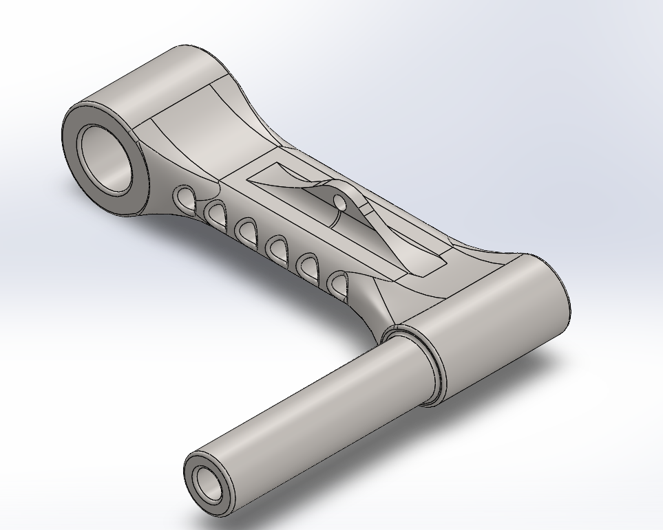 | 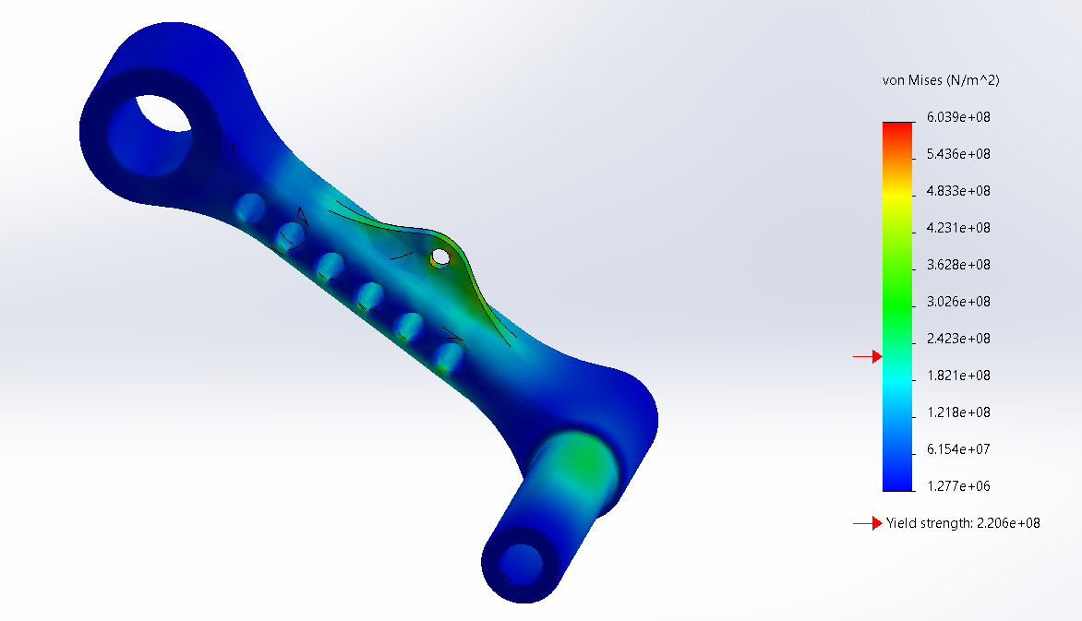
Radius arm 2 | Stress
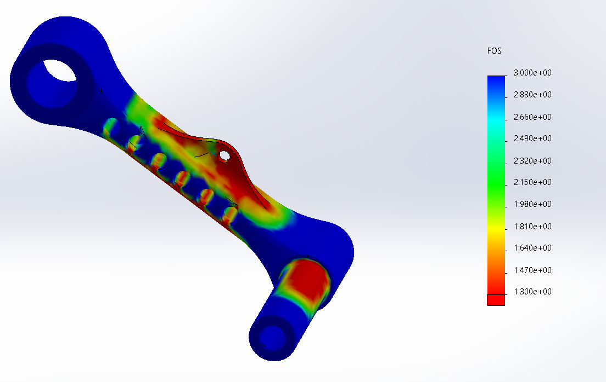
Factor of safety
Table 4 Shows the second radius arm design

Radius arm 3

Re using the initial radius arm design, iteration 3 tried to lower the mounting point to within the main body of the arm. In doing this the lower damper collided with the radium arm meaning this design was not viable. This design also weight 111Kg so failed on the weight aspect of the brief. Large stresses and a poor factor of safety can be seen around the edge of the main body as the hole has weakened the structure of the arm.
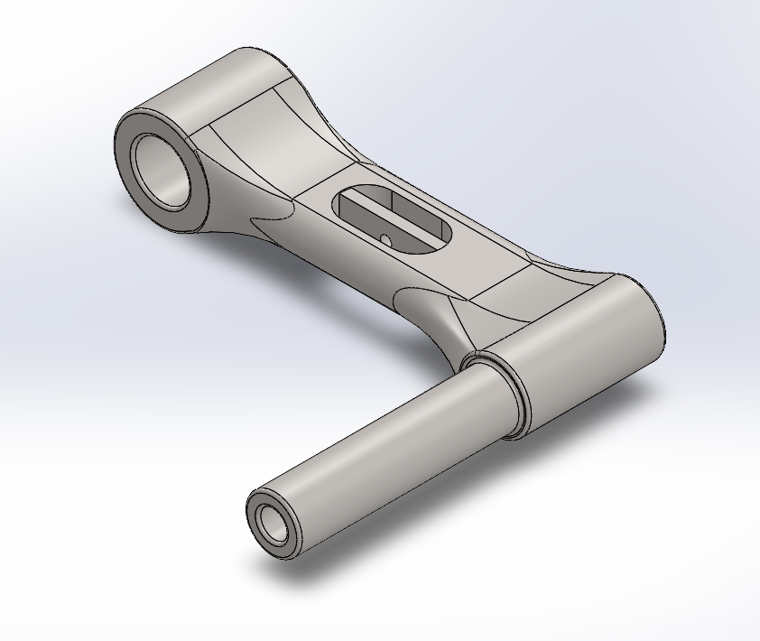 | 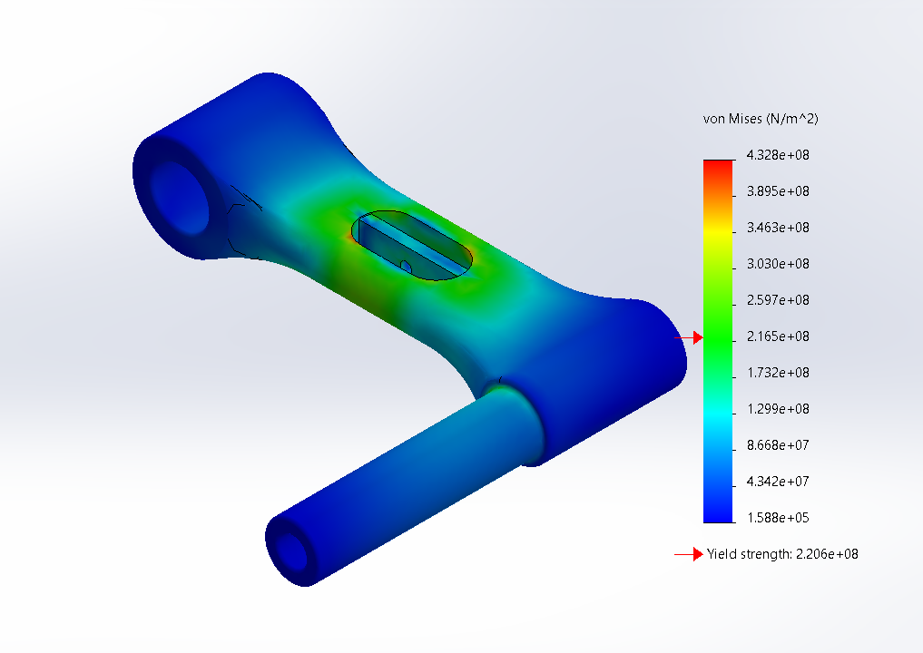
Radius arm 3 | Stress
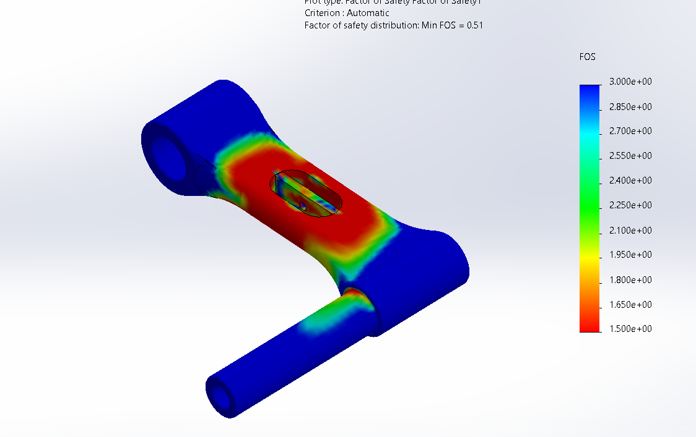
Factor of safety
Table 5 Shows the third radius arm design

Radius arm 4

The fourth re design used a tube for the main body with a large bar across the top to mount the damper to. A cut out was incorporated into the bar so the damper would not collide with the radius arm. This design weighs 120Kg, this could be reduced by hollowing out the central bar. This bulk of this design performed well under stress with only the mounting point showing high stress, the factor of safety across the design was low.
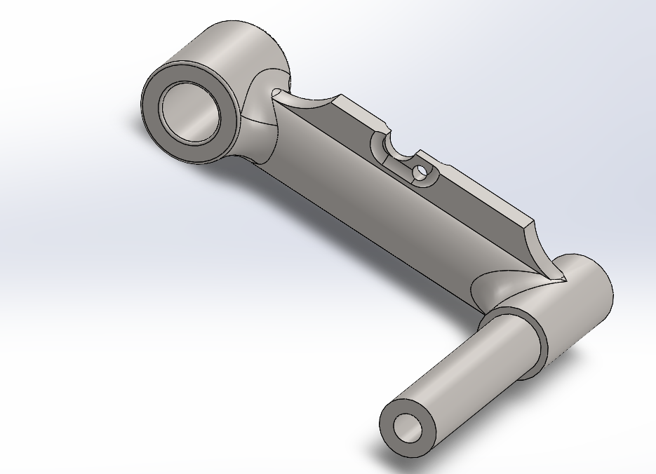 | 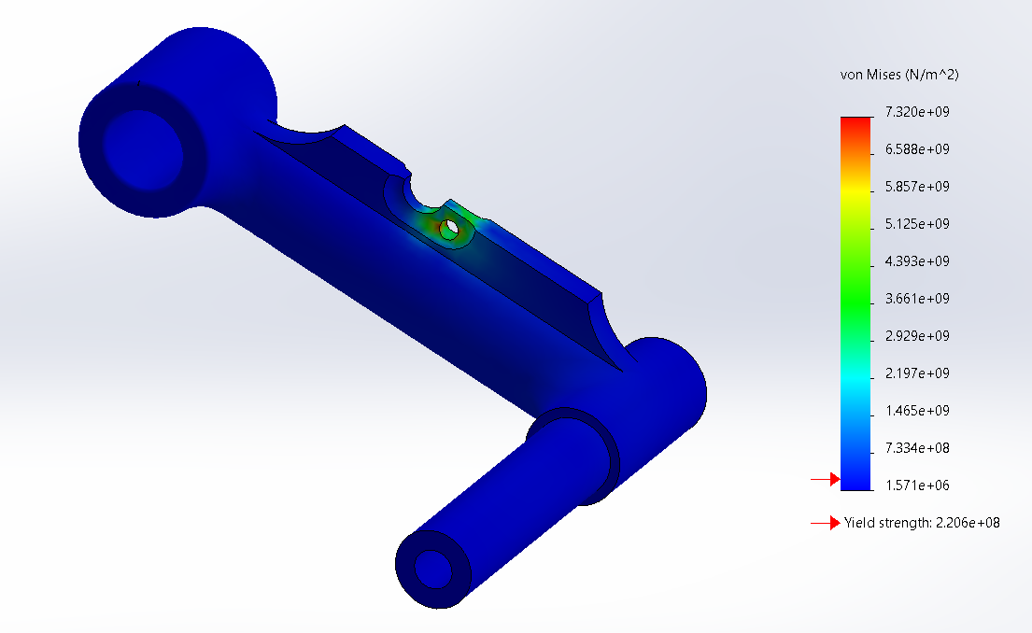
Radius arm 4 | Stress
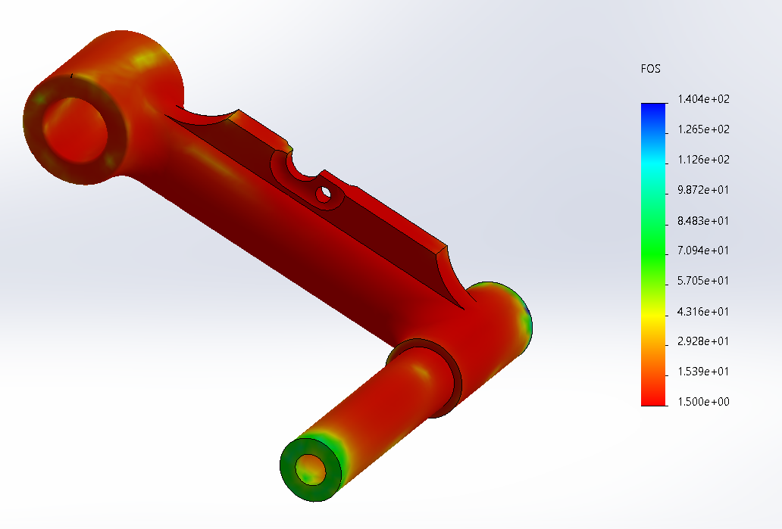
Factor of safety
Table 6 Shows the fourth radius arm design

Radius arm 5

For this re design the focus was placed on designing a strong mounting plate. This used the initial body of the arm with a square bar along the top and a cut out, so the damper did not collide with the arm. As with previous designs the weakest point is around the mounting point, due to the addition of the bar this increased the weight to 127Kg.

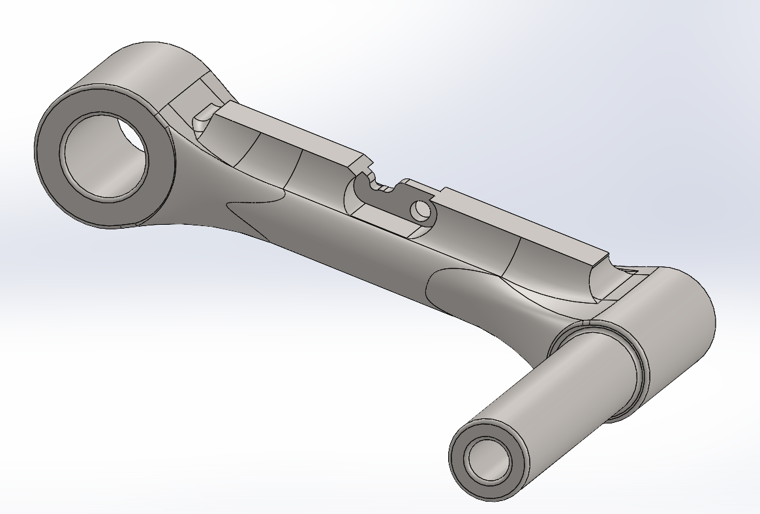 | 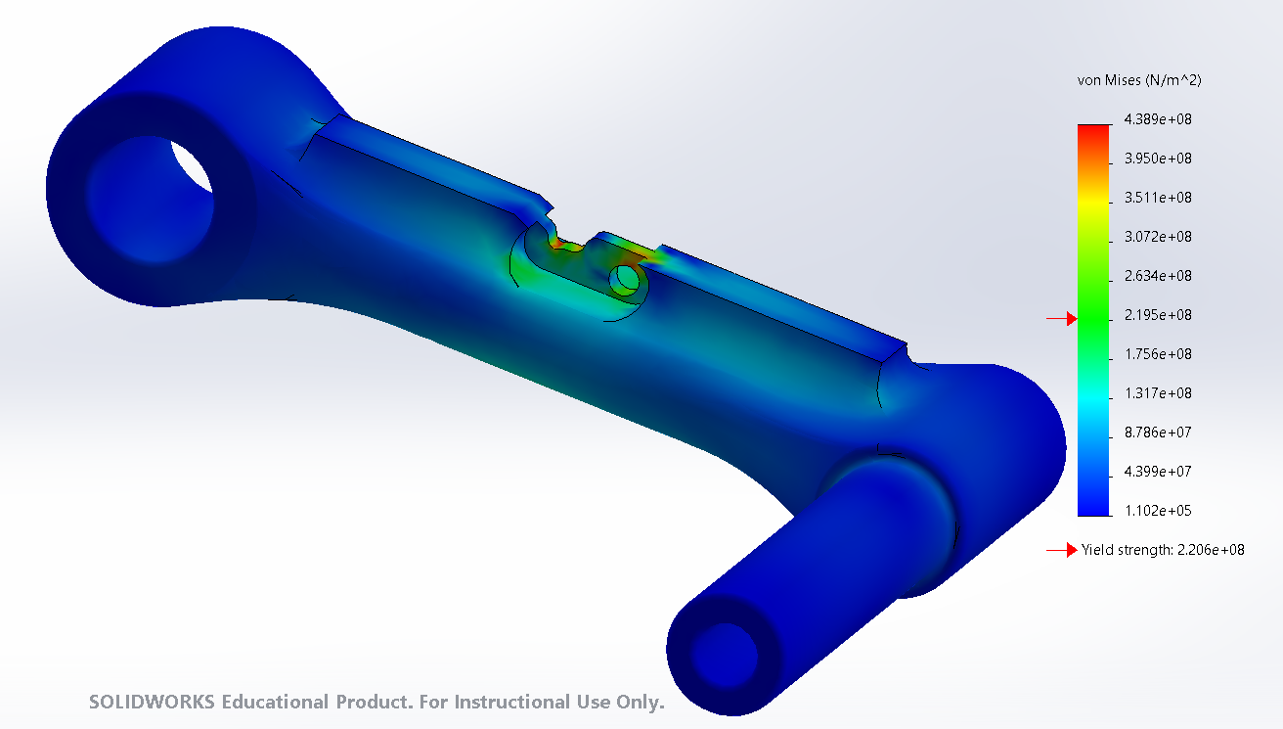
Radius arm 5 | Stress
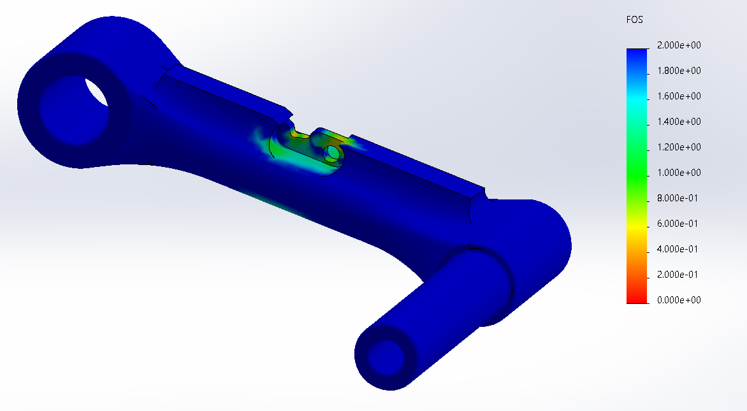
Factor of safety
Table 7 Shows the fifth radius arm design

Radius arm 6

This design furthered on design one and the use of an I beam for the main body of the arm; this reduced the weight enough to add a bar to the top to strengthen the mounting point. The weight of this component was 109.99Kg meaning it met the weight criteria. Unfortunately, this component still failed on the factor of safety around the mounting point, a low factor of safety was also seen on the bottom of the arm from where the force of the damper is being transferred through the arm. The black areas on this factor of safety show areas of 1.5 and under.

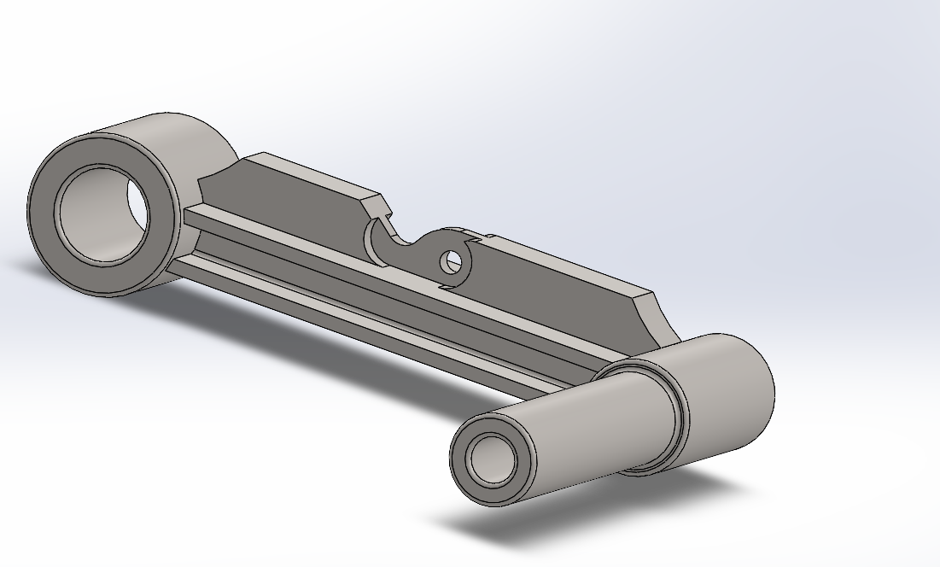 | 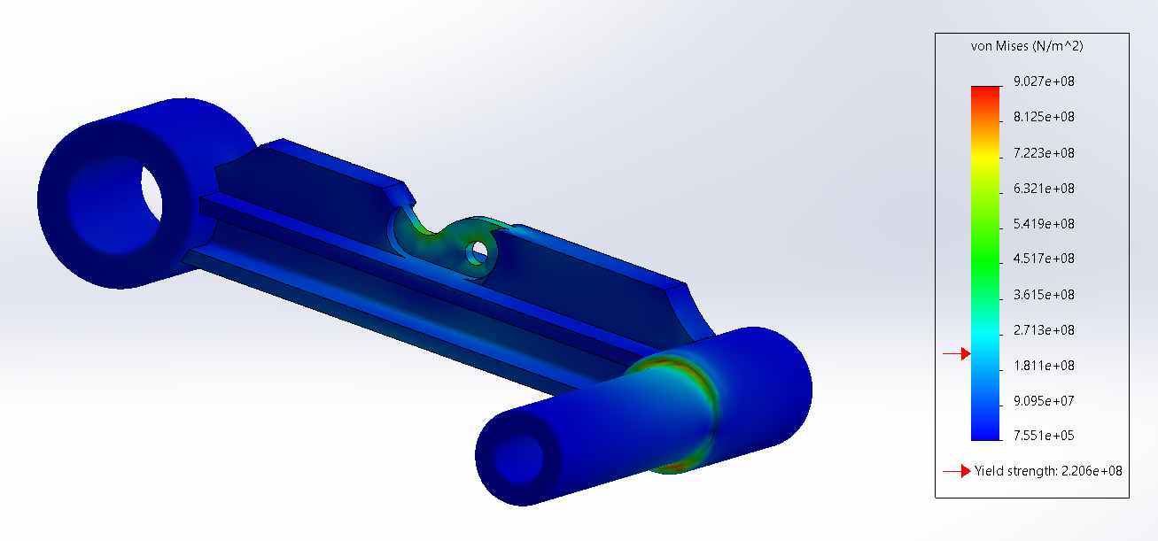
Radius arm 6 | stress
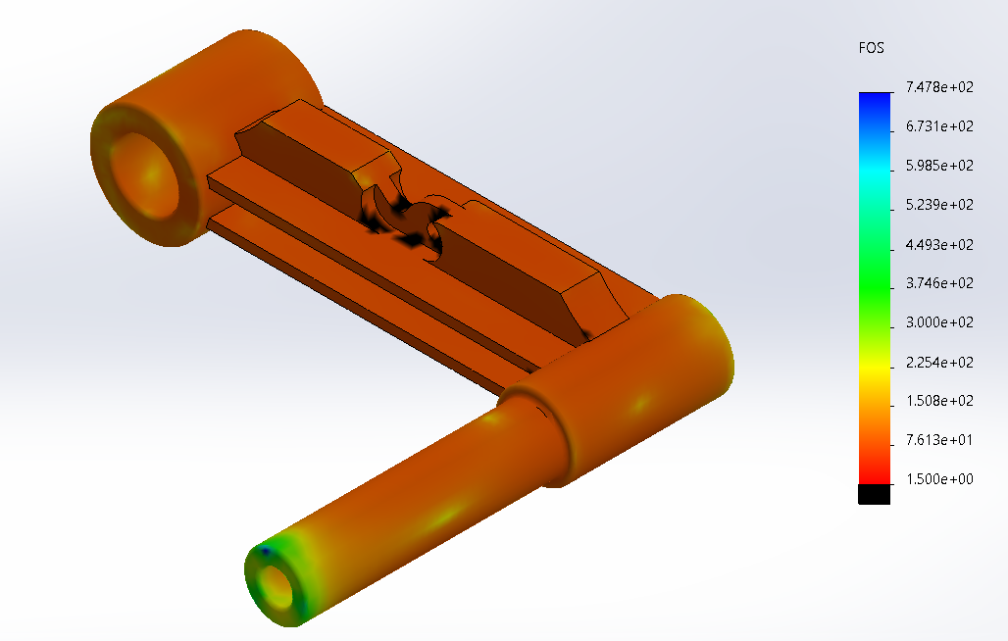 | 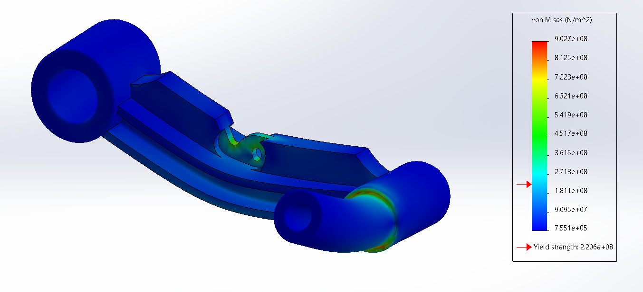
Factor of safety | Deformed result
Table 8 Shows the sixth radius arm design including a deformed result

Limitations of CAE

Through this modelling process limitations of CAE have been identified. One limitation is the competence of the modeller. Having an experienced modeller can save a lot of time and ensure the modelling is carried out in an efficient way. One limitation of CAE is the initial cost, software and hardware can be very expensive to purchase. Although modelling and simulation can be undertaken on standard computers the time taken to run the simulations will be long. Having a specification computer will allow the models and simulations to be completed in a shorter time.

Solid works automatically displays a distorted deformed result when viewing stress following a FEA simulation as seen in Table 8. This deformed result is factored to increase the deformation to enhance the user experience. If this scale is changed to 1 no deformation is observed as shown in Figure 5, this can be misleading if you are not aware of the auto scaling. Another limitation of CAE is system failure, if software or hardware fails all work could be lost if not backed up. One way to solve this is to store data on the cloud, however loading and downloading large files from the cloud can take a long time. Another limitation is the need to validate any results with a physical experimentation or mathematical study.
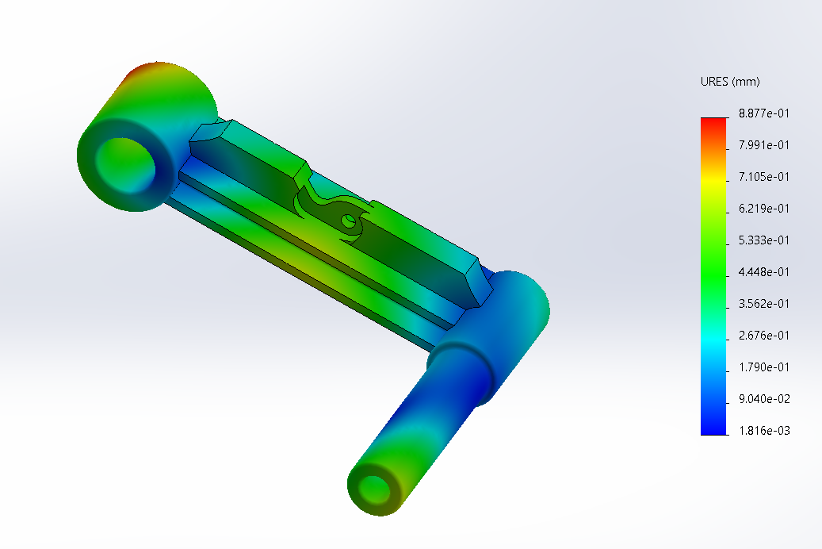
Figure 5 shows radius arm six with the deformed scale at 1

Conclusions & Future study

Both requirements could not be met for the redesign of the radius arm, designs one, two and six met the weight criteria. None of the designs met the factor of safety criteria, with design six coming closest to reducing the overall factor of safety to above 1.5.
Had more time allowed further designs would have been developed, these would have focused around strengthening the mounting point. This could be done by reinforcing the bracket using supports at the bottom or adding larger webs to spread the load.

Had other parameters been available for modification then it is possible the model could have been solved. Changing the material to a different material would greatly reduce the weight of the component but could change the way it behaves under load. Another parameter that couldn’t be changed was the size of the lower damper. If the pin on the damper could have been enlarged this would have enabled the mounting point to be larger. This should allow the arm to handle stress better and increase the factor of safety. The increase in size of the mounting point would naturally increase the weight of the arm.

Bibliography

[1] | Autodesk, “Buy AutoCAD,” autodesk, [Online]. Available: https://www.autodesk.co.uk/products/autocad/overview?term=1-YEAR&tab=subscription. [Accessed 11 3 2022].
[2] | history, “Tacoma Narrows Bridge collapses,” history, 11 2007. [Online]. Available: https://www.history.com/this-day-in-history/tacoma-narrows-bridge-collapses. [Accessed 14 3 2022].
[3] | Simscale, “What is CFD | Computational Fluid Dynamics?,” simscale, [Online]. Available: https://www.simscale.com/docs/simwiki/cfd-computational-fluid-dynamics/what-is-cfd-computational-fluid-dynamics/. [Accessed 15 3 2022].
[4] | K. Lee, principles of CAD/CAM/CAE systems, Addison-Wesley, 1999.
[5] | S. K. M. Y. Soo-Young Kim, “Application of CAE in cold forging and heat treatment processes for manufacturing of precision helical gear part,” Journal of Materials Processing Technology, vol. 201, no. 1-3, pp. 25-31, 2008.
[6] | I. C. P. H. David Felix, “Real-Time Simulation of a Fragmenting Explosion for Cylindrical Warheads,” Journal of Defense Modeling and Simulation: Applications, Methodology, Technology, pp. 1-15, 2021.
[7] | S. FERGUSON, “Lotus Revolutionise Le Mans Prototype Racing,” Auto Tech Review, vol. 2, no. 9, pp. 46-49, 2013.
[8] | G. Goddard, “CRITICAL COMPARRISON OF LAGRANGIAN & EULERIAN APPROACHES TO MODELLING SHAPED CHARGES,” UWTSD, Swansea, 2021.

