
Marketing Fundamentals (LCBB4004)

Assessment 2
Individual Report: Marketing Fundamentals External Analysis & Evaluation

Submission Date:
Name of the Lecture: TUSHARA BALENDRAN
Student ID: 2236845
Student name: SLAVI SINAPOV
TABLE OF CONTENT:

- Definition of marketing ………………………………………………… 3
- Marketing process ……………………………………………………… 3,4
- Procter and Gamble company ………………………..……………..…. 4
- Marketing analysis …………………………………………………..….. 4
  - Marketing goals ………………………………………………..……. 5
  - Marketing strategy ……………………………………………….…. 5
  - Marketing monitoring…………………………………………..…… 5
- PESTLE Analysis………………………………………………..…….… 6-10
- Porter's Five Forces Model……………………………………………... 11-13
- Ansoff Matrix……………………………………………………………. 13
- Recommendation……………………………………………………...… 14
- Conclusion ………………………………………………………….…… 15
- Reference …………………………………………………………………16-17

This report provides an external analysis of Procter & Gamble, using PESTLE analysis and Porter’s Five Forces model.

1.Definition of Marketing
Marketing is a vital process for businesses to promote their products and services to potential customers. It involves identifying customer needs and preferences, creating and promoting products that meet those needs, and building customer relationships to foster brand loyalty and repeat business. Marketing is often divided into four stages: analysis, planning, implementation, and evaluation (Kotler and Keller 2016).

2.Marketing process

Situational Analysis

Objectives

Strategy

Tactics

Control

Created by Slavi Sinapov.
The first stage, analysis, involves researching the market to identify customer needs, preferences, and trends. This includes understanding the competition and market conditions, as well as examining consumer behaviour and demographics.
The second stage, planning, involves developing a marketing strategy based on the analysis conducted in the first stage.
Once the plan is in place, the third stage, implementation, involves executing the marketing tactics outlined in the plan. This includes creating and delivering marketing messages through various channels. Implementation also involves monitoring and adjusting marketing activities as necessary to ensure they are effective and efficient.
The final stage, evaluation, involves measuring the success of the marketing activities against the goals and objectives outlined in the plan. This includes analysing sales data, customer feedback, and other metrics to assess the effectiveness of the marketing tactics used. Based on the results of the evaluation, companies can adjust their marketing strategies to improve future performance.
Marketing is a multi-stage process that involves researching customer needs, developing a marketing plan, executing marketing activities, and measuring success. By following this process, businesses can create effective marketing strategies that reach the right audience, promote their products and services, and build lasting customer relationships (Armstrong and Kotler,2015).

3.Procter and Gamble company
Procter and Gamble is a global company that sells personal hygiene products, household products and health products. P&G has a robust marketing strategy that involves analysing consumer needs and preferences, setting specific goals and objectives, developing effective marketing strategies, implementing a well-rounded marketing mix, and monitoring the success of its marketing initiatives.

4. Marketing Analysis
P&G conducts extensive market research to identify consumer needs and preferences across different regions and demographics. The company uses various methods such as consumer surveys, focus groups, and social media listening to gather insights on consumer behaviour, trends, and attitudes towards its products. P&G also analyses market trends, competitor strategies and technological advances to better adapt to ever-changing market conditions. (Jobber & Ellis-Chadwick, 2016).

4.1Marketing Goals
P&G sets specific and measurable marketing goals that align with its overall business objectives. For example, the company aims to increase its market share in key product categories, drive brand loyalty and awareness, and improve customer satisfaction. P&G also sets sustainability goals to reduce its environmental impact and improve its reputation as a responsible corporate citizen.

4.2Marketing Strategies
P&G uses a variety of marketing strategies to promote its products to consumers. One of its key strategies is to create compelling brand stories that resonate with consumers' emotions and values. This is achieved through engaging advertising campaigns that highlight the benefits and features of its products. P&G also leverages digital marketing channels such as social media, e-commerce, and mobile apps to reach consumers where they spend the most time (Jobber & Ellis-Chadwick, 2016).

4.3Marketing Monitoring
P&G continuously monitors the success of its marketing initiatives to ensure that they meet their goals and objectives. The company uses various metrics such as sales data, customer feedback, and market share to measure the effectiveness of its marketing strategies (David, 2004).

Global companies like Procter and Gamble (P&G) use external analysis tools like PESTLE and Porter's Five Forces to better understand the business environment in which they operate. These tools help companies to identify and analyse external factors that can impact their business, such as political, economic, social, technological, legal, and environmental factors (PESTLE), as well as the competitive forces that affect their industry (Porter's Five Forces). One of the main reasons why P&G and other global companies use these tools is to gain a comprehensive understanding of the external factors that can influence their business decisions. By analysing the external environment, companies can identify opportunities and threats that they may face and develop strategies to capitalize on opportunities and mitigate threats.

PESTLE Analysis

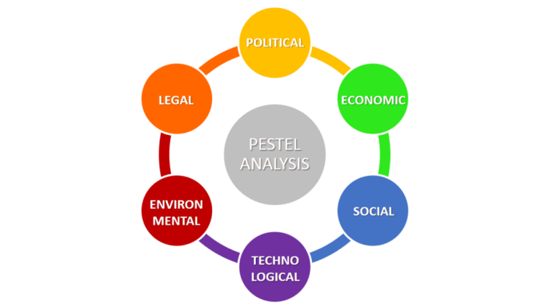
This photo has been copied from: https://www.business-to-you.com/scanning-the-environment-pestel-analysis/

PESTLE is an acronym that stands for a set of macro-environmental factors that affect a business. Each of the words P, E, S, T, L, E stands for political, economic, social, technological, legal and environmental factors. The PESTLE analysis was developed as a strategic tool to help understand the most important external factors that can affect the business in some way. The goal of the analysis is to anticipate opportunities and lessen the risks that these factors may pose (Housden, 2010).
Consequently, PESTLE analysis is a valuable tool for businesses in determining their strategies while gauging the influence of diverse external factors. Political factors may encompass aspects such as government policies and political stability. Similarly, economic factors refer to inflation, interest rates, and growth rates.
The PESTLE framework is an established and widely used approach to making informed decisions in the business realm. It is beneficial for companies to consider external factors, and PESTLE analysis helps in this regard. By thoroughly examining these factors, businesses can grab hold of opportunities and avoid potential risks to their operations, ensuring a strong foundation for growth and continued success (Bhasin, 2020).
P&G may use PESTLE analysis to identify emerging trends in consumer behaviour, such as a preference for environmentally friendly products or a growing concern for social responsibility. This information can help P&G to develop new products that align with these trends, and to position themselves as a socially responsible company.
Political Factors
Political factors are of great importance in determining the sustainability and profitability of Procter Gamble in the long run, within the framework of PESTEL.
When the company is in the international market it must be aware of all the political changes in the different countries.
To succeed in such a dynamic international business environment, it is crucial to diversify systematic risks. The political environment of each country has multifaceted aspects that affect the business in different ways and Procter Gamble must take them into account during strategic planning. One of the most important political factors for Procter Gamble to consider is political stability. (Housden, 2010).
Another political factor that influences Procter Gamble is changing policies. Frequent changes in government policies create an environment of uncertainty, which can harm business performance.
Political factors refer to the rules and regulations set by government agencies that directly impact a company’s operations. In the case of P&G, the company operates in several countries, and as a result, it has to adhere to the local laws and regulations in each country. For instance, the company has been affected by the recent trade war between the United States and China; this had led to an increase in tariffs on P&G’s products, which has had a significant impact on its bottom line (Maulik, 2018).
The political factors for P&G are generally favourable as the company operates in stable political environments in most of the countries where it operates.

Economic Factors
Economic factors refer to macroeconomic conditions such as inflation rates, GDP growth, and unemployment rates that affect a company’s profitability. P&G generates a significant amount of revenue from emerging markets such as India, China, and Brazil, and the company has been affected by the economic downturn in those countries. In recent years, the company has reported a decline in revenue growth due to the economic slowdown in these markets (Bhasin, 2015).
To make informed decisions, Procter Gamble should consider the following economic factors: inflation rates, GDP growth, and unemployment rates, directly impact a company’s profitability. Procter Gamble (P&G) has been affected by the economic downturn in emerging markets like India, China, and Brazil, which has resulted in a decline in revenue growth. P&G should consider economic factors like a country's economic development, industry lifecycle stage, infrastructure development, inflation, employment, interest and exchange rates, and supply and demand of labour to make informed decisions (Housden, 2010). These factors can both positively and negatively impact P&G's business, depending on the country and the economic conditions there. For example, if there is economic growth in a country, P&G may see an increase in demand for its products. However, if there is high inflation, P&G's costs may increase, leading to lower profits. Overall, the economic factors for P&G are neutral, as they can have both favourable and unfavourable impacts on the company's business.

Social Factors

Social factors are also extremely critical for Procter Gamble to be addressed within the PESTEL framework because of the strong influence that societal norms, values and trends have on organizational culture. A comprehensive understanding of different demographic trends, as well as different power structures, consumer spending patterns, and shared beliefs can help Procter Gamble create effective marketing messages and meet all of its stated goals (Jobber & Ellis-Chadwick, 2016).
To conduct a macro environmental analysis, Procter Gamble will need to consider these social factors: Social factors like demographic patterns, power structures, gender roles, local norms and values, online shopping behaviour, and consumer spending patterns also play a crucial role in determining an organization's marketing and human resource strategies. Understanding these factors can help P&G design effective marketing messages and fulfil corporate objectives.
The sociocultural factors for P&G are favourable, as the company has a strong brand and reputation and is well-positioned to adapt to different cultural norms and social attitudes.
Technological Factors
According to Kell (2017) Procter Gamble invests heavily in research and development to create innovative products and improve its manufacturing processes. The company uses digital technology to develop a direct-to-consumer sales model. P&G can benefit from the use of social media marketing to engage with customers and create online brand communities. The company should analyse emerging technologies to stay ahead of the competition and invest in disruptive technologies to maximize profits. P&G must consider the development and maturity level of technology in each market to increase its market share. Research and development activities greatly impact P&G's value chain and cost structure. The adoption of new technologies shortens product life cycles, and P&G must increase product range diversity and integrate flexibility into its value chain. Additionally, P&G must develop healthy business relationships with its value chain partners and keep a close eye on R&D investments made by its competitors to understand how emerging technologies affect its firm's value chain and cost structure.
The technological factors for P&G are favourable, as the company has a strong research and development department and is constantly innovating to improve its products and processes.
Environmental Factors
Environmental factors refer to factors such as climate change, pollution, and waste disposal that directly impact the environment. As one of the world's leading consumer goods company, P&G has been under scrutiny for its environmental impact. The company has taken steps to address these concerns by investing in environmentally friendly packaging and implementing sustainable supply chain practices (Kell, 2017).
To achieve long-term sustainability, companies must also adopt innovative waste management practices, invest in renewable technologies, and consider the influence of weather and climatic conditions on their operations. Additionally, eco-friendly products are becoming more popular, and regulatory bodies are emphasizing environmental compliance, making it crucial for businesses to prioritize and market the eco-friendliness of their products. Finally, excessive resource depletion can result in negative backlash from media, customers, and the general public, making it necessary for businesses to study environmental regulations and avoid overconsumption of rare resources or harm to endangered species.
The environmental factors for P&G are favourable, as the company is taking steps to reduce its environmental footprint and is well-positioned to capitalize on the growing consumer demand for sustainable products.

Legal Factors
Legal factors refer to the rules and regulations set by government agencies and other regulatory bodies. In the case of P&G, the company has had to adhere to strict regulations on product safety and advertising standards in multiple countries. Failure to comply with these regulations has led to significant fines and penalties for the company (Bhasin, 2020).
The legal environment is a crucial factor to consider in the PESTEL analysis framework, as Procter Gamble cannot enter a new market without carefully evaluating the legal aspects of the regulatory structure in place. Ignorance in this regard can lead to serious consequences, including damage to the organization's competitive advantage due to intellectual property rights violations, and harm to the organizational image resulting from violations of consumer/employee/environment protection standards. Compliance with consumer protection laws is also crucial to protect customer data, ensure price and quality standards, and prevent fraudulent marketing. Moreover, companies must adhere to intellectual property regulations to safeguard their patents and ideas to maintain competitive advantage over other market players.
This PESTLE analysis has highlighted the external factors that affect P&G's operations in multiple markets around the world. P&G has been affected by factors such as trade tariffs, economic slowdown, and changes in consumer preferences, while also investing in technology and taking steps to address environmental issues. The company needs to continue to adapt its operations to meet changing market conditions and maintain its position as a leading global consumer goods company.
The legal factors for P&G are favourable, as the company has a strong legal and compliance department and is committed to ethical business practices.

Porter's Five Forces Model:
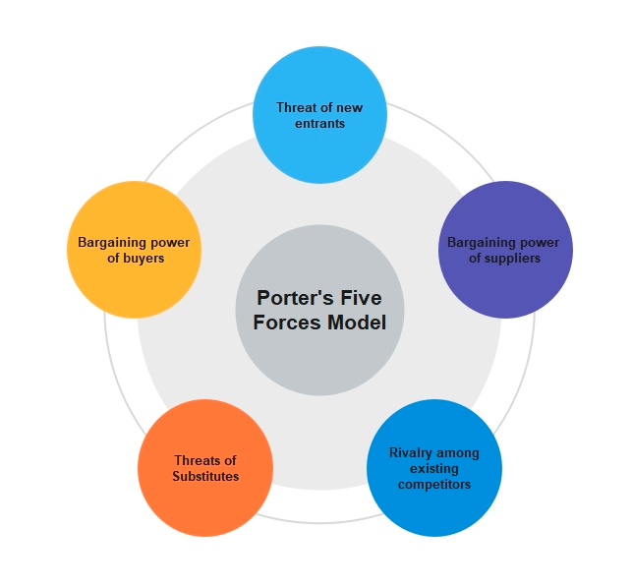
https://day.io/blog/porters-five-forces-model-using-this-powerful-management-tool/

Porter's Five Forces model is a framework for analysing the competitive environment of an industry. The five forces are threat of new entrants, bargaining power of suppliers, bargaining power of buyers, threat of substitute products or services, and rivalry between existing firms.
Porter's Five Forces analysis can help P&G examine the competitive environment they are in and develop the right strategies to maintain their advantage over their competitors. Through this approach of analysing the bargaining power of suppliers and buyers, the threat of new entrants, the threat of substitutes, and the intensity of competition among competitors, P&G can identify areas in which they can differentiate themselves from their competitors and develop strategies to maintaining its market share.

Threat of New Entrants:
The threat of new entrants in the consumer goods industry is relatively low due to the high level of capital investment required to enter the market. The presence of established brands and a well-established distribution network further limits the entry of new players into the market.
Bargaining Power of Suppliers:
P&G sources raw materials from a large number of suppliers worldwide. However, the company has strong relationships with its suppliers, and the suppliers are aware of the role they play in P&G's success. P&G's purchasing power and scale of operations allow the company to negotiate favourable terms and pricing with suppliers. Thus, P&G faces a low bargaining power of suppliers.
Bargaining Power of Buyers:
P&G customers include both retailers and consumers. Retailers have significant bargaining power due to their large buying volume and ability to switch suppliers relatively easily. Consumers have less bargaining power as they are ultimately influenced by product branding, advertising and marketing campaigns, and product quality. P&G’s strong brand image and market presence across different product categories limit buyers’ bargaining power.
Threat of Substitute Products or Services:
Products such as soap, shampoo, and toothpaste are essential in the daily lives of consumers, and therefore it is challenging to find a complete substitute. This makes P&G’s products less susceptible to substitution. However, P&G faces some threat from substitutes with rising consumer awareness of organic and natural products, which are seen as healthier and eco-friendlier.
Rivalry among existing competitors:
P&G Competes with other major consumer goods companies like Unilever and Johnson & Johnson, among others. However, P&G has a massive product range and significant brand recognition, which gives it a dominant position within the industry. The company’s innovation and Marketing strategies, such as its “Brand in Hand” philosophy, have helped maintain market share and competitive edge (Dobbs, 2014).
Advantages and disadvantages:
Advantages:
Comprehensive analysis: The Five Forces framework is comprehensive in that it looks at all aspects of an industry, including suppliers, buyers, competitors, new entrants, and substitutes. This provides a complete view of the industry and the competitive forces at play.
Holistic approach: The framework looks at both external and internal factors affecting the company's competitiveness. This helps identify areas where the company can leverage its strengths and address potential weaknesses.
Strategic insights: The framework helps identify areas where the company can create competitive advantage and develop a strategic response to market conditions.

Disadvantages:
Limited focus: The Five Forces framework looks only at the competitive forces within an industry and does not consider broader macroeconomic factors that may also affect the company's position.
Static analysis: The framework provides a snapshot of the industry at a point in time and may not reflect changes in the industry over time.
Ignores collaboration: The framework assumes that companies are in direct competition with each other and does not account for potential collaboration among competitors that could change the competitive landscape.

The Ansoff matrix

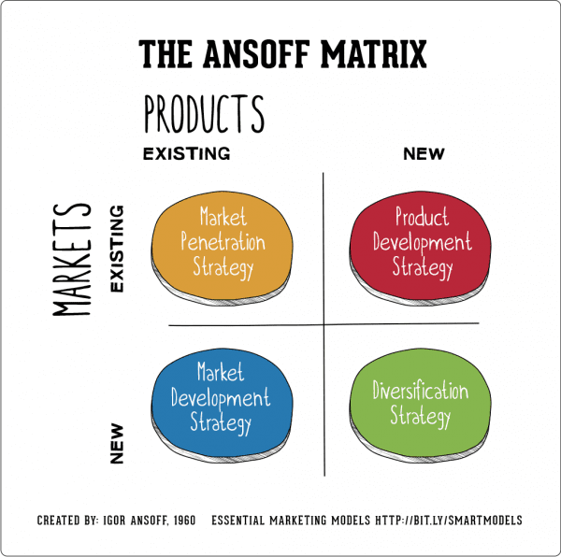 https://www.smartinsights.com/marketing-planning/create-a-marketing-plan/ansoff-model/
Market Penetration: Procter and Gamble uses market penetration strategy by increasing its market share in existing market. This strategy is implemented by launching promotional campaigns, advertising, and reducing prices. P&G also create deeper connections with existing customers to boost sales.
Product Development: P&G implements product development strategy by creating new products for its existing market. For example, the company launched a new line of Tide laundry detergent that uses less water and has reduced packaging, addressing environmentally conscious consumers.

Recommendation:

Based on P&G's current financial and market position, the following recommendations could be useful:
1. Increase investment in e-commerce: P&G should continue its investment in e-commerce channels such as Amazon, Walmart, and other online retail sites. With the growth of e-commerce, P&G should focus on creating a user-friendly online shopping experience to attract customers to purchase its popular brands. Reference: "Procter & Gamble Co. (PG) - Financial and Strategic SWOT Analysis Review" (2021)
2. Product diversification: P&G should focus on diversifying its product offerings by introducing new product lines or acquiring smaller companies with complementary products. This approach will enable the company to attract new customers and expand its customer base.
3. From strategic partnership: P&G could consider forming strategic partnerships with other companies to leverage strengths and resources, resulting in better market coverage and operational efficiencies. Reference: "Procter & Gamble Co. (PG) - Financial and Strategic SWOT Analysis Review" (2021)
4. Invest in sustainability: With increasing global concerns about climate change, P&G should continue its investment in sustainable products and packaging to attract customers who prioritize environmental sustainability.
The above recommendations will help P&G to maintain its market position, improve customer experience and loyalty, expand its product offerings, and optimize operational efficiency.

Conclusion:
In conclusion, the external analysis of P&G using Porter’s Five Forces model reveals that the company operates in a highly competitive industry with relatively low entry barriers. external analysis tools like PESTLE and Porter's Five Forces are important for global companies like P&G because they provide a structured approach to understanding the external environment in which they operate. By gaining a comprehensive understanding of the external factors that can impact their business, companies can develop strategies to capitalize on opportunities and mitigate threats, and ultimately, achieve long-term success.
However, P&G's scale, global reach and significant investment in R&D and Marketing stifle new entrants. P&G’s significant investment in R&D keeps the company ahead of the competition with new innovative products year by year. P&G’s marketing strategies help the company maintain a stable position in the market amid fierce competition. P&G’s key challenge lies in continuing to innovate and maintain its product quality and marketing strategies to continue dominating the consumer goods industry.

References:
- Armstrong, G., & Kotler, P. (2015). Marketing: An introduction (12th ed.). Pearson.
- Bhasin, H. (2020) What is pestle analysis? excellent business analysis tool, Marketing91. Available at: https://www.marketing91.com/pestle-analysis [Accessed: April 18, 2023].
- David, F.R. (2004) Strategic management: Concepts and cases. Upper Saddle River: Prentice Hall.
- Dobbs, M.E. (2014) Guidelines for applying Porter's five forces framework: a set of industry analysis templates. Competitiveness Review. Vol 24, No 1, pp32-45.
- Grant, R. M. (2016). Contemporary strategy analysis: Text and cases edition. John Wiley & Sons.
- Jobber, D. and Ellis-Chadwick, F. (2016) Principles and practice of marketing. Maidenhead: McGraw-Hill Higher Education.
- 7.Kell, J. (2017). P&G's "smart" digital strategy is driving growth. Retrieved from https://www.fortune.com/2017/10/19/procter-gamble-digital-strategy/
- Kotler, P., & Armstrong, G. (2010). Principles of marketing. Upper Saddle River, NJ: Pearson.
- Kotler, P., & Keller, K. L. (2016). Marketing management (15th ed.). Pearson.
- Mangold, W. G., & Faulds, D. J. (2009). Social media: The new hybrid element of the promotion mix. Business Horizons, 52(4), 357-365.
- Photo of Ansoff Matrix diagram. Available at: https://www.smartinsights.com/marketing-planning/create-a-marketing-plan/ansoff-model/ [Accessed on: 30/04/23].
- Photo of PESTLE analysis diagram. Available at: https://www.business-to-you.com/scanning-the-environment-pestel-analysis/ [Accessed on: 30/04/23].
- Photo of Five Porter’s diagram: https://day.io/blog/porters-five-forces-model-using-this-powerful-management-tool/ [Accessed on 23/04/23].
- Porter, M. E. (2008). The five competitive forces that shape strategy. Harvard Business Review, 86(1), 78-93.
- 12.P&G Annual Report (2022). Available at: https://www.pginvestor.com/financial-reporting/annual-reports/ [Accessed on 27/04/23].
- Housden, M. (2010) CIM coursebook marketing information and research. Saint Louis: Routledge.
- Hitt, M. A., Ireland, R. D., & Hoskisson, R. E. (2012). Strategic management: Concepts and cases: Competitiveness and globalization. Cengage Learning.

