Assignment For Analysing And Solving Problems:

Problem Scenario: A local college is facing difficulties in managing its classroom allocations efficiently. Some rooms are overcrowded while others remain underused, leading to timetable clashes and wasted time as staff and students move between rooms. The college aims to optimise classroom allocation to make better use of available space and improve the overall learning experience. You have been asked to develop a solution that achieves the following:
1. Efficient allocation of classrooms based on class sizes and room capacities.
2. Minimised time wasted by students and staff moving between classes.
3. Accurate timetabling to ensure all lessons start on time without scheduling conflicts.
Your Task You are required to:
- Deconstruct the Problem: Break down the scenario into smaller components. Identify key requirements and constraints using tools such as the MoSCoW technique. Clearly describe the relevant variables involved.
Deconstructing the Problem
1.1 Key Components
The scenario can be broken into three main sub-problems:
- Room Allocation Problem
Matching class sizes with appropriate room capacities.
- Timetabling Problem
Scheduling classes without overlaps or conflicts.
- Movement Optimisation Problem
Reducing travel time between consecutive classes for students and staff.

1.2 Requirements Analysis (MoSCoW Method)
Must Have:
- Classes assigned to rooms with sufficient capacity
- No timetable clashes (room or lecturer conflicts)
- All scheduled lessons must have a room
Should Have:
- Minimise distance between consecutive classes
- Prioritise accessibility (e.g., disabled access rooms where needed)
Could Have:
- Preferences (e.g., lecturer preferred rooms)
- Special equipment matching (projectors, labs)
Won’t Have (for now):
- Real-time dynamic changes during live teaching
- AI-based predictive scheduling

1.3 Constraints
- Limited number of classrooms
- Fixed room capacities
- Fixed teaching hours
- Some rooms have specialised equipment
- Lecturer availability constraints

1.4 Key Variables
Variable | Description | Type
classSize | Number of students in a class | Integer
roomCapacity | Maximum capacity of a room | Integer
roomID | Unique room identifier | String
timeSlot | Scheduled lesson time | Time/Array
lecturerID | Lecturer assigned | String
roomLocation | Coordinates/building | String
distance | Distance between rooms | Float

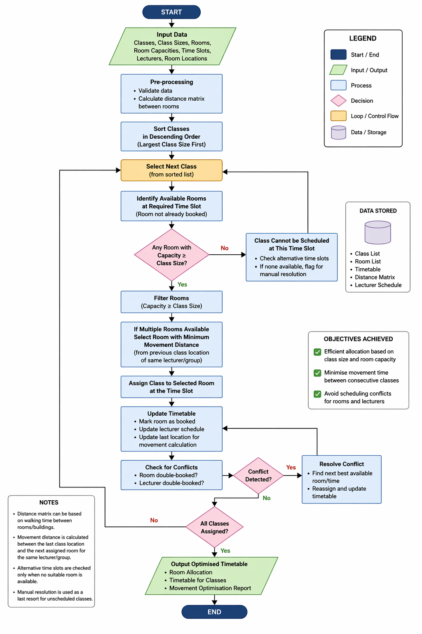
2.2 Explanation of the Solution
This solution uses a greedy algorithm approach, where the largest classes are allocated first to ensure they are not left without suitable rooms.
Key Decision Points:
- Room Selection:
Choose a room where:
roomCapacity ≥ classSize
- Optimisation Criteria:
  - Primary: Capacity fit
  - Secondary: Shortest distance between consecutive classes
- Conflict Handling:
If:
  - Two classes are assigned the same room at the same time, OR
  - A lecturer is double-booked
→ The system reassigns using the next best available room.

2.3 Assumptions
- All class sizes are known in advance
- Room capacities are fixed and accurate
- Distances between rooms can be estimated (e.g., building-based)
- Students follow a fixed timetable

2.4 How Objectives Are Achieved
Efficient Room Usage:
- Sorting by class size ensures large rooms are not wasted on small classes
Minimised Movement Time:
- Location-based selection reduces travel distance between consecutive classes
No Scheduling Conflicts:
- Conflict detection step ensures no overlaps for rooms or lecturers

3. Reflection and Justification
3.1 Problem-Solving Techniques Used
- Decomposition:
Breaking the problem into allocation, scheduling, and movement sub-problems
- Abstraction:
Ignoring unnecessary details (e.g., student preferences) to focus on core logic
- Algorithmic Thinking:
Designing step-by-step logic (flowchart)
- Greedy Strategy:
Making locally optimal decisions (assign largest classes first)

3.2 Justification of Approach
This approach is appropriate because:
- It is efficient and practical for real-world implementation
- Greedy algorithms are commonly used in resource allocation problems
- It balances simplicity and effectiveness

3.3 Limitations
- Greedy algorithms may not always produce the global optimal solution
- Distance estimation may be inaccurate
- Does not handle real-time disruptions (e.g., room unavailable suddenly)
- Ignores personal preferences (students/lecturers)

3.4 Possible Improvements
- Use optimization algorithms (e.g., linear programming)
- Implement AI-based scheduling systems
- Add real-time adjustment features

4. Engagement with Literature
Relevant Models and Theories
- MoSCoW Prioritisation Technique
(Clegg & Barker, 1994) – Used to classify requirements
- Greedy Algorithms
(Cormen et al., Introduction to Algorithms) – Efficient for allocation problems
- Systems Thinking
(Checkland, 1981) – Viewing the timetable as an interconnected system
- Timetabling Problem Theory
(Burke & Petrovic, 2002) – Educational timetabling as an optimisation problem

