Report on intercultural competence and leadership

Student: Vasile-Alexandru Vasile
Student ID number: 2207749
The module title: Foreign Languages & Cultural Awareness (BMIH5003)
Lecturer: Giulia Chifari
Date: 10 November 2023
Word count: 1080
Executive Summary
This report emphasizes cultural sensitivity and intelligence in front of Diversity Hotel & Spa's entry into Spain. Success depends on having an understanding of the warm and vibrant culture of Spain. Customised services, varied recruiting, and cultural training are among the recommendations. The hotel can create great connections, offer outstanding guest experiences, and prosper in the Spanish culturally diverse market by putting these principles into practice.

Table of Contents
Introduction 4
Overview of Spanish Culture and Customs 5
Globe Project Country Analysis ………………………....……………………………….. 6
The Significance of Sensitivity and Cultural Intelligence in the Hotel Sector 9
Recommendations to the General Manager 10
Conclusion 11
References 12

Introduction
The General Manager's planned visit to the new foreign hotel will require the Assistant General Manager of Diversity Hotel & Spa in London to prepare a report on intercultural competency and leadership. Spain has been selected as the destination for this expansion. An introduction to Spanish culture and customs will be given at the outset of this report, which will be followed by a national analysis based on the culture and leadership research conducted by the GLOBE Project. Following a discussion of the value of cultural sensitivity and intelligence in the hotel sector, the report will offer suggestions for the general manager.

Overview of Spanish Culture and Customs
Spanish culture is rich and diverse, reflecting a blend of influences from various regions and historical periods. Some of the key elements of Spanish culture and customs refers to its cuisine, Spain being renowned for the diverse and flavourful cuisine, for its long festivals, for its art and architecture (Salvador Dali and Sagrada Familia, Spain’s iconic symbols) for the culture built around sport, with an emphasis on football, for the fact that greetings in Spain often involve physical contact like kisses on the cheek and that personal space is generally closer than in many other cultures.
According to Statisa, 2022, Spanish hotel industry is a large contributor to Spain’s economy, and one of the biggest players in the European market. In 2020 Spanish Hospitality Industry generated the 5th biggest revenue on the continent, approximately 7 billion euros, while in 2021 it accounted for a third of the European market. In 2022, according to Reuters (2023) there were about 71 million foreign tourists visiting Spain.

Globe project country analysis
- Spain’s Cultural Practices and Values Analysis.
Performance Orientation: Spain tends to value hard work and performance, although there is also a cultural emphasis on enjoying life and leisure.
Future Orientation: Although there is a balance, Spain leans towards a more present-focused orientation, with a strong emphasis on immediate enjoyment.
Assertiveness: Assertiveness is moderate in Spain. Communication styles may include elements of both assertiveness and modesty, with an importance placed on maintaining social harmony.
Power Distance: Spain has a moderate to high power distance, reflecting a respect for hierarchical structures and authority. However, there is an expectation that those in power will use it benevolently.
Gender Egalitarianism: Spain took significant steps towards gender equality, with increasing emphasis on minimizing gender role differences in both societal and organizational contexts.
Uncertainty Avoidance: Spain has a moderate level of uncertainty avoidance. While there is a preference for clear guidelines, there is also an openness to ambiguity and a willingness to adapt to change.
In-Group Collectivism: Spain displays a balanced collectivism, emphasizing the importance of social connections and relationships, both within the family and among close friends.
Institutional Collectivism: The societal institutions in Spain encourage loyalty to the family, extended family, and close friends, reflecting a strong sense of collectivism.
Humane Orientation: Spain values humaneness, emphasizing altruistic and caring behaviour. There is a focus on maintaining interpersonal relationships and supporting one another.

- Spain’s Leadership behaviour dimensions analysis
Charismatic Leadership: Spain often values leaders who inspire and motivate through personal qualities and values. Charismatic leadership may be effective in engaging and aligning teams with a shared vision.
Team-Oriented Leadership: Team-oriented leadership aligns well with Spain's emphasis on collaboration and social connections. Leaders who foster a sense of teamwork and build cohesive work environments are likely to be well-received.
Participative Leadership: Spain generally appreciates leaders who involve others in decision-making. Participative leadership, which encourages collaboration and values diverse perspectives, can contribute to effective leadership in Spain.
Human-Oriented Leadership: Leaders in Spain are often expected to demonstrate care for the well-being of their team members. Human-oriented leadership, emphasizing empathy and support, aligns with the cultural value placed on interpersonal relationships.
Autonomous Leadership: While Spain values collaboration, there is also room for leaders to demonstrate autonomy and self-reliance in decision-making. Autonomous leadership may be effective in situations where individual initiative is valued.
Self-Protective Leadership: While self-protective leadership is recognized in the GLOBE project, it's essential to balance this with other dimensions. Overemphasis on self-protection without considering the well-being of the team might not align well with Spanish cultural values.

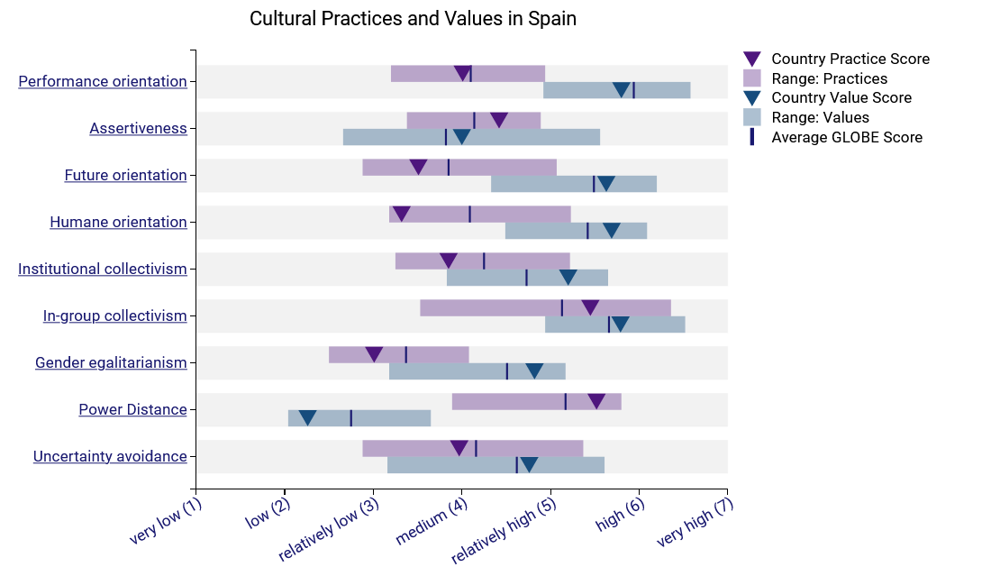
Figure 1. Source: Globeproject.com
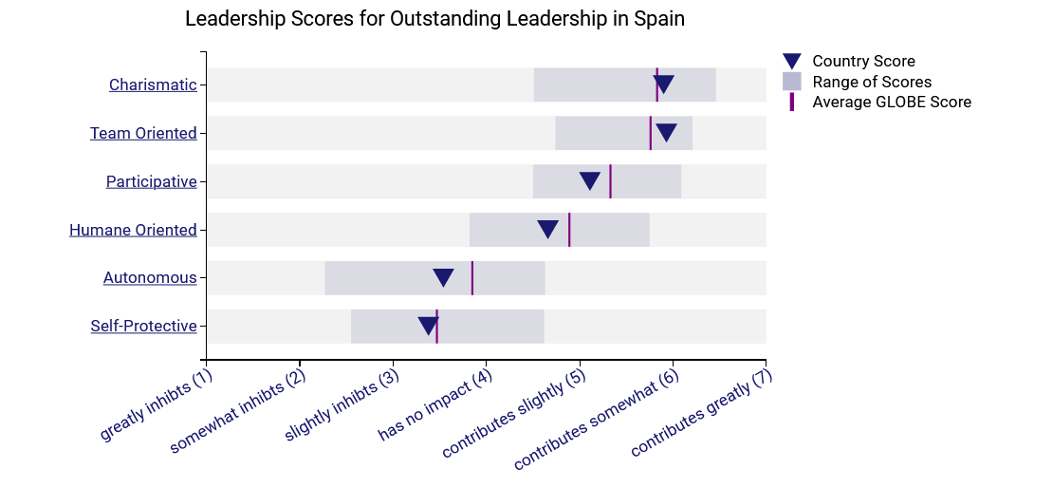
Figure 2. Source: Globeproject.com

The Significance of Sensitivity and Cultural Intelligence in the Hotel Sector
Improved Customer Service: Hotels want their visitors to have an unforgettable stay. Providing exceptional customer service requires an understanding of and respect for the cultural inclinations and sensitivities of visitors.
Effective Communication: Hotel employees need to interact with visitors, co-workers, and managers in an effective manner (Armstrong, 2020). Building solid professional connections and preventing misunderstandings are made easier with cultural intelligence.
Developing Relationships and Trust: Establishing trust with Spanish co-workers and visitors is essential in Spain’s high-power distance culture. Building healthy relationships requires respecting authority figures and regional traditions (Barrett, 2020).
Cultural Etiquette: It is possible to avoid unintentional cultural offences by being aware of appropriate social norms and etiquette.
Cross-Cultural Team Dynamics: While diversity in the hotel sector is frequently embraced, there are times when it poses difficulties (Birdie, 2020). A team with cultural intelligence is better able to work together and settle disputes.

Recommendations to the General Manager
Training in Culture: All hotel employees, including front-desk employees and management, should get training in cultural sensitivity and understanding. Important facets of Spanish culture, traditions, and the GLOBE elements that are pertinent to the diverse nation should be included in this course (Armstrong, 2020).
Diverse Workforce: Promote diversity among hotel personnel, especially via the employment of Spanish workers. A diversified staff is better able to accommodate visitors' requirements and tastes.
Language Proficiency: To improve contact with local visitors, encourage staff members to acquire some basic Spanish greetings and phrases.
Frequent Feedback and Adaptation: Establish a way for visitors to voice their opinions and make suggestions for enhancements (Barrett, 2020). Make adjustments to hotel services based on this knowledge to better suit their demands.
Celebrate Local Festivals: Show respect for and knowledge of regional cultures by acknowledging and celebrating Spanish celebrations and holidays.

Conclusion
The incorporation of cultural knowledge and sensitivity into the hotel's operations is critical to the success of Diversity Hotel & Spa's growth in Spain. The hotel can establish a welcoming atmosphere for both Spanish and foreign visitors by putting the suggested tactics such as cultural training, a diversified staff, and personalised services into practice. This strategy not only guarantees the hotel's successful future in this dynamic market, but it also improves customer satisfaction and cultivates beneficial connections.

REFERENCES:
Armstrong, J.P., (2020). Assessing intercultural competence in international leadership courses: Developing the global leader. Journal of Leadership Education, 19(4). Available at: https://journalofleadershiped.org/wp-content/uploads/2020/09/19_4_Armstrong.pdf. Accessed: 03.11.2023
Barrett, M., (2020). The Council of Europe's reference framework of competencies for democratic culture: Policy context, content and impact. London Review of Education. Available at: https://www.scienceopen.com/document_file/bccb0eb9-8bf7-427e-9f36-ae4bcd5318f9/ScienceOpen/s1.pdf. Accessed: 07.11.2023
Birdie, A.K. (2020). Cross-cultural exposure and connections: Intercultural learning for global citizenship. CRC Press. Available at: https://books.google.ro/books?hl=en&lr=lang_en&id=zgTuDwAAQBAJ&oi=fnd&pg=PT12&dq=Cross-cultural+exposure+and+connections:+Intercultural+learning+for+global+citizenship&ots=kZgm8yiu80&sig=anv6iQPFin6_l4YAMoWG8TzQ7Y4&redir_esc=y#v=onepage&q=Cross-cultural%20exposure%20and%20connections%3A%20Intercultural%20learning%20for%20global%20citizenship&f=false. Accessed: 04.11.2023
Christiansen, B., Branch, J.D. and Karmowska, J. eds., 2020. Cultural Factors and Performance in 21st Century Businesses. IGI Global. Available at: https://books.google.ro/books?hl=en&lr=lang_en&id=28XhDwAAQBAJ&oi=fnd&pg=PP1&dq=cultural+factors+and+performance+in+21st+century+businesses&ots=bez3QKgCc_&sig=1B-NI2_gIMXAbpubnR5gla05vio&redir_esc=y#v=onepage&q=cultural%20factors%20and%20performance%20in%2021st%20century%20businesses&f=false. Accessed: 10.11.2023
Globe 2020 (2023). Culture and Leadership data - Spain. Available at: https://globeproject.com/results/countries/ESP?menu=list#country. Accessed: 17.11.2023
Knowledgiate (2023). What are the nine cultural dimensions of the GLOBE model? Available at: https://www.knowledgiate.com/what-are-the-nine-cultural-dimensions-of-the-globe-model/. Accessed 09.11.2023
Mansour J. (2009). Managerial implications of the GLOBE project: A study of 62 societies. Academia.edu. Available at: https://www.academia.edu/27926370/Managerial_implications_of_the_GLOBE_project_A_study_of_62_societies. Accessed: 14.11.2023
Nina Evason, (2018). Spanish Culture. Cultural atlas. Available at: https://culturalatlas.sbs.com.au/spanish-culture/spanish-culture-core-concepts. Accessed: 15.11.2023
Patricia Jenkinson (2022). Globe Project Cultural Dimension. Available at: https://www.youtube.com/watch?v=3du_rZ0U90Q. Accessed: 14.11.2023
The culture factor group (2023). Country comparison tool – Spain. Available at: https://www.hofstede-insights.com/country-comparison-tool?countries=spain. Accessed: 09.11.2023
Reuters (2023). Over 71 million foreign tourists visited Spain in 2022, minister says. Available at: https://www.reuters.com/markets/europe/over-71-million-foreign-tourists-visited-spain-2022-minister-says-2023-02-01/. Accessed: 17.11.2023
Shreya (2023). Expat guide to Spanish culture and traditions. Housing Anywhere. Available at: https://housinganywhere.com/Spain/spanish-culture-and-traditions. Accessed: 15.11.2023
Sofia Godoy (2021). A brief introduction to Spanish culture, traditions and beliefs. Spanish Academy. Available at: https://www.spanish.academy/blog/a-brief-introduction-to-spanish-culture-traditions-and-beliefs/. Accessed: 15.11.2023
Statisa (2022). Hotel Industry in Spain – Statistics and facts. Available at: https://www.statista.com/topics/7746/hotel-industry-in-spain/#topicOverview. Accessed: 17.11.2023

