Effective Team Work &Communication

Student Name: Marius Daniel Osan
Student ID: 1914787
Lecture’s Name: Yajesh Kumar

Executive Summary
The main purpose of report is to describe effective communication and its significance in workplace. I want to show communication process between me and my friends. The report has applied numerous communication models and identified the significance of feedback. Further, the report determines how communication work between employees and management.

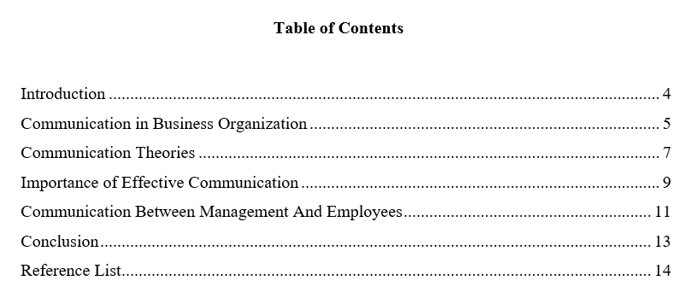

Introduction
Communication is defined as act of conveying message to other through language, symbols and body language. Effective Communication is considered as integral part of management practices. The main purpose of effective communication is to help managers in decision making process and reviews employees performance on regular basis. Communication is a systematic procedure where employees exchange their ideas, information and experiences with other subordinates. The main purpose of effective communication is to improve management practices and reduce errors. Good communication is essential for the development of organization. Communication plays significant role in creating collaborative environment for workers. It usually serves four major functions in an organization which are emotional expression, motivation and information. The report is based on current communication and its significance in business operations. The report has applied strategic models and framework to understand communication process. The report provides brief description about different methods of communication and its usefulness in employees behavior. At last, the report has evaluated the communication process between management team and employees.

Communication in Business Organization
Communication is helpful in managing employees behavior in certain circumstances. Organization often used upward and downward communication to share valuable information with employees. Many organization used email, instant messaging or arrange regular meetings to engage with employees. These communication methods may help businesses to achieve employees confidence and morale(Hartley, 2019). There are several strategies that can make communication more effective. Some of them are described below:
Creating Receptive Atmosphere: Organization should avoid stressful environment to engage with employees. Good atmosphere may enable businesses to deliver right message to their targeted audience. In stressful environment, employees may not be able to understand the information clearly. Thus, strong corporate culture is essential for creating job satisfaction among employees.
Training Programs: These programs are essential for improving employees performance. Through training programs, firms can exchange significant information and notices with their staff members. Employees pays much attention to training programs when it’s a part of appraisal. Thus, training programs increases the motivational level of employees and they are more committed towards achieving business objectives(Howarth, 2019).
Listening to team members: Communication is usually a two way process. Business owners does not only dictate but also listen to employees opinions for making effective decisions. Firms must ask open minded questions to their team members. They must encourage their team members to suggest new ideas for improving customer service.
Using Body Language: Positive body posture and language may helps firms to deliver strong brand message to customers. It usually involves handshakes, smiles, positive facial expressions and greeting customers kindly.
Using Presentations: Some people tries to grasp messages through its pictures and graphics. Firms must make unique presentations to communicate effectively with team members. In this way, employees can easily interpret the message and share their opinions with other subordinates. These presentations may provide wide opportunity to team members to express clear their confusion regarding certain things.
Be Appreciative: After each communication session, organization must thank their listeners for their time. This may lead to higher productivity and sense of belongingness among employees. Organization needs to clear employees confusion and doubts regarding specific tasks. In this way, employees can easily complete significant project on given time period(Stasser, 2020).
Thus, Communication strategies is essential for achieving employees trust and confidence. Apart from this, Organization should involve employees in every business activity whether its decision making process or implementing significant change in business operations. This may create happiness and unity among team members. Departments may able to exchange valuable information with others.

Communication Theories
Organization needs to adopt several communication models to improve employees performance and give constructive feedback to employees. These theories are quite useful in improving business performance. Organization can develop mutual collaboration among different departments by adopting communication models. Some of them are described below:
Shannon and Weaver Model of Communication
An American Mathematician Shannon and Weaver has worked together to establish this communiqué model. This model is usually designed for developing effective message among sender and receiver. The model states that noise has deep impact on entire communication process. Under this model, the sender encrypts the message to receive through technical channel like telephone. Further, the sender transformed the letter into codes. The receiver needs to decode before interpreting the message(Lin, 2020).
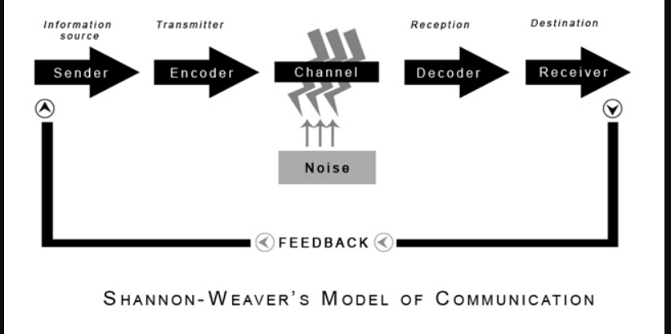
Source: communication theory.com
The channel has noise that cause several issues in communication procedure. For instance, A business owner sends message to its employees through phone text. However, the worker may not receive full text due to message or phone network disruption. The main advantage of this model is that it takes communication as a two-way process and perfectly applicable in general communication. The drawback of Shannon model is that it does not consider feedback as integral part of communication process. This communication model usually involves sender, channel, noise, encoder and receiver.
Schramm Model of Communication
It is a circular model where each individual acts as both sender and recipient. This model takes place in three different stages which are encoding, decoding and interpretation. This communication model introduces a concept named semantic noise. It usually occurs when sender and recipient interpret different meaning of same message. Semantic noise usually happens due to technical language and phrases that deviates the actual meaning of message. When semantic noise occurs, individual finds difficult to interpret the message(DeFleur, 2016).
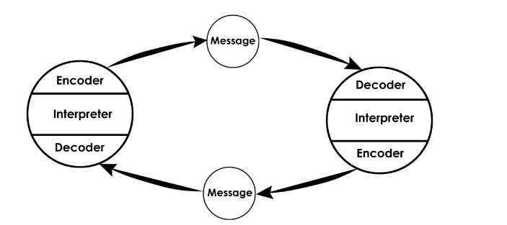
Source: Communication theory.com
The main advantage of this communication model is that it is dynamic and pose communication in circular nature. It considers feedback as an important aspect of communication process. However, Schramm Model does not talk much about semantic noise. Schramm implies that communication process is entirely incomplete without constructive feedback. The model implies that encoding and decoding are two significant factors for transmitting information.
Berlo’s model of communication
This model mainly includes source, attitudes, knowledge and communication skills. The model implies that individuals can only communicate upto social systems. Berlo’s model that source and receiver needs to be at same level for developing effective communication. However, this communication model lacks feedback and does not consider barriers to communication. It is a complex model and there is no consideration of noise.

Importance of Effective Communication

Effective Communication may give clear directions to people and encourage employees to demonstrate their talent with other subordinates. Stronger Communication may increase project efficiency and improve staff morale. For instance, I have used instant messaging, email and other communication methods to interact with my friends. For example, My friend has failed in one subject. She was depressed and does not take interest in any things. I motivated her to not lose hope and put best efforts to excel in academics. I have motivated my friend to make suitable deadlines for each subject. In this way, she may able to concentrate on all subjects. I also suggested that she should not take much pressure as it may affect their health. Effective communication has motivated my friend to work harder for getting good marks in all subjects. Through effective communication, I was able to understand my colleagues opinions and ideas. I have tried to control my negative emotions in accordance with situations. I have tried to behave in a positive and polite way with my friends. Communication tools has boosts my self confidence and able to collect constructive feedback from my colleagues. I was able to complete my significant project by discussing with my friends and gaining deep knowledge from others experiences(Genç, 2017).
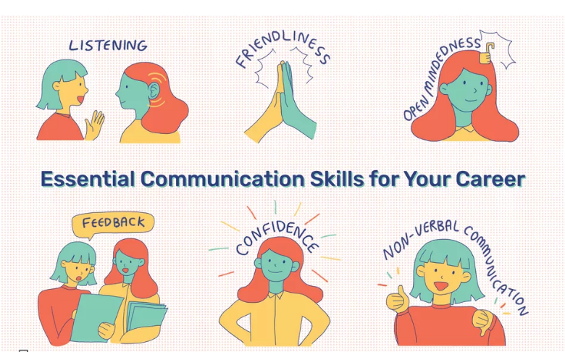
Source: thebalance.com
Thus, effective message may help employees to become good listener and clarify their questions with other subordinates. I have tried to used suitable body language and good facial expressions to convey right message for my friends. A relaxed and friendly tone may encourage others to speak openly with you. Good eye contact is very much essential for developing effective communication. Some people often pays much attention to others body postures while talking. Thus, Effective Communication plays significant role in developing mutual relationship with others. Clarity of thoughts may help individuals to engage with others and create good impression among top-level managers(Holbrook, 2020).
Methods of Communication
There are several methods of communication that helps organization to transmit accurate information to employees. Organization often used memo, email and video conferencing to interact with employees and discuss about business operations. These communication methods makes employees more productive and efficient towards business tasks.
Verbal Communication: It is defined as used of language for exchanging significant information. It is the most common type of communication often used in presentations, meetings, phone calls and face to face interactions. Verbal Communication may help employees to be more clear and confident while talking with others(Spencer, 2020).
Non Verbal Communication: Under this procedure, individuals convey their message through body gestures, facial expressions and eye contact. Non verbal communication is very much helpful in understanding others emotions and ideas. For example, Closed body language like crossed arms states that individuals might be nervous or angry. On the other side, open body language states that individual has positive attitude and willing to share information with others.
Written Communication: It is basically concerned with writing and printing symbols like letters for conveying right message to others. This communication is most commonly used for sharing information through books, blogs, pamphlets and memo. The most common form of written communication is chats and emails used by business to share significant information with staff members(Waisbord, 2020).
Visual Communication: It is defined as utilization of art, sketches, charts and graphs to convey information. Visuals are useful for making effective presentations and gaining deep knowledge regarding particular topic.

Communication Between Management And Employees

A manager plays significant role in boosting employees confidence and morale. Management team may used suitable communication channels to interact with employees. Skilled Managers provides proper guidance and instructions to employees regarding business operations and motivates them to work harder for improving business performance. Managers mainly listen to employees opinions a develop strategic plan accordingly. Efficient managers makes feel employees that they are integral part of business operations and involves them in decision making process. Skilled Managers spend most of their time in resolving employees problems and analyzing employees opinions regarding business operations. Managers are good listeners and reviews employees performance on regular basis(Stasser, 2020).
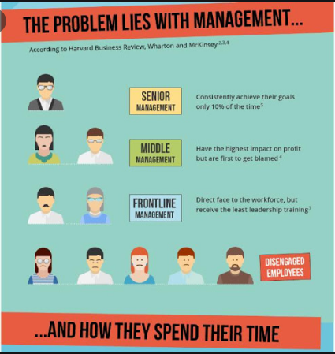
Source: scotdir.com
Managers plays significant role in establishing clear lines of communication and encourage employees to become more efficient. They often used social media and emails to interact with employees and appreciate them for their remarkable efforts. In this way, employees feel more engaged in business activities and puts best efforts to accomplish business goals. Skilled managers tries to collect valuable feedback from staff members. This constructive feedback may help managers to enhance brand image and perform certain activities in organized way. Managers encourage employees to explore new ideas for improving business performance and deliver better services to customers.
Employees must understand that their managers are credible and must obey certain instructions for achieving business objectives. Managers must used right non-verbal signals and communicate effectively with their employees. They must never mock employees’ ideas and opinions in front of others. This may cause frustration and dissatisfaction among employees as they feel that their suggestions have no value.
Thus, managers must satisfy workers needs for smooth operative of firm. In this way, employees will feel appreciated and committed more towards achieving business objectives. Therefore, Strong communication skills is essential for business success. Skilled managers often set suitable deadlines for specific targets and assign responsibilities to employees based on their performance and skills. Managers needs to adopt certain motivational theories to boost employees confidence and morale. They must celebrate success together and appreciated employees for their hard work and dedication towards their work. This leads to higher productivity among employees and they build loyalty towards organization.
Managers must appreciate their employees for their hardwork . In this way , business may keep employees happy and satisfied. They must not overload information on employees and encourage them to take active participation in group activities. This will cause sense of belongingness and satisfaction among staff members(Hartley, 2019).

Conclusion
The report concluded that effective communication is essential for supporting the development of potential employees. The report has analyzed several communication model that helps businesses to maintain good coordination with staff members. The report has evaluated several strategies that makes communication more effective and strengthen the bond between employees and organization. Further, the report has illustrated that businesses used different forms of communication to deliver right message to employees. At last, the report has identified communication process between manager and employees.

Reference List

DeFleur, M.L. and DeFleur, M.H., 2016. Mass communication theories: Explaining origins, processes, and effects. Routledge.

Genç, R., 2017. The importance of communication in sustainability & sustainable strategies. Procedia Manufacturing, 8, pp.511-516.

Hartley, J., 2019. Communication, cultural and media studies: The key concepts. Routledge.

Holbrook, T.R., 2020. The Importance of Communication to Possession in IP.

Howarth, C. and Morse-Jones, S., 2019. The Importance of Communication, Collaboration and Co-production. In Resilience to Climate Change (pp. 65-86). Palgrave Pivot, Cham.

Lin, X. and Lin, C., 2020, March. Communication Theories Applied in Mentimeter to Improve Educational Communication and Teaching Effectiveness. In 4th International Conference on Culture, Education and Economic Development of Modern Society (ICCESE 2020) (pp. 870-875). Atlantis Press.

Spencer, C., 2020. Introduction: Communication studies. Manchester University Press.

Stasser, G. and Abele, S., 2020. Collective Choice, Collaboration, and Communication. Annual Review of Psychology, 71, pp.589-612.

Waisbord, S., 2020. Family tree of theories, methodologies, and strategies in development communication. Handbook of Communication for Development and Social Change, pp.93-132.

