5/5/2024
Assessment
Portfolio Report on Contemporary Software Applications for Business


Student Name: Paul John Hudson Synnot
Student ID: 2533495

Module NaMe: Software solutions for business
Module Code: ACCA 4026
Lecturer: Amitave Banik
Trinity saint david University of Wales (London Campus)

Table of Contents
Introduction 2
Main Body 2
Task 1 2
e-Commerce Website builders/software solutions 2
Task 2 2
Mind-map of Contemporary Software Applications 2
Task 3 3
Office Applications for Creating, Storing, Presenting, and Analysing Data 3
a. 3
b. 3
Task 4 3
Communication and Collaboration applications 3
a. 3
b. 4
Conclusion 4
References 4
Appendices 4

Introduction

Main Body

Task 1a
(10 marks)

e-Commerce Website builders/software solutions
(Approx. 500 words)

A t-shirt company is looking to make a website. They are a business to customer-based ecommerce business. The website needs to be appealing to the eye, stylish, memorable. No one will want to spend their time on a website that is unattractive. People generally make up their mind with in one minute of being on a website or even less if they want to browse thoroughly or not. There needs to be automatic stock maintenance software available as inventory is critical to success. Sell to many and you could end up with bad feedback. It should allow for the option of dropshipping. Dropshipping is an e-commerce retail model where you sell products without holding inventory or handling shipping. This can greatly increase revenue as it brings more customers. Secure payment is a must for requirements. It should be fast, accurate, and easy to use for the customer. Returns are another thing facing the t shirt company. They should be straight forward, easy to understand, and quick. Lastly There is one of the most important, customer feedback. Customer feedback is a make-or-break area for ecommerce. Bad feedback can ruin a company. It should be easy to use, customers are encouraged to write in it, quick and easy.

The answer to a good-looking web page using Wix or Shopify is exploring the themes selection. They give businesses total control over all aspects of the front end of their website including HTML, stylesheets, and scripts. These themes can be downloaded from Shopify or Wix, sourced from a third party, built custom from a freelancer, or developed in house by merchant. [1]

Stock automation maintenance software is set to tell you everything you need to know about your sales. Inventory reports are included which will let you know quantity and percentage of inventory sold per day. You can view the last 180 days of inventory history to stay on top of previous orders and data. This includes tracking tricky things like committed orders, items that are part of an unfulfilled order. [2]

Secure payments mean Shopify and Wix are PCI compliant by default (a key standard for handling card data). Shopify uses firewalls, regular security audits, and undergoes SOC 1 and SOC 2 audits every six months to help protect and store customer data. For card payments they use 3D secure (a verification with the card issuer) to help reduce fraud. [2]

Customer reviews and feedback are covered by many third-party product review apps making sure your reviews are viewed by the most available views. There is product feedback, service feedback for improving shipping returns and overall experience, and internal tracking which takes notes on customers outcomes. [2]

Dropshipping uses a POD (print on demand) app to source and help automate fulfilment. When a customer places an order, they go from them to your Shopify Wix store then straight to the supplier. The supplier chooses, packages, and ships the product to the customer. Only needing to now deal with customer service and order tracking. [2]

Returns are broken down into return you receive items back, refund you send money back, exchange you send a different item (size/colour) sometimes with an amount owing to the customer for the difference. You also have return window how long they must return an item, return shipping cost how much it will be to return the item, with optional restocking fee, final sale items that cannot be returned. [2]

Task 1b

Task 2
(15 marks)

Mind-map of Contemporary Software Applications
(Approx. 500 words)

- Describe mind mapping and explain the benefits of using mind mapping in business operations (approx. 2/3 sources). 5 marks

The smart card with an embedded integrated circuit chip. It combines plastic and magnetic cards used for identification purposes in one card, used to access multiple services, networks, and the internet. The smart card offers three factor authentication for verification of the user. There is (PIN) personal identification number, digital signature, fingerprint, and biometric. This method increases the security of the transaction. As credit cards, debit cards, and prepaid card make up most of the marketplace when it comes to making online payments. [3]

Mobile phone based payment system allows customers to make payments via their mobile phone.

End to end encryption (E2EE) is the best known way to protect users digital communication as it disguises them from everyone. E2EE has been adopted by the popular messaging systems WhatsApp and iMessage. Using a key to decode the information at either end preventing information from escaping into the hands of hackers. [4]

3D Secure is the most prominent user authentication protocol for cred card based online payment. It relies on risk assessment whether or not to challenge the payment indicator for second factor authentication (through a passcode). The standard its self does not specify how to implement transaction risk assessment. [5]

Blockchain enables users to verify, preserve, and synchronize the contents of data (a ledger) replicated by multiple users. Blockchain technology has provided considerable advantages and incentives to industries in terms of enabling better services. [6]

b. Create a mind map of contemporary software applications that are used to support day-today business/Organisation operations. 10 marks

Mind Map Link: https://mm.tt/map/3957059449?t=H8a4aeTmj5
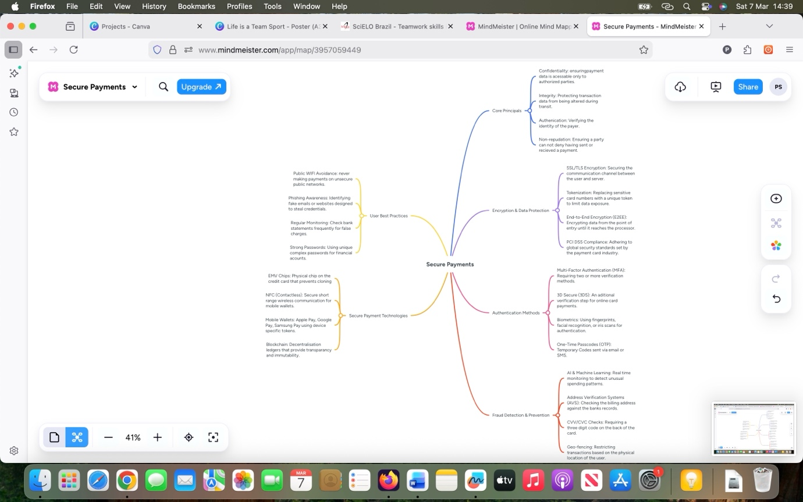
Figure 1: Mind Map

Task 3
(50 marks)

Office Applications for Creating, Storing, Presenting, and Analysing Data
(Approx. 2000 words)

a.
30 marks
Explain four office software solutions for business operations (MS Word, MS PowerPoint, MS Excel, and MS Access), highlighting their major features, benefits, and limitations (if there are any). You can use some images in addition to text (approx. 4/5 sources).
- Please try to avoid using bullet points. Rather, describe them in separate paragraphs.

In the contemporary corporate landscape data is often described as the new oil. How ever data only holds merit when it can be organised, and changed into actionable insights. Microsoft Excel is the most ubiquitous and versatile tool for achieving this, serving as a foundational tool for businesses of all size and structure. From small startups to multinational corporation. Excels benefits reach across financial management, data visualization, and operational efficiency.
One of the main advantages of Excel is unmatched capability in financial modelling and budgeting. For finance departments Excel is unmatched for creating balance sheets, cash flow projections, and profit loss statements. Its well built library of mathematical and financial formulas lets users complete complex calculations instantly. Features like What-If Analysis and Goal Seek enable managers to simulate various business scenarios, like this increase of price or shift in market conditions making for proactive rather than reactive decision-making.
Beyond simple arithmetic, Excel serves as a powerful data management and analysis tool. As businesses generate vast amounts of information, the ability to sort, filter, and categorize data becomes critical. Excels PivotTable feature is perhaps the most potent analytical asset allowing users to summarize thousands of rows of data into a concise table in seconds. By identifying trends, patterns and outliers businesses can gain a better understanding of customer behaviour, inventory turnover, and sales performance. This level of insight allows that resources are allocated efficiently and growth opportunities are not over looked.
Further more, Excel plays a vital role in enhancing productivity through automation. Through the use of macros and visual basic for applications (VBA). Repetitive tasks like generating weekly reports or cleaning data sets can be automated with a single click. This not only saves man hours but also reduces the risk of human error, which is often present in data entry. By streamlining these mundane processes employees are freed to focus on high level strategic tasks that drive the business forward.
Data visualization is another area where Excel excels. Raw numbers can be difficult to interpret, but excels extensive charting and graphing tools allow businesses to present information visually. Dashboards created in Excel provide a real time snap shot of key performance indicators (KPIs), making it easier for stakeholders to grasp complex information at a glance. Clear visual communication is essential during board meetings and investor pitches, where the ability to tell a compelling story through data can influence major corporate outcomes.
Finally the accessibility and cost effectiveness of Excel can not be ignored. Unlike specialized enterprise resource planning (ERP) software that may require expensive licences and extensive training. Excel is relatively affordable and features a user interface that most professionals are already familiar with. Its compatibility with other software and the ease in which files can be shared make it a universal language in the business world.
In conclusion, Microsoft Excel is far more than a simple spreadsheet program, it is a comprehensive business tool. By facilitating complex financial planning, enabling deep data analysis, automating work flows, and providing clear visualizations, Excel empowers organizations to operate with precision and agility. In an area where efficiency and data driven strategy are the keys to success, Excel remains an essential asset for any competitive business. [7]

b.
20 marks
Test some (Two different functions/tools from two different software applications. Show the process step by step through screenshots) business-related features of Office Applications (e.g., Mail merge, IF Function, VLOOKUP, Pivot Table, Goal Seek, Database concept using MS Access) and document several screenshots with accompanying description to provide evidence of practical use.
-Note: This task is based on your own practical activity.

Mail Merge is an automation process used to create personalised, bulk documents, emails, or labels by combining a single template (master document) with a structured data source, such as an excel spreadsheet or contact list. It replaces place holders with unique data to generate personalised letters, envelopes, or emails at scale

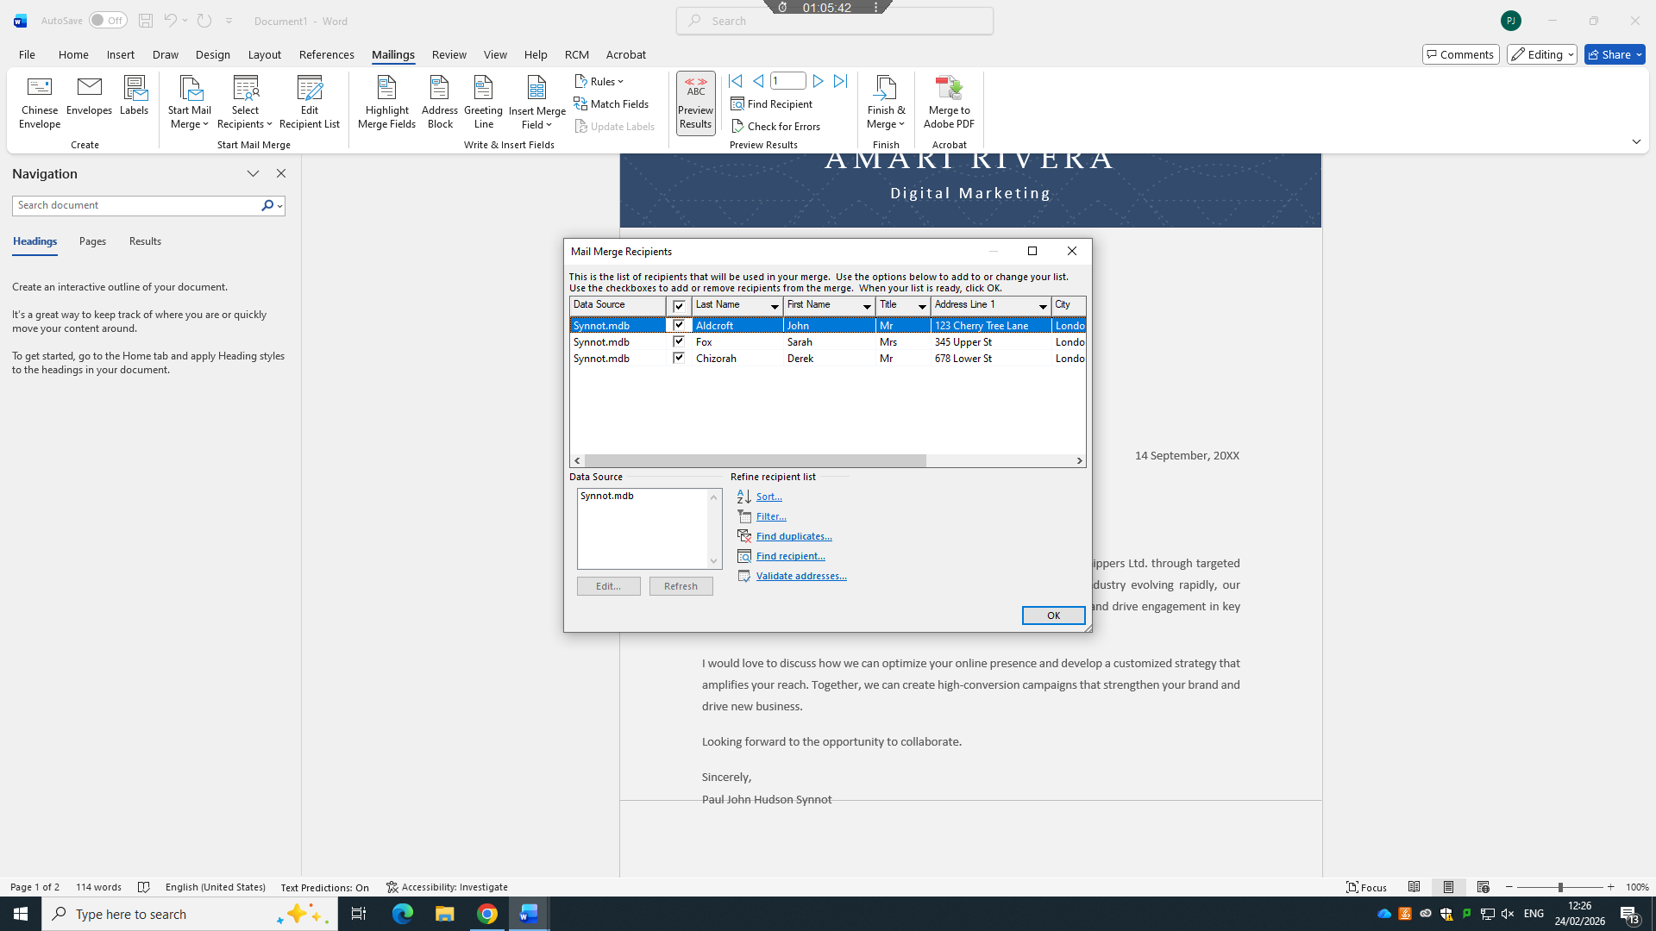
Figure 1: Mail Merge Recipient List
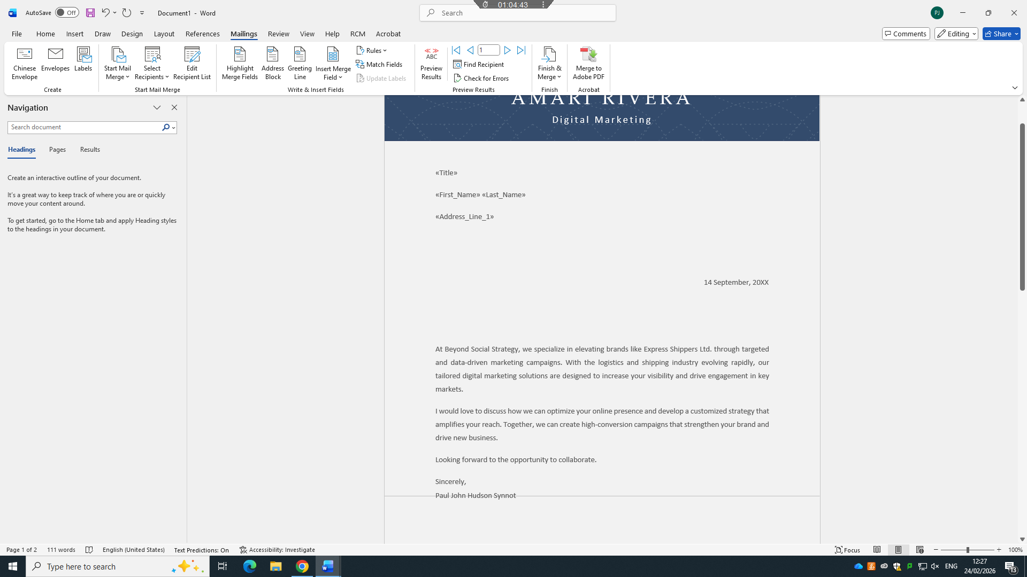
Figure 2: Mail Merge Insert Fields
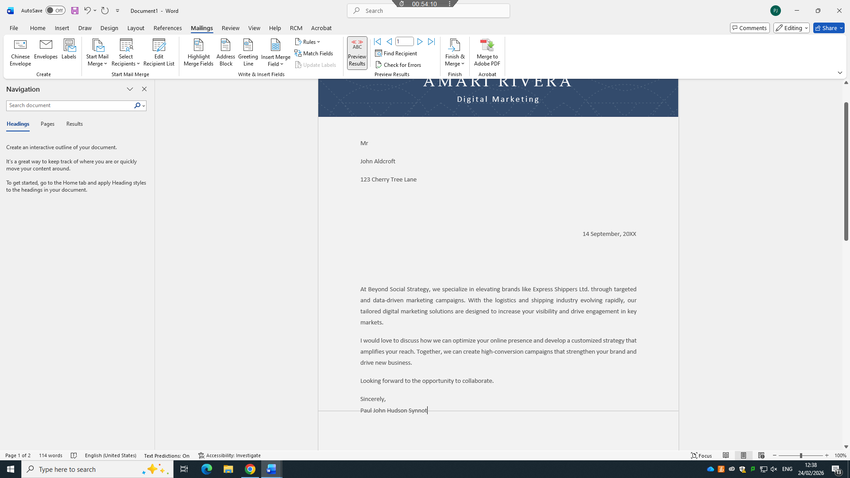
Figure 3: Mail Merge Preview Results

Task 4
(25 marks)

Communication and Collaboration applications

(Approx. 1000 words)

Re

Communication

a. 13 marks
Analyse one contemporary Communication (Email, MS Teams etc.) and one Collaboration (SharePoint, One Drive etc.) applications/tools used frequently in modern business world and document a summary of their key features, benefits and limitations using written text with some images and relevant citations. (approx. 2/3 sources)
b. 12 marks
Test some features of a freely available Communication (1) and Collaboration (1) application and document several screenshots with brief accompanying description to provide evidence of practical use.
-First you need to consider one communication and one collaboration application. Then discuss one use (How they are getting used in the business world) of each application showing the process step by step through screenshots.
-Note: This task is based on your own practical activity.

Conclusion

References
Present 10-15 sources. Please use IEEE referencing style. Do not forget to use in-text citations all the way through out this portfolio report.

References

[1] | G. Ballard, themes, The difinative guide to shopify, Melbourne : Apress, 2017.
[2] | Shopify, “Shopify,” [Online]. Available: https://help.shopify.com/.
[3] | B.-A. URS, SECURITY ISSUES AND SOLUTIONS IN E-PAYMENT SYSTEMS.
[4] | W. Bai, M. Pearson, p. kelley and M. Mazurek, “Improving Non-Experts’ Understanding of End-to-End Encryption: An Exploratory Study,” 2020. [Online]. Available: https://ieeexplore.ieee.org/abstract/document/9229664.
[5] | M. A. Ali and a. von morsel, “Designed to Be Broken: A Reverse Engineering Study of the 3D Secure 2.0 Payment Protocol,” 2019. [Online]. Available: https://link.springer.com/chapter/10.1007/978-3-030-32101-7_13.
[6] | o. Ali, “A Comparative Study: Blockchain Technology Utilization Benefits, Challenges and Functionalities,” [Online]. Available: https://ieeexplore.ieee.org/abstract/document/9317729.
[7] | D. James, A User Manual for Benefit Cost Analysis Using Microsoft Excel, 2006.
[8] | T. Buzan, Mind Maps For Business.
[9] | C. Gargouri, Naatus and M. Kate, An Experiment in Mind-Mapping and Argument-Mapping: Tools for Assessing Outcomes in the Business Curriculum, 2017.
[10] | R. Rezapour-Nasrabad, Mind Map Learning Technique: An Educational Interactive, 2019.

[1] | G. Ballard, themes, The difinative guide to shopify, Melbourne : Apress, 2017.
[2] | Shopify, “Shopify,” [Online]. Available: https://help.shopify.com/.
[3] | B.-A. URS, SECURITY ISSUES AND SOLUTIONS IN E-PAYMENT SYSTEMS.
[4] | W. Bai, M. Pearson, p. kelley and M. Mazurek, “Improving Non-Experts’ Understanding of End-to-End Encryption: An Exploratory Study,” 2020. [Online]. Available: https://ieeexplore.ieee.org/abstract/document/9229664.
[5] | M. A. Ali and a. von morsel, “Designed to Be Broken: A Reverse Engineering Study of the 3D Secure 2.0 Payment Protocol,” 2019. [Online]. Available: https://link.springer.com/chapter/10.1007/978-3-030-32101-7_13.
[6] | o. Ali, “A Comparative Study: Blockchain Technology Utilization Benefits, Challenges and Functionalities,” [Online]. Available: https://ieeexplore.ieee.org/abstract/document/9317729.
[7] | D. James, A User Manual for Benefit Cost Analysis Using Microsoft Excel, 2006.
[8] | T. Buzan, Mind Maps For Business.
[9] | C. Gargouri, Naatus and M. Kate, An Experiment in Mind-Mapping and Argument-Mapping: Tools for Assessing Outcomes in the Business Curriculum, 2017.
[10] | R. Rezapour-Nasrabad, Mind Map Learning Technique: An Educational Interactive, 2019.

Appendices
-Supplementary information (Optional)
An appendix page/section can be used to include relevant supplementary information such as indirect supporting information to task answers, tutorial activity answers, any other evidence.
NB: Also, look at your assessment brief to see the guidance for students in completion of the tasks section, students’ feedback form for overall marking criteria and assessment criteria to understand your level of work for grading.
Thanks, and good luck.

