Module: Managing Guest Service Operations
Module code: BMIH6003
Student Name: Ayesha Siddiqua
Student Id: 2233548
Assignment Title: Student Learning Log
Assessment Component 1 – Student Learning Log
Word Count: 1224

AI Declaration
I confirm that I have not used any AI tools in the research and creation of this assignment. I confirm that I have not presented any AI generated materials as my own work. I confirm I have copies of my drafts, notes, and other resources I used, which I may be asked to provide in evidence.

Table of Contents
Introduction 2
Section 1: Role Reflection using Gibbs’ Reflective Cycle 2
Section 2: Management Performance & Guest Service Analysis 4
Section 3: Guest Service Improvement Plan 4
Conclusion 5
References 6

Introduction
During my 10-week placement at the Hampton by Hilton London Luton Airport, I was assigned to the Housekeeping Department, a vital division responsible for maintaining high standards of cleanliness, hygiene, and guest comfort across the hotel’s 188 rooms and public areas. To achieve both, they collaborate well with the front office and maintenance departments. I chose to analyse housekeeping because it has the most direct effects on both guest happiness and how operations work. By holding the position, I was able to practise every step of the service process and learn how to manage this area at the restaurant. The most important things I expected to achieve were: (1) getting familiar with the duties and problems that supervisors in housekeeping face, (2) practising communication and teamwork and (3) using material examined in my studies on this topic in real settings.

Section 1: Role Reflection using Gibbs’ Reflective Cycle
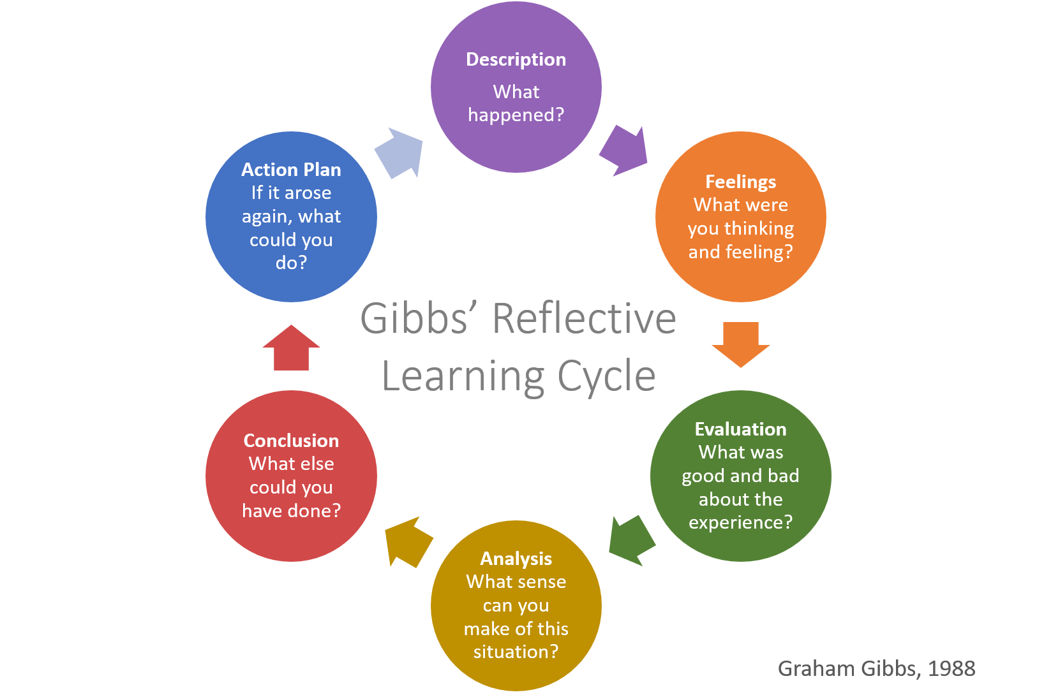
Figure 1: Gibbs’ Reflective Cycle
(Source: Porfírio et al. 2021)
Description
At Hampton by Hilton London Luton Airport, I worked as a Housekeeping Assistant. I was required to clean rooms, replace bathroom supplies, answer guest needs and help the laundry staff. On occasion, I was with the housekeeping supervisor during the shift planning and when checking the quality of their work (Porfírio et al. 2021). I watched how stress from a busy day was managed and could see clearly that good teamwork was key to achieving day-to-day goals.
Feelings
I felt I would struggle at first to meet the very strict cleanliness level and to work within the time limits. I started feeling more confident once I trusted my team and had supervisors give me complimentary feedback (Suprayitno, 2024). I liked how fast things moved and how supportive the team was. I managed to enjoy solving problems when I accomplished tasks properly and the guests praised me (de Araujo et al. 2021). Feeling like this made me better able to stay motivated and manage pressure, so I decided to interact more in daily briefings and aid my colleagues whenever their work got tough.
Evaluation
A major benefit was the team’s open and easily understood way of organising tasks and exchanging ideas. Every day, briefings made sure everyone knew what they should do and were motivated. But, during busy days, delaying room readiness caused issues and trouble with the people working at the front desk. I saw that, on one occasion, a guest had to wait because the hotel did not communicate room preparation in real time which exposed a flaw in how things were organised (Alo et al. 2023). Although employees handled stressful situations well, problems in communication between team members affected the way guests were served. I saw that it’s important to provide good leadership, update regularly and give clear instructions for things to run smoothly day to day.
Analysis
I found that most service problems started because there was a breakdown in communication. Performing well as a team and under pressure was good, but the slow turnaround of rooms revealed inefficient teamwork and organisation. Briefings worked well, but there wasn’t a way to easily update one another from the field. This difference caused frustration, mostly between the front desk and the team (Elia et al. 2024). Most supervisors helped staff with useful suggestions and advice, but the absence of updated information meant that teams could not meet expectations and some guests might be disappointed.
Conclusion
Looking back on what I’ve done, I see that being successful in housekeeping depends on group efforts, organisation and strong leadership. Now I recognise how much structured leadership, timely updates and helpful systems are needed in hospitality (Senadjki et al. 2023). With time, I learned that supervision, feedback from co-workers and a good team culture are important for good learning.
Action Plan
I will find opportunities to learn about Property Manage Systems (PMS) so I can explore how all departments can work together seamlessly. I try to strengthen my leadership skills by stepping up in team talks and supplying ideas (Zhu et al.2022). I am also interested in discovering how technology supports efficient organising with real-time task management tools.

Section 2: Management Performance & Guest Service Analysis
I observed in my placement in Housekeeping at Hampton by Hilton London Luton Airport that the management team mostly led using a democratic method which boosted staff motivation and their involvement. This came through during daily briefings as team members were urged to join in and share their views, similar to what we studied in Management & Organisational Behaviour (Suprayitno, 2024). At times, during tough moments, supervisors chose a more authoritative way to guarantee efficiency. All safety requirements were strictly followed, thanks to the Health and Safety at Work Act 1974 and PPE use, COSHH guidance and weekly cheques. Because of its welcoming culture, the teamwork in the hotel was very effective, following the Personnel Resourcing & Development principles of appreciating culture and helping staff (Riyadi, 2021). Hospitality & Guest Services principles connecting service quality were supported by managing cleanliness scores and using guest feedback.

Section 3: Guest Service Improvement Plan
A useful advancement would be to add in a digital system that instantly shows if rooms are occupied, free or being serviced, integrated into the hotel’s main software. Consequently, guests can receive their room assignment quickly and there won’t be any confusion for the front desk (Mahdi and Nassar, 2021). Training team members in different areas of the hotel can help everyone understand each other better and work together smoother in busy periods (Xia et al.2023). Every department should meet on a regular basis to set the same daily objectives and discuss what everyone faces. Employing these steps would keep services free of disruptions, shorten guest waits and raise awareness of responsibility, making the company more efficient and getting better guest satisfaction scores.
Apart from better technology, guest experience can only be improved by motivated workers and steady, outstanding service. Letting housekeeping staff find out how well they are performing in the eyes of guests (by looking at Medallia scores) could make them feel happier and encourage them to do great work. Making sure staff attend refresher training each month in customer care, resolving problems and providing customer service will help them handle guest needs confidently (Alo et al. 2023). Recognising exceptional employees in a formal way can encourage the team to work together and stick to important service standards. Also, supervisors need to check for problems randomly and make sure they take immediate action on anything below the desired standard (Dicke and Ott, 2023). The goal of these practices is to help a business operate efficiently and also to make guests feel valued, generating loyalty and more repeat visits.

Conclusion
I found out the importance of strong communication, cooperation by teams and leadership in assuring high-quality service. Applying the ideas learned in my coursework taught me the need for structure in supervision, motivated personnel and effective organisation to maintain high operating levels. Noticing the areas the department was strong in, along with areas it could work on helped me see a possible need for better communication between teams. I became more confident, practised at solving challenges and learned to function well under stress because of this role. Reflecting on my progress by using Gibbs’ cycle made it clear to me what I was learning and aiming towards at work.

References
Alo, O., Ali, I., Zahoor, N., Arslan, A. and Golgeci, I., (2023). Impression management and leadership in failing or failed business-to-business firms during and post-COVID-19: Empirical insights from Africa. Industrial Marketing Management, 113, pp.1-13. Available at: https://www.sciencedirect.com/science/article/pii/S0019850123000950
Alo, O., Ali, I., Zahoor, N., Arslan, A. and Golgeci, I., (2023). Impression management and leadership in failing or failed business-to-business firms during and post-COVID-19: Empirical insights from Africa. Industrial Marketing Management, 113, pp.1-13. Available at: https://www.sciencedirect.com/science/article/pii/S0019850123000950
de Araujo, L.M., Priadana, S., Paramarta, V. and Sunarsi, D., (2021). Digital leadership in business organizations. International Journal of Educational Administration, Management, and Leadership, pp.45-56. Available at: http://www.harpressid.com/index.php/IJEAMaL/article/view/18
Dicke, L.A. and Ott, J.S. eds.,(2023). Understanding nonprofit organizations: Governance, leadership, and management. Taylor & Francis. Available at: https://books.google.com/books?hl=en&lr=&id=gKazEAAAQBAJ&oi=fnd&pg=PA2017&dq=Dicke,+L.A.+and+Ott,+J.S.+eds.,(2023).+Understanding+nonprofit+organizations:+Governance,+leadership,+and+management.+Taylor+%26+Francis.+Available+at:+&ots=yNWzyxuWZJ&sig=kqpr3JfMUU6J4mOdqxLq_PsrGHA
Elia, G., Solazzo, G., Lerro, A., Pigni, F. and Tucci, C.L., (2024). The digital transformation canvas: A conceptual framework for leading the digital transformation process. Business Horizons, 67(4), pp.381-398. Available at: https://www.sciencedirect.com/science/article/pii/S0007681324000454
Mahdi, O.R. and Nassar, I.A., (2021). The business model of sustainable competitive advantage through strategic leadership capabilities and knowledge management processes to overcome covid-19 pandemic. Sustainability, 13(17), p.9891. Available at: https://www.mdpi.com/2071-1050/13/17/9891
Porfírio, J.A., Carrilho, T., Felício, J.A. and Jardim, J., (2021). Leadership characteristics and digital transformation. Journal of Business Research, 124, pp.610-619. Available at: https://www.sciencedirect.com/science/article/pii/S0148296320307360
Riyadi, S., (2021). Effect of E-Marketing and E-CRM on E-Loyalty: An Empirical Study on Indonesian Manufactures. Turkish Journal of Physiotherapy and Rehabilitation, 32(3), pp.5290-5297. Available at: http://repository.unitomo.ac.id/3218/
Senadjki, A., Yong, H.N.A., Ganapathy, T. and Ogbeibu, S., (2023). Unlocking the potential: the impact of digital leadership on firms' performance through digital transformation. Journal of Business and Socio-economic Development, 4(2), pp.161-177. Available at: https://www.emerald.com/insight/content/doi/10.1108/JBSED-06-2023-0050
Suprayitno, D., (2024). The Influence of Leadership on Employee Performance. Journal of Law, Social Science and Humanities, 1(2), pp.87-91. Available at: https://www.researchgate.net/profile/Sara-Alzubi-2/publication/388062910_A_Review_of_Literature_on_Human_Resource_Management_Leadership_Style_and_Employee_Performance/links/6788e8f743ffa93f52d8e84e/A-Review-of-Literature-on-Human-Resource-Management-Leadership-Style-and-Employee-Performance.pdf
Xia, Y., Liu, X., Wang, X., Deng, H., Han, C., Liu, Z. and Tsai, S.B., (2023). The power of role models in a team: The impact of lead entrepreneur's digital leadership on digital entrepreneurial success. Information Processing & Management, 60(6), p.103498. Available at: https://www.sciencedirect.com/science/article/pii/S0306457323002352
Zhu, J., Zhang, B., Xie, M. and Cao, Q., (2022). Digital leadership and employee creativity: The role of employee job crafting and person-organization fit. Frontiers in Psychology, 13, p.827057. Available at: https://www.frontiersin.org/articles/10.3389/fpsyg.2022.827057/full

