How can we promote engagement in collaborative work through the use of pupil choice?

It came to my attention through studying the PGCE course that pupil voice can really improve children’s feelings of autonomy and therefore the amount which they wish to learn. Thus the importance of this research question which I have chosen to find out whether using pupil voice in the classroom setting can give a positive enhancement towards engagement to focus on learning. In this research we will be looking into pupil voice when deciding seating arrangements, and whether pupils decisions to where and who they sit by will influence their engagement in a lesson. As a practitioner I have an interest in pupil voice and rights of the child which is in the UNCRC Article 12, I believe this is extremely importance to adhere by, but as I know this can be difficult to conform to when there are such reasons to stray away from this, such as behaviour management which was very apparent in the class which I was teaching. During the time in this class children were frequently moved from peers as they would distract each other, but it made me wonder whether the children would be more engaged in their learning if every day they had a choice where they would like to sit in the classroom, and they could sit by whoever they wanted to. This brought a vast interest to understand the impact that seating arrangements could have and whether pupil voice could enhance learning by allowing children to have the freedom of whether they would like to locate themselves. I understand the importance of research as it shapes the way in which children can learn and as an enquiring teacher it is part of my career to continuously further my own content, curricular and pedagogical knowledge.

The research will be taken place in two schools, the first day we shall proceed with the research and identify anything would could be altered for the second day. School 1 is in an affluent urban area on the outskirts of Swansea, there are 365 pupils. In this school approximately 8% of pupils are entitled to free school meals which is well below the national average as reported in (estyn.gov.wales, 2013). There are a few pupils which receive support for English as an additional language and around 10% of pupils have additional learning needs and a very few have a statement of special educational needs. School 2 is also in an affluent area, there are 235 pupils who study here as reported in (estyn.gov.wales, 2014). Most of the pupils here live in the catchment area and an extremely low level of 2% of pupils receiving free school meals, this is below the average in Wales. There are 3% of children having additional learning needs which is also below the average for Wales. Very few of the students have English as an additional language but no pupils receive support to learn English.

From my heightened concern in this matter I decided to read into how seating arrangement can affect engagement and how peer voice can affect engagement. There were many arguments and opinions which gave me a good insight on what I am going to find when the research takes place. In a Journal of Applied Psychology, (Gremmen, 2018) they discussed how students spend the majority of their time during lessons with students who are sat next to them and that this will play a crucial role in the students development, which I conquer with. Gremmen & Yvonne, (2018) hypothesized that near seated peers did in fact influence students academic engagement and achievement, especially when they are already friends. Knowing this, shouldn’t teachers be considering students friendships and academic engagement when designing these seating arrangements? I believe yes they should, although there are many other factors which prevent this from happening such as classroom behaviour problems, distraction and arguments. From previous research in this area there has been knowledge of students stimulating other students and for students to de motivate academic engagement and achievement, therefore it is hard to decide whether a certain seating arrangement is in fact benefiting a learner. What if this could be changed by more research behind this phenomena? As, (Snijder et al, 2007 as cited in Gremmen, 2018) stated that, ‘in response to being in contact with friends, a students behaviour and attitude can often change, this being due to the social influence process’.

A friends choice can also affect the teacher’s judgements of certain academic outcomes as teachers will normally associate certain students within the group that they are part of and spend most time with, and this will then cause a judgement for friends who are more similar to each other than that of non-friends, (Knecht, 2014, as cited in Gremmen, 2018). Therefore, the group that a certain learner will sit next to or spend time with will portray their personality across, even if it is positive or negative. This can become fair or unfair if sat next to the wrong peer, especially as student’s academic engagement and achievement in primary school affect their level of education in secondary school, and subsequently, their future academic and career opportunities, (Flashman, 2012, as cited in Gremmen, 2018). Thus the importance of research to examine the determinants of academic development, which must necessarily surround peer seating arrangement, as this is who is bringing on the learner or setting them back. So this could bring the question, shouldn’t it be a better idea for teachers to decide whether children sit so there is no chance of a child being distracted or misled, but in fact this is taking away the child’s pupil voice and autonomy which has a negative effect on how they look at education and want to succeed in it. As Martin et al, (2005) as cited in Bragg, (2007) stated, ‘without the wholehearted adult support for, and belief in, the potential of student Voice, we believe the role and contribution of students to their learning communities cannot be fully realised’.

It has been found, (Yvonne, 2015) that there are psychologically two arguments for seating arrangements. The first argument being that surrounding ‘Proximity’ and social relationships being developed and maintained. This argument suggests that when an object or person is exposed more this will create a positive outlook about the object or person, (Zajonc, 2001, as cited in Yvonne, 2015). This can even take place about a similar stimulus which the person has not yet been exposed to. This suggests that peers sitting next to each other will eventually give positive reinforcement to engagement. The second argument suggesting that, ‘effect does not come from mere exposure but rather from the reinforcement that stems from the social interaction with the person one is exposed to’. This suggests that peers will either give a positive outlook to each other or a negative, meaning it could be beneficial or it could be distracting depending on the type of social interaction which will take place, therefore depending upon the learner’s personality and motivation.

There are different reasons for why teachers sit children in their seats such as, academic reasons, and placing similar or dissimilar students close to another. Whereas, other teachers will focus more on the students social relationships, by placing friends or non-friends next to each other, (Rodkin 2011, as cited in Gremmen, 2018). For example, there have been studies which mainly focus on same abilities instead of friendships and relationships, you could say that this is a very behaviourist approach, although it was found that cognitive development can be enhanced when working this way, (Kutnick, 2005, as cited in Gremmen, 2018). Also, having temporary groups to complete certain tasks can also benefits learners if they are the same abilities, Blatchford et al, 2005, as cited in Gremmen, 2018). Although, there has been research to suggest that mixed ability groups can also work well, especially as there is no stigma surround this which can negatively affect a lower ability child. Another argument is that proximity can influence a students behaviour especially as students want to be liked, and be part of a group, they are constantly seeking approval from their peers, (Webb, 1989, as cited in Gremmen, 2018). For peers to avoid the feeling of rejection they will copy the behaviours of peers from their group, whether these are positive or negative. According to the social learning theory, (Bandura, 1977) it is known that students will learn mostly by observing their peers, which suggests if they are sitting by a student whom they have a close bond with they are more likely to pass on positive behaviours, and vice versa. The students will regularly observe their peers academic engagement and achievement and copy this, this will have a positive effect when absorbing knowledge, skills, resources and academic subjects.
Although, there is a contrast of a student having the potential to demotivate their close to peer by showing distracting behaviour and role modelling getting negative, low grades, (Dieterick, 2015, as cited in Gremmen, 2018). On the other hand, students who have a group of lower-achieving peers can improve their self-confidence and motivation as they feel like they are doing okay compared to that of their peers. This over time, can increase academic engagement and achievement. Although, this can also decrease ambitions and motivations. It is very difficult to find the correct scenario for all students to have the right amount of engagement through pupil voice and seating arrangement, thus the importance of this particular research study.

As this research study is going to be set in a real classroom with real pupils, and that it also involves an element of collaborative enquiry between the teachers and learners to improve a certain approach, the appropriate way of doing this would be to use Lesson Study, (Dudley, 2011). As lesson study has a benefit of finding out how to plan teaching around learners needs and change their teacher to better support learning, this will back up the aim of our study which is, to see if pupil choice enhances engagement in collaborative group work. Lesson study, which is a form of action research is in fact a great way of empowering teachers as it allows them to test whether their opinions and assumptions can actually be beneficial and life changing, (Cohen, 2009). Lesson Study is a great tool to use because it helps a teacher to see the learning of pupils in a heightened amount of detail than normal which allows gaps to be seen in what they have assumed and in what is actually happening, (Dudley, 2011) As classrooms are an extremely complex working environment it is easy to miss out on certain issues which learners face, but this allows more important information to be seen, and therefore to be altered for the good of the children and teachers. It also enhances the way of planning, especially as the teacher can find out what matches certain pupils needs. It can be known that lesson study is flexible, authentic and offers a voice from the teaching world, although there are negative thoughts about this due to the fact that it can be too controlling and unnecessary especially as school life is stressful at the best of times. Therefore, there is a problem between the action of teaching and the research of teaching as there is an incompatibility between these two acts, (Halsey 1972, as cited in Cohen 2009). This being explained as research in the classroom is hypocritical as a teaching job does not allow such mannerisms to take place. The classroom is too busy and too much going on for observations, reflections and interviews. It is just not feasible. There is also an issue which staff as they are not likely to want to endure in change, so this seems unnecessary to look into and investigate the chance of it, (Rein 1967, as cited in Cohen, 2009). For this Lesson study, it shows that yes it can have great impacts on learners but when a school has the choice to take these impacts forwards, it is more than likely not going to agree with the policy, therefore there is not an equilibrium between these matters.

A method which is going to be used to gather data on engagement will be structured observation in the classroom. There will a structured check list of things to observe which is included in the observational schedule. This was created using the ideas of the Leuven Scale of Involvement, which is a scale that scores a learner from 1-5. 1 is being extremely low and 5 is being extremely high, and the three participants which are being focused on shall be scored along this to give a measure of their engagement. There will be other aspects which are going to be observed, such as the scale of interaction between learners and there will be additional notes including verbal and nonverbal communication. To ensure the observation strategies run smoothly, I shall be participating in a Pilot observation prior to the research. The reason for choosing a structured observation is due to the fact that it is systematic and allows the researcher to conform to numerical data, which can give a good comparison between settings, situations and trends which is what we intend to investigate, (Cohen, 2007). It also allows the observer to blend in to the background as they can have a passive and non-intrusive role which will prevent learners from being different to what they normally intend to be as there is not a feeling of ‘being watched’ as such. There are also some limitations to this method as it can be looked at as a behaviourist action because there is an exclusion of learners being motivated because they are being observed, therefore it’s not treating the learners in an open minded way, (Bennet et al 1984, as cited in Cohen, 2007). It can deem to negative in the respect of individuality as the learners being observed are just an aggregated score with no true meaning of the reason for their behaviour and underlying feelings. Therefore, how can this be completely reliable as it’s not always the case that a particular behaviour will indicate a particular intention and motivation.

Due to this unreliability there is much need for a semi structured interview. This will be taken place in a focus group with 3 participants and these interviews will be tape recorded. The high need for this method is due to the realisation that human subjects are not simply just data but can be measured more thoroughly through conversation as this can brings views, opinions and true interests through from social interaction, (Kvale 1996, as cited in Cohen, 2007). As Tuckman, (1972) as cited in Cohen, (2007) said, ‘interviews can provide a gateway to see what is going on inside someone’s head’ which gives the best type of qualitative data when looking for an answer. On the other hand there are limitations of this process being that certain learners may have more mutual trust to the interviewer than others which can give an unreliable result. Some particular learners may not be feeling honest in their answers or wanting to talk about their own feelings, which cannot be helped in this instance. It is merely impossible for everyday life to be brought up in an interview as human beings have emotions that are not constant.

Finally, there will be teacher reflective notes to be made after the interviews to see how the research went. This will be underpinned by the, Brookfield’s (1995) 4 lenses model of reflection. The four areas which are going to be looked at are self, pupil, peer and literature. This is a good way to access all angles of the research and it doesn’t allow any room to miss a perception out. It helps the researcher to learn from the experience which took place and therefore to change or adapt the research for the future, (Brookfield, 1995). Again, this cannot be completed reliable as a pupil may interpret what happened very differently to what the literature, self or peer may see it. There will also be exit slips to be given out at the end of the lesson to see a view point from the entire class, this gives a quantitative element of the data to increase validity.

There are many ethical considerations which needed to take place, and an ethics form was sent out and approved by the committee at the University of Wales Trinity Saint David. All learners must have consent from parents that they are being able to be observed and interviewed through the research, without this they cannot take part. Also, adhering to the BERA Guidelines, (2018) there must be confidentiality and anonymity to ensure that all participants are safe during and after the lesson study. Students and parents are to be made aware that individuals will not be identified, and no personal information will be recorded. It must be known that all data recorded will be stored on a password protected laptop which is adhering to the GDPR guidelines, (2018). Parents and learners must be aware that all data collected is to be stored on a password protected device and that it will be confidential and anonymised as it will not identify any participants or the school which the lesson study takes place in. The data will be shared with the research partner so they are able to discuss and analyse results but the data shared will ensure participants are not identifiable. Following this, the data will be stored securely by the research partner within the school which they are working in and this will also be stored on a password protected computer until the end of the Primary PGCE Programme. Finally, adhering to the UWTSD Research Ethics and Integrity Code of Practice, (2017) the data will be retained in a safe and secure place which is available to others in line with appropriate ethical, data sharing and open access principles. The participants are able to withdraw from any time and they must be aware of this.

The first lesson study took place in School 1 and many themes emerged. The aim of the lesson was to create 3D shapes out of different materials so this was a good way to see how groups could work collaboratively and if the seating arrangement and pupil choice affected this. The children did achieve the lesson goals as it was an exciting lesson which created an engaging atmosphere where the learners worked well in a group and prior knowledge was activated as they had been learning bout 3D shapes in a previous lesson. The learners seemed to have heightened well-being compared to a lesson where there were set seats, this became aware through communication with peers from the observation notes in the Leuven Scale of engagement. As quoted Child A is, ‘working well with her partner and doesn’t necessarily sit with or socialise with this peer’. This shows that child A had more autonomy when choosing who to sit by because she may want to discuss ideas with a different peer she doesn’t normally sit by. This is proven by what was said in the interview as Child A said, ‘If you sit by someone different you may find out different things as different children have different ideas’. Child A was given a high score of 4 on the Leuven Scale of Involvement as she was very engaged at the start of the task and wanted to do her very best. This was also shown by the fact that she would want to share her skills and help her peers with their model, this is why her scale of engagement reached the high 5 mark and her interaction with others reached the high 5 mark. Interestingly, in the interview she said, ‘I like to explore new groups and share creativity’. This was obviously seen while observing this particular child and her heightened engagement was shown by using Mathematic skills to count the exact number of ‘sticks’ which she needs to create a Triangular Prism. At the end of the task she seemed pleased with her outcome and the pupil choice enhanced her engagement through being able to socialise with different learners and share ideas collaboratively.

The learners were able to choose materials independently to use without hesitation, this is showing that they are using their intelligence on certain materials to understand whether a 3D shape could be made correctly. Some children chose the correct materials and used the correct amount of materials whereas some children struggled with this. For example Child B decided to sit by a male oriented table whom were his close peers, although this table were engaged at the beginning of the lesson but this deteriorated quickly because they were distracting each other. Child B knew he was being watched so he had very low communication with peers. As the observation notes say, ‘Does not want to get distracted by his peers although he normally has the potential to’. He was given a high 4 mark of engagement at the beginning of the task as he was extremely focused, although he was not communicating with other peers which showed that he was unsure about whether his close peers would distract him or encourage him. As seen from the interviews Child B said, ‘In a lesson where I am writing a story I would like the teacher to choose where I am sitting because if I sit by my friends they would talk and I would not get as much work done as I liked’. It was interesting to see a child discuss this theme because of ‘being distracted by peers’ because children enjoy being around their friends, but obviously they are aware that sometimes it does not help you with motivation in education. As the lesson went on Child B was losing engagement and went down to a mark of 3, this was shown by falling off his chair and being immature with his peers. He seemed to be frustrated that he had not made a model, which was due to being distracted and falling into negative behaviours. At the end of the task his engagement did go up to a mark of 4 because he was under pressure and wanted to create a model.

At the end of the lesson there was a chance for learners to discuss how they made their 3D shape. This showed which learners were engaged and which learners were not. Child C is a very hard working child who always wants to do her best. As said in the interview, ‘I would like to choose where I sit as I would like to get as much work done as possible so I would sit next to somebody sensible’. This became apparent in the observation as she did not sit with her close peers but somebody she thought was sensible and would increase her learning. At the start of the task Child C as at a high mark of 5 for engagement and a low mark of 2 of interacting with others, this seemed to be because she was only communicating with one peer who was sharing ideas with her. It was shown that she wanted to succeed as she kept asking the teacher for help when the model was not completely working. Therefore, it was shown that this child would always want to sit by a higher level achiever than herself to push her on, and the teacher would not always do this, and Child C would suffer because she would not be getting as much help from a lower achiever. Although Child C did comment in the interview, ‘I was happy to sit where I choose’.

While interviewing the children it was interesting to see what the believed would improve the lesson. The thoughts they gave were, ‘I would quite like to have two people a table instead of a group table. You can spend more quality time with fewer people without getting as distracted’. This was a good idea but was not what we were looking for as working collaboratively as a group was the main focus, although it was something to think about for a Numeracy or Literacy lesson where concentration needed to be high. Secondly, ‘letting the people sit where they want to sit but sometimes having a little bit of control over it if you can see that they are not working so well with a certain person’. This was a good idea as for the Second Lesson study this is what we changed and gave a ‘warning system’.

We learnt that this approach worked well because children could generally work with friends, although there was a slight distraction with noise levels. This was not as damaging in this type of lesson compared to a Literacy or Numeracy. Children agreed with this as in the interview they said, ‘in a literacy lesson I would like the teacher to choose where I sit because I need to think quietly about what I am writing, but in an Art lesson I enjoy talking creatively with peers’. Finally, from a student’s perspective in the Brookfield’s 4 lenses it was shown that, ‘it made their well-being positive as they got to sit by their close friends or explore different friendships, but pupils were reflective about being more easily distracted.

Lesson study 2 was taken place in School 2, again there were many themes that emerged. From looking at Brookfield’s 4 lenses reflection it is seen that, ‘there were some groups which worked well together and go on with the given task, sitting by friends increased the well-being and social interaction amongst groups and great models were made’. On the other hand there were some negatives being, ‘arguments and conflicts breaking out amongst groups, noisy disruption, and task was not achieved by all due to the disruption and lack of concentration. From this lesson which was again creating 3D shapes the children could activate their prior knowledge on this as they learnt about it in a previous lesson. This was a good way to use what they knew and it worked well because models were made, although this was not always appropriate to the task. At the beginning of the lesson the children were aware that there were 3 strikes given if behaviour was not good and then they would be moved from their chosen seat. Child A decided to sit by his close friends who he would play with and this child did not necessarily create anything which was appropriate to the task, unless told to. This seemed to be because he sat by peers who also were not on task, as he would usually be placed by peers who were and they would motivate him to do so. As seen in the Observation notes Child A, ‘not on task or doing what is supposed to be done. Completely unaware of what is expected from him and is on his own agenda’. At the start of the task Child A was given a low mark of 2 for engagement as he was often caught making things which were not on topic. Obviously, this type of seating arrangement did not suit this learner for engagement. As he said in the interview, ‘I like to teacher to sit me by smart children so they can help me, especially in Maths and Literacy’. This child did enjoy being able to choose where he sat as he had the autonomy which increased his well-being and enjoyment but this did not necessarily help him with his work.

Child B chose to sit in a table full of females like herself, which were her close peers. Her well-being seemed extremely high as during the task she was very engaged and enjoying what she was learning and creating. This was seen by the observation notes of, ‘constructing a shape as a team and evidently taking pride in work’. This child had a high mark of 4 for engagement at the start of the task and she was verbally communicating to her team about the task and she even walked around the classroom to get more materials to improve her construction. This particular child is normally very motivated in her work, but she is a lower achiever but her friends do motivate her to do well. As said in the interview Child B said, ‘I like to sit by my friends because they are really smart and help me’ and that when the teacher chooses where she sits she, ‘sits by children who annoy her and this puts her off her work’. This particular child seemed to benefit greatly by choosing to sit by her friends and this was seen by her model and how she asked to discuss to the class what she had done.

However being some benefits, there were also some negatives in this study. There were a few arguments regarding sharing the materials and this was when one warning was given. Child C whom is a very intelligent learner was excited to choose where he sat and he decided to sit on a male oriented table which his close peers. Child C was most definitely aware that this table could distract him from his work, as he said in the interview, ‘I would quite like to sit on a table of two so that there is less chance of being distracted from my work as I like to work hard’. This became obvious throughout the observation as he was working on his own and concentrated at the start of the task, therefore he was given a high mark of 4 for engagement. He was quickly to drop down to a mark of 2 because he was quick to show off his work and this annoyed some of his peers on the table, which caused a disruption. Child C does like to help other children as was said in his interview although this tends to be a lower achiever. The children on this table were leaning more towards the higher achiever and did not want the help as they enjoyed to work on their own. Suddenly, somebody broke his structure and from then Child C stood up and started arguing with others on the table. This was a very negative and confrontational interaction with peers which decreased engagement. This particular child went on to say in the interview, ‘I would rather have cardboard walls around our desks so that we can concentrate without our friends talking to us and causing arguments’.

Therefore, this lesson study showed how pupil voice in seating arrangements can work well and how it can be a disaster. This lesson could be improved in the future by decreasing the segregation in Gender. In this particular class the Males were more orientated to argue and the females were more orientated to be motivated. The children agreed that if they were mixed on tables by boy and girl they would have achieved more. What was interesting from this lesson study was that the children would actually quite like to sit on their own, as was said in the interview, ‘I would rather sit on my own so I can get more work done, especially in Literacy and Maths, although in Art it would be nice to sit by my friends because it is more of a relaxing subject’. The pupils loved having choice in this lesson however some learners found it difficult to make a decision where they sat because it was out of routine, this could be a limitation of the validity of the results.

From analysing these results there were some main themes which I can identify of the learners engagement from having pupil voice in sitting where they chose. Firstly, learners enjoyed being able to choose where they sat because they were able to sit by close friends or explore different friendships. This is understandable for a child as Cialdini, (2004), as cited in Gremmen, (2018) said students will always wanted to be liked, to feel like they belong to a group and to seek approval from other peers. This suggests that the genetic makeup of the youth will always want to change around in the classroom and seek approval from other peers instead of changing opinions with the same group of peers. It is known that it is very narrow minded of the elder human in the room, being the teacher to predominantly focus on the same ability peers to sit next to each other instead if friendships and relationships, (Gremmen, 2018). Therefore, for the future of this class I think it is important to reinforce the fact that temporary groups should be used to complete tasks as it has been shown by, (Blatchford et al, 2005, as cited in Gremmen, 2018) that this will enhance their academic achievement and progress over time, and also a learners well-being and autonomy will be increased which is also extremely important for the success in the future.

Secondly what was emerged was pupil’s engagement not being as high as it should be, and also pupils feeling that they did not work as well as they normally would. This was due to distraction, high noise level because of learners becoming too excited and having an animosity between certain peers because their personalities did not suit during this task. Also, certain learners found it difficult to choose where to sit because it was not their normal routine and this gave them anxiety. This theme which emerged was what was hypothesised as learners have been known to either stimulate or de motivate academic engagement and achievement, (Yvonne, 2018). This is obviously the reason that these particular students would not normally sit by these other learners, as the teacher designed the seating arrangement which would promote student’s academic development, (Farmer 2001, as cited in Gremmen 2018), and this seating arraignment would obviously not promote this or promote positive friendships in some instances as these personalities were not compatible. Positive motivation and friendships work when they choose where to sit as learners are likely to imitate behaviours be peers and get reinforced by valued peers through social rewards or social sanctions, (Gremmen, 2018) and therefore having contact with these peers the students can gain knowledge and skills, but if there is a negative atmosphere there will not be any positive outcome for these peers. Which suggests that in this instance it is important for the teacher to choose where the learners sit as students can demotivate near seated peers, by showing distracting behaviour or by being negative role models, (Dieterick 2015, as cited in Gremmen, 2018).

Finally, an interesting theme which emerged was that learners found in a Literacy or Numeracy lesson they would like to sit on their own, on a small two person’s table or for the teacher to decide where they sat. On the other hand, if the learners were having an Art or a Creative lesson they would like to choose where to sit so they would express their opinions and share ideas. This was not hypothesised at the beginning of the research project, which is why it came as a surprise and it so interesting to us for future research. It has been known that some teachers mainly have academic reasons for their arrangements by sitting higher achievers by other higher achievers and vice versa, although this can create a stigma for the children especially in a Literacy and Numeracy lesson, but the learners seemed to agree with this as they worked harder when the teacher chose where they sat, (Kutnick et al 2002, as cited in Gremmen, 2018). I agree that it is important for other peers to express views and opinions and not to be constricted to the same peer on a daily basis. Recently, (Van den Berg, 2012, as cited in Yvonne, 2016) found that a teacher’s strongest consideration was to separate students with behaviour problems, which would then promote academic diversity and promoting new friendships. This is in my view a narrow minded way to prevent conflict as learners need to have the experience in an argument for future life, so preventing this for them is constricting their future personality. I understand classroom management is essential but there needs to be a balance.

The lesson studies most definitely had strengths and weaknesses as it did allow us as enquiring teachers to theorize about our own practices, and to be inquisitive about different circumstances and understanding relationships, actions and consequences in the classroom, (Cohen, 2007). It gave us scaffolding about learners wanting to choose where they sit for more creative lessons so they could explore new relationships, although when it came to Literacy and Numeracy lessons the learners wanted to be sat by somebody that the teacher chose. This can then be used for future lessons in schools if they wish as it has come from the pupils voice itself. On the other hand, there were many limitations to the lesson studies as it is a systematic learning process in which people act deliberately, which was most definitely seen from the leaners that were being observed and interviewed. It became obvious that there was a pressure to give certain answers in the focus groups as they kept looking at their friends for reassurance, so for future research I would suggest to use individual interviews to give more of a reliable result. Also, the research was very out of routine for the learners which does affect the reliability because it, ‘reduced the practical impact of the everyday school life’, (Cohen, 2007), therefore in future research the lesson study could be repeated a few times or given a ‘test run’ for the learners to get used to the different feeling of the day, in this case choosing where to sit instead of the teacher choosing where they sit.

During the observations, it was felt that these would give a reliable result as, (Patton 1990, as cited, in Cohen 2007) suggested that observational data can be useful for recording non-verbal behaviour and behaviour in natural or contrived settings. This was definitely seen as the learner’s engagement and communication with other peers could be watched from a far and analysed using the Leuven Scale of involvement, and it was said by (Patton 1990, as cited in Cohen 2007) that observational data can enable the researcher to enter and understand the situation that is being described. On the other hand, it was noticed that the learners were copying behaviours of their friends especially as they may have felt slightly anxious that the classroom teacher left the room and that there was a new person being in the room. This is most definitely a limitation for the research as the learners would have been acting in a different way to what they normally would have been. Especially as the observer knows that hypothesis which they are looking for which can influence their observations, as in they are deliberately looking for a certain behaviour without even knowing, (Cohen, 2007).

Before the research took place we piloted some of the methods to increase the reliability and validity of the results. We piloted the questions on one another whilst practicing the answers which were expected on the tape recorder. We also discussed the Leuven scale and how there were 5 marks which could be used, these being 1 for extremely low engagement, 2 for low engagement, 3 for moderate engagement, 4 for high engagement and 5 for extremely high engagement. We agreed that this was a good way to evidence their engagement but we did realise that there could be a problem if they were in between a certain mark, therefore for the next researcher it would be valued to give an in-between marker such as, (4-5 etc.).

This research has been helpful as the results can be shared as good practice, for example I shall share this with my next school mentor and suggest making alterations around seating arrangements and pupil choice. I think it is important for a classroom to have a pupil choice table and to have different tasks available for children to choose, as this can incorporate more autonomy and well-being for the learners. Although, for group activities the children should choose where to sit but there should be a warning system in the subject which was suggested.

References
Bragg Sara (2007). Educational Action Research, ‘But I listen to children anyway!’- Teacher perspectives on pupil voice. The Open University, UK.

BERA (2018) Ethical Guidelines for Educational Research, Fourth Edition.

Buchard J, Daniel M (2017). Lesson study and its effects. Hellenic Journal of Research in Education.

Cohen Louis, Manion Lawrence, Morrison Keith (2007). Research Methods in Education. Sixth Edition.

Dudley P (2014). Lesson Study : a handbook.

Gremmen M, Yvonne M, Veenstra R (2018). The importance of near-seated peers for elementary students academic engagement and achievement. Journal of Applied Developmental Psychology.

Gremmen Mariola, Yvonne H, Segers E, Antonious N (2016). Considerations for classroom seating arrangements and the role of teacher characteristics and beliefs. Social Psychological Education.

Huang Jinyan, Fernandes Amanda (2013). Chinese Teacher Perceptions of the Impact of Classroom Seating Arrangements on Student Participation.

McKeown Shelly, Stringer Maurice, Cairns Ed (2016). British Educational Research Journal. Classroom segregation; where do students sit and how is this related to group relations?

UWTSD (2017) Research Ethics and Integrity Code of Practice.

Yvonne H, Van den Berg, Antonious C (2015). Peer status and classroom seating arrangements: A social relations analysis. Journal of Experimental Child Psychology.

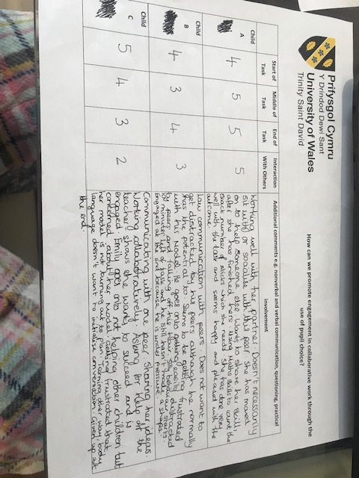
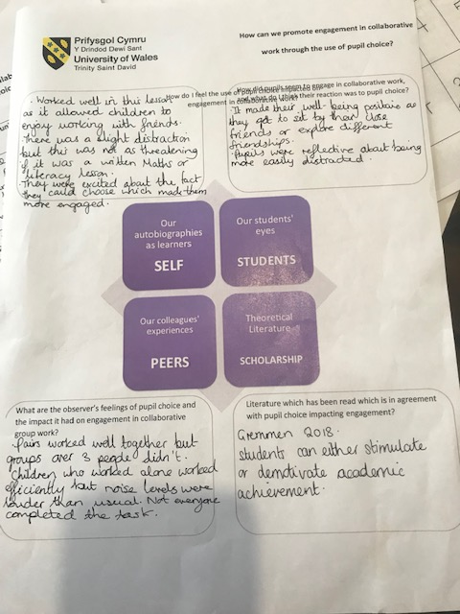
Day One

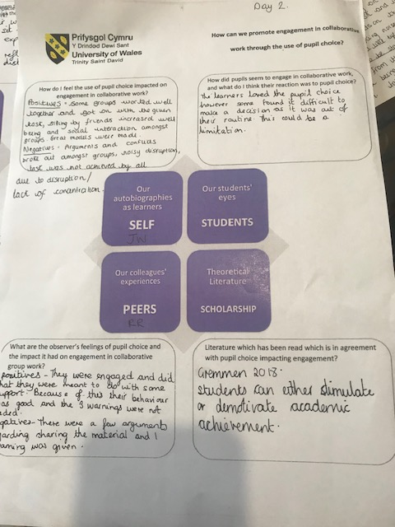
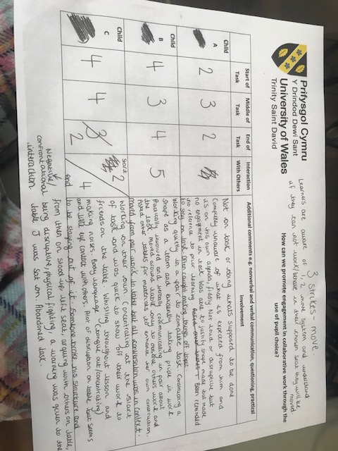
Day Two

