How do individuals with astrological background understand the nature of the cosmos?

Individuals are often in a rush to observe and believe whatever the mainstream is embodying, especially in regards to predictions about personal health or the future. Knowing the future often indicates a mystical background that attracts great interest and attention, especially when visible tools or methods are used. In relation to the objective nature in this research, secular views of cosmology and astrology, occurring through mainstream, presenting astrological wisdom, more likely as a magic tool for future predictions and secret knowledge. The level of attention given to astrology in the western world, has significantly increased in the last few decades, showing a wider interest to the subject. Astrological and cosmological information is presented in a diverse way , and some astrological websites count over eighteen astrological branches. Scientific research relating to ‘astrology’ often shows ‘pseudo-science’, suggesting a non-scientific nature or a lack of significant evidence. Nevertheless, other planets and stars in our universe are objective, representing by nature a complex and endless space, without any centre or edge, reaching human rational limits. This research paper aims to identify and reflect astrological views of individuals, interested in the topic, although without any professional expertise, in comparison to the original purpose of cosmology and astrology. The objectives of the research will be based on Nick Campion and Freya Mathew's assumptions of personal ‘prejudice’ in cosmology. Which causes in return often a falsification of primary purpose, leading the interest of the subject in a wrong direction. The analysis uses both a personal and collective perspective of participants to explore the research question: ‘How do individuals with astrological background understand the nature of the cosmos?’. The research narrative is multi-part, headings on related topics will be explored in the context of the research approach. Questionnaires have been used to capture a broad view of ‘astrology’ and ‘cosmology’, and a series of in-depths interviews have been used to clarify themes and patterns. This research concluded that cosmological and astrological knowledge in the tested group is still largely misinterpreted, resulting in misinformation and limited practice.
Cosmology
The term cosmology can be found in history from the early seventeenth century, but scientifically speaking, the term arises only after the second world war. The word ‘cosmology’ is derived from the Greek ‘kosmos’ meaning ‘order’ or ‘world’ and Greek ‘logia’ meaning ‘discourse’ in this context, or in Nick Campions definition it is: ‘an account of the cosmos’. The definition of ‘cosmology’ can be viewed from a scientific and anthropological viewpoint. Scientifically speaking, cosmology describes knowledge about the universe in a physical manner, through theoretical and observational approaches, including physical laws. Anthropologically speaking, cosmology defines an integral part of social systems and human societies. Studying the ancient spirit and view of cosmology from a professional perspective, Scholars Nick Campion and Freya Mathew support the argument that the cosmos is often misinterpreted. Mathews argues that cosmologies are influenced by a number of factors, such as the technological, historical, psychological and social factors, for the purpose of creating interest rather than expanding and sharing true wisdom and knowledge. Nick Campion in his book "Astrology and Cosmology in the World Religions" refers to this way of thinking in which concepts of personal interpretation reflect a false direction to the origin, such as: "Cosmogony, Cosmophilia, Cosmophobia, Cosmovision".
Cosmology in this relation is often perceived as external sort, assuming any impact of meaning from the external perspective, excluding the holistic meaning behind the real nature of cosmology, which implies also the internal characteristics. Campion to cosmology; ‘For pre-modern cultures, the cosmos was interior as much as exterior; it was inside us as much as outside us’. Campion explains the meaning behind cosmology in a simple but meaningful manner, referring to a ‘thought’, which takes humankind back to the notion of cosmos, not as something that encompasses us but as an idea that we ‘create’.

Astrology
The term astrology derived from the Greek ‘Astron’ (star) and the word ‘logos’ (meaning; word), representing the “word of stars”. Astrology and astronomy indicate often further misinterpretation, in relation to the cosmos, mixing up the terminology. Where astronomy involves the measurement and positions of celestial bodies, astrology is linked to the assumption that the stars and planets possess or impart meaning in life. The origin of astrology implies a relationship between human beings and the stars, as everything is impacted by and connected with each other, including all individuals and the stars, believing astrology. Most ancient cultures have believed in a system of ‘all-is-one connection’, which connects everything, representing a web of the universe. The pre-modern societies recognised astrological phenomena through two observations; one, periodicities events between the observable planets of that time (moon, sun, stars) in relation to the calendar, and second, the manifestation of change in the planets (moon surrounded by a halo), shooting stars and natural events like thunder. Historically speaking astrological knowledge is developed through empirical data, involving celestial events with a terrestrial occurrence and through a theoretical framework, referring to a biography of human life, displaying the relationship to the universe. Additionally, western astrology implies the distinction between natural astrology and judicial astrology. Natural astrology indicates the natural basis of celestial cycling, involving planet consultation, whereas judicial astrology is based on a judgment, often using horoscopes, predicting personal, environmental and destiny-related outcomes. One of the most influential astrologist Dane Rudhyar describes astrology as something that has no more meaning than algebra itself, it is rather more formal and symbolic, providing a symbolic language. However, Dane Rudhyar believed that the spiritual truths in the cosmos are ‘absolute’. Sometimes astrology is associated with a type of religion, which is not correct if following the true meaning of astrology. Religion implies external personification, worshipping and believing what is said, in contrast, astrology implies facts based on planets and star constellations, which does not require worship or any specific belief.

Practical purpose
The literature around astrology is more recent than literature relating to other disciplines, with academic studies on this topic on emerging at the start of the twenty-first century. The most up-to-date astrological wisdom and practise is provided through text books, a pragmatic mode rather than a reflective purpose of knowledge, triggering the interest for the ‘real’ nature of this practise, even if limited. Many believe astrology is a science, whereas the scientific community do not believe that astrology fits the scientific model. Astrologer Claire Chandler defines astrology as follows: ‘Astrology is a rich, sophisticated, symbolic language that can be used explore a wide variety of areas: it is the study of the nature of time as measured by the motions of the planets’. The Faculty of Astrological Studies (FAS), an astrological institution in the UK defines astrology as a meaningful relationship between the wider cosmos and the ‘inner’ world of an individuals’ consciousness and intrinsic motivations. The fundamental nature of astrology has been described by the majority of Scholars in the filed as ‘ a psychological tool’ . The Scottish astrologer Jane Ridder-Patrick defines astrology as: ‘… a powerful tool, for the purpose of physical and mental process for greater freedom and the opportunity of greater self-knowledge’. Western astrology includes not only ‘natal’ astrology, what is known through birth-charts, it also consists of the ‘electional’, ‘horary’ and ‘mundane’ astrology. Electional astrology is centred in time, finding the perfect match of time and event. Horary astrology implies a type of fortune telling, asking a specific question in relation to the chart, to uncover the right answer. Mundane astrology examines the ‘collective’ in relation to events, nations, cities or specific countries, identifying the collective impact on occurrences.

Research
Studies about astrology and the motivation behind individuals’ behaviour, often show a misinterpretation of astrological wisdom. The study by Robert Wuthnow (1976) in the United States, suggested that the openness of individuals to horoscopes and astrological charts is significant, but less common in relation to the origin and true meaning of astrology. Nick Allum’s research (2010) conducted with North American and European citizens (across 22 countries) examined the motives behind individuals’ interest in astrology, from an entertainment perspective and a scientific perspective. N. Allum’s research suggests that there is confusion between the term ‘astrology’ and ‘astronomy’, amongst his sample. The results of Allum’s research support the notion that there is confusion about astrological tools and purpose, separating astrological knowledge through the scientific nature, creating consequently ‘pseudoscience’. The study by M. Bauer and J. Durant (1997), indicates a similar pattern, examining the interests and knowledge of followers in astrology, and testing what attracts them to the subject. Results in this study suggest that individuals with a superficial view of science and astrology are more likely to be attracted out of interest and due to the guidance provided, rather than wisdom behind astrology itself. Another factor that may play a role in this confusion could be the lack of scientific explanation about astrological claims and beliefs, allowing the followers to conduct and express personal observations on this topic without any grounding in science / fact. The psychological study by Ivan W. Kelly (1997) argues that astrology is too unclear as a discipline, due in part to the variety of explanations in place and the lack of scientific proof, meaning that claims often change and can be unsignificant. ‘Natal astrology’, also known as ‘genethliacal astrology’, is one of the most attractive tools for individuals with interests towards astrology, well known amongst western practitioner and astrologers. This is a function that assess the star constellation and the day of birth in relation to the individuals, promising divine insight into individuals’ lives. The paper by Darrelyn Gunzburg (2011) examined this technique between western astrologers and the informative perception of natal astrology. The study suggest, that type of natal astrology in the western world, is more an act of ‘creativity’ rather than precise ancient wisdom, indicating unsupported astrological claims, through personal interpretation.

Methodology
Approach

J. Rowley (2014) suggests that quantitative data, captured through questionnaires allows for the collection of data without direct interaction, and allows the researcher to identify key themes or issues to explore further in the research. According to Hennink, Bailey and Hutter (2011), the purpose of qualitative research is to identify certain factors or themes in ‘individuals’ beliefs linked to their behaviour. In-depth interviews are required to provide a detailed read on key themes, and will therefore play an important part in this research. Therefore a mixed-method approach was used in this research to identify astrological beliefs, which were then analysed using thematic analysis. The data approach is used to identity a greater perspective, between collective and personal views around astrology and the overall conclusion of the objective.

The qualitative research takes a narrative approach, building on literature reviews, alongside an inductive approach, identifying patterns and themes through a coding procedure. The sample includes 22 respondents, all with an interest in astrology (defined as engaging with astrology on a weekly basis), but without any academic background / knowledge on it. In addition, both methods of data collection were designed to analyse the general view of the group, in terms of a dependent "or" independent "cosmos, relative to a benign or" hostile "cosmos.

Data collection

The quantitative stage involved a questionnaire (appendix 1.), which was designed on ‘Google Forms’. The questionnaire contained a set of structured questions, both multiple choice and open-end questions. The Questionnaire was structured to identify the purpose and the nature of cosmology and astrology, from the respondents’ perspective. The survey was conducted online (with an online-link to the Form), sent to the door keeper of the group, who disseminated this amongst members of the target group. The questionnaire was analysed online, with the results presented using diagrams and graphs. The qualitative data was collected using one-to-one online interviews with participants from the target group. The interview was semi-structured, examining the ‘personal’ view, reflecting beliefs, motivation and the understanding, behind the nature of astrology and cosmology. Thematic analysis was used to analyse responses from the 5 interviews to identify themes and patterns linked to the research question.

Reflexivity

The motive behind the research was my personal experience with astrology, I often experiencing very meaningful and wise concept in personal conversations. The wisdom and relationship between individuals and planetary constellations, made a lot of sense. Nevertheless, going into detail of the subject, discussions have end on the point, when the question of ‘deeper meaning’ and ‘origin’ was asked. Therefore I decided to do a research project on this particular group, where I had in the first place a discussion around the stars and the significance of astrology. A dual data collection method was used; the quantitative element took on an ‘outsider’ position, and the qualitative method took on an insider position. The benefit of taking on the ‘outsider’ position when conducting the research, was that it allowed for an objective and critical approach to design and analysis of the research, centered in academic facts around astrology. However, the communication between door keeper and participants of the group, required a constant exchange and forwarding of question/ answers in terms of the questionnaire. By conducting the qualitative element using one-to-one online interviews, I took an ‘insider’ position; the advantage was that I could interact with participants and understand their views and experiences from a much deeper perspective. However, I was conscious of the impact of the moderator effect, where participants may have answered in a certain way, or answer cautiously so as not to fail. According to D. Hellawell, the insider position allows access to data, which an ‘outsider’ position may not provide, as in accessing their participants, referring to a mix of “involvement and estrangement”. Matching to Corbin Dwyer & Buckle, the ‘outsider’ position allows the researcher to analyse the complexity of group dynamic and bias thinking within the group itself.

Findings/ discussion
The results of the qualitative and quantitative data revealed 3 key themes related to the research question: simplification, misguidance and a two-sided view.
Simplification
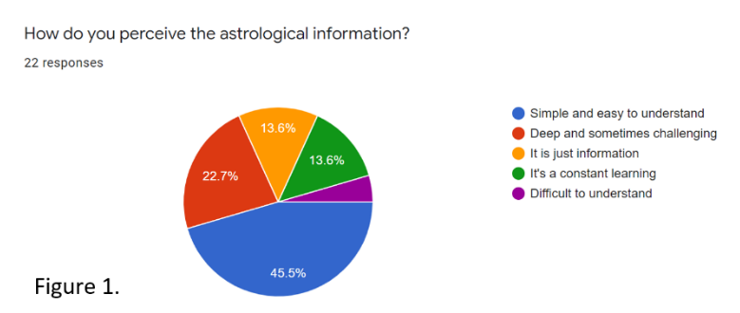
The nature of ‘astrology’ is such a complex field of information, and most textbooks on ‘astrology’, are more likely to use western-oriented descriptions, according to Campion. The diversity and meaning between cultural diversity and the stars, has no ‘one’ right approach, showing the complexity in this subject. The particular group was asked to give a personal view on astrological information, the results of which are shown in figure 1. Through analysing the questionnaire data (22 responses), the results suggest that the majority of 45,5% (10/22) recognise ‘astrology’ as a simple and easy subject. Only 13,6% (3/20) in this group, agree that astrology is ‘constant learning’. The analysis of qualitative data from the interviews revealed a further simplification of the subject. Four of five participants in the one-to-one interviewees, showed interest and familiarity, in only one of four astrological chart approaches, referring to natal astrology (Birth chart). The question was asked: ‘Could you give an example where you think astrological knowledge /wisdom has been of significant help?’
Respondent 3: ‘My personal birth chart allows me to understand and learn more about myself,…….’
Respondent 5: ‘My birth chart explains a lot in my opinion, to understand, what it means, to have my sun in the 12th house……..’
Respondent 4: ‘Yes, the birth chart provides and guides me around my daily life. My sun conjunction neptune, gives me the certainty of my sensitivity and intuition and my ascendent …….’
Respondent 1: ‘I do not know if I would consider it helpful but I could say that in my astral chart I have seen significant events of my life exposed in it..…’
This results support the research of Robert Wuthnow (2002) and M. Bauer & J. Durant (1997), which indicate that particpatnts are attracted to astrology for the external guidance it provides on life, rather than the wisdom that lies behind this. Campion and Matthew’s argument around astrology and the consequences of ‘prejudice’, find in this relation support, showing a simplified and limited approach, in terms of astrological knowledge. Overall, astrology in this group, seems to be understood in a limited form – it’s enjoyed for the personal reflection and entertainment it provides, rather than the more complex theory behind this.
Misguidance
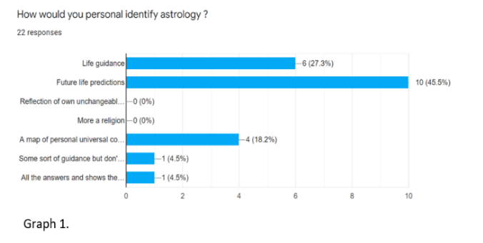
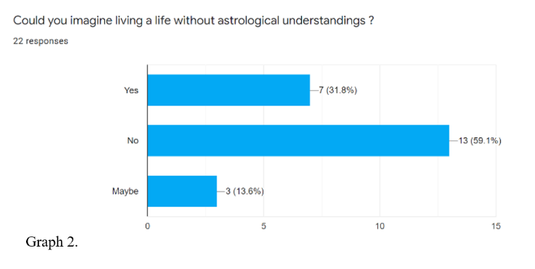
Astrology provides the opportunity to understand the impact of star constellations / planetary bodies on the individual, through a variety of charts, that should not be confused with life-predictions. This research assessed both the personal and collective ‘usage’ of astrology. First, the group was asked to answer how they personally view / identify astrology (graph 1.). The data revealed in graph 1. Illustrates that 45,5% (10/22) say that astrology is a ‘predicter’ of future events 33,8% (7/22) say it is ‘life guidance’ and 13,6% (3/22) refer to it as ‘a map of personal universal constellations’. The group was also asked if ‘life’ without astrology (and the meaning that it provides) could be possible (graph 2.) and the results suggest that these participants have a strong dependency on astrology and the knowledge that it provides (59,1% - 13/22).
Additionally, in the one-to-one interviews, the respondents were asked two questions relating to their use of astrology, the first being: ‘what motivates you regards astrology, what is your goal in this relationship?’. Three out of five respondents answered that astrology offers them “guidance” to anticipate future results based on astrological tools.
Respondent 1: ‘………to understand myself in a better way, being ready for what is coming as a life lesson.’
Respondent 2: ‘…….It helps me to understand my place on this planet, my birth date allows me to understand and overcome predicted challenges’.
Respondent 3: ‘I think we are all born with a connection to the stars, we all know what will happen, and we should listen to this predictions,……’.
The second question asked: ‘when was your first encounter with astrology and do you remember in what form?’. Three of five respondents referred to engaging with astrological charts and horoscope at a young age.
Respondent 1; ‘When I was very little, my mother and my aunt used to tell me about horoscopes and my sign, and I remember…….’
Respondent 2; ‘Yes , horoscopes, as a teenager in magazines. And then through an astrologer friend and little by little through social networks…….’
Respondent 3; ‘When I was little (around 10 years old) I used to read the horoscope in the magazines that were around my house, and sometimes information about the signs of the zodiac came out and that of my sign was very correct…..’
Summarised, data indicated in this particular group, an attitude of dependency through astrological knowledge, showing early life engagement with popular astrological tools (Horoscopes). It reflects the earlier mentioned study by W. Kelly (1997), suggesting that ‘astrology’ is not clearly defined, is interpreted in a limited way, and is not fully understood. Likewise, the research of N. Allum found similar results, suggesting a misinterpretation of astrological tools. Followers are more interested in horoscopes than astrology, Allum suggests that activity in this state is more of a leisure activity than a deep interest in the subject.

Two-sided view
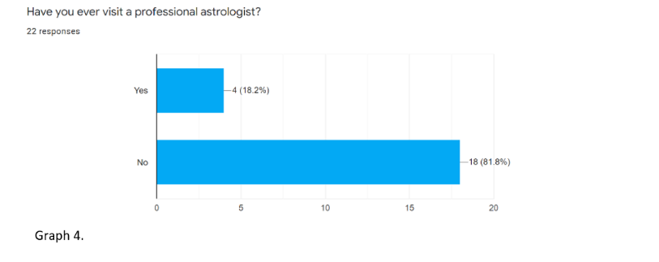
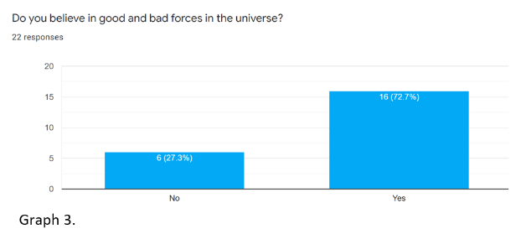
Astrology assumes a significant relationship between the stars, planets and events on earth. In this regard, astrology represents star constellations, celestial bodies, mathematical and geometrical order, excluding any good vs. bad dogmas. This research explored how participants viewed astrology and whether it was seen as a benign or hostile in nature. Participants were asked: ‘Do you believe in good and bad forces in the universe?’ (graph 3.) and the majority 72,7% (16/22) answered with ‘Yes’. Further, the question was asked; ‘Have you ever visit a professional astrologist ?’ (graph 4.) to which 81,8% (18/22) in this group, answered with ‘No’. Additionally, in the one- to- one interviews the participants been asked; ‘Do you believe in ‘good’ and ‘bad’ forces around astrology, if so, what exactly are they representatives?’ and four out of the five interviewees, responded with ‘Yes’.
Respondent 1; ‘Yes I do, for me the dispute between good and bad is not only present on earth, the sky and the stars, are the higher realm of similar events, in my opinion’.
Respondent 2; ‘Yes, I do. Many Hollywood movies around the stars, are involving more reality, that people might think, we are not alone……….’.
Respondent 3; Yes, just look around you, this world has its opposites, why should be other planets be without this universal dilemma……’.
Respondent 4; Of course, we are all here to learn and guide ourselves through the challenges of life in this universe, without it, nothing would make sense ….’.
The data suggests dualistic thinking in this particular group, from the collective and personal standpoint. Moreover, the questionnaire revealed the belief of a hostile view of the universe, reflecting personal interpretation behind the subject ‘astrology’. Nevertheless, in the one-to-one interviews the participants are confirming the belief of a hostile universe, however implying the chance of ‘personal growth’, demonstrating a slice of astrological knowledge. Overall, the lack of knowledge around astrology in this group, is significant (graph 4), reflecting a more two sided attitude, in terms of good and bad. Supporting studies by Robert Wuthnow (1976), which suggest the possibility of conventional religious nature between astrological teachings.

Conclusion
This research was conducted to identify and understand the astrological views of this group, from both a personal and collective standpoint, in relation to the true nature of cosmology and astrology. The results of the research identify three key themes: firstly, ‘simplification’ of the subject revealed that this group has limited insight with regard to knowledge and usage of cosmology and astrology. The majority in this group describe astrology as simple and easy to understand, although at the same time participants are only interested in a limited range of astrological tools (natal charts). The second theme, ‘misguidance’ observed in this group through the usage of charts, demonstrating a unconscious dependency on astrological tools. The members in this group indicated they believed astrological charts are a predictor for events, rather than a reflection of unconscious characteristics determined through the experience of objective astrological information. Finally, the third theme, a ‘two-sided-view’ of cosmology and astrology showed confusion as to the origin and purpose of the subject, limiting the opportunity of personal growth and inner freedom. Overall , the group showed limited awareness of detailed cosmological and astrological knowledge, using tools for predictions rather than self-development. Additionally, the research reflects the possibility of half-truths between individuals interested in the subject and the dissemination of information, resulting in a negative effect on credibility for astrology and cosmology. The complexity surrounding cosmology and astrology does not appear to be recognised or scientifically fully understood, either by scholars or interested individuals. Scholars are arguing about the subject of astrology and the real meaning from an ancient viewpoint. Whereas followers of astrology, appear to have taken limited ideas from ancient astrology, instead interpreting their own personal views for wider entertainment. However, it is likely that the facts behind the stars and planets in the universe, requires a more respectful approach to the discipline. The difficulty of the scientific research approach behind astrology does not guarantee the reliability of the subject, rather it should be viewed as something that is there to reveal complex facts and characteristics through the limited tools of science. Further studies might reveal more profound insights around the cause of ‘misinformation’ on this topic. The findings in this research conclude that ancient cosmological and astrological wisdom are a potential tool for self-development, however the test group here demonstrated limited knowledge on the subject.

Bibliography
Allum, Nick. 2010. “What Makes Some People Think Astrology Is Scientific?,” Papers.ssrn.com (Rochester, NY) <https://papers.ssrn.com/sol3/papers.cfm?abstract_id=1860385>
Appleby, Derek. 1985. Horary Astrology (Wellingborough: Aquarian Press)
Attride-Stirling, Jennifer. 2001. “Thematic Networks: An Analytic Tool for Qualitative Research,” Qualitative Research, 1.3: 385–405 10.1177/146879410100100307>
Bauer, Martin, and John Durant. 1997. “Belief in Astrology: A Social-Psychological Analysis,” Culture and Cosmos, 1.01: 55–71 10.46472/cc.0101.0211>
Braun, Virginia, and Victoria Clarke. 2006. “Using Thematic Analysis in Psychology,” Qualitative Research in Psychology, 3.2: 77–101 10.1191/1478088706qp063oa>
Campion, Nicholas. 2012. Astrology and Cosmology in the Worlds Religions, JSTOR (NYU Press) <https://www.jstor.org/stable/j.ctt9qg5q5.2>
———. 2016a. Astrology and Popular Religion in the Modern West : Prophecy, Cosmology, and the New Age Movement (London ; New York: Routledge, Taylor & Francis Group)
———. 2016b. “Cosmos / Cosmologies,” Vocabulary for the Study of Religion <https://referenceworks.brillonline.com/entries/vocabulary-for-the-study-of-religion/cosmos-cosmologies-COM_00000249>
———. 2017. “The Importance of Cosmology in Culture: Contexts and Consequences,” Trends in Modern Cosmology 10.5772/67976>
Campion, Nick. 2010. “Journal of Cosmology Home Page and Contents,” Journalofcosmology.com <http://journalofcosmology.com/>
———. 2012. “Astrology and Cosmology in the World’s Religions,” NYU Press <https://nyupress.org/9780814717141/astrology-and-cosmology-in-the-worlds-religions/>
Clynes, Frances, Nicholas Campion, and Rachel Casiday. 2015. An Examination of the Impact of the Internet on Modern Western Astrology () <https://core.ac.uk/download/pdf/96773669.pdf>
Darvill, Timothy. 2008. The Concise Oxford Dictionary of Archaeology (Oxford University Press) 10.1093/acref/9780199534043.001.0001>
Dwyer, Sonya Corbin, and Jennifer L. Buckle. 2009. “The Space Between: On Being an Insider-Outsider in Qualitative Research,” International Journal of Qualitative Methods, 8.1: 54–63 10.1177/160940690900800105>
Gunzburg, Darrelyn. [n.d.]. “How Do Astrologers Read Charts?,” Www.academia.edu <https://www.academia.edu/1320415/How_Do_Astrologers_Read_Charts>
Hellawell, David. 2006. “Inside–Out: Analysis of the Insider–Outsider Concept as a Heuristic Device to Develop Reflexivity in Students Doing Qualitative Research,” Teaching in Higher Education, 11.4: 483–94 10.1080/13562510600874292>
Hennink, Monique, Inge Hutter, and Ajay Bailey. 2015. Qualitative Research Methods (London: Sage Publications Ltd)
Kelly, I. W. 1997. “Modern Astrology: A Critique,” Psychological Reports, 81.3: 1035–66 10.2466/pr0.1997.81.3.1035>
Kiger, Michelle E., and Lara Varpio. 2020. “Thematic Analysis of Qualitative Data: AMEE Guide No. 131,” Medical Teacher, 42.8: 1–9 10.1080/0142159x.2020.1755030>
Komath, Manoj. 2009. “Testing Astrology,” Current Science, 96.12: 1568–72 <https://www.jstor.org/stable/24104881>
Kragh, Helge S. 2006. “Conceptions of Cosmos” 10.1093/acprof:oso/9780199209163.001.0001>
Matthews, Freya. 1994. “The Ecological Self,” Routledge & CRC Press <https://www.routledge.com/The-Ecological-Self/Matthews/p/book/9780415107976>
Radermacher, Lindsay. 2011. “THE ROLE of DIALOGUE in ASTROLOGICAL DIVINATION. Lindsay Radermacher. MPhil in Theology and Religious Studies. University of Kent at Canterbury - PDF Free Download,” Docplayer.net <https://docplayer.net/136837692-The-role-of-dialogue-in-astrological-divination-lindsay-radermacher-mphil-in-theology-and-religious-studies-university-of-kent-at-canterbury.html>
Ridder-Patrick, Jane. 2006. A Handbook of Medical Astrology (Edinburgh: Crabapple Press)
Rowley, Jenny. 2014. “Designing and Using Research Questionnaires,” Management Research Review, 37.3: 308–30 10.1108/mrr-02-2013-0027>
Rudhyar, Dane. 2015. Astrology of Transformation : A Multilevel Approach (Santa Fe: Aurora Press)
Thagard, Paul R. 1978. “Why Astrology Is a Pseudoscience,” PSA: Proceedings of the Biennial Meeting of the Philosophy of Science Association, 1978: 223–34 <https://www.jstor.org/stable/192639>
“What Are the Different Kinds of Astrology? | Horoscope.com.” [n.d.]. Www.horoscope.com <https://www.horoscope.com/us/editorial/faqs/editorial-faq-schools-of-astrology.aspx>
“Why Study Astrology with the Faculty? – Faculty of Astrological Studies.” [n.d.]. Faculty of Astrological Studies <https://www.astrology.org.uk/why-study-astrology/>
Williams, Katie. 2020. “U.S. Astrology App Revenue Grew 64.7% to Nearly $40 Million in 2019,” Sensor Tower Blog <https://sensortower.com/blog/astrology-apps-2019-revenue-downloads>
Wuthnow, Robert. 1976. “Astrology and Marginality,” Journal for the Scientific Study of Religion, 15.2: 157 10.2307/1385359>

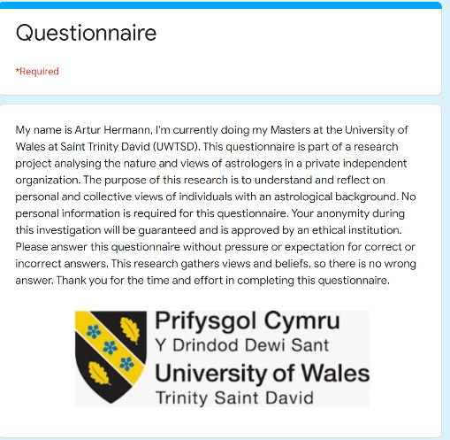
Appendix 1.

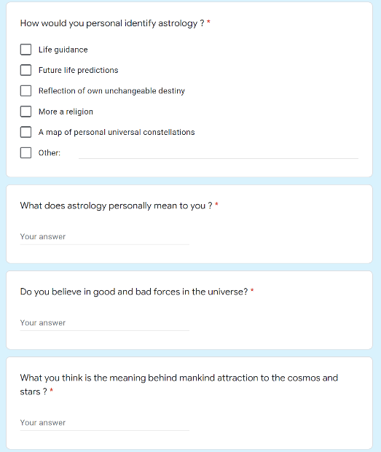

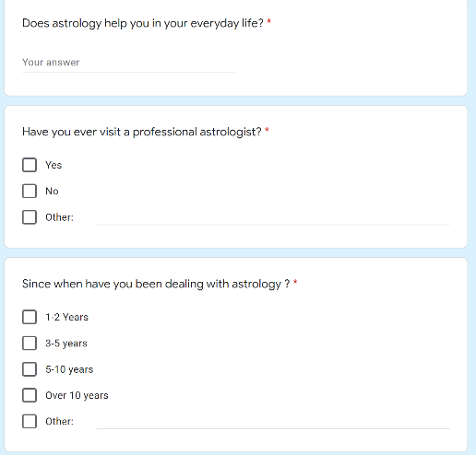
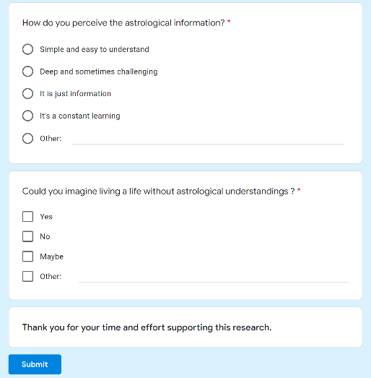

Komath, Manoj. “Testing Astrology.” Current Science, vol. 96, no. 12, 2009, pp. 1568–1572. JSTOR, www.jstor.org/stable/24104881.
William, Katie. 2020. “U.S. Astrology App Revenue Grew 67.7% to Nealry $40 Million in 20019,” Sensor Tower Blog< https://sensortower.com/blog/astrology-apps-2019-revenue-downloads
“Horoscope.com”, https://www.horoscope.com/us/editorial/faqs/editorial-faq-schools-of-astrology.aspx
Thagard, Paul R. “Why Astrology Is a Pseudoscience.” PSA: Proceedings of the Biennial Meeting of the Philosophy of Science Association, vol. 1978, 1978, pp. 223–234. JSTOR, www.jstor.org/stable/192639.
Campion, N. 2012. “ Astrology and Cosmology in the World’s Religions”.
Mathews, Freya, 1994.”The Ecological Self, p. 109.
Kragh HS. Conceptions of Cosmos. From Myths to the Accelerating Universe: A History of Cosmology. Oxford: Oxford University Press; 2007. p. 1.
Nick Campion, 2017. “The Importance of Cosmology in Culture: Contexts and Consequences”.
Campion N. Cosmos and Cosmology. In: Segal R, Stukrad K, editors. Vocabulary for the Study of Religion. Leiden: Brill; 2015. pp. 359–364.
Darvill T. Archaeology. In: Concise Oxford Dictionary of Archaeology. Oxford: Oxford University Press; 2008.
Mathews, Freya,1992.” The Ecological Self, p. 109.
Campion, N., Astrology and Cosmology in the World’s Religions, p.p. 1-10.
Campion, Nicholas, 2012. “Astrology and Cosmology in the World’s Religions”. Chapter 1p. 6.
Ibid.
Campion, Nicholas, 2012. “Astrology and Cosmology in the World’s Religions”. Chapter 2, p.11
Nick Campion, 2017. “The Importance of Cosmology in Culture: Contexts and Consequences”, chapter 1.
Campion, Nicholas, 2010. “Astronomy and Psyche in the Classical World: Plato, Aristotle, Zeno, Ptolemy,” Journal of Cosmology 9, http://journalofcosmology.com/ AncientAstronomy118.html.
Campion, Nicholas, 2012. “Astrology and Cosmology in the World’s Religions”. Chapter 2, p. 15.
Rudhyar, Dane, 1980.‘The Astrology of Transformation: A Multilevel Approach.’ Wheaton: Theosophical Publishing House.
Wuthnow, Robert. “Astrology and Marginality.” Journal for the Scientific Study of Religion, vol. 15, no. 2, 1976, pp. 157–168.
Campion, Nicholas. Astrology and Cosmology in the World’s Religions. NYU Press, 2012. Chapter 2
Lindsay Radermacher, 'The Role of Dialogue in Astrological Divination', chapter 1.
Claire Chandler, "What Is Astrology?," www.clairechandler.com/astrology/what-isastrology.
"Why Study Astrology?," Faculty of Astrological Studies, http://www.astrology.org.uk/why-study-astrology/.
Nicholas Campion, 2014.” Astrology and popular religion in the modern West : prophecy, cosmology, and the New Age movement”, chapter 11.
Jane Ridder-Patrick, 2006. “A Handbook of medical astrology”.
Frances Clynes, 2015. “An Examination of the Impact of the Internet on Modern Western Astrology”, chapter 5.
Derek Appleby, 1985 .“Horary Astrology”, Wellingborough: Aquarian Press,p. 9
Frances Clynes, 2015. “An Examination of the Impact of the Internet on Modern Western Astrology”, chapter 5.
Wuthnow, Robert. “Astrology and Marginality.” Journal for the Scientific Study of Religion, vol. 15, no. 2, 1976, pp. 157–168.
Nick Allum, 2010. “What Makes Some People Think Astrology is Scientific?”, p.p. 1-26.
M. W. Bauer, J. Durant, 1997.“ Belief in Astrology: a social-psychological analysis”.
Kelly I. W., 1997. “Modern Astrology: A Critique”.
Komath, Manoj. “Testing Astrology.” Current Science, vol. 96, no. 12, 2009, pp. 1568–1572.
Darrelyn Gunzburg, “How do astrologers read charts?”
Jenny Rowley, 2014. "Designing and using research questionnaires," vol. 37(3), pages 308-330
Hennink, Hutter, Bailey, 2015. “Qualitative research methods”.
Johnson, R. Burke, and Anthony J. Onwuegbuzie. “Mixed Methods Research: A Research Paradigm Whose Time Has Come.” Educational Researcher, vol. 33, no. 7, 2004, pp. 14–26
“Kriger, Varpio, 2020.”Thematic analysis of qualitative data: AMEE guide no. 131”, Pages 846-854.
Attride-Stirling, Jennifer, 2001. “Thematic Networks: An Analytic Tool for Qualitative Research.” p.p. 385–405
Braun V, Clarke V. 2006. Using thematic analysis in psychology. Qual Res Psychol. 3(2):77–101.
Hellawell, D. (2006). Inside-out: Analysis of the insider-outsider concept as a heuristic device to develop reflexivity in students doing qualitative research.
Dwyer, Sonya Corbin, and Jennifer L. Buckle. “The Space Between: On Being an Insider-Outsider in Qualitative Research.” International Journal of Qualitative Methods, Mar. 2009, pp. 54–63,
Campion, Nicholas, 2012. “Astrology and Cosmology in the World’s Religions”. chapter 2, page 12
Ibid.
Wuthnow, Robert. "Astrology and Marginality." Journal for the Scientific Study of Religion15, no. 2 (1976): 157-68. JSTOR
Bauer, Martin, and John Durant, 1997. “Belief in Astrology: A Social-Psychological Analysis.” Culture and Cosmos, 55–71.
Campion, Nicholas, 2012. “Astrology and Cosmology in the World’s Religions”. Chapter 1.
Mathews, Freya, 1991.” The Ecological Self” , p. 112.
Campion, Nicholas, 2012. “Astrology and Cosmology in the World’s Religions”. Chapter 2.
Kelly I. W., 1997. “Modern Astrology: A Critique”.
Campion, Nicholas. Astrology and Cosmology in the World’s Religions. NYU Press, 2012. Chapter 2
Ibid.
Bauer, Martin, and John Durant, 1997. “Belief in Astrology: A Social-Psychological Analysis.” Culture and Cosmos, 55–71

