
Module Name: Academic Skills in the Digital Era
Module Code: BMSW4013
Assessment 1:
Student Name: Marie Sugarova
Student Number:2531367
Lecturer:
Deadline: 27.02.2026

Wordcount: 1500
AI Acknowledgement

I confirm that I have not presented any AI generated materials as my own work.
I confirm that I have copies of my drafts, notes, and other resources I used, which I may be asked to provide in evidence.
Contents
Component 1 Development of Academic Skills…………………………………………………….4
Source 1,CRAAP test……………………………………………………………………………………….4
Source 2.CRAAP test…………………………………………………………………………………………5
Synthesis of academic sources………………………………………………………………………5-6
Challenge and opportunity ………………………………………………………………………………..6
Academic planning component 2………………………………………………………………………6
Timeline………………………………………………………………………………………………………….6
Reference list component 1……………………………………………………………………………….7

Component 2 Application of Academic Skills……………………………………………………..8
Introduction………………………………………………………………………………………………….8
Challenge……………………………………………………………………………………………………..8
Opportunities………………………………………………………………………………………………8-9
Three strategies…………………………………………………………………………………………….9
Conclusion…………………………………………………………………………………………………9
Reference list component 2………………………………………………………………………….10
component3……………………………………………………………………………………………….11 academic…. poster………………………………………………………………………………………11
reference list for component 3……………………………………………………………………12

Component 1 – Development of Academic Skills
Source 1
Authors and year Al-Sharman, A,Shalash,R.J.,Omran,T.A.M.,Elsayed,R.M.,Warfa,I.A.,Aldawi,W.S.E.A.,Aljaberi,A.O.,Alabdooh,A.A.,Arumugam,A.,Ramakrishnan,S.,Saad,N.,Ahbouch,A.,Issa,W.B.,Hijazi,H.,Kim,M.,Hegazy,F.,Nashwan,A.(2025)
‘Exploring the impact of note taking methods on cognitive function among university students’,
University library vol.25(1), p.1218-8
Using the CRAAP Test,
This article was published in 2025 and its recent source, no updates.
It relates to my topic shows how digital technology effect students learning. Academic use for lecturers, students and experts. Organisation behind the source is BMC Medical Education well know publisher that prints academic work checked by experts. Authors hold high qualifications PhD- Doctor of Philosophy and MD- Medical Education. Experiment that been done between students taking notes on paper and notes on laptop shows that paper notes are more executive for students’ brain to process, analyse and learn topic faster. The source is supported by many other authors cite this work. There is no spelling or grammar errors. This article was created to inform experts, students and lecturers how notetaking on paper compare computer notes can impact students’ ability to learn, remember and focuses. It doesn’t present clear bias. Authors present evidence mainly based on female precipitate.
Al.Sharmen, et al. (2025).’Exploring the impact of the note-taking methods on cognitive function among university students’, Medical Education,25(1), Article1218.
http://doi.org/10.1186/s12909-025-07593-x

Source 2

Cojean,S.,Grand,M.(2024)

‘Note-taking by university students on paper or a computer: strategies during initial note-taking and revision’,
University library vol.94, issue 2, p.557-570(14)

Using the CRAAP Test,
This article was published in 2024 and has not been updated. Information this article is up to date. The source showed that students taking notes writing in their own words on paper, concentrate more compared to students using laptop. This article is for academic use students, professors. Authors are Salamo Cojean and Manon Grand both have PhD very high qualifications. Published by British psychological society. The source is supported by evidence based on the experiments that has been done. To inform students and peers. This article is clear bias balanced and objective. Authors presents evidence fairly.
Salome,C. et al.(2024)’Note-taking by university students on paper or a computer:Strategies during initial note-taking and revision’.British Journalof Educational Psychology,92(2),pp.557-570.https://doi.org/10.1111/bjep.12663.

Synthesis of Academic Sources

Cojean and Grand (2024) and Al-Sharmen et al. (2025) focused on how different note taking methods effect students in higher education.
Cojean and Grand (2024) Study students preferred note taking method, what students do while taking note during a lesson, the process of note taking and how students approach revising their notes later.
Al-Sharmen et al. (2025) shift the study more to student’s brain ability to process and remember the information’s while taking note.
Both studies agree laptop note taking can be faster but it less effective when it comes to learning.
Combinations of both sources gives deeper understanding to strategies of learning knowing which methods work the bests and implying the right method. Analysing, thinking and summering comes more naturally by handwritten notes studying become much more effective students tent to remember more due to actively using a brain Cojean and Grand (2024) and Al-Sharmen et al. (2025).

Identifying a Key Challenge and Opportunity
Al-Sharman et al. (2025) based on experiment students get opportunity to gain knowledge on how brain process, learn and remember information. Using four different tasks to analysed students learning ways. Study showed students writing note scored higher in faster processing and remembering task than students taking digital notes.

It can be very challenging for students to use the right tools when it comes to digital or paper notes. Students believe their prefer method is the best chose without considering the effect of active learning not just passive one. Many studies show that written notes on paper can lead to faster remembering the task (Cojean and Grand 2024).

Academic Planning for Component 2
Component 2 Introducing digital learning in higher education will highlight research how is important for students to understand the challenges and opportunities in digital world, then reviewing some useful information’s on strategies showing positive access to knowledge. All evidence is supported by scholar research and analysed by professionals for maximum standard. Helping students to identify and develop essential academic skills team working skill, digital literacy skill, critical thinking and navigation skills. The report layout will be introduction followed by challenges and opportunities, strategies for success then conclusion.
Timeline
Task | Date/ Deadline
Finish research | 13.02.2026
Draft first section | 17.02.2026
Complete first draft | 22.02.2026
Final editing | 27.02.2026

Reference List – Component 1
Cojean, S. and Grand, M. (2024) “Note‐taking by university students on paper or a computer: Strategies during initial note‐taking and revision,” British journal of educational psychology, 94(2), pp. 557–570. Available at: https://doi.org/10.1111/bjep.12663.

Al-Sharman, A. et al. (2025) “Exploring the impact of note taking methods on cognitive function among university students,” BMC medical education, 25(1). Available at: https://doi.org/10.1186/s12909-025-07593-x.

Component 2 – Application of Academic Skills

Introduction
Digital learning in higher education has rapidly changed over the years. Now in days digital technology plays big part in students live more than ever and can cost some distractions on the academic journey. Considering the challenges and opportunities, digital world offers it important for students to gain knowledge of the powerful tools and be able to master it for their best benefit. It’s essential for students to believe in power of note taking for their studies.
The central theme of this essay are challenges, opportunities for scholars in digital world. Presented by academic research and explored with several surveys. In conclusion, adding tips of positive opportunity and negative outcomes.
Challenges
One of the digital challenge students facing is using devices for non – related lecture purposes sending, receiving messages. Students who type note in laptop are more likely to multitasking, that can lead to distractions and potentially lack of note taking during a class. Which can be crucial for students understanding the lecture (Flanigan and Titswoth 2020).
Online classing can be very challenging for students, independent learning making right decision wherever notes taking its necessary, considering that students can access the lecture as it being online any time. Survey findings showed that 58 students out of 107 students do not take any type of notes in online classes (Morehead et al. 2019).
Classroom discussion highlighted the importance of note taking during a class it help students to learn and improve their ability to understand the specific topic they study.
Opportunities
Digital technology developing extremely fast, students have chance to explore many unique features technology offers from digital library, online support, educational videos and games, connecting with one another. Online educational games become very popular all over the world. Students find more positive approach towards digital learning, 38.58% students become greatly motivate due to online games learning. Encouraging students to actively involve themselves in a new exciting academic digital environment (Li and Deng 2024).
Beside all opportunities digital technology offers its importance to expand basic skills set, many students lacking in effective notes taking techniques skill and would like to get additional training including how to effectively organise notes (Morehead et al. 2019) Therefore, students will benefit from and have great impact on them. Increasing note taking skills to the next level will motivate students to take notes during class making learning will become more clearer, easier to study, less stressful and more fun.
THREE strategies
Students should get familiar with their university online platform to fully understand all the built-in features and helpful tools provided. It will help them to easily navigate through give them some knowledge for example how to submit homework and founding right materials for they study. Students will gain digital literacy skill as well as navigation skills. Understanding how the platform work and where may need to be improved it beneficial for all users it’s a big opportunity for students to collaborate in possible improvement (Songkram et al.2023).
The positive effect on to students learning is that they are well organised this can be due to time planning, creating note in calendar, dividing the task in smaller sections frames and work from the most urgent one. Building positive attitude towards digital technology, can develop students when engaging online world improves self-confident, reduce social and emotional disconnections helping students to connect and gain team working skill which its essential in academic environment (Getenet et al.,2024).
Strategies students can use to succeed is practising active critical thinking by asking questions the author purpose, analysing arguments and founding evidence. Understanding the proses of learning, how to learn not just what to learn. Students will gain critical thinking skills. Opportunity to really understand difficult text and fix problem like bias or confusing facts by checking arguments and founding proofs (Cottrell, 2023).
Conclusion
In conclusion due to technological devices being used on students educational journey it has provided positive and negative impact on students. Comes with a huge opportunity for students’ wide access to knowledge not just classroom base learning but also online material from books to more advanced way of studying. A combination of tutorials and educational games make learning exiting students have greater chance to found what learning technic is most beneficial. One of the negative challenges students facing in digital world is distraction the temptations to check social media replay to text message during lesson. In summary its essential for students in higher education to master digital literacy skills by fully understanding university platform, navigating academic needs and implying organisation habits most importantly critical thinking help students to analysed text and verify evidence. With all the opportunities and challenges digital technology offers students must handle and minimalised multitasking which potentially decrees digital distraction on students.
Reference List – Component 2

Cottrell, S. (2023) ‘Critical thinking skills: effective analysis, argument and reflection’. Fourth edition. London: Bloomsbury.

Li, Y. et al. (2024) “The impact of digital educational games on student’s motivation for learning: The mediating effect of learning engagement and the moderating effect of the digital environment,” vol. 19(1), p. e0294350. Available at: https://doi.org/10.1371/journal.pone.0294350.

Flanigan, A.E. and Titsworth, S. (2020) “The impact of digital distraction on lecture note taking and student learning,” Instructional science, 48(5), pp. 495–524. Available at: https://doi.org/10.1007/s11251-020-09517-2.

Getenet, S. et al. (2024) “Students’ digital technology attitude, literacy and self-efficacy and their effect on online learning engagement,” International Journal of Educational Technology in Higher Education, 21(1). Available at: https://doi.org/10.1186/s41239-023-00437-y.

Morehead, K. et al. (2019) “Note-taking habits of 21st Century college students: implications for student learning, memory, and achievement,” Memory (Hove), 27(6), pp. 807–819. Available at: https://doi.org/10.1080/09658211.2019.1569694.

Songkram, N. et al. (2023) “Success Factors to Promote Digital Learning Platforms: An Empirical Study From an Instructor’s Perspective,” International Journal of Emerging Technologies in Learning (iJET), 18(9), pp. 32–48. Available at: https://doi.org/10.3991/ijet.v18i09.38375.

Component 3 – Academic Poster

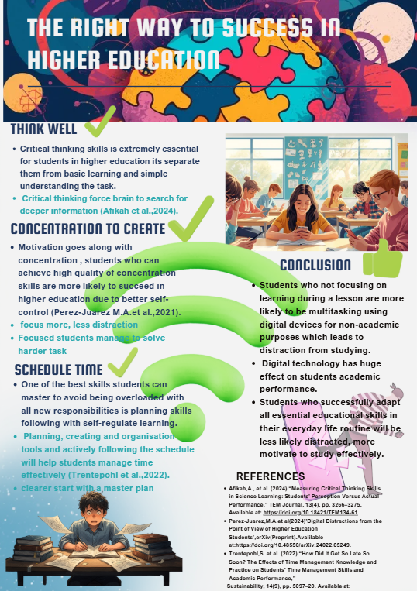

Reference List – Component 3
Afikah, A., et al. (2024) “Measuring Critical Thinking Skills in Science Learning: Students’ Perception Versus Actual Performance,” TEM Journal, 13(4), pp. 3266–3275. Available at: https://doi.org/10.18421/TEM134-61.

Pérez-Juárez, M.Á. et al. (2024) “Digital Distractions from the Point of View of Higher Education Students.” Available at: https://doi.org/10.48550/arxiv.2402.05249.

Trentepohl, S. et al. (2022) “How Did It Get So Late So Soon? The Effects of Time Management Knowledge and Practice on Students’ Time Management Skills and Academic Performance,”Sustainability, 14(9), pp. 5097–20. Available at: https://doi.org/10.3390/su14095097.

