Liam Joeseph Berner
1706870
HND Construction Management
Learning Contract Submission 1
Work Based Project
Ceredigion Sustainable Development
Peter Egan, 07720155434
ACBA5009

My role within the company where I am experiencing elements of my work- based project is as a part time assistant construction site manager. The company operates as a private development company in mid-Wales. The company buys land and develops sites for new domestic housing. All the developments projects undertaken by the company include the minimum provision of affordable housing as per the legal requirements of the Section 106 agreements (A) these agreements apply to each individual development site.
My first experience on site with the company in my current role has been the drainage system to nine number domestic dwellings. All the drainage work carried out on the nine dwellings has been in the curtilage of each plot and not in areas affected by the Section 104 and Section 38 agreements (B). The layout of the roads and drainage system can be seen in appendix (1). Evidence of the work undertaken with my involvement can be seen in appendix (2 to 5). This work required my involvement with the setting out of the levels required for the new pipe-runs and manholes. The drainage as installed in the photographic evidence in appendix was installed at levels agreed from drawings prior to the foul drainage system having been completed in the road.
Initially it was expected I would be involved on the setting out of the estate road extension including extending the existing foul water and surface water systems being built as required by Suds regulations (C). All the elements of this work were part of statutory agreements applicable to the site (for example, Section 38). The delay to the road and drainage system extensions was caused by a discrepancy between the agreed layout of the road as part of the section 38 agreement and the plan of the works lodged with the land registry. This discrepancy meant that an electronic satellite survey was required to be carried out in agreement with the land registry. The agreement of the exact position of the road layout is critical for the local authority to adopt the road and drainage in the future. If the road is not on land that is part of the section 38 and 104 agreements the local authority would not complete the adoption process. The adoption process is whereby the estate road and drainage become maintainable by the local adopting authority rather than the residents of the estate being liable to maintain the roads and drainage in the future.
The drainage works carried out required the use of a five-ton tracked digger and a five-ton dumper to complete the excavation of the trench runs. The trenches were marked out and dug as per the architects and Civil Engineers companies’ drawings. The pipework laid into the trenches was 100mm plastic surrounded by pea gravel as can be seen in appendix (1). During the time of my involvement on site the works being carried out would have implications on the health and safety company procedures and operations. An example of this is can be seen in appendix (2), whereby the depth of the trench dig could have an impact on the risk assessment for the drainage works that had been carried out. A risk assessment under ‘health and safety at work regulations’ can be defined as the identity of what hazards exist in the workplace and how likely any hazards identified are to cause harm. (HSE, Work Regulations 1999). If the trench dug was of sufficient depth, guard rails would have been required around the top of the excavations to prevent anyone falling into the excavation and being injured (HSE, high risk activities 2013). The guard rails would be a requirement if the trenches were of sufficient depth as the drainage installed requires a minimum of 24 hours’ notice for inspection by building control before the trenches can be backfilled.
The drainage system of the nine houses in appendix (1 to 5) requires a completion date prior to the 28th of February 2020. After this date, six of the nine houses are programmed to be transferred to new owners. The three remaining detached houses on completion are part of a sales and marketing open day whereby the selling agents acting for the development company will invite members of the public to the site who they consider potential purchasers. The company site manager and company director informed me that in the past the company has achieved at least fifty percent of the sales on site today by having open days where invited members of the public view completed properties. The company site manager also confirmed that a majority of the communication with potential purchasers is made initially online in the form of email.
The development company itself is a small private limited company, all areas of the day to day running of the company requires all the assets owned be they physical or financial are part of the output of the company. The company has a financial director, project manager, construction site manager, site foreman and various employed operatives and subcontractors all of them being part of the day to day running of the company.
The drainage system I am involved with installing requires the use of Computer Aided Design (CAD), used by the Civil engineers advising the company and dealing with the local authority for the adoption of the road and drainage systems. The drawings as supplied for each house have been drawn using CAD by the architects, these drawings include dimensions and levels required to adjoin to driveways, footpaths and roads. On site I have been using a laser level as can been seen in appendix (2 to 5), there is also the use of laptops and tablets by team members on site.
The work placement I have with the company requires that I spend one day a week in attendance on site to be involved in the processes required to complete the works relevant to the section 38 and section 104 adoption agreements. My agreement with the company is that I will attend for eight hours on every Friday until my work-based project module is completed.

Word Count: 1011

Appendix:
1)
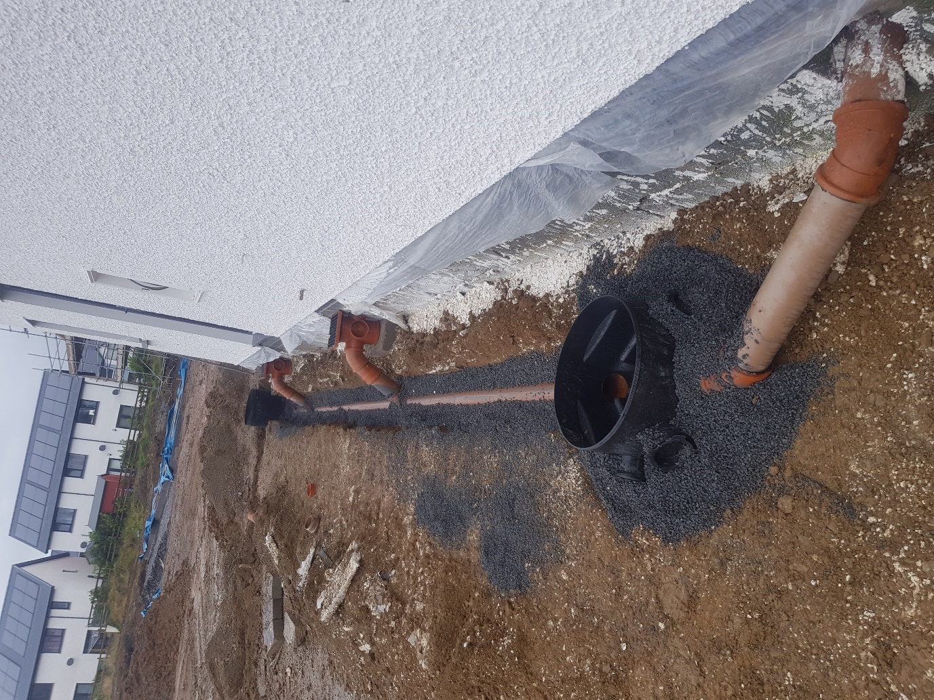

2)
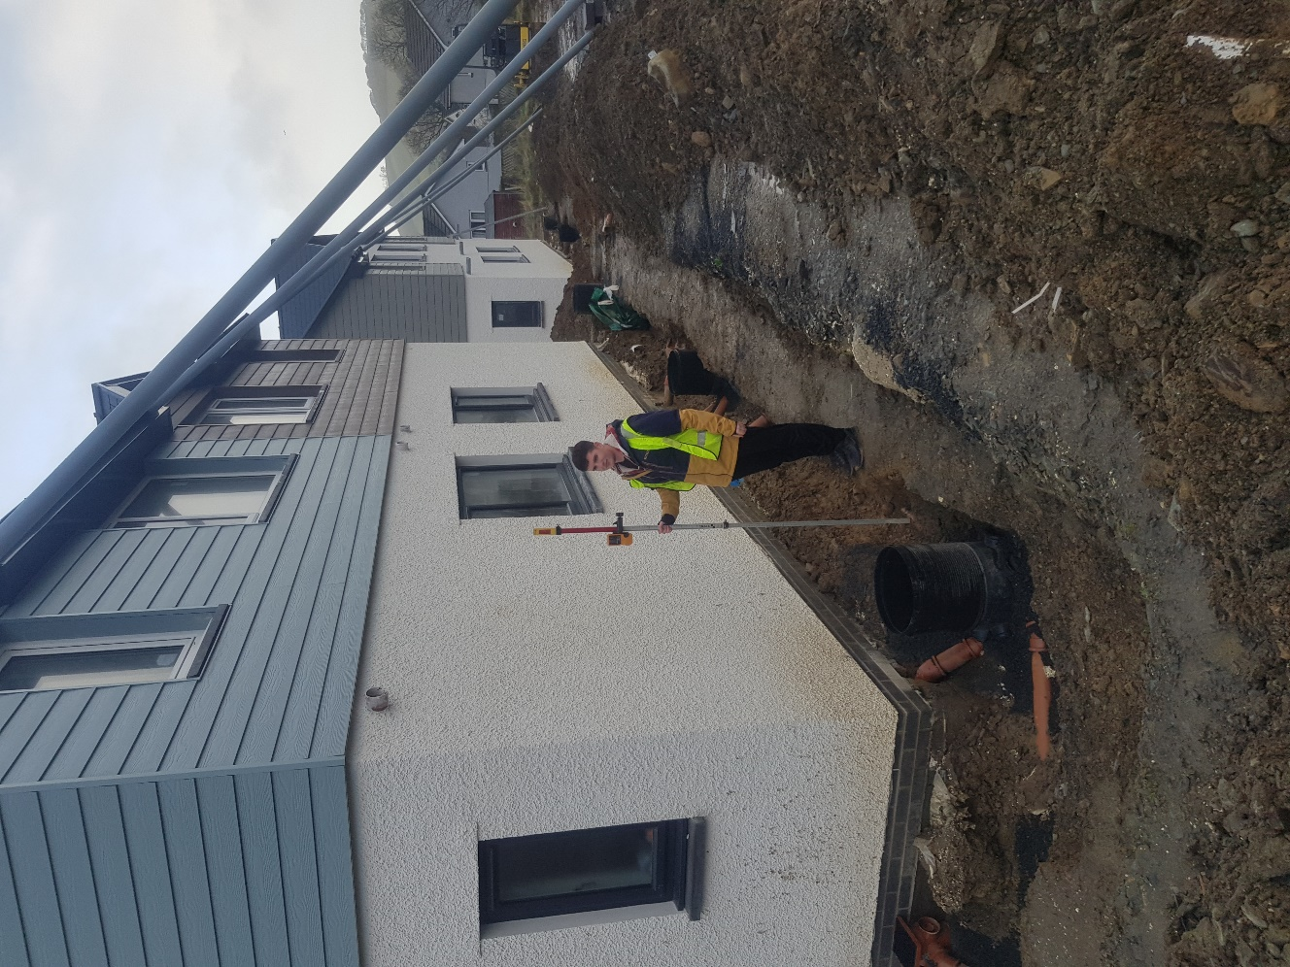

3)
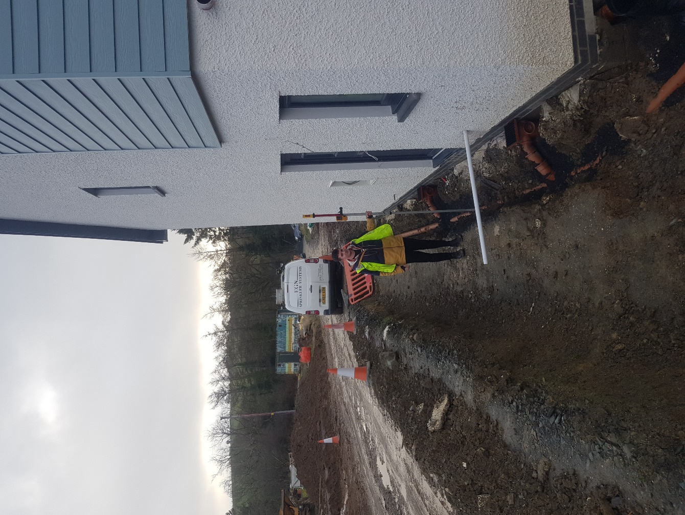

4)
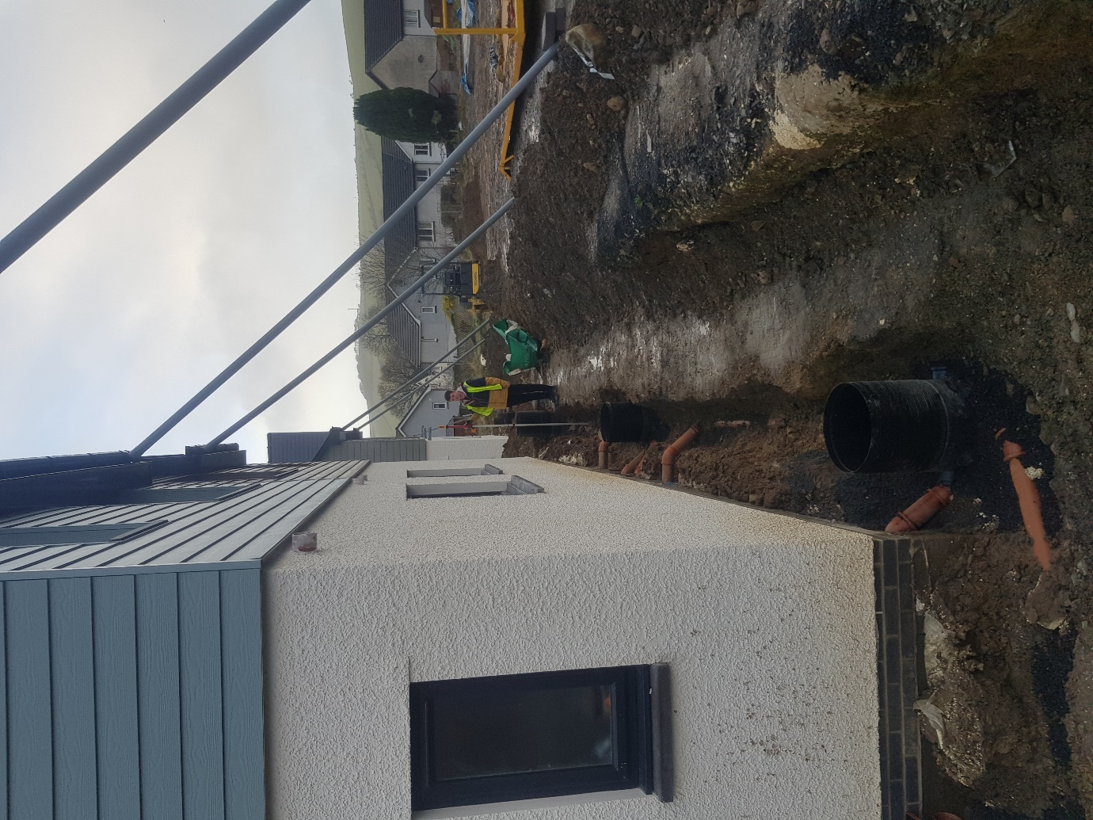

5)
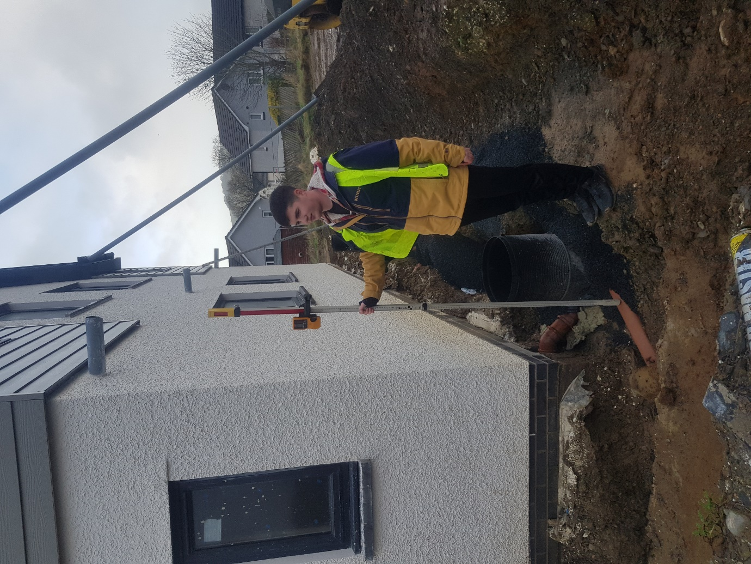

Reference List:
A)
https://www.gov.uk/guidance/planning-obligations - Section 106
B)
https://www.assembly.wales/Research%20Documents/QG15-007-Planning-Section%20106%20agreements/QG15-007.pdf - Section 104 Agreements
https://www.ceredigion.gov.uk/your-council/about-the-council/pay-policy/ - Section 38
C)
https://gov.wales/sites/default/files/publications/2019-06/statutory-national-standards-for-sustainable-drainage-systems.pdf - Suds Regulations

