BMIH5007
Financial Management for the Hotel Industry
Business Report- Comparison of Two Hospitality Organisations
Shahekur Rahman
2210706
Jaliya deSilva
Word Count: 1935

Executive Summary
This report analyses the financial performance and sustainability of two very popular hotel brands. Research is carried out on the 5-star Corinthia hotels and the budget friendly hotel Ibis hotels, specifically the critical areas which impact the financial performance of both hotels, this includes researching on their total revenue, market performance, brand reputation and corporate social responsibility. The findings are compared and evaluated to see how two very different hotels are impacted by these and concluded in the end. Recommendations are made to improve financial management in the future.

Content Table
Introduction…………………………………………………………………………………… 04
Revenue Analysis…………….………………………………………………………….…... 05
Market Position & Growth Potential …………………………………………………….…. 06
Corporate Social Responsibility.………………………………………………………….… 07
Conclusion ……….…………………………………………………………………….…….. 08
Recommendations…………………………………………………………………………… 08
References …………………………………………………………………………………… 09

Introduction
Due to the unpredictability of the hotel industry, accounting and financial management are particularly crucial for enterprises in this sector. In order to remain strong during slow business times, you must effectively manage your money, regardless of any shifts in trends or seasonal variations in demand. The hospitality industry's best practices for financial management include developing an annual budget, a comprehensive financial monitoring model, conducting regular audits, and setting up a reporting framework that makes it easier for managers to monitor profit and loss data (Yvanovich, 2023). Research has been carried out on two major chains of hotels. Both hotels have their own strategies and also target separate audiences. The Corinthia hotels are part of the Corinthia Group, which trades as International Hotel Investments PLC., the holding company for the Group. Established in 1962 by the Pisani family from Malta, it currently stands for classic elegance in some of the most renowned cities and locales worldwide. (Corinthia, 2024). It is dedicated to upholding family values via kindness and excellent service, and it includes nine hotels. In addition to realizing how crucial hospitality is to satisfying every sense. The other hotel this report focuses on is the Ibis Hotel. The hotel holding company AccorHotels is the owner of the global chain of Ibis hotels. Founded in 1967, AccorHotels is traded on the Paris Stock Exchange. In Bordeaux, the first Ibis Hotel debuted in 1974. The Ibis Hotel chain spread throughout France in less than ten years, mostly in the cities. The hotels are typically found close to airports, train stations, and city centres. In addition, there are currently 1,152 Ibis Hotels spread over 65 nations and 6 continents (Ibis, 2021). An assessment of their financial situation and pinpointing the most important patterns and aging data will guide the hoteliers to make wise business decisions in the future. In addition to keeping a check on the labour, supervising employees, and managing visitors, it’s imperative that they strike a balance when it comes to effectively managing finance.

A review of the finance management will allow hoteliers to come up with a strategy to tackle any shortfalls. It entails carefully arranging how the company will spend and earn revenue. The well-thought-out financial plan should guide all financial decisions, including creating budgets and taking out loans.
Revenue Analysis
The Corinthia Hotels revenue has shown inclines and declines over the last 5 years this is due to the Covid- 19 pandemic. However, since 2022 the revenue has increased. As seen on figure 1 below, the group's overall revenues increased by 30% to €124.8 million from €95.8 million during the same period the previous year. The 2023 interim report, which notes that the Omicron variant had an impact on the first few months of 2022, is the first report that has not been affected by direct performance limitations because to Covid. The first half of 2023's total revenues have reached 95% of the pre-pandemic levels recorded during the same period in 2019. Most operations' revenue is comparable to that of 2019, with London leading the way with an increase of €6 million over 2019. Hotels reliant on conference business are recovering more slowly than anticipated, which makes sense considering the lengthy lead time that bookings for this market sector often require (Pisani & Caruana, 2023).
Figure 1: Corinthia- Financial Report (Half Year 2023)
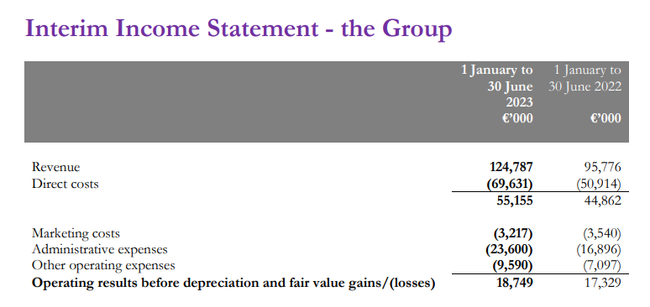
With the aid of the newest technologies such as IDeaS G3 system, Corinthia's yield and revenue management system directs their hotels' segment and sub-segment selling decisions about room rates with the goal of driving the highest room rates and high occupancy levels.
The Accor Group reported a 35% increase in first-half revenues to €2.4 billion (Percival, 2023). The Group's revenue in 2022 was €4,224 million, an 80% increase like-for-like (LFL) over FY 2021. This increase can be divided into two categories: hotel assets and other (63%) and hotel services (89%) (Press Accor, 2023).
Figure 2: Accor Group Half Year Revenue Report (2023)
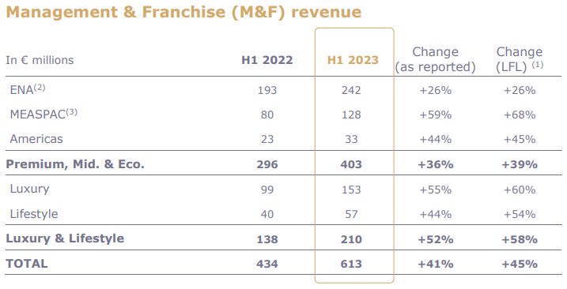
It is evident from both financial reports that the revenue has significantly increased in 2023 in comparison 2022. This is due to consumers demands increasing since the Covid- 19 pandemic.
Both hotels must plan ahead for a crisis like this in the near future because they ma never when the world may have to go in to lockdown. The current situation with inflation and conflict between Russia and Ukraine could be another threat to the industry and therefore they will need to come up with a crisis plan on how to tackle this.

Market Position
The term "hotel market positioning" describes how your business has established a distinct identity in the minds of consumers and sets itself apart from the guest experiences provided by your rivals. The more prominently you place yourself, the more probable it is that visitors will make a reservation and stick around as regular clients.
Although both hotels belong to the same industry, Corinthia Hotels is a luxury brand and it is marketed to the rich and more wealthier people who can afford the high-end luxury, they have only a number of hotels in comparison to Ibis but are located in popular tourist attracted cities. TripAdvisor users have rated the Corinthia London with a total of 3797 reviews, yielding a score of 5 out of 5 (US News, 2023). On the other hand, Ibis Hotels are an economically friendly hotel, they are located in nearly every other town and appeal to all because it is affordable and they are simply selling a good night stay. The acquisition of the Corinthia brand has shown to be a crucial component of the Group's plan to profit from the Corinthia brand's repositioning as a high-end, worldwide hotel brand (Mohnani, 2023). Corinthia focuses on targeting wealthy audience and popular cities, whereas, Ibis is targeting all kinds of consumers and their hotels are scattered in multiple locations which allows people to commute for business, travel and leisure. This makes it more convenient and more popular amongst the consumers.

Growth Potential
With 20 hotels opened and 16 properties signed under the ibis Styles brand in 2023 to date, Accor, a global leader in the hospitality industry, shows the strong portfolio expansion and development momentum of its ibis Styles brand in Europe (HN, 2023). The two new hotels by the shore represent a combined investment of over £70 million. This newest addition to the brand's UK collection, which represents a £30 million investment in the region, promises to completely transform South Devon's commercial and leisure scene (Turner, 2024). With these most recent additions, the portfolio of ibis hotels in the UK and Ireland will now stand at 119, with 64 ibis hotels, 33 ibis budget hotels, and 22 ibis Styles hotels (Hospitality On, 2023).
Future openings for Corinthia hotels include seven more in prestigious cities like Riyadh, New York, and Rome. Once again, they have chosen locations in popular tourist cities, which has a demand for the wealthy consumers. They have appointed Industry heavyweights to lead the opening of their new properties in Rome, New York, and Brussels (Rokou, 2023). Talent shortage is an issue in the hospitality industry, by recruiting well known leaders, the hotelier has promoted and attracted more desirable audience.
Opening more hotels will mean expenditures will increase and keeping an eye on costs is essential. In the long run however, this will mean they own more assets and more revenue from the sales of rooms.
Financial Commitment to Corporate Social Responsibility (CSR)
The capabilities of the business can be used to measure the sustainability of the hotel (Getz & Page, 2016). The hotel's capabilities are linked to shifts in the industry's present trends and in traveller’s viewpoints when they purchase hospitality services.
Being a significant player in the hospitality sector, Ibis are well aware of the difficulties our sector faces with regard to food waste. As they serve 200 million meals annually across our 10,000+ restaurants and bars, it accounts for approximately 43% of all operating waste at Accor specifically, or almost 20 tons per hotel annually. Their teams are concentrating on a three-fold plan: measuring food waste, being creative in their culinary approach, and changing habits (Accor, 2024). They make sure that their hotels are created with sustainability in mind from the beginning, and they change and improve the way they operate in order to promote a circular economy, eliminate single-use plastics, manage waste, and use less energy and water (Accor Group, 2024).
Even though Corinthia manages their hotels, they don't really distinguish between being operators and owners. Their top priorities continue to be attaining manpower and efficiency levels in line with customer value expectations and owners' intended return on investment, as well as reasonable spending levels. All of their hotel managers are able to properly balance expenses against earnings thanks to scheduled audits and efficiency reviews (Corinthia, 2023). In 2022, they announced the following subjects will receive prominent attention in 2023, packaging waste, hazardous trash, non-recyclable items, and food waste are all included in waste reduction and environmental and energy efficiency (Corinthia Group, 2022). They consider the demands of each and every one of their stakeholders. Contribute to sustainable development by ensuring the safety of their employees and the communities in which they operate. Integrate corporate sustainability throughout the business and put it into effect in our interactions with outside parties (Corinthia, 2024).
In order for both businesses to carry out their social responsibilities, they are required to sign up to the corporate social responsibility programme. To do this they will have had to make significant changes to how they operate such as, buying new energy efficient technology and changing the infrastructure to carry out jobs more responsibly and efficiently following the guidelines set by the CSR.

Conclusion
It is crucial for small businesses to have well-defined financial objectives. These objectives provide these companies direction, a sense of purpose, and a road map. They facilitate improved resource allocation, decision-making, and effort prioritization by assisting small business owners and stakeholders in understanding the direction the company is going (Johnson, 2023). In the hotel management sector, having an effective revenue management plan, which includes tactics and methods to maximize each hotel income opportunity is essential. Hotel revenue management seeks to sell a room at the correct price and time, coupled with the right value-adding services, to maximize revenues from every guest, even though delivering a first-rate guest experience is always crucial (Glion, 2023). It is clear that both hotels need to carry out financial review more often to identify any threats to losses. There are opportunities for growth for both hotel chains as the demand for travelling and hospitality has increased even more post pandemic.

Recommendations
There are companies in the market who will take care of financial management for you. They can generate weekly reports showing expenditures, forecasts and cash flow. Outsourcing this to a third-party company who specialises in this field will be an advantage to the hotels. It will help you identify any threats which the hotels management may have missed. It also relieves the pressure of the management and allows them to focus on providing excellent customer service. Corinthia has the potential to grow further as they only have a number of hotels in a number of locations. The world is full of tourist attractions, where the rich people would love to go on vacation so there is a market for growth. Ibis hotels should focus on opening hotels not just for premium customer but also for the high-end customers in remote locations where there is privacy but also has all the facilities. This will expand the business and attract more customers.

References
(2024) Accor Group: Sustainability Strategy. Available at: Sustainability Strategy (accor.com) [Accessed 20 January 2024]
(2024) Accor Group: Tackling Food Waste. Available at: Tackling Food Waste: a Spotlight on Our Teams Making a Difference (accor.com) [Accessed 20 January 2024]
(2024) Corinthia: We Are Corinthia. Available at: About Corinthia | Corinthia Hotels International | Corinthia.com | Corinthia [Accessed 28 January 2024]
(2023) Accor: Half Year 2023. Available at: blockchained_H1_23_PR_vDef.pdf [Accessed 20 January 2024]
(2023) Corinthia: Uplifting Lives. Available at: corinthia-development-presentation-may-2023-compressed.pdf [Accessed 28 January 2024]
(2023) Glion: The Ultimate Guide To Revenue Management in Hotels. Available at: The ultimate guide to revenue management in hotels - Glion blockchained_H1_23_PR_vDef.pdf [Accessed 20 January 2024]
(2023) Press Accor: Full-Year 2022 Results Solid and sustainable rebound in activity in 2022. Available at: Full-Year 2022 Results Solid and sustainable rebound in activity in 2022 | Accor – Newsroom [Accessed 20 January 2024]

(2023) Corinthia: Sustainability At Corinthia. Available at: SUSTAINABILITY AT CORINTHIA | Corinthia [Accessed 28 January 2024]
(2023) Hospitality Net: Ibis Styles drives growth across Europe. Available at: ibis Styles drives growth across Europe (hospitalitynet.org) [Accessed 20 January 2024]

(2023) Hospitality On: Accor Expands IBIS Brand Presence In The UK. Available at: Accor expands ibis Brand presence in the UK - English | Hospitality ON (hospitality-on.com) [Accessed 20 January 2024]

(2023) Statista: Revenue of Accor Group worldwide from 2005 to 2022. Available at: Accor Group: revenue 2022 | Statista [Accessed 28 January 2024]

(2023) US News: Corinthia London. Available at: Corinthia London Reviews & Prices | U.S. News Travel (usnews.com) [Accessed 28 January 2024]
(2022) Corinthia Group: Annual Report. Available at: 37547-CORINTHIA-ANNUAL-REPORT-2022_WEB-min.pdf (corinthiagroup.com) [Accessed 16 January 2024]
(2021) Best Hotels Home: Ibis History. Available at: Ibis History | What hotel Group does Ibis belong to? | Popular Ibis Hotels - Best Hotels Home [Accessed 16 January 2024]
Getz, D. Page, S.J. (2016) Event Studies: Theory, Research and Policy for Planned events. 5th Edition. Routledge.
Johnson, R. (2023) Invensis: 7 Key Financial management Strategies for Small Businesses. Available at: Effective Financial Management Strategies for Small Businesses (invensis.net) [Accessed 16 January 2024]

Mohnani, E. (2023) International Hotel Investment PLC: Financial Summary. Available at: Microsoft Word - IHI 2023 FAS_31.05.2023 (corinthiagroup.com) [Accessed 16 January 2024]
Percival, G. (2023) ITTN: Ibis Hotel Owner Ups Performance Expectation After Revenue Surge. Available at: Ibis Hotel Owner Ups Performance Expectation After Revenue Surge | ittn.ie [Accessed 20 January 2024]
Pisani, A. Caruana, R.C. (2023) Corinthia Group: Financial Report. Available at: IHI-Interim-Financial-Statements-30-June-2023.pdf (corinthiagroup.com) [Accessed 28 January 2024]
Rokou, T. (2023) Travel Daily News: Corinthia Hotels New Appointments. Available at: Corinthia Hotels announces the appointment of industry leaders to open their new hotels in Rome, New York, and Brussels - TravelDailyNews International [Accessed 16 January 2024]
Turner, A. (2024) Business Live: New ibis Styles hotel is set to boost Paignton's local economy. Available at: New ibis Styles hotel is set to boost Paignton's local economy - Business Live (business-live.co.uk) [Accessed 20 January 2024]

Yvanovich, R. (2023) TR International: Financial Management In The Hospitality Industry. Available at: Financial Management in the Hospitality Industry: the Best Practices (trginternational.com) [Accessed 20 January 2024]

