When will advertising embrace diversity, gender, and race equality, and start reflecting the real world? Critically discuss and respond.

Student Number: 2003815
Course: BA Graphic Design
Word Count: 2258 Words
Course Tutor: Donna Williams

For years, advertisement has shown inequality towards many people. Gender, race, and sexuality equality is something that is rarely found in most productions mostly because of the shocking feedback that is usually given by viewers. For many years the idea of family meant a husband, a wife and usually 2 or 3 children because this was what was seen as normal, however as years have gone on, family can now mean many more things such as two women or two men as the parents. In advertising, there must be a target audience that you are aiming the product towards such as a toy product would be directed towards children or how a kitchen appliance would be directed towards adults. Many products have been associated with assigning a gender towards a specific item much like how football is highly linked with the male gender and horse riding is associated with the female gender. If an advertisement does try to venture out and express modern equality, it is usually repaid with many negative comments, unrealistic accusations and in some extreme cases, threats of violence and/or avoidance of the product and brand using the advertisement.
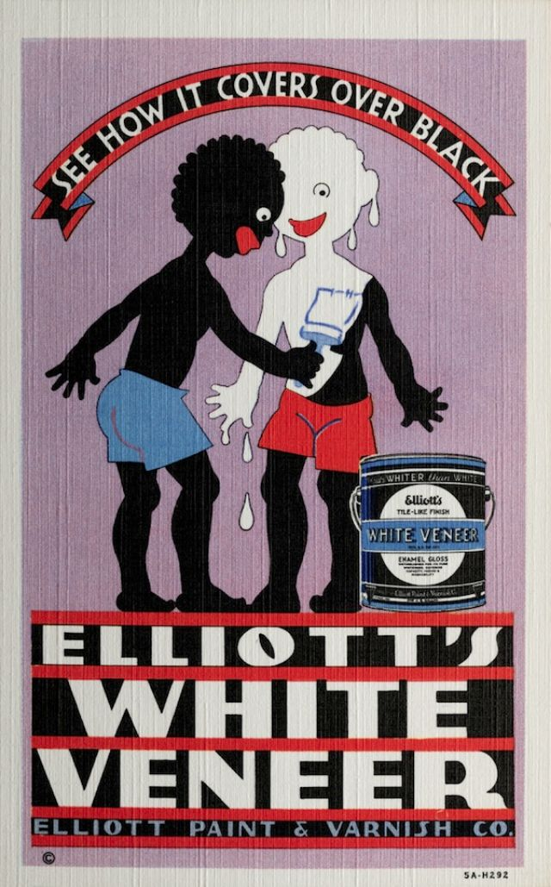
In the 1970s and 1980s, the ability to get away with producing racist and sexist advertisement was extremely over looked. Stereotypes of black people were used in many advertisements for things such as smoking and being a servant to a white person. In earlier years, although racism was thought to be decreasing and equality was in sight, many companies still used shocking ideas around black people, such as Elliot’s Paint and Varnish Co. used an advertisement of two drawn black men using the product of the advertisement, which was a can of white paint, the two stood facing each other as the one man painted over the other with the product and text above them saying “See how it covers over black”. In 2020, the well-known car brand Volkswagen removed an Instagram advertisement of one of their cars because of many issues seen. The advertisement was seen using a café named “Petit Colon” which translates to “Little Colonist” and even the word “Neger” which is a highly racist slur. The firm has a number of internal schemes designed to promote diversity and unprejudiced cooperation, it said, so it is "all the more frustrating that we have made this mistake." (Espiner, 2020). Katherine Frith and Barbara Mueller wrote the book titled ‘Advertising and Societies: Global Issues’ which talks quite often of stereotypes and inequalities in adverting, on page 110 it is wrote that “From the advertiser’s point of view, the bottom line is profit and sales. Advertisers have little time for character development” (Frith and Mueller, 2010, p. 110). As disappointing as that statement maybe it is also true, as I stated earlier in this essay, target audiences are a priority and by using a stereotype such as a Mexican wearing a sombrero or a short, ginger Irishman, it can gain the attention of the audience quickly as they will understand the advertisement easier.

(Elliott Paint & Varnish Co., 1935)
A big development for the black committee was the movement ‘Black Lives Matter’(BLM). This movement started after the devastating death of a black male named George Floyd. He was a victim of people brutality against black people and his unfair death is what made people stand up and say, ‘no more’. People of all ethnicities started to protest against police brutality and helped the BLM movement spread. Many companies showed support with the movement by making adjustments to adverts and many social media posts. ‘For ad agencies — oft criticised for the 'male, pale and stale' approach to leadership and a lack of diversity within their walls — the Black Lives Matter movement has forced those at the top to hold a mirror up to their own policies around diversity, inclusion and supporting Black talent.’ (Stewart, 2020). Though many saw George Floyd’s death as an opportunity to riot and steal from shops, it was also the opportunity to raise awareness of what was happening on the streets. Advertisements began showing more and more black people in adverts which was helping spread the awareness, however it was also thought that some companies were just using the movement for publicity and attention as some companies were doing more than others. Nike for example repurposed their iconic ‘Just Do It’ slogan for ‘For Once, Just Don’t Do It’. Colin Kaepernick, who is associated with Nike, started the practice of kneeling in solidarity with BLM amongst the NFL (Hurst, 2020).
Stereotypes are used in advertisements as a way of getting the point across. As a man, it is common to be seen as the provider of the family as the stereotype says a man is stronger, smarter, and more capable of getting the job done properly however as a woman, it is believed that she would be the house wife, her job being to stay home to clean, cook and look after the children. Although this ideology is gladly dying out, it is still used in advertisements today. During the 2020/21 Coronavirus pandemic, the government released multiple advertisements recommending people stay inside and work from home if possible, however it is noticed that the people in these small graphical animations and drawings are mostly women. It is shown with women holding babies and helping the children with school work. In other advertisements from the government, it shows mostly female nurses in hospitals and in vaccine centres. Advertising is meant to replicate the society we currently live in so when advertisers use strong stereotypes such as these, it strongly reinforces the representations of the stereotypes. In 2019, the Committee of Advertising Practice helped make it illegal to use harmful stereotyping in UK adverts, worrying that it could cause harm or widespread offence (Hamilton, 2019), this caused relief and joy for most however it is worrisome that for the many decades that sexism has been around, it is only now being attempted to be fixed.
By using stereotypes in advertising, it leads on to other issues such as over sexualising women for the sake of selling a product. “While women in bikinis had been draped over cars and washing machines for decades, it was only in the 1970s that women began to take issue with this representation” (Frith and Mueller, 2010, p. 94). Women have been using their bodies to gain attention for produces for many years but once feminists decided to stand up for what they believe, this advertising method went in to questioning. Although sexualising women is still rather high on the advertising methods, there is a much bigger chance of it being pointed out and hopefully corrected in today’s society. Video games have benefited from over sexualising female characters for sales for decades, in games such as Tomb Raider where the main character, Laura Croft, is seen to wear a small tank top and tiny shorts as she makes her way through dangerous jungles, in reality a person going through dangerous territories and being shot at would wear appropriate clothing, however by using the popular ‘sex sells’ method, giving the main character little to no clothes can improve the attention it gets, mostly from a male audience. In the earlier versions of Tomb Raider, it is seen that Laura Croft has an unrealistic figure with a very small waist but extremely large breasts. According to the designer, Toby Gard, he was messing around with the character when he accidently enlarged her breast size to 150% instead of the original 50%, after showing the character to the team with the plan of reducing her breast size, the team were quick to deny any changes because “sex sells” (Tailford, 2016).


(Laura Croft outfit)
Along with sexism and racism being an issue in the advertising department, sexuality is also an issue that is commonly over looked. A Snickers chocolate bar advert was banned in Spain after including a homophobic ideology. The classic slogan “You’re not you when you’re hungry” is a recognisable slogan to most people, however when used in this advert it became rather offensive. The short advert featured 2 men sat in a beach bar, the one male acting feminine and ordering in a stereotypical gay style, this is when the other, more masculine male places a Snickers ice cream in front of the feminine male and following all Snickers adverts he takes a bite, after eating the ice cream he is shown as a completely different male and is shown more masculine. Not for the first time Snickers is confronted with the accusation of homophobia: In 2008 the brand withdrew a video of its “Get some nuts” campaign, in which a speed walker is described as a “disgrace” and asked to run “like a real man” (NewsyList). The Snickers brand stated that to avoid any chance of the advert being misinterpreted, they pulled the advert and apologised. By using a male that was seen as feminine and exchanging him for a more masculine male, it is not only homophobic but it also sexist.
Same sex couple tend to be avoided over worry from brands about negative feedback. For example, an American channel called Hallmark removed a wedding advert that featured a lesbian couple. The channel admitted to pulling the advert because “they do not run adverts that are controversial”. The reasoning behind the advert being brought to attention was because of a group called ‘One Million Moms’, an American group that commonly protest against LGBTQ+ rights. One Million Moms started creating posts about the advert, claiming that the channel could no longer be trusted and to boycott the channel, causing the outcome of Hallmark to side with the homophobic group (Young, 2019). Although the One Million Moms group saw this as a victory, they continued their negative comments to the wedding brand, Zola, who were responsible for the advertisement. Zola repaid Hallmark Channel for removing their add by cancelling all adverts with the channel and refusing to work with them again under those circumstances. Zola had stated that even though they had negative comments from homophobic individuals, they had an overall positive outcome from a wider range of people. People also took to social media to spread their anger and disappointment with Hallmark Channel for caving so easily. By Hallmark Channel backing down so easily after being threatened with a possible boycott, it proves that companies will do what is best for themselves rather than sticking up for a disadvantaged group. It is commonly understood that most complaints that are given are based on children, for some reason many people that call or write to complain about same sex couples being shown on TV use the excuse of how they believe it would encourage their children to become homosexual and how it is inappropriate for them to be seeing same sex couples.
By not improving and fixing the current advertising methods, it could have a possible outcome on how the children of our time see things when they grow up. I believe that a child not being able to see a same sex couple on TV is ridiculous as sexuality is not something that you choose, however I also believe that by not allowing children to view such natural things could possibly lead the child into having a confusing or negative view on it as an adult. The younger the child is, the more likely it is to imitate the adult which is why we as adults need to lead by example. “Children don’t only imitate their parents. As we well know, they don’t simply experience isolated scenarios. Nowadays, they have more social stimulation than ever, and even “models” outside their own home or school. We also can’t forget television and those new technologies they use from a very early age.” (Valeria123, 2021). Children learn from everything, therefore by choosing to shelter children from non-existent threats and unreasonable fears, it holds the door open of the big possibility that the child will not only hold onto a negative attitude about things such as same sex couples and different ethnicities but will also heighten the risk of passing it on to the next generation. There is a delightful statement that says, “no one is born racist, it is simply taught”. When advertisements show stereotypical racism or sexism, it is usually down played and over looked however the subtle hints of how a woman is always home with the children could lead little girls to believe that is the role they are meant to play in life.
My point of view on this matter has hardly changed from the beginning and after doing some research on the matter, I’d say I feel even stronger about it now. I understand that there are two sides to every argument and conversation, however I believe that it is cowardly to back down after showing support of same sex couples or inter-racial couples simply because there is the threat of a boycott from a small group. I strongly believe that advertising needs to improve on its approach towards equality and express a more realistic type of society. It is impossible to please everyone as no one is the same, however being proud of who you support and helping out struggling societies is something I believe every company and brand should do. The current rate of improvement is steady as I feel I am seeing a wider range of families on TV and in advertisements, and I would like to see a more positive reaction towards the supportive advertisements.

Bibliography
Espiner, T. (2020) ‘VW pulls Instagram ads after racism row’ BBC News. Available at: https://www.bbc.co.uk/news/business-52733444 (Accessed: 9 December 2021)
Frith, K and Mueller, B. (2010) Advertising and Societies: Global Issues. 2nd edn. New York: Peter Lang Publishing Inc.
Stewart, R. (2020) ‘Black Lives Matter: what have advertising's biggest agencies promised?’ The Drum. Available at: https://www.thedrum.com/news/2020/07/13/black-lives-matter-what-have-advertisings-biggest-agencies-promised (Accessed: 9 December 2021)
Hurst, B. (2020) ‘Brands backing Black Lives Matter: it might be a marketing ploy, but it also shows leadership’ THE CONVERSATION. Available at: https://theconversation.com/brands-backing-black-lives-matter-it-might-be-a-marketing-ploy-but-it-also-shows-leadership-139874 (Accessed: 9 December 2021)
Hamilton, R. (2019) UK finally bans sexist adverts [blog]. Available at: https://www.creativebloq.com/news/new-uk-gender-stereotyping-advertising-law (Accessed: 9 December 2021)
Frith, K and Mueller, B. (2010) Advertising and Societies: Global Issues. 2nd edn. New York: Peter Lang Publishing Inc.
Tailford, S. (2016) 9 Insane Origins of Gaming’s Most Over-Sexualised Female Characters [blog]. Available at: https://whatculture.com/gaming/9-insane-origins-of-gamings-most-oversexualised-female-characters (Accessed: 9 December 2021)
NewsyList. Available at: https://www.newsylist.com/homophobic-advertising-snickers-withdraws-commercial-after-criticism/ (Accessed: 9 December 2021)
Young, S. (2019) ‘Hallmark Channel removes same-sex wedding advert’ The Independent. Available at: https://www.independent.co.uk/life-style/hallmark-channel-advert-same-sex-couple-wedding-zola-complaint-one-million-moms-a9247096.html (Accessed: 9 December 2021)
Valeria123. (2021) Why do Children Imitate Adults? [blog]. Available at: https://exploringyourmind.com/why-do-children-imitate-adults/ (Accessed: 9 December 2021)

